Supplementary information
The Competition between DNA Methylation and Demethylation is Associated with Transcription Regulation and Tumorigenesis
Jiejun Shi¹, Jianfeng Xu², Yiling Elaine Chen³, Jingyi Jessica Li³, Lanlan Shen⁴, Wei Li^{1*}

Affiliations:
¹Division of Computational Biomedicine, Department of Biological Chemistry, School of Medicine, University of California, Irvine, Irvine, CA 92697, USA
²Department of Molecular and Cellular Biology, Baylor College of Medicine, Houston, TX 77030, USA
³Department of Statistics, University of California, Los Angeles, CA 90095, USA
⁴Department of Pediatrics, Baylor College of Medicine, USDA/ARS Children's Nutrition Research Center, Houston, Texas, 77030, USA
*Correspondence: wei.li@uci.edu

Supplementary Tables
Supplementary Table 1. Datasets used in this study
Supplementary Table 2. Lists of genes repressed by promoter methylation competition-elevation, hypermethylation, or both of them in uterus tumor
Supplementary Table 3. List of methylation canyons and their target genes in CD3+ T-cell
Supplementary Table 4. List of ‘methyl-plus’ and ‘methyl-minus’ motifs used in this study. Enrichment at aCanyon and pCanyon in CD3+ T-cell is indicated.
Supplementary Figures

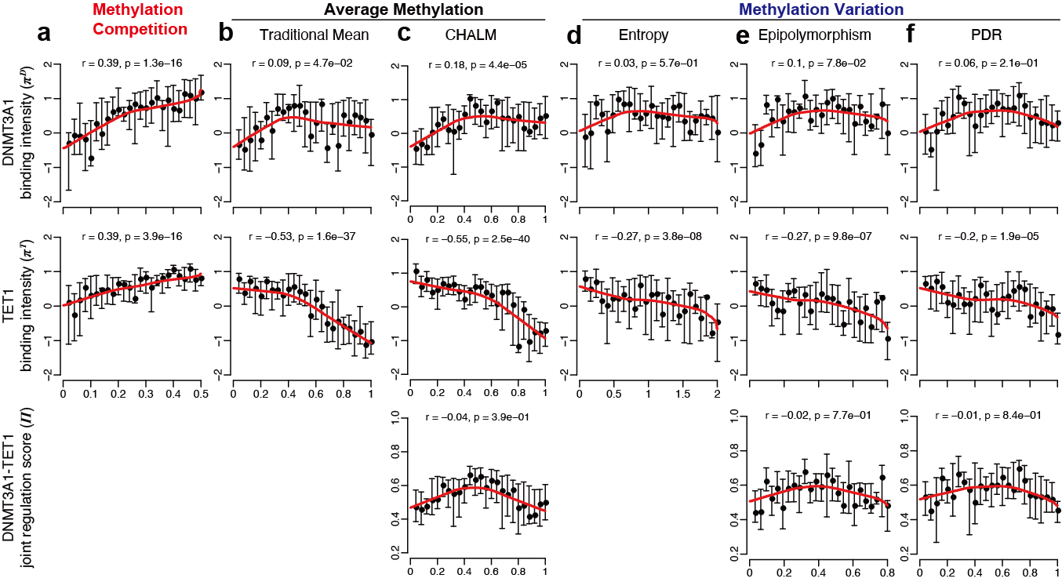

Supplementary Figure 1. Methylation competition ratio is positively correlated with both DNMT3A1 binding and TET1 binding in mouse embryonic stem cells (mESCs)
(a) Correlation of methylation competition ratio versus DNMT3A1 binding (1st row) and TET1 binding (2nd row) in gene promoter regions. (b) Correlation of traditional mean methylation ratio versus DNMT3A1 binding (1st row) and TET1 binding (2nd row). (c) Correlation of CHALM versus DNMT3A1 binding (1st row), TET1 binding (2nd row), and ‘DNMT3A1-TET1 joint regulation score’ (3rd row) at promoters. (d) Correlation of methylation entropy versus DNMT3A1 binding (1st row) and TET1 binding (2nd row). (e) Correlation of Epipolymorphism versus DNMT3A1 binding (1st row), TET1 binding (2nd row), and ‘DNMT3A1-TET1 joint regulation score’ (3rd row) at promoters. (f) Correlation of PDR versus DNMT3A1 binding (1st row), TET1 binding (2nd row), and ‘DNMT3A1-TET1 joint regulation score’ (3rd row) at promoters. Spearman’s rank correlation was calculated based on all data points. P-values were calculated by the two-tailed correlation test for Spearman’s correlation. For visualization, gene promoters were divided into 25 groups based on the methylation scores. LOWESS lines were plotted to describe the relationships between variables (indicated by red curves).

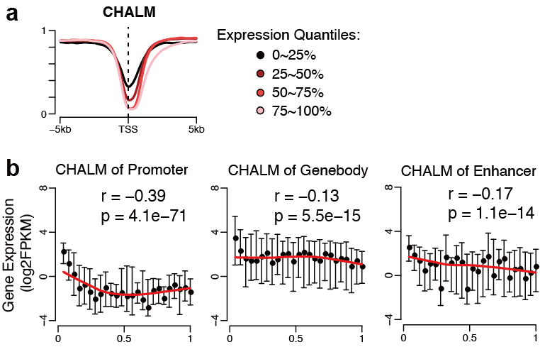

Supplementary Figure 2. The correlation between cellular heterogeneity-adjusted mean methylation (CHALM) and gene expression.
(a) Average profiles of CHALM in TSS proximal regions of four groups of genes in CD3+ T-cell. The four gene groups are the same as in Fig 2a. (b) The promoter CHALM scores (1st column) are negatively associated with gene expression level in CD3+ T-cell. But the correlation of gene-body (2nd column) and enhancer (3rd column) CHALM scores are very low. Promoter regions are from 1kb upstream to 500bp downstream of TSS. Gene-body regions are from 500bp downstream of TSS to TTS. Enhancer regions are defined based on chromatin interactions validated by Hi-C data (see Methods). Spearman’s rank correlation was calculated based on all data points. P-values were calculated by the two-tailed correlation test for Spearman’s correlation. For visualization, genomic regions (e.g., promoter, gene-body, and enhancer) were divided into 25 groups based on the CHALM scores. LOWESS lines were plotted to describe the relationships between variables (indicated by red curves).
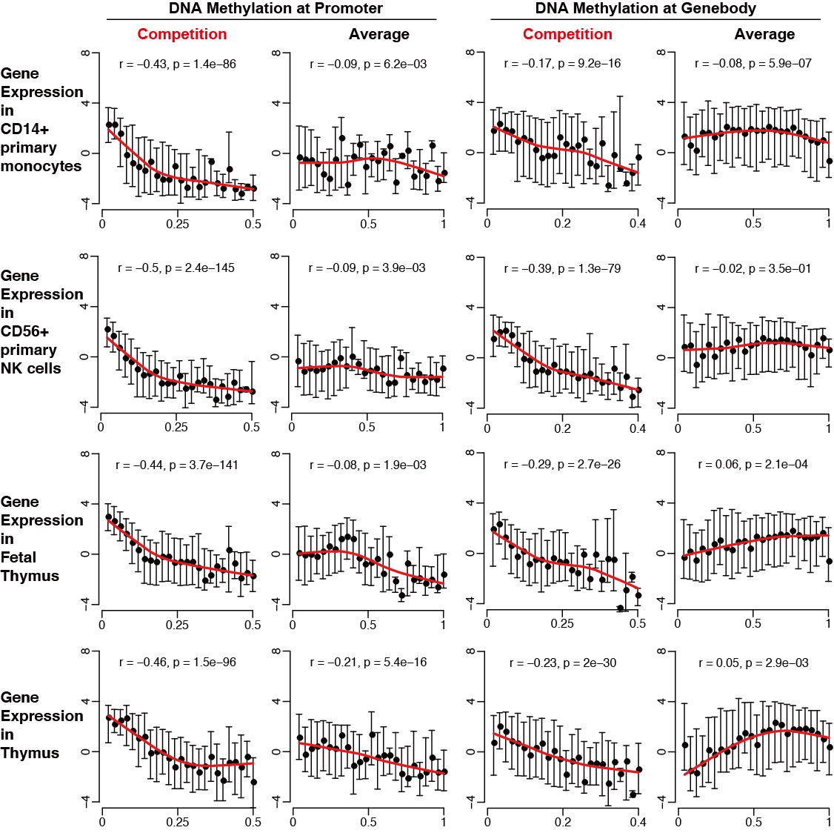

Supplementary Figure 3. Methylation competition ratio is consistently associated with gene expression in various samples.
The Spearman correlation between gene expression and promoter methylation competition (1st column), promoter average methylation (2nd column), gene-body methylation competition (3rd column), gene-body average methylation (4th column) in 4 different samples, i.e., CD14+ primary cells (1st row), CD56+ primary cells (2nd row), fetal thymus tissue (3rd row), and adult thymus tissue (4th row). Spearman’s rank correlation was calculated based on all data points. P-values were calculated by the two-tailed correlation test for Spearman’s correlation. For visualization, genes were divided into 25 groups based on the methylation scores. LOWESS lines were plotted to describe the relationships between variables (indicated by red curves).

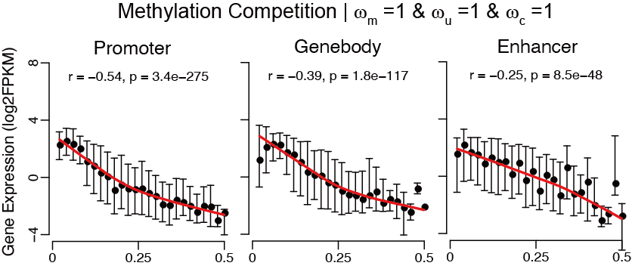

Supplementary Figure 4. Spearman correlations between unweighted methylation competition ratios and gene expression.
The methylation competition ratios in CD3+ T-cells were calculated with $ω_{m}=1$ , $ω_{u}=1$, and $ω_{c}=1$. Scatter plots show the correlation between gene expression and methylation competition ratios on promoter (left), gene-body (middle), and enhancer (right). Spearman’s rank correlation was calculated based on all data points. P-values were calculated by the two-tailed correlation test for Spearman’s correlation. For visualization, regions were divided into 25 groups based on the unweighted methylation competition ratios. LOWESS lines were plotted to describe the relationships between variables (indicated by red curves).

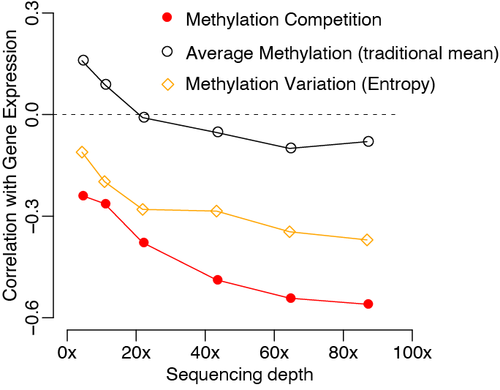

Supplementary Figure 5. Spearman correlations between methylation quantitative measures and gene expression at varying sequencing depths.
Y-axis indicates the Spearman correlation between gene expression and three methylation quantitative measures of gene promoters in CD3+ T-cells. The X-axis shows the average sequencing depth of down-sampled bisulfite-seq data.

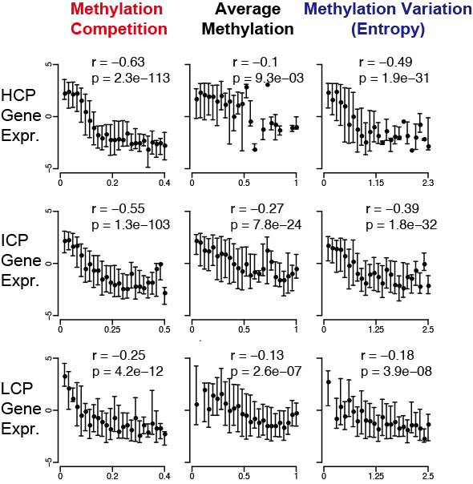

Supplementary Figure 6. Spearman correlation between methylation quantitative measures and gene expression in three gene groups with different CpG densities at promoter.
Scatter plots show the correlation of HCP (1st row), ICP (2nd row), and LCP (3rd row) gene expression versus promoter methylation competition (1st column), average methylation (2nd column), and methylation variation (entropy, 3rd column), in CD3+ T-cell. Spearman’s rank correlation was calculated based on all data points. P-values were calculated by the two-tailed correlation test for Spearman’s correlation. For visualization, each group of promoters was divided into 25 subgroups based on each methylation quantitative measure.

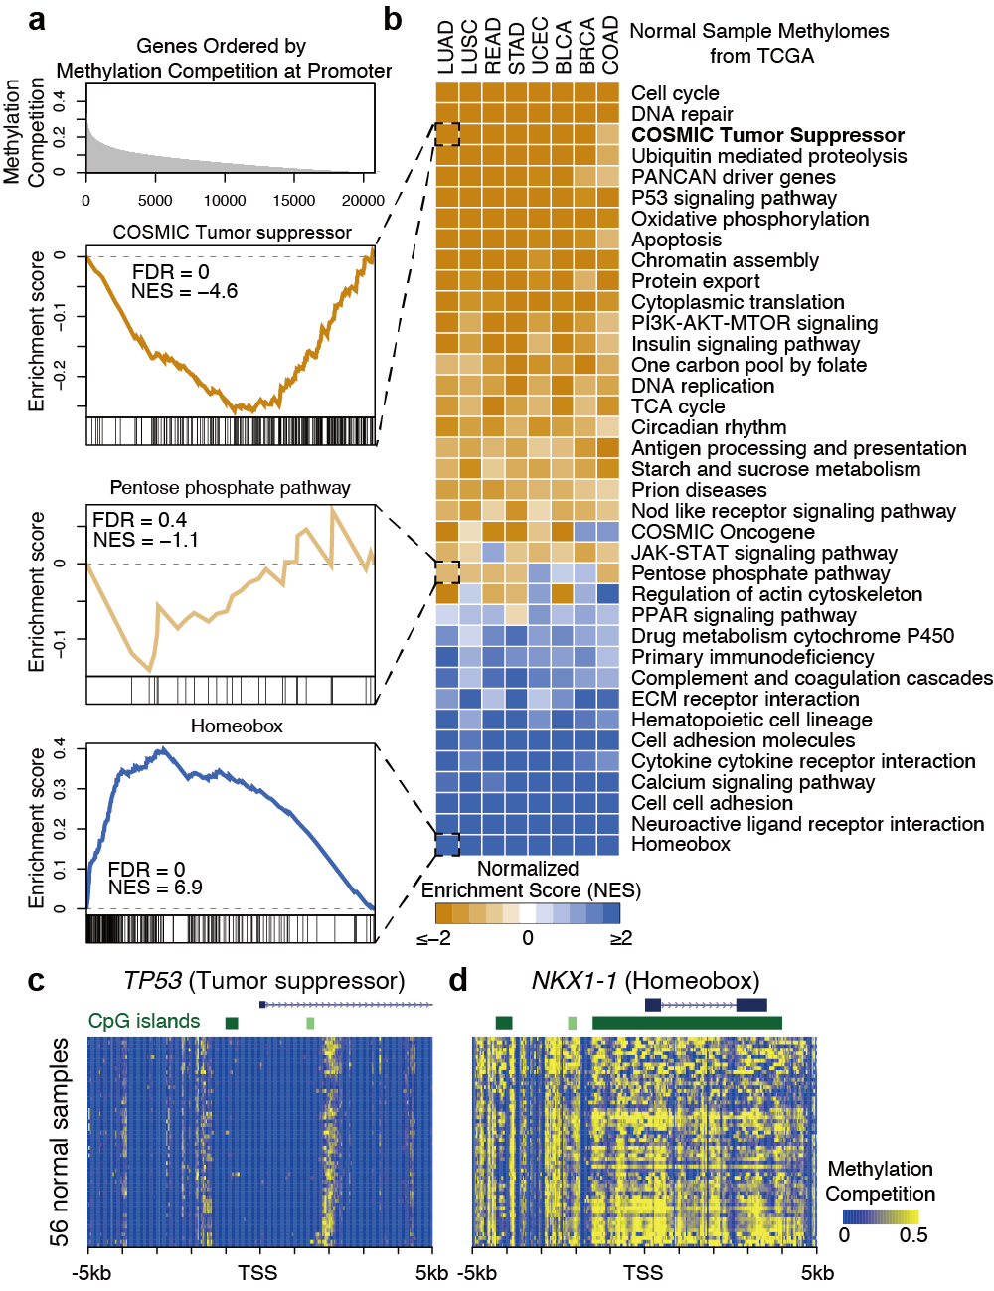
Supplementary Figure 7. Tumor suppressor genes are characterized by low methylation competition level in normal tissues
(a) Genes were decreasingly ordered by promoter methylation competition ratios (1st row). The GSEA running enrichment scores of ‘COSMIC Tumor suppressor’ (2nd row), ‘Pentose phosphate pathway’ (3rd row), and ‘Homeobox’ genes (4th row) in TCGA-LUAD normal sample. Normalized enrichment scores (NES) and FDR values were given by GSEA software. (b) Heatmap showing GSEA NES in TCGA normal samples related to 8 cancer types. Pathways and functional terms are curated by GSEA MutSigDB, except ‘COSMIC Tumor suppressor’, ‘COSMIC Oncogene’, and ‘PANCAN driver genes’ (see Methods). (c) Methylation competition profiles in TSS proximal regions of tumor suppressor TP53 in 56 normal human methylomes. (d) Same as (c), but for Homeobox gene NKX1-1.

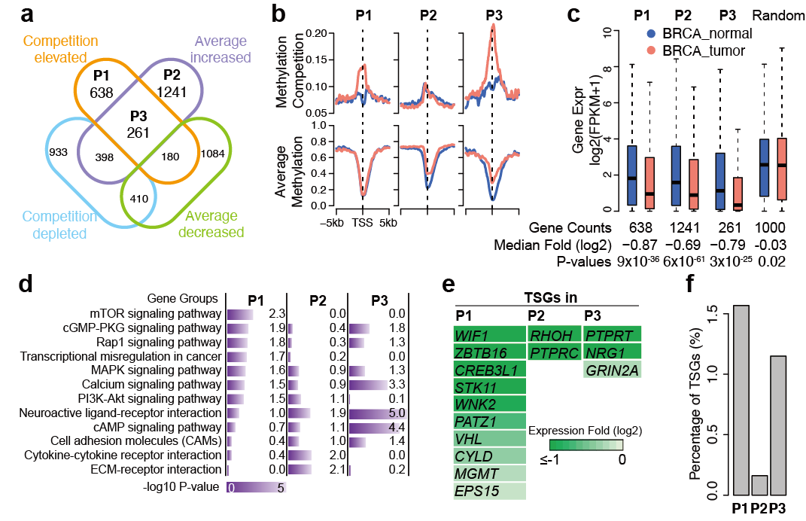

Supplementary Figure 8. Cancer-related genes can be repressed by methylation competition elevation rather than hypermethylation in breast tumor
(a) Venn diagram shows the overlap between promoter methylation competition altered genes and average methylation altered genes in the TCGA breast tumor (BRCA). P1, competition-elevated but average-methylation-stable genes; P2, hypermethylated but competition-stable genes; P3, competition-elevated and hypermethylated genes. (b) Average profiles of methylation competition (upper panel) and average methylation (lower panel) in TSS regions of P1, P2, and P3 genes. The BRCA normal is in blue, and the BRCA tumor is in red. (c) Gene expression change of P1, P2, P3, and 1,000 randomly selected genes. The fold changes between median values (log2 scale) are indicated below. The two-tailed Wilcoxon signed-rank test was used for the significance test. (d) Gene ontology analysis on P1, P2, and P3 genes using DAVID online tool. The Benjamini-Hochberg adjusted p-values were given by DAVID. (e) COSMIC tumor suppressors which are overlapped with P1, P2, and P3 genes. Gene expression fold changes (log2 scale) are indicated. Darker green means higher repression in the BRCA tumor sample. (f) The percentages of tumor suppressors in P1, P2, and P3 genes.

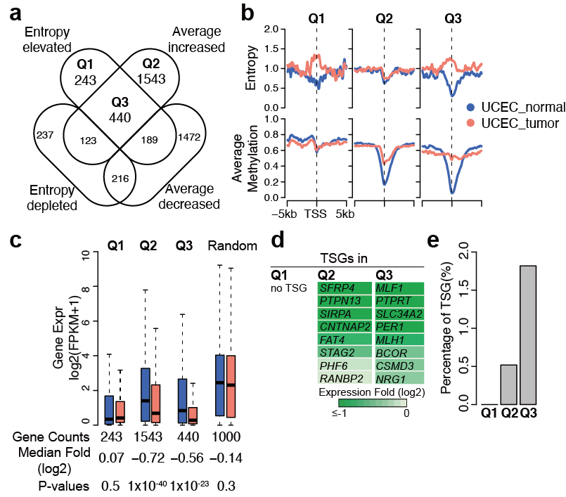

Supplementary Figure 9. Methylation entropy-elevation is not able to define TSG repression
(a) Venn diagram shows the overlap between promoter methylation entropy altered genes and average methylation altered genes in the TCGA uterus tumor (UCEC). Q1, entropy-elevated but average-methylation stable genes; Q2, hypermethylated but entropy-stable genes; Q3, entropy-elevated and hypermethylated genes. (b) Average profiles of methylation entropy (upper panel) and average methylation (lower panel) in TSS regions of Q1, Q2, and Q3 genes. UCEC normal is in blue, and UCEC tumor is in red. (c) Gene expression change of Q1, Q2, Q3, and 1,000 randomly selected genes. The fold changes between median values (log2 scale) are indicated below. The two-tailed Wilcoxon signed-rank test was used for the significance test. (d) COSMIC tumor suppressor genes which are overlapped with Q1, Q2, and Q3 genes. Gene expression fold changes (log2 scale) are indicated. Darker green means higher repression in the UCEC tumor sample. (e) The percentages of tumor suppressors in Q1, Q2, and Q3 genes.

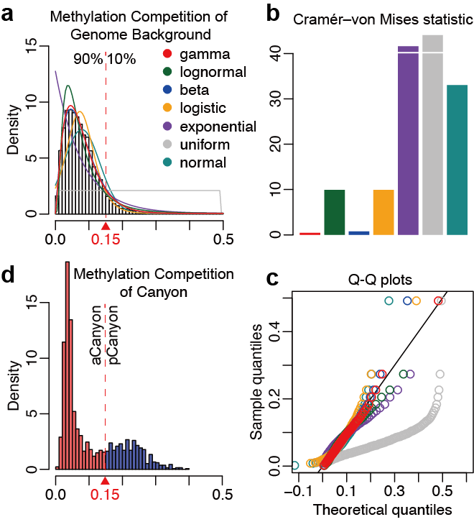
Supplementary Figure 10. Determining the threshold of methylation competition ratio for categorizing methylation canyons
(a) Methylation competition ratios of genome background in CD3+ T-cell are fitted to various distribution models, including ‘gamma’, ‘log-normal’, ‘beta’, ‘normal’, ‘uniform’, ‘exponential’, and ‘logistic’ distributions. The curves indicate the fitted models based on parameters from maximum likelihood estimation. (b) Judging the goodness of fitness in (a) using the Cramér–von Mises criterion. (c) Q-Q plots comparing the sample distribution with theoretical distributions. (d) Methylation canyons are categorized by cutoff from the genome background (indicated as the red triangle and vertical dashed lines).

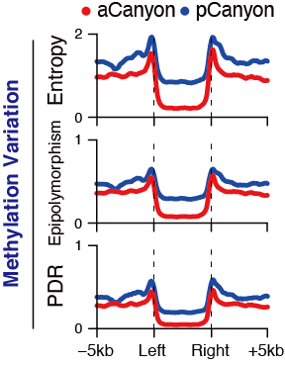

Supplementary Figure 11. The profiles of methylation variation scores at two canyon groups
Average profiles of methylation Entropy, Epipolymorphism, and PDR on methylation canyons in CD3+ T-cell. ‘aCanyons’ (red) are low-competition canyons. ‘pCanyons’ (blue) are high-competition canyons. The X-axis indicates the distance to canyon borders. And all canyons are normalized to 5kb length.
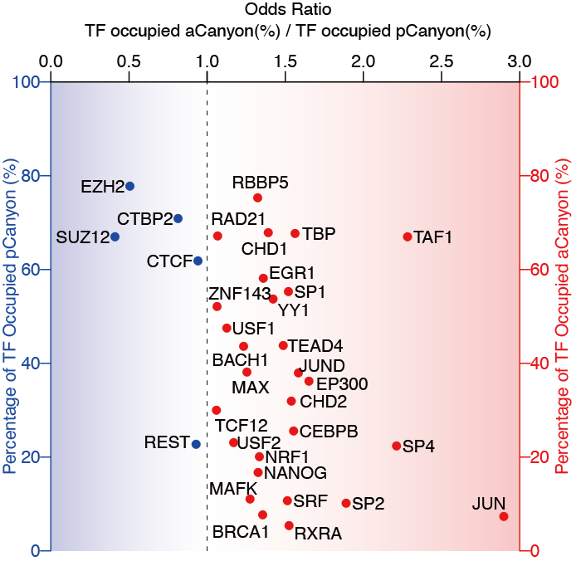
Supplementary Figure 12. The transcription factor binding difference between canyon groups
Scatter plot showing TF binding difference between aCanyon and pCanyon in H1 human stem cells. X-axis indicates odds ratio between TF-bound-aCanyon (%) and TF-bound-pCanyon (%). For the left part (blue shaded), the Y-axis is the percentage of pCanyons which are bound by TF. For the right part (red shaded), the Y-axis is the percentage of aCanyons which are bound by TF. Each dot represents a TF.

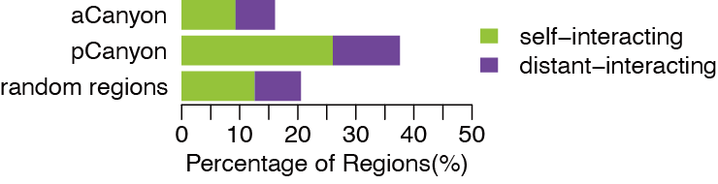

Supplementary Figure 13. The chromatin interactions on methylation canyons
Percentages of canyons and random genomic regions that have high-order chromatin interactions in CD3+ T-cell. Chromatin interactions were defined by pairs of Hi-C anchors. ‘Self-interacting’ indicates the anchor pairs located in the same canyon/random region. ‘Distant-interacting’ means only one of them is in the canyon/random region (see Methods).

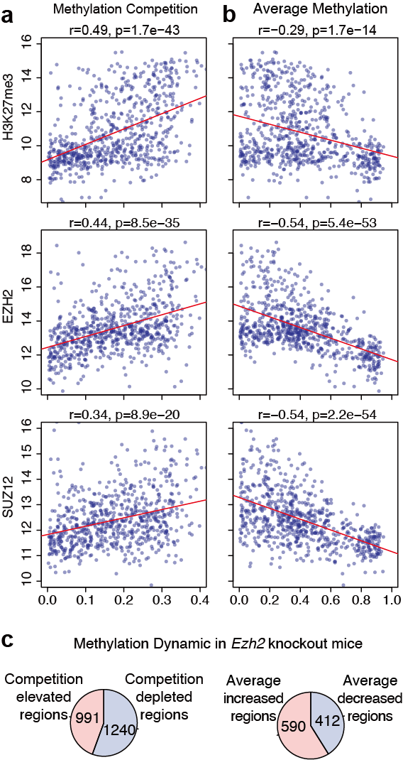
Supplementary Figure 14. Methylation competition is promoted by Polycomb complex binding
(a) Methylation competition is positively correlated with H3K27me3, EZH2, and SUZ12 binding in promoter regions in H1 human stem cells. (b) Average methylation is negatively associated with Polycomb binding in H1. Spearman’s rank correlation was used in (a) and (b). P-values were calculated by the two-tailed correlation test for Spearman’s correlation. Linear models were plotted to describe the relationships between variables (indicated by red lines). (c) Ezh2 knockout in mice leads to more methylation-competition depleted regions (left) and more hypermethylated DMRs (right).

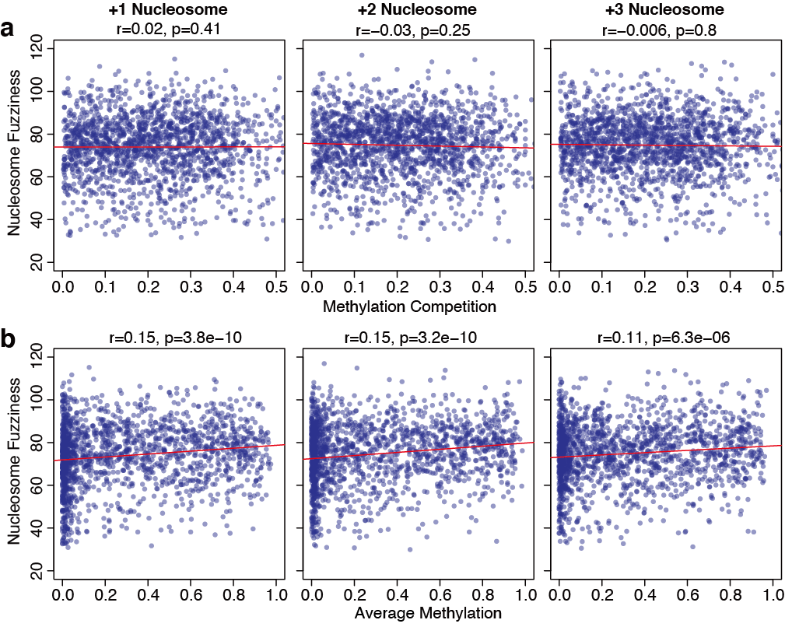
Supplementary Figure 15. Methylation competition is independent of nucleosome positioning fuzziness
(a) The methylation competition ratios of +1, +2, +3 nucleosomes are not correlated with fuzziness in human brain tissue. (b) The weak correlation between average methylation and nucleosome fuzziness in human brain tissue. Spearman’s rank correlation was used in (a) and (b). P-values were calculated by the two-tailed correlation test for Spearman’s correlation. Linear models were plotted to describe the relationships between variables (indicated by red lines).

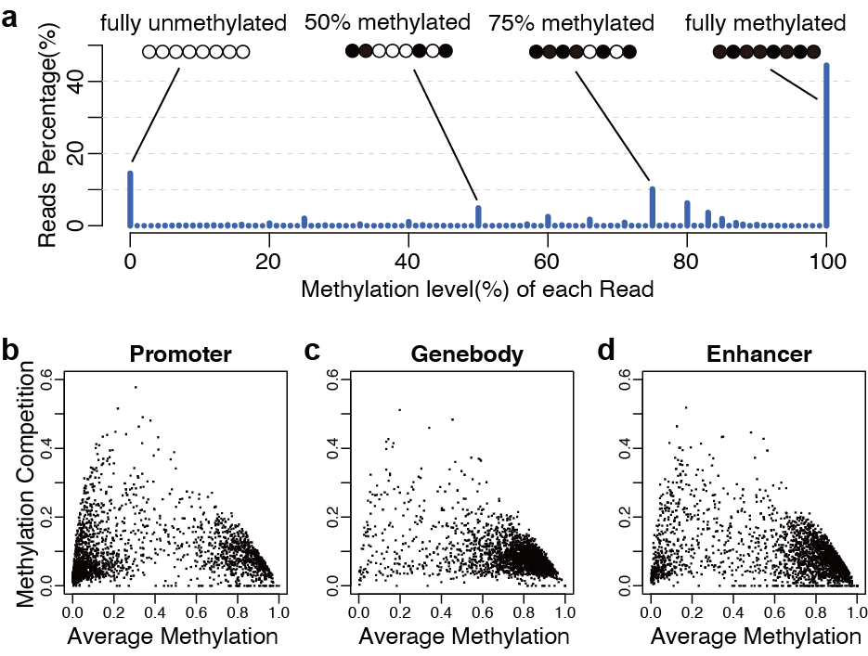
Supplementary Figure 16. Methylation levels of each bisulfite-seq reads and the distribution of methylation competition ratio
(a) Histogram of the methylation level of each bisulfite-seq read from CD3+ T-cell. The distribution of methylation competition (Y-axis) and average methylation (X-axis) ratios in the promoter (b), gene-body (c), and enhancer (d) regions.

