A novel MALDI-TOF mass spectrometry sample preparation strategy for improved proteomic biotyping of clinically significant Mycobacteria

Melendhran Pillay¹, Siyanda Myende², Suresh Babu Naidu Krishna^{3*}, Ezekiel Green⁴ and Patrick Govender²

Authors and Affiliations
¹ School of Health Science, University of KwaZulu-Natal, Private Bag X54001, Durban, 4000, South Africa. Email: melenpillay1@gmail.com; ORCID: 0000-0002-5570-1010
²School of Life Sciences , University of KwaZulu-Natal, Private Bag X54001, Durban, 4000, South Africa. Email: myendesiyanda@yahoo.com.
³ Department of Biomedical and Clinical Technology, Durban University of Technology, Durban-4000, South Africa. Email: sureshk@dut.ac.za; ORCID: 0000-0003-3155-8878
⁴ Prof. Ezekiel Green, Department of Biotechnology and Food Technology, University of Johannesburg University of Johannesburg, Doornfontein Campus, Doornfontein, Johannesburg, Email: egreen@uj.ac.za, ORCID NUMBER: 0000-0002-4962-0724

*Corresponding Author
Dr Suresh Babu Naidu Krishna, Department of Biomedical and clinical Technology, Durban University of Technology, Durban-4000. Email: sureshk@dut.ac.za; ORCID: 0000-0003-3155-8878

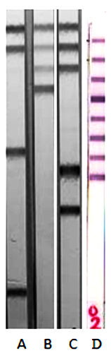

Supplementary Data set file:
Figure 1 Genotype CM assay (Strips A, B and C). M.fortuitum (StripA, bands 7 and 14), M. avium (StripB, band 4) and M.gordonae (StripC, bands 8 and 10). Genotype MTBC assay (Lane D) showing M.tuberculosis (bands 1-8).

