Supplementary Table 1: The annual average air temperature and precipitation for the 2031-2060 considering SSP4.5 and historical period.
 |  | 2031-2060 |  | 1981-2010
GCM Models | Precipitation |  | Temperature | Precipitation Reference | Temperature Reference | ∆T | ∆Pr (%)
ACCESS-CM2_r1i1p1f1 | 882.27 |  | 21.62 | 1225.76 | 16.27 | 5.34 | -3.43
ACCESS-CM2_r2i1p1f1 | 847.20 |  | 21.58 | 1225.76 | 16.27 | 5.31 | -3.79
ACCESS-CM2_r3i1p1f1 | 857.89 |  | 21.63 | 1225.76 | 16.27 | 5.35 | -3.68
ACCESS-ESM1-5_r1i1p1f1 | 1600.53 |  | 21.00 | 1225.76 | 16.27 | 4.72 | 3.75
ACCESS-ESM1-5_r2i1p1f1 | 1613.67 |  | 20.97 | 1225.76 | 16.27 | 4.69 | 3.88
ACCESS-ESM1-5_r3i1p1f1 | 1617.96 |  | 20.98 | 1225.76 | 16.27 | 4.71 | 3.92
CanESM5_r1i1p1f1 | 917.74 |  | 24.00 | 1225.76 | 16.27 | 7.73 | -3.08
CanESM5_r1i1p2f1 | 915.43 |  | 24.00 | 1225.76 | 16.27 | 7.72 | -3.10
CanESM5_r2i1p1f1 | 854.70 |  | 24.30 | 1225.76 | 16.27 | 8.03 | -3.71
CanESM5_r2i1p2f1 | 949.76 |  | 24.00 | 1225.76 | 16.27 | 7.73 | -2.76
CanESM5_r3i1p1f1 | 929.68 |  | 24.05 | 1225.76 | 16.27 | 7.77 | -2.96
CanESM5_r3i1p2f1 | 856.28 |  | 24.01 | 1225.76 | 16.27 | 7.73 | -3.69
CanESM5_r4i1p1f1 | 927.17 |  | 24.03 | 1225.76 | 16.27 | 7.76 | -2.99
CanESM5_r4i1p2f1 | 914.71 |  | 23.97 | 1225.76 | 16.27 | 7.69 | -3.11
CanESM5_r5i1p1f1 | 865.17 |  | 24.22 | 1225.76 | 16.27 | 7.95 | -3.61
CanESM5_r5i1p2f1 | 941.59 |  | 23.83 | 1225.76 | 16.27 | 7.56 | -2.84
CanESM5_r6i1p1f1 | 876.15 |  | 24.10 | 1225.76 | 16.27 | 7.82 | -3.50
CanESM5_r6i1p2f1 | 898.96 |  | 24.00 | 1225.76 | 16.27 | 7.73 | -3.27
CanESM5_r7i1p1f1 | 903.85 |  | 24.15 | 1225.76 | 16.27 | 7.88 | -3.22
CanESM5_r7i1p2f1 | 924.26 |  | 23.98 | 1225.76 | 16.27 | 7.71 | -3.02
CanESM5_r8i1p1f1 | 929.63 |  | 24.04 | 1225.76 | 16.27 | 7.76 | -2.96
CanESM5_r8i1p2f1 | 854.76 |  | 24.04 | 1225.76 | 16.27 | 7.76 | -3.71
CanESM5_r9i1p1f1 | 905.06 |  | 24.09 | 1225.76 | 16.27 | 7.82 | -3.21
CanESM5_r9i1p2f1 | 913.85 |  | 23.93 | 1225.76 | 16.27 | 7.66 | -3.12
CanESM5_r10i1p1f1 | 910.77 |  | 23.95 | 1225.76 | 16.27 | 7.68 | -3.15
CanESM5_r10i1p2f1 | 884.96 |  | 24.07 | 1225.76 | 16.27 | 7.80 | -3.41
CanESM5_r11i1p1f1 | 899.86 |  | 24.13 | 1225.76 | 16.27 | 7.86 | -3.26
CanESM5_r11i1p2f1 | 927.41 |  | 23.86 | 1225.76 | 16.27 | 7.59 | -2.98
CanESM5_r12i1p1f1 | 898.39 |  | 24.07 | 1225.76 | 16.27 | 7.79 | -3.27
CanESM5_r12i1p2f1 | 885.10 |  | 23.89 | 1225.76 | 16.27 | 7.61 | -3.41
CanESM5_r13i1p1f1 | 891.30 |  | 24.08 | 1225.76 | 16.27 | 7.80 | -3.34
CanESM5_r13i1p2f1 | 937.49 |  | 23.82 | 1225.76 | 16.27 | 7.55 | -2.88
CanESM5_r14i1p1f1 | 940.43 |  | 24.05 | 1225.76 | 16.27 | 7.78 | -2.85
CanESM5_r14i1p2f1 | 903.14 |  | 24.00 | 1225.76 | 16.27 | 7.73 | -3.23
CanESM5_r15i1p1f1 | 915.78 |  | 24.09 | 1225.76 | 16.27 | 7.81 | -3.10
CanESM5_r15i1p2f1 | 906.92 |  | 23.91 | 1225.76 | 16.27 | 7.63 | -3.19
CanESM5_r16i1p1f1 | 925.57 |  | 24.05 | 1225.76 | 16.27 | 7.78 | -3.00
CanESM5_r16i1p2f1 | 908.95 |  | 23.99 | 1225.76 | 16.27 | 7.72 | -3.17
CanESM5_r17i1p1f1 | 930.45 |  | 24.01 | 1225.76 | 16.27 | 7.74 | -2.95
CanESM5_r17i1p2f1 | 882.85 |  | 23.98 | 1225.76 | 16.27 | 7.70 | -3.43
CanESM5_r18i1p1f1 | 923.42 |  | 24.07 | 1225.76 | 16.27 | 7.80 | -3.02
CanESM5_r18i1p2f1 | 848.57 |  | 24.12 | 1225.76 | 16.27 | 7.85 | -3.77
CanESM5_r19i1p1f1 | 948.20 |  | 24.12 | 1225.76 | 16.27 | 7.84 | -2.78
CanESM5_r19i1p2f1 | 885.41 |  | 24.02 | 1225.76 | 16.27 | 7.75 | -3.40
CanESM5_r20i1p1f1 | 872.30 |  | 24.15 | 1225.76 | 16.27 | 7.88 | -3.53
CanESM5_r20i1p2f1 | 940.44 |  | 23.88 | 1225.76 | 16.27 | 7.61 | -2.85
CanESM5_r21i1p1f1 | 932.26 |  | 23.94 | 1225.76 | 16.27 | 7.66 | -2.93
CanESM5_r21i1p2f1 | 882.38 |  | 24.00 | 1225.76 | 16.27 | 7.73 | -3.43
CanESM5_r22i1p1f1 | 949.32 |  | 24.04 | 1225.76 | 16.27 | 7.77 | -2.76
CanESM5_r22i1p2f1 | 913.62 |  | 23.97 | 1225.76 | 16.27 | 7.70 | -3.12
CanESM5_r23i1p1f1 | 950.89 |  | 24.01 | 1225.76 | 16.27 | 7.73 | -2.75
CanESM5_r23i1p2f1 | 880.70 |  | 23.98 | 1225.76 | 16.27 | 7.70 | -3.45
CanESM5_r24i1p1f1 | 912.15 |  | 24.03 | 1225.76 | 16.27 | 7.76 | -3.14
CanESM5_r24i1p2f1 | 889.33 |  | 23.90 | 1225.76 | 16.27 | 7.63 | -3.36
CanESM5_r25i1p1f1 | 915.57 |  | 24.05 | 1225.76 | 16.27 | 7.78 | -3.10
CanESM5_r25i1p2f1 | 865.10 |  | 24.05 | 1225.76 | 16.27 | 7.78 | -3.61
CESM2_r4i1p1f1 | 1273.75 |  | 21.56 | 1225.76 | 16.27 | 5.28 | 0.48
CESM2_r10i1p1f1 | 1233.06 |  | 21.64 | 1225.76 | 16.27 | 5.36 | 0.07
CESM2_r11i1p1f1 | 1310.31 |  | 21.45 | 1225.76 | 16.27 | 5.18 | 0.85
CNRM-CM6-1_r1i1p1f2 | 1033.10 |  | 17.65 | 1225.76 | 16.27 | 1.38 | -1.93
CNRM-ESM2-1_r1i1p1f2 | 1145.39 |  | 17.77 | 1225.76 | 16.27 | 1.50 | -0.80
EC-Eearth3-Veg_r1i1p1f1 | 960.95 |  | 20.88 | 1225.76 | 16.27 | 4.61 | -2.65
FGOALS-g3_r1i1p1f1 | 1396.30 |  | 20.17 | 1225.76 | 16.27 | 3.89 | 1.71
FGOALS-g3_r2i1p1f1 | 1391.06 |  | 20.13 | 1225.76 | 16.27 | 3.86 | 1.65
FGOALS-g3_r3i1p1f1 | 1326.95 |  | 20.25 | 1225.76 | 16.27 | 3.98 | 1.01
FGOALS-g3_r4i1p1f1 | 1392.22 |  | 20.14 | 1225.76 | 16.27 | 3.87 | 1.66
GFDL-ESM4_r1i1p1f1 | 1172.66 |  | 17.36 | 1225.76 | 16.27 | 1.09 | -0.53
HadGEM3-GC31-LL_r1i1p1f3 | 1083.06 |  | 20.77 | 1225.76 | 16.27 | 4.50 | -1.43
INM-CM4-8_r1i1p1f1 | 1528.57 |  | 21.67 | 1225.76 | 16.27 | 5.40 | 3.03
INM-CM5-0_r1i1p1f1 | 1287.32 |  | 21.73 | 1225.76 | 16.27 | 5.45 | 0.62
IPSL-CM6A-LR_r1i1p1f1 | 1353.29 |  | 19.29 | 1225.76 | 16.27 | 3.02 | 1.28
IPSL-CM6A-LR_r2i1p1f1 | 1279.74 |  | 19.30 | 1225.76 | 16.27 | 3.03 | 0.54
IPSL-CM6A-LR_r3i1p1f1 | 1404.43 |  | 19.31 | 1225.76 | 16.27 | 3.04 | 1.79
IPSL-CM6A-LR_r4i1p1f1 | 1338.74 |  | 19.23 | 1225.76 | 16.27 | 2.96 | 1.13
IPSL-CM6A-LR_r6i1p1f1 | 1426.88 |  | 19.32 | 1225.76 | 16.27 | 3.05 | 2.01
IPSL-CM6A-LR_r14i1p1f1 | 1397.78 |  | 19.15 | 1225.76 | 16.27 | 2.88 | 1.72
MIROC6_r1i1p1f1 | 2887.97 |  | 21.47 | 1225.76 | 16.27 | 5.20 | 16.62
MIROC6_r2i1p1f1 | 2891.73 |  | 21.34 | 1225.76 | 16.27 | 5.07 | 16.66
MIROC6_r3i1p1f1 | 2732.37 |  | 21.52 | 1225.76 | 16.27 | 5.24 | 15.07
MIROC-ES2L_r1i1p1f2 | 1852.32 |  | 21.93 | 1225.76 | 16.27 | 5.65 | 6.27
MPI-ESM1-2-LR_r1i1p1f1 | 1000.80 |  | 18.73 | 1225.76 | 16.27 | 2.45 | -2.25
MPI-ESM1-2-LR_r2i1p1f1 | 981.19 |  | 18.77 | 1225.76 | 16.27 | 2.49 | -2.45
MPI-ESM1-2-LR_r3i1p1f1 | 994.50 |  | 18.68 | 1225.76 | 16.27 | 2.40 | -2.31
MPI-ESM1-2-LR_r4i1p1f1 | 928.88 |  | 18.80 | 1225.76 | 16.27 | 2.53 | -2.97
MPI-ESM1-2-LR_r5i1p1f1 | 982.78 |  | 18.66 | 1225.76 | 16.27 | 2.39 | -2.43
MPI-ESM1-2-LR_r6i1p1f1 | 960.31 |  | 18.88 | 1225.76 | 16.27 | 2.61 | -2.65
MPI-ESM1-2-LR_r7i1p1f1 | 988.91 |  | 18.75 | 1225.76 | 16.27 | 2.48 | -2.37
MPI-ESM1-2-LR_r8i1p1f1 | 963.99 |  | 18.77 | 1225.76 | 16.27 | 2.50 | -2.62
MPI-ESM1-2-LR_r9i1p1f1 | 980.45 |  | 18.61 | 1225.76 | 16.27 | 2.33 | -2.45
MPI-ESM1-2-LR_r10i1p1f1 | 965.26 |  | 18.72 | 1225.76 | 16.27 | 2.45 | -2.61
MPI-ESM1-2-HR_r1i1p1f1 | 799.11 |  | 21.27 | 1225.76 | 16.27 | 5.00 | -4.27
MPI-ESM1-2-HR_r2i1p1f1 | 786.78 |  | 21.27 | 1225.76 | 16.27 | 4.99 | -4.39
MRI-ESM2-0_r1i1p1f1 | 1279.90 |  | 21.03 | 1225.76 | 16.27 | 4.76 | 0.54
NESM3_r1i1p1f1 | 914.63 |  | 19.43 | 1225.76 | 16.27 | 3.15 | -3.11
NESM3_r2i1p1f1 | 891.67 |  | 19.67 | 1225.76 | 16.27 | 3.40 | -3.34
UKESM1-0_r1i1p1f2 | 1015.50 |  | 20.81 | 1225.76 | 16.27 | 4.53 | -2.10
UKESM1-0_r2i1p1f2 | 1050.24 |  | 20.82 | 1225.76 | 16.27 | 4.55 | -1.76
UKESM1-0_r3i1p1f2 | 1081.11 |  | 20.73 | 1225.76 | 16.27 | 4.46 | -1.45
UKESM1-0_r4i1p1f2 | 1060.89 |  | 20.77 | 1225.76 | 16.27 | 4.50 | -1.65
UKESM1-0_r8i1p1f2 | 1037.51 |  | 20.94 | 1225.76 | 16.27 | 4.67 | -1.88

Supplementary Table 2: The same as Supplementary Table 1 but considering SSP8.5
 | 2031-2060 |  | 1981-2010
GCM Models | Precipitation | Temperature | Precipitation Reference | Temperature Reference | ∆T | ∆Pr (%)
ACCESS-CM2_r1i1p1f1 | 939.65 | 21.84 | 1225.76 | 16.27 | 5.56 | -2.86
ACCESS-CM2_r2i1p1f1 | 901.75 | 21.98 | 1225.76 | 16.27 | 5.71 | -3.24
ACCESS-CM2_r3i1p1f1 | 894.36 | 21.92 | 1225.76 | 16.27 | 5.65 | -3.31
ACCESS-ESM1-5_r1i1p1f1 | 1773.99 | 21.30 | 1225.76 | 16.27 | 5.03 | 5.48
ACCESS-ESM1-5_r2i1p1f1 | 1762.43 | 21.26 | 1225.76 | 16.27 | 4.98 | 5.37
ACCESS-ESM1-5_r3i1p1f1 | 1730.28 | 21.22 | 1225.76 | 16.27 | 4.94 | 5.05
CanESM5_r1i1p1f1 | 1106.59 | 24.30 | 1225.76 | 16.27 | 8.03 | -1.19
CanESM5_r1i1p2f1 | 1096.48 | 24.23 | 1225.76 | 16.27 | 7.95 | -1.29
CanESM5_r2i1p1f1 | 1092.84 | 24.40 | 1225.76 | 16.27 | 8.13 | -1.33
CanESM5_r2i1p2f1 | 1070.63 | 24.20 | 1225.76 | 16.27 | 7.93 | -1.55
CanESM5_r3i1p1f1 | 1063.88 | 24.36 | 1225.76 | 16.27 | 8.09 | -1.62
CanESM5_r3i1p2f1 | 1099.25 | 24.13 | 1225.76 | 16.27 | 7.86 | -1.27
CanESM5_r4i1p1f1 | 1113.93 | 24.35 | 1225.76 | 16.27 | 8.08 | -1.12
CanESM5_r4i1p2f1 | 1111.61 | 24.23 | 1225.76 | 16.27 | 7.95 | -1.14
CanESM5_r5i1p1f1 | 1060.83 | 24.41 | 1225.76 | 16.27 | 8.14 | -1.65
CanESM5_r5i1p2f1 | 1019.01 | 24.33 | 1225.76 | 16.27 | 8.06 | -2.07
CanESM5_r6i1p1f1 | 1066.30 | 24.31 | 1225.76 | 16.27 | 8.03 | -1.59
CanESM5_r6i1p2f1 | 1086.59 | 24.28 | 1225.76 | 16.27 | 8.00 | -1.39
CanESM5_r7i1p1f1 | 1111.59 | 24.30 | 1225.76 | 16.27 | 8.03 | -1.14
CanESM5_r7i1p2f1 | 1032.83 | 24.38 | 1225.76 | 16.27 | 8.11 | -1.93
CanESM5_r8i1p1f1 | 1074.83 | 24.33 | 1225.76 | 16.27 | 8.05 | -1.51
CanESM5_r8i1p2f1 | 1084.73 | 24.13 | 1225.76 | 16.27 | 7.86 | -1.41
CanESM5_r9i1p1f1 | 1084.68 | 24.31 | 1225.76 | 16.27 | 8.04 | -1.41
CanESM5_r9i1p2f1 | 1045.75 | 24.36 | 1225.76 | 16.27 | 8.09 | -1.80
CanESM5_r10i1p1f1 | 1036.21 | 24.38 | 1225.76 | 16.27 | 8.11 | -1.90
CanESM5_r10i1p2f1 | 1065.93 | 24.18 | 1225.76 | 16.27 | 7.91 | -1.60
CanESM5_r11i1p1f1 | 1070.57 | 24.32 | 1225.76 | 16.27 | 8.05 | -1.55
CanESM5_r11i1p2f1 | 1090.45 | 24.14 | 1225.76 | 16.27 | 7.86 | -1.35
CanESM5_r12i1p1f1 | 1055.61 | 24.27 | 1225.76 | 16.27 | 8.00 | -1.70
CanESM5_r12i1p2f1 | 1027.68 | 24.32 | 1225.76 | 16.27 | 8.05 | -1.98
CanESM5_r13i1p1f1 | 1072.12 | 24.26 | 1225.76 | 16.27 | 7.99 | -1.54
CanESM5_r13i1p2f1 | 1123.17 | 24.21 | 1225.76 | 16.27 | 7.93 | -1.03
CanESM5_r14i1p1f1 | 1141.61 | 24.19 | 1225.76 | 16.27 | 7.92 | -0.84
CanESM5_r14i1p2f1 | 1080.81 | 24.18 | 1225.76 | 16.27 | 7.91 | -1.45
CanESM5_r15i1p1f1 | 1057.05 | 24.34 | 1225.76 | 16.27 | 8.07 | -1.69
CanESM5_r15i1p2f1 | 1069.86 | 24.24 | 1225.76 | 16.27 | 7.97 | -1.56
CanESM5_r16i1p1f1 | 1099.75 | 24.21 | 1225.76 | 16.27 | 7.93 | -1.26
CanESM5_r16i1p2f1 | 1053.75 | 24.17 | 1225.76 | 16.27 | 7.89 | -1.72
CanESM5_r17i1p1f1 | 1058.31 | 24.38 | 1225.76 | 16.27 | 8.11 | -1.67
CanESM5_r17i1p2f1 | 1055.88 | 24.20 | 1225.76 | 16.27 | 7.93 | -1.70
CanESM5_r18i1p1f1 | 1045.52 | 24.30 | 1225.76 | 16.27 | 8.03 | -1.80
CanESM5_r18i1p2f1 | 996.35 | 24.29 | 1225.76 | 16.27 | 8.02 | -2.29
CanESM5_r19i1p1f1 | 1055.78 | 24.33 | 1225.76 | 16.27 | 8.06 | -1.70
CanESM5_r19i1p2f1 | 1063.83 | 24.08 | 1225.76 | 16.27 | 7.81 | -1.62
CanESM5_r20i1p1f1 | 1094.88 | 24.44 | 1225.76 | 16.27 | 8.17 | -1.31
CanESM5_r20i1p2f1 | 1032.09 | 24.32 | 1225.76 | 16.27 | 8.04 | -1.94
CanESM5_r21i1p1f1 | 1069.43 | 24.33 | 1225.76 | 16.27 | 8.05 | -1.56
CanESM5_r21i1p2f1 | 1042.00 | 24.31 | 1225.76 | 16.27 | 8.04 | -1.84
CanESM5_r22i1p1f1 | 1081.50 | 24.26 | 1225.76 | 16.27 | 7.99 | -1.44
CanESM5_r22i1p2f1 | 950.40 | 24.47 | 1225.76 | 16.27 | 8.20 | -2.75
CanESM5_r23i1p1f1 | 1106.76 | 24.26 | 1225.76 | 16.27 | 7.98 | -1.19
CanESM5_r23i1p2f1 | 1065.77 | 24.10 | 1225.76 | 16.27 | 7.83 | -1.60
CanESM5_r24i1p1f1 | 1154.12 | 24.15 | 1225.76 | 16.27 | 7.88 | -0.72
CanESM5_r24i1p2f1 | 1077.99 | 24.14 | 1225.76 | 16.27 | 7.86 | -1.48
CanESM5_r25i1p1f1 | 1062.95 | 24.30 | 1225.76 | 16.27 | 8.03 | -1.63
CanESM5_r25i1p2f1 | 1043.22 | 24.30 | 1225.76 | 16.27 | 8.03 | -1.83
CESM2_r4i1p1f1 | 1490.21 | 22.14 | 1225.76 | 16.27 | 5.86 | 2.64
CESM2_r10i1p1f1 | 1445.39 | 22.22 | 1225.76 | 16.27 | 5.95 | 2.20
CESM2_r11i1p1f1 | 1296.87 | 22.12 | 1225.76 | 16.27 | 5.85 | 0.71
CNRM-CM6-1_r1i1p1f2 | 1222.43 | 17.89 | 1225.76 | 16.27 | 1.62 | -0.03
CNRM-ESM2-1_r1i1p1f2 | 1167.82 | 18.07 | 1225.76 | 16.27 | 1.79 | -0.58
EC-Eearth3-Veg_r1i1p1f1 | 951.04 | 21.30 | 1225.76 | 16.27 | 5.03 | -2.75
FGOALS-g3_r1i1p1f1 | 1356.15 | 20.67 | 1225.76 | 16.27 | 4.39 | 1.30
FGOALS-g3_r2i1p1f1 | 1369.35 | 20.61 | 1225.76 | 16.27 | 4.34 | 1.44
FGOALS-g3_r3i1p1f1 | 1379.04 | 20.58 | 1225.76 | 16.27 | 4.30 | 1.53
FGOALS-g3_r4i1p1f1 | 1398.76 | 20.41 | 1225.76 | 16.27 | 4.14 | 1.73
GFDL-ESM4_r1i1p1f1 | 1178.69 | 17.61 | 1225.76 | 16.27 | 1.34 | -0.47
HadGEM3-GC31-LL_r1i1p1f3 | 1215.47 | 21.33 | 1225.76 | 16.27 | 5.06 | -0.10
INM-CM4-8_r1i1p1f1 | 1577.65 | 22.04 | 1225.76 | 16.27 | 5.76 | 3.52
INM-CM5-0_r1i1p1f1 | 1365.10 | 22.04 | 1225.76 | 16.27 | 5.77 | 1.39
IPSL-CM6A-LR_r1i1p1f1 | 1494.20 | 19.50 | 1225.76 | 16.27 | 3.23 | 2.68
IPSL-CM6A-LR_r2i1p1f1 | 1398.76 | 19.66 | 1225.76 | 16.27 | 3.38 | 1.73
IPSL-CM6A-LR_r3i1p1f1 | 1610.21 | 19.45 | 1225.76 | 16.27 | 3.18 | 3.84
IPSL-CM6A-LR_r4i1p1f1 | 1457.23 | 19.62 | 1225.76 | 16.27 | 3.34 | 2.31
IPSL-CM6A-LR_r6i1p1f1 | 1394.44 | 19.74 | 1225.76 | 16.27 | 3.47 | 1.69
IPSL-CM6A-LR_r14i1p1f1 | 1462.95 | 19.71 | 1225.76 | 16.27 | 3.44 | 2.37
MIROC6_r1i1p1f1 | 2783.30 | 21.82 | 1225.76 | 16.27 | 5.54 | 15.58
MIROC6_r2i1p1f1 | 2927.43 | 21.72 | 1225.76 | 16.27 | 5.44 | 17.02
MIROC6_r3i1p1f1 | 2847.32 | 21.70 | 1225.76 | 16.27 | 5.42 | 16.22
MIROC-ES2L_r1i1p1f2 | 1854.10 | 22.17 | 1225.76 | 16.27 | 5.89 | 6.28
MPI-ESM1-2-LR_r1i1p1f1 | 1005.98 | 18.91 | 1225.76 | 16.27 | 2.63 | -2.20
MPI-ESM1-2-LR_r2i1p1f1 | 1005.30 | 18.88 | 1225.76 | 16.27 | 2.60 | -2.20
MPI-ESM1-2-LR_r3i1p1f1 | 964.97 | 18.99 | 1225.76 | 16.27 | 2.72 | -2.61
MPI-ESM1-2-LR_r4i1p1f1 | 975.05 | 18.89 | 1225.76 | 16.27 | 2.62 | -2.51
MPI-ESM1-2-LR_r5i1p1f1 | 973.00 | 19.14 | 1225.76 | 16.27 | 2.87 | -2.53
MPI-ESM1-2-LR_r6i1p1f1 | 970.14 | 19.05 | 1225.76 | 16.27 | 2.78 | -2.56
MPI-ESM1-2-LR_r7i1p1f1 | 991.26 | 18.96 | 1225.76 | 16.27 | 2.69 | -2.35
MPI-ESM1-2-LR_r8i1p1f1 | 977.05 | 18.86 | 1225.76 | 16.27 | 2.59 | -2.49
MPI-ESM1-2-LR_r9i1p1f1 | 1038.81 | 18.73 | 1225.76 | 16.27 | 2.46 | -1.87
MPI-ESM1-2-LR_r10i1p1f1 | 993.86 | 18.83 | 1225.76 | 16.27 | 2.56 | -2.32
MPI-ESM1-2-HR_r1i1p1f1 | 763.21 | 21.63 | 1225.76 | 16.27 | 5.36 | -4.63
MPI-ESM1-2-HR_r2i1p1f1 | 792.27 | 21.59 | 1225.76 | 16.27 | 5.32 | -4.33
MRI-ESM2-0_r1i1p1f1 | 1421.65 | 21.30 | 1225.76 | 16.27 | 5.03 | 1.96
NESM3_r1i1p1f1 | 927.72 | 20.06 | 1225.76 | 16.27 | 3.79 | -2.98
NESM3_r2i1p1f1 | 924.02 | 20.21 | 1225.76 | 16.27 | 3.93 | -3.02
UKESM1-0_r1i1p1f2 | 1135.75 | 21.10 | 1225.76 | 16.27 | 4.83 | -0.90
UKESM1-0_r2i1p1f2 | 1133.84 | 21.07 | 1225.76 | 16.27 | 4.80 | -0.92
UKESM1-0_r3i1p1f2 | 1129.72 | 21.20 | 1225.76 | 16.27 | 4.93 | -0.96
UKESM1-0_r4i1p1f2 | 1137.25 | 21.17 | 1225.76 | 16.27 | 4.90 | -0.89
UKESM1-0_r8i1p1f2 | 1168.00 | 21.06 | 1225.76 | 16.27 | 4.78 | -0.58

Supplementary Table 3: The same as Supplementary Table 1 but for 2061-2090 and historical period
 | 2061-2090 |  | 1981-2010
GCM Models | Precipitation | Temperature | Precipitation Reference | Temperature Reference | ∆T | ∆Pr (%)
ACCESS-CM2_r1i1p1f1 | 878.24 | 22.72 | 1225.76 | 16.27 | 6.45 | -3.48
ACCESS-CM2_r2i1p1f1 | 894.23 | 22.75 | 1225.76 | 16.27 | 6.47 | -3.32
ACCESS-CM2_r3i1p1f1 | 947.36 | 22.62 | 1225.76 | 16.27 | 6.35 | -2.78
ACCESS-ESM1-5_r1i1p1f1 | 1803.05 | 21.67 | 1225.76 | 16.27 | 5.39 | 5.77
ACCESS-ESM1-5_r2i1p1f1 | 1806.85 | 21.68 | 1225.76 | 16.27 | 5.41 | 5.81
ACCESS-ESM1-5_r3i1p1f1 | 1644.12 | 21.83 | 1225.76 | 16.27 | 5.55 | 4.18
CanESM5_r1i1p1f1 | 1036.52 | 24.78 | 1225.76 | 16.27 | 8.50 | -1.89
CanESM5_r1i1p2f1 | 1071.33 | 24.59 | 1225.76 | 16.27 | 8.32 | -1.54
CanESM5_r2i1p1f1 | 1101.34 | 24.76 | 1225.76 | 16.27 | 8.49 | -1.24
CanESM5_r2i1p2f1 | 1051.64 | 24.72 | 1225.76 | 16.27 | 8.44 | -1.74
CanESM5_r3i1p1f1 | 1109.97 | 24.81 | 1225.76 | 16.27 | 8.54 | -1.16
CanESM5_r3i1p2f1 | 1131.53 | 24.62 | 1225.76 | 16.27 | 8.35 | -0.94
CanESM5_r4i1p1f1 | 1125.92 | 24.78 | 1225.76 | 16.27 | 8.50 | -1.00
CanESM5_r4i1p2f1 | 1012.00 | 24.82 | 1225.76 | 16.27 | 8.55 | -2.14
CanESM5_r5i1p1f1 | 1038.88 | 24.96 | 1225.76 | 16.27 | 8.68 | -1.87
CanESM5_r5i1p2f1 | 936.84 | 24.82 | 1225.76 | 16.27 | 8.54 | -2.89
CanESM5_r6i1p1f1 | 1071.86 | 24.81 | 1225.76 | 16.27 | 8.54 | -1.54
CanESM5_r6i1p2f1 | 1096.57 | 24.64 | 1225.76 | 16.27 | 8.37 | -1.29
CanESM5_r7i1p1f1 | 1089.36 | 24.86 | 1225.76 | 16.27 | 8.59 | -1.36
CanESM5_r7i1p2f1 | 998.77 | 24.83 | 1225.76 | 16.27 | 8.56 | -2.27
CanESM5_r8i1p1f1 | 1107.08 | 24.70 | 1225.76 | 16.27 | 8.43 | -1.19
CanESM5_r8i1p2f1 | 1099.29 | 24.53 | 1225.76 | 16.27 | 8.26 | -1.26
CanESM5_r9i1p1f1 | 1105.96 | 24.74 | 1225.76 | 16.27 | 8.46 | -1.20
CanESM5_r9i1p2f1 | 1110.24 | 24.64 | 1225.76 | 16.27 | 8.37 | -1.16
CanESM5_r10i1p1f1 | 1085.26 | 24.85 | 1225.76 | 16.27 | 8.57 | -1.41
CanESM5_r10i1p2f1 | 1003.76 | 24.73 | 1225.76 | 16.27 | 8.46 | -2.22
CanESM5_r11i1p1f1 | 1132.02 | 24.70 | 1225.76 | 16.27 | 8.42 | -0.94
CanESM5_r11i1p2f1 | 1065.10 | 24.59 | 1225.76 | 16.27 | 8.32 | -1.61
CanESM5_r12i1p1f1 | 1130.45 | 24.68 | 1225.76 | 16.27 | 8.40 | -0.95
CanESM5_r12i1p2f1 | 1047.47 | 24.81 | 1225.76 | 16.27 | 8.53 | -1.78
CanESM5_r13i1p1f1 | 1051.80 | 24.81 | 1225.76 | 16.27 | 8.54 | -1.74
CanESM5_r13i1p2f1 | 1039.16 | 24.82 | 1225.76 | 16.27 | 8.54 | -1.87
CanESM5_r14i1p1f1 | 1085.98 | 24.71 | 1225.76 | 16.27 | 8.43 | -1.40
CanESM5_r14i1p2f1 | 1036.47 | 24.76 | 1225.76 | 16.27 | 8.49 | -1.89
CanESM5_r15i1p1f1 | 1020.18 | 24.90 | 1225.76 | 16.27 | 8.63 | -2.06
CanESM5_r15i1p2f1 | 1055.65 | 24.73 | 1225.76 | 16.27 | 8.46 | -1.70
CanESM5_r16i1p1f1 | 1052.38 | 24.83 | 1225.76 | 16.27 | 8.55 | -1.73
CanESM5_r16i1p2f1 | 990.11 | 24.88 | 1225.76 | 16.27 | 8.61 | -2.36
CanESM5_r17i1p1f1 | 1032.11 | 24.77 | 1225.76 | 16.27 | 8.50 | -1.94
CanESM5_r17i1p2f1 | 1128.73 | 24.53 | 1225.76 | 16.27 | 8.26 | -0.97
CanESM5_r18i1p1f1 | 1153.79 | 24.58 | 1225.76 | 16.27 | 8.31 | -0.72
CanESM5_r18i1p2f1 | 1001.72 | 24.74 | 1225.76 | 16.27 | 8.47 | -2.24
CanESM5_r19i1p1f1 | 1085.92 | 24.75 | 1225.76 | 16.27 | 8.47 | -1.40
CanESM5_r19i1p2f1 | 1085.63 | 24.64 | 1225.76 | 16.27 | 8.36 | -1.40
CanESM5_r20i1p1f1 | 1158.98 | 24.65 | 1225.76 | 16.27 | 8.38 | -0.67
CanESM5_r20i1p2f1 | 1047.31 | 24.72 | 1225.76 | 16.27 | 8.44 | -1.78
CanESM5_r21i1p1f1 | 1038.27 | 24.74 | 1225.76 | 16.27 | 8.46 | -1.87
CanESM5_r21i1p2f1 | 1083.53 | 24.62 | 1225.76 | 16.27 | 8.35 | -1.42
CanESM5_r22i1p1f1 | 1125.38 | 24.76 | 1225.76 | 16.27 | 8.49 | -1.00
CanESM5_r22i1p2f1 | 1112.52 | 24.49 | 1225.76 | 16.27 | 8.22 | -1.13
CanESM5_r23i1p1f1 | 1054.00 | 24.87 | 1225.76 | 16.27 | 8.60 | -1.72
CanESM5_r23i1p2f1 | 1060.68 | 24.65 | 1225.76 | 16.27 | 8.38 | -1.65
CanESM5_r24i1p1f1 | 1098.91 | 24.81 | 1225.76 | 16.27 | 8.54 | -1.27
CanESM5_r24i1p2f1 | 1054.23 | 24.74 | 1225.76 | 16.27 | 8.47 | -1.72
CanESM5_r25i1p1f1 | 1030.01 | 24.97 | 1225.76 | 16.27 | 8.69 | -1.96
CanESM5_r25i1p2f1 | 1112.05 | 24.62 | 1225.76 | 16.27 | 8.34 | -1.14
CESM2_r4i1p1f1 | 1390.36 | 22.53 | 1225.76 | 16.27 | 6.26 | 1.65
CESM2_r10i1p1f1 | 1436.40 | 22.42 | 1225.76 | 16.27 | 6.14 | 2.11
CESM2_r11i1p1f1 | 1424.69 | 22.45 | 1225.76 | 16.27 | 6.18 | 1.99
CNRM-CM6-1_r1i1p1f2 | 1109.16 | 18.69 | 1225.76 | 16.27 | 2.41 | -1.17
CNRM-ESM2-1_r1i1p1f2 | 1098.21 | 18.88 | 1225.76 | 16.27 | 2.60 | -1.28
EC-Eearth3-Veg_r1i1p1f1 | 980.17 | 21.73 | 1225.76 | 16.27 | 5.46 | -2.46
FGOALS-g3_r1i1p1f1 | 1369.33 | 20.80 | 1225.76 | 16.27 | 4.52 | 1.44
FGOALS-g3_r2i1p1f1 | 1353.05 | 20.73 | 1225.76 | 16.27 | 4.46 | 1.27
FGOALS-g3_r3i1p1f1 | 1331.51 | 20.67 | 1225.76 | 16.27 | 4.39 | 1.06
FGOALS-g3_r4i1p1f1 | 1322.17 | 20.88 | 1225.76 | 16.27 | 4.60 | 0.96
GFDL-ESM4_r1i1p1f1 | 1234.90 | 17.88 | 1225.76 | 16.27 | 1.61 | 0.09
HadGEM3-GC31-LL_r1i1p1f3 | 1111.14 | 21.93 | 1225.76 | 16.27 | 5.65 | -1.15
INM-CM4-8_r1i1p1f1 | 1596.58 | 22.06 | 1225.76 | 16.27 | 5.79 | 3.71
INM-CM5-0_r1i1p1f1 | 1324.72 | 22.12 | 1225.76 | 16.27 | 5.85 | 0.99
IPSL-CM6A-LR_r1i1p1f1 | 1506.00 | 20.29 | 1225.76 | 16.27 | 4.01 | 2.80
IPSL-CM6A-LR_r2i1p1f1 | 1523.40 | 20.19 | 1225.76 | 16.27 | 3.92 | 2.98
IPSL-CM6A-LR_r3i1p1f1 | 1448.22 | 20.20 | 1225.76 | 16.27 | 3.93 | 2.22
IPSL-CM6A-LR_r4i1p1f1 | 1561.05 | 20.11 | 1225.76 | 16.27 | 3.84 | 3.35
IPSL-CM6A-LR_r6i1p1f1 | 1459.28 | 20.31 | 1225.76 | 16.27 | 4.03 | 2.34
IPSL-CM6A-LR_r14i1p1f1 | 1503.06 | 20.21 | 1225.76 | 16.27 | 3.94 | 2.77
MIROC6_r1i1p1f1 | 2850.62 | 22.05 | 1225.76 | 16.27 | 5.77 | 16.25
MIROC6_r2i1p1f1 | 2890.34 | 21.94 | 1225.76 | 16.27 | 5.66 | 16.65
MIROC6_r3i1p1f1 | 2883.92 | 22.03 | 1225.76 | 16.27 | 5.76 | 16.58
MIROC-ES2L_r1i1p1f2 | 1813.54 | 22.53 | 1225.76 | 16.27 | 6.26 | 5.88
MPI-ESM1-2-LR_r1i1p1f1 | 980.98 | 19.44 | 1225.76 | 16.27 | 3.16 | -2.45
MPI-ESM1-2-LR_r2i1p1f1 | 968.80 | 19.47 | 1225.76 | 16.27 | 3.20 | -2.57
MPI-ESM1-2-LR_r3i1p1f1 | 1001.92 | 19.29 | 1225.76 | 16.27 | 3.02 | -2.24
MPI-ESM1-2-LR_r4i1p1f1 | 1013.95 | 19.26 | 1225.76 | 16.27 | 2.98 | -2.12
MPI-ESM1-2-LR_r5i1p1f1 | 995.05 | 19.36 | 1225.76 | 16.27 | 3.08 | -2.31
MPI-ESM1-2-LR_r6i1p1f1 | 964.05 | 19.43 | 1225.76 | 16.27 | 3.15 | -2.62
MPI-ESM1-2-LR_r7i1p1f1 | 1035.41 | 19.12 | 1225.76 | 16.27 | 2.85 | -1.90
MPI-ESM1-2-LR_r8i1p1f1 | 1002.81 | 19.34 | 1225.76 | 16.27 | 3.07 | -2.23
MPI-ESM1-2-LR_r9i1p1f1 | 999.28 | 19.33 | 1225.76 | 16.27 | 3.06 | -2.26
MPI-ESM1-2-LR_r10i1p1f1 | 1021.00 | 19.21 | 1225.76 | 16.27 | 2.94 | -2.05
MPI-ESM1-2-HR_r1i1p1f1 | 784.96 | 21.99 | 1225.76 | 16.27 | 5.72 | -4.41
MPI-ESM1-2-HR_r2i1p1f1 | 806.92 | 21.97 | 1225.76 | 16.27 | 5.69 | -4.19
MRI-ESM2-0_r1i1p1f1 | 1310.00 | 21.80 | 1225.76 | 16.27 | 5.52 | 0.84
NESM3_r1i1p1f1 | 920.69 | 20.23 | 1225.76 | 16.27 | 3.96 | -3.05
NESM3_r2i1p1f1 | 922.18 | 20.28 | 1225.76 | 16.27 | 4.01 | -3.04
UKESM1-0_r1i1p1f2 | 1115.64 | 21.97 | 1225.76 | 16.27 | 5.70 | -1.10
UKESM1-0_r2i1p1f2 | 1085.82 | 22.06 | 1225.76 | 16.27 | 5.79 | -1.40
UKESM1-0_r3i1p1f2 | 1089.12 | 22.15 | 1225.76 | 16.27 | 5.88 | -1.37
UKESM1-0_r4i1p1f2 | 1073.37 | 22.12 | 1225.76 | 16.27 | 5.84 | -1.52
UKESM1-0_r8i1p1f2 | 1075.15 | 22.05 | 1225.76 | 16.27 | 5.78 | -1.51

Supplementary Table 4: The same as Supplementary Table 3 but considering SSP8.5
 | 2061-2090 |  | 1981-2010
GCM Models | Precipitation | Temperature | Precipitation Reference | Temperature Reference | ∆T | ∆Pr (%)
ACCESS-CM2_r1i1p1f1 | 1042.37 | 24.18 | 1225.76 | 16.27 | 7.91 | -1.83
ACCESS-CM2_r2i1p1f1 | 983.39 | 24.34 | 1225.76 | 16.27 | 8.07 | -2.42
ACCESS-CM2_r3i1p1f1 | 1025.62 | 24.16 | 1225.76 | 16.27 | 7.89 | -2.00
ACCESS-ESM1-5_r1i1p1f1 | 2050.69 | 22.82 | 1225.76 | 16.27 | 6.54 | 8.25
ACCESS-ESM1-5_r2i1p1f1 | 1932.55 | 22.98 | 1225.76 | 16.27 | 6.70 | 7.07
ACCESS-ESM1-5_r3i1p1f1 | 2044.51 | 22.92 | 1225.76 | 16.27 | 6.64 | 8.19
CanESM5_r1i1p1f1 | 1434.95 | 26.53 | 1225.76 | 16.27 | 10.25 | 2.09
CanESM5_r1i1p2f1 | 1516.13 | 26.30 | 1225.76 | 16.27 | 10.03 | 2.90
CanESM5_r2i1p1f1 | 1454.80 | 26.64 | 1225.76 | 16.27 | 10.37 | 2.29
CanESM5_r2i1p2f1 | 1438.47 | 26.53 | 1225.76 | 16.27 | 10.26 | 2.13
CanESM5_r3i1p1f1 | 1424.28 | 26.51 | 1225.76 | 16.27 | 10.24 | 1.99
CanESM5_r3i1p2f1 | 1386.26 | 26.48 | 1225.76 | 16.27 | 10.21 | 1.61
CanESM5_r4i1p1f1 | 1372.40 | 26.63 | 1225.76 | 16.27 | 10.35 | 1.47
CanESM5_r4i1p2f1 | 1352.36 | 26.51 | 1225.76 | 16.27 | 10.23 | 1.27
CanESM5_r5i1p1f1 | 1482.87 | 26.47 | 1225.76 | 16.27 | 10.19 | 2.57
CanESM5_r5i1p2f1 | 1403.11 | 26.53 | 1225.76 | 16.27 | 10.26 | 1.77
CanESM5_r6i1p1f1 | 1460.75 | 26.46 | 1225.76 | 16.27 | 10.19 | 2.35
CanESM5_r6i1p2f1 | 1350.98 | 26.60 | 1225.76 | 16.27 | 10.33 | 1.25
CanESM5_r7i1p1f1 | 1403.40 | 26.72 | 1225.76 | 16.27 | 10.45 | 1.78
CanESM5_r7i1p2f1 | 1379.32 | 26.55 | 1225.76 | 16.27 | 10.27 | 1.54
CanESM5_r8i1p1f1 | 1416.64 | 26.59 | 1225.76 | 16.27 | 10.32 | 1.91
CanESM5_r8i1p2f1 | 1435.54 | 26.44 | 1225.76 | 16.27 | 10.17 | 2.10
CanESM5_r9i1p1f1 | 1410.73 | 26.64 | 1225.76 | 16.27 | 10.37 | 1.85
CanESM5_r9i1p2f1 | 1429.28 | 26.48 | 1225.76 | 16.27 | 10.21 | 2.04
CanESM5_r10i1p1f1 | 1428.53 | 26.62 | 1225.76 | 16.27 | 10.34 | 2.03
CanESM5_r10i1p2f1 | 1382.69 | 26.42 | 1225.76 | 16.27 | 10.15 | 1.57
CanESM5_r11i1p1f1 | 1488.23 | 26.38 | 1225.76 | 16.27 | 10.10 | 2.62
CanESM5_r11i1p2f1 | 1392.66 | 26.51 | 1225.76 | 16.27 | 10.24 | 1.67
CanESM5_r12i1p1f1 | 1390.51 | 26.50 | 1225.76 | 16.27 | 10.22 | 1.65
CanESM5_r12i1p2f1 | 1419.52 | 26.46 | 1225.76 | 16.27 | 10.19 | 1.94
CanESM5_r13i1p1f1 | 1418.86 | 26.45 | 1225.76 | 16.27 | 10.18 | 1.93
CanESM5_r13i1p2f1 | 1351.88 | 26.56 | 1225.76 | 16.27 | 10.29 | 1.26
CanESM5_r14i1p1f1 | 1435.26 | 26.45 | 1225.76 | 16.27 | 10.17 | 2.10
CanESM5_r14i1p2f1 | 1448.91 | 26.41 | 1225.76 | 16.27 | 10.14 | 2.23
CanESM5_r15i1p1f1 | 1426.81 | 26.55 | 1225.76 | 16.27 | 10.28 | 2.01
CanESM5_r15i1p2f1 | 1473.18 | 26.39 | 1225.76 | 16.27 | 10.12 | 2.47
CanESM5_r16i1p1f1 | 1478.65 | 26.45 | 1225.76 | 16.27 | 10.17 | 2.53
CanESM5_r16i1p2f1 | 1431.81 | 26.53 | 1225.76 | 16.27 | 10.26 | 2.06
CanESM5_r17i1p1f1 | 1410.58 | 26.56 | 1225.76 | 16.27 | 10.28 | 1.85
CanESM5_r17i1p2f1 | 1385.19 | 26.49 | 1225.76 | 16.27 | 10.21 | 1.59
CanESM5_r18i1p1f1 | 1418.07 | 26.53 | 1225.76 | 16.27 | 10.26 | 1.92
CanESM5_r18i1p2f1 | 1390.33 | 26.52 | 1225.76 | 16.27 | 10.25 | 1.65
CanESM5_r19i1p1f1 | 1416.53 | 26.55 | 1225.76 | 16.27 | 10.27 | 1.91
CanESM5_r19i1p2f1 | 1397.85 | 26.57 | 1225.76 | 16.27 | 10.30 | 1.72
CanESM5_r20i1p1f1 | 1471.77 | 26.35 | 1225.76 | 16.27 | 10.08 | 2.46
CanESM5_r20i1p2f1 | 1368.40 | 26.41 | 1225.76 | 16.27 | 10.14 | 1.43
CanESM5_r21i1p1f1 | 1430.30 | 26.50 | 1225.76 | 16.27 | 10.23 | 2.05
CanESM5_r21i1p2f1 | 1445.38 | 26.36 | 1225.76 | 16.27 | 10.09 | 2.20
CanESM5_r22i1p1f1 | 1399.29 | 26.67 | 1225.76 | 16.27 | 10.40 | 1.74
CanESM5_r22i1p2f1 | 1384.39 | 26.47 | 1225.76 | 16.27 | 10.19 | 1.59
CanESM5_r23i1p1f1 | 1443.95 | 26.60 | 1225.76 | 16.27 | 10.32 | 2.18
CanESM5_r23i1p2f1 | 1417.44 | 26.44 | 1225.76 | 16.27 | 10.17 | 1.92
CanESM5_r24i1p1f1 | 1465.64 | 26.42 | 1225.76 | 16.27 | 10.15 | 2.40
CanESM5_r24i1p2f1 | 1325.76 | 26.54 | 1225.76 | 16.27 | 10.26 | 1.00
CanESM5_r25i1p1f1 | 1390.11 | 26.64 | 1225.76 | 16.27 | 10.36 | 1.64
CanESM5_r25i1p2f1 | 1422.24 | 26.46 | 1225.76 | 16.27 | 10.19 | 1.96
CESM2_r4i1p1f1 | 1660.85 | 24.28 | 1225.76 | 16.27 | 8.00 | 4.35
CESM2_r10i1p1f1 | 1597.52 | 24.37 | 1225.76 | 16.27 | 8.09 | 3.72
CESM2_r11i1p1f1 | 1600.35 | 24.35 | 1225.76 | 16.27 | 8.08 | 3.75
CNRM-CM6-1_r1i1p1f2 | 1233.43 | 20.67 | 1225.76 | 16.27 | 4.40 | 0.08
CNRM-ESM2-1_r1i1p1f2 | 1283.17 | 20.25 | 1225.76 | 16.27 | 3.97 | 0.57
EC-Eearth3-Veg_r1i1p1f1 | 1104.55 | 23.19 | 1225.76 | 16.27 | 6.91 | -1.21
FGOALS-g3_r1i1p1f1 | 1441.64 | 22.01 | 1225.76 | 16.27 | 5.74 | 2.16
FGOALS-g3_r2i1p1f1 | 1442.08 | 22.10 | 1225.76 | 16.27 | 5.83 | 2.16
FGOALS-g3_r3i1p1f1 | 1413.35 | 22.09 | 1225.76 | 16.27 | 5.82 | 1.88
FGOALS-g3_r4i1p1f1 | 1392.56 | 21.68 | 1225.76 | 16.27 | 5.41 | 1.67
GFDL-ESM4_r1i1p1f1 | 1300.91 | 18.96 | 1225.76 | 16.27 | 2.68 | 0.75
HadGEM3-GC31-LL_r1i1p1f3 | 1376.31 | 23.74 | 1225.76 | 16.27 | 7.47 | 1.51
INM-CM4-8_r1i1p1f1 | 1722.21 | 23.14 | 1225.76 | 16.27 | 6.87 | 4.96
INM-CM5-0_r1i1p1f1 | 1420.74 | 23.12 | 1225.76 | 16.27 | 6.85 | 1.95
IPSL-CM6A-LR_r1i1p1f1 | 1818.65 | 21.89 | 1225.76 | 16.27 | 5.62 | 5.93
IPSL-CM6A-LR_r2i1p1f1 | 1813.73 | 21.81 | 1225.76 | 16.27 | 5.54 | 5.88
IPSL-CM6A-LR_r3i1p1f1 | 1821.79 | 21.95 | 1225.76 | 16.27 | 5.68 | 5.96
IPSL-CM6A-LR_r4i1p1f1 | 1981.03 | 21.80 | 1225.76 | 16.27 | 5.53 | 7.55
IPSL-CM6A-LR_r6i1p1f1 | 1944.01 | 21.86 | 1225.76 | 16.27 | 5.58 | 7.18
IPSL-CM6A-LR_r14i1p1f1 | 1797.77 | 21.92 | 1225.76 | 16.27 | 5.65 | 5.72
MIROC6_r1i1p1f1 | 2884.60 | 22.94 | 1225.76 | 16.27 | 6.67 | 16.59
MIROC6_r2i1p1f1 | 2794.91 | 23.01 | 1225.76 | 16.27 | 6.74 | 15.69
MIROC6_r3i1p1f1 | 2898.32 | 22.96 | 1225.76 | 16.27 | 6.69 | 16.73
MIROC-ES2L_r1i1p1f2 | 1885.47 | 23.63 | 1225.76 | 16.27 | 7.36 | 6.60
MPI-ESM1-2-LR_r1i1p1f1 | 1103.34 | 20.37 | 1225.76 | 16.27 | 4.10 | -1.22
MPI-ESM1-2-LR_r2i1p1f1 | 1023.45 | 20.49 | 1225.76 | 16.27 | 4.21 | -2.02
MPI-ESM1-2-LR_r3i1p1f1 | 1051.03 | 20.35 | 1225.76 | 16.27 | 4.08 | -1.75
MPI-ESM1-2-LR_r4i1p1f1 | 1047.51 | 20.57 | 1225.76 | 16.27 | 4.30 | -1.78
MPI-ESM1-2-LR_r5i1p1f1 | 1075.58 | 20.37 | 1225.76 | 16.27 | 4.10 | -1.50
MPI-ESM1-2-LR_r6i1p1f1 | 1055.52 | 20.54 | 1225.76 | 16.27 | 4.27 | -1.70
MPI-ESM1-2-LR_r7i1p1f1 | 1055.77 | 20.39 | 1225.76 | 16.27 | 4.11 | -1.70
MPI-ESM1-2-LR_r8i1p1f1 | 1058.77 | 20.44 | 1225.76 | 16.27 | 4.16 | -1.67
MPI-ESM1-2-LR_r9i1p1f1 | 1053.71 | 20.32 | 1225.76 | 16.27 | 4.04 | -1.72
MPI-ESM1-2-LR_r10i1p1f1 | 1048.63 | 20.40 | 1225.76 | 16.27 | 4.13 | -1.77
MPI-ESM1-2-HR_r1i1p1f1 | 913.06 | 22.81 | 1225.76 | 16.27 | 6.54 | -3.13
MPI-ESM1-2-HR_r2i1p1f1 | 902.27 | 23.00 | 1225.76 | 16.27 | 6.73 | -3.23
MRI-ESM2-0_r1i1p1f1 | 1428.20 | 23.04 | 1225.76 | 16.27 | 6.77 | 2.02
NESM3_r1i1p1f1 | 1046.80 | 21.79 | 1225.76 | 16.27 | 5.52 | -1.79
NESM3_r2i1p1f1 | 1106.42 | 21.66 | 1225.76 | 16.27 | 5.39 | -1.19
UKESM1-0_r1i1p1f2 | 1308.50 | 23.88 | 1225.76 | 16.27 | 7.61 | 0.83
UKESM1-0_r2i1p1f2 | 1332.17 | 23.69 | 1225.76 | 16.27 | 7.42 | 1.06
UKESM1-0_r3i1p1f2 | 1303.36 | 23.85 | 1225.76 | 16.27 | 7.58 | 0.78
UKESM1-0_r4i1p1f2 | 1368.95 | 23.84 | 1225.76 | 16.27 | 7.56 | 1.43
UKESM1-0_r8i1p1f2 | 1294.20 | 23.72 | 1225.76 | 16.27 | 7.45 | 0.68

(a)
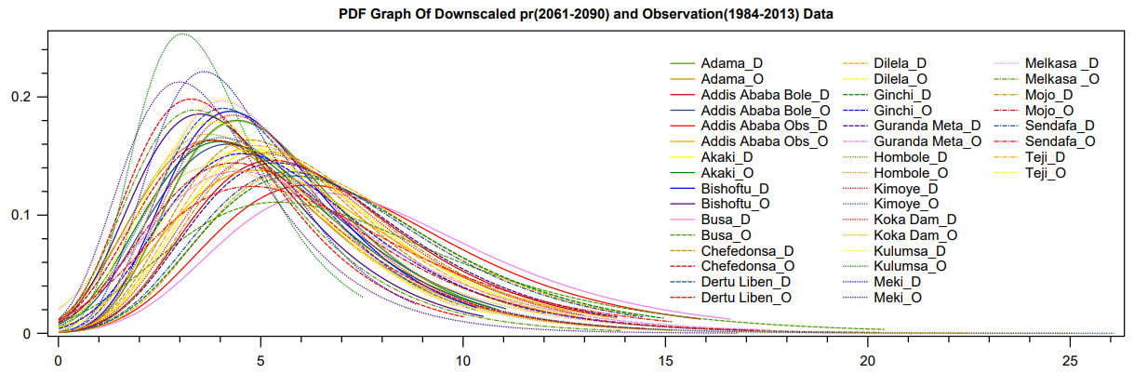(b)
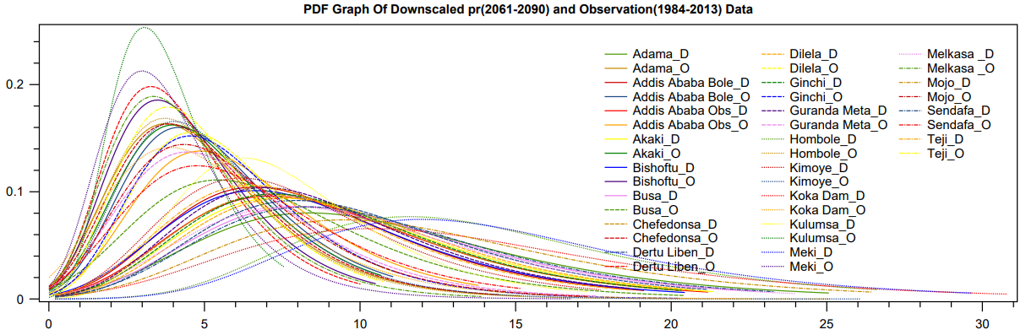(C)
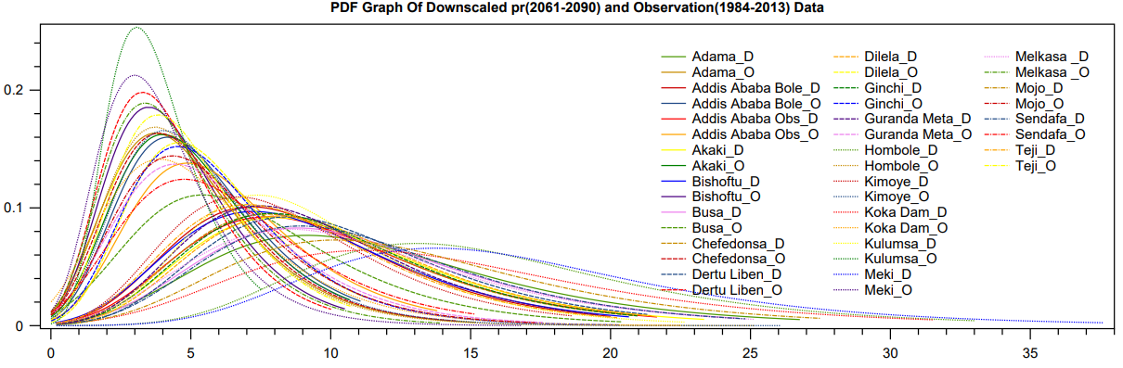
Supplementary Fig. 1 PDF of monthly downscaled average temperature for observed and GCM runs per station (a) ACCESS-CM2_r2i1p1f1, (b) CanESM5_r1i1p2f1 for SSP8.5, (c) CanESM5_r7i1p2f1 considering SSP8.5 and SSP4.5 respectively.

(a)
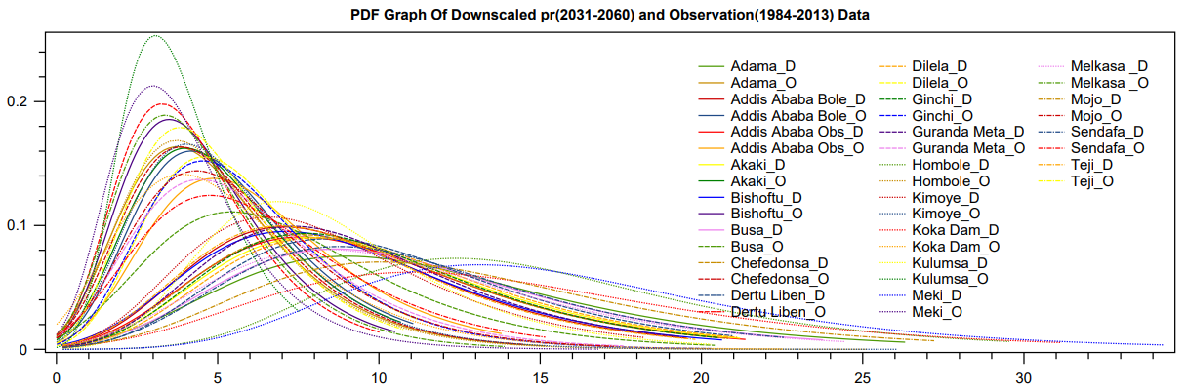
(b)
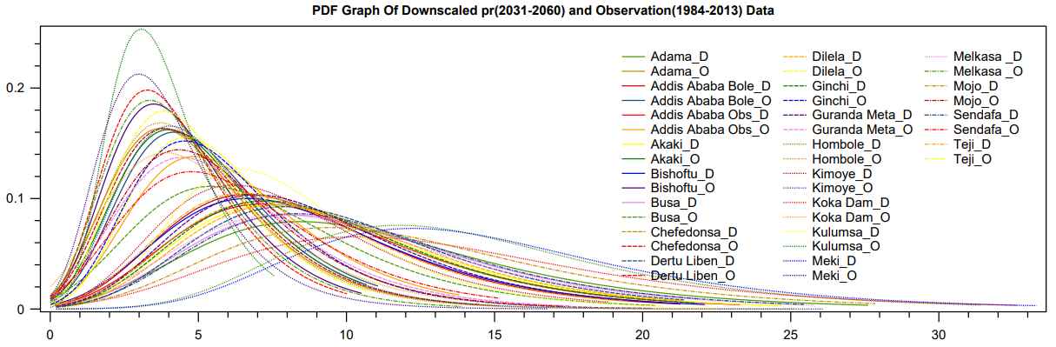
(c)
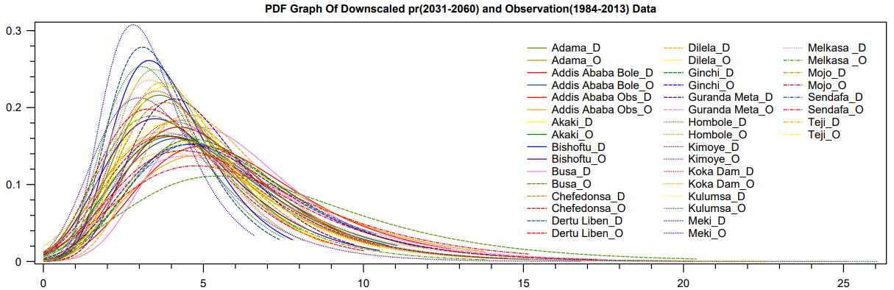
Supplementary Fig. 2 The same as Supplementary Fig. 1 but for (a) CanESM5_r22i1p2f1 SSP85 (b) CanESM5_r25i1p2f1 (c) INM-CM4-8_45_r1i1p1f1 considering SSP8.5, SSP8.5 and SSP4.5 respectively

(a)
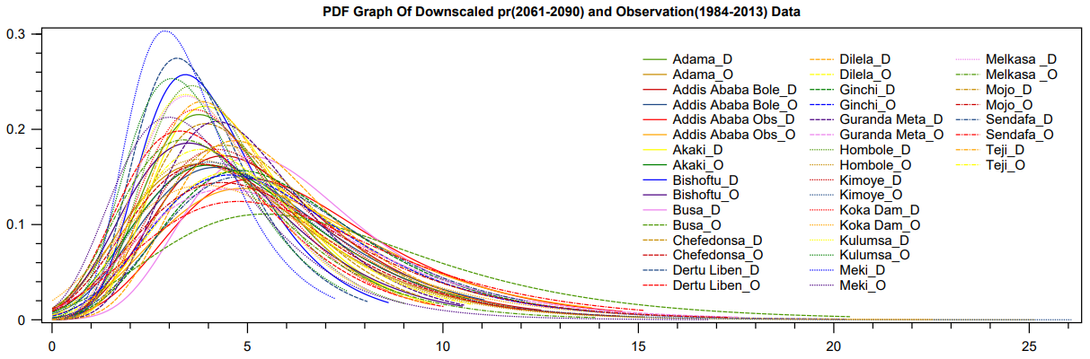
(b)
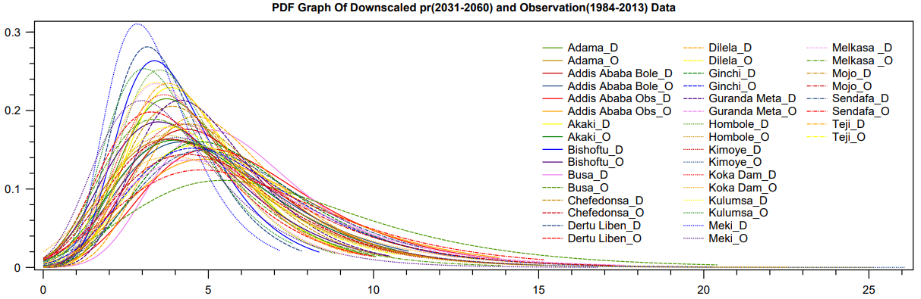
(c)
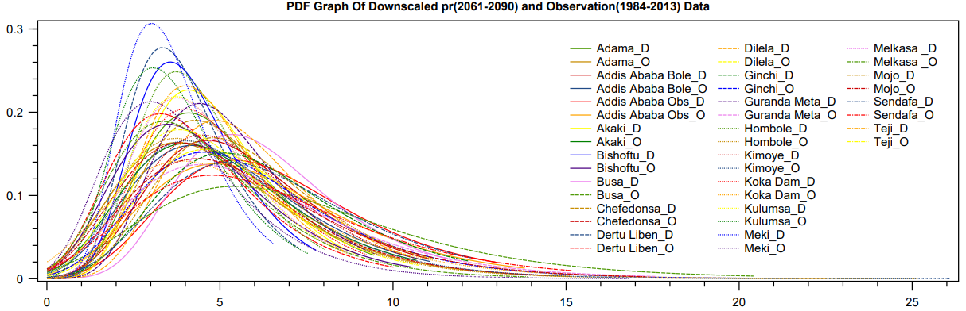
Supplementary Fig. 3 The same as Supplementary Fig1 but for (a) INM-CM4-8_45_r1i1p1f1 SSP85 (b) INM-CM4-8_45_r1i1p1f1 ssp85, 30s (c) INM-CM4-8_45_r1i1p1f1, considering SSP4.5, SSP8.5 and SSP4.5 respectively

(a)
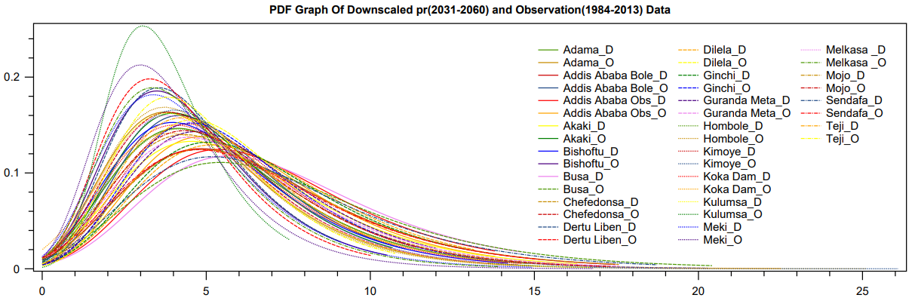
(b)
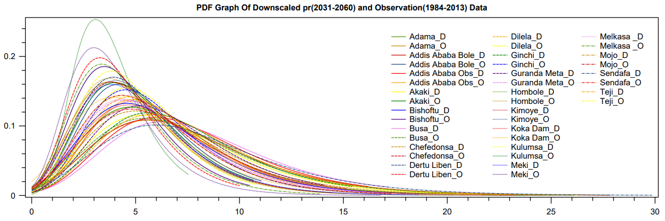
(c)
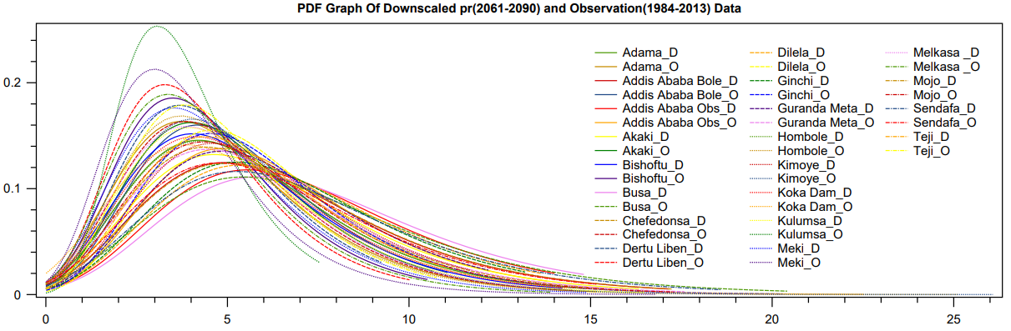
Supplementary Fig. 4 The same as Supplementary Fig. 1 but for (a) IPSL-CM6A-LR_r3i1p1f1 (b) IPSL-CM6A-LR_r3i1p1f1 (c) IPSL-CM6A-LR_r3i1p1f1, considering SSP4.5, SSP4.5 and SSP8.5 respectively

(a)
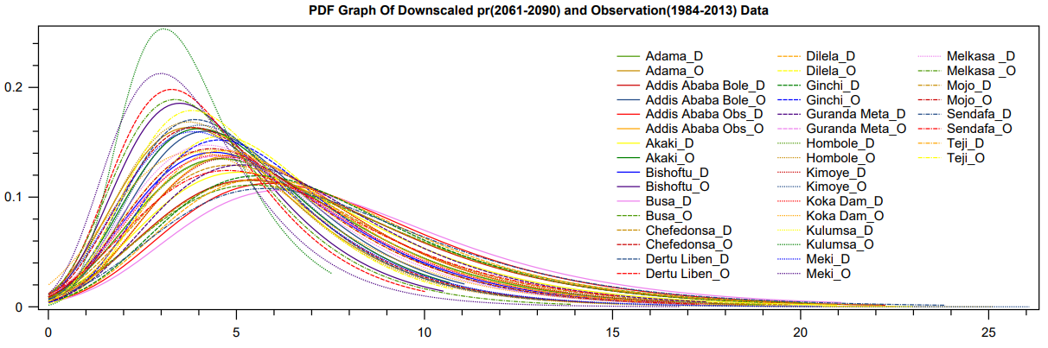
(b)
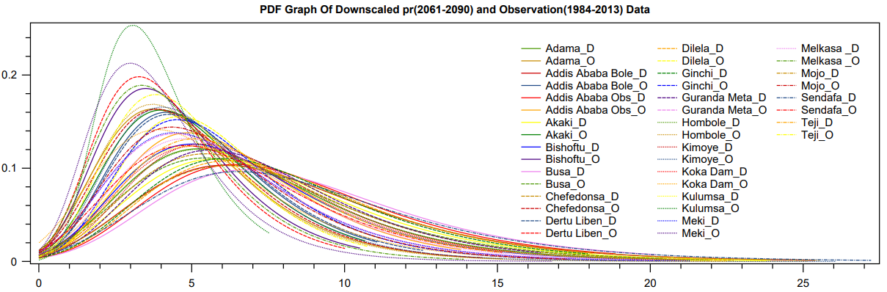
(c)
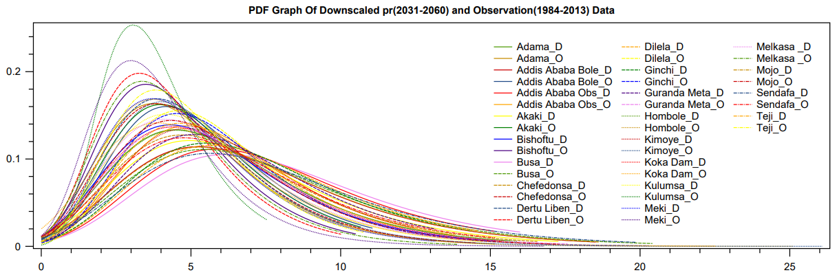
Supplementary Fig. 5 The same as Supplementary Fig. 1 but for (a) IPSL-CM6A-LR_r3i1p1f1 (b) IPSL-CM6A-LR_r4i1p1f1 (c) IPSL-CM6A-LR_r6i1p1f1, considering SSP8.5, SSP4.5 and SSP8.5 respectively

(a)
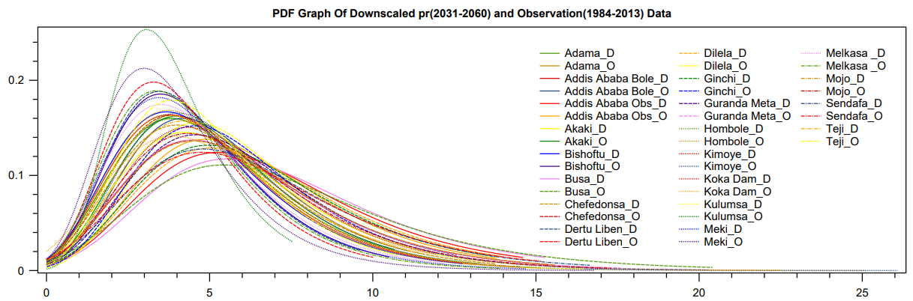
(b)
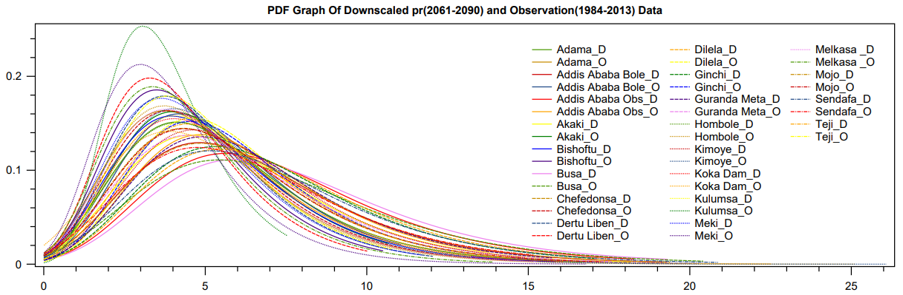
(c)
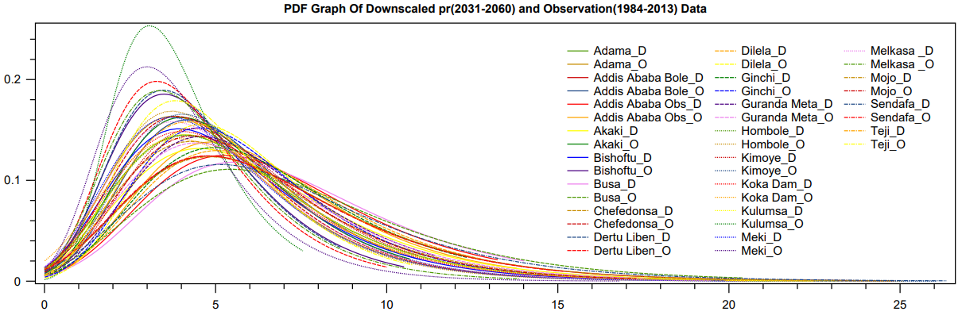
Supplementary Fig. 6 The same as Supplementary Fig. 1 but for (a) IPSL-CM6A-LR_r14i1p1f1 (b) IPSL-CM6A-LR_r14i1p1f1 (c) IPSL-CM6A-LR_r14i1p1f1, considering SSP4.5, SSP4.5 and SSP8.5 respectively

(a)
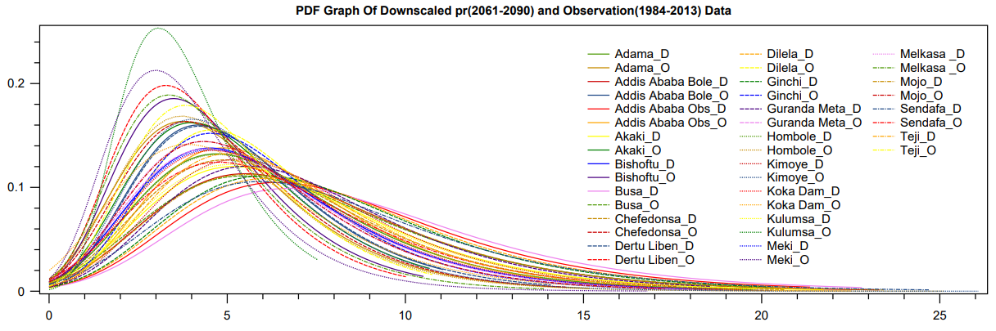
(b)
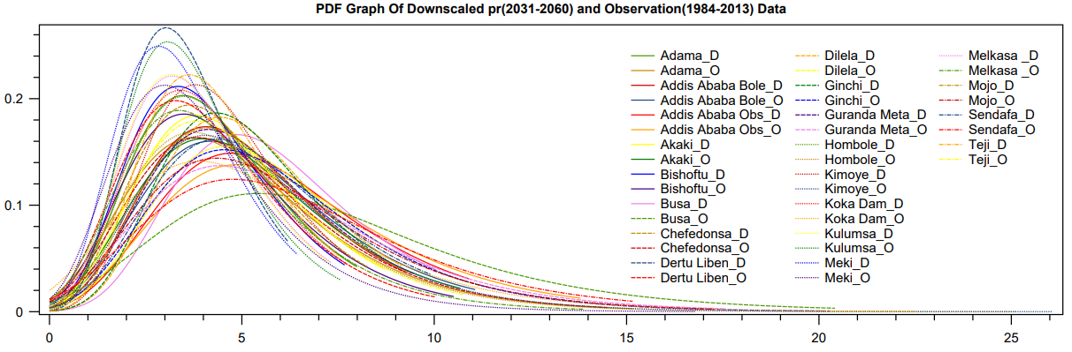
(c)
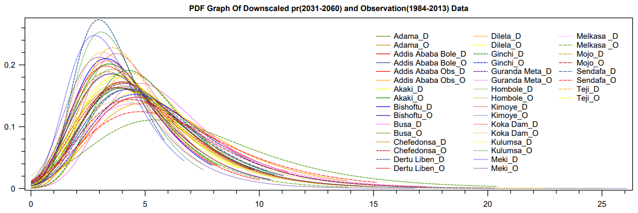
Supplementary Fig. 7 The same as Supplementary Fig. 1 but for (a) IPSL-CM6A-LR_r14i1p1f1 (b) MPI-ESM1-2-LR_r5i1p1f1 (c) IPSL-CM6A-LR_r14i1p1f1, considering SSP8.5, SSP8.5 and SSP4.5 respectively

(a)
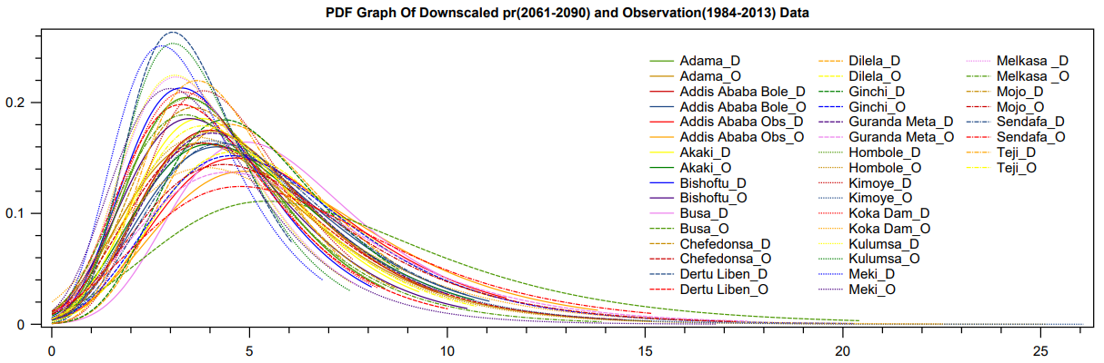
(b)
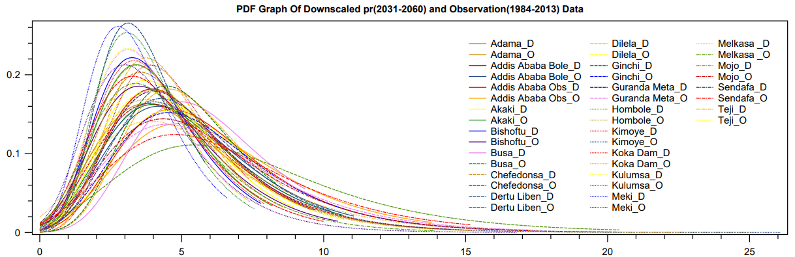
(c)
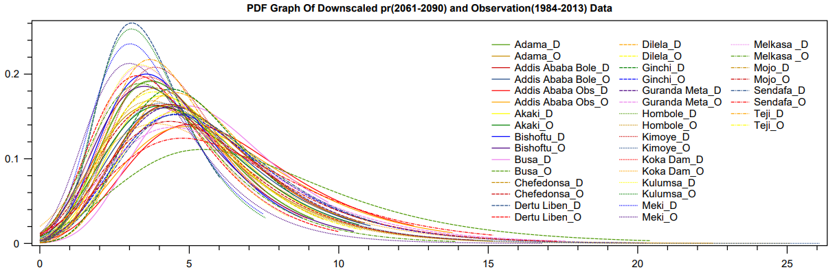
Supplementary Fig. 8 The same as Supplementary Fig. 1 but for (a) MPI-ESM1-2-LR_r6i1p1f1 (b) MPI-ESM1-2-LR_r6i1p1f1 (c) MPI-ESM1-2-LR_r6i1p1f1, considering SSP4.5, SSP8.5 and SSP8.5 respectively

(a)
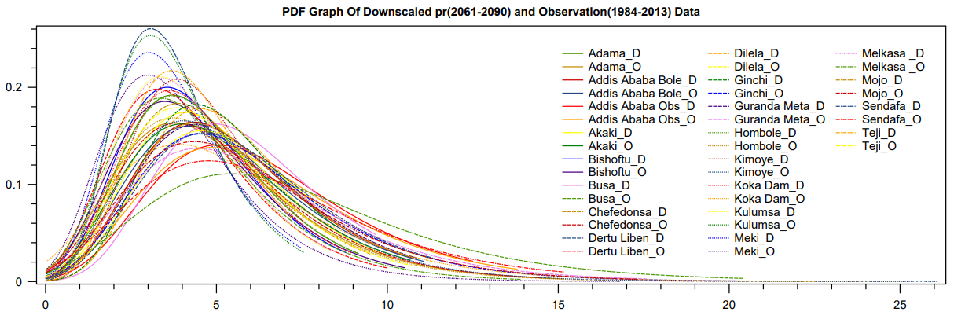
Supplementary Fig. 9 The same as Supplementary Fig. 1 but for (a) MPI-ESM1-2-LR_r6i1p1f1 SSP85, considering SSP8.5

(a)
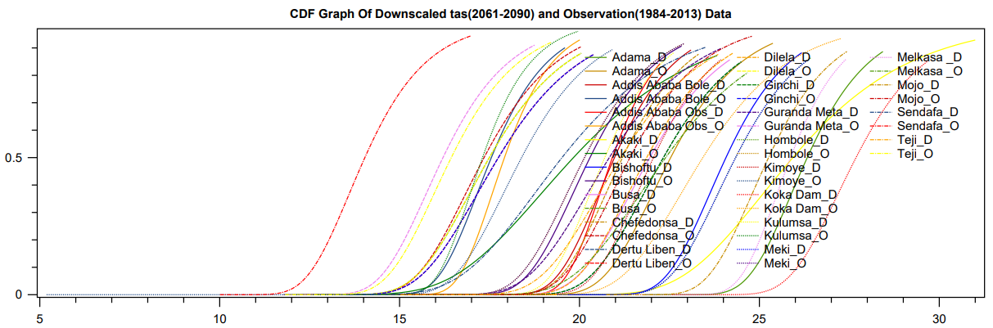
(b)
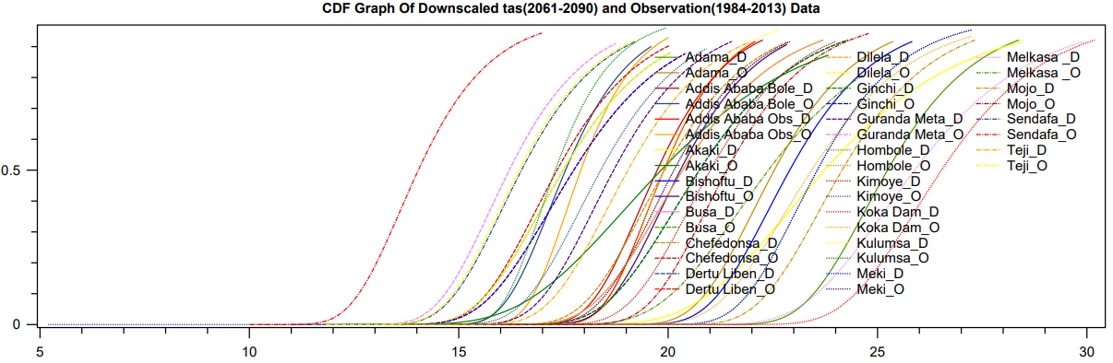

(c)
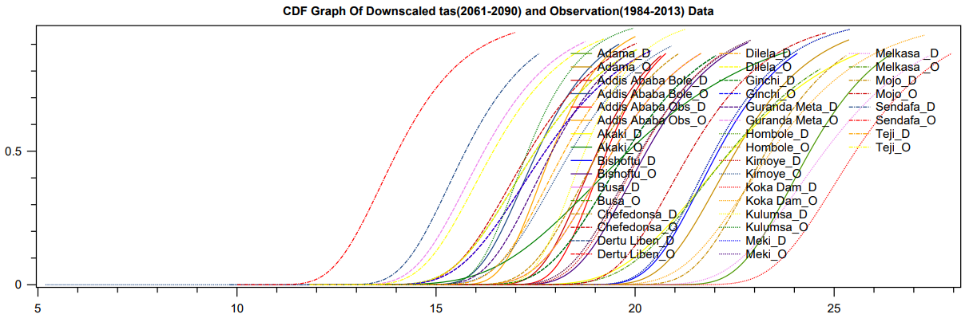
Supplementary Fig. 1 CDF of monthly downscaled average temperature for observed and GCM runs per station (a) ACCESS-CM2_r2i1p1f1, (b) CanESM5_r1i1p2f1 for SSP8.5, (c) CanESM5_r7i1p2f1 considering SSP8.5 and SSP4.5 respectively
(a)
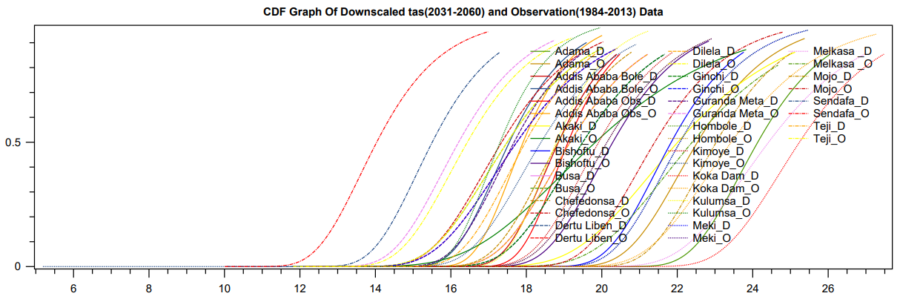
(b)
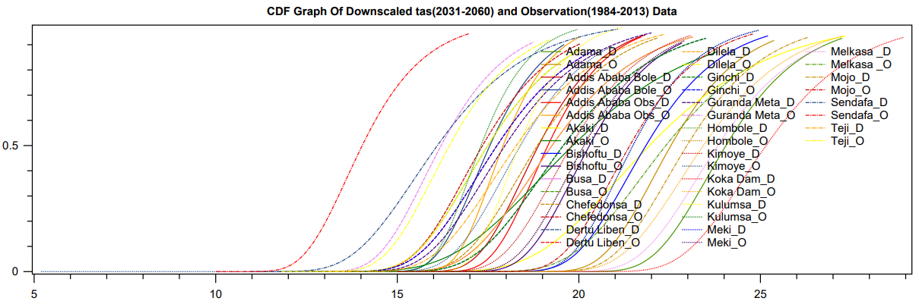

(c)
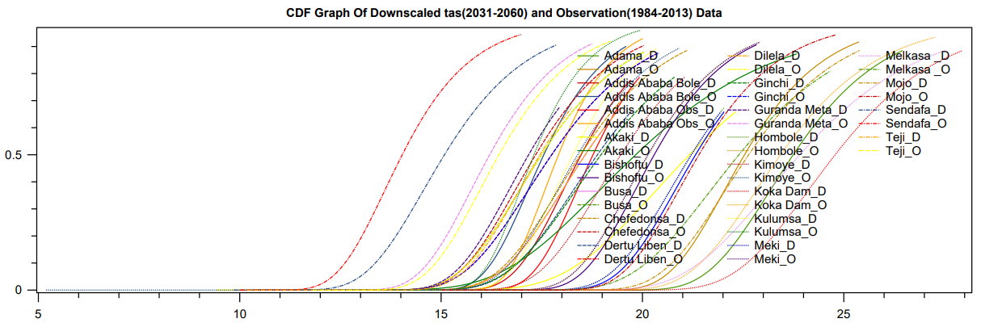
Supplementary Fig. 2 The same as Supplementary Fig. 1 but for (a) CanESM5_r22i1p2f1 SSP85 (b) CanESM5_r25i1p2f1 (c) INM-CM4-8_45_r1i1p1f1 considering SSP8.5, SSP8.5 and SSP4.5 respectively

(a)
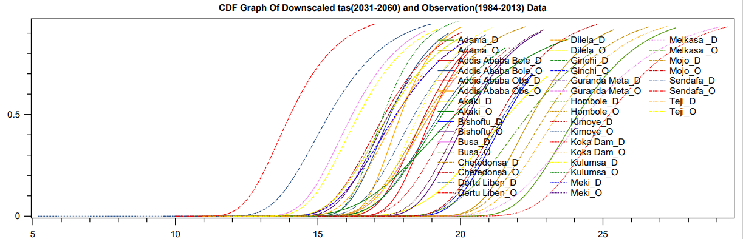
(b) 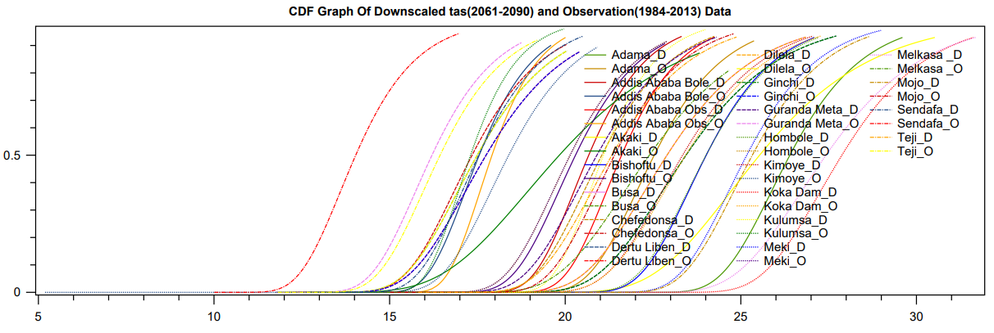(c) 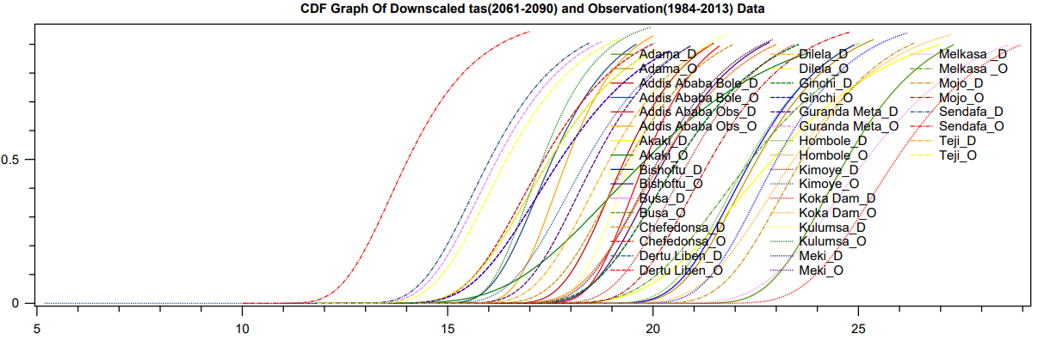
Supplementary Fig. 3 The same as Supplementary Fig. 1 but for (a) IPSL-CM6A-LR_r3i1p1f1 (b) IPSL-CM6A-LR_r4i1p1f1 (c) IPSL-CM6A-LR_r6i1p1f1 considering SSP8.5, SSP4.5 and SSP8.5 respectively

(a)
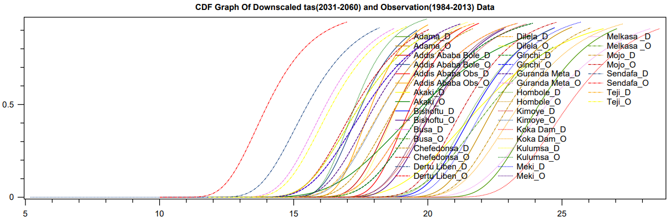
(b)
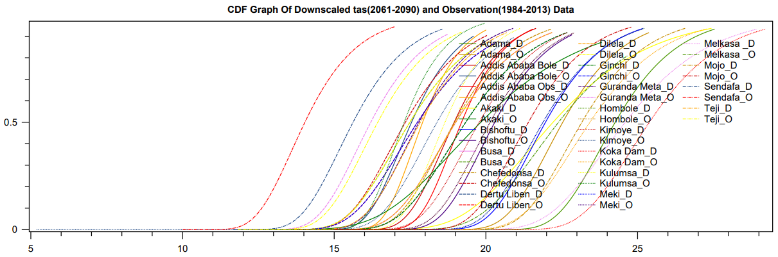

(c)
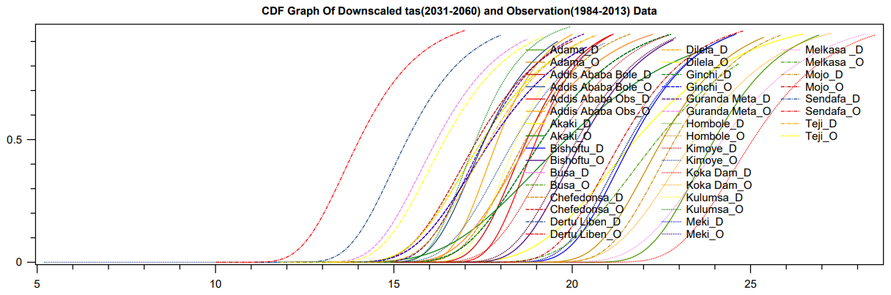
Supplementary Fig. 4 The same as Supplementary Fig. 1 but for (a) IPSL-CM6A-LR_r14i1p1f1 (b) MPI-ESM1-2-LR_r5i1p1f1 (c) MPI-ESM1-2-LR_r5i1p1f1considering SSP4.5, SSP4.5 and SSP8.5 respectively

(a)
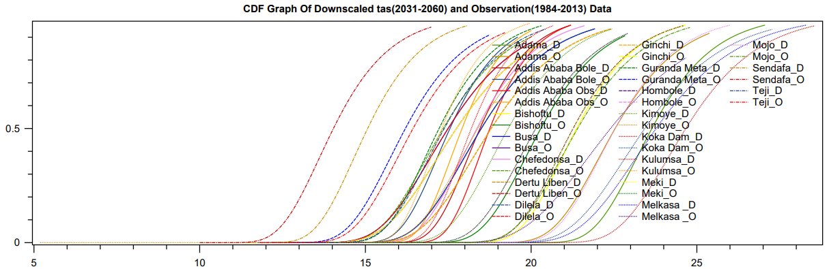
()
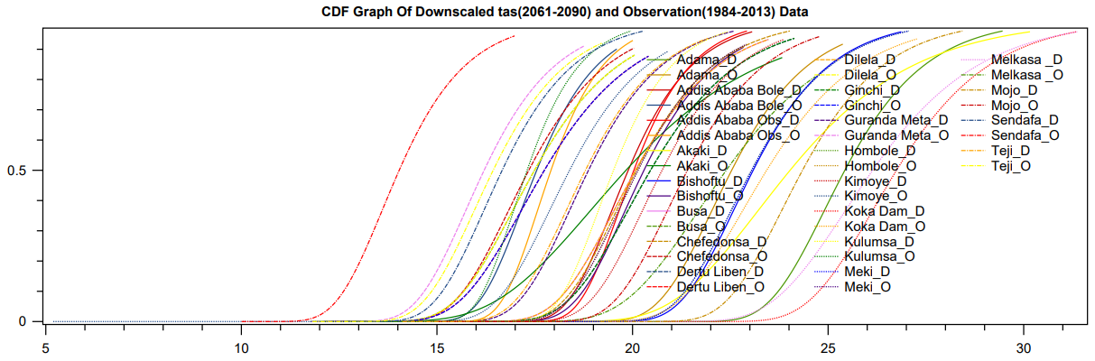
Supplementary Fig. 5 The same as Supplementary Fig. 1 but for (a) MPI-ESM1-2-LR_r6i1p1f1 (b) MPI-ESM1-2-LR_r6i1p1f1 SSP4.5 and SSP8.5 respectively

2031-2060 |  |  |  |  |  |  |  |  |  |  |  | 1981-2010
Projection | Daily GCMs | Pr | Tm | CDD | ∆CDD% | R95PTOT | ∆R95PTOT% | WSDI | ∆WSDI% | CSDI | ∆CSDI% | CDD | R95PTOT | WSDI | CSDI | T index rank |  | P index rank |  | Combined score
W-D | CanESM5_r6i1p1f1 | -3.5 | 7.8 | 92.19 | -4.49 | 25.55 | 33.93 | 10673.00 | 11809.57 | 0.00 | -100.00 | 96.52 | 19.08 | 89.62 | 60.96 | 4 |  | 1 |  | 2.5
 | CanESM5_r25i1p2f1 | -3.6 | 7.8 | 121.95 | 26.34 | 23.75 | 24.51 | 10706.50 | 11846.95 | 0.00 | -100.00 | 96.52 | 19.08 | 89.62 | 60.96 | 5 |  | 3 |  | 4
 | CanESM5_r20i1p1f1 | -3.5 | 7.9 | 109.74 | 13.69 | 25.84 | 35.44 | 10666.40 | 11802.21 | 0.00 | -100.00 | 96.52 | 19.08 | 89.62 | 60.96 | 3 |  | 2 |  | 2.5
 | CanESM5_r21i1p2f1 | -3.4 | 7.7 | 125.31 | 29.82 | 26.24 | 37.57 | 10577.90 | 11703.45 | 0.00 | -100.00 | 96.52 | 19.08 | 89.62 | 60.96 | 1 |  | 4 |  | 2.5
 | CanESM5_r10i1p2f1 | -3.4 | 7.8 | 137.76 | 42.73 | 25.99 | 36.26 | 10578.40 | 11704.01 | 0.00 | -100.00 | 96.52 | 19.08 | 89.62 | 60.96 | 2 |  | 5 |  | 3.5
W-W | INM-CM5-0_r1i1p1f1 | 0.6 | 5.5 | 78.63 | -18.53 | 9.92 | -47.97 | 9695.75 | 10719.10 | 0.00 | -100.00 | 96.52 | 19.08 | 89.62 | 60.96 | 5 |  | 1 |  | 3
 | INM-CM4-8_r1i1p1f1 | 3.0 | 5.4 | 78.98 | -18.18 | 13.46 | -29.47 | 9482.92 | 10481.61 | 0.00 | -100.00 | 96.52 | 19.08 | 89.62 | 60.96 | 4 |  | 2 |  | 3
 | CESM2_r11i1p1f1 | 0.8 | 5.2 | 121.88 | 26.28 | 28.90 | 51.47 | 8844.98 | 9769.76 | 0.00 | -100.00 | 96.52 | 19.08 | 89.62 | 60.96 | 1 |  | 5 |  | 3
 | CESM2_r4i1p1f1 | 0.5 | 5.3 | 119.85 | 24.17 | 27.23 | 42.76 | 9005.33 | 9948.68 | 0.00 | -100.00 | 96.52 | 19.08 | 89.62 | 60.96 | 2 |  | 4 |  | 3
 | CESM2_r10i1p1f1 | 0.1 | 5.4 | 140.52 | 45.59 | 26.26 | 37.67 | 9187.18 | 10151.60 | 0.00 | -100.00 | 96.52 | 19.08 | 89.62 | 60.96 | 3 |  | 3 |  | 3
C-D | MPI-ESM1-2-LR_r4i1p1f1 | -3.0 | 2.5 | 185.09 | 91.76 | 3.97 | -79.21 | 6940.16 | 7644.24 | 23.30 | -61.77 | 96.52 | 19.08 | 89.62 | 60.96 | 5 |  | 5 |  | 5
 | NESM3_r1i1p1f1 | -3.1 | 3.2 | 154.86 | 60.44 | 8.66 | -54.61 | 8302.25 | 9164.15 | 0.66 | -98.91 | 96.52 | 19.08 | 89.62 | 60.96 | 2 |  | 4 |  | 3
 | MPI-ESM1-2-LR_r6i1p1f1 | -2.7 | 2.6 | 141.32 | 46.41 | 4.26 | -77.65 | 7386.45 | 8142.24 | 7.44 | -87.79 | 96.52 | 19.08 | 89.62 | 60.96 | 4 |  | 3 |  | 3.5
 | MPI-ESM1-2-LR_r8i1p1f1 | -2.6 | 2.5 | 135.10 | 39.97 | 4.29 | -77.53 | 7076.07 | 7795.90 | 4.66 | -92.36 | 96.52 | 19.08 | 89.62 | 60.96 | 3 |  | 1 |  | 2
 | NESM3_r2i1p1f1 | -3.3 | 3.4 | 140.21 | 45.26 | 7.60 | -60.19 | 8729.00 | 9640.34 | 0.00 | -100.00 | 96.52 | 19.08 | 89.62 | 60.96 | 1 |  | 2 |  | 1.5
C-W | IPSL-CM6A-LR_r14i1p1f1 | 1.7 | 2.9 | 137.65 | 42.61 | 23.15 | 21.33 | 5392.76 | 5917.56 | 66.81 | 9.60 | 96.52 | 19.08 | 89.62 | 60.96 | 5 |  | 3 |  | 4
 | IPSL-CM6A-LR_r3i1p1f1 | 1.8 | 3.0 | 131.18 | 35.91 | 26.34 | 38.06 | 5787.18 | 6357.68 | 41.76 | -31.51 | 96.52 | 19.08 | 89.62 | 60.96 | 1 |  | 5 |  | 3
 | IPSL-CM6A-LR_r6i1p1f1 | 2.0 | 3.0 | 139.30 | 44.32 | 25.75 | 35.00 | 5742.12 | 6307.40 | 63.77 | 4.60 | 96.52 | 19.08 | 89.62 | 60.96 | 3 |  | 4 |  | 3.5
 | IPSL-CM6A-LR_r1i1p1f1 | 1.3 | 3.0 | 133.18 | 37.98 | 22.67 | 18.81 | 5622.38 | 6173.79 | 64.00 | 4.98 | 96.52 | 19.08 | 89.62 | 60.96 | 4 |  | 2 |  | 3
 | IPSL-CM6A-LR_r4i1p1f1 | 1.1 | 3.0 | 141.53 | 46.63 | 22.30 | 16.91 | 5606.96 | 6156.58 | 53.19 | -12.75 | 96.52 | 19.08 | 89.62 | 60.96 | 2 |  | 1 |  | 1.5
Supplementary Table 5 ETCCDI extreme indices, GCM runs analyzed during the refined selection process for 2031-2060 considering SSP4.5

Supplementary Table 6 The same as Supplementary Table 5 but considering SSP8.5
2031-2060 |  |  |  |  |  |  |  |  |  |  |  | 1981-2010
Projection | Daily GCMs | Pr | Te | CDD | ∆CDD% | R95PTOT | ∆R95PTOT% | WSDI | ∆WSDI% | CSDI | ∆CSDI% | CDD | R95PTOT | WSDI | CSDI | T index rank | P index rank | Combined score
W-D | CanESM5_r22i1p2f1 | -2.8 | 8.2 | 131.09 | 35.81 | 25.66 | 34.49 | 10751.50 | 11897.17 | 0.00 | -100.00 | 96.52 | 19.08 | 89.62 | 60.96 | 5 | 5 | 5
 | CanESM5_r18i1p2f1 | -2.3 | 8.0 | 113.07 | 17.15 | 26.62 | 39.56 | 10713.00 | 11854.21 | 0.00 | -100.00 | 96.52 | 19.08 | 89.62 | 60.96 | 2 | 3 | 2.5
 | CanESM5_r5i1p2f1 | -2.1 | 8.1 | 114.40 | 18.52 | 27.42 | 43.71 | 10720.50 | 11862.57 | 0.00 | -100.00 | 96.52 | 19.08 | 89.62 | 60.96 | 4 | 4 | 4
 | CanESM5_r12i1p2f1 | -2.0 | 8.0 | 104.63 | 8.40 | 28.69 | 50.41 | 10675.90 | 11812.81 | 0.00 | -100.00 | 96.52 | 19.08 | 89.62 | 60.96 | 1 | 2 | 1.5
 | CanESM5_r20i1p2f1 | -1.9 | 8.0 | 93.31 | -3.33 | 29.79 | 56.18 | 10717.50 | 11859.23 | 0.00 | -100.00 | 96.52 | 19.08 | 89.62 | 60.96 | 3 | 1 | 2
W-W | CESM2_r10i1p1f1 | 2.2 | 5.9 | 146.29 | 51.56 | 32.48 | 70.24 | 9831.85 | 10870.97 | 0.00 | -100.00 | 96.52 | 19.08 | 89.62 | 60.96 | 3 | 3 | 3
 | CESM2_r4i1p1f1 | 2.6 | 5.9 | 143.53 | 48.70 | 32.94 | 72.65 | 9786.02 | 10819.83 | 0.00 | -100.00 | 96.52 | 19.08 | 89.62 | 60.96 | 2 | 4 | 3
 | INM-CM4-8_r1i1p1f1 | 3.5 | 5.8 | 74.18 | -23.15 | 14.39 | -24.57 | 9909.14 | 10957.21 | 0.00 | -100.00 | 96.52 | 19.08 | 89.62 | 60.96 | 4 | 2 | 3
 | INM-CM5-0_r1i1p1f1 | 1.4 | 5.8 | 87.39 | -9.46 | 12.20 | -36.02 | 10077.90 | 11145.52 | 0.00 | -100.00 | 96.52 | 19.08 | 89.62 | 60.96 | 5 | 1 | 3
 | CESM2_r11i1p1f1 | 0.7 | 5.8 | 110.64 | 14.62 | 36.65 | 92.11 | 9771.11 | 10803.19 | 0.00 | -100.00 | 96.52 | 19.08 | 89.62 | 60.96 | 1 | 5 | 3
C-D | MPI-ESM1-2-LR_r3i1p1f1 | -2.6 | 2.7 | 150.54 | 55.97 | 4.28 | -77.56 | 7545.71 | 8319.95 | 3.66 | -93.99 | 96.52 | 19.08 | 89.62 | 60.96 | 1 | 2 | 1.5
 | MPI-ESM1-2-LR_r6i1p1f1 | -2.6 | 2.8 | 144.54 | 49.75 | 4.90 | -74.30 | 7625.71 | 8409.22 | 4.88 | -91.99 | 96.52 | 19.08 | 89.62 | 60.96 | 2 | 1 | 1.5
 | MPI-ESM1-2-LR_r4i1p1f1 | -2.5 | 2.6 | 154.87 | 60.45 | 4.25 | -77.72 | 7279.41 | 8022.80 | 26.53 | -56.48 | 96.52 | 19.08 | 89.62 | 60.96 | 5 | 4 | 4.5
 | MPI-ESM1-2-LR_r8i1p1f1 | -2.5 | 2.6 | 151.98 | 57.46 | 3.88 | -79.66 | 7295.21 | 8040.43 | 7.55 | -87.61 | 96.52 | 19.08 | 89.62 | 60.96 | 4 | 3 | 3.5
 | MPI-ESM1-2-LR_r5i1p1f1 | -2.5 | 2.9 | 171.65 | 77.83 | 3.50 | -81.66 | 7854.22 | 8664.21 | 5.22 | -91.44 | 96.52 | 19.08 | 89.62 | 60.96 | 3 | 5 | 4
C-W | IPSL-CM6A-LR_r1i1p1f1 | 2.7 | 3.2 | 125.41 | 29.93 | 29.93 | 56.89 | 6227.66 | 6849.19 | 44.75 | -26.59 | 96.52 | 19.08 | 89.62 | 60.96 | 5 | 5 | 5
 | IPSL-CM6A-LR_r4i1p1f1 | 2.3 | 3.3 | 130.19 | 34.88 | 25.02 | 31.14 | 6487.97 | 7139.66 | 24.50 | -59.81 | 96.52 | 19.08 | 89.62 | 60.96 | 1 | 3 | 2
 | IPSL-CM6A-LR_r14i1p1f1 | 2.4 | 3.4 | 120.54 | 24.88 | 26.38 | 38.28 | 6632.27 | 7300.68 | 26.17 | -57.08 | 96.52 | 19.08 | 89.62 | 60.96 | 2 | 4 | 3
 | IPSL-CM6A-LR_r2i1p1f1 | 1.7 | 3.4 | 135.75 | 40.64 | 23.27 | 21.98 | 6599.87 | 7264.53 | 26.61 | -56.34 | 96.52 | 19.08 | 89.62 | 60.96 | 3 | 1 | 2
 | IPSL-CM6A-LR_r6i1p1f1 | 1.7 | 3.5 | 146.09 | 51.35 | 24.68 | 29.37 | 6784.35 | 7470.38 | 29.28 | -51.97 | 96.52 | 19.08 | 89.62 | 60.96 | 4 | 2 | 3

Supplementary Table 7 The same as Supplementary Table 5 but for 2061-2090
2061-2090 |  |  |  |  |  |  |  |  |  |  |  | 1981-2010
Projection | Daily GCMs | Pr | Tm | CDD | ∆CDD% | R95PTOT | ∆R95PTOT% | WSDI | ∆WSDI% | CSDI | ∆CSDI% | CDD | R95PTOT | WSDI | CSDI | T index rank | P index rank | Combined score
W-D | CanESM5_r16i1p2f1 | -2.4 | 8.6 | 109.16 | 13.09 | 29.33 | 53.76 | 10818.20 | 11971.59 | 0.00 | -100.00 | 96.52 | 19.08 | 89.62 | 60.96 | 2 | 4 | 3
 | CanESM5_r7i1p2f1 | -2.3 | 8.6 | 102.52 | 6.21 | 29.75 | 55.93 | 10823.30 | 11977.28 | 0.00 | -100.00 | 96.52 | 19.08 | 89.62 | 60.96 | 4 | 2 | 3
 | CanESM5_r18i1p2f1 | -2.2 | 8.5 | 89.53 | -7.24 | 30.94 | 62.17 | 10821.40 | 11975.16 | 0.00 | -100.00 | 96.52 | 19.08 | 89.62 | 60.96 | 3 | 1 | 2
 | CanESM5_r10i1p2f1 | -2.2 | 8.5 | 106.06 | 9.89 | 30.03 | 57.44 | 10774.90 | 11923.28 | 0.00 | -100.00 | 96.52 | 19.08 | 89.62 | 60.96 | 1 | 3 | 2
 | CanESM5_r4i1p2f1 | -2.1 | 8.6 | 125.84 | 30.37 | 29.59 | 55.09 | 10835.60 | 11991.01 | 0.00 | -100.00 | 96.52 | 19.08 | 89.62 | 60.96 | 5 | 5 | 5
W-W | CESM2_r10i1p1f1 | 2.1 | 6.1 | 115.09 | 19.23 | 34.68 | 81.81 | 10103.10 | 11173.64 | 0.00 | -100.00 | 96.52 | 19.08 | 89.62 | 60.96 | 2 | 5 | 3.5
 | CESM2_r11i1p1f1 | 2.0 | 6.2 | 108.41 | 12.32 | 34.57 | 81.23 | 10213.60 | 11296.94 | 0.00 | -100.00 | 96.52 | 19.08 | 89.62 | 60.96 | 4 | 4 | 4
 | CESM2_r4i1p1f1 | 1.6 | 6.3 | 109.78 | 13.74 | 33.39 | 75.01 | 10315.30 | 11410.43 | 0.00 | -100.00 | 96.52 | 19.08 | 89.62 | 60.96 | 5 | 3 | 4
 | INM-CM4-8_r1i1p1f1 | 3.7 | 5.8 | 70.64 | -26.81 | 15.51 | -18.69 | 9990.95 | 11048.50 | 0.00 | -100.00 | 96.52 | 19.08 | 89.62 | 60.96 | 1 | 2 | 1.5
 | INM-CM5-0_r1i1p1f1 | 1.0 | 5.9 | 71.29 | -26.14 | 11.62 | -39.11 | 10148.00 | 11223.74 | 0.00 | -100.00 | 96.52 | 19.08 | 89.62 | 60.96 | 3 | 1 | 2
C-D | MPI-ESM1-2-LR_r1i1p1f1 | -2.4 | 3.2 | 119.66 | 23.97 | 4.21 | -77.91 | 8447.93 | 9326.70 | 0.78 | -98.73 | 96.52 | 19.08 | 89.62 | 60.96 | 1 | 1 | 1
 | MPI-ESM1-2-LR_r2i1p1f1 | -2.6 | 3.2 | 139.32 | 44.34 | 4.51 | -76.38 | 8491.28 | 9375.08 | 1.34 | -97.81 | 96.52 | 19.08 | 89.62 | 60.96 | 2 | 3 | 2.5
 | MPI-ESM1-2-LR_r6i1p1f1 | -2.6 | 3.2 | 157.32 | 62.99 | 3.97 | -79.19 | 8488.52 | 9372.00 | 2.66 | -95.63 | 96.52 | 19.08 | 89.62 | 60.96 | 4 | 5 | 4.5
 | MPI-ESM1-2-LR_r5i1p1f1 | -2.3 | 3.1 | 152.98 | 58.49 | 4.33 | -77.31 | 8334.42 | 9200.04 | 3.44 | -94.35 | 96.52 | 19.08 | 89.62 | 60.96 | 5 | 4 | 4.5
 | MPI-ESM1-2-LR_r9i1p1f1 | -2.3 | 3.1 | 136.88 | 41.81 | 3.44 | -81.97 | 8356.30 | 9224.46 | 2.00 | -96.72 | 96.52 | 19.08 | 89.62 | 60.96 | 3 | 2 | 2.5
C-W | IPSL-CM6A-LR_r2i1p1f1 | 3.0 | 3.9 | 125.32 | 29.83 | 28.62 | 50.04 | 7776.06 | 8576.99 | 2.23 | -96.35 | 96.52 | 19.08 | 89.62 | 60.96 | 2 | 5 | 3.5
 | IPSL-CM6A-LR_r14i1p1f1 | 2.8 | 3.9 | 123.21 | 27.64 | 27.72 | 45.29 | 7726.58 | 8521.78 | 7.24 | -88.12 | 96.52 | 19.08 | 89.62 | 60.96 | 4 | 3 | 3.5
 | IPSL-CM6A-LR_r1i1p1f1 | 2.8 | 4.0 | 112.42 | 16.47 | 26.86 | 40.80 | 7891.64 | 8705.96 | 2.23 | -96.35 | 96.52 | 19.08 | 89.62 | 60.96 | 2 | 2 | 2
 | IPSL-CM6A-LR_r4i1p1f1 | 3.4 | 3.8 | 136.72 | 41.65 | 28.54 | 49.60 | 7632.26 | 8416.53 | 6.56 | -89.23 | 96.52 | 19.08 | 89.62 | 60.96 | 3 | 4 | 3.5
 | IPSL-CM6A-LR_r3i1p1f1 | 2.2 | 3.9 | 119.32 | 23.61 | 26.28 | 37.73 | 7785.86 | 8587.93 | 8.46 | -86.12 | 96.52 | 19.08 | 89.62 | 60.96 | 5 | 1 | 3

Supplementary Table 8 The same as Supplementary Table 7 but considering SSP8.5
2061-2090 |  |  |  |  |  |  |  |  |  |  |  | 1981-2010
Projection | Daily GCMs | Pr | Tm | CDD | ∆CDD% | R95PTOT | ∆R95PTOT% | WSDI | ∆WSDI% | CSDI | ∆CSDI% | CDD | R95PTOT | WSDI | CSDI | T index rank | P index rank | Combined score
W-D | ACCESS-CM2_r2i1p1f1 | -2.4 | 8.1 | 119.64 | 23.95 | 18.86 | -1.13 | 10943.10 | 12110.96 | 0.00 | -100.00 | 96.52 | 19.08 | 89.62 | 60.96 | 4 | 5 | 4.5
 | ACCESS-CM2_r1i1p1f1 | -1.8 | 7.9 | 114.87 | 19.01 | 19.29 | 1.14 | 10941.70 | 12109.40 | 0.00 | -100.00 | 96.52 | 19.08 | 89.62 | 60.96 | 2 | 4 | 3
 | ACCESS-CM2_r3i1p1f1 | -2.0 | 7.9 | 104.98 | 8.76 | 18.22 | -4.50 | 10946.90 | 12115.20 | 0.00 | -100.00 | 96.52 | 19.08 | 89.62 | 60.96 | 5 | 3 | 4
 | CanESM5_r24i1p2f1 | 1.0 | 10.3 | 81.53 | -15.54 | 35.94 | 88.38 | 10941.80 | 12109.51 | 0.00 | -100.00 | 96.52 | 19.08 | 89.62 | 60.96 | 3 | 2 | 2.5
 | CanESM5_r6i1p2f1 | 1.3 | 10.3 | 79.08 | -18.07 | 36.51 | 91.36 | 10934.90 | 12101.81 | 0.00 | -100.00 | 96.52 | 19.08 | 89.62 | 60.96 | 1 | 1 | 1
W-W | CESM2_r4i1p1f1 | 4.4 | 8.0 | 114.64 | 18.77 | 38.72 | 102.95 | 10879.50 | 12040.00 | 0.00 | -100.00 | 96.52 | 19.08 | 89.62 | 60.96 | 2 | 5 | 3.5
 | MIROC-ES2L_r1i1p1f2 | 6.6 | 7.4 | 70.33 | -27.13 | 22.02 | 15.42 | 10864.90 | 12023.70 | 0.00 | -100.00 | 96.52 | 19.08 | 89.62 | 60.96 | 1 | 1 | 1
 | CanESM5_r1i1p2f1 | 2.9 | 10.0 | 125.29 | 29.80 | 22.49 | 17.91 | 10942.00 | 12109.74 | 0.00 | -100.00 | 96.52 | 19.08 | 89.62 | 60.96 | 5 | 2 | 3.5
 | CESM2_r11i1p1f1 | 3.7 | 8.1 | 104.72 | 8.49 | 35.81 | 87.70 | 10883.80 | 12044.79 | 0.00 | -100.00 | 96.52 | 19.08 | 89.62 | 60.96 | 3 | 3 | 3
 | CESM2_r10i1p1f1 | 3.7 | 8.1 | 94.54 | -2.05 | 37.21 | 95.05 | 10887.90 | 12049.37 | 0.00 | -100.00 | 96.52 | 19.08 | 89.62 | 60.96 | 4 | 4 | 4
C-D | MPI-ESM1-2-LR_r6i1p1f1 | -1.7 | 4.3 | 151.53 | 56.99 | 4.10 | -78.52 | 9988.59 | 11045.87 | 0.00 | -100.00 | 96.52 | 19.08 | 89.62 | 60.96 | 1 | 5 | 3
 | MPI-ESM1-2-LR_r4i1p1f1 | -1.8 | 4.3 | 148.09 | 53.42 | 4.68 | -75.46 | 10097.80 | 11167.73 | 0.00 | -100.00 | 96.52 | 19.08 | 89.62 | 60.96 | 1 | 3 | 2
 | MPI-ESM1-2-LR_r8i1p1f1 | -1.7 | 4.2 | 146.78 | 52.07 | 5.48 | -71.28 | 9984.79 | 11041.62 | 0.00 | -100.00 | 96.52 | 19.08 | 89.62 | 60.96 | 1 | 2 | 1.5
 | MPI-ESM1-2-LR_r10i1p1f1 | -1.8 | 4.1 | 142.33 | 47.46 | 5.02 | -73.67 | 9945.27 | 10997.53 | 0.00 | -100.00 | 96.52 | 19.08 | 89.62 | 60.96 | 1 | 1 | 1
 | MPI-ESM1-2-LR_r7i1p1f1 | -1.7 | 4.1 | 149.33 | 54.71 | 4.63 | -75.75 | 9945.53 | 10997.82 | 0.00 | -100.00 | 96.52 | 19.08 | 89.62 | 60.96 | 1 | 4 | 2.5
C-W | IPSL-CM6A-LR_r2i1p1f1 | 5.9 | 5.5 | 125.32 | 29.83 | 33.75 | 76.92 | 9929.86 | 10980.33 | 0.67 | -98.90 | 96.52 | 19.08 | 89.62 | 60.96 | 4 | 2 | 3
 | IPSL-CM6A-LR_r1i1p1f1 | 5.9 | 5.6 | 118.64 | 22.91 | 36.62 | 91.96 | 9937.94 | 10989.35 | 0.67 | -98.90 | 96.52 | 19.08 | 89.62 | 60.96 | 4 | 4 | 4
 | IPSL-CM6A-LR_r14i1p1f1 | 5.7 | 5.6 | 122.98 | 27.41 | 36.76 | 92.71 | 9989.19 | 11046.53 | 0.00 | -100.00 | 96.52 | 19.08 | 89.62 | 60.96 | 2 | 5 | 3.5
 | IPSL-CM6A-LR_r3i1p1f1 | 6.0 | 5.7 | 107.98 | 11.87 | 36.00 | 88.72 | 10000.10 | 11058.71 | 1.23 | -97.99 | 96.52 | 19.08 | 89.62 | 60.96 | 5 | 3 | 4
 | IPSL-CM6A-LR_r6i1p1f1 | 7.2 | 5.6 | 99.86 | 3.46 | 36.00 | 88.72 | 9962.68 | 11016.95 | 0.00 | -100.00 | 96.52 | 19.08 | 89.62 | 60.96 | 2 | 3 | 2.5

