Supplementary Material 3. One for one time reallocation figures for Dragon Challenge scores that were significantly associated with the activity compositions and the activity behaviour isometric log ratio pivot coordinates.

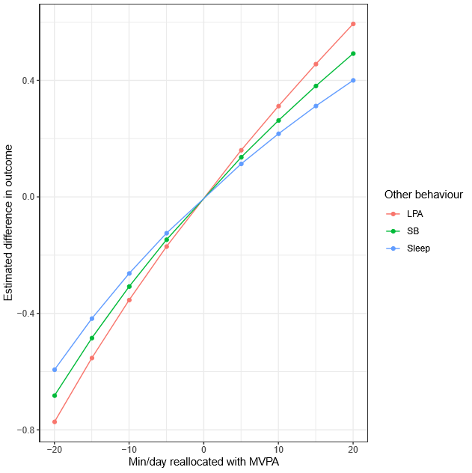
Figure 2. Estimated difference in Dragon Challenge scores associated with time reallocation between pairs of behaviours: difference in all primary school participants’ time score associated with the difference in MVPA to each of the remaining behaviours.

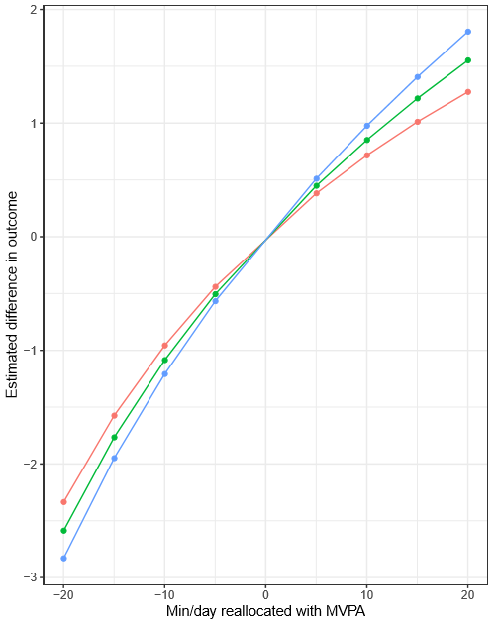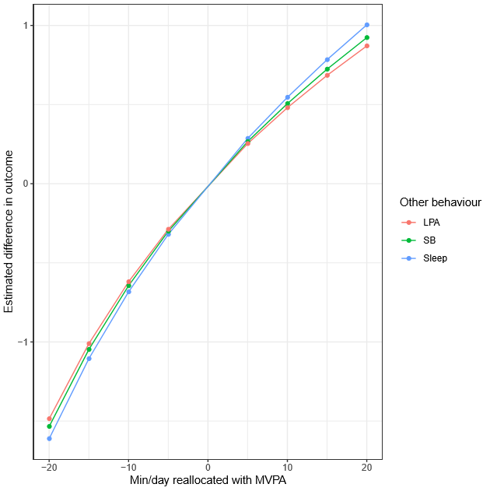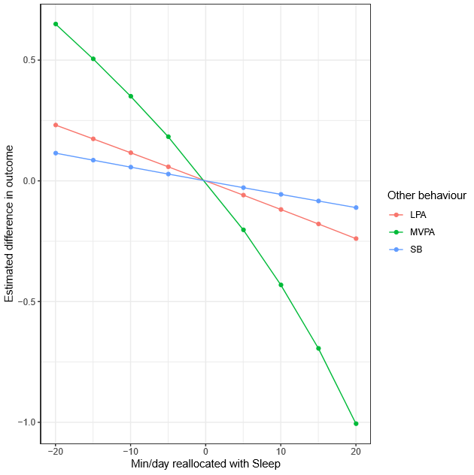
(c)
(b)
(a)
Figure 3a-c. Estimated difference in Dragon Challenge scores associated with time reallocation between pairs of behaviours: difference in secondary school participants’ (a) overall and (b) process scores associated with the difference in MVPA to each of the remaining activities, and difference in (c) product score associated with the difference in sleep to each of the remaining activities. For example, adding 20 minutes to sleep at the expense of MVPA (green line) while keeping LPA and ST constant was associated with a predicted decrease of 1.01 in the product score.

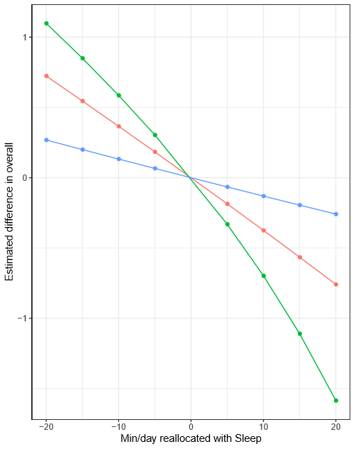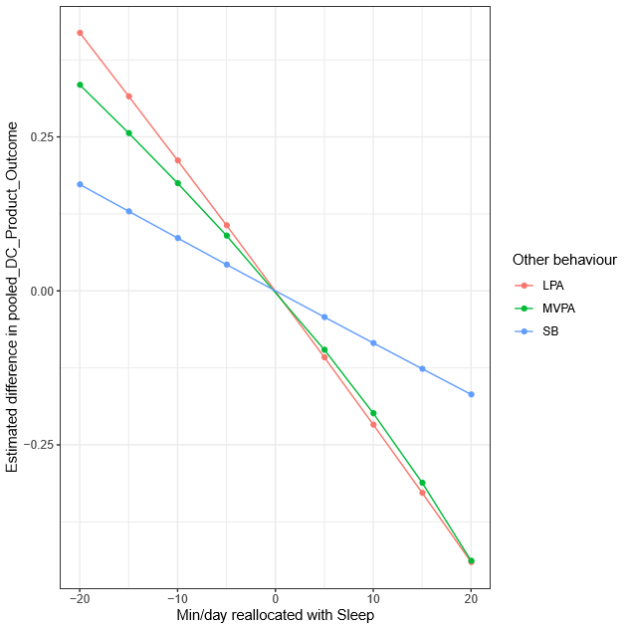
(b)
(a)
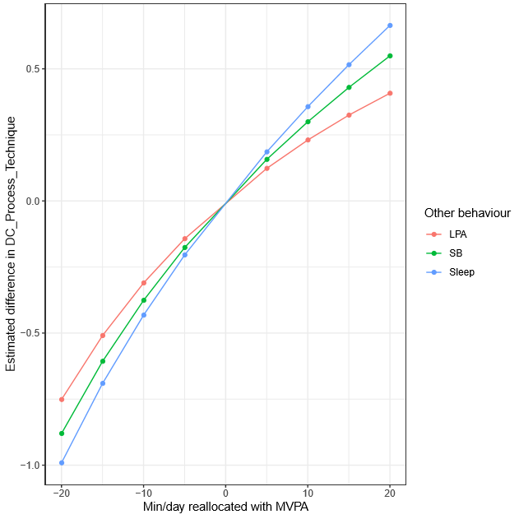
(c)
Figure 4a-c. Estimated difference in Dragon Challenge scores associated with time reallocation between pairs of behaviours: difference in all girls’ (a) overall and (b) product scores associated with the difference in sleep to each of the remaining activities, and (c) process score associated with the difference in MVPA to each of the remaining activities.

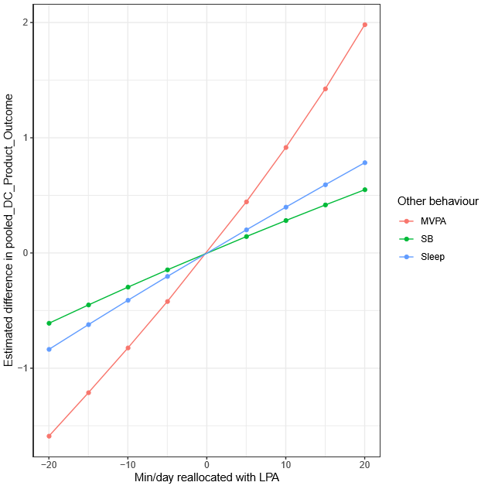
Figure 5. Estimated difference in Dragon Challenge scores associated with time reallocation between pairs of behaviours: difference in primary school girls’ product score associated with the difference in LPA to each of the remaining behaviours.

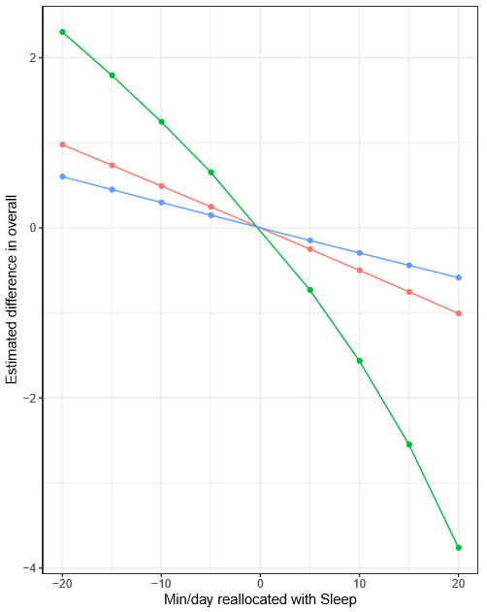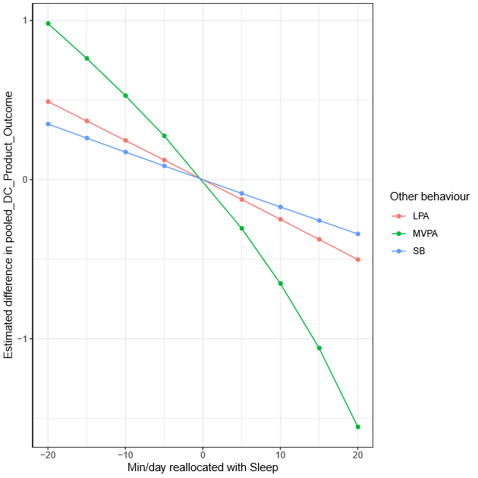
(b)
(a)
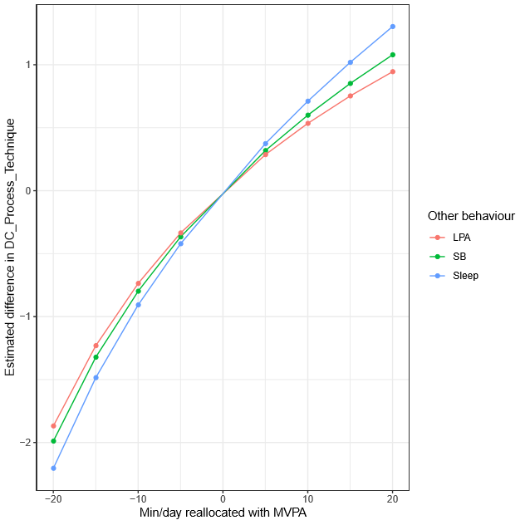
(c)
Figure 6a-c. Estimated difference in Dragon Challenge scores associated with time reallocation between pairs of behaviours: difference in secondary school girls’ (a) overall and (b) product scores associated with the difference in sleep to each of the remaining activities, and (c) process score associated with the difference in MVPA to each of the remaining activities.

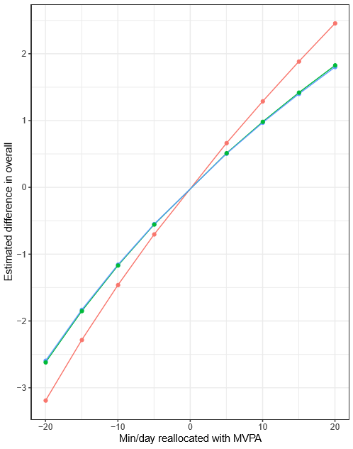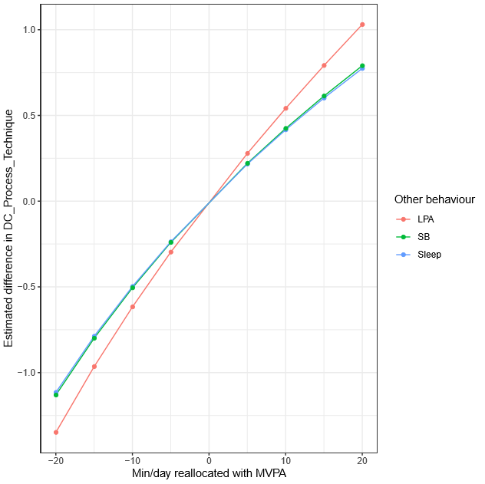
(b)
(a)
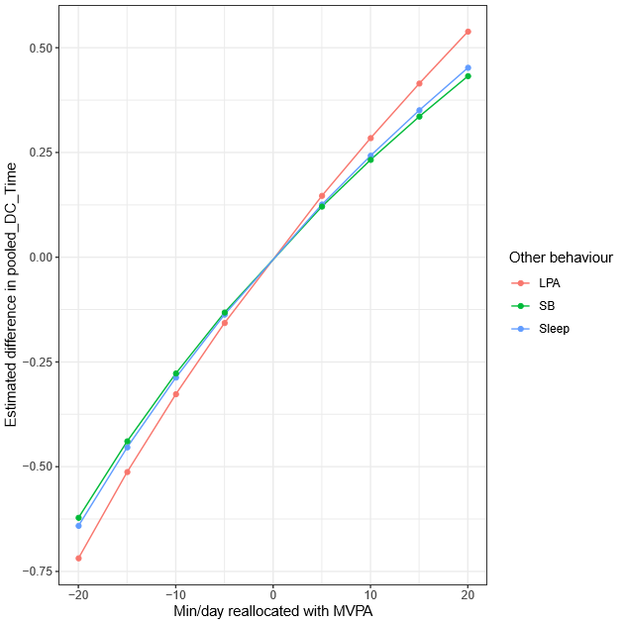
(c)
Figure 7a-c. Estimated difference in Dragon Challenge scores associated with time reallocation between pairs of behaviours: difference in all boys’ (a) overall, (b) process, and (c) time scores associated with the difference in MVPA to each of the remaining activities.

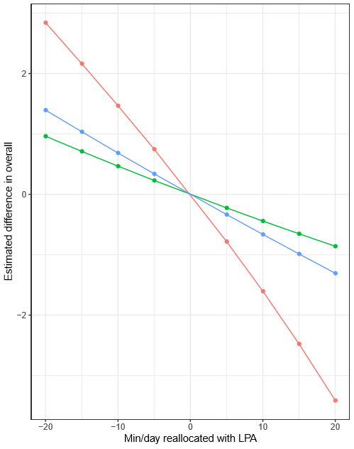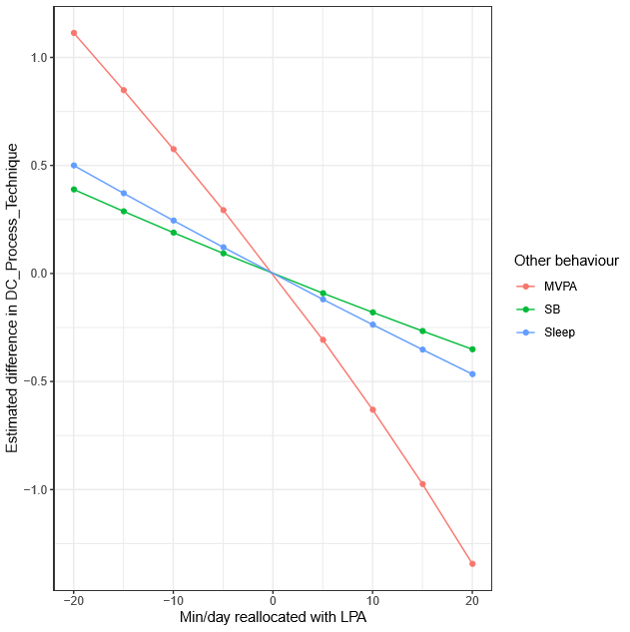
(b)
(a)
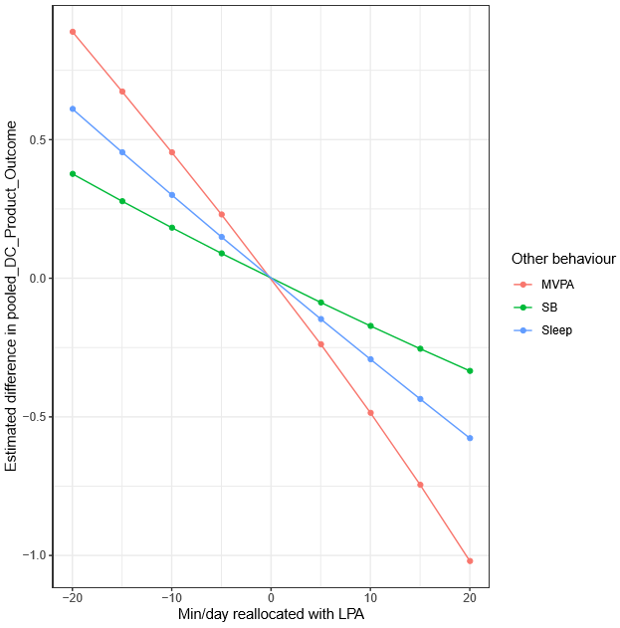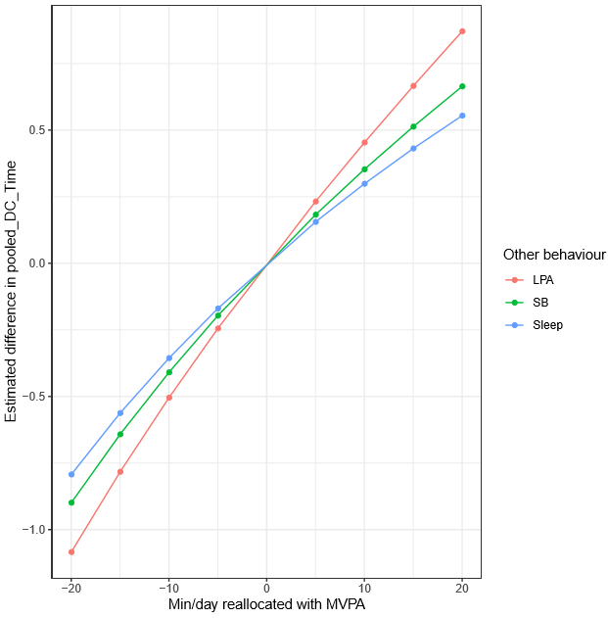
(d)
(c)
Figure 8a-d. Estimated difference in Dragon Challenge scores associated with time reallocation between pairs of behaviours: difference in primary school boys’ (a) overall, (b) process, and (c) product scores associated with the difference in LPA to each of the remaining activities, and (d) time score associated with the difference in MVPA to each of the remaining activities.

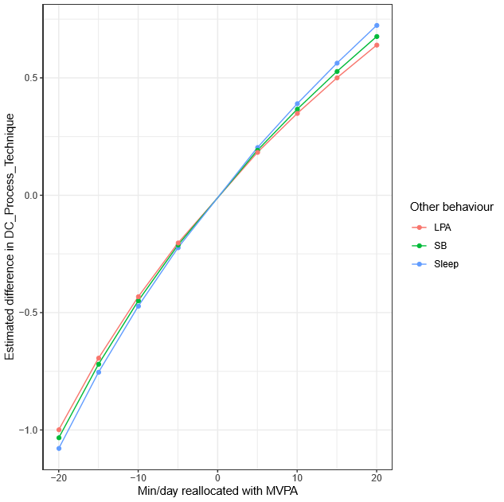
Figure 9. Estimated difference in Dragon Challenge scores associated with time reallocation between pairs of behaviours: difference in secondary school boys’ process score associated with the difference in MVPA to each of the remaining behaviours.

