Supplementary files
Sl. Table 1 Demographic characteristics of the Study location
Characteristics | Classification | Number | %
Gender | M | 224 | 58.3
Gender | F | 160 | 41.7
Age group | <18 | 51 | 13.3
Age group | 18-30 | 108 | 28.1
Age group | 30-45 | 69 | 18.0
Age group | 45-60 | 98 | 25.5
Age group | >60 | 58 | 15.1
Marital status | Married | 254 | 66.1
Marital status | Unmarried | 112 | 29.2
Marital status | Separated | 18 | 4.7
Education | Educated | 376 | 97.9
Education | Uneducated | 8 | 2.1
Occupation | Govt. employee | 43 | 11.2
Occupation | Private job | 111 | 28.9
Occupation | Student | 71 | 18.5
Occupation | Business | 117 | 30.5
Occupation | Housewife | 42 | 10.9
Duration of residence | 1-5 years | 52 | 13.5
Duration of residence | 5-10 years | 81 | 21.1
Duration of residence | 10-15 years | 122 | 31.8
Duration of residence | 15-20 years | 88 | 22.9
Duration of residence | >20 years | 41 | 10.7

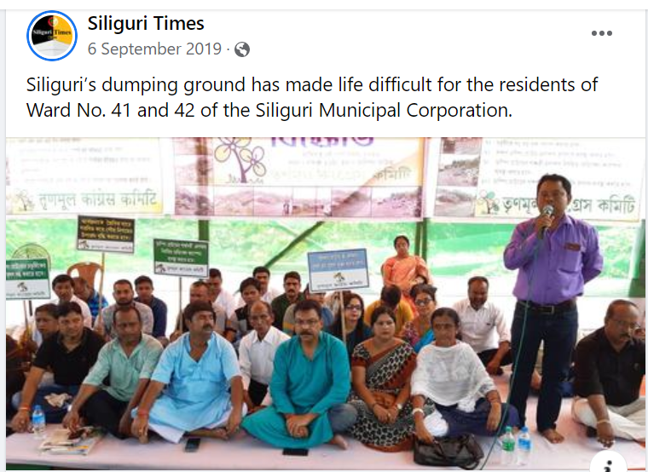

SL Fig.1 People are protesting in demand of relocating of landfill (Source: Siliguritimes)
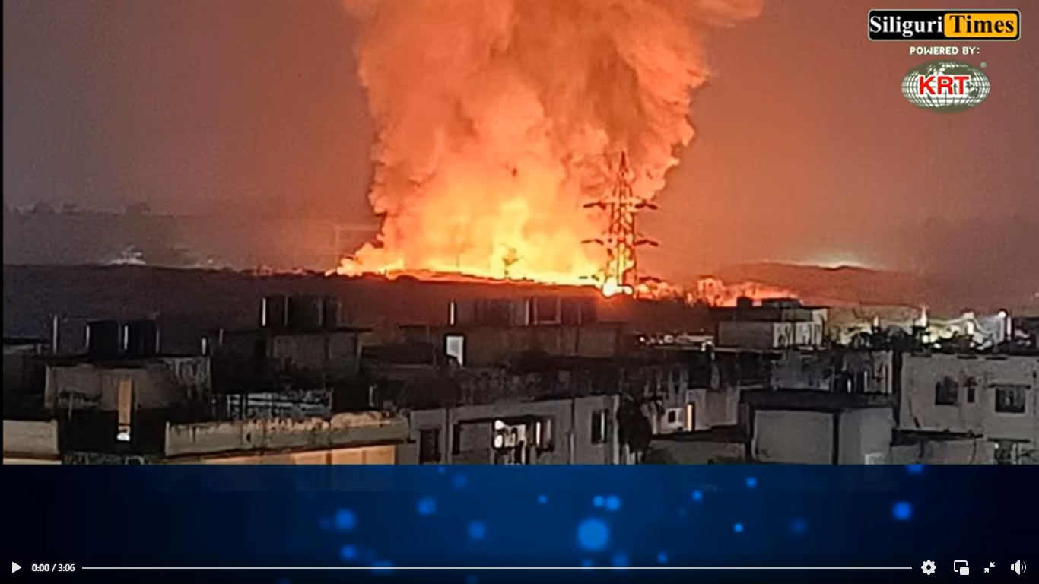
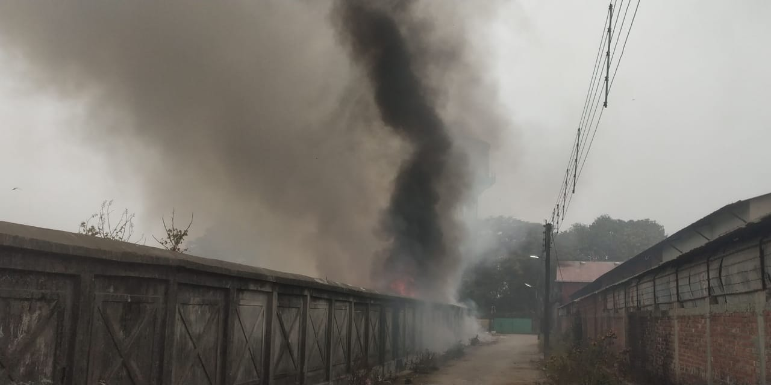
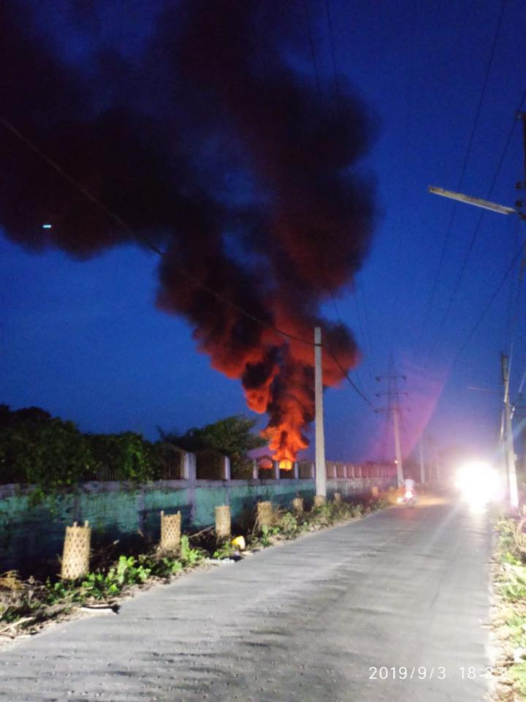
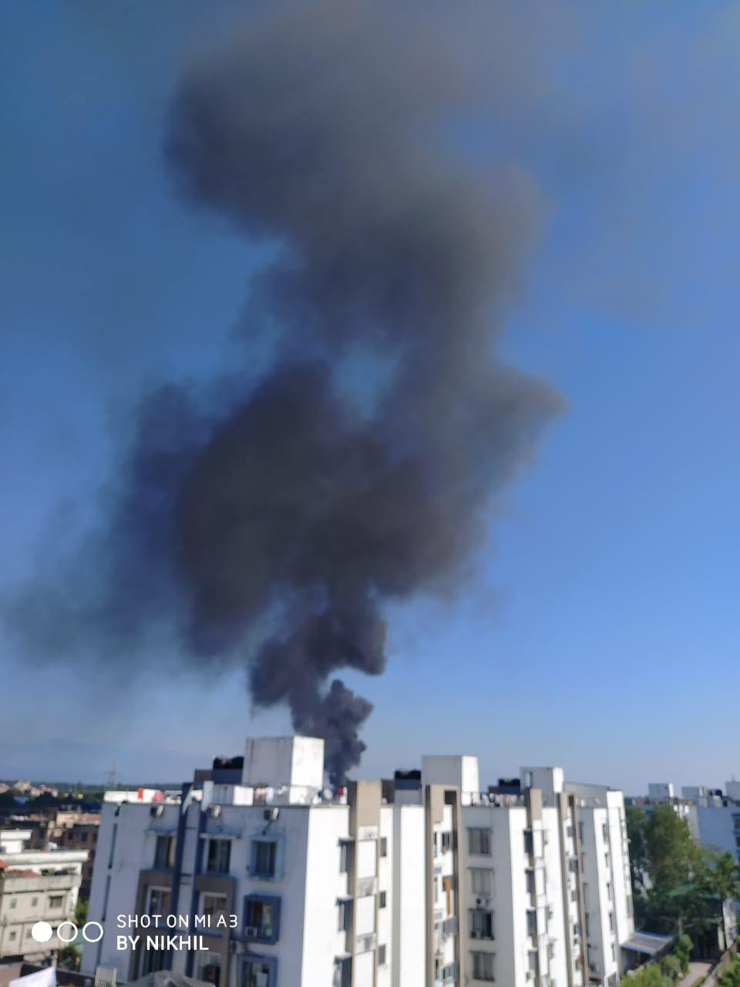

SL Fig. 2 Regular Fire incidents at Siliguri landfill (Source: SiliguriTimes; Siliguri chronicles)
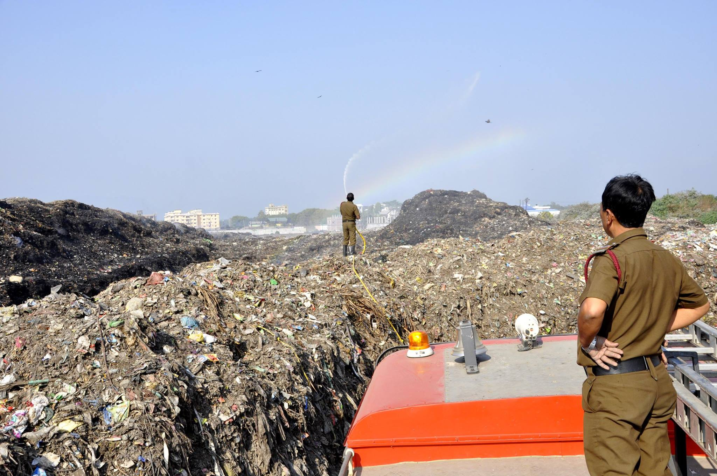

SL Fig. 3 Firemen trying to put out the fire in Siliguri landfill (Source: Tapan Das-Photographer)

.

SL Fig Perception of respondents concerning six major impacts from landfill of Siliguri

