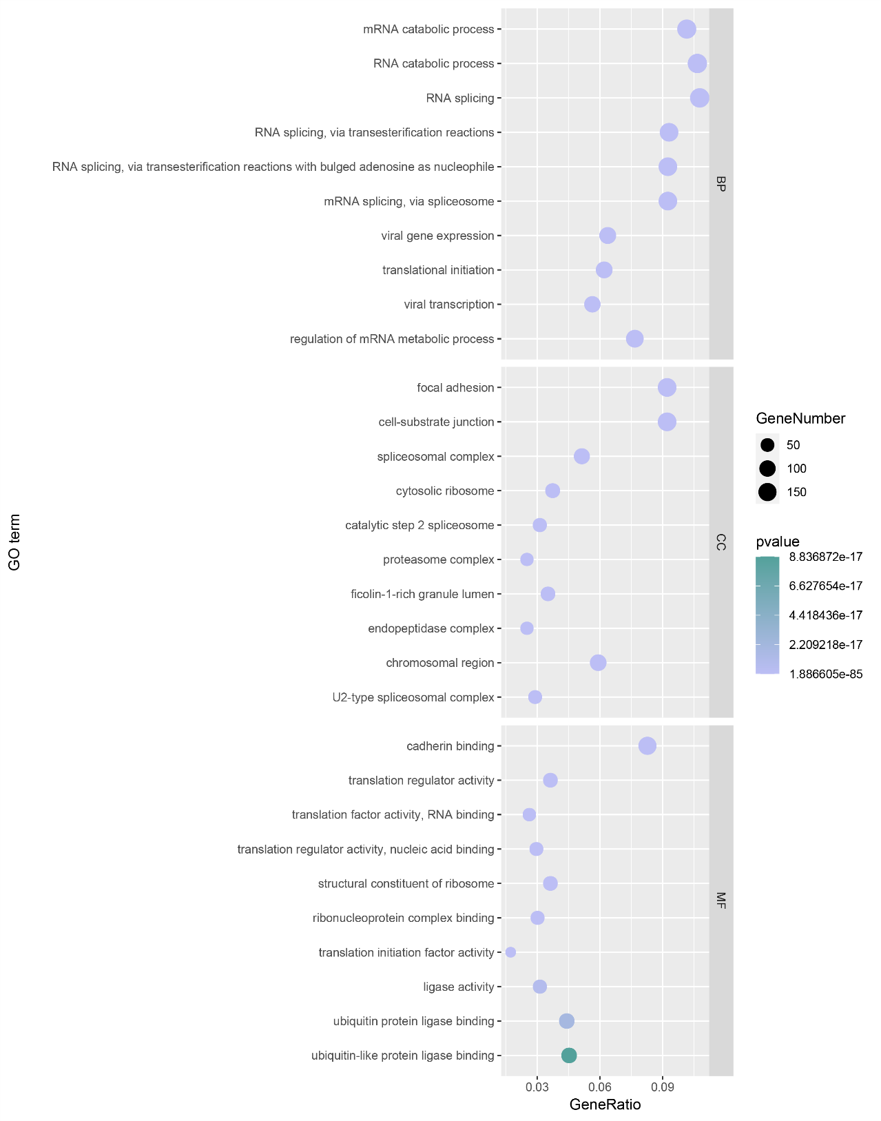
Supplementary Figure 1. GO enrichment of 1793 core proteins that detected in six tissues. The X axis shows GeneRatio, the Y axis shows the enriched GO terms. The Dot size indicates the numbers of proteins found in each enriched GO term; the dot color indicates the adjusted p‐value.

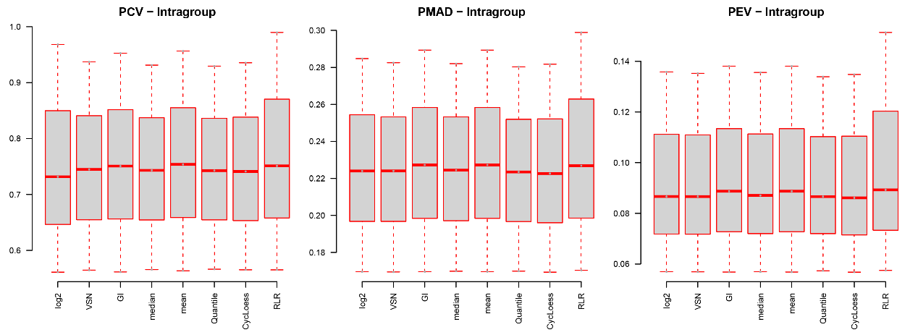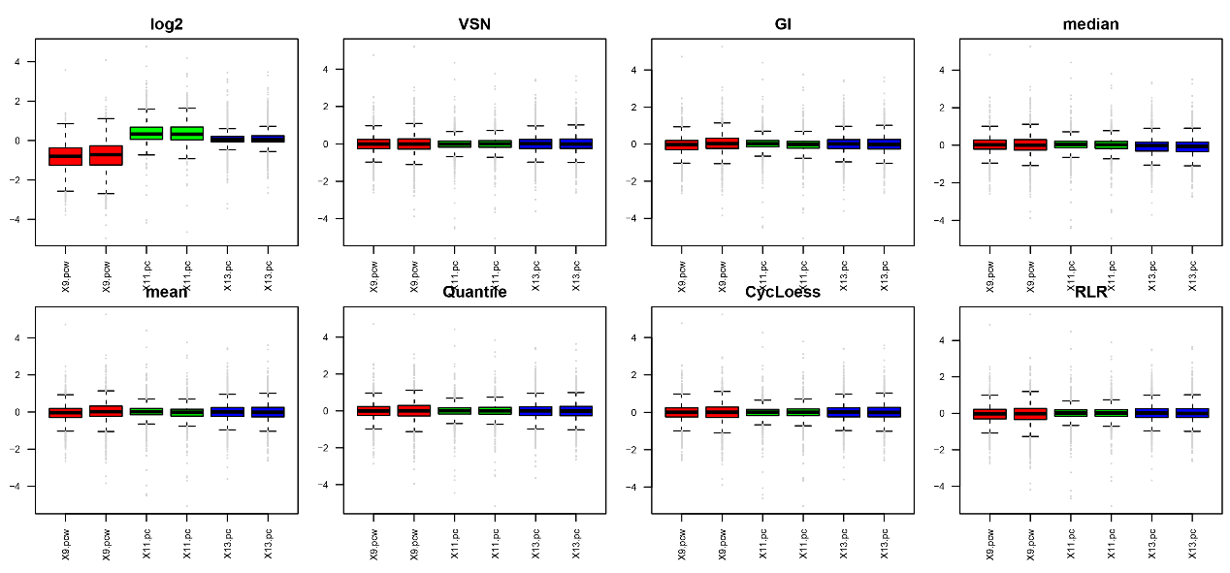 Supplementary Figure 2. Evaluating normalization by NormalyzerDE package.
A. The PCV, PMAD, and PEV plots represent intra-group variability and normalized method selection is based on low intra-group variability. Log2 transformed data and CycLoess normalized data are normalization methods. PCV, Pooled intragroup Coefficient of Variation; PMAD, Pooled intragroup Median Absolute Deviation; PEV, Pooled intragroup estimate of variance. VSN, Variance Stabilization Normalization; GI, Global Intensity; RLR, Robust Linear Regression; Cycloess, Cyclic Loess Normalization.
B. Relative Log Expression (RLE) plots for different normalization methods indicate that samples in CycLoess normalized data are centered better than the log2 transformed data. The top and bottom of the box represents the 75th and 25th percentiles of the distribution, respectively. The line inside the box represents the median value, and the dots represent data points on the extreme of the distribution.

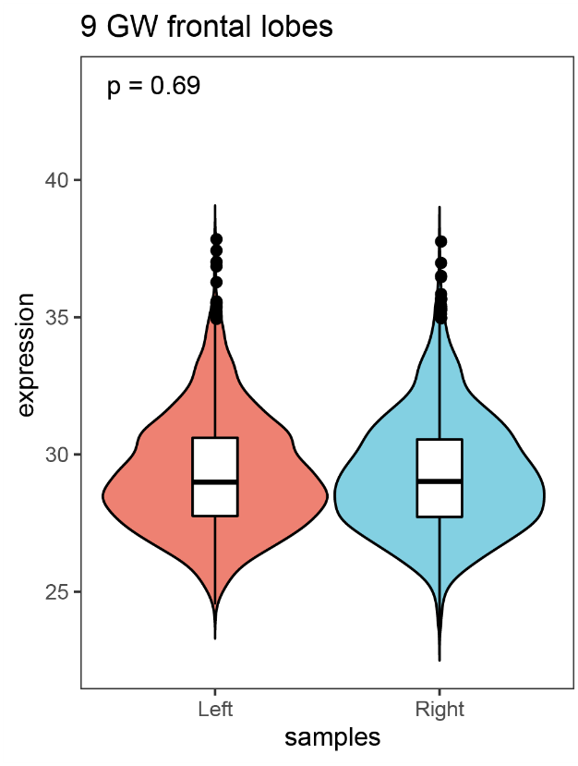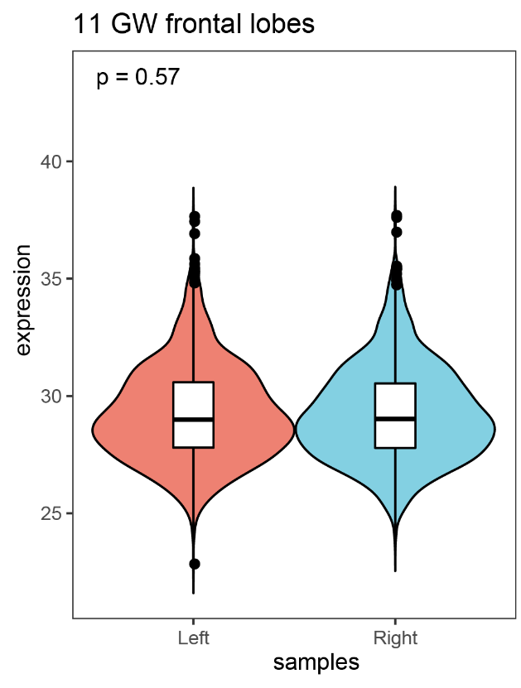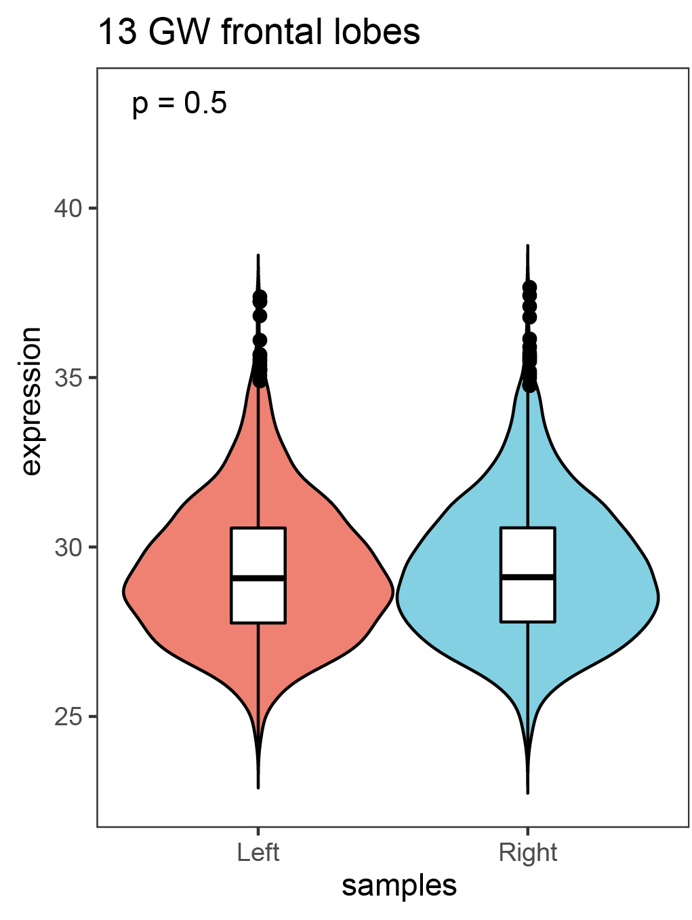
Supplementary Figure 3. Violin plots show distribution of bilateral frontal lobe expression in three gestational weeks. In 9 GW, P = 0.69; In 11 GW, P = 0.57; In 13 GW, P = 0.50; by Wilcoxon signed rank test (non-normal data).

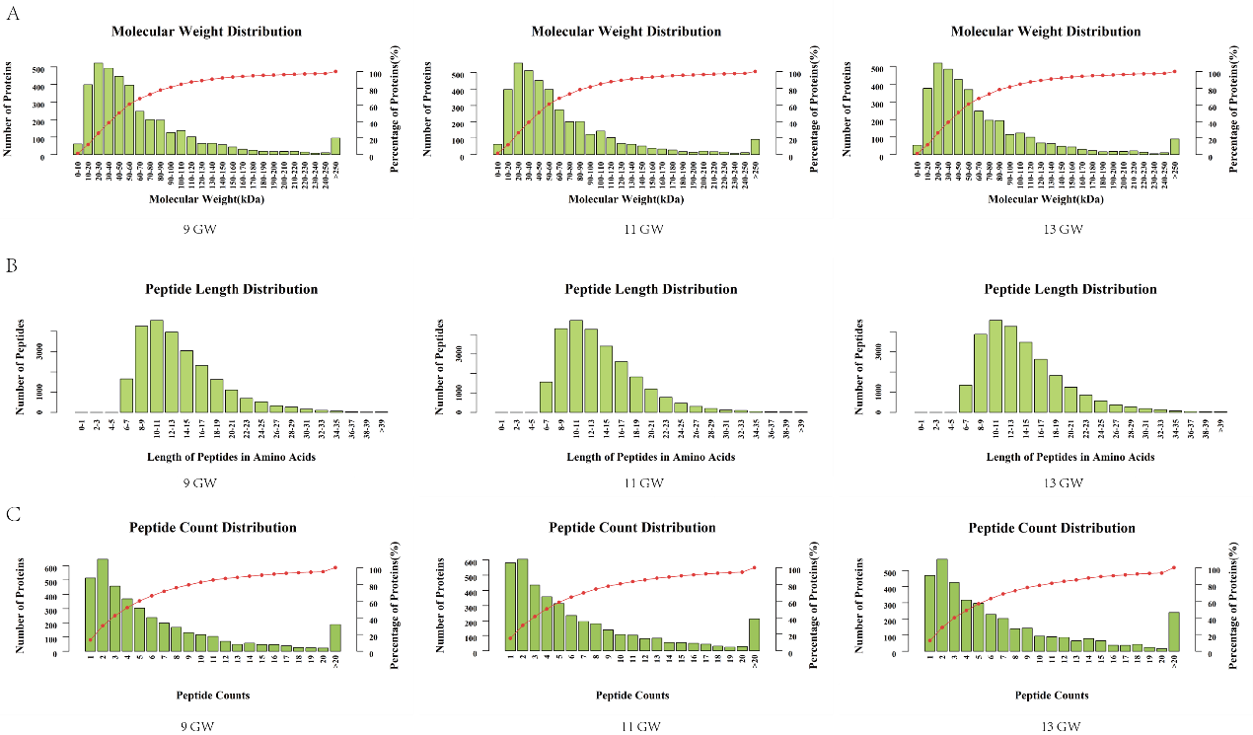 Supplementary Figure 4. Protein identification and quantitative results assessment
- Identified proteins relative molecular weight distribution. The column graph in the main ordinate corresponding graph represents the number of proteins identified with corresponding molecular weight; the cumulative curve in the corresponding sub-ordinate diagram indicates that the cumulative percentage of proteins with no higher than the corresponding molecular weight.
- Peptide length distribution of identified peptides.
- Peptide count distribution of identified peptides. The principal ordinate represents the number of proteins corresponding to the number of identified peptides; subordinate corresponding to the cumulative curve in the graph, indicating the identification of peptide number cumulative percentage.

