Supplementary Materials

Supplementary tables

Table S1. Mean 5 min FIs for different breast cancer subtypes
Subtype | N | Mean 5 min FI | S.D. | Kruskal−Wallis test
Luminal A | 63 | 0.649 | 0.958 | p = 0.214
Luminal B | 25 | 0.511 | 0.668 | p = 0.214
Her2-positive | 8 | 1.075 | 1.425 | p = 0.214
TN | 10 | 0.905 | 0.874 | p = 0.214
FI, Fluorescence increase; S.D., Standard deviation; TN, triple negative

Table S2. Mean 5 min FIs for different clinicopathological features
Parameter | Value | N | Mean 5 min FI | S.D. | Kruskal−Wallis test
T | T1 | 43 | 0.6295 | 0.9505 | p = 0.9522
T | T2 | 38 | 0.5474 | 0.6422 | p = 0.9522
T | T3 | 5 | 0.3455 | 0.2387 | p = 0.9522
pN | pN0 | 61 | 0.5996 | 0.8776 | p = 0.3076
pN | pN1 | 4 | 0.2367 | 0.1876 | p = 0.3076
pN | pN2 | 8 | 0.2483 | 0.2644 | p = 0.3076
Nuclear grade | Grade 1 | 41 | 0.7010 | 1.1419 | p = 0.7616
Nuclear grade | Grade 2 | 13 | 0.6229 | 0.6498 | p = 0.7616
Nuclear grade | Grade 3 | 40 | 0.6509 | 0.8423 | p = 0.7616
Histological grade | Grade I | 16 | 0.7491 | 1.2569 | p = 0.9203
Histological grade | Grade II | 30 | 0.8187 | 1.1318 | p = 0.9203
Histological grade | Grade III | 33 | 0.5581 | 0.6960 | p = 0.9203
Ly | Ly 0 | 42 | 0.8109 | 1.0380 | p = 0.0880
Ly | Ly 1 | 41 | 0.3553 | 0.3572 | p = 0.0880
Ly | Ly 2 | 4 | 0.2289 | 0.1922 | p = 0.0880
Ly | Ly 3 | 1 | 0.3421 | . | p = 0.0880
V | V 0 | 72 | 0.5990 | 0.8321 | p = 0.2465
V | V 1 | 11 | 0.5398 | 0.6425 | p = 0.2465
V | V 2 | 5 | 0.1634 | 0.1029 | p = 0.2465
Neoadjuvant chemotherapy | No | 102 | 0.6921 | 0.9451 | p = 0.2526
Neoadjuvant chemotherapy | Yes | 4 | 0.1741 | 0.0771 | p = 0.2526
FI, fluorescence increase; Ly, lymphatic vessel invasion; V, blood vessel invasion; S.D., standard deviation

Table S3. Statistical parameters for the 5 min and 15 min FIs in each tissue type
FI | Statistical parameters | Invasive | Non-invasive | Low-grade DCIS | Proliferative lesion | Normal
5 min FI | Mean | 0.724 | 0.963 | 0.385 | 0.294 | 0.145
5 min FI | S.D. | 0.989 | 1.412 | 0.441 | 0.302 | 0.351
5 min FI | S.E. of mean | 0.104 | 0.408 | 0.139 | 0.081 | 0.032
5 min FI | 95% CI | 0.930 | 1.860 | 0.700 | 0.468 | 0.207
5 min FI | 95% CI | 0.518 | 0.065 | 0.070 | 0.120 | 0.082
15 min FI | Mean | 2.209 | 2.666 | 1.207 | 1.034 | 0.475
15 min FI | S.D. | 2.303 | 3.162 | 1.008 | 0.815 | 0.896
15 min FI | S.E. of the mean | 0.241 | 0.913 | 0.319 | 0.218 | 0.081
15 min FI | 95% CI | 2.689 | 4.676 | 1.928 | 1.504 | 0.635
15 min FI | 95% CI | 1.730 | 0.657 | 0.486 | 0.563 | 0.315
 | N | 91 | 12 | 10 | 14 | 123
FI, fluorescence increase; DCIS, ductal carcinoma in situ; S.D., standard deviation; S.E., standard error

Table S4. Results of Steel–Dwass testing among the 5 min FIs of five tissue types
Level | Level | Difference of the mean | S.E. of the difference | Z | P-  value | Hodges– Lehmann estimator | 95% CI
DCIS/LCIS | Invasive | 6.178 | 9.176 | 0.673 | 0.962 | 0.080 | -0.310 | 0.504
Proliferative | Low-grade DCIS | -1.250 | 3.005 | -0.416 | 0.994 | -0.033 | -0.399 | 0.303
Low-grade DCIS | DCIS/LCIS | -3.208 | 2.780 | -1.154 | 0.778 | -0.148 | -1.801 | 0.337
Proliferative | DCIS/LCIS | -5.625 | 3.074 | -1.830 | 0.356 | -0.209 | -1.199 | 0.150
Low-grade DCIS | Invasive | -8.491 | 9.761 | -0.870 | 0.908 | -0.070 | -0.597 | 0.281
Proliferative | Invasive | -15.298 | 8.567 | -1.786 | 0.382 | -0.081 | -0.470 | 0.051
Normal | Low-grade DCIS | -33.250 | 12.672 | -2.624 | 0.066 | -0.123 | -0.402 | 0.004
Normal | Proliferative | -35.080 | 10.934 | -3.208 | 0.012 | -0.082 | -0.287 | -0.013
Normal | DCIS/LCIS | -51.631 | 11.830 | -4.365 | 0.0001 | -0.362 | -0.728 | -0.095
Normal | Invasive | -78.905 | 8.562 | -9.216 | <.0001 | -0.186 | -0.360 | -0.100
Z, Z-value of Steel Dwass test; CI, confidence interval; DCIS, Ductal carcinoma in situ; FI, Fluorescence increase; LCIS, Lobular carcinoma in situ; S.E., standard error
The P-values shown in bold orange are significant (P < 0.05)

Table S5. Results of Steel–Dwass testing among the 15 min FIs of five tissue types
Level | Level | Difference of the mean | S.E. of the difference | Z | P-value | Hodges− Lehmann estimator | 95% CI
DCIS/LCIS | Invasive | 7.310 | 9.176 | 0.797 | 0.932 | 0.359 | -1.338 | 1.466
Proliferative | Low-grade DCIS | 0.000 | 3.005 | 0.000 | 1.000 | 0.009 | -1.401 | 1.068
Low-grade DCIS | DCIS/LCIS | -3.575 | 2.780 | -1.286 | 0.700 | -0.615 | -3.430 | 0.833
Proliferative | DCIS/LCIS | -5.925 | 3.074 | -1.927 | 0.303 | -0.736 | -2.877 | 0.406
Low-grade DCIS | Invasive | -8.935 | 9.761 | -0.915 | 0.891 | -0.282 | -2.420 | 0.655
Proliferative | Invasive | -12.813 | 8.567 | -1.496 | 0.565 | -0.391 | -1.958 | 0.241
Normal | Proliferative | -43.083 | 10.934 | -3.940 | 0.0008 | -0.371 | -1.218 | -0.173
Normal | Low-grade DCIS | -44.712 | 12.672 | -3.528 | 0.0038 | -0.582 | -1.483 | -0.159
Normal | DCIS/LCIS | -55.564 | 11.830 | -4.697 | <.0001 | -1.262 | -2.521 | -0.594
Normal | Invasive | -76.362 | 8.562 | -8.919 | <.0001 | -0.799 | -1.463 | -0.494
DCIS, Ductal carcinoma in situ; FI, Fluorescence increase; LCIS, Lobular carcinoma in situ; CI, confidence interval; S.E., standard error

Table S6. Re-validation of the results obtained using the threshold determined in this multicenter study
 | Cancer | Benign lesion | Normal breast tissue | Total
FI + (>0.979) | 6 | 0 | 1 | 7
FI ± | 14 | 3 | 17 | 34
FI− (<0.061) | 0 | 0 | 5 | 5
Total | 20 | 3 | 23 | 46
FI, Fluorescence increase

Supplementary Figures

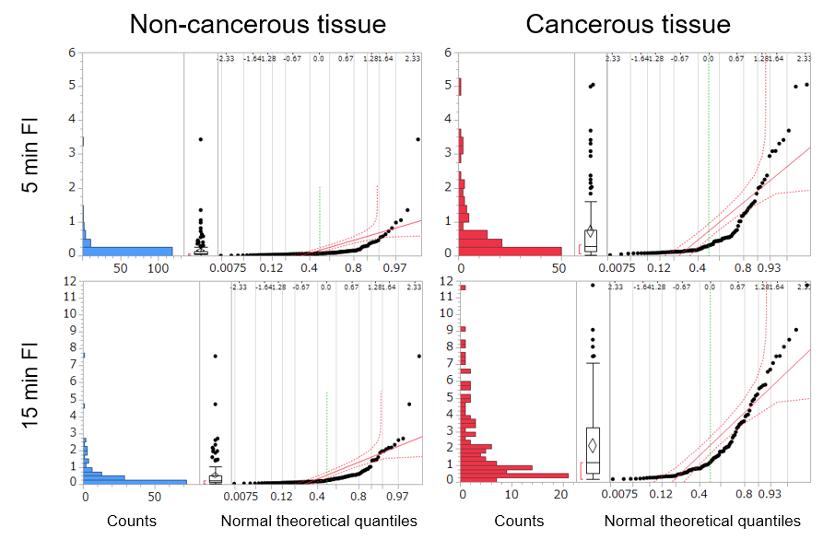
Figure S1. Distributions and quantile-quantile plots of the 5 min and 15 min FIs in cancerous and non-cancerous tissues
The dataset obtained in the multicenter study, including 251 sample measurements (138 non-cancerous and 113 cancerous tissues), was analyzed. The distributions and statistical parameters are indicated as histograms and box-and-whisker plots. The FIs are shown on a linear scale. In the quantile-quantile plot shown in the right side of the box-and-whisker plot, the red dotted curve indicates Lilliefors confidence bounds. FI, fluorescence increase

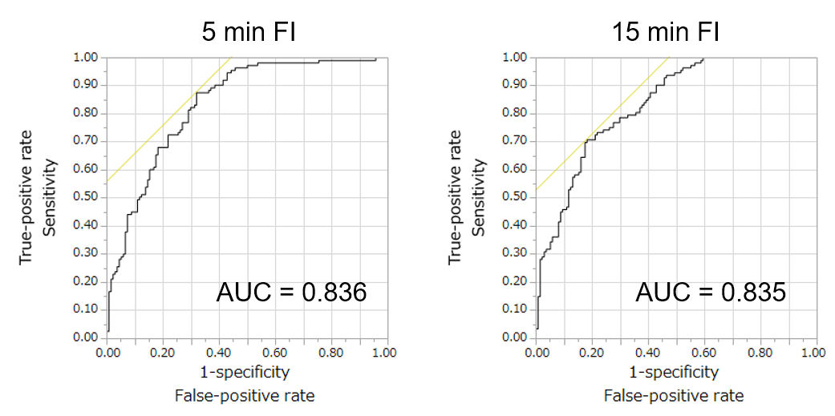

Figure S2. ROC curves of the 5 min and 15 min FIs values obtained in the multicenter study
FI, fluorescence increase

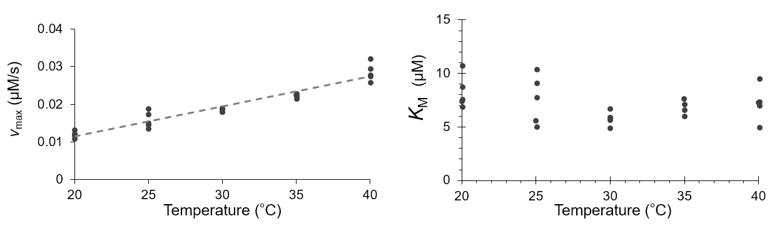Figure S3. Temperature sensitivity of beef-kidney derived GGT enzyme
The Michaelis−Menten kinetic parameters were obtained from in vitro experiments. In these experiments, 0.11 μM GGT (γ-GT from beef kidney, 465556003, Oriental Yeast Co., Ltd.) was mixed with 0–250 μM gGlu-HMRG in PBS (pH 6.8). The fluorescence intensity for the initial 5 min was measured using a fluorescent microplate reader with 10 sec intervals (Infinite M-200 Pro, TECAN) with an excitation wavelength and emission wavelength of 480 nm and 530 nm, respectively. The mean fluorescence increase rate was calculated by the least-square fitting of the fluorescence intensity for the 5 min data. The Michaelis−Menten kinetic parameters from each set of measurements were calculated using R software (https://www.r-project.org).

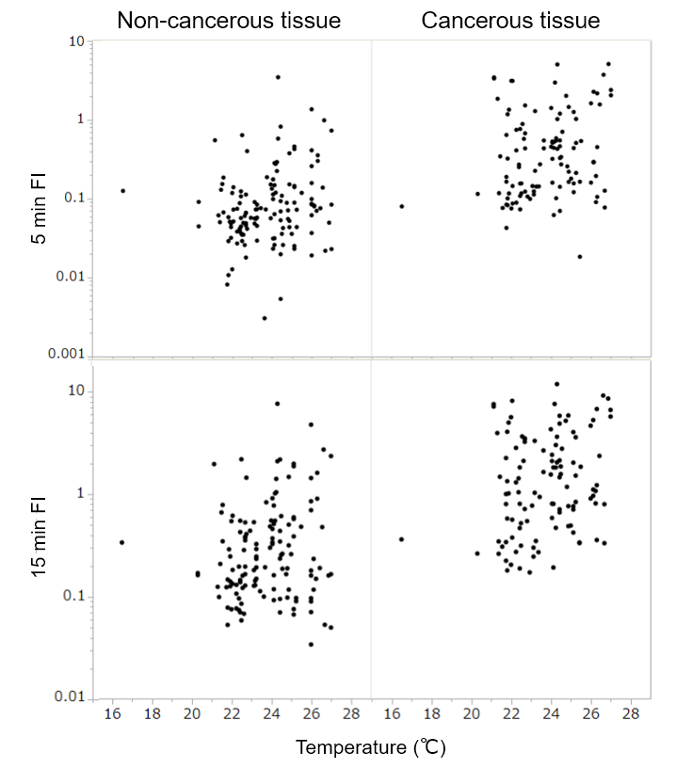

Figure S4. The 5 min and 15 min FI values are plotted against the ambient temperature
FI, fluorescence increase

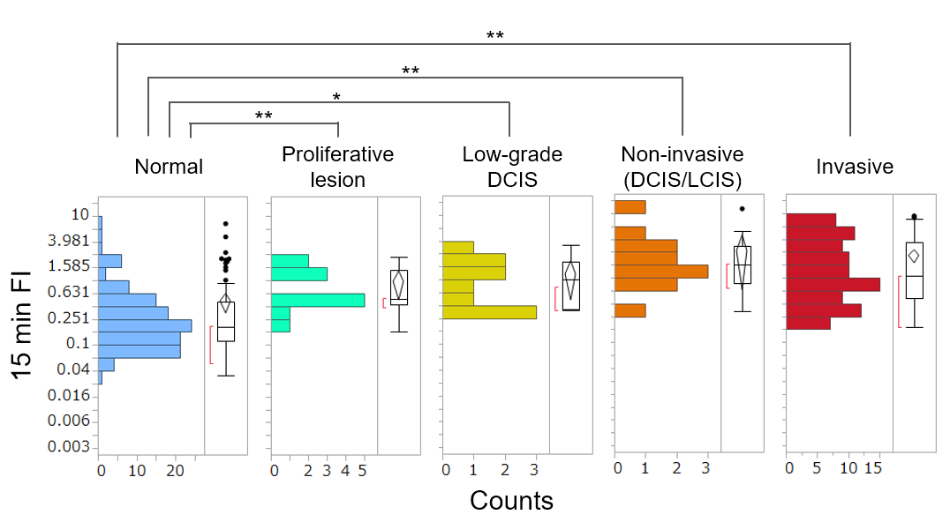

Figure S5. Differences in the 15 min FI distributions between breast tissues with different lesional subtypes
The dataset obtained in the multicenter study, including 251 sample measurements, was analyzed. *p < 0.01, **p < 0.001. FI, fluorescence increase

