SUPPLEMENTARY DATA
Figure S1. GO and KEGG pathway analysis of differentially expressed circRNAs.
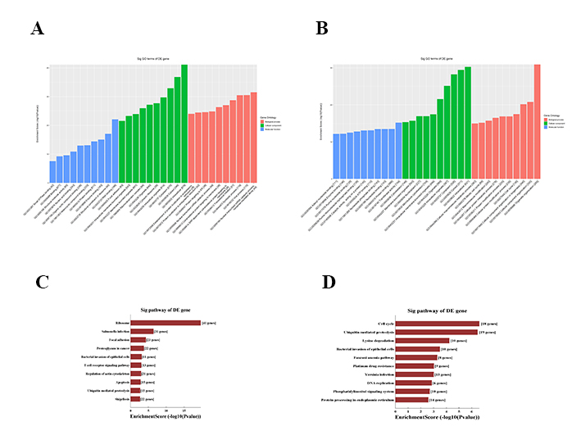

GO annotation of (A) down-regulated and (B) up-regulated circRNAs, via the top 10 enrichment scores-covering domains of biological processes, cellular components and molecular functions. The 10 significant pathways of (C) down-regulated and (D) up-regulated circRNAs by enrichment scores.

Supplementary Table S1: The sequences of the qRT-PCR primers
Primer name | Sequence (5′-3′) |  | Product length (bp)
β-actin（H） | forward | GTGGCCGAGGACTTTGATTG | 73
 | reverse | CCTGTAACAACGCATCTCATATT
hsa_circRNA_100466 | forward | CACGTAATGAAACTCTACGCCC | 191
 | reverse | GCCTGCCAGCTCTGGTTGT
SOX6 | forward | TACCTCTACCTCACCACATAAGC | 221
 | reverse | ACATCGGCAAGACTCCCTTTG
hsa-miR-19b-3p | forward | CCGGCATTGTGCAAATCCATG | 65
 | reverse | GTGCGTGTCGTGGAGTCG
U6 | forward | GCTTCGGCAGCACATATACTAAAAT | 89
 | reverse | CGCTTCACGAATTTGCGTGTCAT

