Supplemental Information

Effects of metal leachates from hydrothermal ore particulates in the marine copepod Tigriopus japonicus

Jeonghoon Han^{1,#} • Yeun Park^{2,3,#} • Hyeryeong Jeong^{3,4} • Sang Bae Kim⁵ • Chan Min Yoo⁶ • Kiseong Hyeong⁷ • Kyun-Woo Lee^{2,*}

¹ Marine Bio-Resources Research Unit, Korea Institute of Ocean Science & Technology (KIOST), Busan 49111, Republic of Korea
² Marine Biotechnology Research Center, Korea Institute of Ocean Science & Technology, Busan, 49111, Republic of Korea
³ University of Science & Technology (UST), Daejeon, 34113, Korea
⁴ Marine Environmental Research Center, Korea Institute of Ocean Science & Technology (KIOST), Busan 49111, Republic of Korea
⁵ Korea institute of Geoscience and mineral resources, Daejeon, 34132, Republic of Korea
⁶ Deep-sea and Seabed Mineral Resources Research Center, KIOST, Busan, 49111, Republic of Korea
⁷ Global Ocean Research Center, Korea Institute of Ocean Science & Technology (KIOST), Busan, 49111, Republic of Korea

Supplemental figure legends

Fig. S1. XRD patterns of the hydrothermal ore deposit used in this study

Fig. S2. Flow sheet of the flotation process optimized for separating sulphide and sulphate minerals from the hydrothermal ore deposits.

Fig. S1

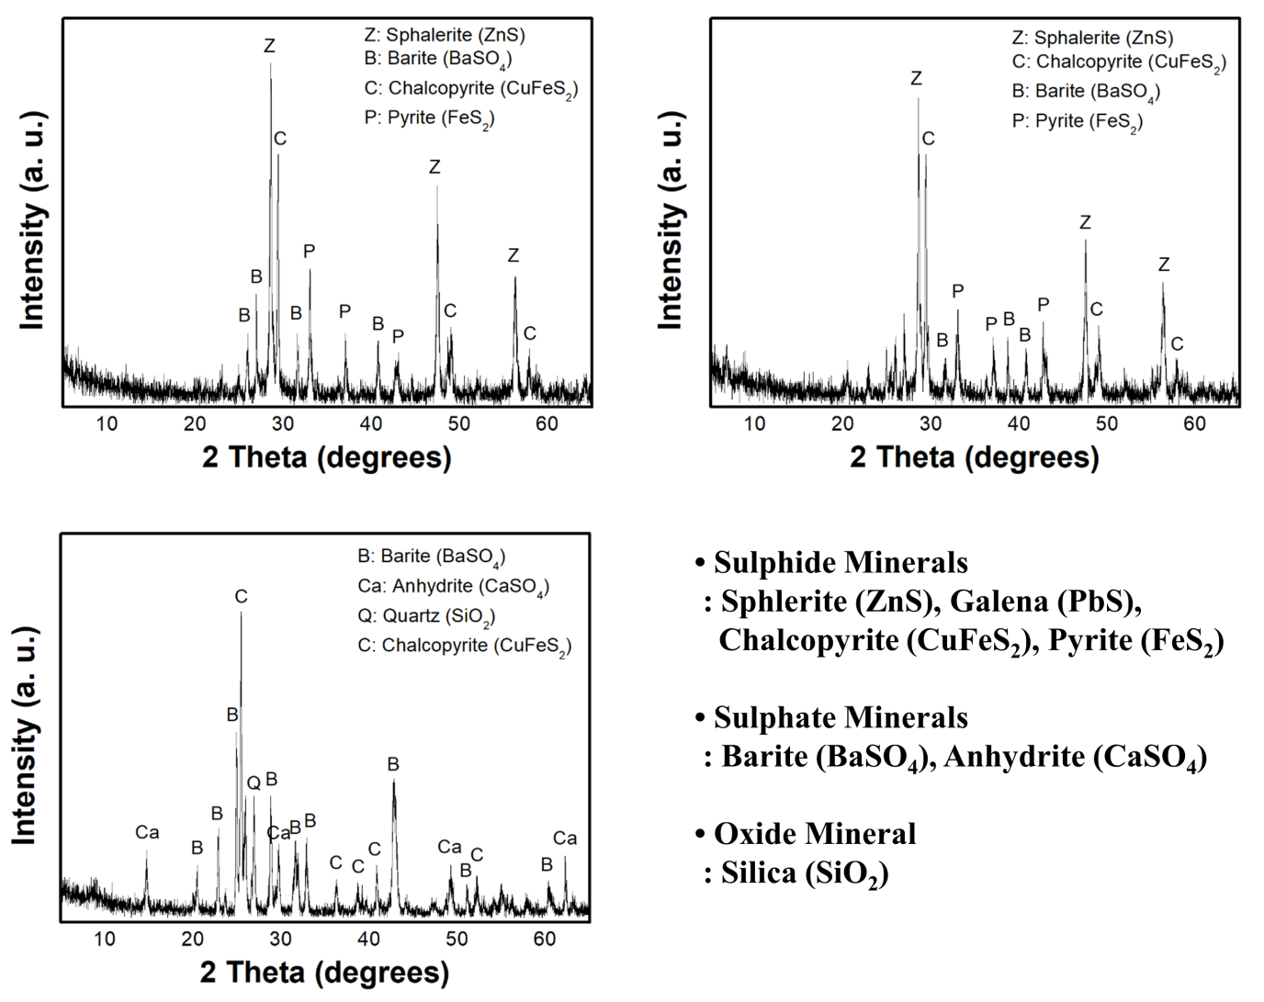

Fig. S2

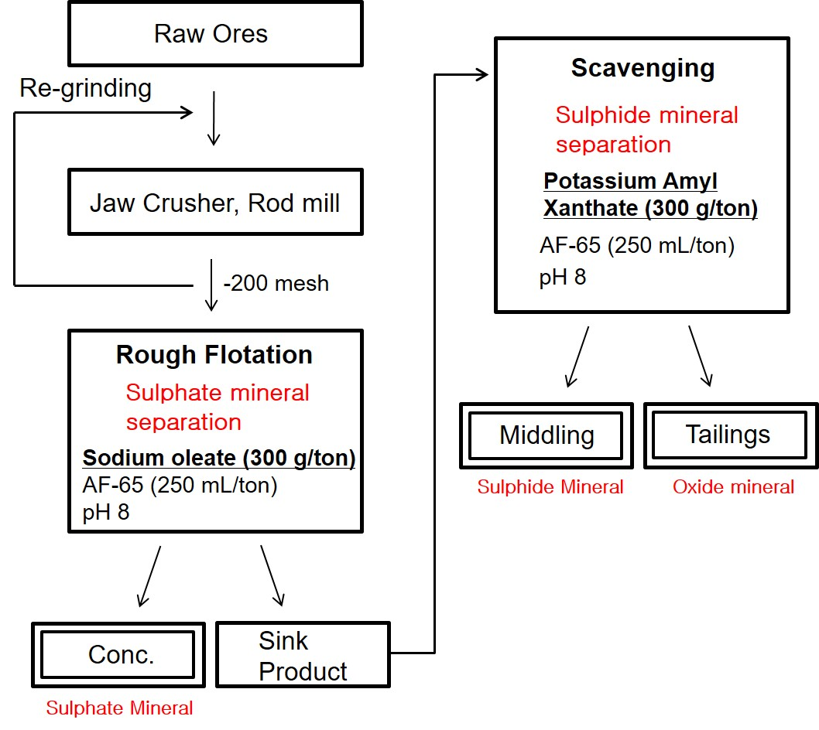

Table S1. Genbank Accession number and primer set used in this study
Genes | Genbank Accession No. | Oligo name | Sequence
CYP307E1 | KF639980 | F  R | GTGGAAAGCCTGTAGGCAAAGATAC  AATGGGGCGCATAAACAAGTG
CYP3037A1 | KF639977 | F  R | TGGCTGAAATTCAACGAAGAG  ATCGGCATTCTTCCAATACTC
CYP3041A1 | KF639978 | F  R | GCTATCTTGGAACTCAAGGAAATC  AGAAGTCCAGGCAAACTGTCAC
CYP3024A2 | KF639994 | F  R | GGACATTCTTACCCTTTGGC  TCCATTTTATTGGAATCACAGTC
CYP3024A3 | KF639992 | F  R | ACGAAGTGGATGAGTTGGCTG  GTGCATCGTCGCACTGTAAAC
CYP3025A1 | KF639995 | F  R | CAAGGTGGTCCATGAAACATTAC  CTCATTGGGGTTGTCATAATACTG
CYP3026A3 | KF639997 | F  R | GATTATCTTATCCCTGGAACCGAC  AGGCATAGGGATGGCGATTAG
CYP3026B2 | KF640008 | F  R | AATAAGAAGTCGGTTGGGAG  CGACAACTACCAGTTCATCAATG
CYP3027C2 | KF640002 | F  R | CTTCCTGGCAGGATTTGAAAC  CAATTCTCCCGTCAAACTCATC
GST-kappa | EU786798 | F  R | AAACAGCAGCGCTTTTTGAC  GAGCTCATCATATTGCTCGTTG
GST-mu5 | EU747061 | F  R | TTTAGGAATGGCCTTGTTCG  AACCAAAGGCAGCCAAATAA
GST-omega | EU747055 | F  R | CGGTCCATTGCATGGTTTGATG  CGTTCAAACCATGGCCAAATAG
GST-sigma | DQ088365 | F  R | ATGACTGGATTCGGATTTGGAC  GGCGTTTGGTCACATATTCGG
GST-theta3 | EU747056 | F  R | GGTTCTCGGTTGGATCAATG  AGCATAAATCGGCCAGAGTC
Vtg1 | EU416312 | F  R | ATGGTGAACACAAGGAAGTCCG  AGAAGACCTCAAGCCCTTCGAC
Vtg2 | EU831281 | F  R | TGTGCCTGTCATTGAGCGAT  AGCATGGGCCAGAGAGTAGA
18S rRNA | EU054307 | F  R | TCGGGCTGTCTCGTTGGTGATTC  TGCCACAGTCGACAGTTGATAGG

