New synthetic 1H-1,2,3-triazole derivatives of 3-O-acetyl-β-boswellic acid and 3-O-acetyl-11-keto-β-boswellic acid from Boswellia sacra inhibits carbonic anhydrase II in vitro
Satya Kumar Avulaª, Najeeb Ur Rehmanª, Majid Khan^{a,c}, Sobia Ahsan Halimª, Ajmal Khanª, Kashif Rafiq^{a,d}, Rene Csuk^{b}, Biswanath Dasª, Ahmed Al-Harrasi^{a*}

ªNatural and Medical Sciences Research Center, University of Nizwa, P.O. Box 33, Postal Code 616, Birkat Al Mauz, Nizwa, Sultanate of Oman (phone: +968 25446328; e-mails: aharrasi@unizwa.edu.om)
^{b}Organic Chemistry, Martin-Luther-University Halle-Wittenberg, Kurt-Mothes-Str. 2, d-06120, Halle (Saale), Germany
^{c}H.E.J Research Institute of Chemistry, International Center for Chemical and Biological Sciences, University of Karachi, Karachi-75270, Pakistan
^{d}Department of Chemistry, Abdul Wali Khan University Mardan, Mardan 23200, Pakistan

*Corresponding author (A. Al-Harrasi)
ªNatural and Medical Sciences Research Center, University of Nizwa, P.O. Box 33, Postal Code 616, Birkat Al Mauz, Nizwa, Sultanate of Oman (phone: +968 25446328; e-mails: aharrasi@unizwa.edu.om)
Table of Contents Page Page
S1: ¹H-NMR spectrum (600 MHz, CDCl₃) of compound 3 4
S2: ¹³C-NMR spectrum (150 MHz, CDCl₃) of compound 3 4
S3: HRMS spectrum of compound 3 5
S4: ¹H-NMR spectrum (600 MHz, CDCl₃) of compound 4 5
S5: ¹³C-NMR spectrum (150 MHz, CDCl₃) of compound 4 6
S6: HRMS spectrum of compound 4 6
S7: ¹H-NMR spectrum (600 MHz, CDCl₃) of compound 5 7
S8: ¹³C-NMR spectrum (150 MHz, CDCl₃) of compound 5 7
S9: HRMS spectrum of compound 5 8
S10: ¹H-NMR spectrum (600 MHz, CDCl₃) of compound 6 8
S11: ¹³C-NMR spectrum (150 MHz, CDCl₃) of compound 6 9
S12: HRMS spectrum of compound 6 9
S13: ¹H-NMR spectrum (600 MHz, CDCl₃) of compound 7 10
S14: ¹³C-NMR spectrum (150 MHz, CDCl₃) of compound 7 10
S15: HRMS spectrum of compound 7 11
S16: ¹H-NMR spectrum (600 MHz, CDCl₃) of compound 8 11
S17: ¹³C-NMR spectrum (150 MHz, CDCl₃) of compound 8 12
S18: HRMS spectrum of compound 8 12
S19: ¹H-NMR spectrum (600 MHz, CDCl₃) of compound 10a 13
S20: ¹³C-NMR spectrum (150 MHz, CDCl₃) of compound 10a 13
S21: HRMS spectrum of compound 10a 14
S22: ¹H-NMR spectrum (600 MHz, CDCl₃) of compound 10b 14
S23: ¹³C-NMR spectrum (150 MHz, CDCl₃) of compound 10b 15
S24: ¹⁹F-NMR spectrum (564 MHz, CDCl₃) of compound 10b 15
S25: HRMS spectrum of compound 10b 16
S26: ¹H-NMR spectrum (600 MHz, CDCl₃) of compound 10c 16
S27: ¹³C-NMR spectrum (150 MHz, CDCl₃) of compound 10c 17
S28: ¹⁹F-NMR spectrum (564 MHz, CDCl₃) of compound 10c 17
S29: HRMS spectrum of compound 10c 18
S30: ¹H-NMR spectrum (600 MHz, CDCl₃) of compound 10d 18
S31: ¹³C-NMR spectrum (150 MHz, CDCl₃) of compound 10d 19
S32: HRMS spectrum of compound 10d 19
S33: ¹H-NMR spectrum (600 MHz, CDCl₃) of compound 11a 20
S34: ¹³C-NMR spectrum (150 MHz, CDCl₃) of compound 11a 20
S35: HRMS spectrum of compound 11a 21
S36: ¹H-NMR spectrum (600 MHz, CDCl₃) of compound 11b 21
S37: ¹³C-NMR spectrum (150 MHz, CDCl₃) of compound 11b 22
S38: ¹⁹F-NMR spectrum (564 MHz, CDCl₃) of compound 11b 22
S39: HRMS spectrum of compound 11b 23
S40: ¹H-NMR spectrum (600 MHz, CDCl₃) of compound 11c 23
S41: ¹³C-NMR spectrum (150 MHz, CDCl₃) of compound 11c 24
S42: ¹⁹F-NMR spectrum (564 MHz, CDCl₃) of compound 11c 24
S43: HRMS spectrum of compound 11c 25
S44: ¹H-NMR spectrum (600 MHz, CDCl₃) of compound 11d 25
S45: ¹³C-NMR spectrum (150 MHz, CDCl₃) of compound 11d 26
S46: HRMS spectrum of compound 11d 26

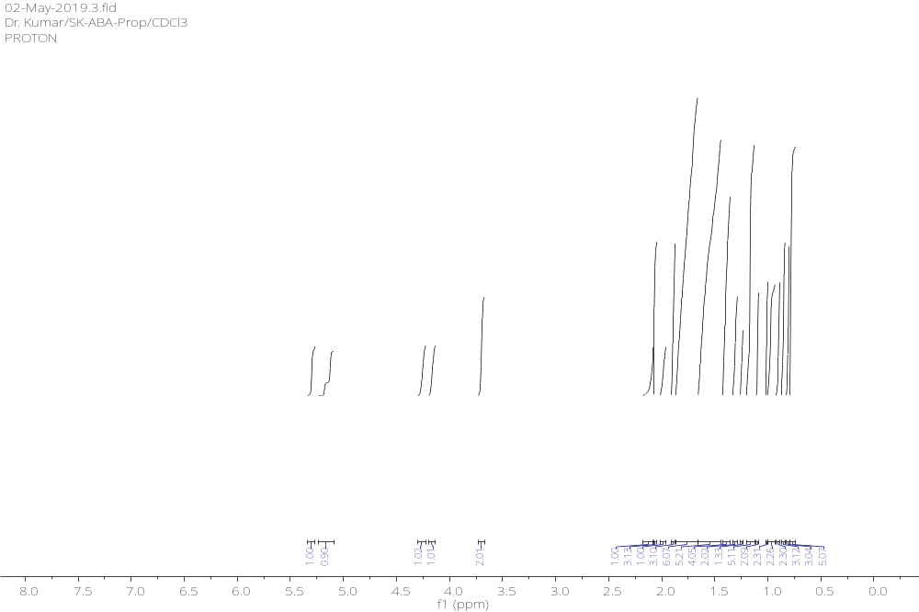S1: ¹H-NMR spectrum (600 MHz, CDCl₃) of compound 3

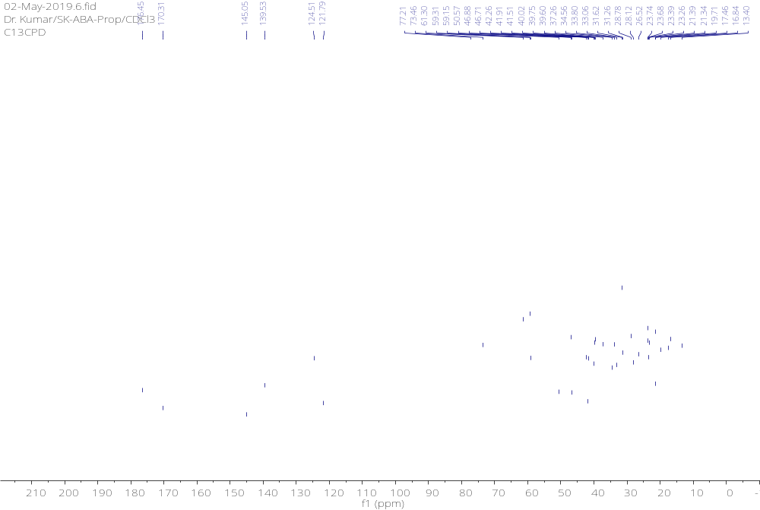S2: ¹³C-NMR spectrum (150 MHz, CDCl₃) of compound 3
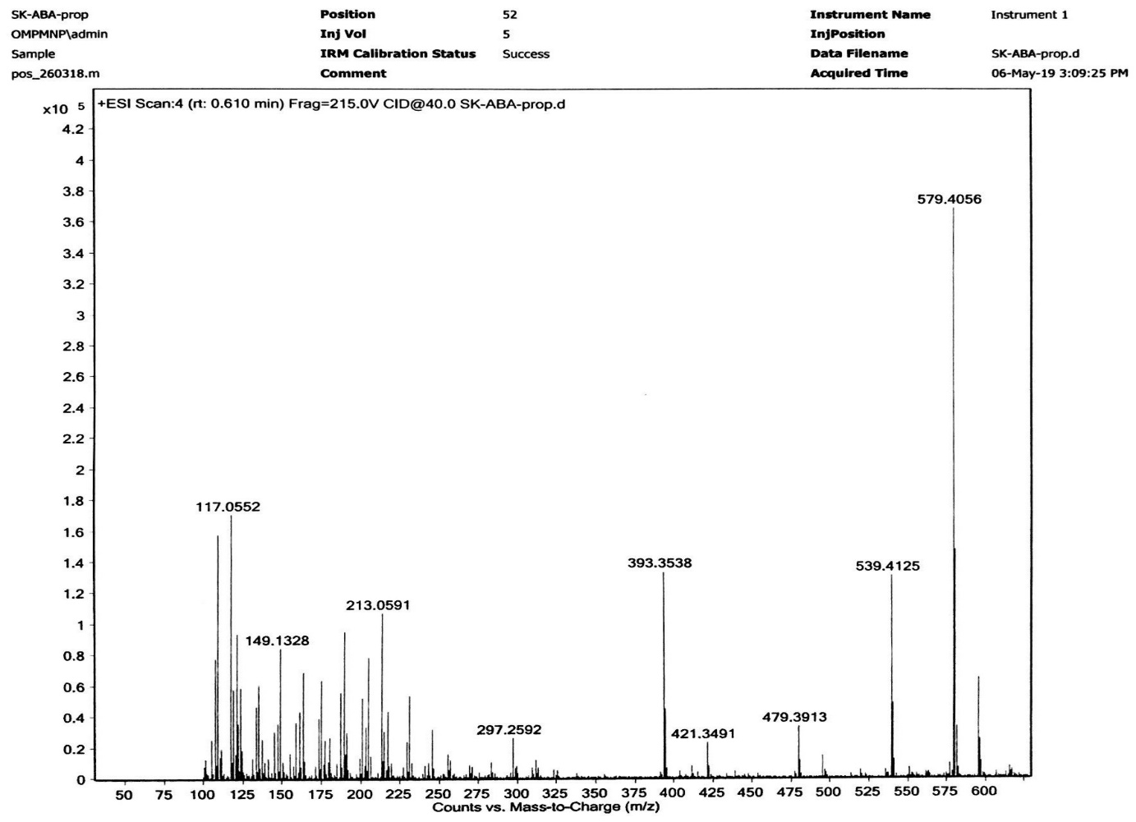
S3: HRMS spectrum of compound 3
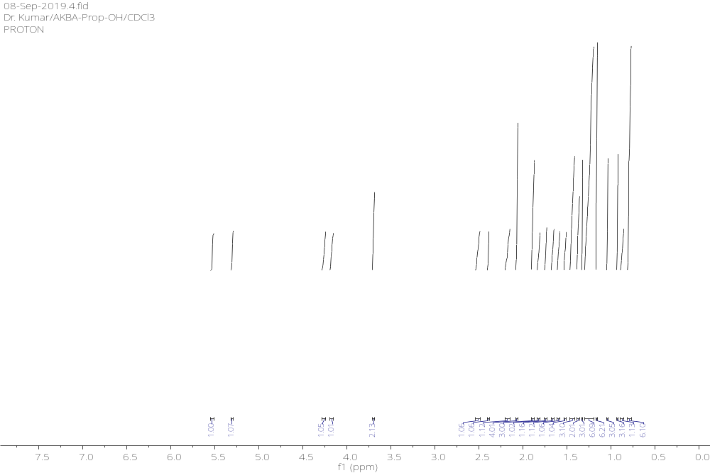S4: ¹H-NMR spectrum (600 MHz, CDCl₃) of compound 4
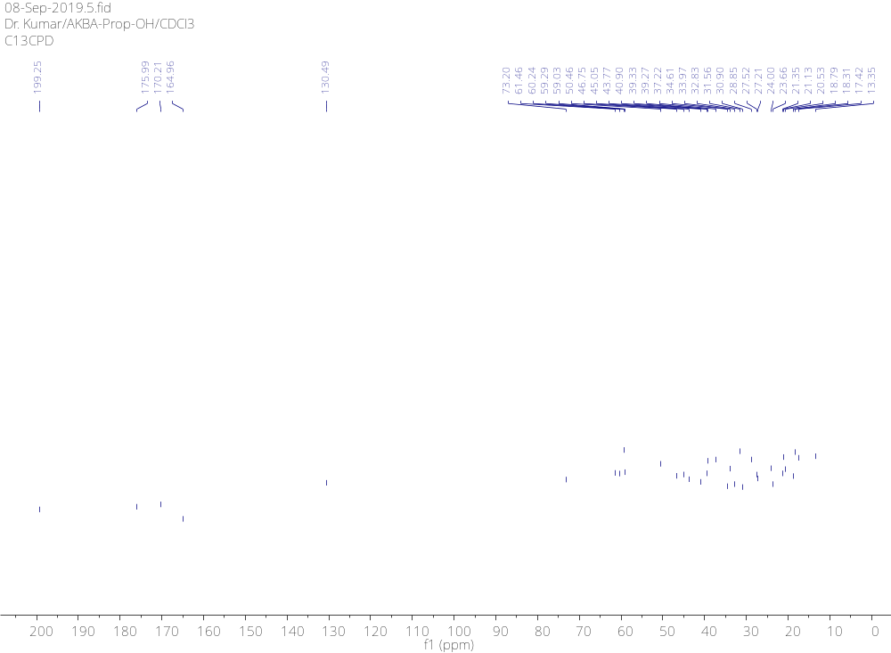
S5: ¹³C-NMR spectrum (150 MHz, CDCl₃) of compound 4
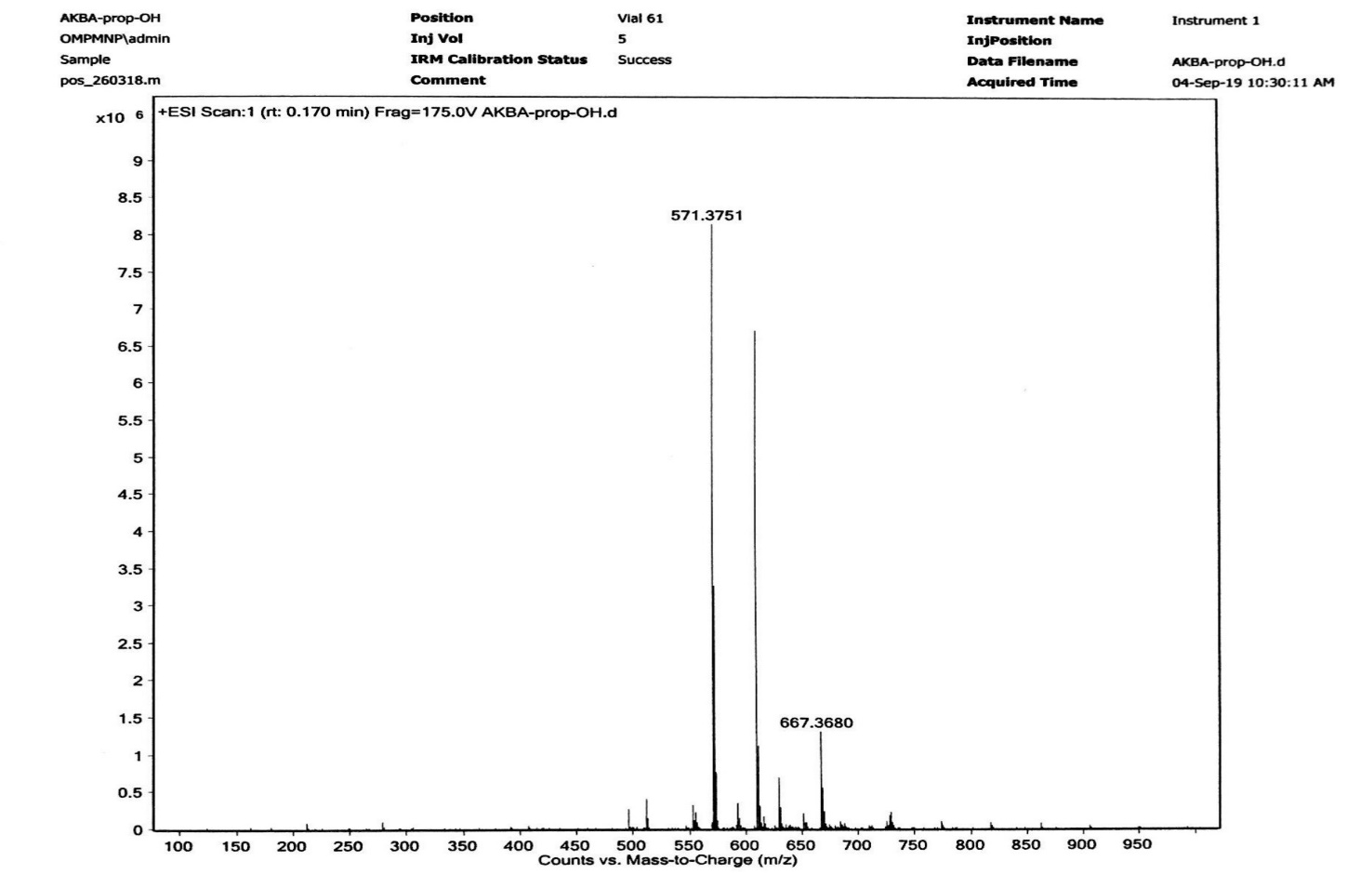
S6: HRMS spectrum of compound 4
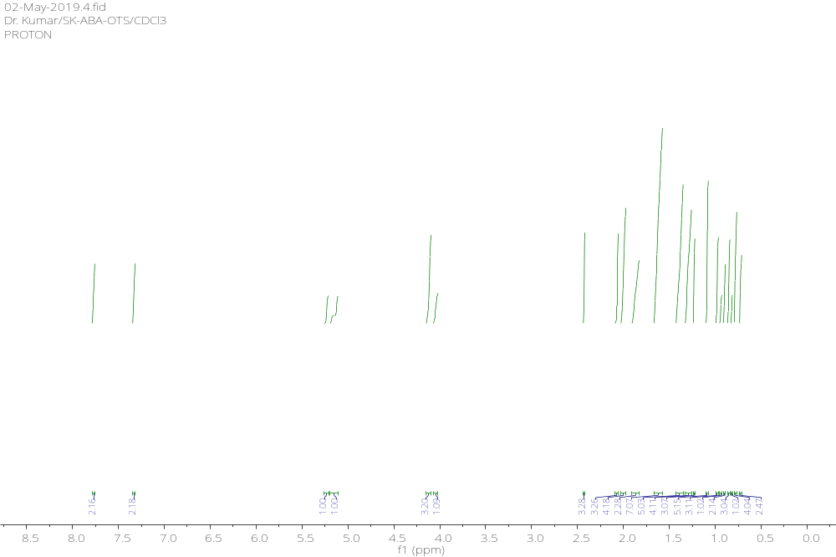
S7: ¹H-NMR spectrum (600 MHz, CDCl₃) of compound 5
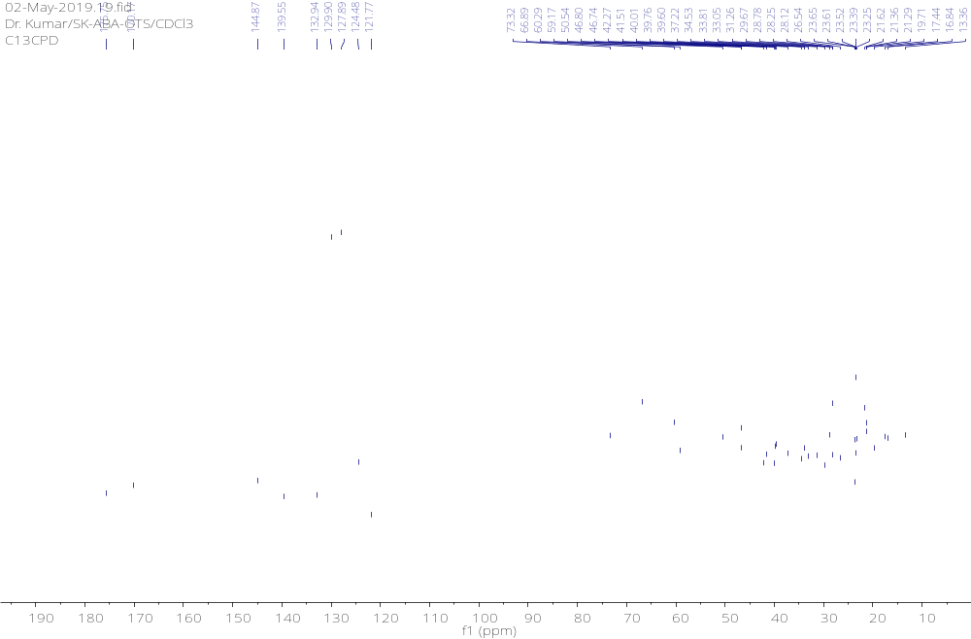S8: ¹³C-NMR spectrum (150 MHz, CDCl₃) of compound 5
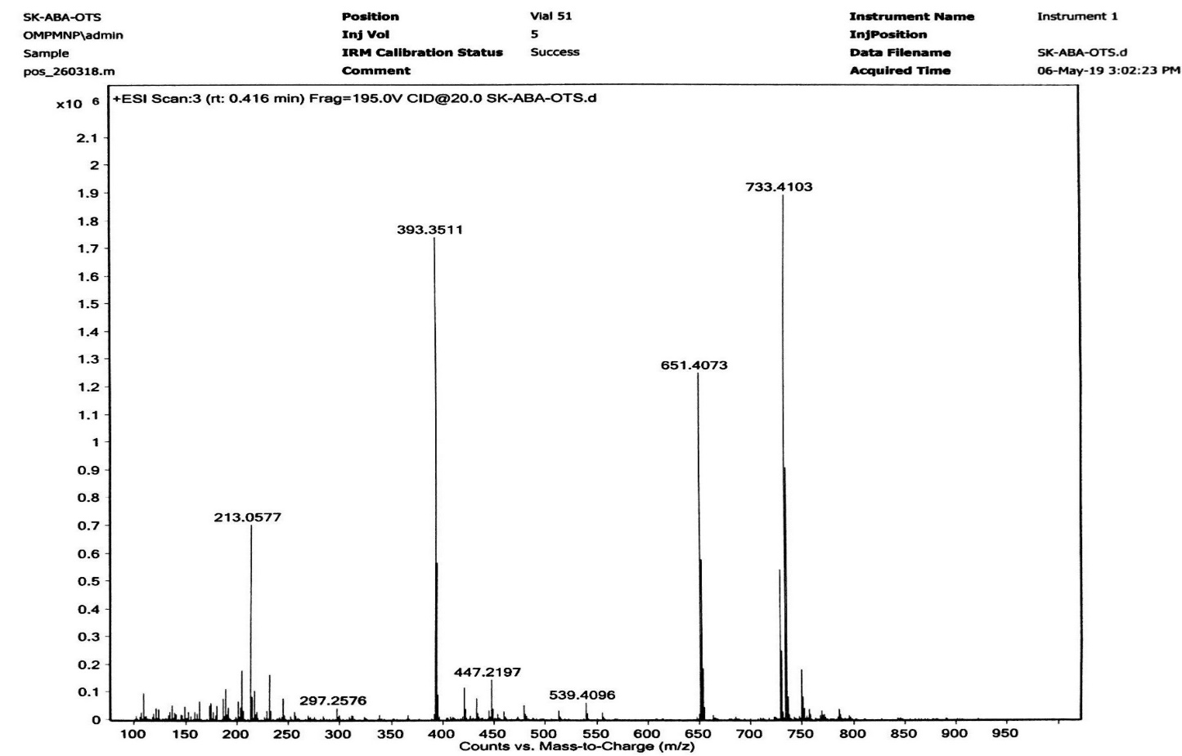
S9: HRMS spectrum of compound 5

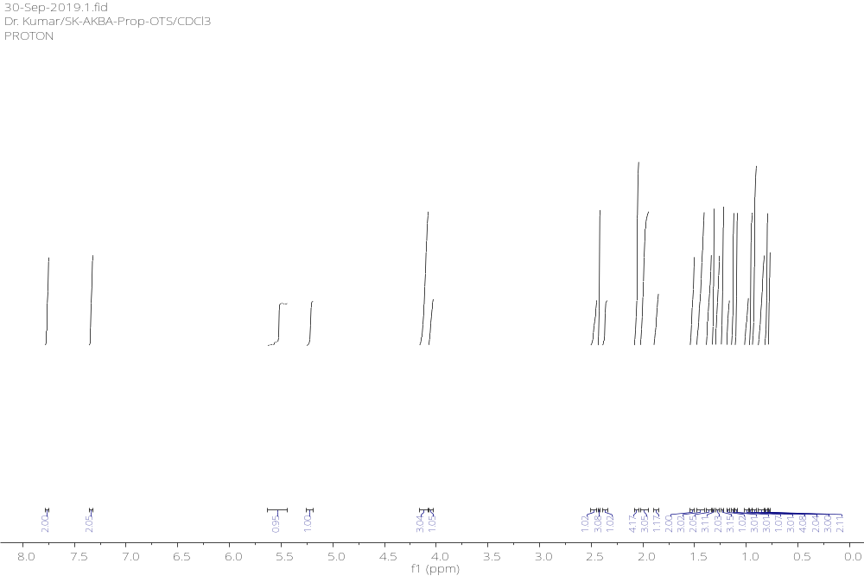S10: ¹H-NMR spectrum (600 MHz, CDCl₃) of compound 6
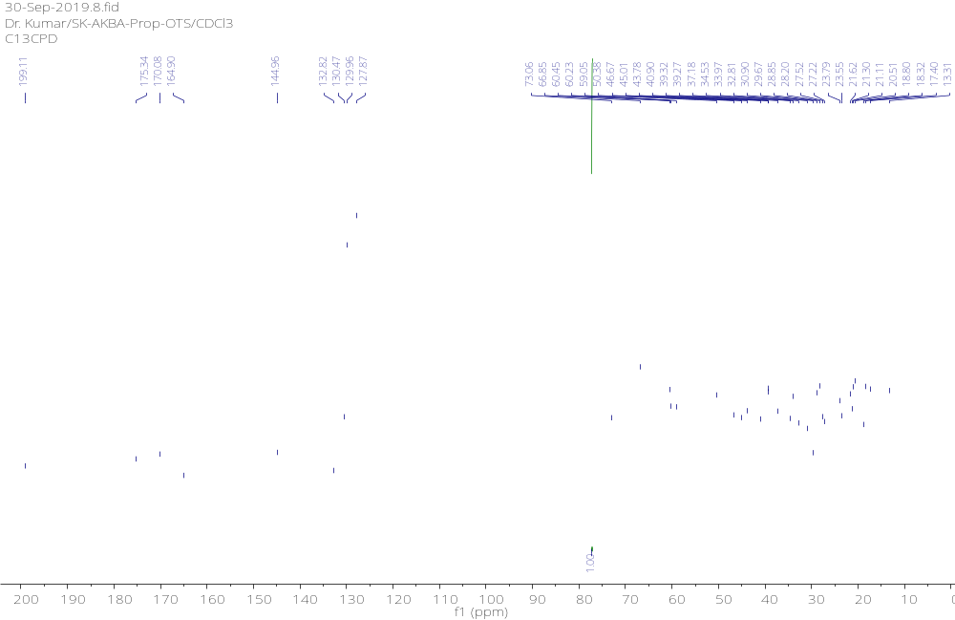
S11: ¹³C-NMR spectrum (150 MHz, CDCl₃) of compound 6
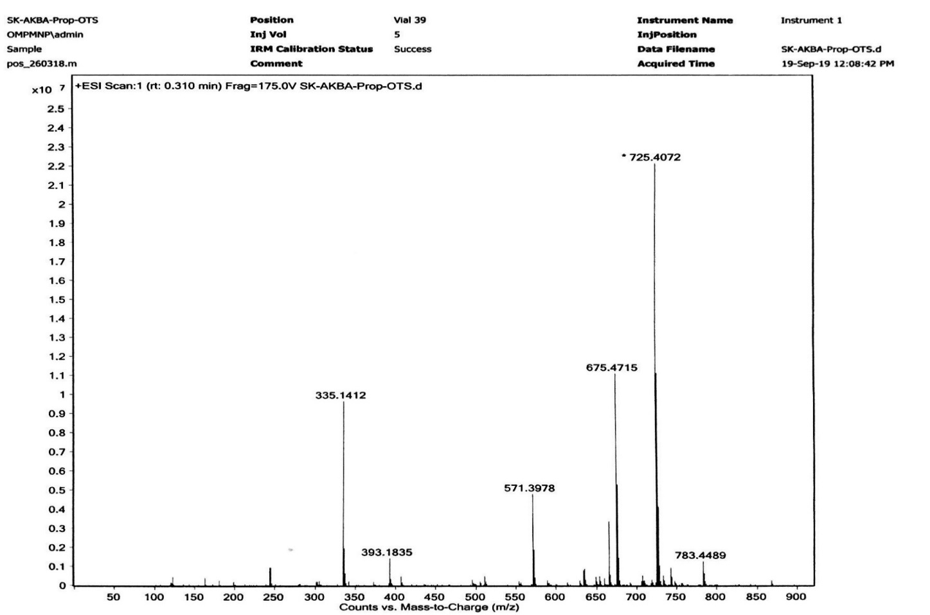
S12: HRMS spectrum of compound 6
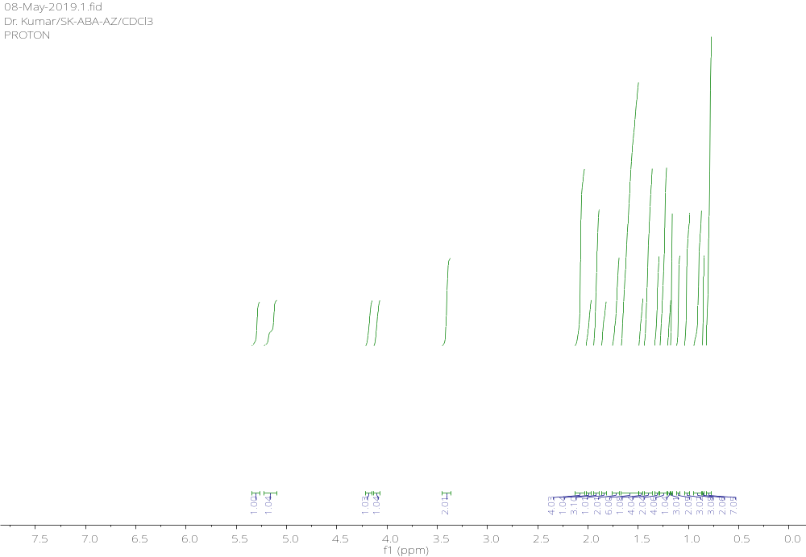
S13: ¹H-NMR spectrum (600 MHz, CDCl₃) of compound 7
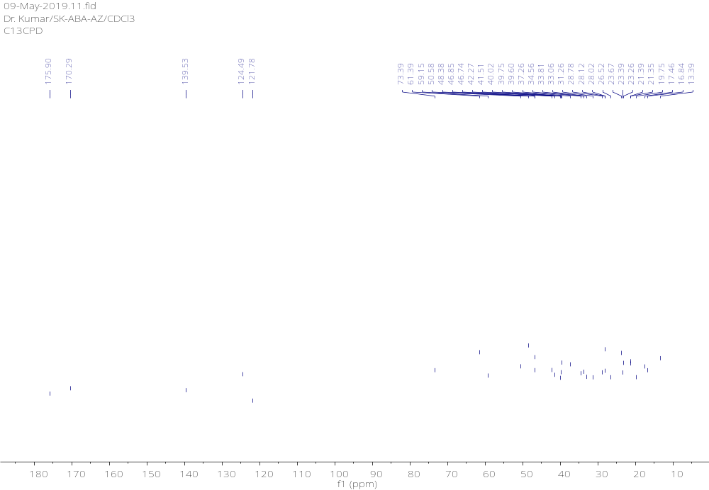
S14: ¹³C-NMR spectrum (150 MHz, CDCl₃) of compound 7
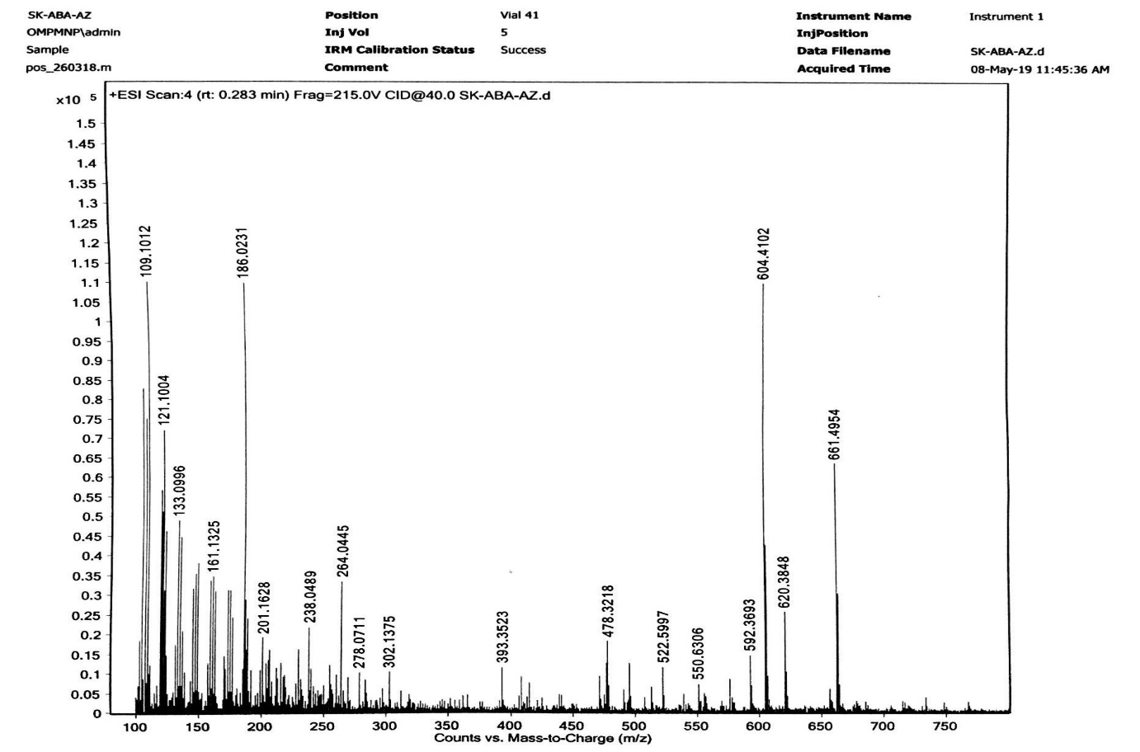
S15: HRMS spectrum of compound 7

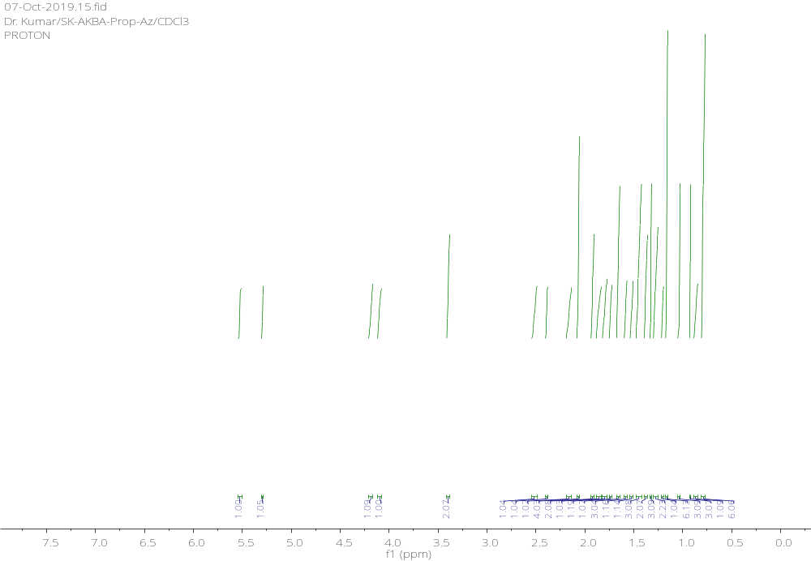
S16: ¹H-NMR spectrum (600 MHz, CDCl₃) of compound 8
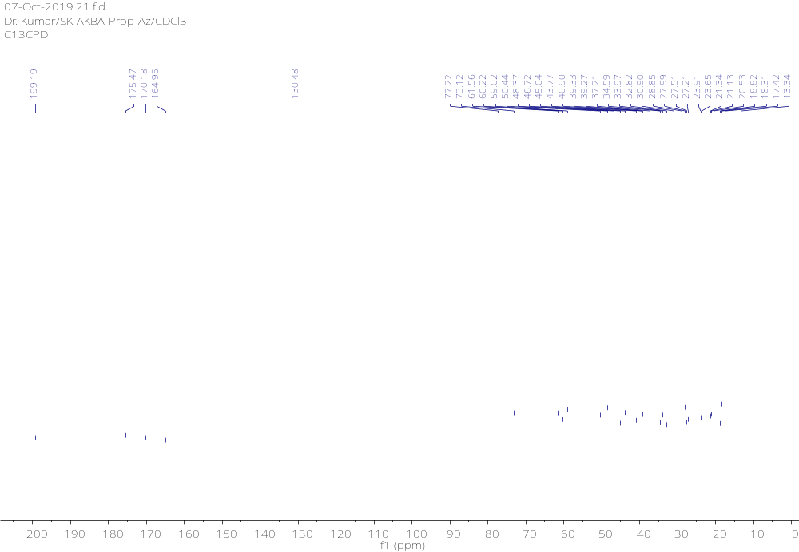
S17: ¹³C-NMR spectrum (150 MHz, CDCl₃) of compound 8
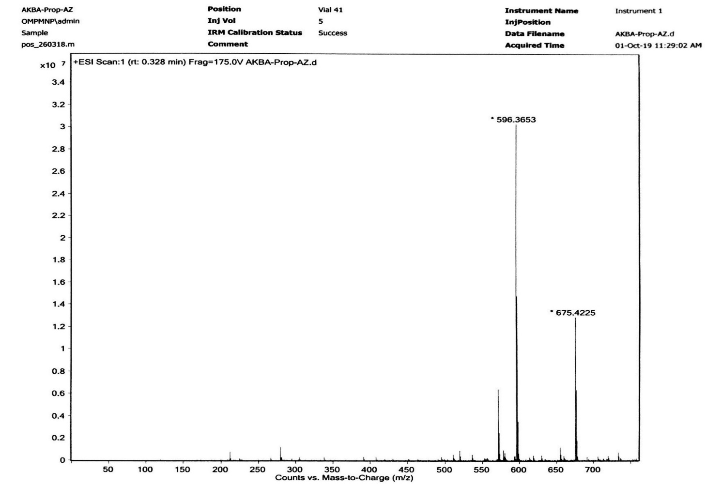
S18: HRMS spectrum of compound 8
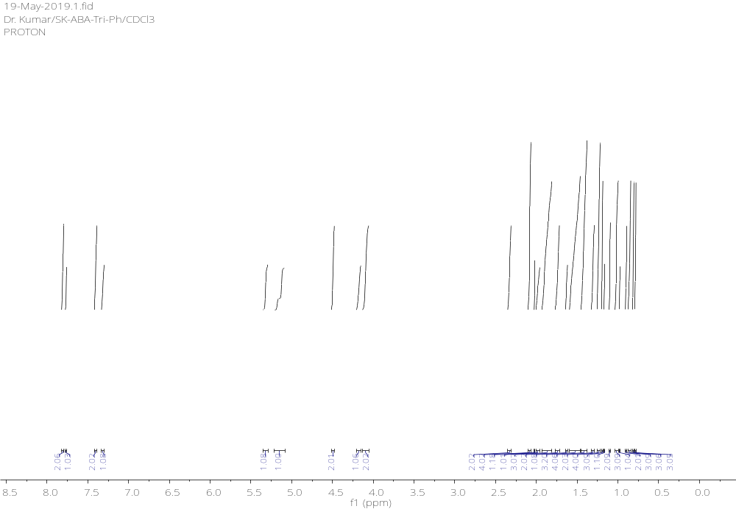
S19: ¹H-NMR spectrum (600 MHz, CDCl₃) of compound 10a
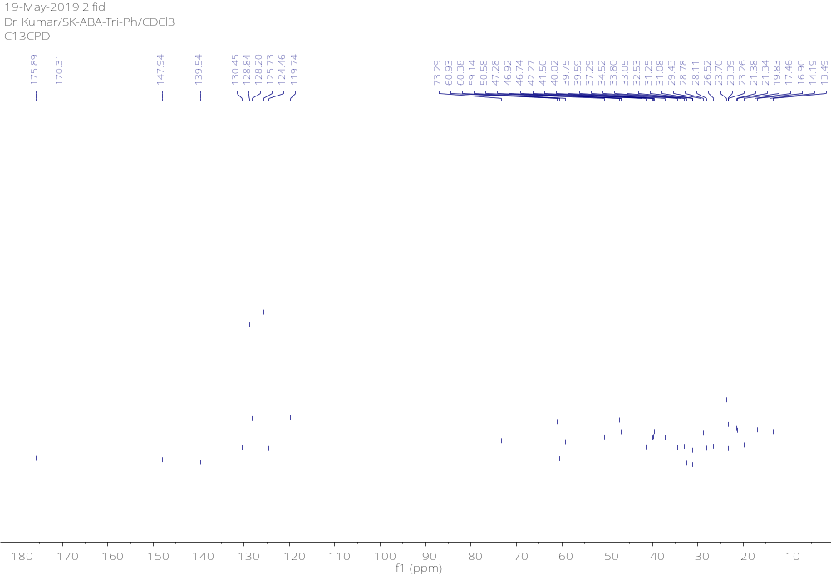
S20: ¹³C-NMR spectrum (150 MHz, CDCl₃) of compound 10a
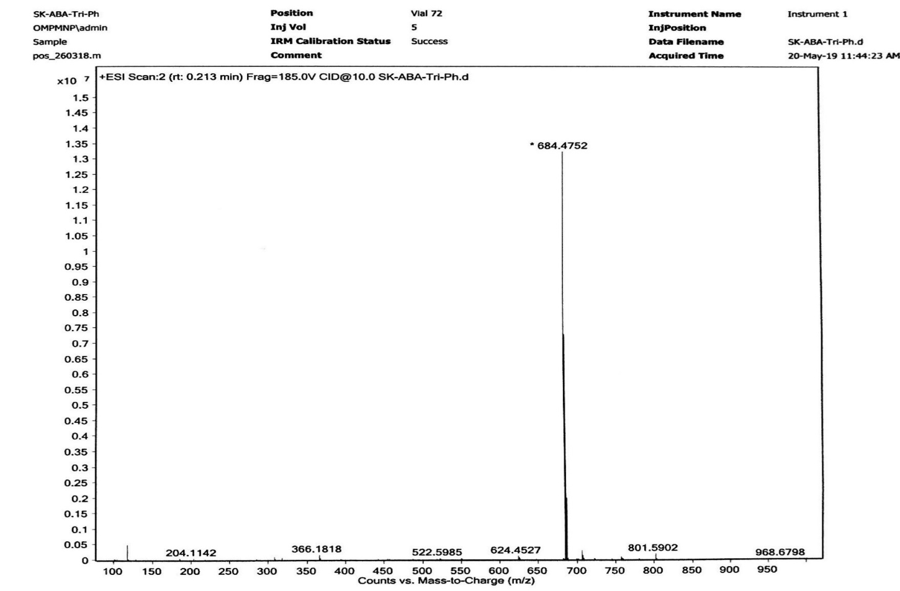
S21: HRMS spectrum of compound 10a
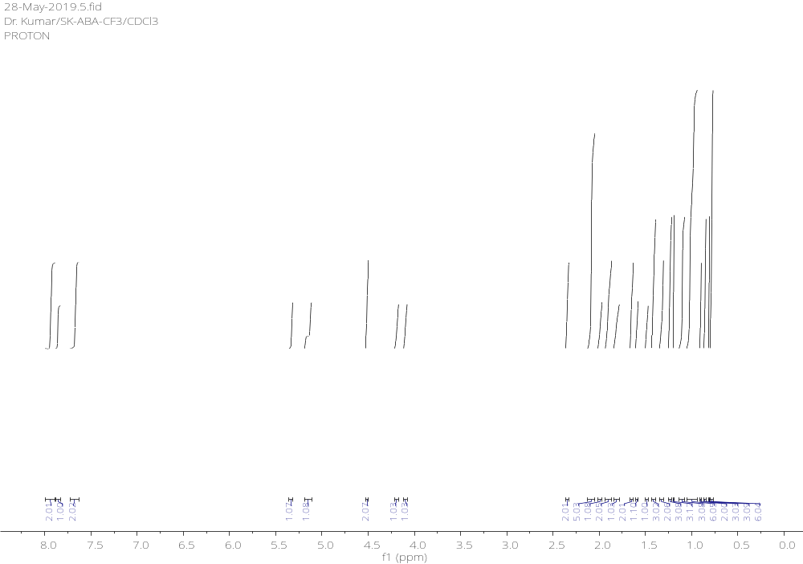S22: ¹H-NMR spectrum (600 MHz, CDCl₃) of compound 10b
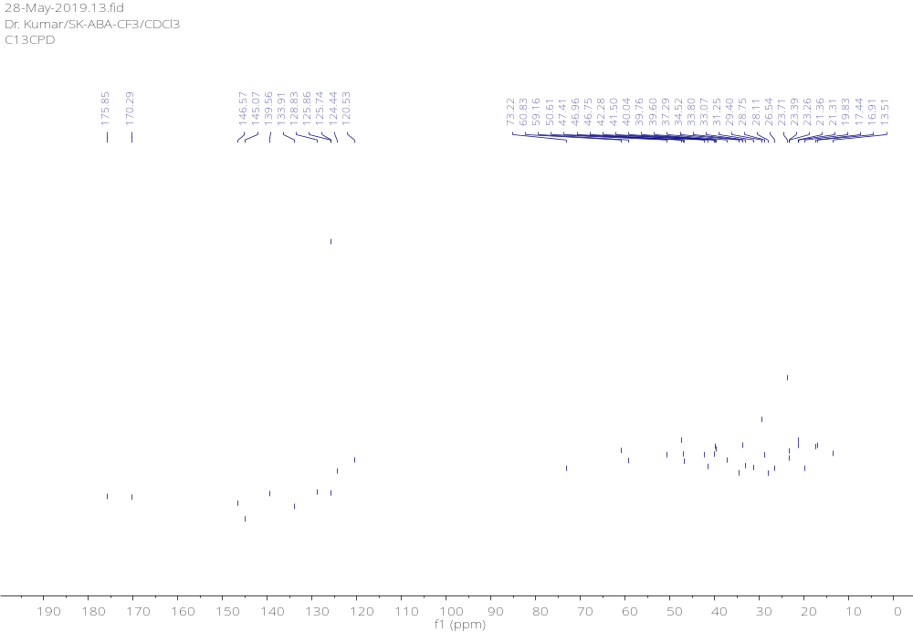
S23: ¹³C-NMR spectrum (150 MHz, CDCl₃) of compound 10b
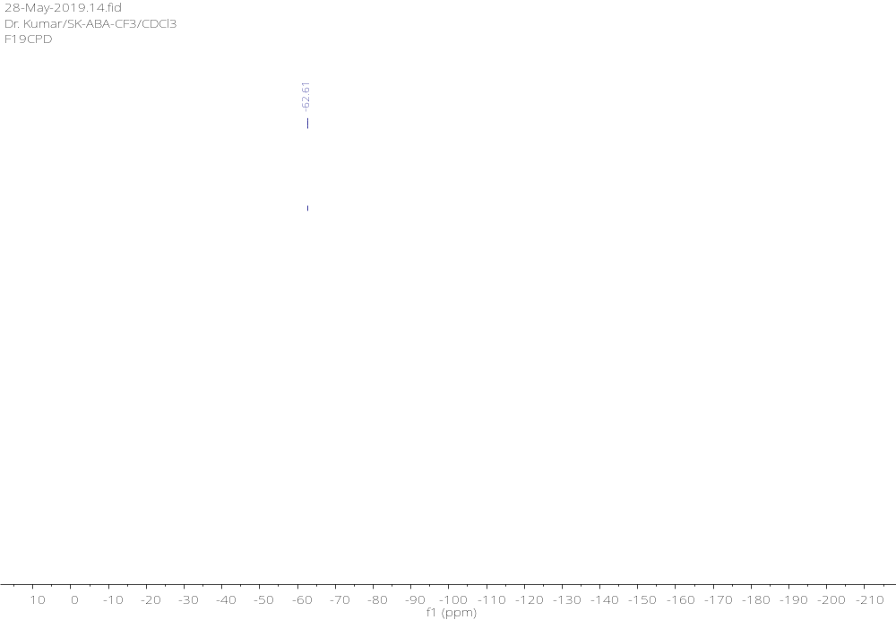
S24: ¹⁹F-NMR spectrum (564 MHz, CDCl₃) of compound 10b
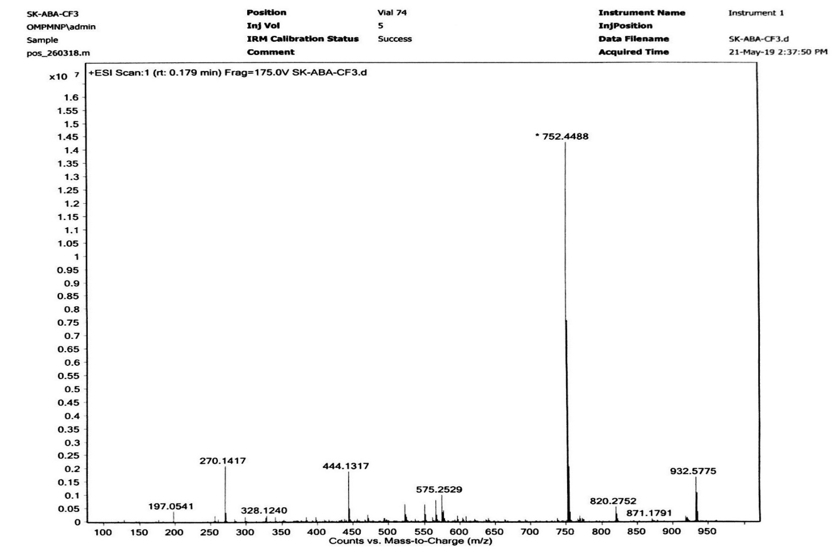
S25: HRMS spectrum of compound 10b
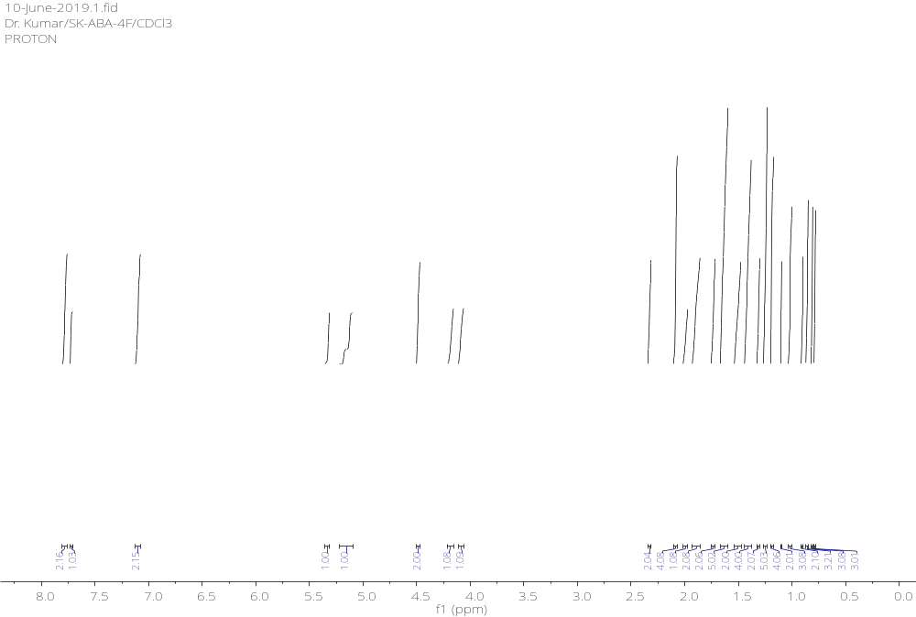S26: ¹H-NMR spectrum (600 MHz, CDCl₃) of compound 10c
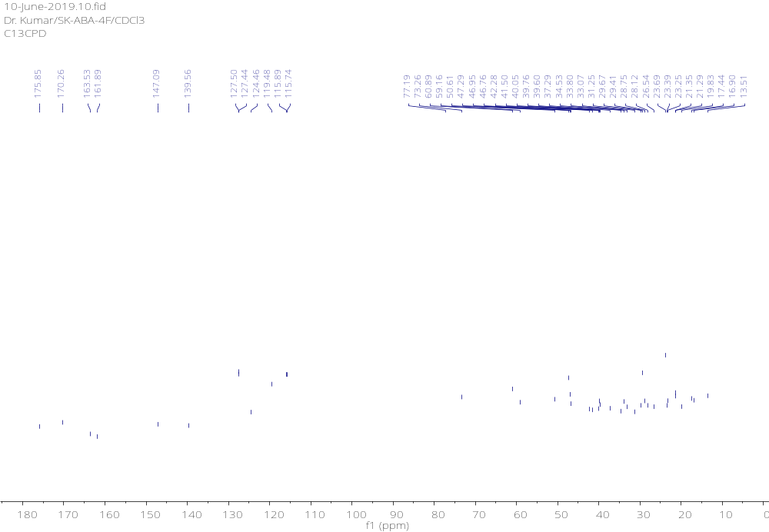
S27: ¹³C-NMR spectrum (150 MHz, CDCl₃) of compound 10c
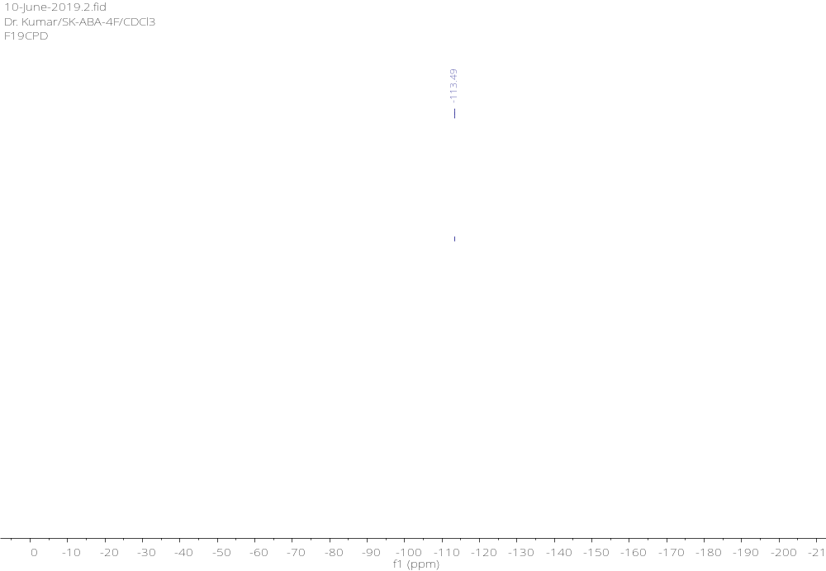
S28: ¹⁹F-NMR spectrum (564 MHz, CDCl₃) of compound 10c
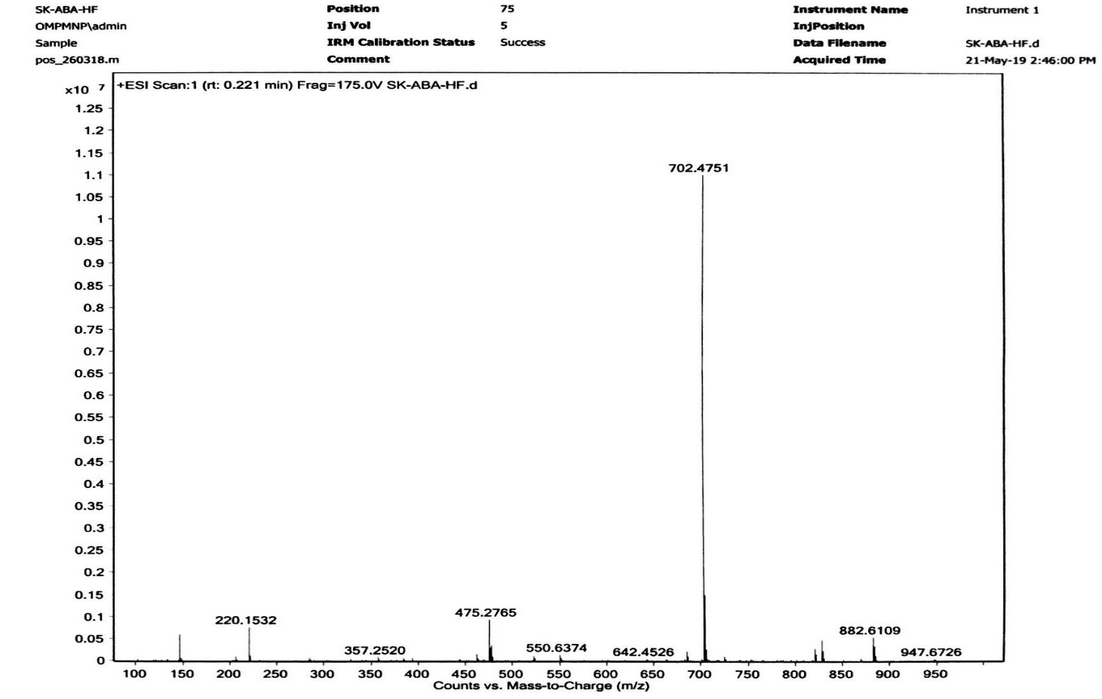
S29: HRMS spectrum of compound 10c

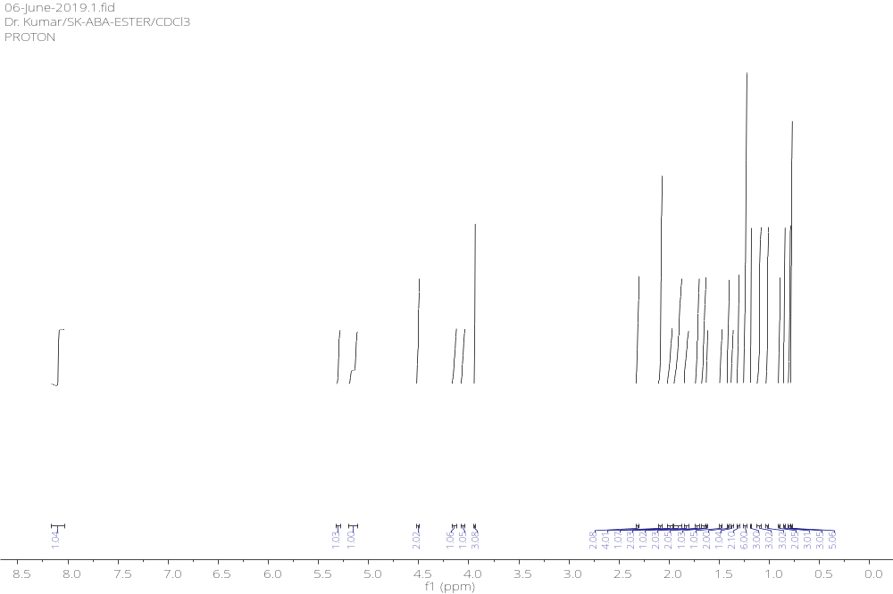S30: ¹H-NMR spectrum (600 MHz, CDCl₃) of compound 10d
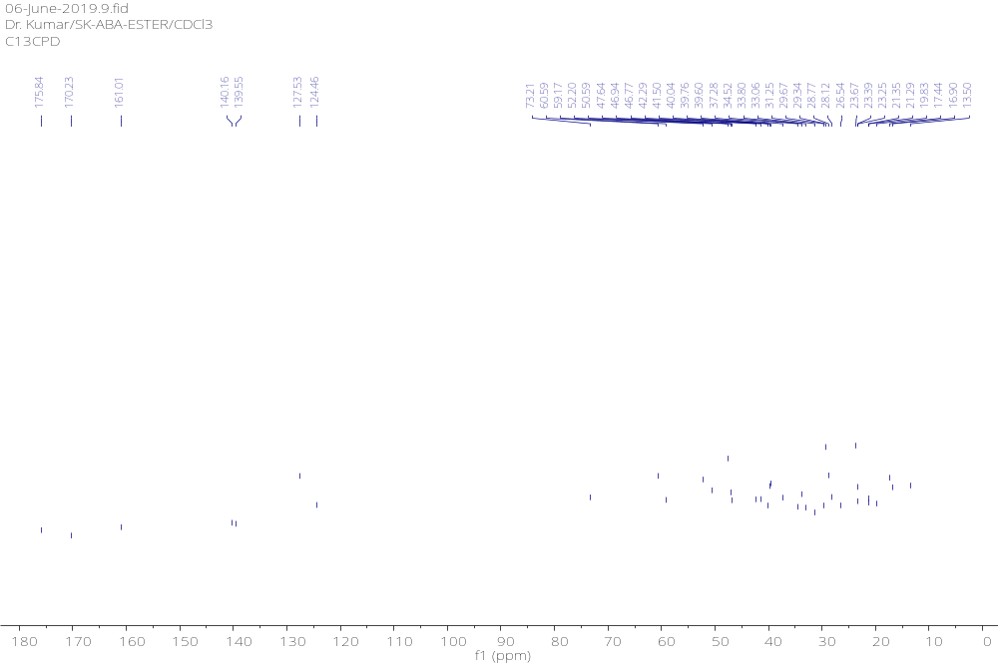
S31: ¹³C-NMR spectrum (150 MHz, CDCl₃) of compound 10d
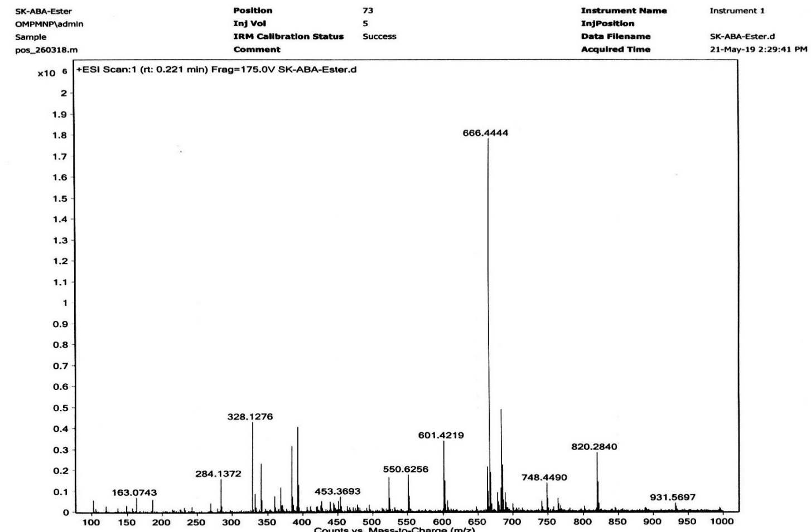
S32: HRMS spectrum of compound 10d
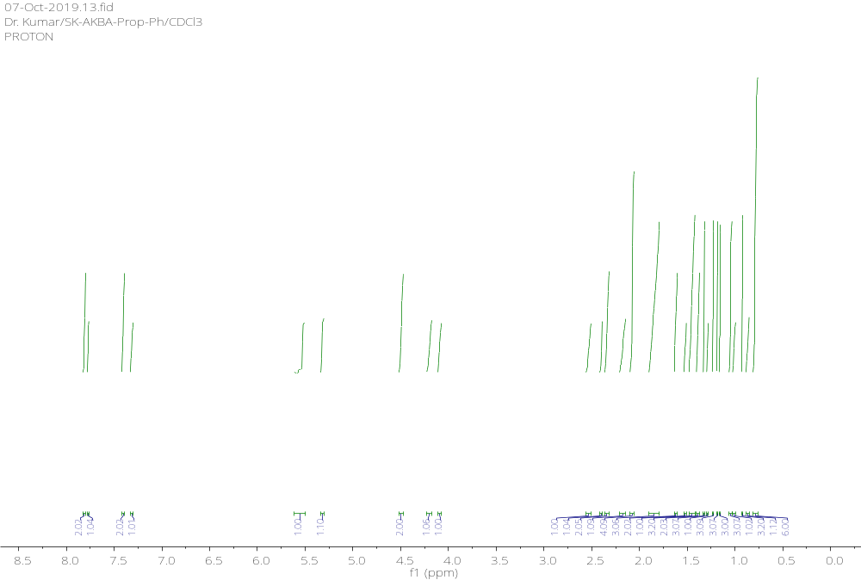
S33: ¹H-NMR spectrum (600 MHz, CDCl₃) of compound 11a
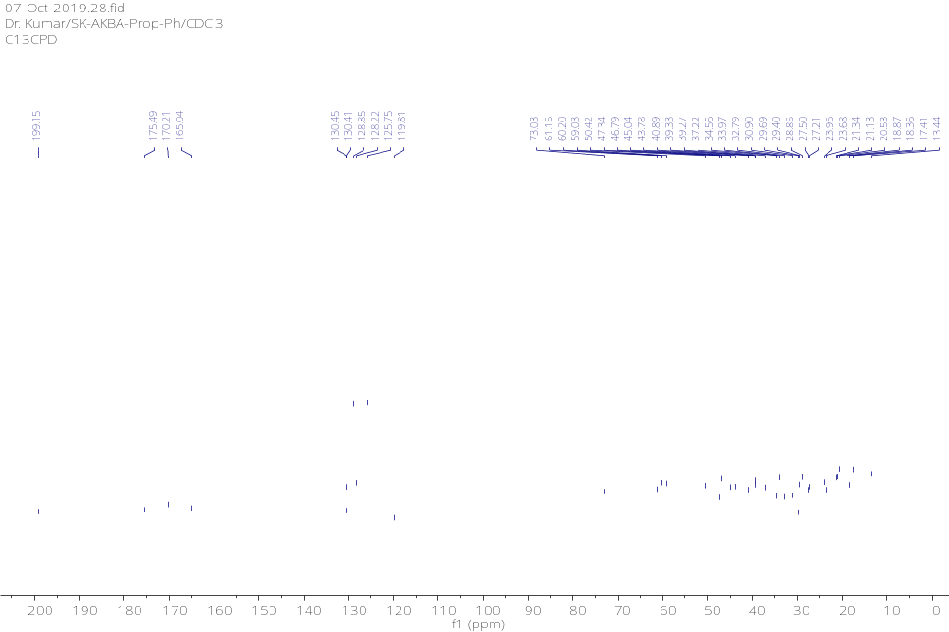S34: ¹³C-NMR spectrum (150 MHz, CDCl₃) of compound 11a
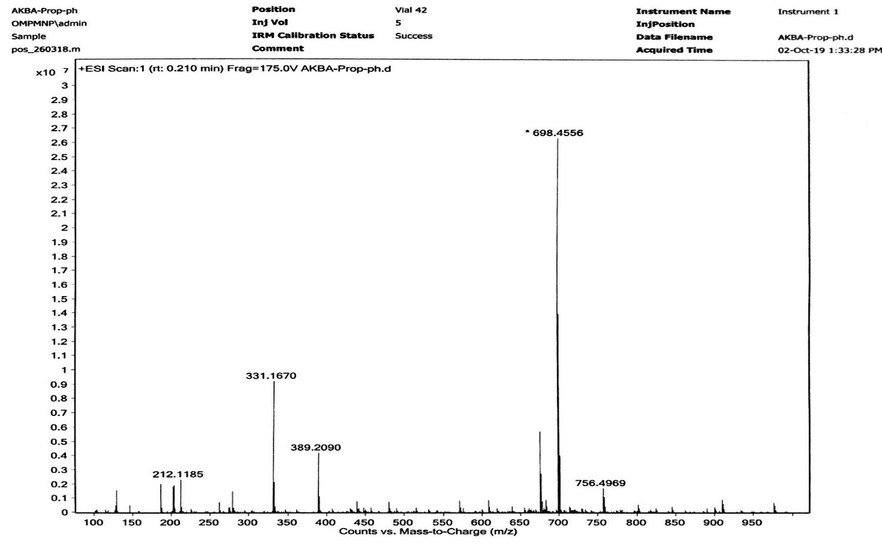
S35: HRMS spectrum of compound 11a

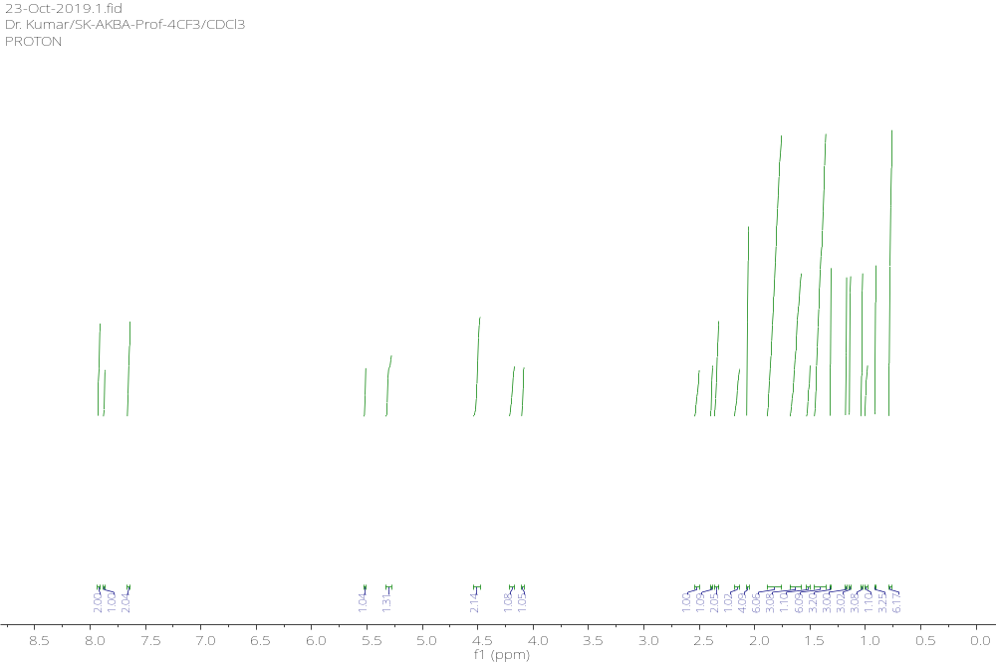S36: ¹H-NMR spectrum (600 MHz, CDCl₃) of compound 11b
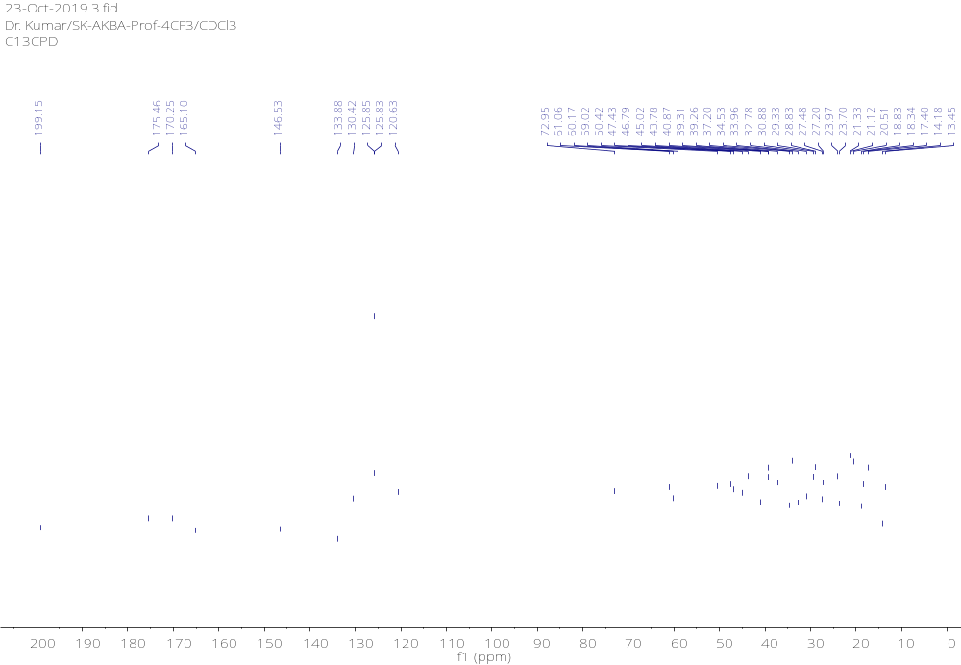
S37: ¹³C-NMR spectrum (150 MHz, CDCl₃) of compound 11b
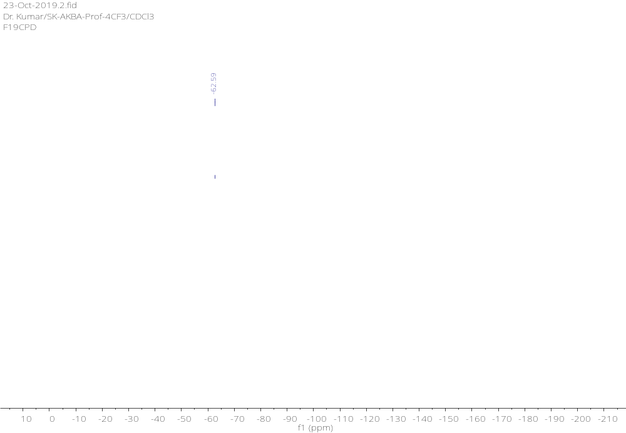
S38: ¹⁹F-NMR spectrum (564 MHz, CDCl₃) of compound 11b
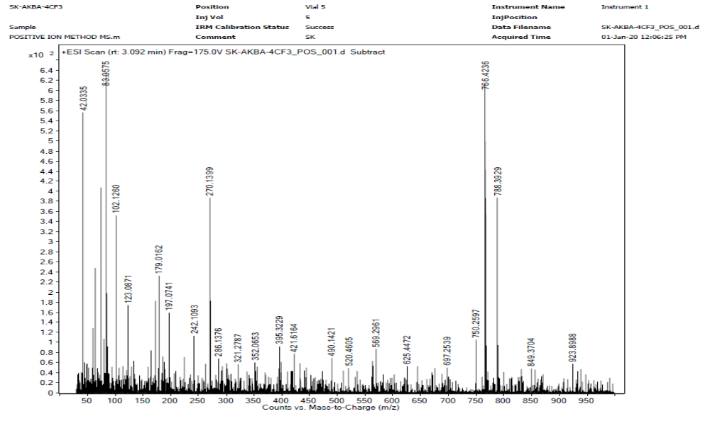
S39: HRMS spectrum of compound 11b

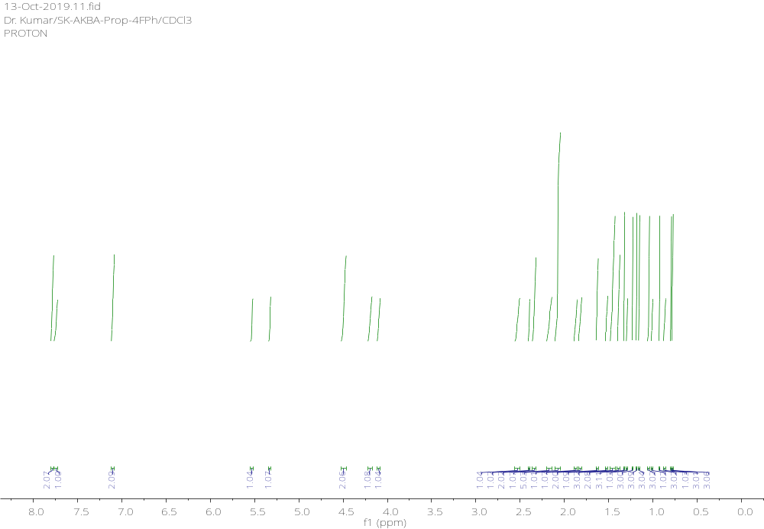
S40: ¹H-NMR spectrum (600 MHz, CDCl₃) of compound 11c
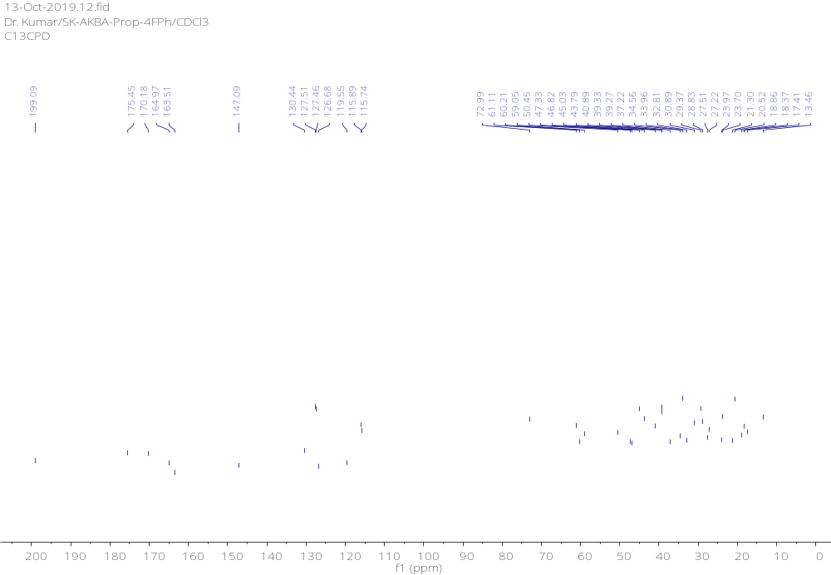
S41: ¹³C-NMR spectrum (150 MHz, CDCl₃) of compound 11c
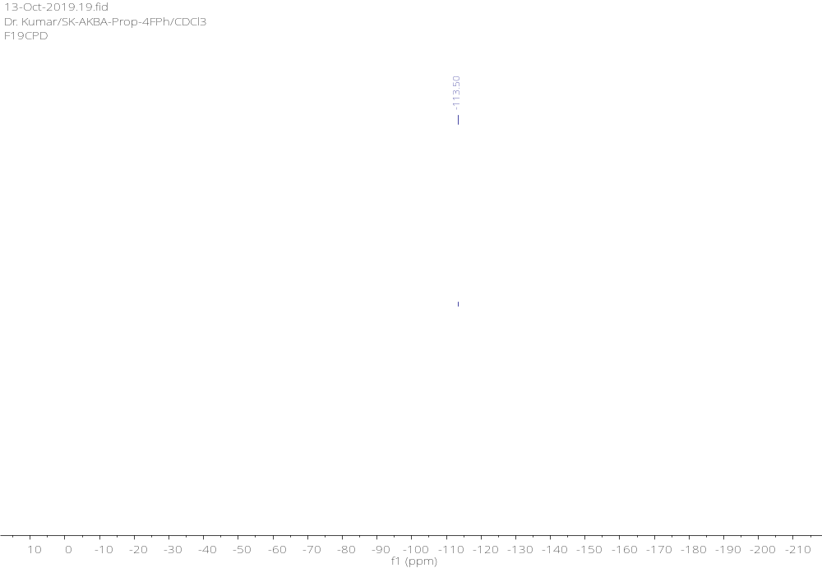
S42: ¹⁹F-NMR spectrum (564 MHz, CDCl₃) of compound 11c
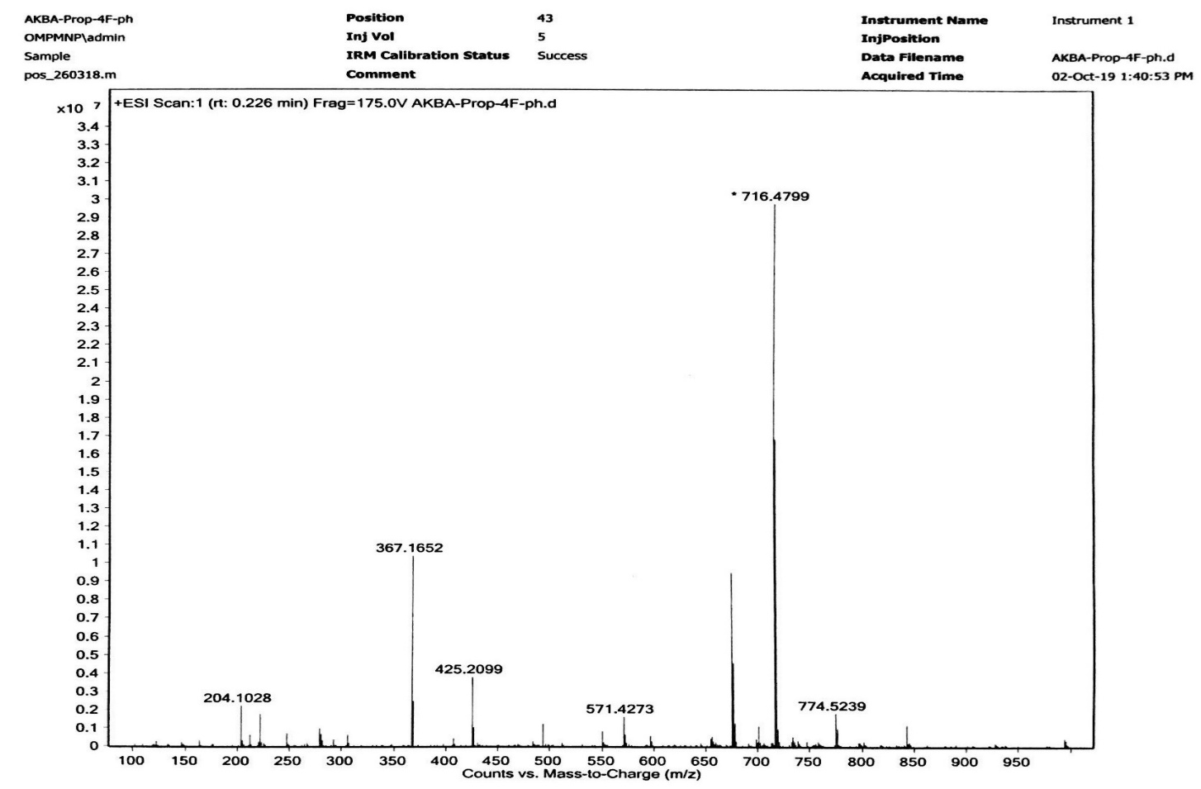
S43: HRMS spectrum of compound 11c
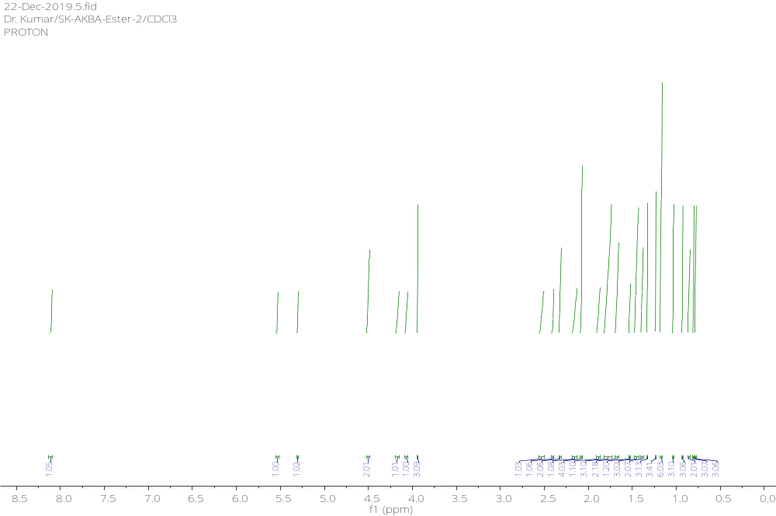
S44: ¹H-NMR spectrum (600 MHz, CDCl₃) of compound 11d
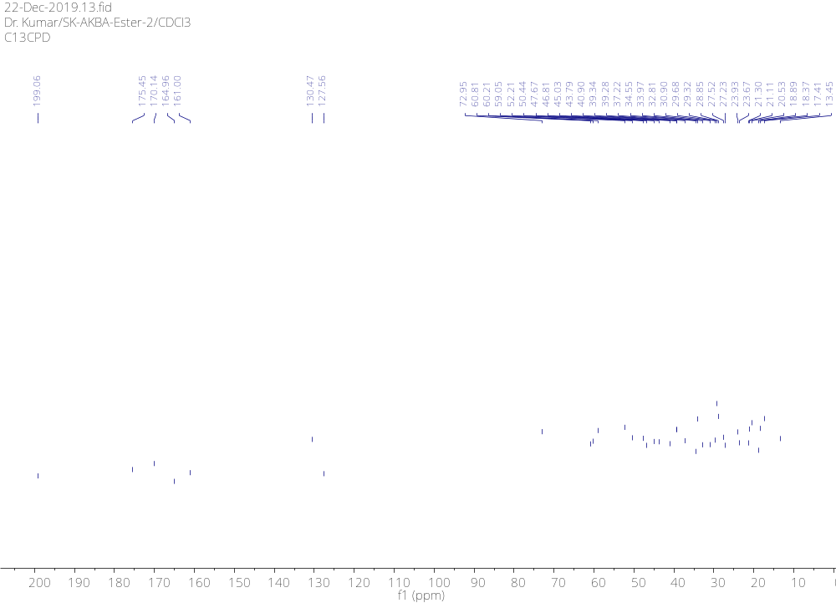
S45: ¹³C-NMR spectrum (150 MHz, CDCl₃) of compound 11d

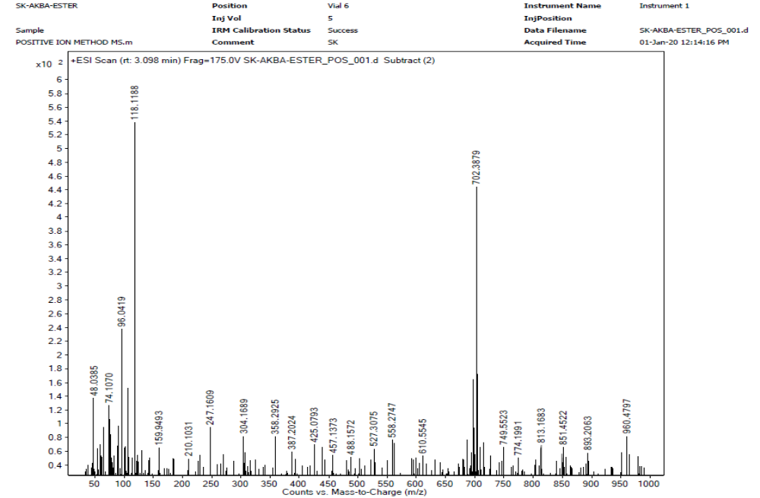
S46: HRMS spectrum of compound 11d

