Model | Scenario | Category | Fraction of Wind + Solar Capacity in 2050 | Fraction of Wind + Solar Generation in 2050
AIM/CGE 2.0 | SSP1-19 | 1.5C_low_OS | 0.81 | 0.68
WITCH-GLOBIOM 3.1 | SSP1-19 | 1.5C_low_OS | 0.78 | 0.72
MESSAGE-GLOBIOM 1.0 | SSP1-19 | 1.5C_low_OS | 0.55 | 0.47
IMAGE 3.0.1 | SSP1-19 | 1.5C_low_OS | 0.64 | 0.67
GCAM 4.2 | SSP1-19 | 1.5C_low_OS | 0.72 | 0.58
GCAM 4.2 | SSP1-26 | Lower_2C | 0.6 | 0.44
AIM/CGE 2.0 | SSP1-26 | Lower_2C | 0.7 | 0.54
WITCH-GLOBIOM 3.1 | SSP1-26 | Lower_2C | 0.76 | 0.71
IMAGE 3.0.1 | SSP1-26 | Lower_2C | 0.52 | 0.47
MESSAGE-GLOBIOM 1.0 | SSP1-26 | Higher_2C | 0.5 | 0.41
GCAM 4.2 | SSP1-34 | Above_2C | 0.5 | 0.34
AIM/CGE 2.0 | SSP1-34 | Above_2C | 0.59 | 0.42
WITCH-GLOBIOM 3.1 | SSP1-34 | Above_2C | 0.76 | 0.7
MESSAGE-GLOBIOM 1.0 | SSP1-34 | Above_2C | 0.47 | 0.38
IMAGE 3.0.1 | SSP1-34 | Above_2C | 0.45 | 0.36
AIM/CGE 2.0 | SSP1-45 | Above_2C | 0.52 | 0.35
WITCH-GLOBIOM 3.1 | SSP1-45 | Above_2C | 0.74 | 0.58
MESSAGE-GLOBIOM 1.0 | SSP1-45 | Above_2C | 0.45 | 0.35
IMAGE 3.0.1 | SSP1-45 | Above_2C | 0.4 | 0.29
GCAM 4.2 | SSP1-45 | Above_2C | 0.46 | 0.3
AIM/CGE 2.0 | SSP2-19 | 1.5C_low_OS | 0.74 | 0.58
GCAM 4.2 | SSP2-19 | 1.5C_high_OS | 0.4 | 0.25
MESSAGE-GLOBIOM 1.0 | SSP2-19 | 1.5C_low_OS | 0.53 | 0.46
GCAM 4.2 | SSP2-26 | Higher_2C | 0.38 | 0.23
WITCH-GLOBIOM 3.1 | SSP2-26 | Lower_2C | 0.58 | 0.62
MESSAGE-GLOBIOM 1.0 | SSP2-26 | Higher_2C | 0.37 | 0.29
IMAGE 3.0.1 | SSP2-26 | Lower_2C | 0.42 | 0.31
AIM/CGE 2.0 | SSP2-26 | Lower_2C | 0.63 | 0.45
GCAM 4.2 | SSP2-34 | Above_2C | 0.34 | 0.2
AIM/CGE 2.0 | SSP2-34 | Above_2C | 0.54 | 0.37
WITCH-GLOBIOM 3.1 | SSP2-34 | Above_2C | 0.55 | 0.56
IMAGE 3.0.1 | SSP2-34 | Above_2C | 0.36 | 0.26
MESSAGE-GLOBIOM 1.0 | SSP2-34 | Above_2C | 0.32 | 0.25
AIM/CGE 2.0 | SSP2-45 | Above_2C | 0.42 | 0.27
WITCH-GLOBIOM 3.1 | SSP2-45 | Above_2C | 0.5 | 0.46
MESSAGE-GLOBIOM 1.0 | SSP2-45 | Above_2C | 0.28 | 0.22
IMAGE 3.0.1 | SSP2-45 | Above_2C | 0.32 | 0.22
GCAM 4.2 | SSP2-45 | Above_2C | 0.31 | 0.18
MESSAGE-GLOBIOM 1.0 | SSP3-34 | Above_2C | 0.31 | 0.25
AIM/CGE 2.0 | SSP3-34 | Above_2C | 0.32 | 0.19
WITCH-GLOBIOM 3.1 | SSP3-34 | Above_2C | 0.54 | 0.57
IMAGE 3.0.1 | SSP3-34 | Above_2C | 0.3 | 0.2
AIM/CGE 2.0 | SSP3-45 | Above_2C | 0.22 | 0.13
IMAGE 3.0.1 | SSP3-45 | Above_2C | 0.26 | 0.17
MESSAGE-GLOBIOM 1.0 | SSP3-45 | Above_2C | 0.29 | 0.24
WITCH-GLOBIOM 3.1 | SSP3-45 | Above_2C | 0.45 | 0.4
WITCH-GLOBIOM 3.1 | SSP4-19 | 1.5C_low_OS | 0.76 | 0.69
AIM/CGE 2.0 | SSP4-26 | Lower_2C | 0.64 | 0.46
WITCH-GLOBIOM 3.1 | SSP4-26 | Lower_2C | 0.74 | 0.67
GCAM 4.2 | SSP4-26 | Higher_2C | 0.39 | 0.24
IMAGE 3.0.1 | SSP4-26 | Lower_2C | 0.51 | 0.44
AIM/CGE 2.0 | SSP4-34 | Above_2C | 0.58 | 0.4
IMAGE 3.0.1 | SSP4-34 | Above_2C | 0.36 | 0.27
WITCH-GLOBIOM 3.1 | SSP4-34 | Above_2C | 0.73 | 0.65
GCAM 4.2 | SSP4-34 | Above_2C | 0.38 | 0.23
AIM/CGE 2.0 | SSP4-45 | Above_2C | 0.5 | 0.33
GCAM 4.2 | SSP4-45 | Above_2C | 0.36 | 0.21
IMAGE 3.0.1 | SSP4-45 | Above_2C | 0.29 | 0.21
WITCH-GLOBIOM 3.1 | SSP4-45 | Above_2C | 0.74 | 0.58
GCAM 4.2 | SSP5-19 | 1.5C_high_OS | 0.37 | 0.22
AIM/CGE 2.0 | SSP5-26 | Lower_2C | 0.36 | 0.21
GCAM 4.2 | SSP5-26 | Higher_2C | 0.36 | 0.21
GCAM 4.2 | SSP5-34 | Above_2C | 0.34 | 0.2
AIM/CGE 2.0 | SSP5-34 | Above_2C | 0.18 | 0.1
WITCH-GLOBIOM 3.1 | SSP5-34 | Above_2C | 0.54 | 0.54
IMAGE 3.0.1 | SSP5-34 | Above_2C | 0.21 | 0.13
AIM/CGE 2.0 | SSP5-45 | Above_2C | 0.14 | 0.08
GCAM 4.2 | SSP5-45 | Above_2C | 0.31 | 0.18
IMAGE 3.0.1 | SSP5-45 | Above_2C | 0.18 | 0.11
WITCH-GLOBIOM 3.1 | SSP5-45 | Above_2C | 0.5 | 0.47
AIM/CGE 2.0 | ADVANCE_2020_1.5C-2100 | 1.5C_low_OS | 0.78 | 0.63
AIM/CGE 2.0 | ADVANCE_2020_WB2C | Lower_2C | 0.71 | 0.53
AIM/CGE 2.0 | ADVANCE_2030_Price1.5C | Lower_2C | 0.8 | 0.66
AIM/CGE 2.0 | ADVANCE_2030_WB2C | Lower_2C | 0.72 | 0.56
MESSAGEix-GLOBIOM 1.0 | LowEnergyDemand | 1.5C_low_OS | 0.84 | 0.63
Supplementary Table 1: List of models and scenarios examined in this study, categorized by global warming impact following the scheme utilized by the IAMC 1.5°C Scenario Explorer and by the fraction of wind and solar capacity and generation over total capacity and generation in the year 2050.

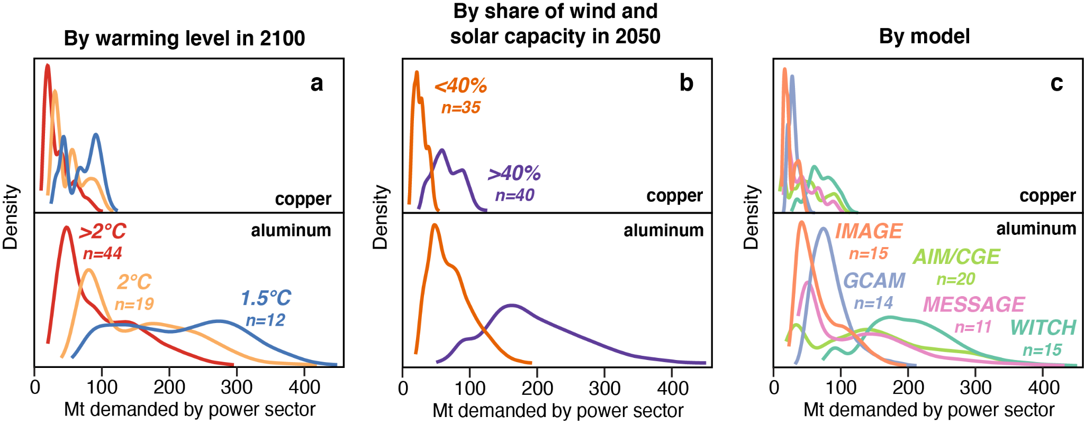
Supplementary Figure 1: Probability density functions showing probability distributions of cumulative 2020-2050 power sector copper and aluminum requirements for a selection of 75 integrated assessment models, categorized by a, b, end-of-century category of global mean warming outcome, c, d, by share of combined wind and solar capacity as a percentage of total electricity generation capacity in 2050, and e, f, by modeling group.

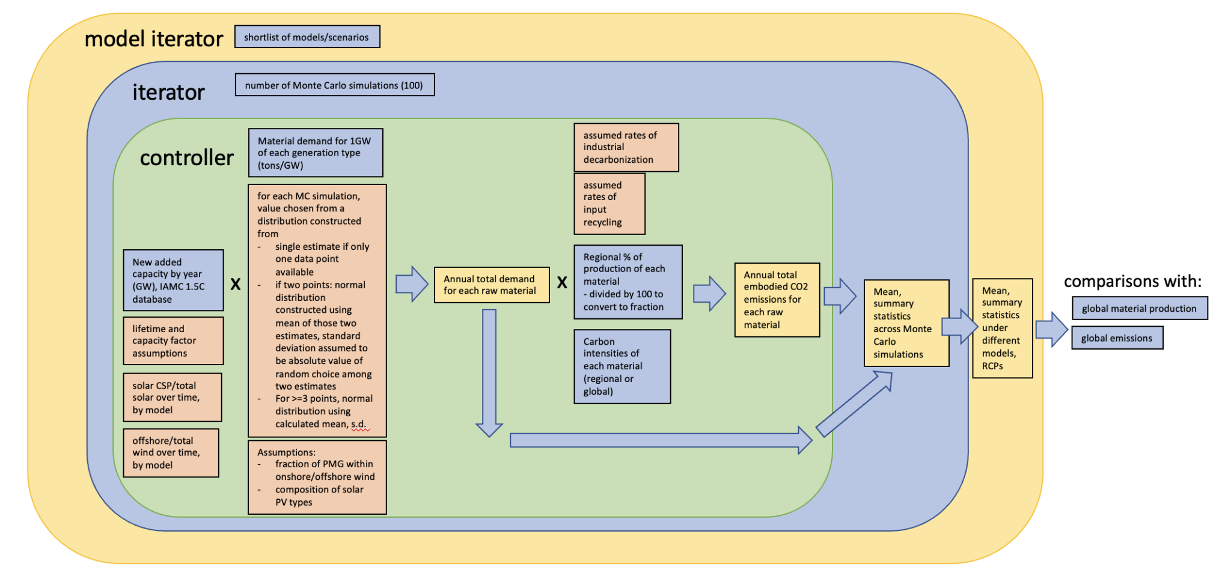
Supplementary Figure 2: Schematic diagram showing model framework and organization.

 | Al | Cement | Cu | Steel
median LED consumption | 279.0 (56.8) | 1033.3 (136.6) | 88.0 (6.0) | 1606.1 (68.2)
grand median of all scenarios besides LED | 109.2 (76.2) | 905.4 (323.8) | 37.8 (24.3) | 1026.2 (758)
grand median of all 1.5C scenarios besides LED | 203.7 (82.5) | 1303.7 (379.7) | 69.0 (25.0) | 1849.3 (642.9)
grand median of all other 1.5C scenarios w W+S >40% | 247.8 (68.6) | 1326.1 (332.2) | 79.7 (21.4) | 1996.3 (584.3)
grand median of all other MESSAGE-GLOBIOM 1.0 scenarios | 101.0 (58.6) | 1111.9 (400.8) | 33.6 (17.8) | 1148.0 (364.9)
units | Mt | Mt | Mt | Mt

Supplementary Table 2: Comparison of cumulative 2020-2050 material demand for aluminum (Al), cement, copper (Cu), and steel under the Low Energy Demand (LED) scenario relative to other groups of scenarios tested.

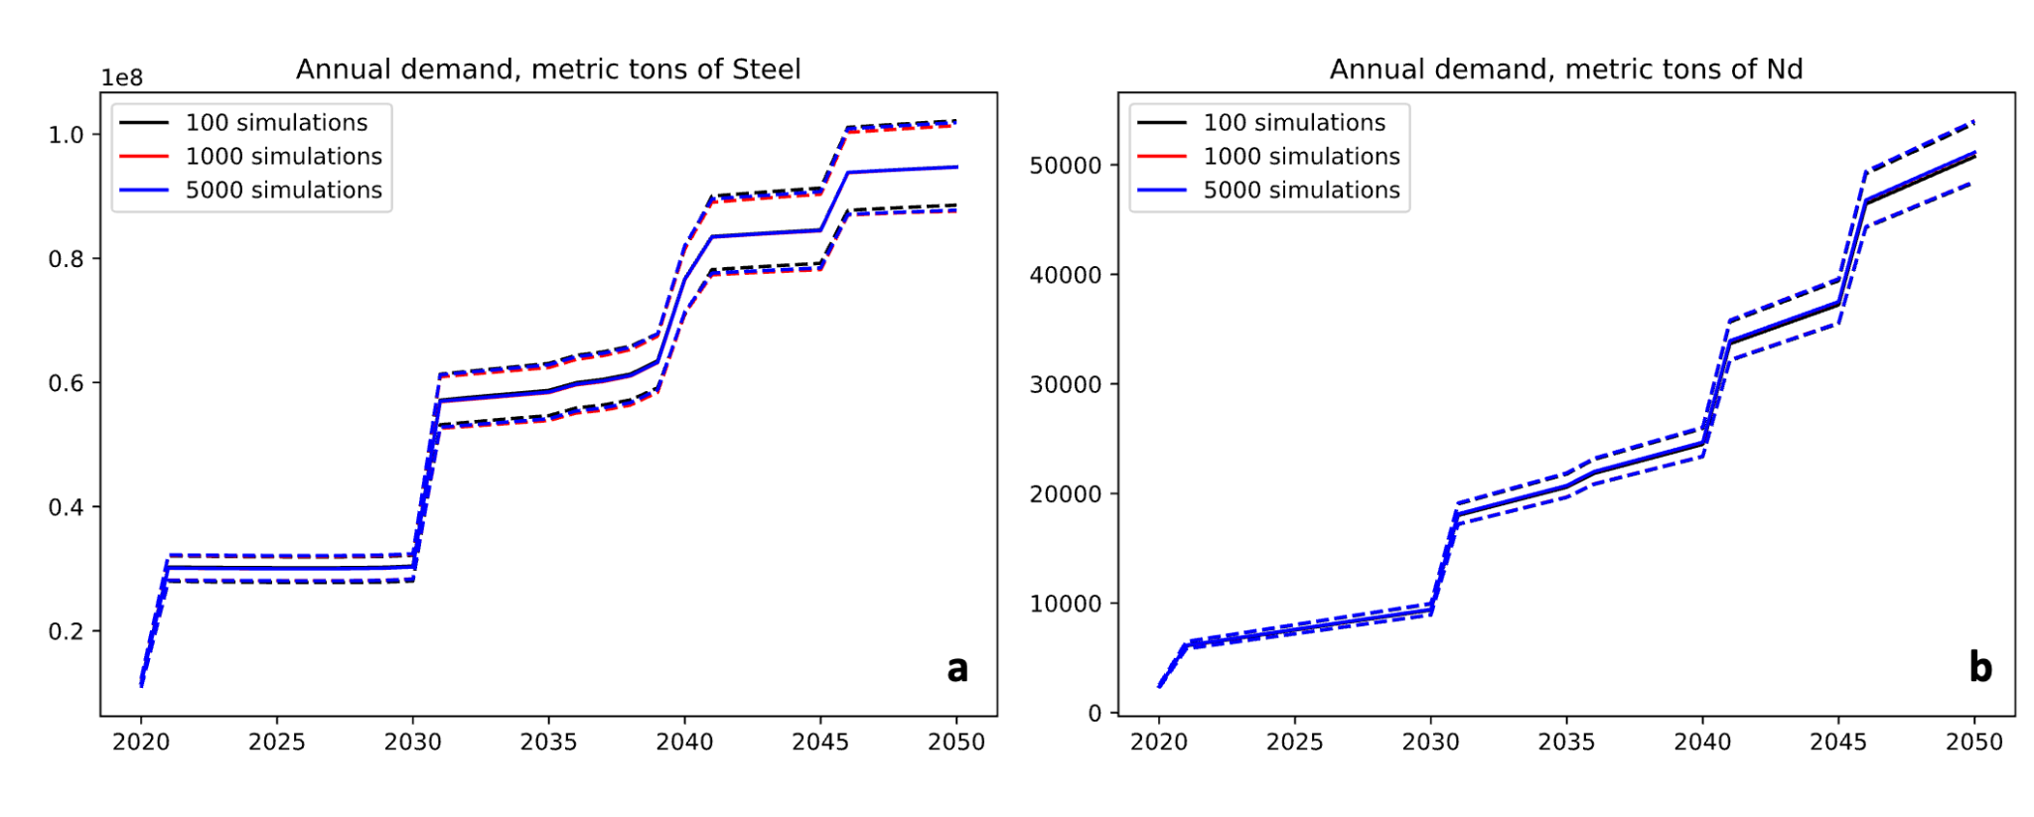

Supplementary Figure 3: Time series plots of annual power sector demand for a, steel, and b, neodymium under modeling runs with different numbers of Monte Carlo simulations (100, 1000, and 5000). Solid lines show median annual demand values, while dashed lines show extent of 2.5th percentile and 97.5th percentile annual demand values.

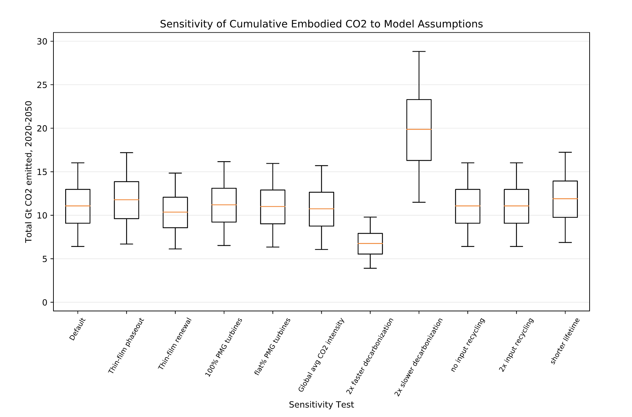
Supplementary Figure 4: Box-and-whisker plots of cumulative 2020-2050 power generation materials-associated CO2 emissions under varying model assumptions using the MESSAGE-GLOBIOM SSP1 1.9 scenario. Gold lines show median values. Boxes are drawn between the upper and lower quartiles. Whiskers denote extent of 2.5th percentile and 97.5th percentile values. See Methods for detailed description of assumptions employed for the sensitivity tests shown.

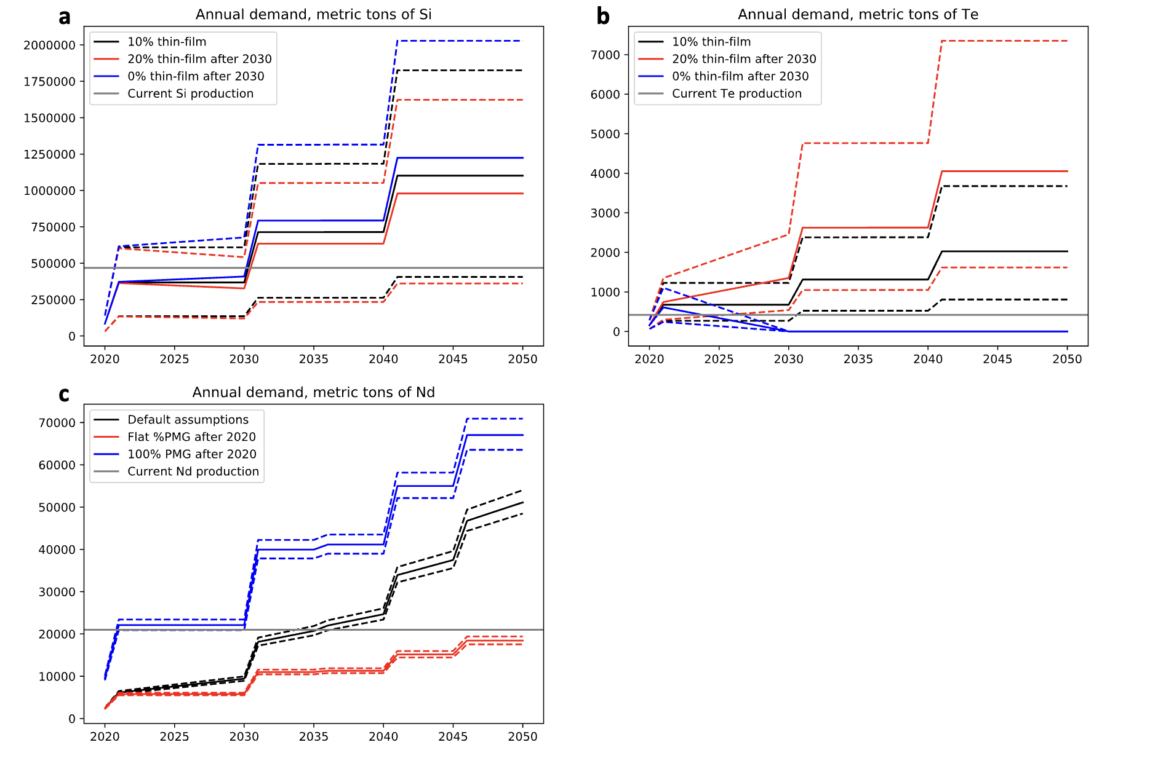

Supplementary Figure 5: Time series plots of annual power sector demand for a, solar-grade polysilicon, b, tellurium, and c, neodymium under different technology assumptions for a, b thin-film solar PV technologies and for c, wind turbine drive technologies. Horizontal grey lines represent current global annual production rates for each material. Solid lines show median annual demand values, while dashed lines show extent of 2.5th percentile and 97.5th percentile annual demand values.

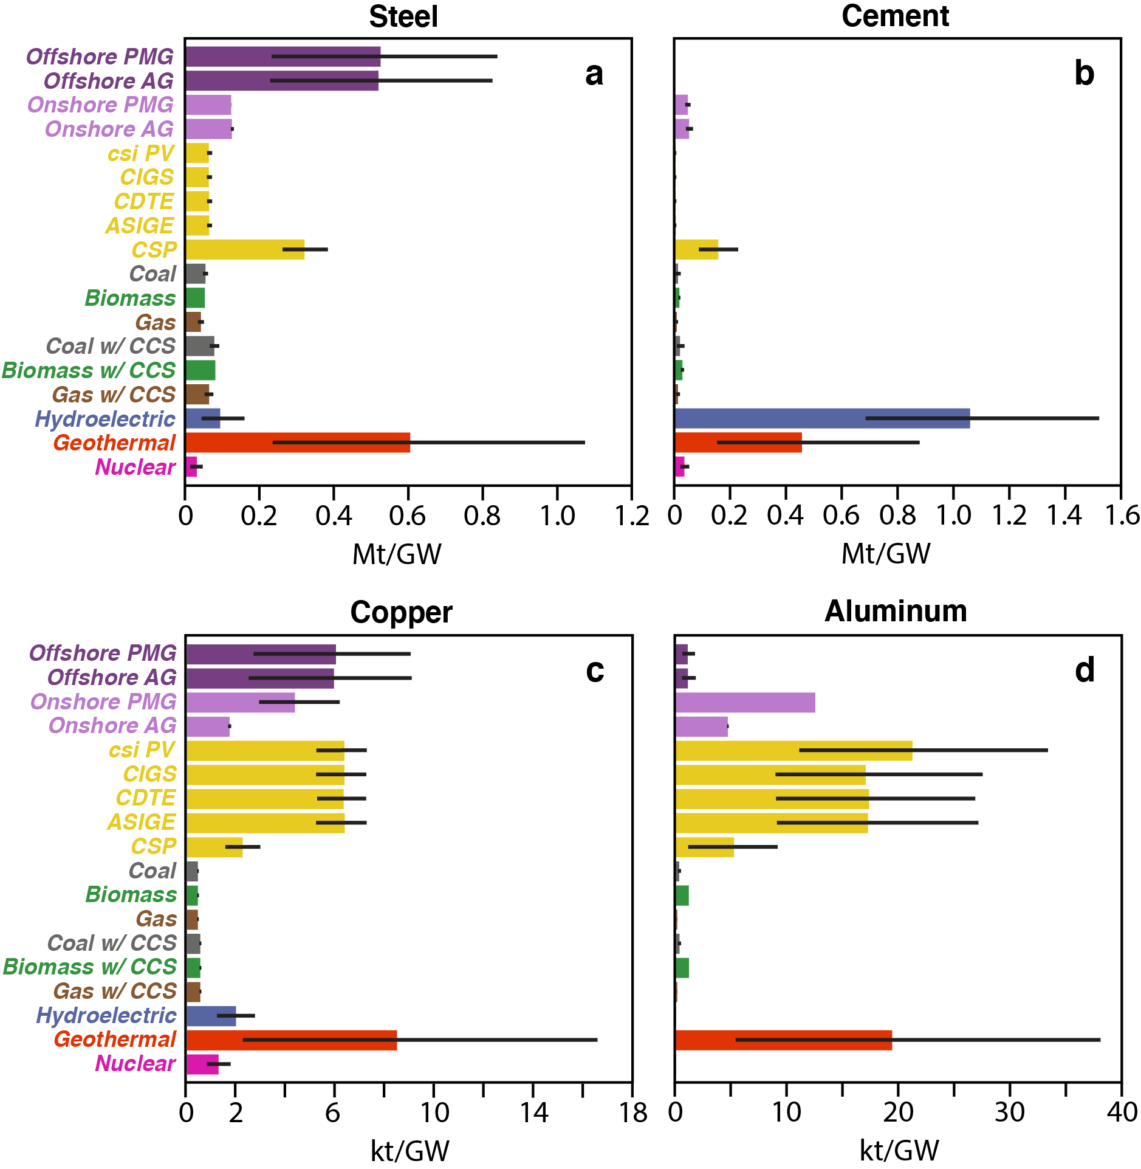
Supplementary Figure 6: Barplots of material intensity for four selected bulk materials. a, steel b, cement c, copper d, aluminum for each generation technology, expressed in tons per GW of electricity generation capacity. Black whiskers denote extent of 2.5th percentile and 97.5th percentile values.

