Supplemental Data

Table S1. Catechol-containing compounds or redox-related anthraquinones from NIHCC library and their amylin amyloid inhibitory potencies in ThT fluorescent screen assays. ª
Compound Serial Number |  | Compound Name | % Normalized RFU |  | Secondary Confirmation
643  601  145  321 | EGCG  rifapentine  rifampicin  daunorubicin |  |  | 2  5  10  11 |  | Yes. See literature ^{b}  Yes ^{c}  Yes ^{c}  Not tested
318  15  548  49  61  177  362  425  531  208  343  117  77  292  87 | idarubicin  epirubicin  rutin  doxorubicin  racepinephrine  hyperoside  taxifolin  norepinephrine  carbidopa  isoquercitrin  phylloquinone  mitoxantrone  dopamine  dihydrexidine  fenoldpam mesylate |  |  | 12  15  16  18  21  23  23  23  28  36  37  48  52  59  61 |  | Yes ^{c}  Not tested  Yes. See literature ^{d}  Yes ^{c}  Yes ^{c}  Yes. See literature ^{e}  Yes ^{c}  Yes ^{f}  Yes ^{c}  Yes. See literature ^{e}  Not tested  Yes ^{c}  Yes. See literature ^{g}  Not tested  Yes ^{c}
27  334 | methyldopa  idebenone |  |  | 65  65 |  | Yes ^{c}  Not tested
414 | isoproterenol |  |  | 90 |  | Not tested
ª Buffer treatment was used as negative control (100% normalized RFU). EGCG served as a positive control. ^{b} EGCG is a well-established amylin amyloid inhibitor (Ehrnhoefer et al, 2008; Bieschke et al, 2010; Palhano et al, 2013). ^{c} Secondary validations were performed using Photo-Induced Cross-linking of Unmodified Proteins (PICUP) assays in this study (Figs. S1C and S3A). ^{d} Rutin was validated as an amylin amyloid inhibitor using TEM (Yu et al, 2015). ^{e} Quercetin was reported as an amylin amyloid inhibitor based on TEM data (Lopez et al, 2016). Hyperoside is a galactoside form of quercetin. Isoquercitrin is a glucoside form of quercetin. ^{f} Norepinephrine was validated as an amylin amyloid inhibitor using TEM (this study). ^{g} Dopamine was validated as an amylin amyloid inhibitor using TEM (Saunders et al, 2016).

Table S2. Catechol-containing compounds or redox-related anthraquinones from NIHCC library and their human tau (2N4R isoform) amyloid inhibitory potencies in ThT fluorescent screen assays. ª
Compound Serial Number |  | Compound Name | % Normalized RFU |  | Secondary Confirmation
643  318  425  321 | EGCG  idarubicin  norepinephrine  daunorubicin |  |  | 6  6  13  16 |  | Yes. See literature ^{b}  Not tested  Yes. See literature ^{c}  Yes. See literature ^{d}
27  15  61  77  414  87  531  49  601  117  145  292  362  343  334  208  177 | methyldopa  epirubicin  racepinephrine  dopamine  isoproterenol  fenoldpam mesylate  carbidopa  doxorubicin  rifapentine  mitoxantrone  rifampicin  dihydrexidine  taxifolin  phylloquinone  idebenone  isoquercitrin  hyperoside |  |  | 19  20  23  27  27  28  30  31  31  32  34  38  46  59  65  74  75 |  | Yes ^{e}  Yes ^{e}  Yes ^{f}  Yes. See literature ^{c}  Yes. See literature ^{c}  Not tested  Not tested  Yes. See literature ^{d}  Yes. See literature ^{g}  Yes ^{f}  Yes. See literature ^{h}  Yes ^{f}  Yes ^{e}  Yes ^{f}  Yes ^{f}  Yes ^{f}  Yes ^{f}
548 | rutin |  |  | 81 |  | Yes ^{f}
ª Buffer treatment was used as negative control (100% normalized RFU). EGCG served as a positive control. ^{b} EGCG has been confirmed as tau amyloid inhibitor (Wobst et al, 2015). ^{c} Norepinephrine, dopamine, and isoproterenol were reported as tau amyloid inhibitor based on dose-dependence inhibition in ThT fluorescence assays (Soeda et al, 2015). ^{d} Daunorubicin and doxorubicin (Adriamycin) were validated as tau amyloid inhibitors using ThS fluorescence assay, filter trapping assay, and TEM (Pickhardt et al, 2005). ^{e} Significant amyloid remodeling activities were observed in ThT fluorescence based assay (this study; Fig. S5A). ^{f} Modest amyloid remodeling activities were observed in ThT fluorescence based assay (this study; Fig. S3). ^{g} Secondary confirmation using Photo-Induced Cross-linking of Unmodified Proteins (PICUP) assays was reported (Umeda et al, 2016). ^{h} Secondary confirmation using cell-based assays was reported (Pickhardt et al, 2007).

Table S3. Catechol-containing compounds or redox-related anthraquinones from NIHCC library and their Aβ42 amyloid inhibitory potencies in ThT fluorescent screen assays. ª
Compound Serial Number |  | Compound Name | % Normalized RFU |  | Secondary Confirmation
643  321  77  117  15  87  318  27  601  49  145  531  292  425  61  362  334  343  414  177  208  548 | EGCG  daunorubicin  dopamine  mitoxantrone  epirubicin  fenoldopam mesylate idarubicin  methyldopa  rifapentine  doxorubicin  rifampicin  carbidopa  dihydrexidine  norepinephrine  racepinephrine  taxifolin  idebenone  phylloquinone  isoproterenol  hyperoside  isoquercitrin  rutin |  |  | 0 ^{b}  0 ^{b}  0 ^{b}  0 ^{b}  0 ^{b}  0 ^{b}  0 ^{b}  0 ^{b}  0 ^{b}  0.3  2  3  9  34  47  47  51  60  63  72  80  97 |  | Yes. See literature ^{c}  Yes. See literature ^{d}  Yes. See literature ^{e}  Yes. See literature ^{f}  Not tested  Not tested  Not tested  Not tested  Not tested  Not tested  Yes. See literature ^{g}  Not tested  Not tested  Yes. See literature ^{h}  Not tested  Yes. See literature ^{i}  Not tested  Not tested  Not tested  Yes. See literature ^{j}  Yes. See literature ^{j}  Not tested
ª Buffer treatment was used as negative control (100% normalized RFU). EGCG served as a positive control. ^{b} Normalized RFU values of these drug-treated samples were the same as the ThT baseline value (highest inhibition possible). ^{c} EGCG is a well-established Aβ amyloid inhibitor (Ehrnhoefer et al, 2008; Bieschke et al, 2010; Palhano et al, 2013). ^{d} Inhibition was confirmed by ELISA using the anti-oligomer specific antibody A11 (Necula et al, 2007). ^{e} Secondary validations were performed using TEM and AFM studies (Li et al, 2004). ^{f} Mitoxantrone was validated as Aβ42 amyloid inhibitor using dose-dependent assay and TEM (Eleuteri et al, 2015). ^{g} Ripampicin was validated as Aβ amyloid inhibitor using a ThT fluorescence assay (Tomiyama et al, 1996). ^{h} Norepinephrine was validated as Aβ amyloid inhibitor using a ThT fluorescence assay (Li et al, 2004). ^{i} Taxifolin was validated as Aβ amyloid inhibitor using a ThT fluorescence assay and TEM analysis (Sato et al, 2013). ^{j} Quercetin was reported as an Aβ amyloid inhibitor based on ThT fluorescence and TEM data (Hasanbasic et al, 2018). Hyperoside is a galactoside form of quercetin. Isoquercitrin is a glucoside form of quercetin.

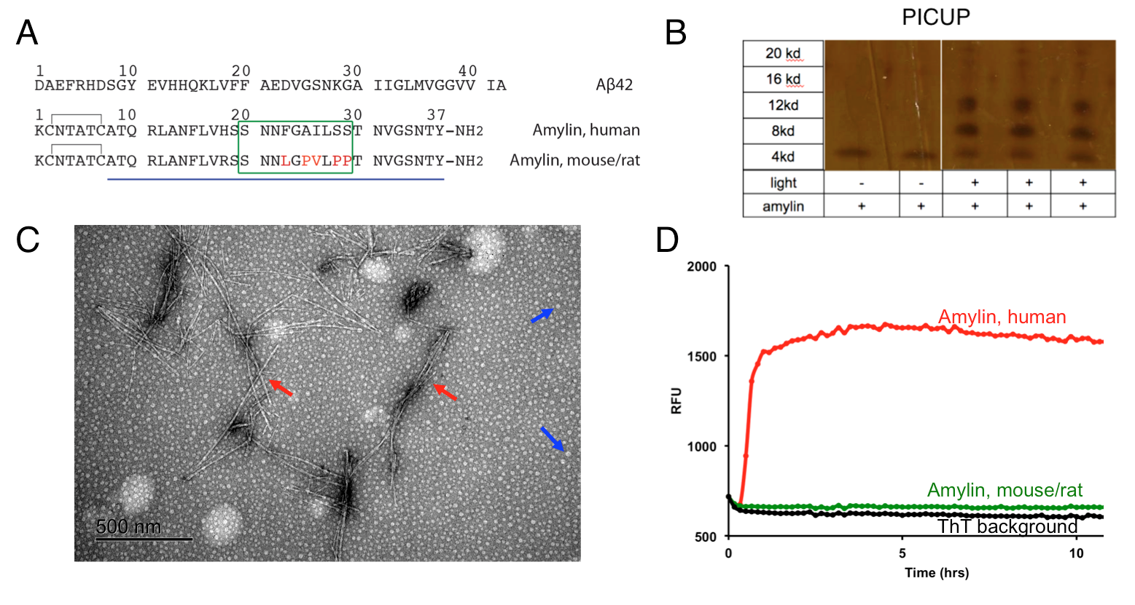

Figure S1. Amylin and Aβ42 sequences and biophysical assays for analyzing protein amyloids and oligomers. (A) Amino acid sequences of human and rodent amylin and amyloid β peptide (Aβ) are shown. The green box indicates a key region in amylin sequence (20-29) determining human amylin amyloid formation. Different amino acids between human and rodent amylin sequences are highlighted in red. (B) Proof-of-principle in vitro photo induced cross-linking of unmodified proteins (PICUP) assay that identifies stable amylin oligomers. The assay was analyzed with SDS-PAGE followed by silver staining. (C) Transmission electron micrographic (TEM) image of human amylin amyloid. Mature fibrils and spherical oligomers are indicated by red and blue arrows respectively. (D) ThT fluorescence assay showing human amylin amyloid formation, but not non-amyloidogenic rodent amylin. ThT only background is also shown.

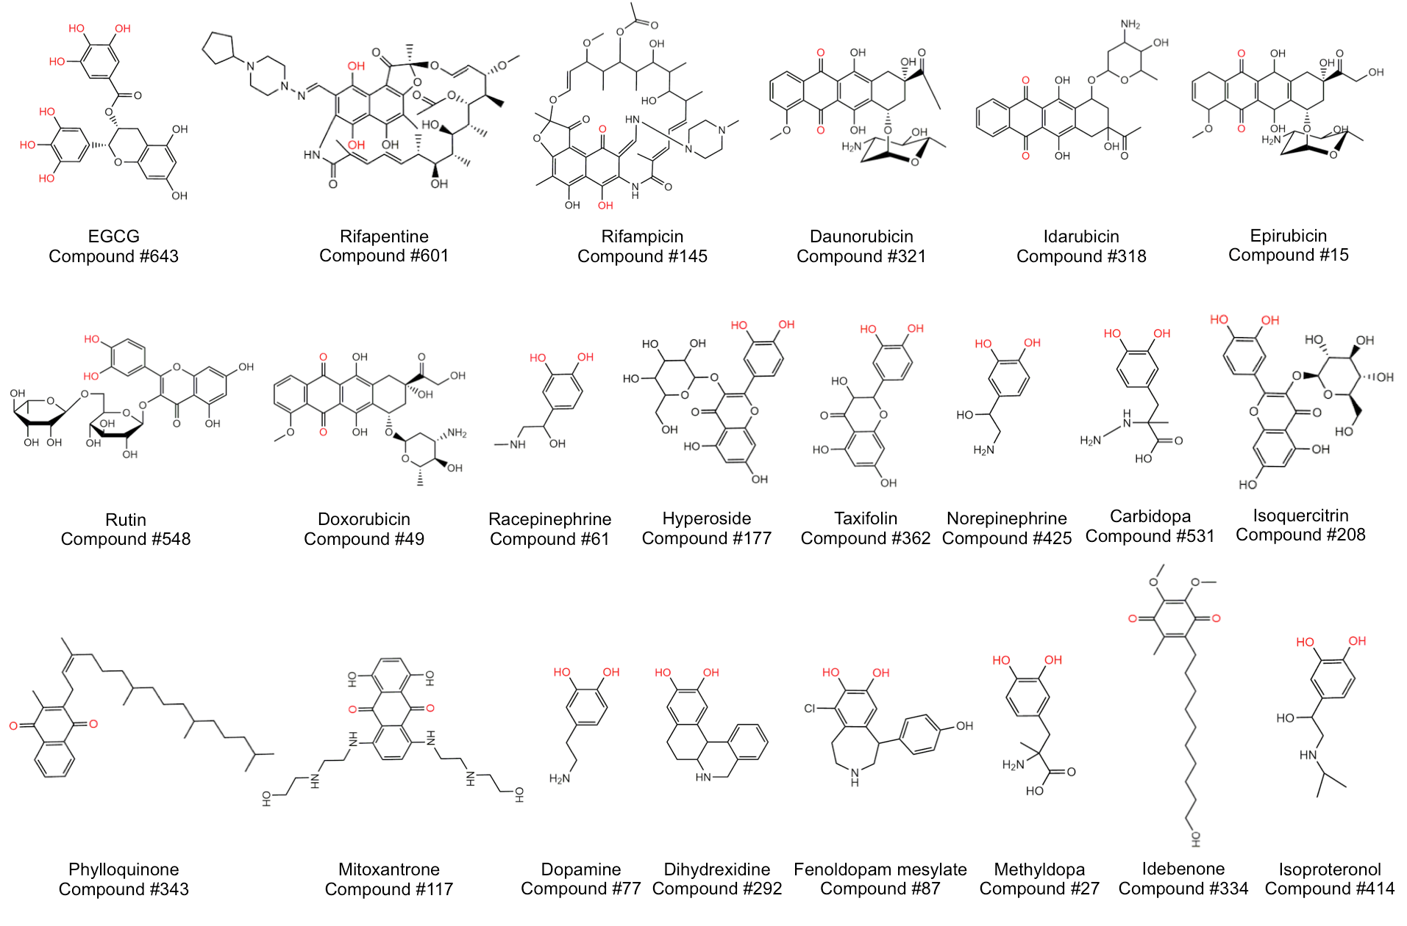

Figure S2. Chemical structures of catechols and redox-related quinones and anthraquinones identified from the NIHCC repurposing library of 700 drug and investigational compounds for their amyloid inhibitory activities of amylin, tau 2N4R and Aβ42. Relevant functional chemical groups are highlighted in red. Out of these 22 compounds, 21 compounds showed significant inhibitory effects against amylin amyloid (Table S1). Similarly, out of these 22 compounds 17 compounds have significant activities against tau 2N4R amyloid (Table S2) and 18 hits have significant activities against Aβ42 amyloid (Table S3).

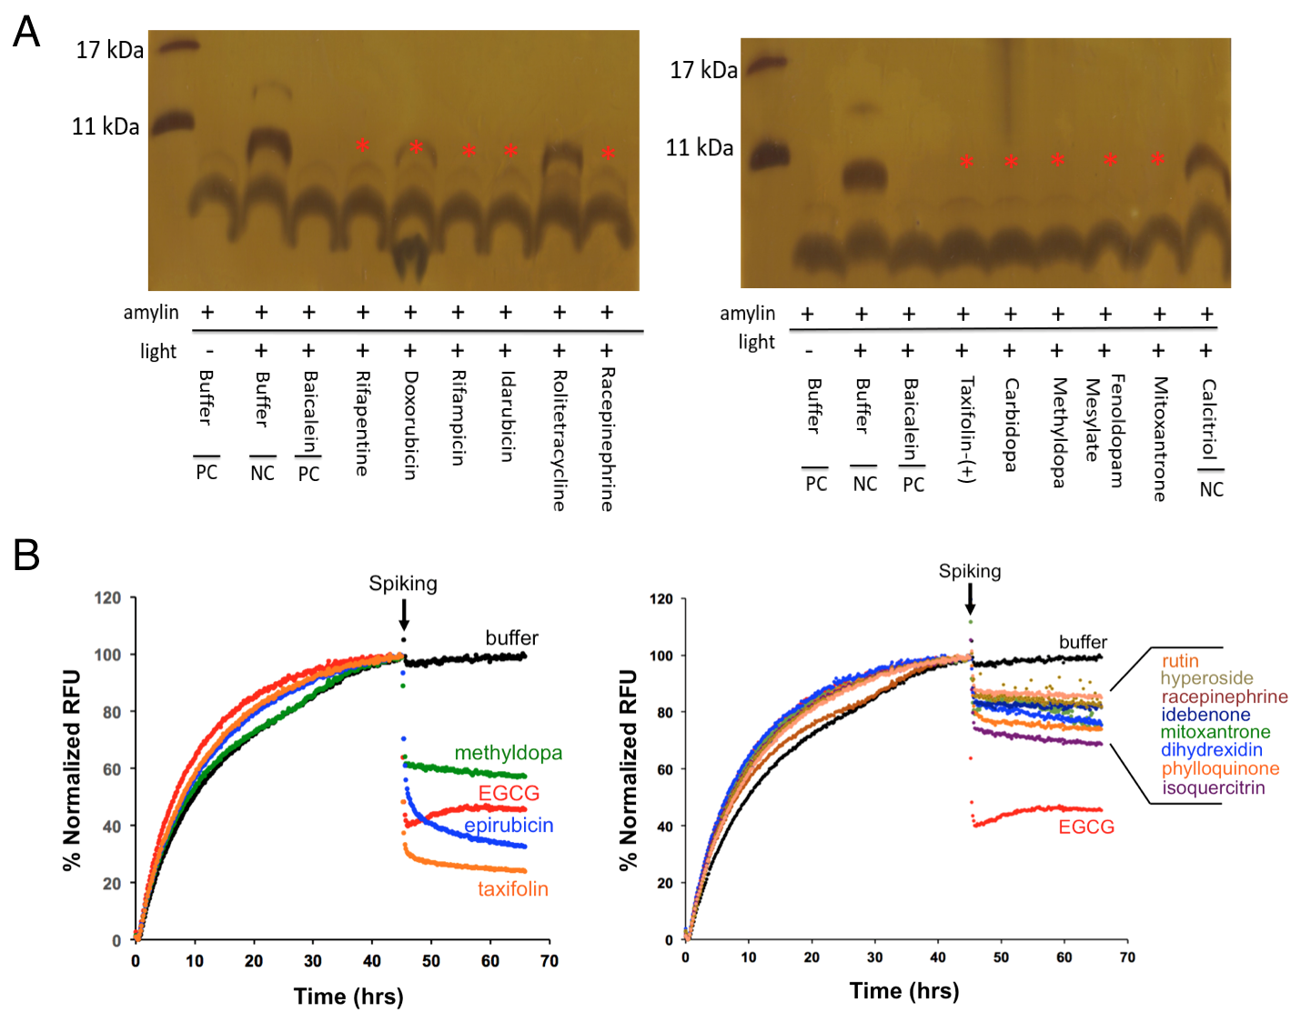

Figure S3. Secondary validation of selected top hits of catechols and quinones/anthraquinones from NIHCC library. (A) Secondary validation of amylin amyloid inhibitor hits by PICUP analysis. Amylin concentration was 30 μM and compound to amylin molar ratio was 5:1. Buffer and two drugs, rolitetracycline and calcitriol, were used as negative controls. Baicalein served as a positive control (Velander et al, 2016). Absence (or reduced intensity in the case of doxorubicin) of dimer formation bands (red asterisks) indicates their significant activities in blocking amylin oligomer formation. (B) Secondary validation of selected tau amyloid inhibitors by ThT fluorescence-based remodeling assay. Tau 2N4R isoform concentration was 30 μM and compound to tau 2N4R molar ratio was 2:1. Drugs are spiked at the indicated time (black arrows). Buffer (black lines) was used as a negative control. EGCG (red lines) served as a positive control. Compounds with strong remodeling effects were shown in the left panel and compounds with moderate remodeling effects were shown in the right panel.

