Materials and methods
All materials with catalogue numbers and manufacturers used in the study are listed in Supplementary Table 1.

Cell lines
HEK-293 and HeLa cells (ATCC; Cat. No.: ATCC-CRL-3249 and ATCC-CCL­2, respectively) were grown in DMEM/F12 containing 10% fetal bovine serum (FBS), 1% Kanamycin, 1% Penicillin-Streptomycin and 1% GlutaMax supplement ¹. CFPAC-1 cells were a generous gift of Michael Gray (School of Biomedical, Nutritional and Sport Sciences; Newcastle University) and were grown in Iscove’s modified Dulbecco’s medium supplemented as described above. Transfection of CFPAC-1 cells with recombinant Sendai virus containing the human CFTR gene was performed as described previously ².

Animals
Cftr KO mice were originally generated by Ratcliff et al. and were kind gift of Professor Ursula Seidler ³. Wild type (WT) refers to WT littermates of the Cftr KO animals. The mice used in this study were 8-12 weeks old and weighed 20-25 grams, whereas guinea pigs were 4-8 week-old. The gender ratio was 1:1 for all groups. The animals were kept at constant room temperature of 22-24°C under a 12 h light–dark cycle with free access to food and water. Animals received VRF1(P) standard rodent food (Manufacturer: Special Diets Services, Cat.No.: 801900), and standard bedding (Manufacturer: JRS; REHOFIX MK2000 corn cob) were purchased from Akronom (https://www.akronom.hu/products/corn-cob-bedding-rehofix.html). Interventions were done during the light cycle and animals were not fasted before the experiments. Animals were used with adherence to the NIH guidelines and the EU directive 2010/63/EU for the protection of animals used for scientific purposes. The study was approved by the National Scientific Ethical Committee on Animal Experimentation under license number XXI./2523/2018.

Isolation of pancreatic ductal fragments and acinar cells
Pancreatic ductal fragments were isolated as described earlier ⁴. Briefly after terminal anaesthesia with pentobarbital (270mg/bwkg) the pancreas was surgically removed from the animals and placed into ice-cold DMEM/F12. The pancreas was injected with 100 U/ml collagenase, 0.1 mg/ml trypsin inhibitor, 1 mg/ml bovine serum albumin in DMEM/F12 and placed into a shaking water bath at 37 ºC for 30 min. Small intra-/interlobular ducts were identified and isolated under stereomicroscope. For pancreatic acinar cell isolation, the tissue was injected with 200 units/ml type 4 collagenase in standard HEPES and placed into a shaking water bath at 37 °C for 30 min as described previously. The tube was vigorously shaken every 5 min. The supernatant was centrifuged for 2 min at 129 RCF and the pellet was resuspended in Media 199 with 0.1% BSA.

Mouse and human organoid cultures
Human pancreatic tissue samples were collected from transplantation donors (Ethical approval No.: 37/2017-SZTE). Mouse pancreatic, mouse liver and human pancreatic tissue samples were placed in Splitting media (Supplementary Table 1). The pancreatic tissue was cut into small pieces with Gillette blade and was incubated in Digestion Media (Supplementary Table 2) at 37 ºC in a vertical shaker for approximately 30 min, depending on tissue density. Digestion of the tissue was verified by stereo microscopy every 5 min. Cells were collected by centrifugation in a 15 ml centrifuge tube (113 RCF 10 min 4 ºC). Collected cells were washed by Wash Media (Supplementary Table 3) two times. The pellet was resuspended in Wash Media and Matrigel in a ratio of 1:5. Matrigel domes (10 µl) were placed in one well of a 24-well cell culture plate and after 10 min of solidification at 37 ºC, 500 µl Feeding Media (Supplementary Table 4) were applied in each well containing a dome. Feeding media was changed every other day. Domes were pooled and collected by centrifugation (113 RCF 10 min 4ºC) for passaging during which Matrigel removal and cell separation were performed simultaneously by TrypLE™ Express Enzyme at 37 ºC for 15 min in a vertical shaker followed by a washing step. Cell plating in Matrigel was performed as described above. For generating adherent 2D culture organoids were digested to single cells by TrypLE™ Express and washed two times as described above. Cells were cultured in feeding media during which 6-well plates and cover glass were applied. Both the organoids and adherent cells were kept under general culturing conditions (37°C, 95% relative humidity and 5% CO₂). 100 mM ethanol (EtOH) and 200 µM palmitic acid (PA) were administered to organoids at 37 °C in a humidified atmosphere overnight, before experiments. Organoids were used for experiments between passage numbers 1-5. The composition of different media is listed in Supplementary tables 2-5.

Generation of human CF-specific induced pluripotent stem cells
Reprogramming of keratinocytes isolated from plucked hair of a CF patient or a healthy donor was performed to generate CF-specific and control induced pluripotent stem cells as previously described ⁵. The pluripotent state of the established iPS cell lines was validated by immunostaining of essential pluripotency markers including OCT4, NANOG and SSEA4, and by transcriptional profiling. DNA sequencing confirmed the patient-specific CFTR gene alteration in the respective iPSCs. The CF patient harboured the compound heterozygous mutations p.F508del and p.L1258Ffs*7.

Constructs and transfection
HEK-293 cells were transfected with plasmids coding EGFP-hPMCA4b, mCherry-CFTR-3xHA and mCherry-CFTR-3xHA(S768A). Transfection was carried out using Lipofectamine2000 as described earlier ¹. EGFP-hPMCA4b was ordered from Addgene (Plasmid #: 47589). CFTR-3xHA was a generous gift from Gergely Lukács (McGill University, Montreal, Canada) ⁶, which was then cloned into a mCherry vector. Calmodulin binding site on human CFTR was disrupted by introducing a point mutation at the position 768 using Q5 Site-Directed Mutagenesis Kit resulting in a switch from serine to alanine (Fwd: AAGGAGGCAGGCTGTCCTGA, Rev: CGTGCCTGAAGCGTGG) ⁷. Anti-CFTR siRNA and transfection control were used for Cftr silencing. The ducts were transfected with 50 nM siCFTR or siGLO Green transfection indicator in Opti-MEM then left to incubate for 12 h and were used for immunofluorescent staining or in vitro Ca²⁺ measurements.

Fluorescent microscopy
Intracellular Ca²⁺ concentration ([Ca²⁺]_{i}), Cl⁻ ion levels, or intracellular pH were measured as described earlier ⁴ by loading the cells with Fura-2-AM, MQAE or with BCECF-AM, respectively. Ducts, acini, or organoids were attached to poly-L-lysine-coated coverslips and mounted on an Olympus IX71 fluorescent microscope equipped with an MT-20 illumination system. Filter sets for BCECF, Fura-2 and MQAE were described previously ⁴. The signal was captured by a Hamamatsu ORCA-ER CCD camera trough a 20X oil immersion objective (Olympus; NA: 0.8) with a temporal resolution of 1 s. Changes of ΔΨ_{m} was followed by 100 nM tetramethylrhodamine-methyl ester (TMRM) using a Zeiss LSM880 confocal microscope (excitation: 543 nm; emission: 560-650nm).

Gene expression analysis
Total RNA was isolated from whole pancreatic tissue or from isolated ductal fragments ⁴. The isolated RNA was reverse transcribed, and amplicons were detected by ABI PRISM 7000 using SyberGreen. Beta-2 microglobulin (B2M) and Proteasome Subunit Beta 6 (PSMB6) were selected for reference genes. Relative gene expression analysis was performed by ΔΔCq technique. RNA-seq was performed as follows, RNA extraction was carried out on mouse and human pancreatic ductal organoids. After the pellet collection of organoids from Matrigel, RNA was extracted with Nucleospin RNA plus kit according to manufacturer’s protocol. RNA sequencing was carried out by an Illumina NextSeq 500 instrument. Data analysis service was provided by DeltaBio200 Ltd. The pattern of gene expression was determined by TPM (transcript/million) values.

Immunfluorescent labelling
Isolated pancreatic ducts, or organoids were frozen in Shandon Cryomatrix and were sectioned by a Leica cryostat into 7 µM slices ^{4,6}. Cell lines were grown on cover glass and fixed without sectioning. Sections were fixed in 4% paraformaldehyde (PFA) in phosphate-buffered saline (PBS) for 15 min then washed in 1x Tris-buffered saline (TBS) for 3 x 5 min. After the 1 passage fully grown organoids were placed into Shandon Cryomatrix and frozen at -20 ˚C.. The slides were kept at -20 °C until staining. Immunofluorescent staining was performed in a humidified chamber at room temperature. Sections were fixed in 4% PFA-PBS for 15 minutes then washed in 1x TBS (Tris-buffered saline) for 5 min, repeated 3 times. Antigen retrieval was performed in 0.001 M Sodium Citrate (pH 6.0) and 0.05% Tween 20 buffer by heating the solution between 93-98°C then we placed the slides into the preheated solution for 20-30 min. After cooling to room temperature in 1xTBS the sections were blocked with 0.1% goat serum and 5% BSA-TBS (bovine serum albumin in Tris Saline Buffer) for 1 h. After blocking, the primary antibody diluted 1:100 in 5% BSA-TBS was administered then left for overnight incubation on 4°C. The next day the slides were washed 3x5 min in 1xTBS, then secondary antibody was added 1:400 in 5% BSA-TBS and incubated for 3h at room temperature, protected from light. After 3h the slides were washed 3x5 min with 1x TBS, then Hoechst 1:1000 in 5% BSA-TBS was added and left for 15 min to incubate then washed 3 times in 1x TBS when mounting medium was added. The slides were covered, then left to dry in a dark slidebox. After drying the slides, they were stored at 4°C until visualising with confocal microscopy (ZEISS LSM 880). Antibodies were used according to Supplementary Table 6. Applied antibodies are listed in Supplementary Tables 6-7.

Line Profile and Colocalisation Analysis
Line profile analysis was carried out with ImageJ FiJi (NIH) software by Plot Profile analysis of converted confocal images. Grey value intensity of the lines are shown in pictures. Maximal grey value intensity was averaged from 3-6 individual evaluations. Mander’s coefficient was calculated by ImageJ JACoP plugin. All data are expressed as means ± SEM.

DuolinkDuolink® Proximity Ligation Assay
DuolinkDuolink® assay guinea pig pancreatic ductal fragments were used due to the primary antibody compatibilities. The pancreas of guinea pigs were surgically removed and washed in PBS and pancreatic ductal fragments were isolated as described above. After cryoprotection, ductal fragments were frozen and sectioned as described above. Duolink® assay was performed on a humidified chamber according to the manufacturer’s protocol (Sigma-Aldrich). Sections were fixed in 4% PFA-PBS for 20 min then washed in TBS 3 times for 5 min. Antigen retrieval was performed as described earlier. After cooling to room temperature, the sections were blocked by the Duolink®-blocking solution and we progressed with the Duolink® protocol according to Sigma-Aldrich. Briefly, primary antibodies for CFTR and PMCA4 were incubated overnight at 4 °C. The next morning PLA plus and minus probes were incubated with the slides at 37 °C for 1 hour. In the next step DuolinkDuolink® Ligase was added for 30 min at 37 °C. After the ligation of the plus and minus probes, the DuolinkDuolink® Polymerase was added in Duolink® Amplification buffer for 100 min at 37 °C. After washing the slides according to the protocol, the samples were mounted in Fluoromount mounting medium (Sigma-Aldrich) and visualised with a ZEISS LSM 880 confocal microscope equipped with a Plan-Apochromat 40x oil immersion objective (NA 1.4; Zeiss). Images were taken as Z-stacks as suggested by Sigma-Aldrich.

Immunohistochemistry
Paraffin-embedded, 3- to 4-µm-thick sections of surgically removed resection specimens and autopsy liver tissue samples were used for immunohistochemistry. Immunohistochemical labelling was performed with a Leica Bond-MAX Fully Automated IHC and ISH Staining System. Briefly, deparaffinization step was carried out with Bond Dewax Solution at 72 °C. After washing with BondTM Wash Solution, epitope retrieval was carried out with Bond TM Epitope Retrieval Solution 2 at 100 °C for 20 min at pH 9. After slides were washed with wash solution at 35 °C, peroxidase blocking was performed by Novocastra Peroxidase Block for 5 min. Primary CFTR antibody was diluted in BondTM primary antibody diluent and incubated on samples for 20 min. For immunohistochemical labelling and visualisation, Bond Polymer Refine Detection was applied for 8 min. Sections from human pancreas were used as positive controls.

Direct Stochastic Optical Reconstruction Microscopy (dSTORM)
HeLa cells grown on cover glass were co-transfected with EGFP-hPMCA4b, mCherry-CFTR-3xHA and mCherry-CFTR-3xHA(S768A) plasmids. Primary human pancreatic ductal cells were isolated from transplantation donors and were generated for dSTORM by digesting and plating human pancreatic ductal organoids on cover glass. HeLa cells were fixed with 4% PFA for 10 min and AGR was performed by 0.01% Triton-X-100 for 10 min. Applied antibodies are listed in Supplementary Table 7. Adherent primary cell and sectioned organoids were fixed and retrieved by methanol for 10 min at -20 °C. After fixation with 4% PFA in PBS for 10 min, antigen retrieval was performed by 0.01% Triton-X-100 in PBS for 10 min. Aspecific binding sites were blocked by applying 10% BSA in PBS for 2 h at 37 °C. The following primary antibodies (1:100) were used during overnight incubation at 4 °C: anti-PMCA4, anti-CFTR. Samples were washed three times for 10 min with PBS. Fluorophore conjugated secondary antibodies were applied prior to another washing step (3 x 10 min). For dSTORM imaging, cover glasses were placed on cavity slides filled with blinking buffer and sealed with two-component adhesive. Blinking buffer contains 100 U glucose oxidase, 2000 U catalase, 55.5 mM glucose and 100 mM cysteamine hydrochloride in 1 mL final volume with sterile PBS. Cover glasses were placed in blinking buffer and dSTORM images were captured by Nanoimager S (Oxford Nanoimaging ONI Ltd.). Organoids derived from human pancreatic tissue were cryosectioned as described above and placed on cover glasses (VWR, ECN 631-1583). Adherent primary cells and sectioned organoids were fixed and retrieved by methanol (Sigma, 34860) for 10 min at -20°C. Further steps of immunofluorescence labelling as well as the imaging process are the same as previously described. Cluster analysis of dSTORM images were evaluated by CODI (Oxford Nanoimaging ONI Ltd.).

Transmission Electron Microscopy
The pancreas of WT and CFTR KO mice were surgically removed on ice after being sacrificed. We cut the pancreas into approximately 2 mm x 2 mm pieces and placed it into fixative solution overnight at 4°C in 2% glutaraldehyde in PBS containing 2.25% dextran (20KD). After fixation, the cells were embedded in Embed 812 (EMS, USA) with routine transmission electron microscope (TEM) embedding protocol. After the semithin sections (1 μm), the thin (70 nm) sections were made for TEM examination. To estimate the volume fraction of mitochondria in cells, micrographs of 18-30 cells were prepared in each case, on a TEM. The fractions of the TEM micrographs were automatically generated into 9 images using the module of Jeol 1400 plus. The original magnification of TEM micrographs (single or montage) were 12000X. The area of cells and mitochondria were measured by point counting. The area per test point for cells were 500nm x 500nm, and 50nm x50nm for mitochondria. Three locations per mitochondria were estimated separately (luminal, middle and basal). The luminal area was defined from the luminal side of the ductal cells, tangent of nucleus, parallel with the luminal surface of the cell. The middle was between the two tangents of nucleus, parallel with the luminal surface of the cell. The basal area was defined as opposite of the basal side of the cells.

Experimental alcohol-induced acute pancreatitis in mice
We induced acute pancreatitis via fatty acid ethyl ester (FAEE) in wild-type FVB/N mice according to Huang et al. ⁸ The animals received two intraperitoneal injections of ethanol (1.35 g/kg) and palmitoleic acid (POA; 150 mg/kg) at 1-h intervals. Prior to the ethanol-POA injections, the animals received 200 µl physiological saline solution injection intraperitoneally to prevent potential damaging effects and to protect the organs at the injection site. Control animals received one intraperitoneal injection of vehicle (25% DMSO, 75% sterile water) 90 min before the administration of either saline or ethanol/POA. Treated groups received one intraperitoneal dose of aurintricharboxylic acid (ATA) (5mg/kg) in vehicle (25% DMSO, 75% sterile water) 90 min before the injections of either saline or ethanol/POA ⁹. Animals were sacrificed 24 h after the first ethanol/POA injection. The severity of pancreatitis was assessed on both paraffin embedded hematoxylin eosin stained 5 µm slices, and the measurement of serum amylase activity. Hematoxylin eosin- stained slides were scored by three independent individuals, blind for the experimental set up. Scoring was carried out by the following histological parameters: edema, leukocyte infiltration and acinar cell necrosis ¹⁰. The serum amylase activity was measured by Alpha Amylase Assay kit based on the colorimetric kinetic method. Absorbance of the samples were measured at 405 nm with a CLARIOstar Plus (BMG Labtech).

References

1. Maléth J, Choi S, Muallem S, et al. Translocation between PI(4,5)P2-poor and PI(4,5)P2-rich microdomains during store depletion determines STIM1 conformation and Orai1 gating. Nat Commun 2014;5:5843.
2. Rakonczay Z, Hegyi P, Hasegawa M, et al. CFTR gene transfer to human cystic fibrosis pancreatic duct cells using a Sendai virus vector. J Cell Physiol 2008;214:442–455.
3. Ratcliff R, Evans MJ, Cuthbert AW, et al. Production of a severe cystic fibrosis mutation in mice by gene targeting. Nat Genet 1993;4:35–41.
4. Molnár R, Madácsy T, Varga Á, et al. Mouse pancreatic ductal organoid culture as a relevant model to study exocrine pancreatic ion secretion. Lab Invest 2020;100:84–97.
5. Hohwieler M, Illing A, Hermann PC, et al. Human pluripotent stem cell-derived acinar/ductal organoids generate human pancreas upon orthotopic transplantation and allow disease modelling. Gut 2017;66:473–486.
6. Maléth J, Balázs A, Pallagi P, et al. Alcohol disrupts levels and function of the cystic fibrosis transmembrane conductance regulator to promote development of pancreatitis. Gastroenterology 2015;148:427-439.e16.
7. Bozoky Z, Ahmadi S, Milman T, et al. Synergy of cAMP and calcium signaling pathways in CFTR regulation. Proc Natl Acad Sci U S A 2017;114:E2086–E2095.
8. Huang W, Booth DM, Cane MC, et al. Fatty acid ethyl ester synthase inhibition ameliorates ethanol-induced Ca2+-dependent mitochondrial dysfunction and acute pancreatitis. Gut 2014;63:1313–1324.
9. Lewis S, Little R, Baudoin F, et al. Acute inhibition of PMCA4, but not global ablation, reduces blood pressure and arterial contractility via a nNOS-dependent mechanism. J Cell Mol Med 2018;22:861–872.
10. Fanczal J, Pallagi P, Görög M, et al. TRPM2-mediated extracellular Ca2+ entry promotes acinar cell necrosis in biliary acute pancreatitis. J Physiol 2020;598:1253–1270.

Supplementary Figures
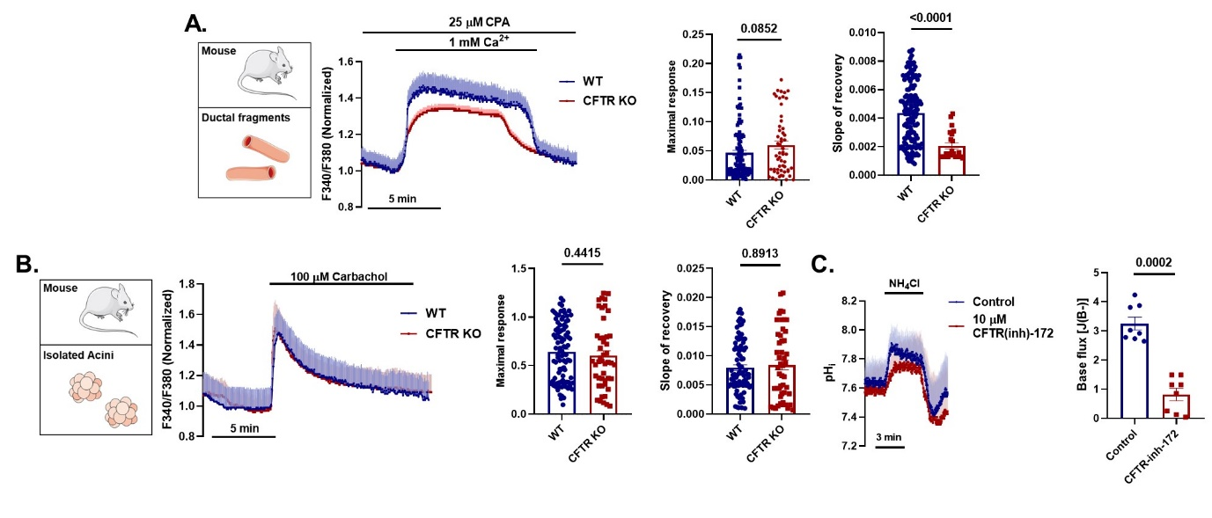
Supplementary Figure 1. Absence of CFTR inhibits the Ca²⁺ efflux in pancreatic ductal cells. A. Average traces and bar chart shows that the Ca²⁺ release from the ER during 25 µM CPA treatment did not show significant difference among WT CFTR KO pancreatic ductal fragments, whereas the Ca²⁺ extrusion was significantly impaired. B. Average traces of the maximal Ca²⁺ elevation and the slope of recovery in WT and Cftr KO pancreatic acinar cells in response to 100 µM carbachol showed no difference. C. Average traces and bar charts demonstrating the effect of CFTR inhibition in isolated pancreatic ducts. The inhibition of CFTR significantly decreased the recovery from alkali load. n: 4-10 individual experiments.

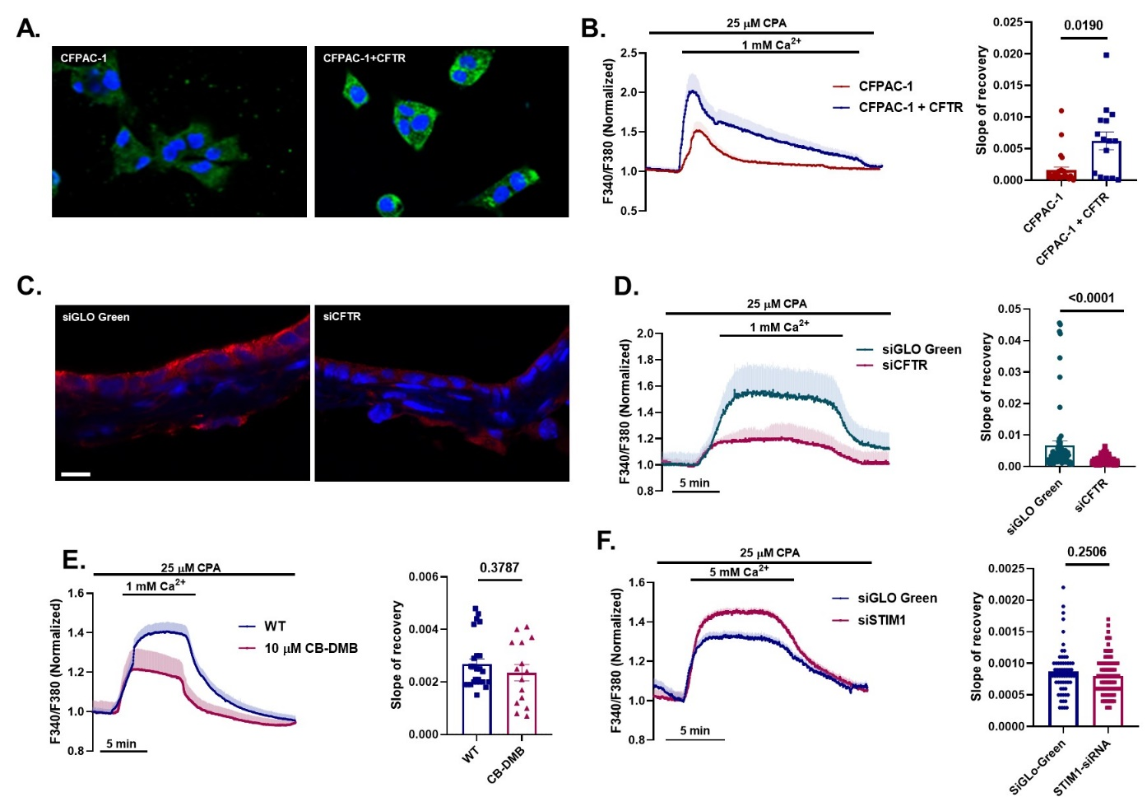
Supplementary Figure 2. Restoration of CFTR expression improves the Ca²⁺ extrusion.
A. Restoration of CFTR expression in CFPAC-1 human pancreatic ductal cell line CFPAC-1 with Sendai virus mediated gene delivery was confirmed by immunostaining. B. Average traces of intracellular Ca²⁺ concentration and bar chart of the slope of recovery highlight that the correction of CFTR expression also improved PMCA function. C. siRNA-mediated knockdown in isolated mouse ductal fragments markedly decreased apical CFTR distribution in mouse pancreatic ductal fragments. D. Average traces of intracellular Ca²⁺ concentration and bar chart of the slope of recovery demonstrate that the siCFTR treatment significantly decreased the PMCA4 function in mouse pancreatic ductal fragments. E. Average traces and bar charts demonstrating the inhibition of NCX with 10 µM CB-DMB had no effect on the Ca²⁺ extrusion in pancreatic ductal cells. F. Average traces and bar charts show the effect of STIM1 knock down on PMCA4 activity. Tyreatment of mouse pancreatic ductal fragments with siSTIM1 did not alter the PMCA4 function compared to SiGLO-Green treated ducts. Scale bars: 10 µm. n: 4-10 individual experiments.

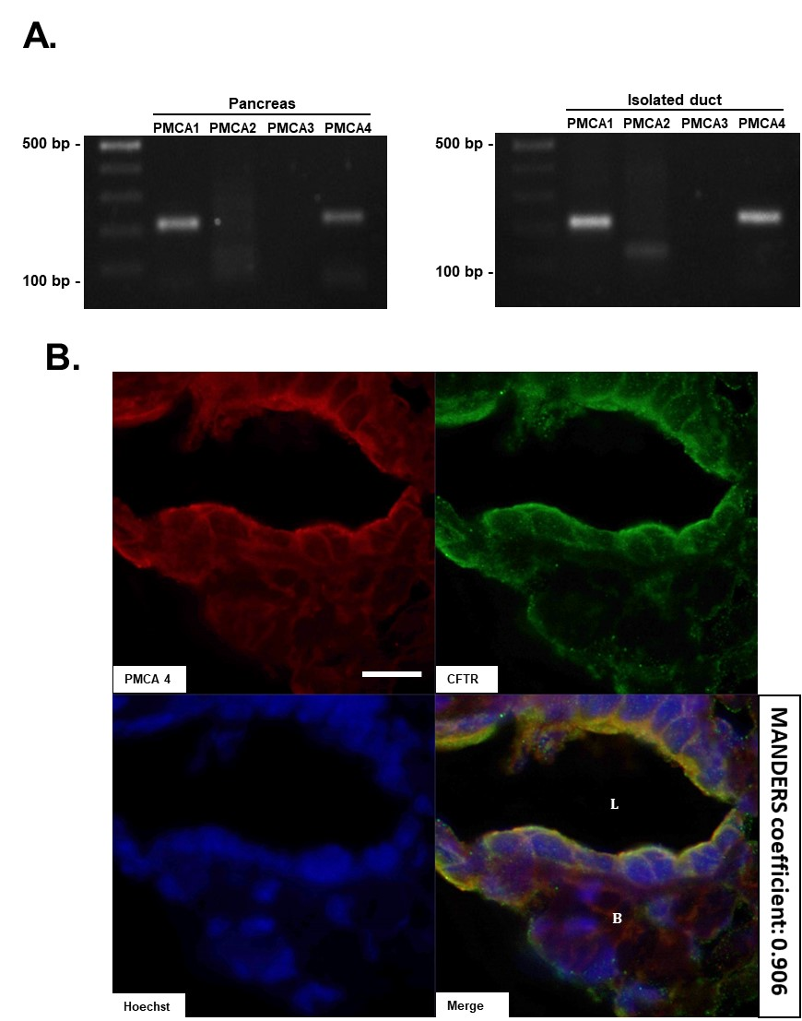

Supplementary Figure 3. Expression of PMCA isoforms and colocalization of PMCA4 with CFTR in pancreatic ductal cells. A. Endpoint RT-PCR analysis of PMCA isoforms in whole pancreas (left panel) and in isolated ducts (right panel). The strongest expression was detected of Pmca1 and Pmca4. B. PMCA4 and CFTR colocalize at the apical membrane of pancreatic ductal epithelial cell in isolated mouse ductal fragments with a Mander's overlap coefficient of 0.906. Scale bars: 10 µm. B: basolateral side; L: lumen.

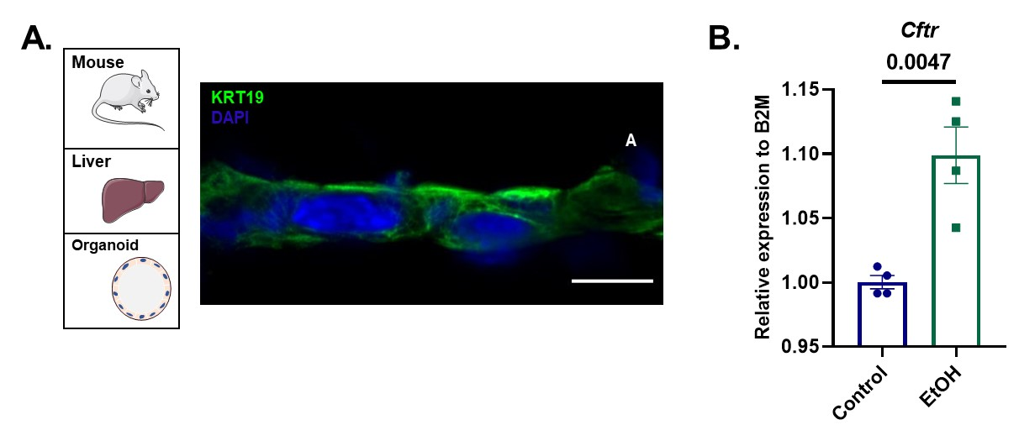
Supplementary Figure 4. CFTR gene expression analysis in mouse liver organoid cultures. A. Immunofluorescent staining of Cytokeratin 19 confirms the epithelial fate of generated mouse liver organoid cultures, suggesting clean lineage of cholangiocytes. Scale bar: 10 µm. B. Gene expression analysis of Cftr relative to b2m showed minor elevation of Cftr in mouse liver organoid culture after EtOH-PA treatment.

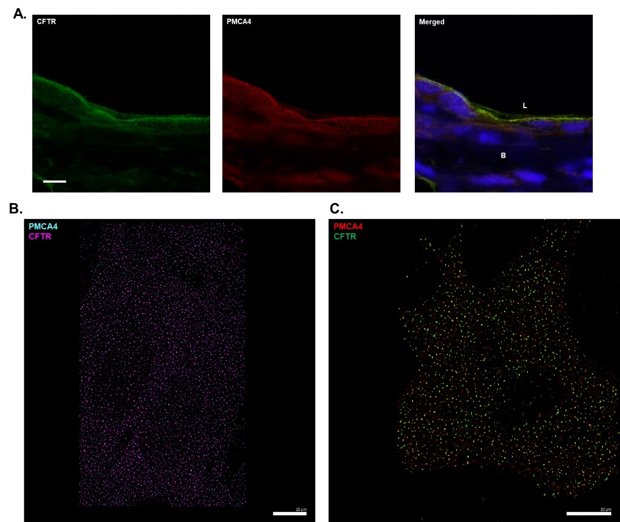

Supplementary Figure 5. Colocalization of CFTR and PMCA4 in different in vitro models. A. Colocalization of CFTR and PMCA4 in isolated guinea pig pancreatic ducts. B: basolateral side; L: lumen. B-C. Original dSTORM images of PMCA4 and CFTR in transfected Hela cells (B) and in primary 2D human pancreatic ductal cell (C). Scale bar: 10 µm.

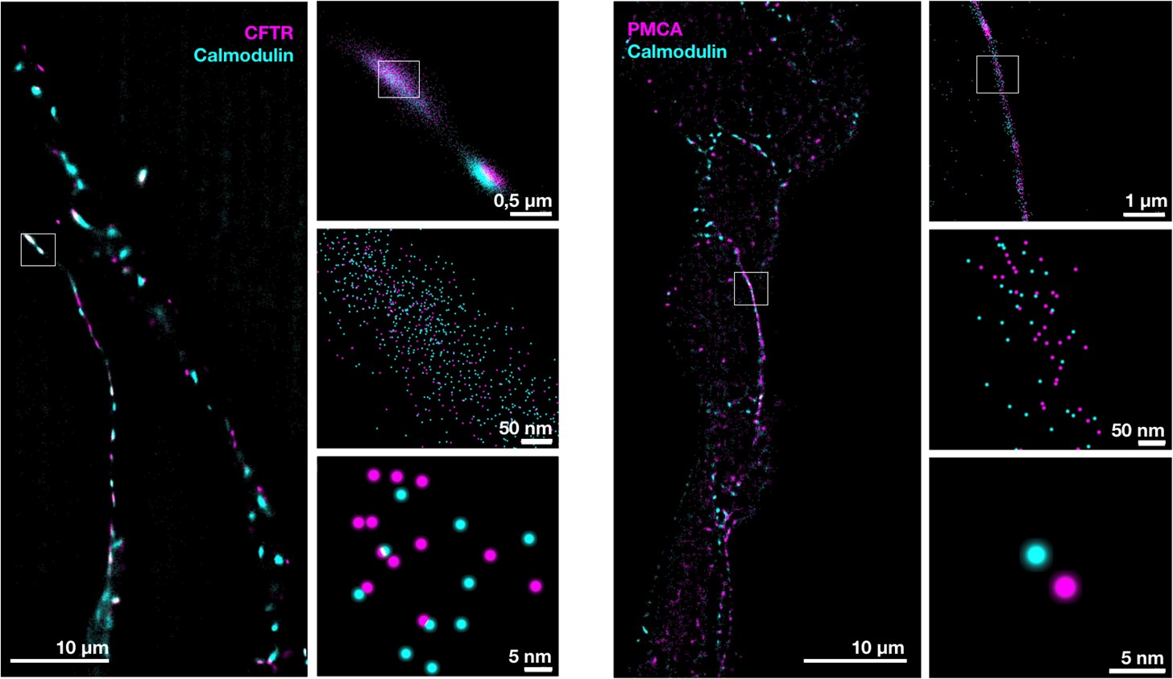

Supplementary Figure 6. Colocalization of calmodulin with CFTR and PMCA4. dSTORM images revealed a strong co-localization of calmodulin with CFTR (left panel) and PMCA4 (right panel) at the apical membrane of ductal epithelial cells on cross-sections of mouse pancreatic ductal organoids

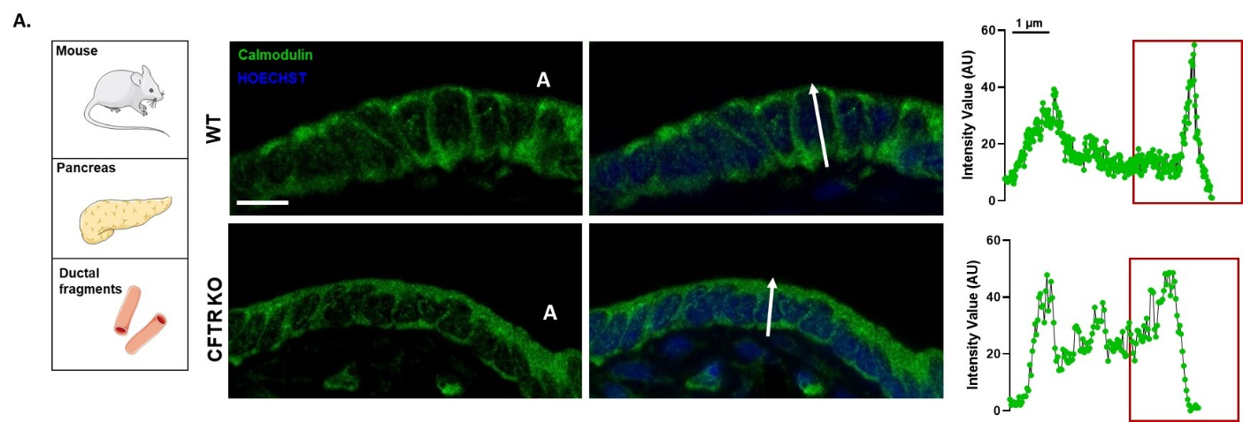

Supplementary Figure 7. Distribution of calmodulin in pancreatic ductal cells. A. Confocal images and line profile analysis of the intracellular distribution of calmodulin in WT and Cftr KO pancreatic ductal cells. Calmodulin was strongly associated with the apical membrane in WT ductal epithelial cells, in Cftr KO cells this association was lost. A: apical side. Scale bar: 10 µm. n: 3 individual experiments.

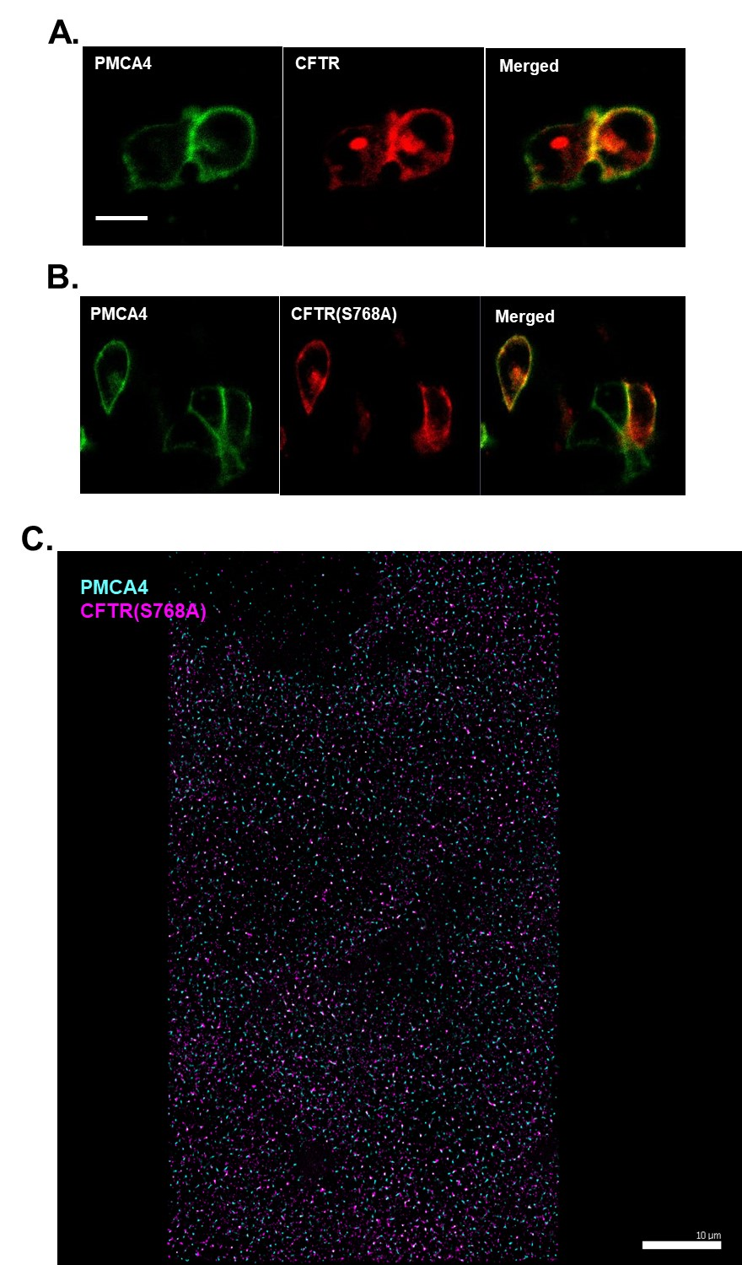

Supplementary Figure 8. Expression of CFTR(S768A) in transfected cells. A-B. Confocal images of WT and calmodulin binding site mutant CFTR(S768A) and PMCA4 in transfected HEK-293 cells. C. dSTORM images demonstrate the colocalization of calmodulin binding site mutant CFTR and PMCA4 on transfected Hela cells. Scale bars: 10 µm.

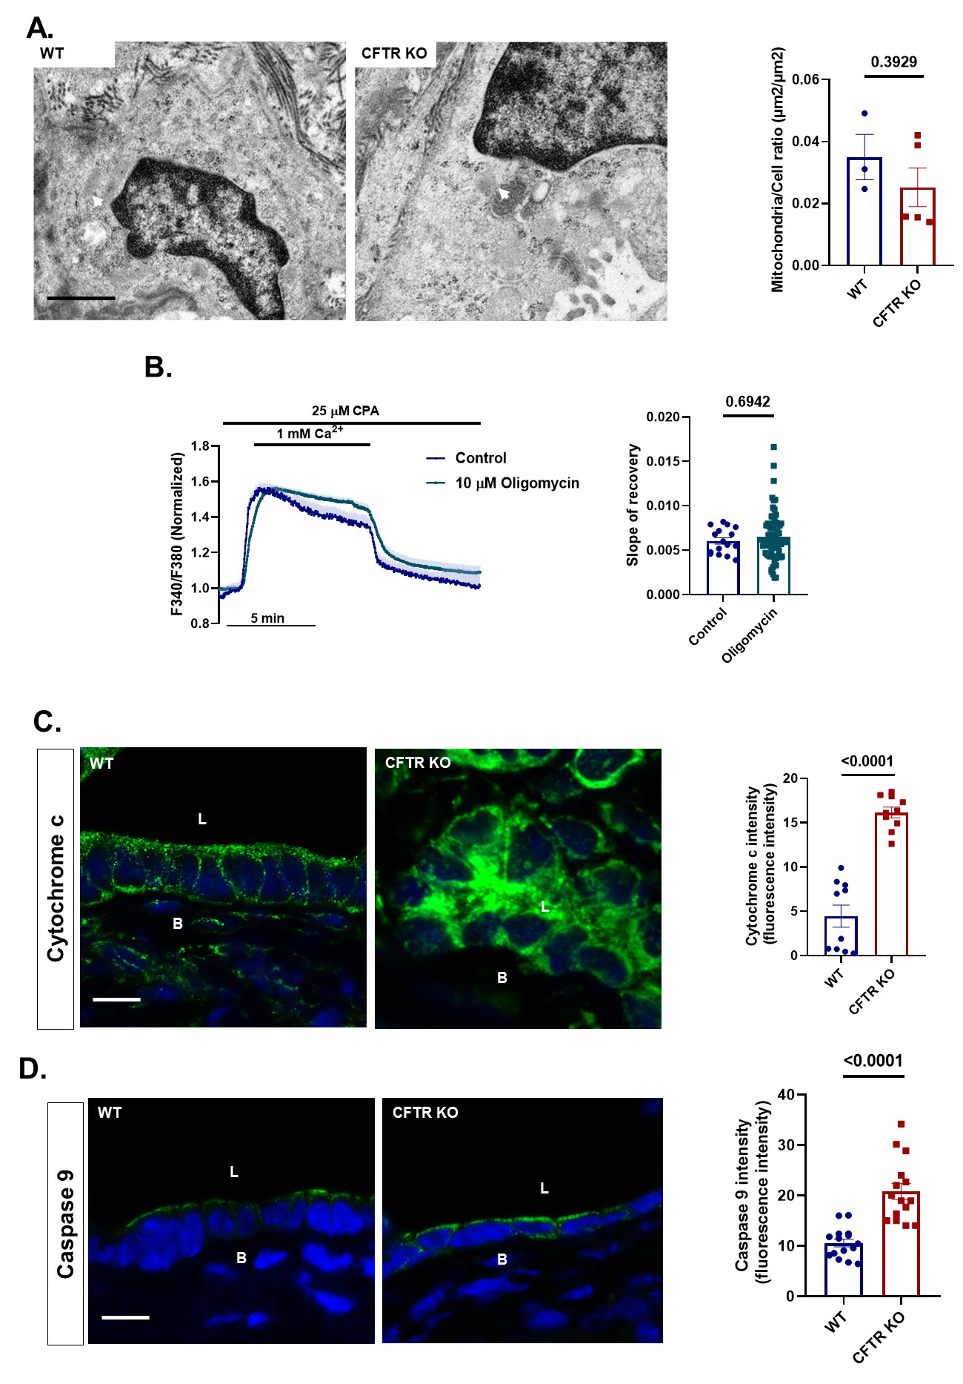

Supplementary Figure 9. Mitochondrial dysfunction and increased expression of apoptotic proteins in Cftr KO pancreatic ductal cells. A. Representative transmission electron microscopy images of WT and Cftr KO mouse pancreatic ductal cells (arrowheads highlight the mitochondria). The mitochondrial volume/cell volume was not changed in Cftr KO ductal cell compared to WT. Scale bar: 1 µm. B. Average traces and bar charts demonstrating the effect of the inhibition of mitochondrial ATP production on the Ca²⁺ extrusion in isolated pancreatic ducts. Oligomycin had no effect on the PMCA activity. C. Intracellular distribution of cytochrome c and D. caspase 9 staining in WT and Cftr KO ductal cells. In WT ductal cells cytochrome c showed a granular pattern, whereas in Cftr KO cells this was changed to a cytosolic staining. The intensity of caspase 9 staining was increased in Cftr KO cells. All averages were calculated from 4-10 individual experiments. Scale bars: 10 µm. B: basolateral side; L: lumen. n: 4-10 individual experiments.

Supplementary Table 1. Materials used during experiments.

Name | Provider | Cat. No.:
HEK 293 cell line | ATCC | ATCC-CRL-3249
HELA cell line | ATCC | ATCC-CCL-2
DMEM (5796) | Sigma Aldrich | D6421
Fetal Bovine Serum | Sigma-Aldrich | F7524
Kanamycin | ThermoFisher Scientific | 15160047
Strep-Pen | ThermoFisher Scientific | 15140122
GlutaMax | ThermoFisher Scientific | 35050061
IMDM | ThermoFisher Scientific | 12440061
DME-F12 | Sigma-Aldrich | D6421
collagenase | Worthington | LS005273
trypsin inhibitor | ThermoFisher Scientific | 17075029
type 4 collagenase | Worthington | LS004186
Media 199 | ThermoFisher Scientific | 11150059
TrypLETM Express | Gibco | 12605028
corning matrigel | Corning | 354234
FURA-2,AM | ThermoFisher Scientific | F1201
Pluronic F-127 | ThermoFisher Scientific | P3000MP
BCECF,AM | ThermoFisher Scientific | B1170
poly-L-lysine | Sigma-Aldrich | P4707-50ML
TMRM | ThermoFisher Scientific | T668
LBP buffer | Macherey-Nagel | 740906.125
NucleoSpin RNA Plus kit | Macherey-Nagel | 740984.25
High Capacity cDNA Reverse Transcription Kit (ABI) | ThermoFisher Scientific | 4368814
Maxima SYBR Green/ROx qPCR MasterMix | ThermoFisher Scientific | K0222
Shandon Cryomatrix | ThermoFisher Scientific | 6769006
Sodium Citrate | Sigma Aldrich | C8532
Tween20 | Sigma Aldrich | P1379
goat serum | Sigma Aldrich | G9023
bovine serum albumin | Sigma Aldrich | A8022
Hoechst33342 | ThermoFisher Scientific | 62249
Flouromount | Sigma Aldrich | F4680
Duolink® assay | Sigma Aldrich | DUO92014, DUO82049, DUO92001, DUO92005
ON-TARGETplus Mouse siRNA, SMARTpool mouse CFTR | Dharmacon | L-042164-00-0005
siGlo Green transfection indicator | Dharmacon | D-001630-01-05
eGFP-hPMCAb | Addgene | 47589
Lipofectamine 2000 | Invitrogene | 11668-019
Embed 812 | EMS | 14120
15 ml centrifuge tube | Greiner BioOne | 188261
6-well plates | Greiner BioOne | 657160
cover glass | VWR | ECN 631-1583
PFA | Alfa Aesar | 43368
PBS | Sigma Aldrich | P4417-100TAB
Triton-X-100 | Reanal | 32190-1-99-33
cavity slides | Sigma Aldrich | BR475505-50EA
two-component adhesive | Picodent | 13 007 100
glucose oxidase | Sigma Aldrich | G2133-50KU
catalase | Sigma Aldrich | C100
glucose | Sigma Aldrich | G8270
cysteamine hydrochloride | Sigma Aldrich | M6500
methanol | Sigma Aldrich | 34860
cerulein | Bachem | H-3220
A Amylase Assay | Diagnosticum | 47462
Bond Dewax Solution | Leica biosystems | AR9222
BondTM Wash Solution | Leica biosystems | AR9590
Bond TM Epitope Retrieval | Leica biosystems | AR9640
Novocastra Peroxidase Block | Leica biosystems | RE7101-CE
BondTM Primary Antibody Diluent | Leica biosystems | AR9352
Bond Polymer Refine Detection | Leica biosystems | DS9800

Supplementary Table 2. Splitting media.
Component | Manufacturer/Cat.No. | Final cc/volume
Advanced DMEM/F-12 | Gibco, 12634-010 | 500 ml
1 M HEPES | Gibco, 15630080 | 5 ml  (10 mM)
GlutaMax Supplement  (100X) | Gibco, 35050061 | 5ml  (1X)
Primocin  (400X) | Invivogen, ant-pm-2 | 1,25 ml  (1X)
Supplementary Table 3. Digestion media.
Component | Manufacturer/Cat.No. | Final cc/volume
Splitting media | - | 20 ml
Collagenase IV. | Worthington, LS004188 | 1250 U/ml
Dispase | Sigma-Aldrich, D4693 | 0,5 U/ml
FBS | Gibco, 10500064 | 0,5 ml  2,5% v/v
Trypsin inhibitor | Sigma-Aldrich, T9128 | 1mg/ml

Supplementary Table 4. Wash media.
Component | Manufacturer/Cat.No. | Final cc/volume
Splitting media | - | -
FBS | Gibco, 10500064 | 2,5% v/v
Antibiotic-Antimycotic Solution (100X) | Gibco, 15240062 | 1X
Kanamycin Sulfate (100X) | Gibco, 15160047 | 1X
Voriconazole | TOCRIS, 3760/10 | 2 µg/ml

Supplementary Table 5. Feeding media.
Component | Manufacturer/Cat.No. | Final cc/volume
Splitting media | - | 19 ml
L-WRN conditioned media | - | 25 ml
A-83 | TOCRIS, 2939 | 500 nM
mEGF | Gibco, PMG8041 | 50 ng/ml
hFGF10 | Peprotech, 100-26 | 100 ng/ml
Gastrin I | TOCRIS, 3006 | 0.01 µM
N-acetylcytstein | Sigma-Aldrich, A9165 | 1.25 mM
Nicotinamide | Sigma-Aldrich, N0636 | 10 mM
B-27 Supplement  (50X) | Gibco, 17504001 | 1ml  (1X)
Y-27632 Rho-Kinase Inhibitor | TOCRIS, 1254 | 10.5 µM
Prostaglandin E2 (PGE2) | TOCRIS, 2296 | 1 µM
Antibiotic-Antimycotic Solution | Gibco, 15240062 | 1 % v/v
Kanamycin  (100X) | Gibco, 15160047 | 1X
Voriconazole | TOCRIS, 3764 | 2 µg/ml

Supplementary Table 6. Primary antibodies used during experiments.

Name | Source | Clonality | Cat. No. | Provider
anti-CFTR | rabbit | polyclonal | ACL-006 | Alomone Labs
anti-PMCA1 | rabbit | polyclonal | ACP-005 | Alomone Labs
anti- PMCA4 | rabbit | polyclonal | ACP-004 | Alomone Labs
anti-CFTR | mouse | monoclonal | ab2784 | Abcam
panPMCA | mouse | monoclonal | ab2825 | Abcam
anti-cytochrome C | mouse | monoclonal | ab13575 | Abcam
anti-Calmodulin | rabbit | monoclonal | ab45689 | Abcam
anti-caspase9 | rabbit | monclonal | ab202068 | Abcam

Supplementary Table 7. Secondary antibodies used during experiments.

Name | Cat. No. | Provider
Goat anti-Mouse IgG (H+L) Cross-Adsorbed Secondary Antibody, Alexa Fluor 488 | A-11001 | Invitrogen
Goat anti-Mouse IgG (H+L) Highly Cross-Adsorbed Secondary Antibody, Alexa Fluor 594 | A-11032 | Invitrogen
Goat anti-Rabbit IgG (H+L) Cross-Adsorbed Secondary Antibody, Alexa Fluor 568 | A-110011 | Invitrogen
Goat anti-Rabbit IgG (H+L) Highly Cross-Adsorbed Secondary Antibody, Alexa Fluor 488 | A-11034 | Invitrogen
Donkey anti-Mouse IgG (H+L) Highly Cross-Adsorbed Secondary Antibody, Alexa Fluor 647 | A-31571 | Invitrogen
Goat anti-Rabbit IgG (H+L) Cross-Adsorbed Secondary Antibody, Alexa Fluor 568 | A-11011 | Invitrogen

Supplementary Table 8. Composition of solutions used during experiments. HCO₃⁻ containing solutions were gassed with carbogen.
 | Standard HEPES |  | Ca²⁺-free HEPES | Standard HCO₃⁻ | NH₄Cl-HCO₃⁻ | Cl⁻-free HCO₃⁻
NaCl |  | 130 | 132 | 115 | 95
KCl |  | 5 | 5 | 5 | 5
MgCl₂ |  | 1 | 1 | 1 | 1
CaCl₂ |  | 1 |  | 1 | 1
Hepes |  | 10 | 10
Glucose |  | 10 | 10 | 10 | 10 | 10
NaHCO₃ |  |  |  | 25 | 25 | 25
EGTA |  |  | 0.1
NH₄Cl |  |  |  |  | 20
Na-gluconate |  |  |  |  |  | 115
K₂-sulfate |  |  |  |  |  | 2.5
Ca-gluconate |  |  |  |  |  | 6
Mg-gluconate |  |  |  |  |  | 1

