Supporting Information

for

J‑Aggregates of meso-[2.2]Paracyclophanyl-BODIPY Dye for NIR-II Imaging

Kang Li,^{#a} Xingchen Duan,^{#b} ZhiyongJiang,ª Dan Ding,^{b} Yuncong Chen,*^{c} Guo-Qiang Zhang,*^{b} Zhipeng Liu*ª

ªCollege of Materials Science and Engineering, Nanjing Forestry University, Nanjing 210037, China. Email: zpliu@njfu.edu.cn.
^{b}Key Laboratory of Bioactive Materials, Ministry of Education, and College of Life Sciences, Nankai University, Tianjin 300071, China. Email: guoqiangzhang@mail.nankai.edu.cn
^{c}State Key Laboratory of Coordination Chemistry, School of Chemistry and Chemical Engineering, Nanjing University, Nanjing 210093, China. Email: chenyc@nju.edu.cn.
# These authors contributed equally to this work.

Table of Contents
1. Methods and materials S2
2. Synthesis S2
3. X-ray crystallographic analysis S3
4. Photophysical properties S3
5. Theoretical modeling S3
6. Preparation of PCP-BDP2 NPs S3
7. Photostability S3
8. NIR-II imaging S3
9. Supplementary Tables and Figures S5
10. References S15

1. Methods and materials
All chemicals were commercially available and used as received without further purification unless otherwise specified. All reactions of air-sensitive compounds were carried out under dry nitrogen by using Schlenk techniques. Reaction progress was monitored by thin-layer chromatography (TLC) on silica plates (250 µmol/L thickness, bought from Qingdao Haiyang Chemical Co.) and spots were visualized by UV254 fluorescent indicator. Flash column chromatography was carried out using silica gel (200−300 mesh) bought from Qingdao Haiyang Chemical Co. The ¹H and ¹³C NMR spectra were acquired over a Bruker AV-600 and AVANCE III HD spectrometer. HRMS spectra were recorded on a NeXion 300X spectrometer. A transmission electron microscope (TEM, JEM-1400, Japan) was used to investigate the structural features and the morphological of the samples.

2. Synthesis

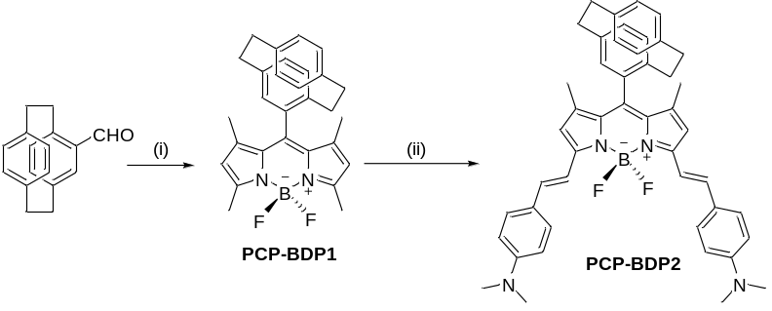
Scheme S1. Synthetic routes for PCP-BDP1 and PCP-BDP2. Reaction conditions: (i) 2,4-dimethylpyrrole (2.0 equiv), TFA (0.1 equiv), DDQ (1 equiv), Et₃N (14 equiv), BF₃·Et₂O (15 equiv), DCM, r.t. 6 h; (ii) 4-dimethylaminobenzaldehyde (2.2 equiv), piperidine (10 equiv), glacial acetic acid (13 equiv), molecular sieves (4 Å), toluene, reflux, 38 h.

Ph-BDP1 and Ph-BDP2 were synthesized according to the literature.¹
Synthsis of PCP-BDP1. To a mixture of 4-formyl[2.2]paracyclophane² (472 mg, 2.0 mmol) and 2,4-dimethylpyrrole (268 mg, 4.0 mmol) in CH₂Cl₂ (50 mL) was added trifluoroacetic acid (20 μL). After the reaction mixture was stirred at room temperature for 3 h, 2,3-dichloro-5,6-dicyano-1,4-benzoquinone (DDQ) (454 mg, 2.0 mmol) in CH₂Cl₂ (20 mL) was added at 0 °C. Then the mixture was warmed up to room temperature and stirred for additional 1 h. Et₃N (3.9 mL, 28.0 mmol) and BF₃·Et₂O (3.8 mL, 30.0 mmol) were added, and further stirred at room temperature for 2 h. The reaction mixture was washed with water (3×100 mL) and the organic layers were combined, dried over anhydrous MgSO₄ and evaporated in vacuo. The crude product was further purified using column chromatography (EtOAc: hexane = 1: 15, v/v) to give PCP-BDP1 as an orange power (136 mg, 15%). ¹H NMR (500 MHz, CDCl₃) δ (ppm), 6.88 (d, J = 7.7 Hz, 1H), 6.82 (s, 2H), 6.21 (d, J = 9.8 Hz, 2H), 5.83 (s, 1H), 3.50–3.32 (m, 2H), 3.11–2.80 (m, 6H), 2.77 (d, J = 6.8 Hz, 3H), 2.61 (s, 3H), 2.50 (s, 3H), 0.77 (s, 3H). ¹³C NMR (100 MHz, CDCl₃) δ (ppm), 154.5, 144.1, 143.0, 140.0, 140.0, 139.3, 137.0, 136.3, 134.1, 132.6, 132.4, 131.5, 131.1, 130.6, 126.5, 121.8, 121.4, 109.9, 77.2, 76.9, 76.66, 35.2, 34.9, 34.9, 33.0, 17.0, 14.6, 14.6, 13.7. HRMS (ESI): C₂₉H₃₀BF₂N₂⁺ calcd: [M+H]⁺ = 455.2465, found: [M+H]⁺ = 455.2451.
Synthsis of PCP-BDP2. PCP-BDP1 (140 mg, 0.31 mmol) and 4-dimethylaminobenzaldehyde (120 mg, 0.68 mmol) were refluxed for 38 h in a mixture of toluene (20 mL), piperidine (0.28 mL, 3.10 mmol) and glacial acetic acid (0.23 mL, 4.03 mmol) together with a small amount of molecular sieves (4Å). After cooling to room temperature the mixture was placed on top of a silica column and eluted with CH₂Cl₂/hexane (1: 1, v/v) to give PCP-BDP2 as a dark green powder (81 mg, 37 %). ¹H NMR (600 MHz, CDCl₃) δ (ppm), 7.71 (d, J = 16.1 Hz, 1H), 7.62 – 7.55 (m, 3H), 7.53 (d, J = 8.7 Hz, 2H), 7.15 (d, J = 16.1 Hz, 1H), 6.93 – 6.88 (m, 2H), 6.87 – 6.81 (m, 2H), 6.74 (dd, J = 21.2, 8.8 Hz, 4H), 6.53 (d, J = 7.7 Hz, 1H), 6.48 (s, 1H), 6.40 (s, 2H), 6.29 – 6.24 (m, 1H), 3.49 – 3.36 (m, 2H), 3.09 – 2.83 (m, 20H). ¹³C NMR (150 MHz, CDCl₃) δ 152.3, 152.1, 150.8, 142.0, 140.5, 140.2, 139.3, 139.1, 138.6, 137.3, 136.9, 136.3, 136.2, 136.1, 133.8, 133.1, 132.6, 132.4, 131.5, 131.3, 131.2, 129.0, 127.3, 125.4, 125.2, 118.0, 117.5, 115.3, 115.3, 115.1, 115.0, 112.1, 112.1, 77.2, 77.0, 76.8, 40.3, 40.2, 35.2, 35.0, 33.0, 31.9, 31.4, 30.3, 30.2, 29.7, 29.3, 22.7, 17.3, 14.1, 13.7. HRMS (ESI): C₄₇H₄₈BF₂N₄⁺ calcd: [M+H]⁺ = 717.3935, found: [M+H]⁺ = 717.3901.

3. X-ray crystallographic analysis
Red single crystals of PCP-BDP1 and PCP-BDP2 were crystallized from a solution of CH₂Cl₂. Intensity data of PCP-BDP1 and PCP-BDP2 were collected on a Bruker SMART APEX-II CCD X-ray diffractometer with Cu-Kα radiation (λ = 1.54184 Å). The structure was interpreted and refined by SHELX-2014.³

4. Photophysical properties
UV/vis absorption spectra were measured at room temperature on a Shimadzu UV-1750 spectrophotometer with a resolution of 1.0 nm, using quartz cuvettes of 1 cm path length. Fluorescent spectra of PCP-BDP1, Ph-BDP1, and Ph-BDP2 were recorded on a FLUOROMAX-4 spectrometer under an air atmosphere at room temperature. Fluorescence spectra of PCP-BDP2 in THF-water binary solvents and the crystalline powder state were measured on Edinburgh FLS1000 by exciting with an 808 nm laser. Fluorescent spectra of PCP-BDP2 NPs were measured on HORIBA FL-3 by exciting with an 808 nm laser.

5. Theoretical modeling
TD-DFT calculations were performed at the density functional theory level (B3LYP) with the 6-31G(d) basis set for C, H, N, B, and F atoms, using the Gaussian 09 software package. The polarized continuum model (PCM) was used to provide a DCM solvation environment.

6. Preparation of PCP-BDP2 NPs
PCP-BDP2 (2 mg) was dissolved in THF (1 mL) by bath sonication. 10 mg Pluronic F-127 was dissolved in 1 mL of PCP-BDP2 stock solution, and then the solutions were added to 10 mL deionized water and vibration dispersion 30 min with an ultrasonic apparatus. After dispersion, THF was removed under reduced pressure. Then, the solutions were filtered through a filter. To remove the excess Pluronic F-127, the PCP-BDP2 NPs water dispersion was treated by the repeated centrifugal washing process thrice.

7. Photostability
The photostability of PCP-BDP2 NPs and IR1061 (Sigma-Aldrich, CAS: 155614-01-0) were investigated in PBS solution containing 5% DMSO as co-solvent with a concentration of 10 μM. The respective dye’s solution in 1cm quartz cuvettes (200 μL) was illuminated with a continuous laser (808 nm, 100 mW/cm²) for 60 min. The emission intensity of PCP-BDP2 NPs and IR1061 was measured every 1 min.

8. NIR-II imaging
1) In vitro and in vivo NIR-II fluorescence imaging. All images of fluorescence were collected on a home-built imaging set-up consisting of a 2D InGaAs camera (Princeton Instruments, 2D OMA-V). An 808 laser was used as the excitation resource, and all signals were detected utilizing an 1100 nm LP filter. The NIR-II fluorescence of blood vessels in the brain and hindlimb were imaged at several time points (5 min, 3 h, 4 h, 6 h, 8 h, and 24 h) after the PCP-BDP2 NPs and ICG were injected via the tail vein respectively.
2) In vivo biodistribution study. After 24 h, at the end of imaging, the mice were euthanized and their major organs contain the heart, liver, spleen, lung, kidney, and brain were isolated and imaged.
3) Animals and Tumor Xenograft Model. We chose luciferase-expressed 4T1 tumors to establish the peritoneal carcinomatosis-bearing mouse model. one million cells were injected intraperitoneally for each mouse and the model could be formed in 5 days. All animal studies were performed according to the guidelines set by the Tianjin Committee of Use and Care of Laboratory Animals, and the overall project protocols were approved by the Animal Ethics Committee of Nankai University. The accreditation number of the laboratory is SYXK(Jin) 2019-0003 promulgated by Tianjin Science and Technology Commission.
4) In vivo NIR-II Fluorescence Imaging of the lymphatic system. Adult nude mice (6-8 weeks old) were selected and anesthetized with isoflurane and with subsequently subcutaneous injection (50 μL, 1 mg/mL) of PCP-BDP2 NPs in the footpads, and then imaged immediately at the time points of 5 min, 10 min, 30 min,1 h, 2 h, 3 h, 4 h 5 h 7.5 h and 24 h. Then the lymph nodes were dissected out and imaged by the guidance of NIR-II fluorescence imaging at 24h, and then the excised lymph nodes were fixed in 4% paraformaldehyde, sectioned at a thickness of 6 μm, and stained with hematoxylin and eosin (H&E). The slices were imaged by a digital microscope (Leica QWin).
5) NIR-II Fluorescence Image-Guided Surgery. The PCP-BDP2 NPs (200 μL,1 mg/mL) was injected intravenously into the peritoneal carcinomatosis-bearing mice overnight. Before the surgery, D-luciferin suspended in PBS buffer was intraperitoneally injected into the mice firstly. About 5 minutes later, when the luciferase and luciferin are reacting completely, the mice were euthanatized and the abdomen cavity of mice was opened for subsequent Image-Guided Surgery. The Xenogen IVIS® Lumina II system was used for bioluminescence imaging, while the NIR-II fluorescence imaging was carried out on a home-built NIR-II imaging instrument. Then the removed tumor nodules were also stained with hematoxylin and eosin for further analysis.

9. Supplementary Tables and Figures
Table S1 Crystal data
Compound | PCP-BDP1 | PCP-BDP2
Empirical formula | C₂₉H₂₉BF₂N₂ | C₄₇H₄₈BF₂N₄
Formula weight | 454.35 | 717.70
Crystal system； | monoclinic | triclinic
space group | P121/n1 | P1
Unit cell dimensions | a = 7.257 (2) Å  α = 90°  b = 15.405 (3) Å  β = 93.57 (2)°  c = 20.881 (4) Å  γ = 90° | a = 8.9866 (11) Å  α = 91.869 (7) °  b = 9.3762 (10) Å  β = 98.726 (9)°  c = 26.506 (3) Å  γ = 90.267 (7) °
Volume | 2330.0 (10) Å³ | 2206.3 (4) Å³
Z; | 4 | 2
Cal. density | 1.295 mg/m^{–3} | 1.080 mg/m^{–3}
F（000） | 960 | 762
Crystal size | 0.08 x 0.08 x 0.07 mm³ | 0.1 x 0.05 x 0.05 mm³
GOF | 0.977 | 0.960
R indices | R₁ = 0.0737，  wR₂ = 0.1568 | R₁ = 0.1383，  wR₂ = 0.3147

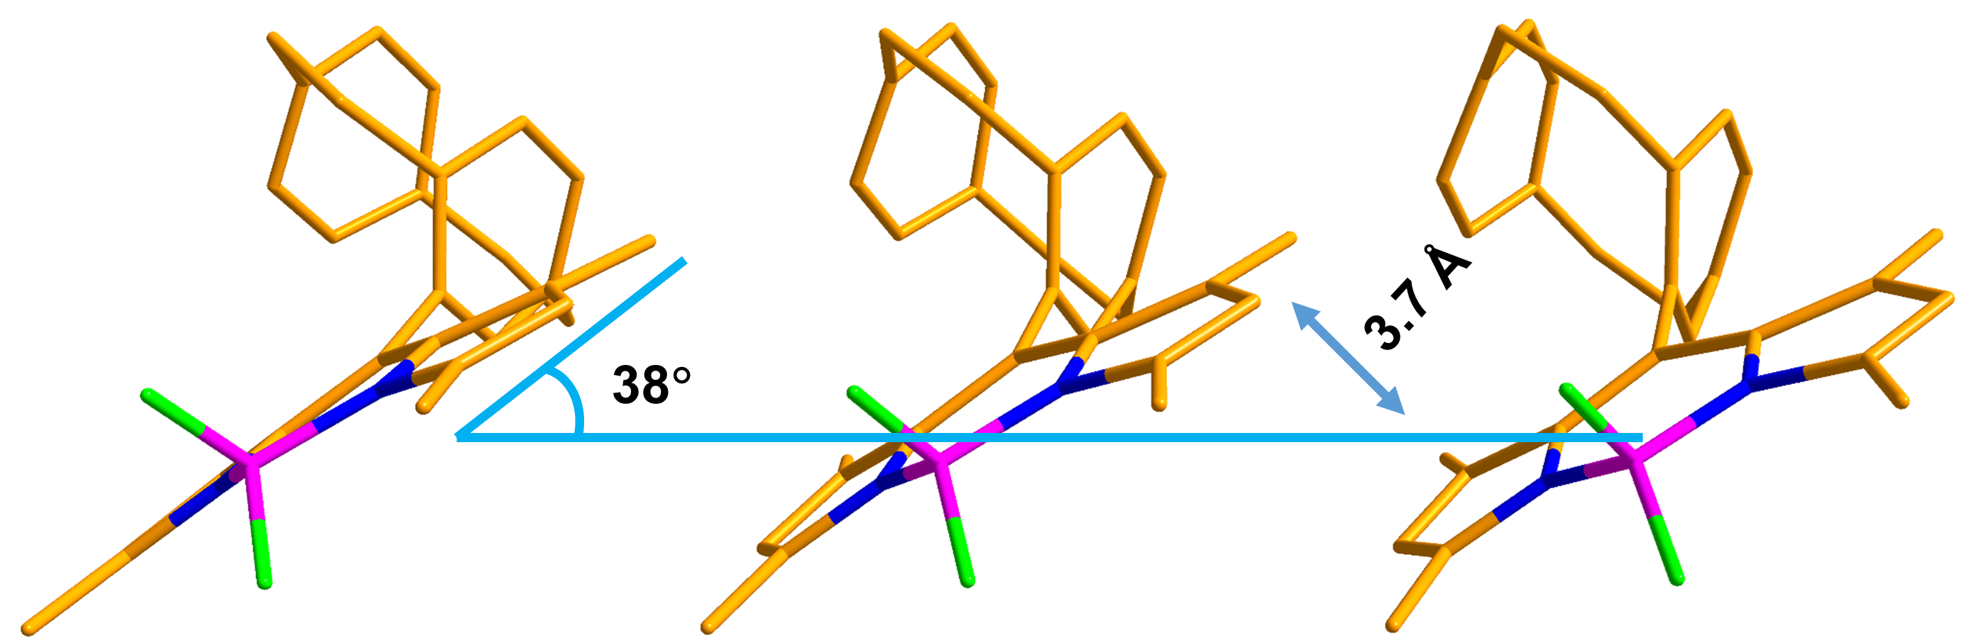
Figure S1. Packing diagram of PCP-BDP1. Solvent molecules and H atoms are omitted for clarity.

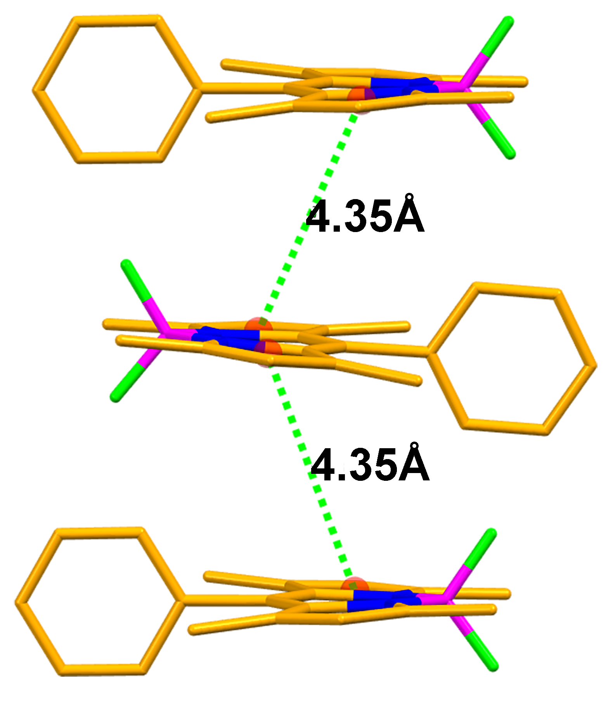

Figure S2. Packing diagram of Ph-BDP1 (CCDC No. 1858006). H atoms are omitted for clarity.

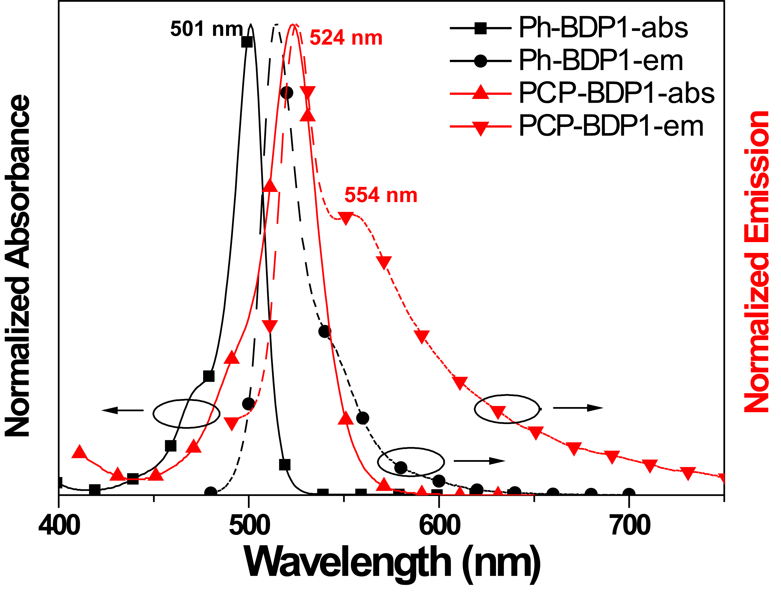
Figure S3. Normalized spectra of Ph-BDP1 and PCP-BDP1 in DCM (1.0×10⁻⁵ mol L⁻¹).

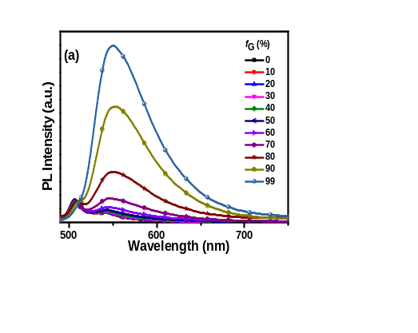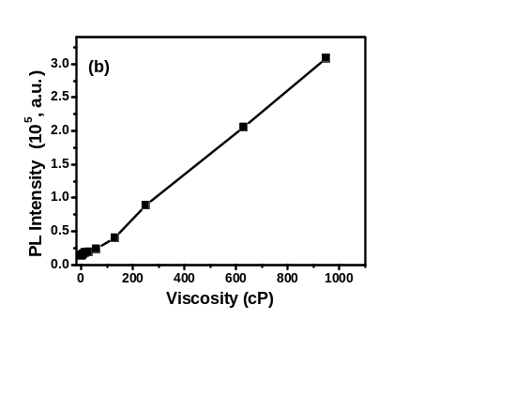
Figure S4. (a) Fluorescence spectra of PCP-BDP1 in MeOH/Glycerol binary solvents (10 μM) with varied volumetric fractions of Glycerol (f_{G}). λ_{ex} = 470 nm. (b) Fluorescence intensity changes at 550 nm vs viscosity for PCP-BDP1.

Table S2. Calculated excited wavelength (λ) and oscillator strengths (f) and related wave functions
Compound |  | Electronic transition ^{[a] [b]} | Energy [eV] | λ [nm] | f^{[c]} | Orbitals (coefficient)^{[d]}
Ph-BDP1 |  | S₀→S₁ | 2.9155 | 425.26 | 0.5926 | H>L (97%), H-1>L (3%), H<L (2%)
 |  | S₁→S₀ | 2.6772 | 463.12 | 0.7293 | H>L (99%)
PCP-BPD1 |  | S₀→S₁ | 2.6953 | 460.01 | 0.2732 | H>L (72%), H-1>L (24%), H-3>L (3%)
 |  | S₀→S₂ | 2.8680 | 432.31 | 0.2146 | H>L (26%), H-1>L (69%), H-3>L (4%)
 |  | S₁→S₀ | 2.1258 | 583.24 | 0.0900 | H>L (77%), H-1>L (20%)
 |  | S₂→S₀ | 2.5344 | 489.20 | 0.4344 | H>L (19%), H-1>L (76%), H-2>L (4%)
Ph-BDP2 |  | S₀→S₁ | 1.7855 | 694.38 | 1.0902 | H>L (99%)
 |  | S₀→S₂ | 2.3663 | 523.97 | 0.5364 | H-1>L (94%), H>L+1 (5%)
 |  | S₁→S₀ | 1.5373 | 806.53 | 1.2319 | H>L (99%)
PCP-BPD2 |  | S₀→S₁ | 1.7083 | 725.80 | 0.9949 | H>L (99%)
 |  | S₀→S₂ | 2.2836 | 542.94 | 0.6569 | H-1>L (95%), H>L+1 (4%)
 |  | S₁→S₀ | 1.4361 | 863.36 | 1.0867 | H>L (99%)
^{[a]} Only selected excited states were considered. ^{[b]} DCM was employed as the solvent for the DFT calculations. ^{[c]} Oscillator strength. ^{[d]} MOs involved in the transitions. H = HOMO; L = LUMO. Coefficient of the wavefunction for each excitation.

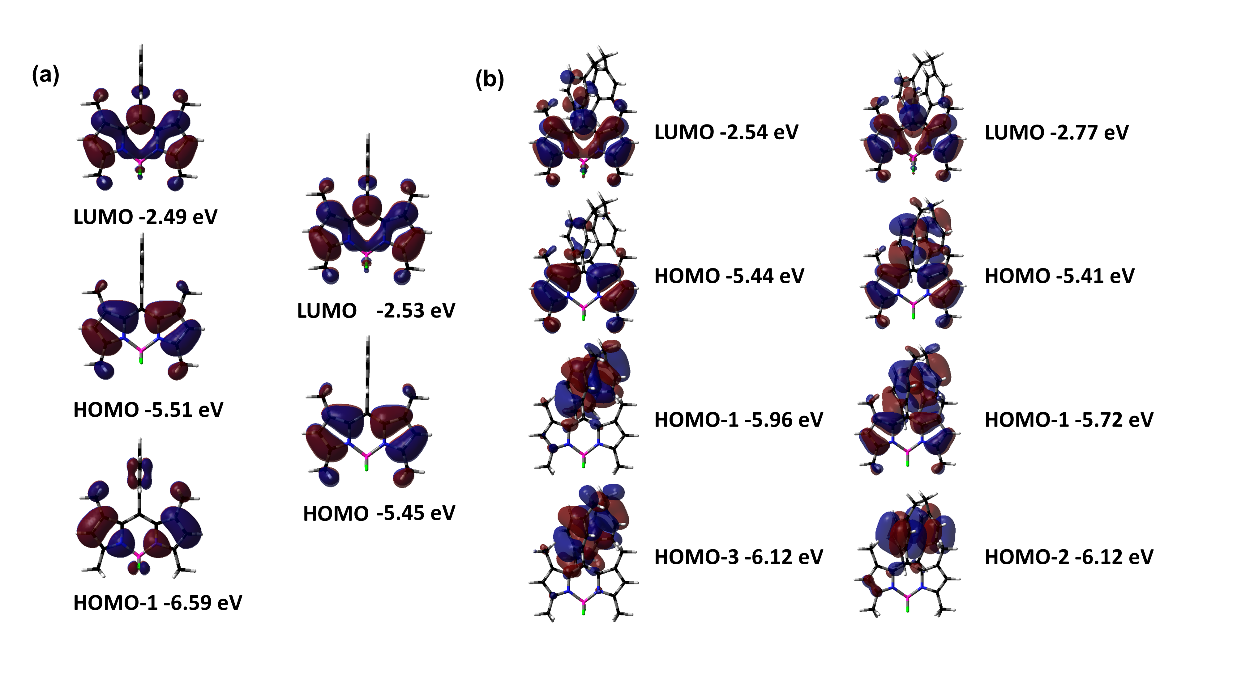
Figure S5. Calculated frontier molecular orbitals for Ph-BDP1 and PCP-BDP1 and their orbital energies in the optimized ground (left) and excited state (right).

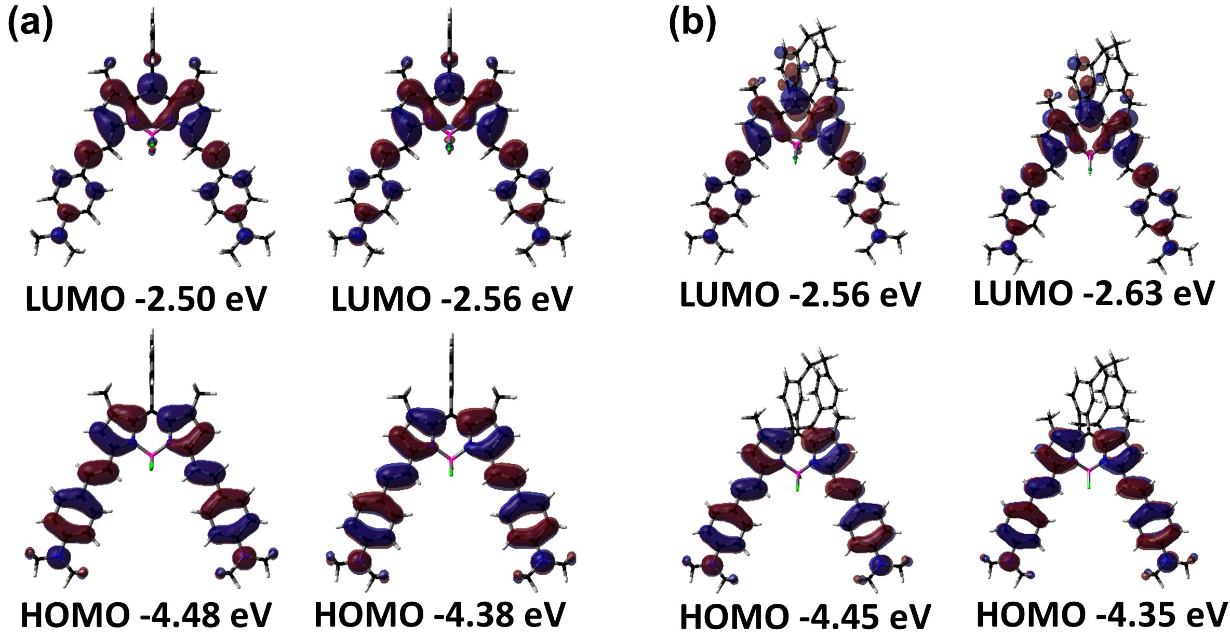
Figure S6. Calculated frontier molecular orbitals for Ph-BDP2 and PCP-BDP2 and their orbital energies in the optimized ground (left) and excited state (right).
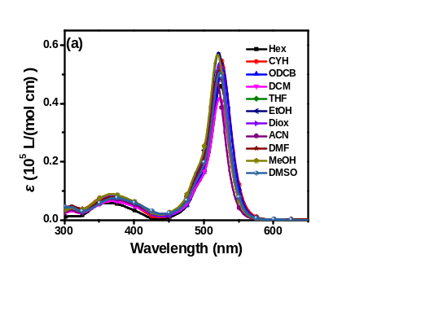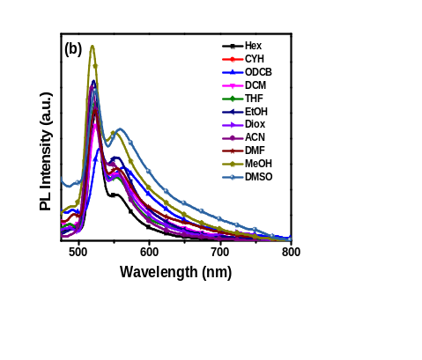
Figure S7. Absorption (a) and emission (b) spectra of PCP-BDP1 (10 μM) in various solvents including hexane (Hex), cyclohexane (CYH), 1,2-dichlorobenzene (ODCB), dichloromethane (DCM), tetrahydrofuran (THF), ethanol (EtOH), 1,4-dioxane (Diox), acetonitrile (ACN), N,N-dimethylformamide (DMF), methanol (MeOH), dimethyl sulfoxide (DMSO), respectively.

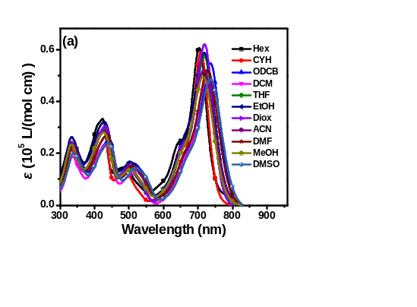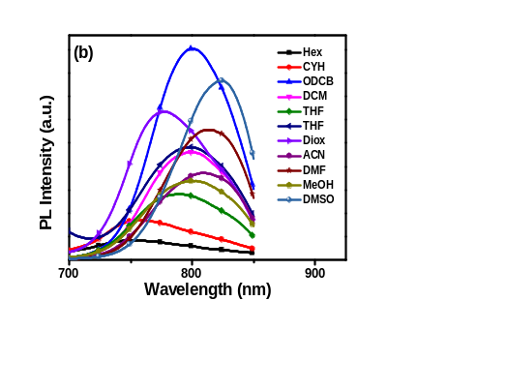
Figure S8. Absorption (a) and emission (b) spectra of PCP-BDP2 (10 μM) in various solvents including hexane (Hex), cyclohexane (CYH), 1,2-dichlorobenzene (ODCB), dichloromethane (DCM), tetrahydrofuran (THF), ethanol (EtOH), 1,4-dioxane (Diox), acetonitrile (ACN), N,N-dimethylformamide (DMF), methanol (MeOH), dimethyl sulfoxide (DMSO), respectively.

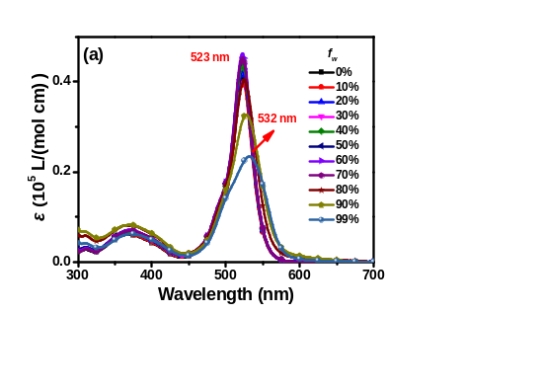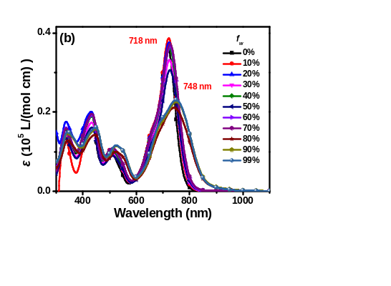
Figure S9. Absorption spectra of PCP-BDP1 (a) (10 μM) and PCP-BDP2 (b) (10 μM) in THF-water binary solvents varied f_{w}.

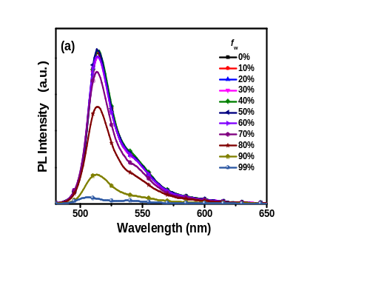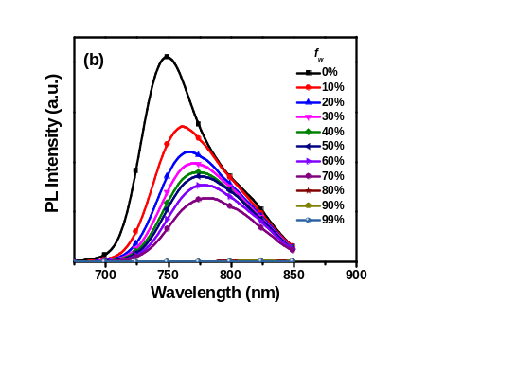
Figure S10. Emission spectra of Ph-BDP1 (10 μM) (a) and Ph-BDP2 (b) (10 μM) in THF-water mixtures with varied volumetric fractions of water (f_{w}).

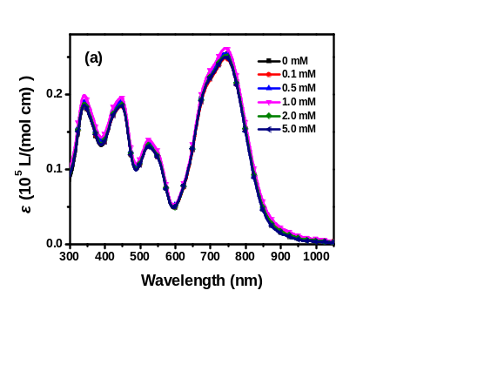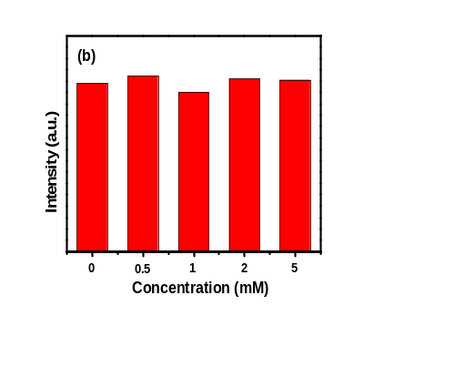
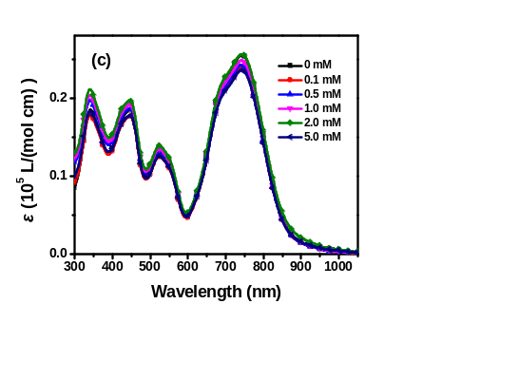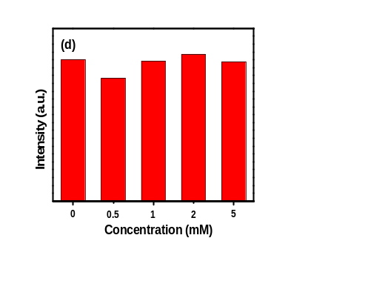
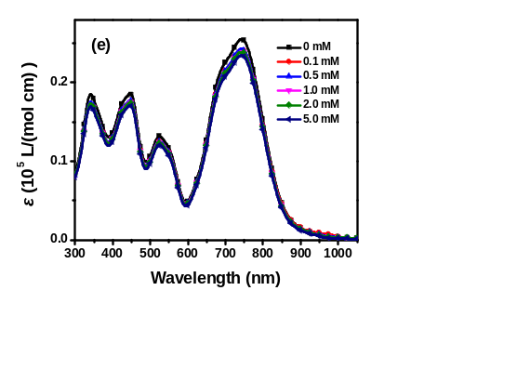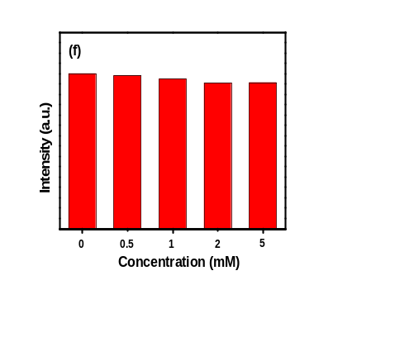
Figure S11. Absorption spectra and emission intensity of PCP-BDP2 NPs against cysteine (Cys) (a-b), glutathione (GHS) (c-d), and hydrogen peroxide (H₂O₂) (e-f). PCP-BDP2 NPs were incubated with different medium at room temperature for 6 h.

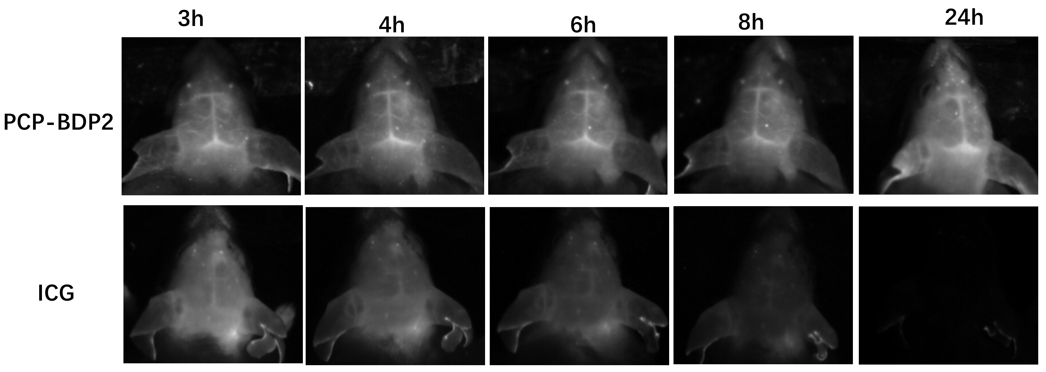
Figure S12. The fluorescent imaging of brain blood vessels at other time points of PCP-BDP2 NPs and ICG.
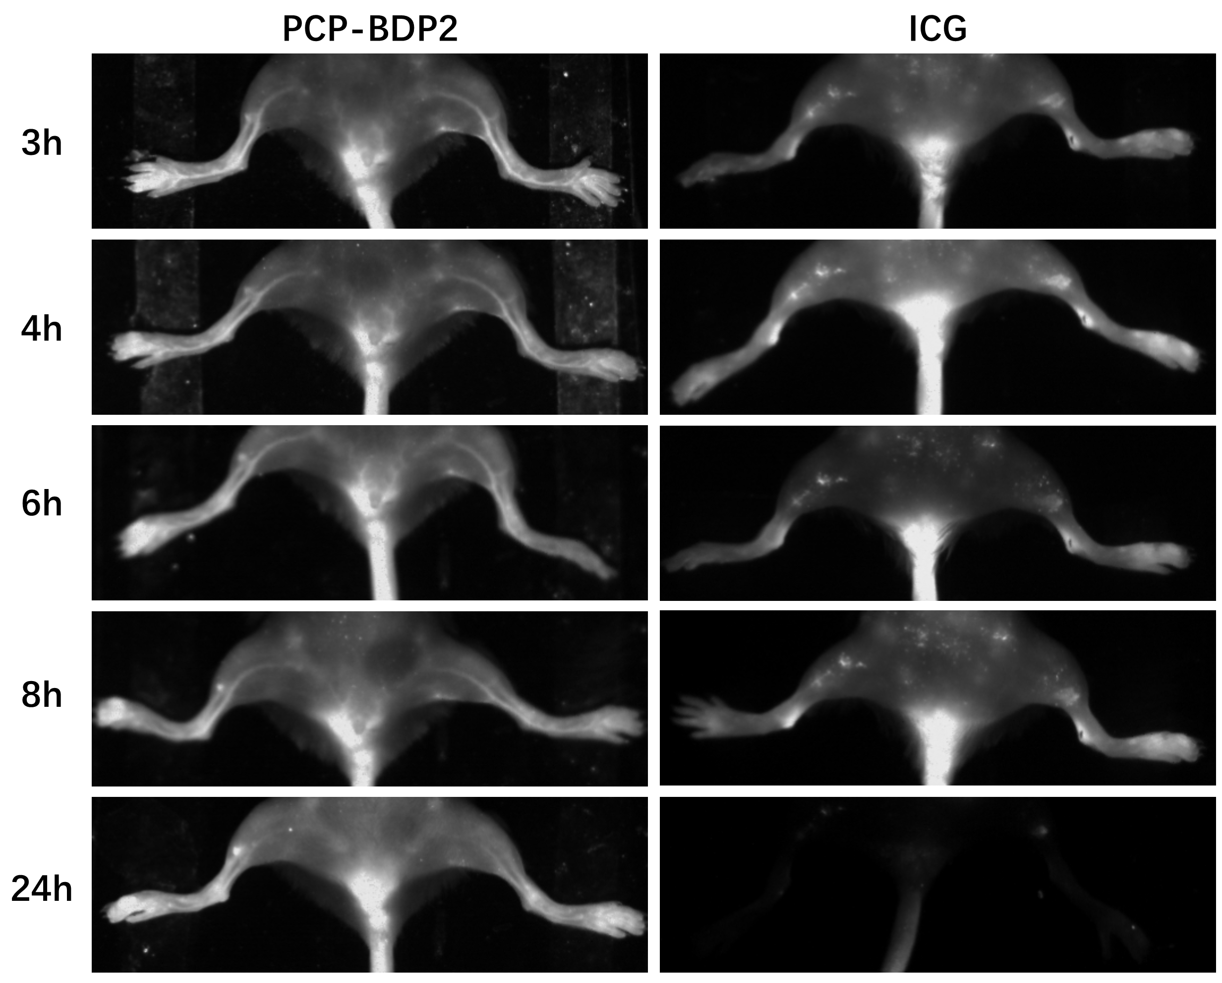
Figure S13. The fluorescent imaging of hindlimb vessels at other time points of PCP-BDP2 NPs and ICG.

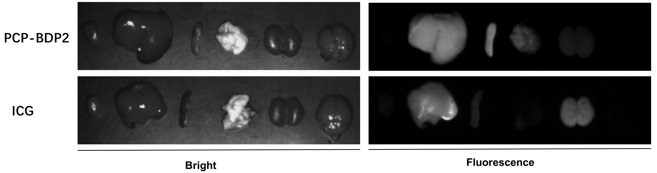Figure S14. In vivo biodistribution of PCP-BDP2 NPs and ICG in mice.

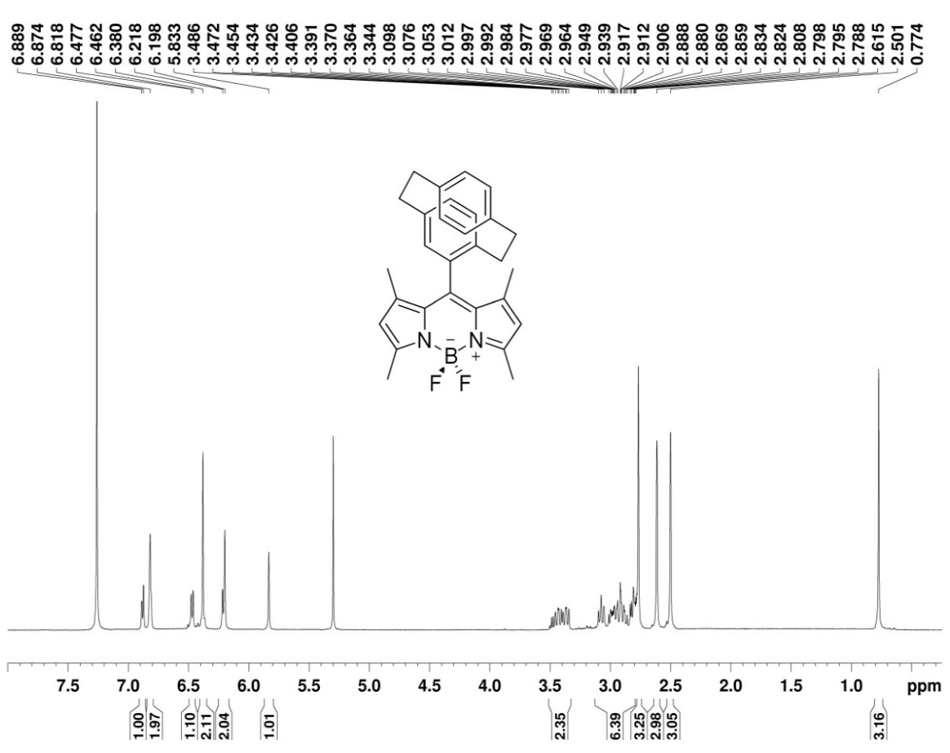
Figure S15. ¹H NMR spectrum of PCP-BDP1 in CDCl₃.
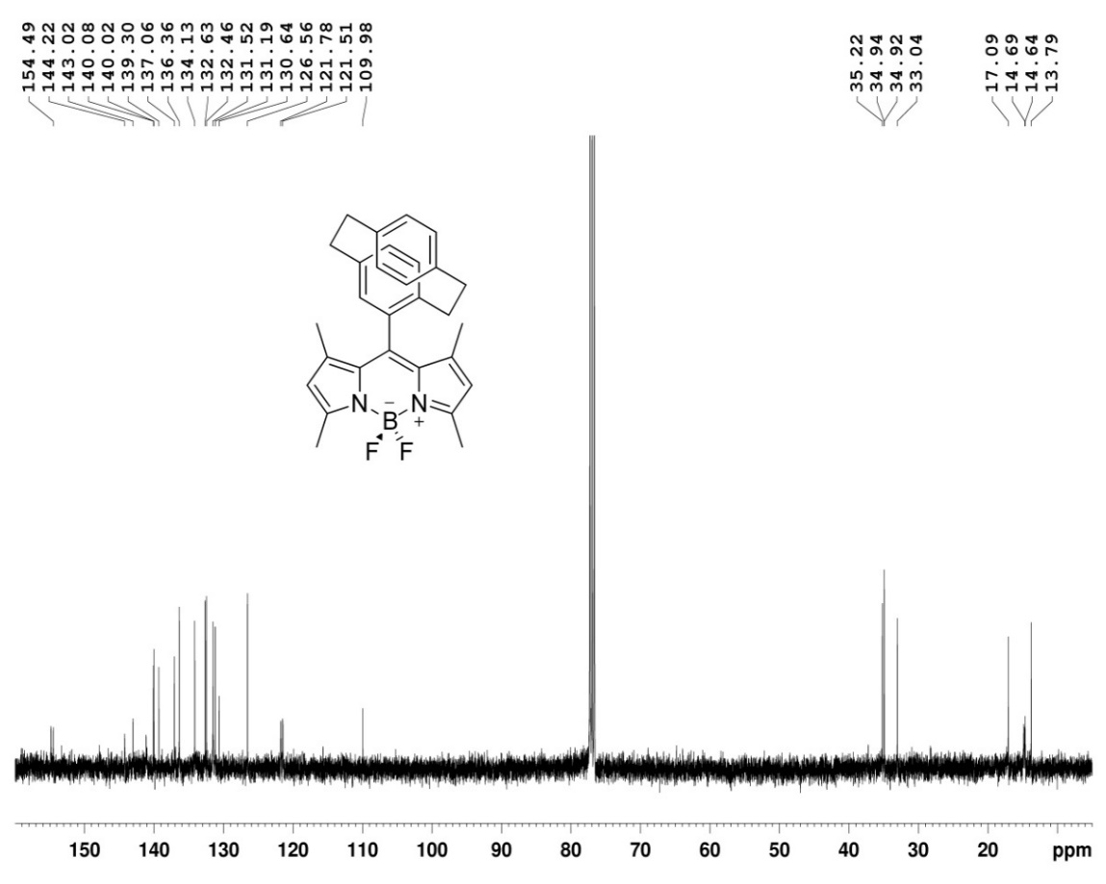
Figure S16. ¹³C NMR spectrum of PCP-BDP1 in CDCl₃.
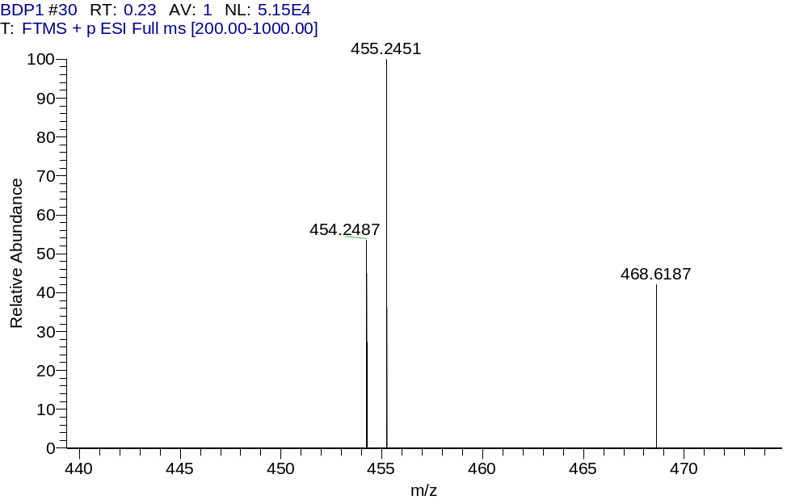
Figure S17. HRMS spectrum of PCP-BDP1.

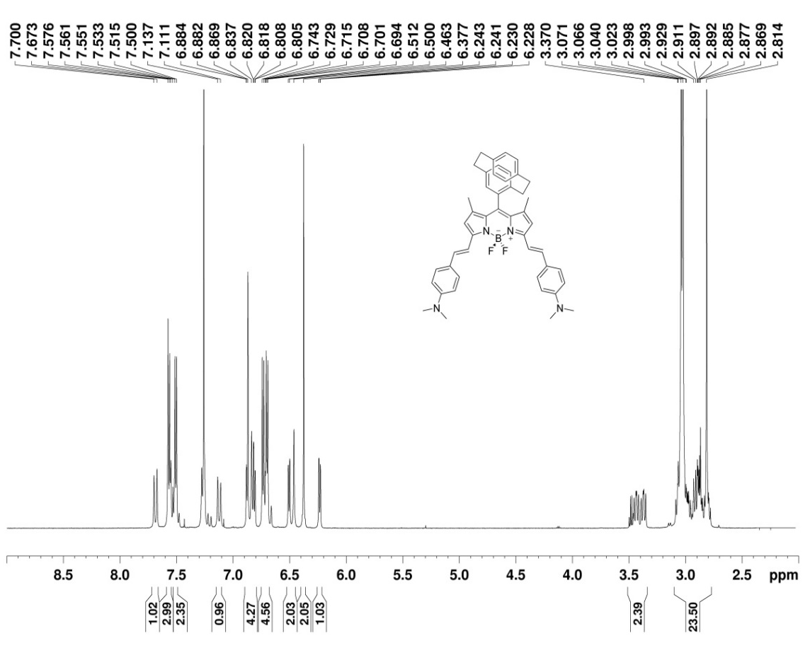
Figure S18. ¹H NMR spectrum of PCP-BDP2 in CDCl₃.

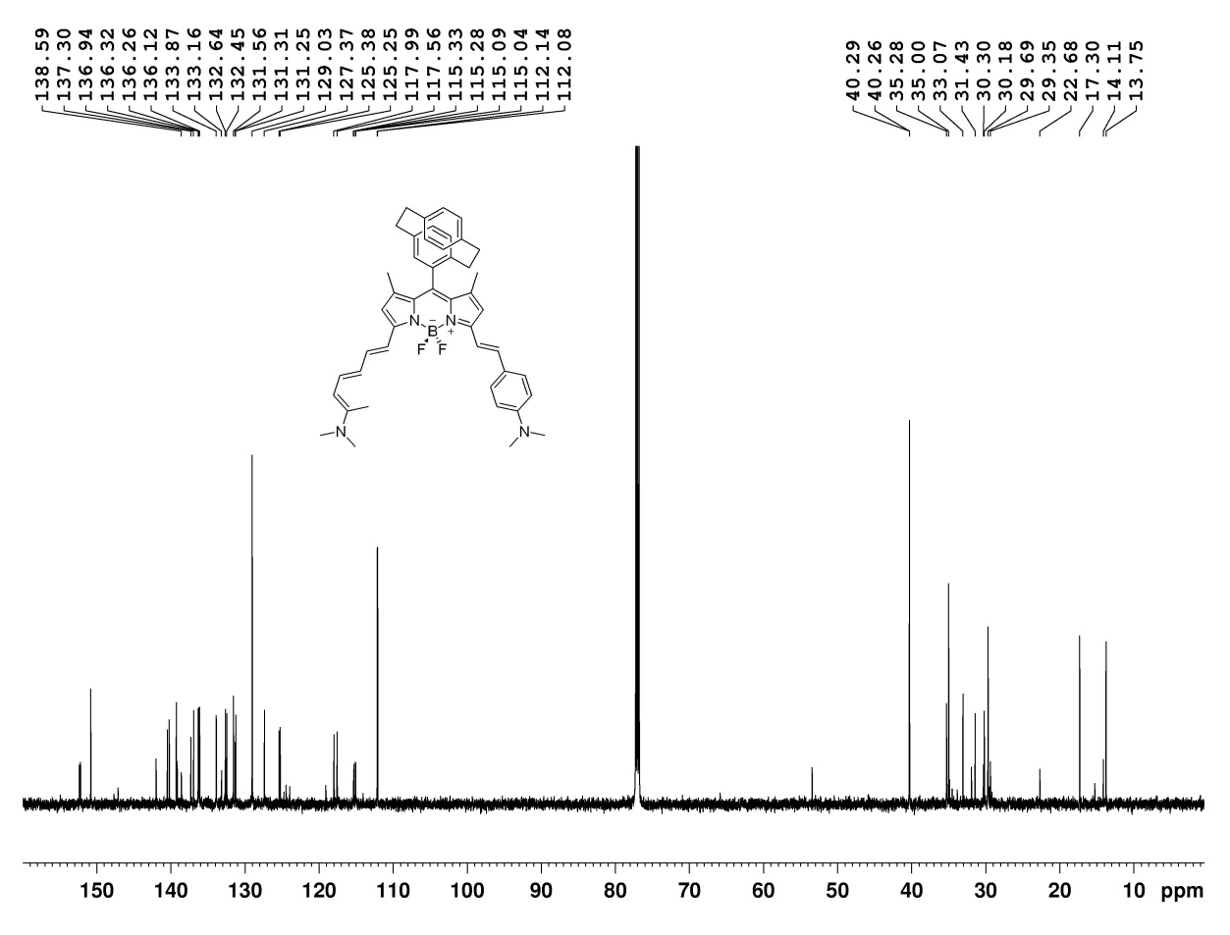
Figure S19. ¹³C NMR spectrum of PCP-BDP2 in CDCl₃.
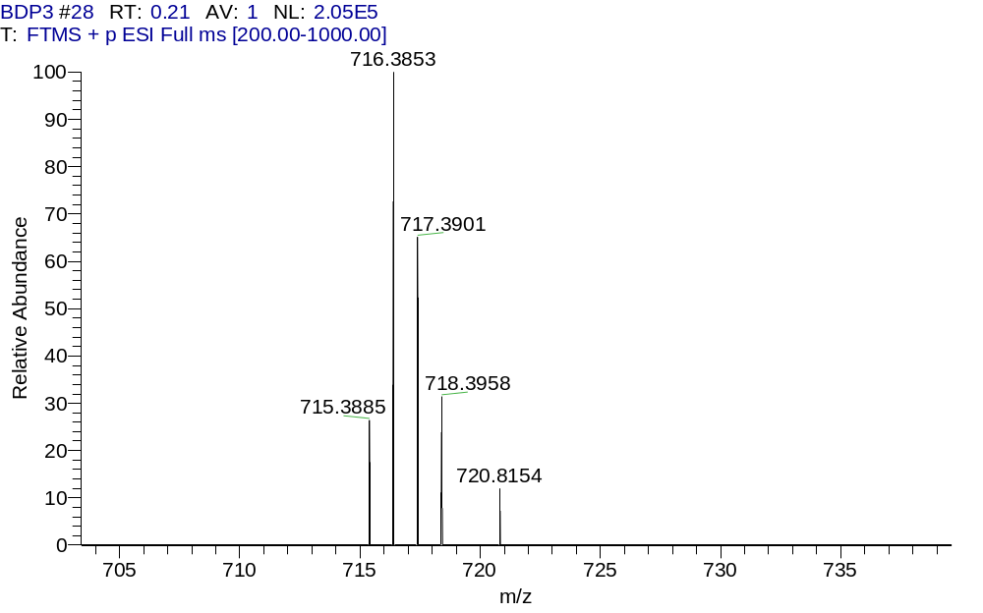
Figure S20. HRMS spectrum of PCP-BDP2

10. References
1. (a) Kollmannsberger, M.; Gareis, T.; Heinl, S.; Breu, J.; Daub, J., Electrogenerated Chemiluminescence and Proton‐Dependent Switching of Fluorescence: Functionalized Difluoroboradiaza‐s‐indacenes. Angew. Chem. Int. Ed. 1997, 36 (12), 1333-1335; (b) Deniz, E.; Isbasar, G. C.; Bozdemir, O. A.; Yildirim, L. T.; Siemiarczuk, A.; Akkaya, E. U., Bidirectional switching of near IR emitting boradiazaindacene fluorophores. Org. Lett. 2008, 10 (16), 3401-3.
2. Friedmann, C. J.; Ay, S.; Brase, S., Improved synthesis of enantiopure 4-hydroxy[2.2]paracyclophane. J. Org. Chem. 2010, 75 (13), 4612-4.
3. Sheldrick, G. M., Crystal structure refinement with SHELXL. Acta Crystallogr C Struct Chem 2015, 71 (Pt 1), 3-8.

