Table S1. 50 selected gene probes.
Probe | Gene
8156228 | CTSL1
8051066 | MPV17, MPV17
8028652 | ZFP36
7952325 | HSPA8
8179827 | CLIC1
7948606 | C11orf10
8101322 | MOP-1
8138466 | MACC1
8146216 | VDAC3
7985166 | IREB2
8178891 | HLA-DPA1
8041015 | SLC4A1AP
8156538 | HIATL1
8125556 | HLA-DPA1
7989735 | CLPX
7904726 | TXNIP
8115831 | DUSP1
7978905 | RN7SL2, RN7SL1
8117800 | HLA-B, HLA-A, HLA-A
8088526 | THOC7
8046604 | AGPS
7934196 | PSAP
7905571 | S100A9
7965812 | GNPTAB
8178435 | IER3
8054611 | LOC541471, LINC00152
8112033 | ARL15
8068593 | ETS2
8114861 | LARS
7953385 | GAPDH
8043363 | LOC541471, LINC00152
8071649 | LOC96610, BMS1
7985662 | PDE8A
7933084 | NAMPT
8056201 | RBMS1
8069541 | SAMSN1, SAMSN1
8154531 | DENND4C
8177732 | HLA-B, HLA-A
7961142 | OLR1
8166469 | SAT1
7954997 | ANO6
7903507 | FAM102B
7935776 | SCD
7968344 | ALOX5AP
7960865 | SLC2A3
7963046 | TUBA1B
8131844 | GPNMB
7962085 | IPO8
8040386 | DDX1
7981722 | IGHG1, IGHA1, IGHV3-48

Table S2. Support Vector Regression results (MSE and variance explained).
Traits (mean) | DEG | H.var | H.sig | top.genes | top.genes.selected
POST FEV1/FVC  (0.7288) | 0.0168  (-0.147) | 0.0151  (-0.0502) | 0.0138  (0.0556) | 0.0119  (0.1828) | 0.0116  (0.1909)
PRE FEV1/FVC  (0.6976) | 0.0169  (-0.0865) | 0.0166  (-0.1414) | 0.0147  (-0.0157) | 0.0122  (0.1426) | 0.0122  (0.1522)

Table S3. LASSO results (MSE and variance explained).
Traits (mean) | DEG | H.var | H.sig | top.genes | top.genes.selected
POST FEV1/FVC  (0.7288) | 0.0154  (-0.0864) | 0.0139  (0.0227) | 0.0135  (0.0563) | 0.0128  (0.0569) | 0.0121  (0.134)
PRE FEV1/FVC  (0.6976) | 0.0154  (-0.0835) | 0.0141  (0.0004) | 0.0139  (0.0284) | 0.0138  (-0.008) | 0.0130  (0.071)

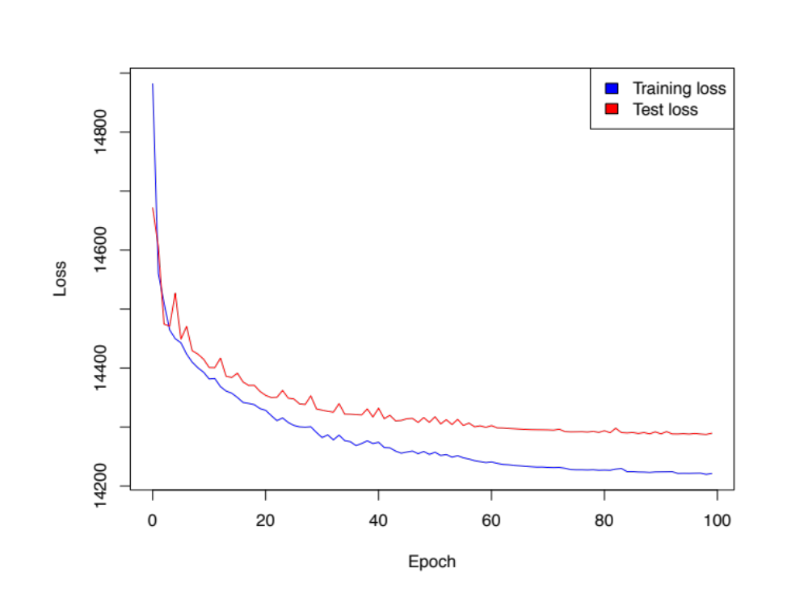
Fig S1. Convergence of the average training and test loss.

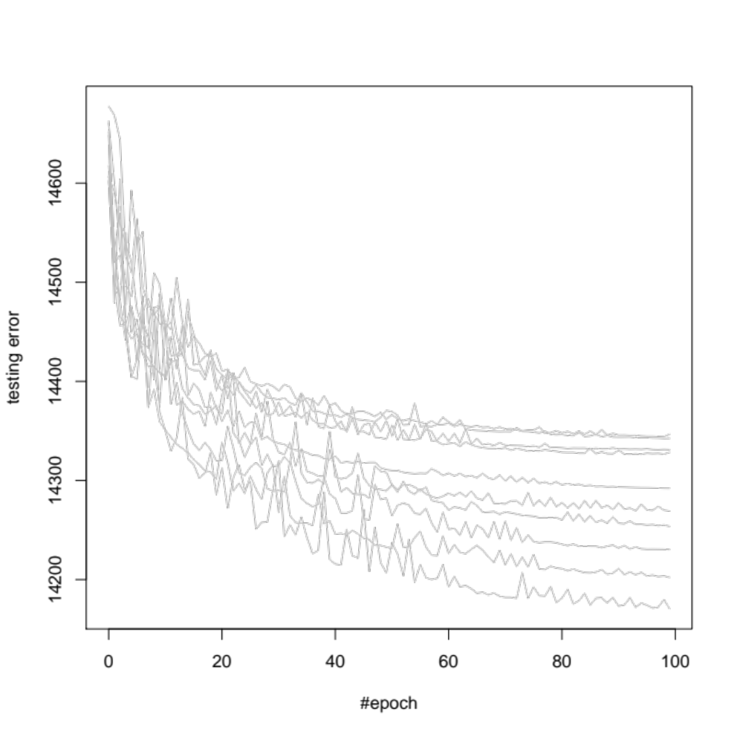
Fig S2. Convergence of cross validation with 10 repeats.
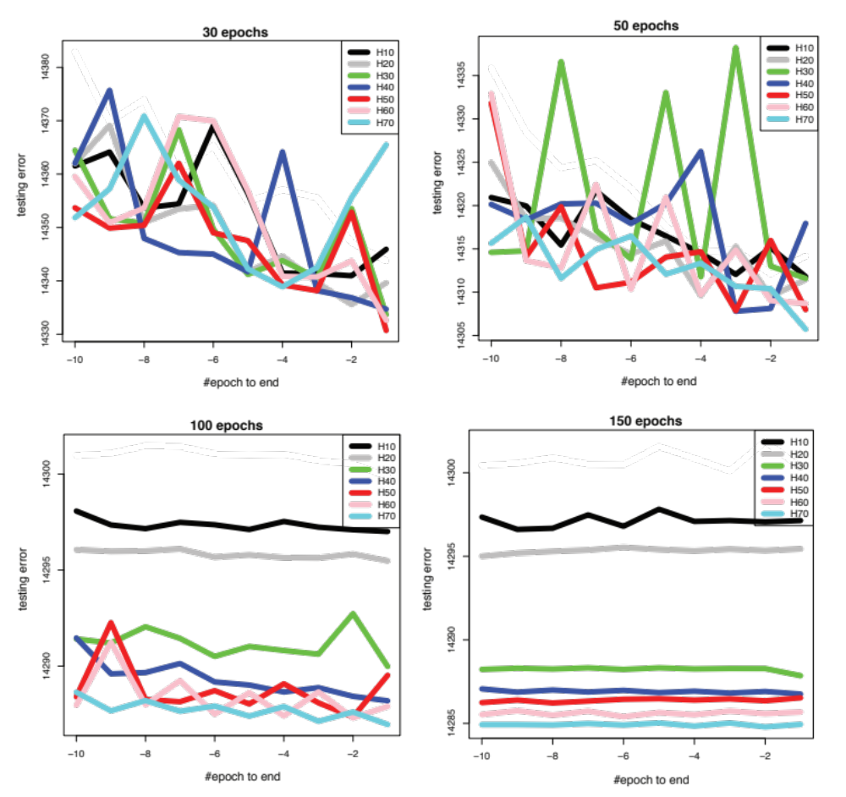
Fig S3. Selection of number of hidden units based on test error.

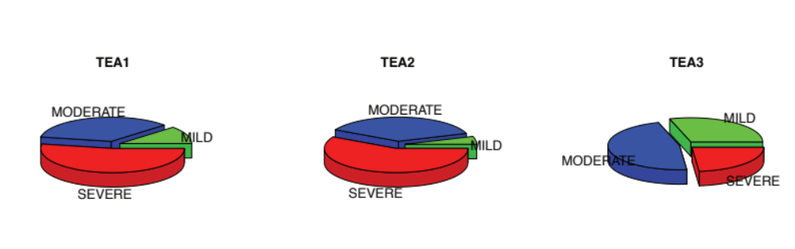
Fig S4. Demographics of the TEA clusters.

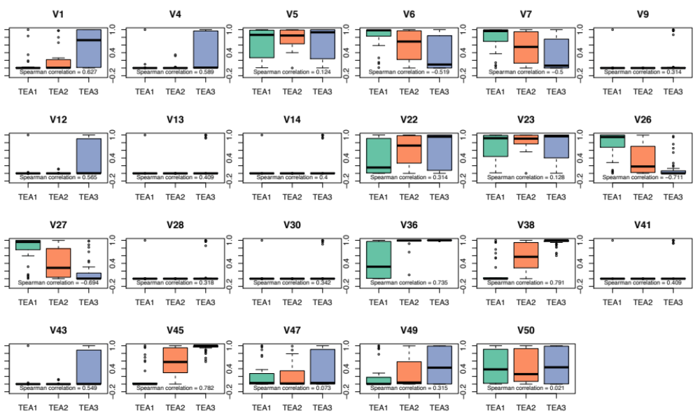
Fig S5. Spearman correlation between hidden unit values and TEA cluster labels.

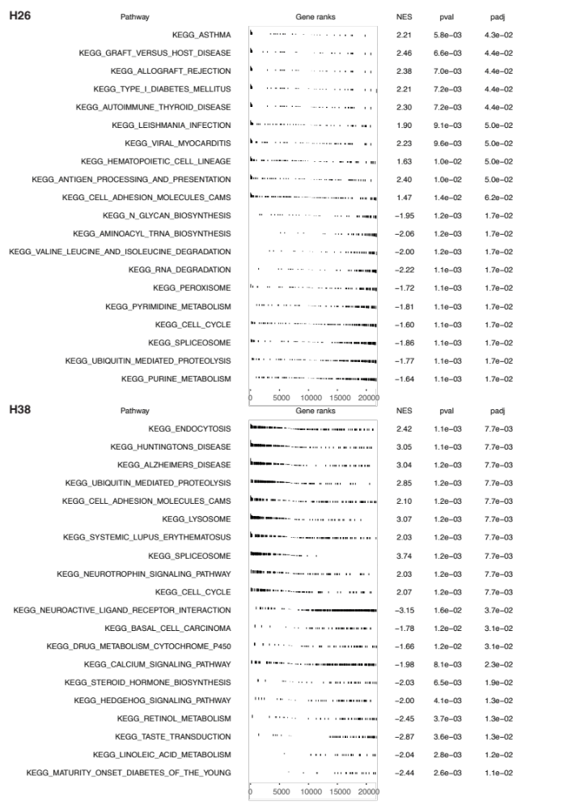

Fig S6. GSEA results of two sample hidden units using encoder weights, H26 from the negative set and H38 from the positive set.
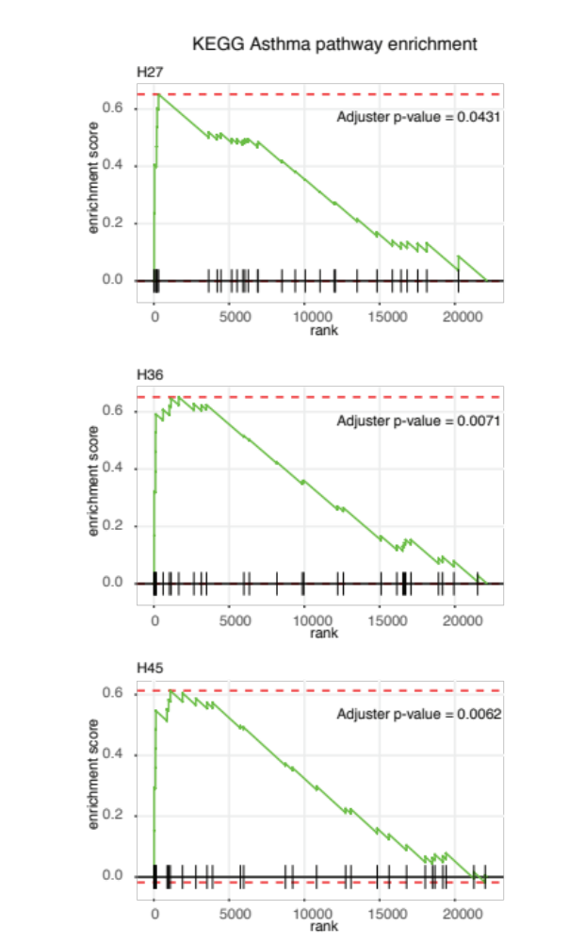
Fig S7. Gene set enrichment of asthma pathway from KEGG (KEGG_ASTHMA) for H27, H36 and H45

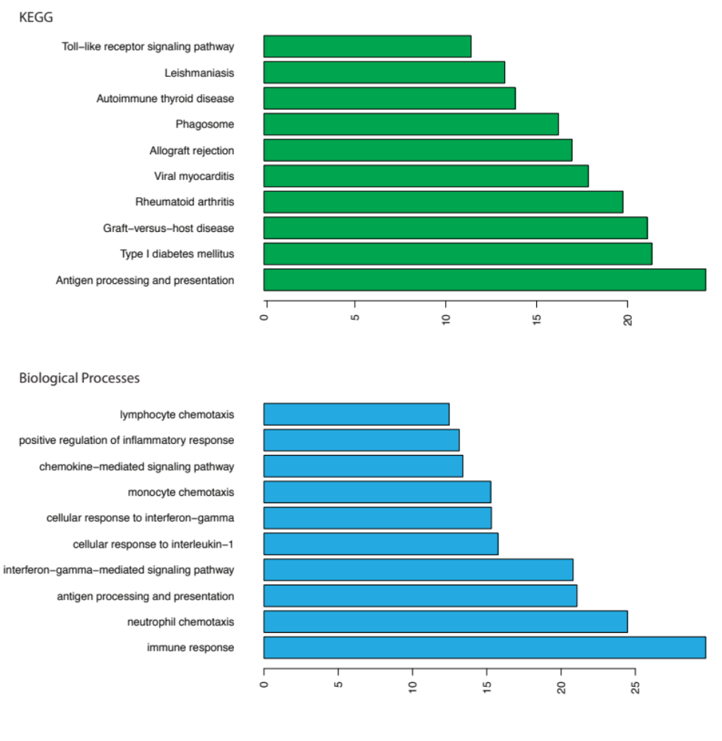
Fig S8. GSEA results of two sample hidden units using encoder weights, H26 from the negative set and H38 from the positive set.

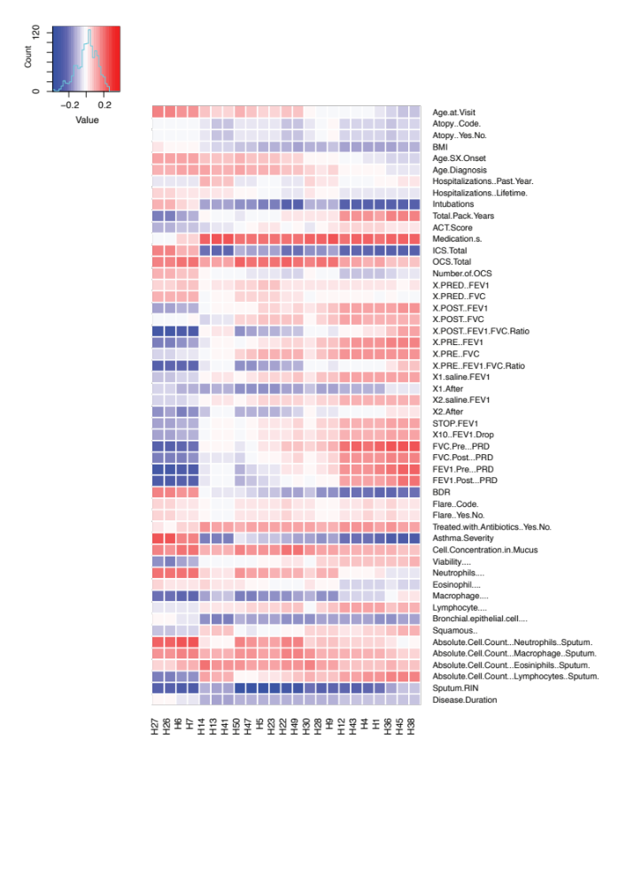
Fig S9. Correlation between hidden unit values and clinical traits.
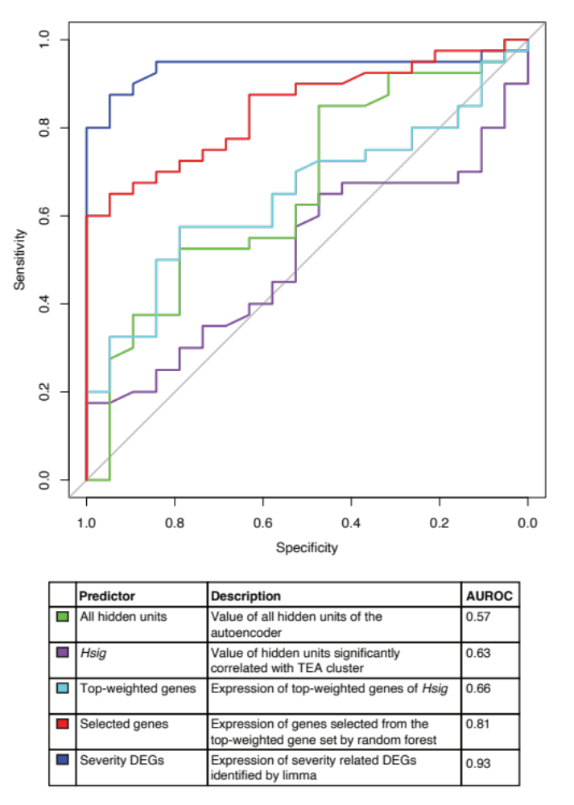
Fig S10. AUROC of the prediction of asthma severity using different feature sets.

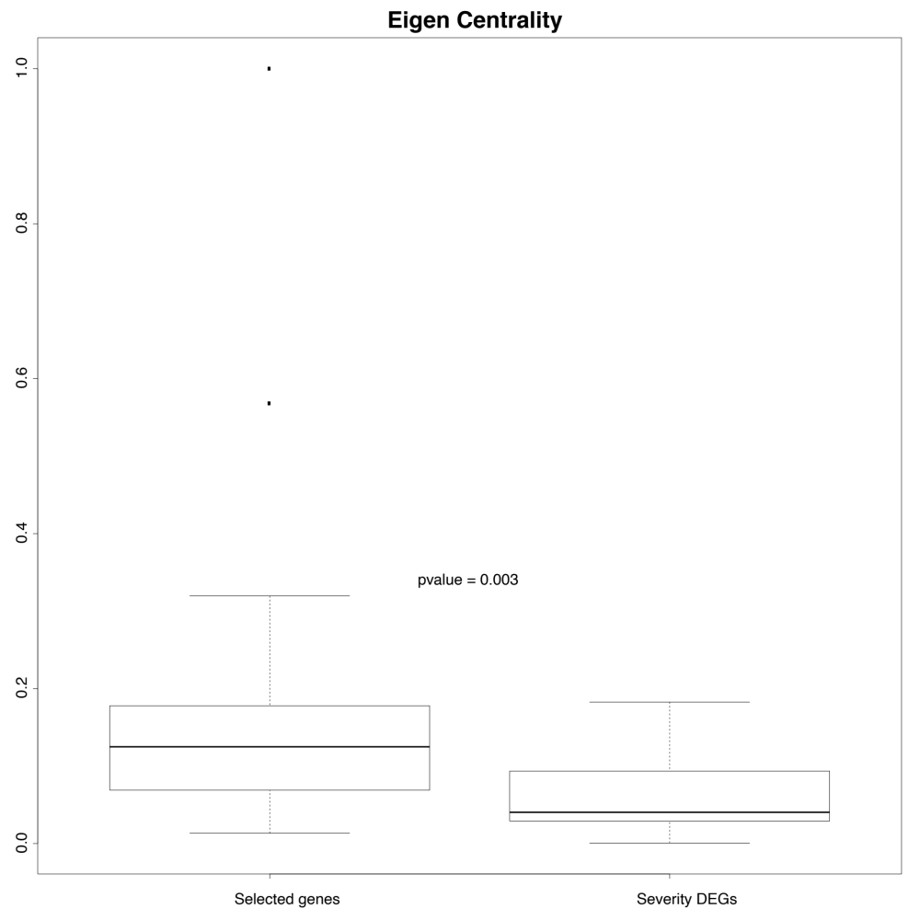
Fig S11. Comparison of network centrality between our selected genes and severity-related DEGs.

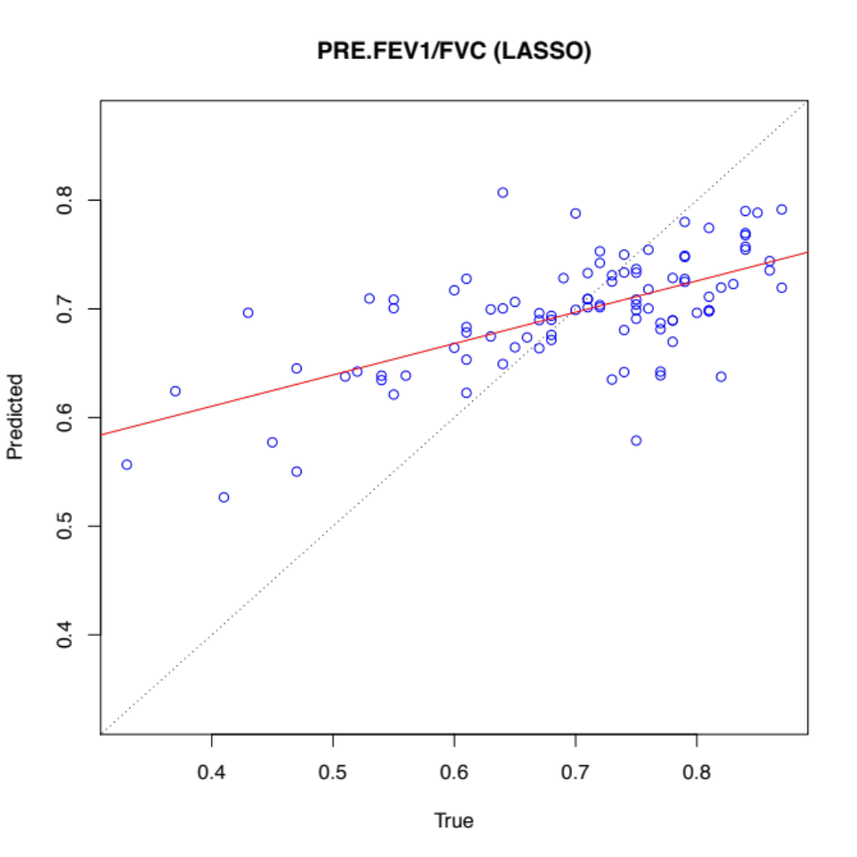
Fig S12. Plot of predicted value v.s true value of pre-treatment FEV1/FVC using LASSO with selected gene expression.

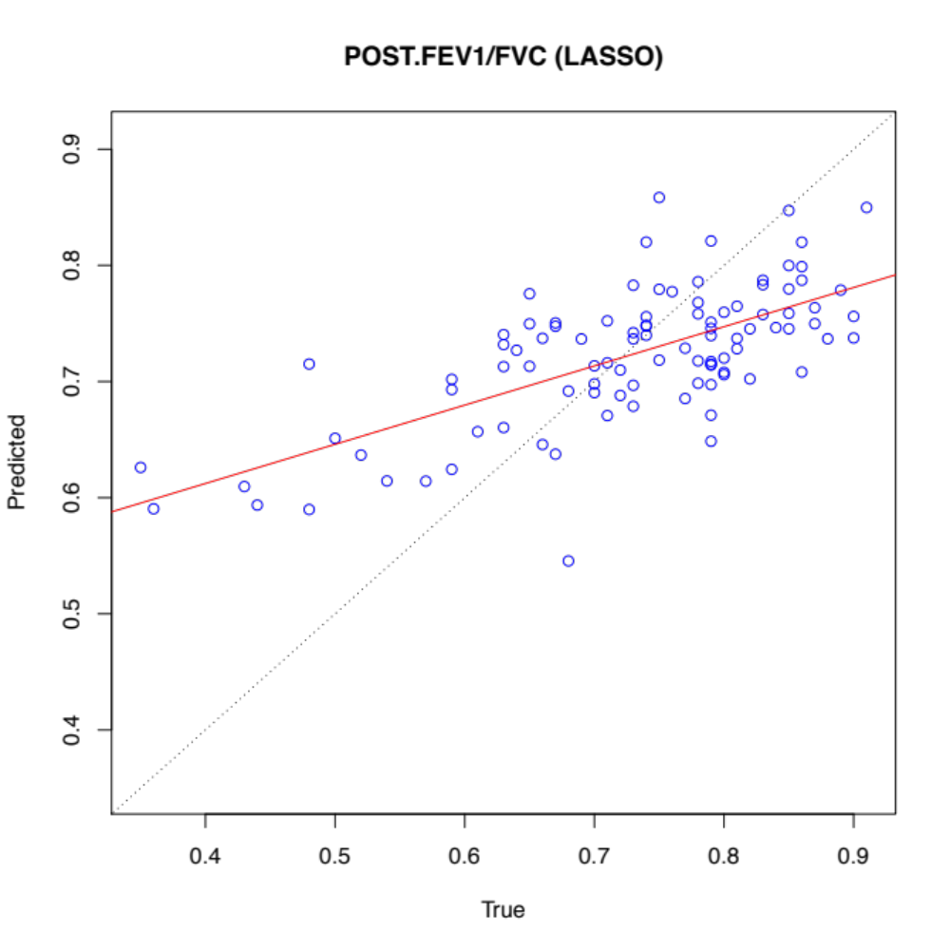
Fig S13. Plot of predicted value v.s true value of post-treatment FEV1/FVC using LASSO with selected gene expression.

.

