Supplemental Figures
eFig. 1 Study flow chart.
eFig. 2 Frequency distribution of patients according to the time interval (TI) to initiation of adjuvant chemotherapy based on pathological staging .

eFig.1
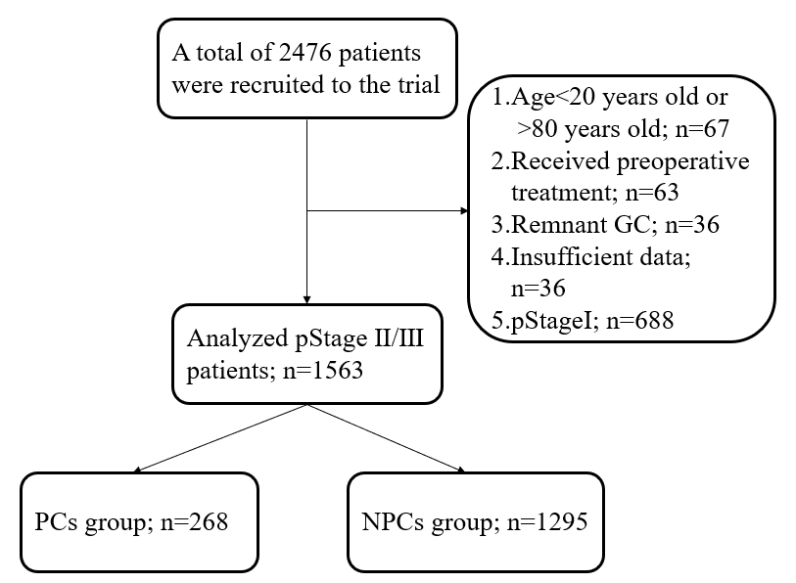

eFig.2
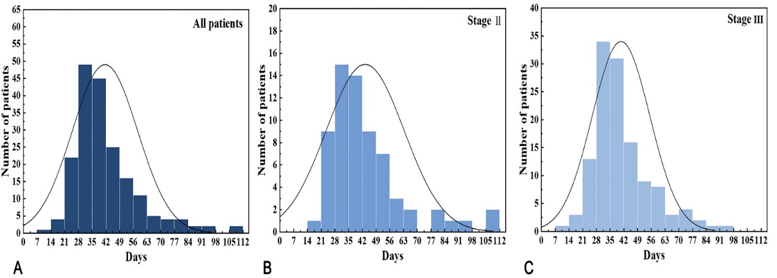

Supplemental 1 eTables
eTable 1 Type and time of recurrence in chemotherapy cohort after surgery
eTable 2 Type and time of recurrence in Pstage Ⅱ chemotherapy cohort after surgery
eTable 3 Type and time of recurrence in Pstage ⅡI chemotherapy cohort after surgery
eTable 4 Univariate analyses of factors associate with overall survival in entire group complication group、Non-complication group
eTable 5 Multivariable analysis of risk factors associated with overall survival in entire group、postoperative complications(PC) group and non-complications(NPC) group.
eTable 6 Univariate analyses of factors associate with Recurrence-free survival in entire group、complication group、Non-complication group
eTable 7 Multivariable analysis of risk factors associated with Recurrence-free survival in entire group、postoperative complications(PC) group and non-complications(NPC) group.

eTable1 Detail of complications
Type of complications | Total(%) | Grade according to Clavien-Dindo classification
Type of complications | Total(%) | II III IV/V
All complications | 268(17.14) | 206 | 34 | 28
Wound complications | 16(1.08%) | 10 | 5 | 1
Intra-abdominal infection | 60(3.83%) | 45 | 8 | 7
Anastomotic leakage | 34(2.17%) | 21 | 9 | 4
Pulmonary infection | 106(6.78%) | 89 | 8 | 9
Other complications | 52(3.32%) | 41 | 4 | 7
*Wound complications include wound infection and wound dehiscence
*Other complications include postoperative bleeding、reflux esophagitis、dumping syndrome and delayed gastric emptying
*Values are numbers of patients, unless indicated otherwise

eTable2 Type and time of recurrence in chemotherapy cohort after surgery
 | Type of Recurrence |  |  |  | Median time to recurrence (months)
 | PC group | NPC group | p value |  | PC group | NPC group | p value
Overall | 124 (46.3%) | 533 (41.2%) | 0.123 |  | 15.8 | 17.6 | 0.618
Local recurrence | 11（4.1%） | 70（5.4%） | 0.382 |  | 55.0 | 50.0 | 0.238
Peritoneal metastasis | 40（13.8%） | 160（12.4%） | 0.243 |  | 24.0 | 17.7 | 0.188
Distant metastasis | 87（32.5%） | 380（29.3%） | 0.310 |  | 16.6 | 14.7 | 0.637

eTable 3 Type and time of recurrence in PstageⅡchemotherapy cohort after surgery
 | Type of Recurrence |  |  |  | Median time to recurrence (months)
 | PC group | NPC group | p value |  | PC group | NPC group | p value
Overall | 17 (20.0%) | 75(17.4%) | 0.567 |  | 68 | 72 | 0.467
Local recurrence | 4（4.7%） | 29（6.7%） | - |  | 62.5 | 53 | -
Peritoneal metastasis | 3（3.5%） | 13（3.0%） | - |  | 40 | 36 | -
Distant metastasis | 13（15.3%） | 57（13.2%） | 0.611 |  | 33 | 29 | 0.889

eTable 4 Type and time of recurrence in Pstage Ⅲ chemotherapy cohort after surgery
 | Type of Recurrence |  |  |  | Median time to recurrence (months)
 | PC group | NPC group | p value |  | PC group | NPC group | p value
Overall | 107 (58.5%) | 458 (53.0%) | 0.178 |  | 25 | 27.5 | 0.138
Local recurrence | 7（2.3%） | 41（29.5%） | - |  | 13 | 47 | -
Peritoneal metastasis | 34（18.6%） | 147（17%） | 0.176 |  | 20 | 17 | 0.280
Distant metastasis | 74（40.4%） | 323（37.4%） | 0.439 |  | 14 | 15 | 0.635

eTable 5 Univariate analyses of factors associate with overall survival in entire group complication group、Non-complication group
Univariate | entire group |  |  | PC group |  |  | NPC group
 | HR | 95%CI | P value | HR | 95%CI | P value | HR | 95%CI | P value
Sex
Male | 1.000 |  |  | 1.000 |  |  | 1.000
Female | 1.034 | 0.879-1.216 | 0.687 | 1.174 | 0.802-1.719 | 0.408 | 1.012 | 0.846-1.211 | 0.895
Age(years)
＜60 | 1.000 |  |  | 1.000 |  |  | 1.000
≥60 | 1.367 | 1.181-1.581 | ＜0.000 | 0.981 | 0.698-1.378 | 0.910 | 1.454 | 1.237-1.708 | ＜0.000
Surgery type
0 | 1.000 |  |  | 1.000 |  |  | 1.000
1 | 0.677 | 0.583-0.788 | 0.093 | 1.978 | 0.739-5.295 | 0.175 | 3.077 | 0.766-12.35 | 0.113
2 | 0.817 | 0.388-1.723 | 0.596 | 1.533 | 0.571-4.119 | 0.397 | 2.450 | 0.608-9.867 | 0.207
ASA
＜3 | 1.000 |  |  | 1.000 |  |  | 1.000
≥3 | 0.789 | 0.391-1.592 | 0.508 | 1.363 | 0.670-2.771 | 0.393 | 1.003 | 0.659-1.529 | 0.998
Tumor diameter(mm)
＜50 | 1.000 |  |  | 1.000 |  |  | 1.000
≥50 | 2.072 | 1.785-2.404 | ＜0.000 | 2.178 | 1.529-3.012 | ＜0.000 | 2.041 | 1.732-2.405 | ＜0.000
Tumor location
Upper | 1.000 |  |  | 1.000 |  |  | 1.000
Middle | 1.044 | 0.852-1.278 | 0.681 | 0.693 | 0.429-1.119 | 0.134 | 1.141 | 0.911-1.428 | 0.250
Lower | 0.816 | 0.679-0.981 | 0.031 | 0.676 | 0.447-1.023 | 0.064 | 0.854 | 0.695-1.049 | 0.132
Mix | 1.486 | 1.197-1.845 | ＜0.000 | 1.307 | 0.809-2.112 | 0.274 | 1.532 | 1.203-1.952 | 0.001
BMI
＜25 | 1.000 |  |  | 1.000 |  |  | 1.000
≥25 | 0.891 | 0.731-1.084 | 0.248 | 0.840 | 0.556-1.269 | 0.407 | 0.892 | 0.713-1.117 | 0.320
Vessel/Lymphatic
infiltration
Absent | 1.000 |  |  | 1,000 |  |  | 1.000
Present | 1.408 | 1.226-1.616 | ＜0.000 | 1.474 | 1.075-2.023 | 0.016 | 1.388 | 1.190-1.619 | ＜0.000
Never infiltration
Absent | 1.000 |  |  | 1.000 |  |  | 1.000
Present | 1.440 | 1.243-1.668 | ＜0.000 | 2.133 | 1.528-2.949 | ＜0.000 | 1.300 | 1.101-1.534 | 0.002
Adjuvant chemotherapy
No | 1.000 |  |  | 1.000 |  |  | 1.000
Yes | 0.673 | 0.573-0.792 | ＜0.000 | 0.576 | 0.406-0.816 | 0.002 | 0.707 | 0.588-0.849 | ＜0.000

eTable 6 Multivariable analysis of risk factors associated with overall survival in entire group、postoperative complications group(PC) and non-complications(NPC) group.
multivariate | entire group |  |  | PC group |  |  | NPC group
 | HR | 95%CI | P value | HR | 95%CI | P  value | HR | 95%CI | P  value
Age(years)
＜60 | 1.000 |  |  | 1.000 |  |  | 1.000
≥60 | 1.222 | 1.052-1,420 | 0.009 | 0.709 | 0.490-1.027 | 0.069 | 1.336 | 1.133-1.576 | 0.001
Tumor diameter(mm)
＜50 | 1.000 |  |  | 1.000 |  |  | 1.000
≥50 | 1.866 | 1.601-2.174 | ＜0.000 | 1.985 | 1.377-2.860 | ＜0.000 | 1.828 | 1.544-2.165 | ＜0.000
Tumor location
Upper | 1.000 |  |  | 1.000 |  |  | 1.000
Middle | 1.109 | 0.903-1.362 | 0.325 | 0.790 | 0.482-1.296 | 0.351 | 1.204 | 0.959-1.512 | 0.110
Lower | 1129 | 0.841-1.515 | 0.421 | 1.022 | 0.518-2.019 | 0.949 | 1.120 | 0.808-1.554 | 0.496
Mix | 1.403 | 1.128-1.746 | 0.002 | 1.166 | 0.705-1.926 | 0.550 | 1.486 | 1.164-1.897 | 0.001
Vessel/Lymphatic infiltration
Present | 1.000 |  |  | 1.000 |  |  | 1.000
Absent | 1.245 | 1.076-1.440 | 0.003 | 1.154 | 0.826-1.614 | 0.402 | 1.276 | 1.084-1.502 | 0.003
Nerve infiltration
Present | 1.000 |  |  | 1.000 |  |  | 1.000
Absent | 1.351 | 1.158-1.577 | ＜0.000 | 2.236 | 1.575-3.176 | ＜0.000 | 1.211 | 1.017-1.442 | 0.032
Adjuvant chemotherapy
No | 1.000 |  |  | 1.000 |  |  | 1.000
Yes | 0.701 | 0.461-0.723 | ＜0.000 | 0.498 | 0.316-0.783 | 0.003 | 0.759 | 0.629-0.916 | 0.004

eTable 7 Univariate analyses of factors associate with Recurrence-free survival in entire group、complication group、Non-complication group
Univariate | Entire group |  |  | PC group |  |  | NPC group
 | HR | 95%CI | P value | HR | 95%CI | P value | HR | 95%CI | P value
Sex
Male | 1.000 |  |  | 1.000 |  |  | 1.000
Female | 1.048 | 0.879-1.216 | 0.687 | 0.599 | 0.802-1.719 | 0.408 | 1.012 | 0.846-1.211 | 0.895
Age(years)
＜60 | 1.000 |  |  | 1.000 |  |  | 1.000
≥60 | 1.321 | 1.181-1.581 | 0.001 | 1.213 | 0.829-1.773 | 0.320 | 1.338 | 1.125-1.592 | 0.001
Surgery type
0 | 1.000 |  |  | 1.000 |  |  | 1.000
1 | 1.978 | 0.583-0.788 | 0.175 | 0.867 | 0.213-3.531 | 0.842 | 3.077 | 0.766-12.35 | 0.113
2 | 1.533 | 0.388-1.723 | 0.397 | 0.592 | 0.142-2.464 | 0.472 | 2.450 | 0.608-9.867 | 0.207
ASA
＜3 | 1.000 |  |  | 1.000 |  |  | 1.000
≥3 | 0.808 | 0.523-1.249 | 0.338 | 1.014 | 0.670-2.771 | 0.972 | 0.723 | 0.425-1.230 | 0.232
Tumor diameter(mm)
＜50 | 1.000 |  |  | 1.000 |  |  | 1.000
≥50 | 2.116 | 1.785-2.404 | ＜0.000 | 2.197 | 1.429-3.233 | ＜0.000 | 2.092 | 1.748-2.504 | ＜0.000
Tumor location
Upper | 1.000 |  |  | 1.000 |  |  | 1.000
Middle | 0.669 | 0.852-1.278 | 0.001 | 0.579 | 0.340-0.984 | 0.044 | 0.696 | 0.532-0.911 | 0.008
Lower | 0.755 | 0.679-0.981 | 0.025 | 0.612 | 0.355-1.056 | 0.078 | 0.793 | 0.603-1.043 | 0.097
Mix | 0.643 | 1.197-1.845 | ＜0.000 | 0.522 | 0.317-0.860 | 0.011 | 0.674 | 0.525-0.865 | 0.002
BMI
＜25 | 1.000 |  |  | 1.000 |  |  | 1.000
≥25 | 0.947 | 0.731-1.084 | 0.610 | 0.832 | 0.556-1.269 | 0.428 | 0.892 | 0.713-1.117 | 0.320
Vessel/Lymphatic infiltration
Absent | 1.000 |  |  | 1,000 |  |  | 1.000
Present | 1.518 | 1.226-1.616 | ＜0.000 | 1.523 | 1.083-2.143 | 0.016 | 1.512 | 1.280-1.786 | ＜0.000
神经浸润
Absent | 1.000 |  |  | 1.000 |  |  | 1.000
Present | 1.377 | 1.243-1.668 | ＜0.000 | 1.882 | 1.319-2.685 | ＜0.000 | 1.268 | 1.058-1.520 | 0.010
Adjuvant chemotherapy
No | 1.000 |  |  | 1.000 |  |  | 1.000
Yes | 0.694 | 0.582-0.827 | ＜0.000 | 0.586 | 0.406-0.816 | 0.005 | 0.728 | 0.596-0.889 | 0.002

eTable8 Multivariate analyses of factors associate with Recurrence-free survival in entire group、complication group、Non-complication group
Multivariate | Entire group |  |  | PC group |  |  | NPC group
 | HR | 95%CI | P  value | HR | 95%CI | P  value | HR | 95%CI | P  value
Age(years)
＜60 | 1.000 |  |  | 1.000 |  |  | 1.000
≥60 | 1.189 | 1.011-1.399 | 0.036 | 0.941 | 0.622-1.422 | 0.772 | 1.224 | 1.024-1.463 | 0.026
Tumor diameter(mm)
＜50 | 1.000 |  |  | 1.000 |  |  | 1.000
≥50 | 1.963 | 1.662-2.319 | ＜0.000 | 1.968 | 1.319-2.936 | 0.001 | 1.950 | 1.623-2.343 | ＜0.000
Tumor location
Upper | 1.000 |  |  | 1.000 |  |  | 1.000
Middle | 0.744 | 0.585-0.947 | 0.016 | 0.689 | 0.396-1.199 | 0.188 | 0.752 | 0.574-0.985 | 0.039
Lower | 0.864 | 0.676-1.105 | 0.245 | 0.795 | 0.795-0.449 | 0.432 | 0.878 | 0.667-1.156 | 0.354
Mix | 0.799 | 0.637-1.003 | 0.053 | 0.624 | 0.370-1.055 | 0.078 | 0.827 | 0.642-1.067 | 0.144
Vessel/Lymphatic infiltration
Present | 1.000 |  |  | 1.000 |  |  | 1.000
Absent | 1.374 | 1.173-1.608 | ＜0.000 | 1.246 | 0.869-1.787 | 0.232 | 1.412 | 1.184-1.684 | ＜0.000
Nerve infiltration
Present | 1.000 |  |  | 1.000 |  |  | 1.000
Absent | 1.300 | 1.099-1.537 | 0.002 | 1.193 | 1.312-2.791 | 0.001 | 1.437 | 1.189-0.984 | 0.072
Adjuvant chemotherapy
No | 1.000 |  |  | 1.000 |  |  | 1.000
Yes | 0.717 | 0.599-0.859 | ＜0.000 | 0.485 | 0.320-0.737 | 0.001 | 0.764 | 0.624-0.937 | 0.010

