Supplementary Material

The Role of Dislocation-solute Interactions on the Creep Behaviour of
Binary Mg-RE Alloys

Jing Liª, Jialin Wuª, Li Jin^{a,} *, Mert Celikin^{b}, Fenghua Wangª, Shuai Dongª, Jie Dongª
ª National Engineering Research Center of Light Alloy Net Forming and State Key Laboratory of Metal Matrix Composite, School of Materials Science and Engineering, Shanghai Jiao Tong University, Shanghai 200240, China.
^{b} I-Form Advanced Manufacturing Research Centre, School of Mechanical and Materials Engineering, University College Dublin, Belfield, Dublin. 4, Ireland.

1. Fig.S1-Fig.S2

* Corresponding author:
Li Jin, E-mail address: j_jinli@sjtu.edu.cn, Tel: 86-21-34203052, Fax: 86-21-34202794

1. Fig.S1-Fig.S2

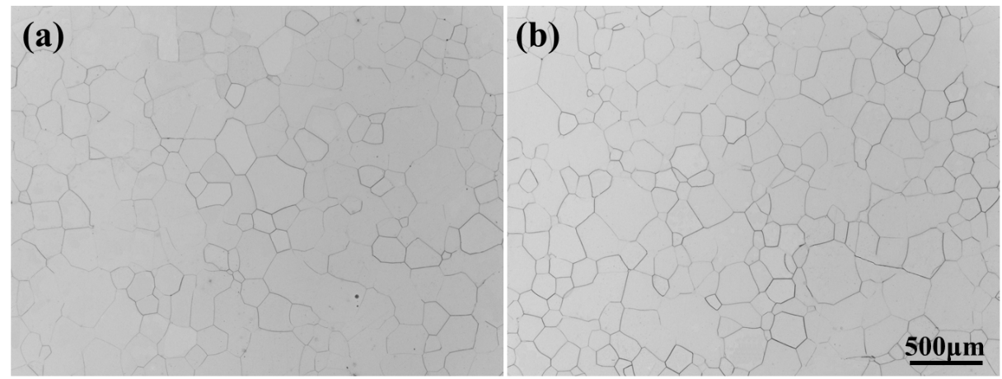
Fig. S1 Optical images of Mg-0.5Ce and Mg-2Gd alloys after solid solution treatment.

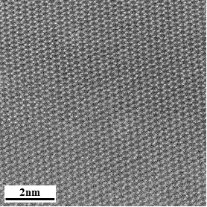
Fig. S2 HAADF-STEM image taken near the minimum creep rates of Mg-0.5Ce alloys along the [$0001$] zone axis.

