Supplementary Material
Supplementary Figure 1. Clinically validated ORMED brushing robot with replicated human teether and brushing force assessment
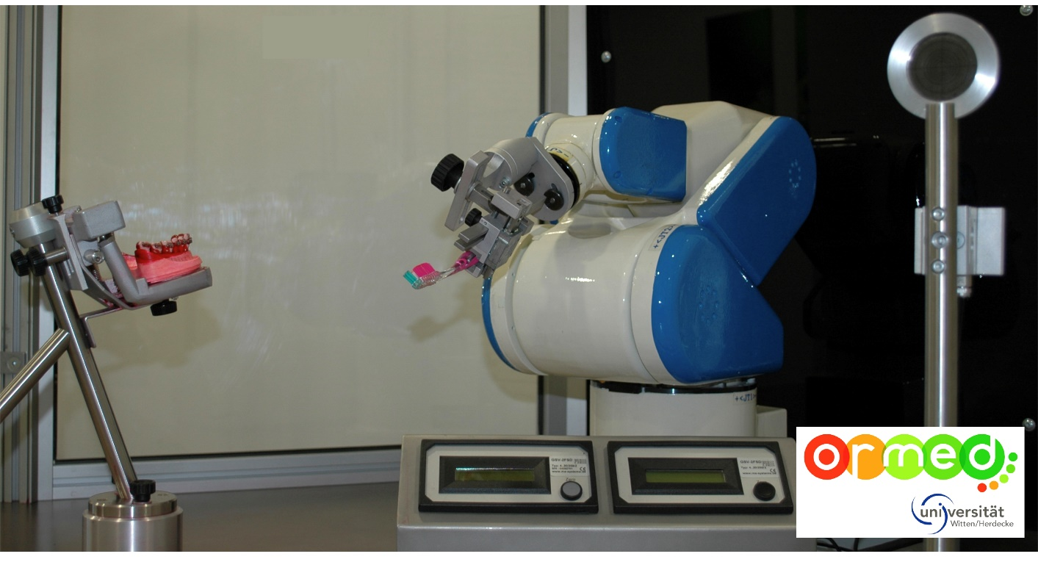
Supplementary Figure 2. Automated plaque planimetry index (APP-Index) tooth locations: A. left: APP index buccally (towards the cheek); right APP Index lingually (towards the tongue); B. APP index mesially (proximal in-between teeth, anterior side, right: APP-Index distally (proximal in-between teeth, posterior side)
A.
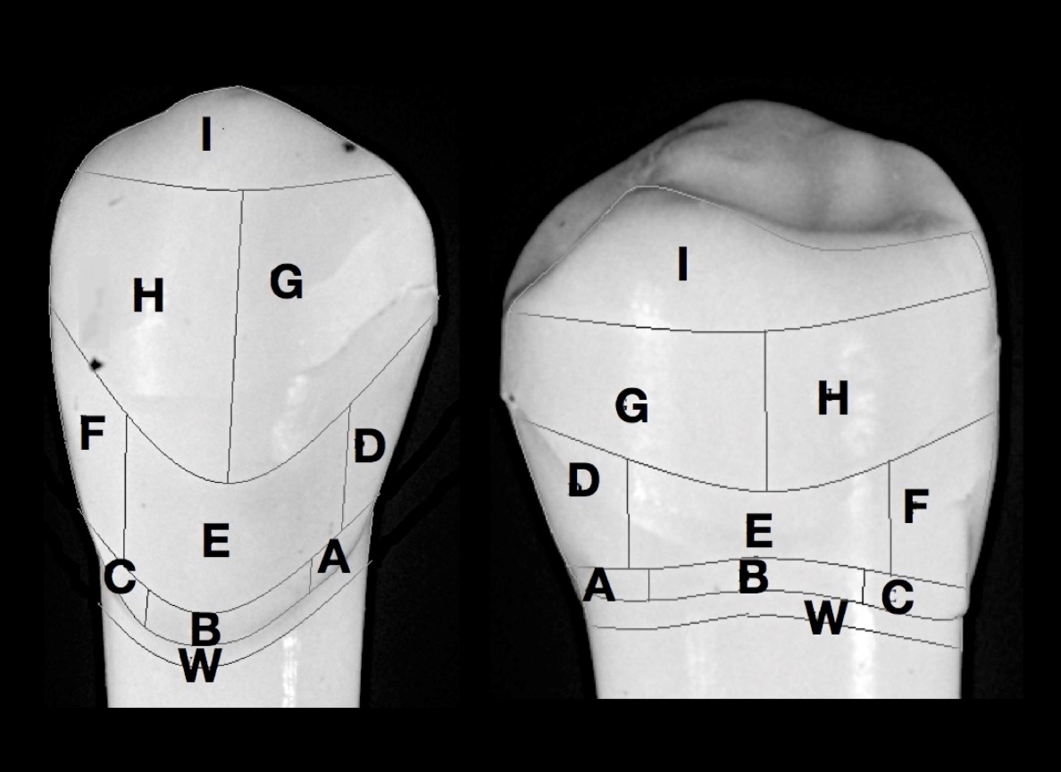
B.
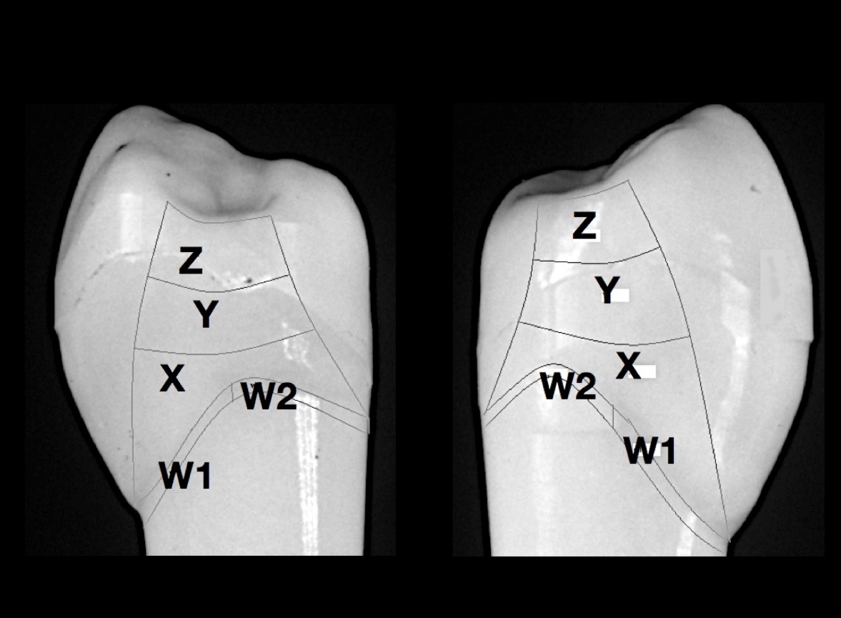

Supplementary Figure 3. Cleaning efficacy across root sites using A. horizontal, B. rotating and C. vertical brushing.
A.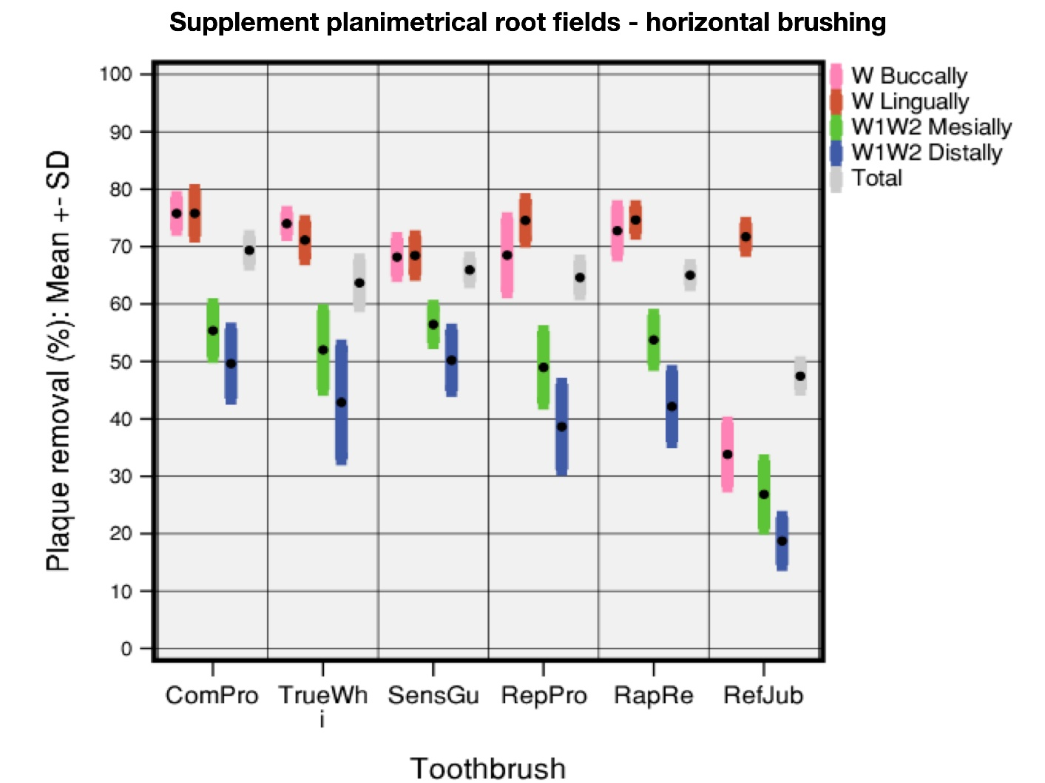
B.
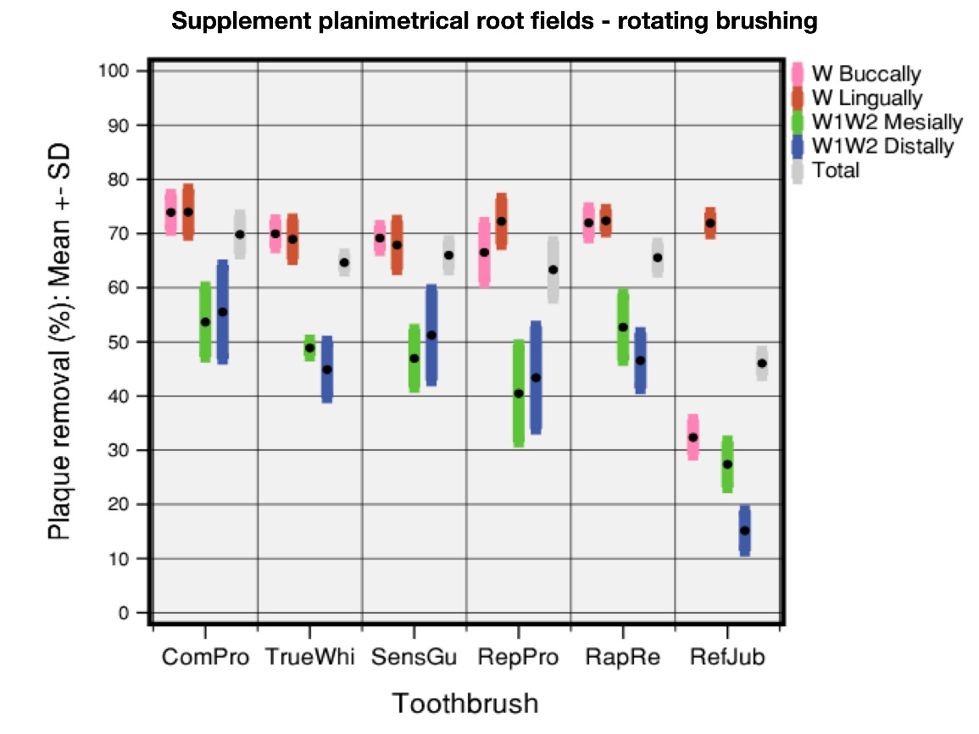
C.
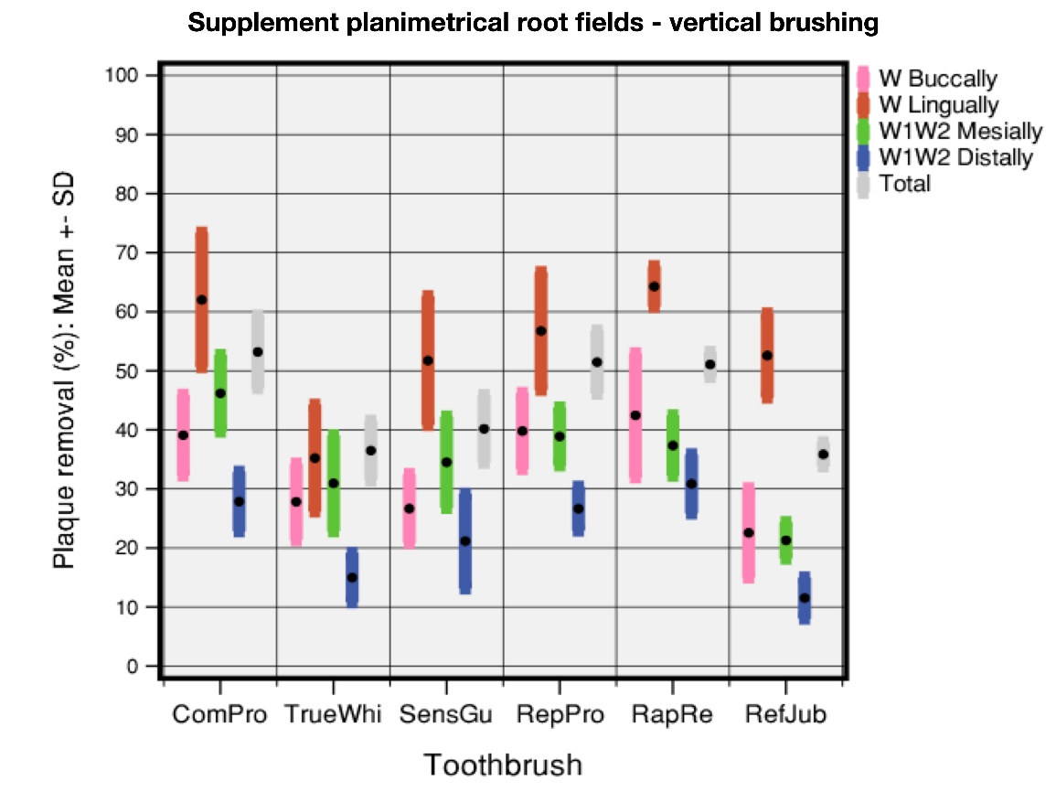

Supplementary Table 1 Means (M)) and standard deviations (SD), medians (Med) and interquartile ranges (IQR; LL = lower limit, UL = upper limit) of cleaning efficacy parameters (5 plaque removal) for the tested toothbrushes Horizontal brushing movement

Supplementary Table 1 (continued) Means (M)) and standard deviations (SD), medians (Med) and interquartile ranges (IQR; LL = lower limit, UL = upper limit) of cleaning efficacy parameters (5 plaque removal) for the tested toothbrushes Horizontal brushing movement

Supplementary Table 1 (continued) Means (M)) and standard deviations (SD), medians (Med) and interquartile ranges (IQR; LL = lower limit, UL = upper limit) of cleaning efficacy parameters (5 plaque removal) for the tested toothbrushes Horizontal brushing movement

Supplementary Table 2 Means (M)) and standard deviations (SD), medians (Med) and interquartile ranges (IQR; LL = lower limit, UL = upper limit) of cleaning efficacy parameters (5 plaque removal) for the tested toothbrushes - Rotating brushing movement

Supplementary Table 2 (continued) Means (M)) and standard deviations (SD), medians (Med) and interquartile ranges (IQR; LL = lower limit, UL = upper limit) of cleaning efficacy parameters (5 plaque removal) for the tested toothbrushes - Rotating brushing movement

Supplementary Table 2 (continued) Means (M)) and standard deviations (SD), medians (Med) and interquartile ranges (IQR; LL = lower limit, UL = upper limit) of cleaning efficacy parameters (5 plaque removal) for the tested toothbrushes - Rotating brushing movement

Supplementary Table 3 (Means (M)) and standard deviations (SD), medians (Med) and interquartile ranges (IQR; LL = lower limit, UL = upper limit) of cleaning efficacy parameters (5 plaque removal) for the tested toothbrushes - Vertical brushing movement

Supplementary Table 3 (continued) (Means (M)) and standard deviations (SD), medians (Med) and interquartile ranges (IQR; LL = lower limit, UL = upper limit) of cleaning efficacy parameters (5 plaque removal) for the tested toothbrushes - Vertical brushing movement

Supplementary Table 3 (continued) (Means (M)) and standard deviations (SD), medians (Med) and interquartile ranges (IQR; LL = lower limit, UL = upper limit) of cleaning efficacy parameters (5 plaque removal) for the tested toothbrushes - Vertical brushing movement

Supplementary Table 4 Mann-Whitney-Test of cleaning efficacy (%plaque removal): contrasts of six toothbrushes included in Study 2

Supplementary Table 4 (continued) Mann-Whitney-Test of cleaning efficacy (%plaque removal): contrasts of six toothbrushes included in Study 2 - Horizontal brushing movement

Supplementary Table 4 (continued) Mann-Whitney-Test of cleaning efficacy (%plaque removal): contrasts of six toothbrushes included in Study 2 - Horizontal brushing movement

Supplementary Table 4 (continued) Mann-Whitney-Test of cleaning efficacy (%plaque removal): contrasts of six toothbrushes included in Study 2 - Horizontal brushing movement

Supplementary Table 4 (continued) Mann-Whitney-Test of cleaning efficacy (%plaque removal): contrasts of six toothbrushes included in Study 2 - Horizontal brushing movement
U = test statistic of the Mann-Whitney-Test
Z = normalized test statistic of the Mann-Whitney-Test
p = significance value
*significant (p≤0.05)
**very significant (p≤0.01)
***highly significant (p≤0.001)
Yellow marking = not significant using Bonferroni correction

Supplementary Table 5 Mann-Whitney-Test of cleaning efficacy (%plaque removal): contrasts of six toothbrushes included in Study 2 - Rotating brushing movement

Supplementary Table 5 (continued). Mann-Whitney-Test of cleaning efficacy (%plaque removal): contrasts of six toothbrushes included in Study 2 - Rotating brushing movement

Supplementary Table 5 (continued). Mann-Whitney-Test of cleaning efficacy (%plaque removal): contrasts of six toothbrushes included in Study 2 - Rotating brushing movement

Supplementary Table 5 (continued). Mann-Whitney-Test of cleaning efficacy (%plaque removal): contrasts of six toothbrushes included in Study 2 - Rotating brushing movement

Supplementary Table 5 (continued). Mann-Whitney-Test of cleaning efficacy (%plaque removal): contrasts of six toothbrushes included in Study 2 - Rotating brushing movement
U = test statistic of the Mann-Whitney-Test
Z = normalized test statistic of the Mann-Whitney-Test
p = significance value
*significant (p≤0.05)
**very significant (p≤0.01)
***highly significant (p≤0.001)
Yellow marking = not significant using Bonferroni correction

Supplementary Table 6. Mann-Whitney-Test of cleaning efficacy (%plaque removal): contrasts of six toothbrushes included in Study 2 - Vertical brushing movement

Supplementary Table 6 (continued). Mann-Whitney-Test of cleaning efficacy (%plaque removal): contrasts of six toothbrushes included in Study 2 - Vertical brushing movement

Supplementary Table 6 (continued). Mann-Whitney-Test of cleaning efficacy (%plaque removal): contrasts of six toothbrushes included in Study 2 - Vertical brushing movement

Supplementary Table 6 (continued). Mann-Whitney-Test of cleaning efficacy (%plaque removal): contrasts of six toothbrushes included in Study 2 - Vertical brushing movement

Supplementary Table 6 (continued). Mann-Whitney-Test of cleaning efficacy (%plaque removal): contrasts of six toothbrushes included in Study 2 - Vertical brushing movement
U = test statistic of the Mann-Whitney-Test
Z = normalized test statistic of the Mann-Whitney-Test
p = significance value
*significant (p≤0.05)
**very significant (p≤0.01)
***highly significant (p≤0.001)
Yellow marking = not significant using Bonferroni correction

