Additional file 1 of Chromosome-level genome assembly provides insights into evolution of chromosome and globin gene superfamily in Gymncypris eckloni

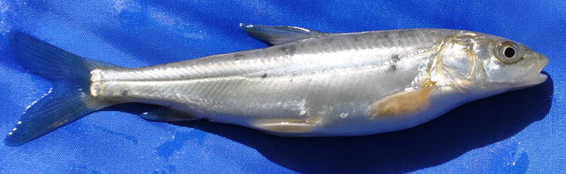
Fig. 1. A picture of Gymncypris eckloni used in the genome sequencing and assembly.

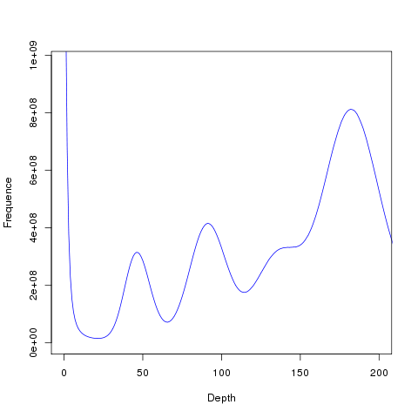
Fig. 2. 17-mer distribution of G. eckloni. The X-axis is the Kmer depth and Y-axis represents the frequency of the Kmer for a given depth. The genome size was estimated using the k-mer number divided by k-mer depth.

Fig. 3. The composition of gene elements in the G. eckloni genome to other species.
Fig. 4. Venn diagram of number of genes with homology or functional classification by each method.

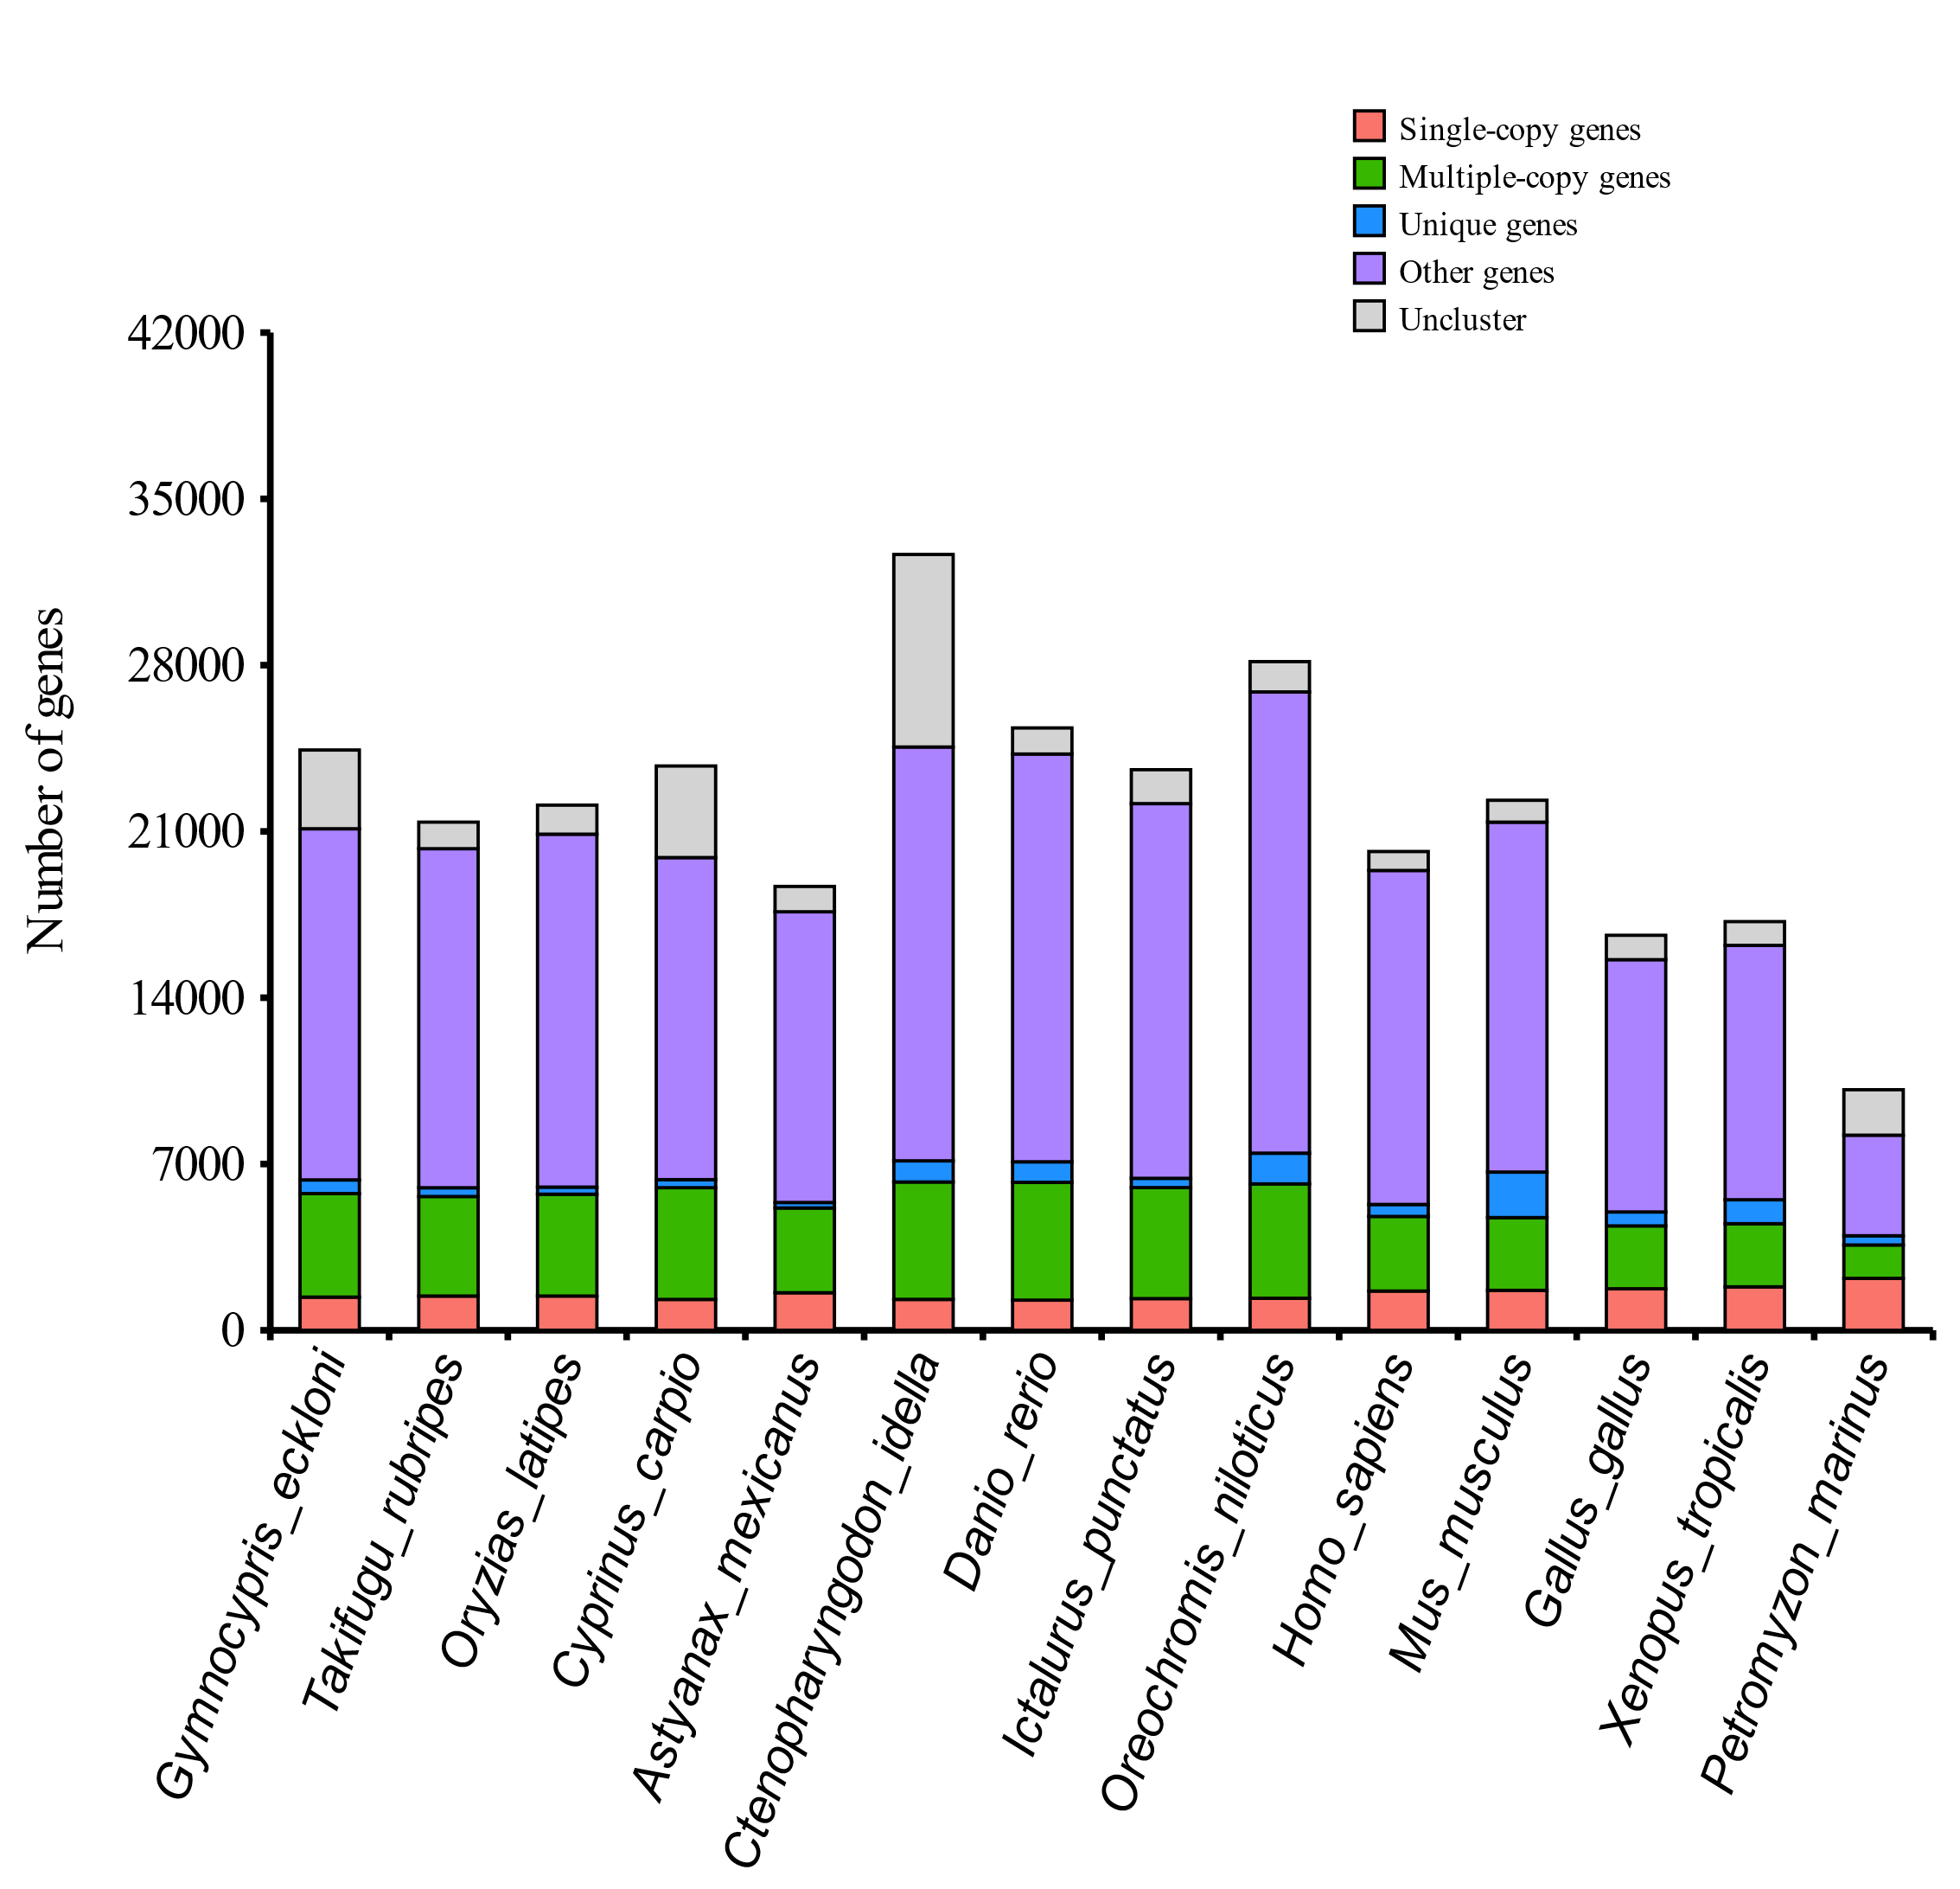
Fig. 5. Statistics of gene families among the 14 species. Single-copy and multiple-copy homologs are the families in which each species has only one or more than one copy, respectively. Unique genes show the species-specific families. Other genes are the genes that have matches in the other species but cannot be placed into the other orthologue categories. Unclustered genes are the genes in each species that cannot be associated with gene predictions in any of the other lineages.
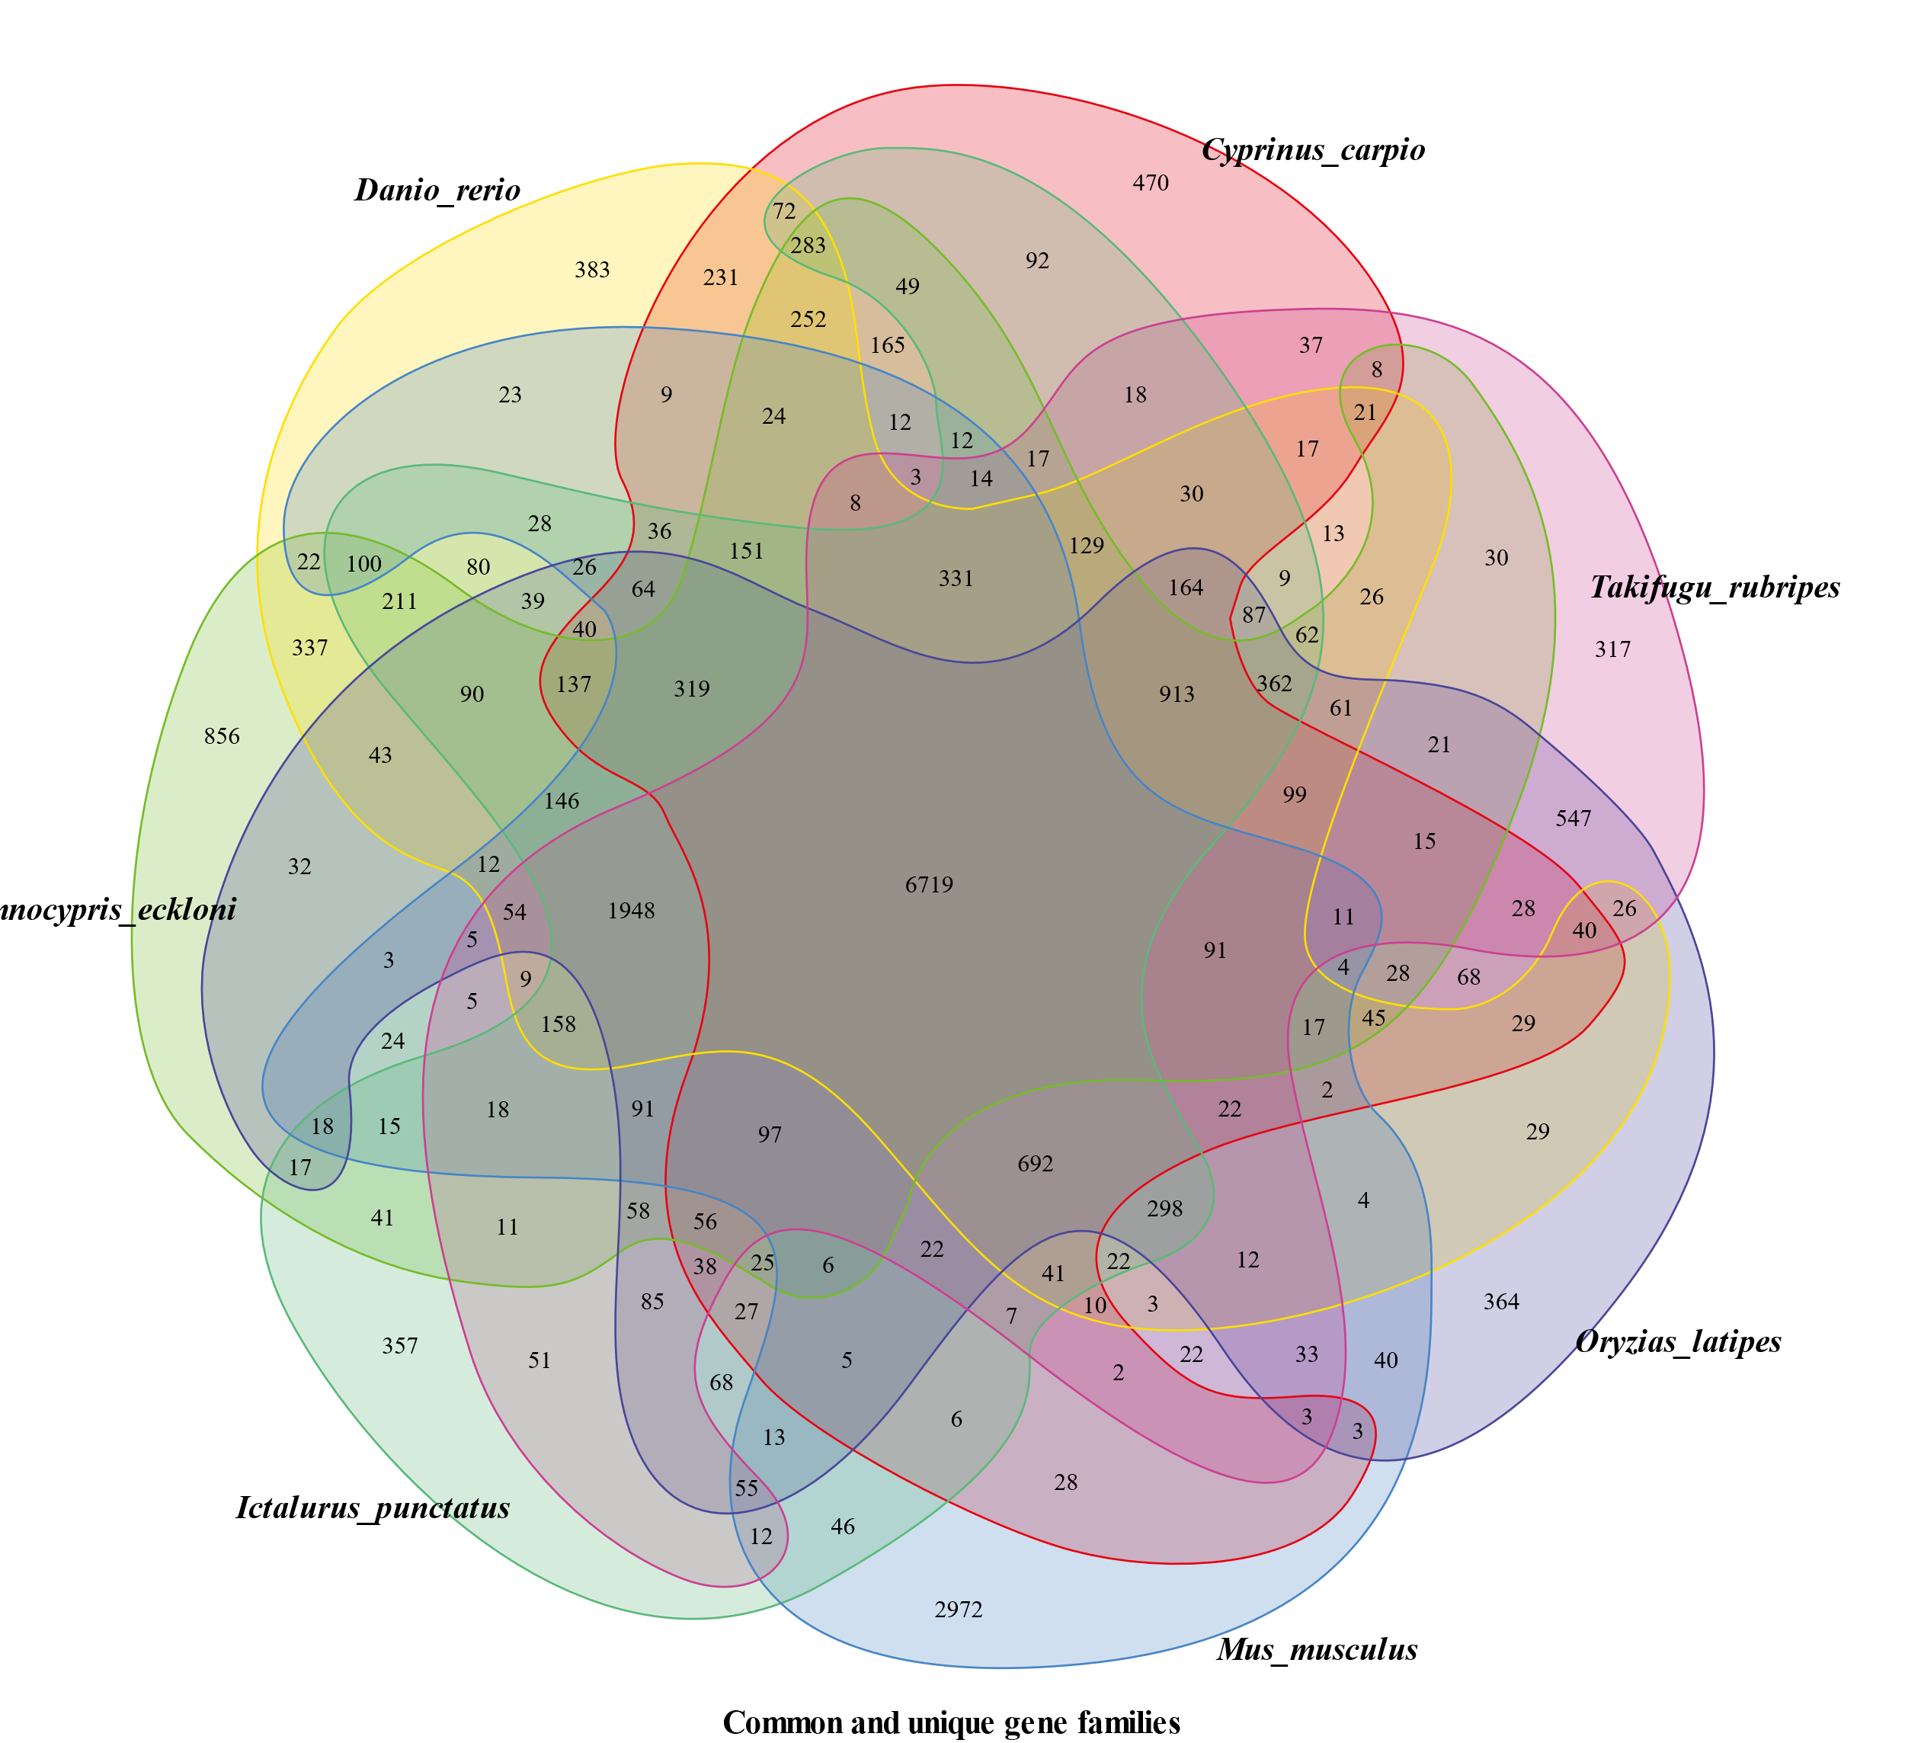
Fig. 6. Number of gene families shared among 14 species shown as a Venn diagram.
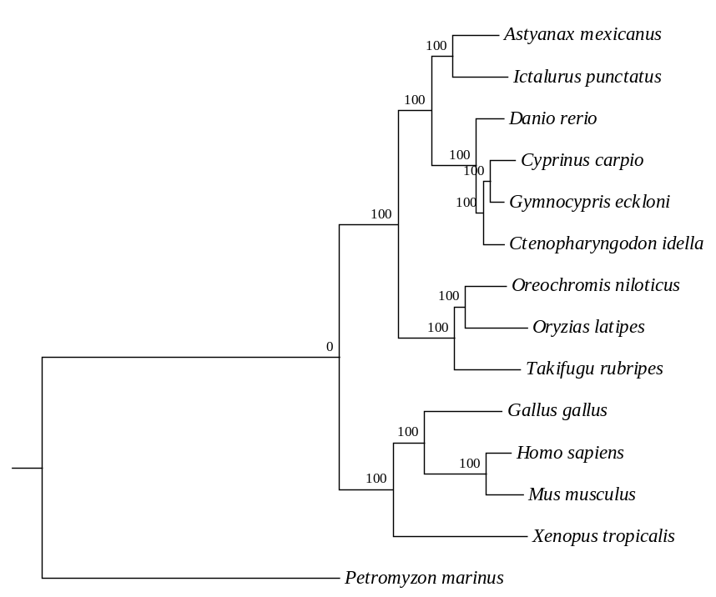

Fig. 7. The phylogenetic tree of 14 species based on gene orthology. The bootstrap values are shown on the branches.

Fig. 8. 4dTv analyses among colinear genes, within (continuous lines) and between genomes (dashed).
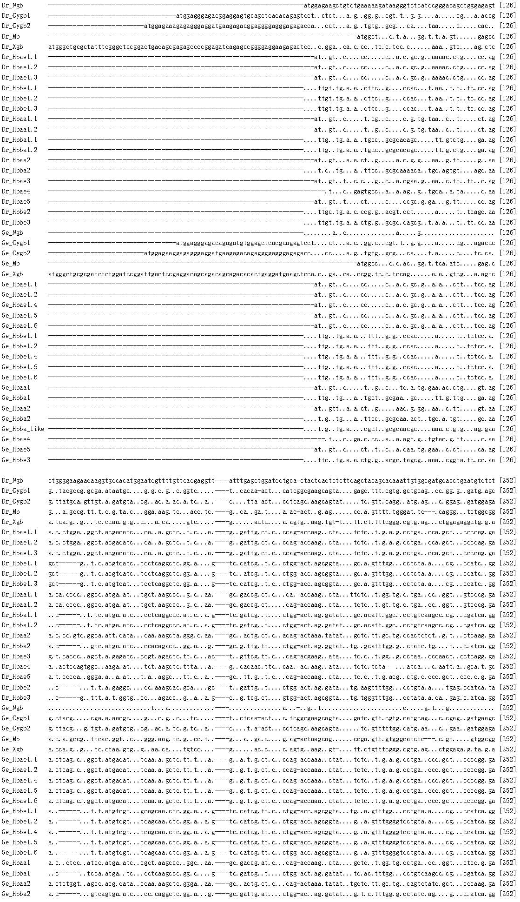
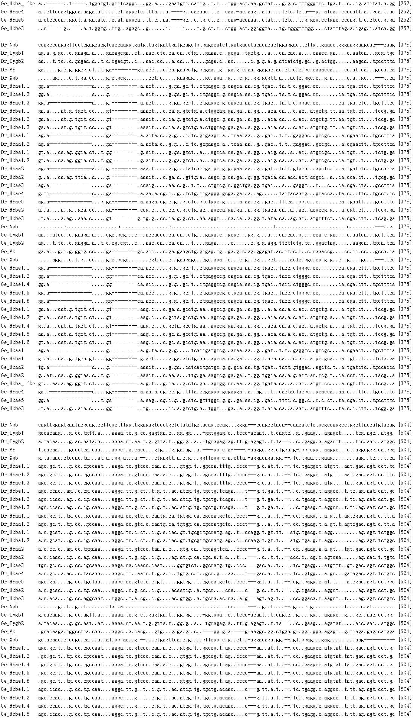
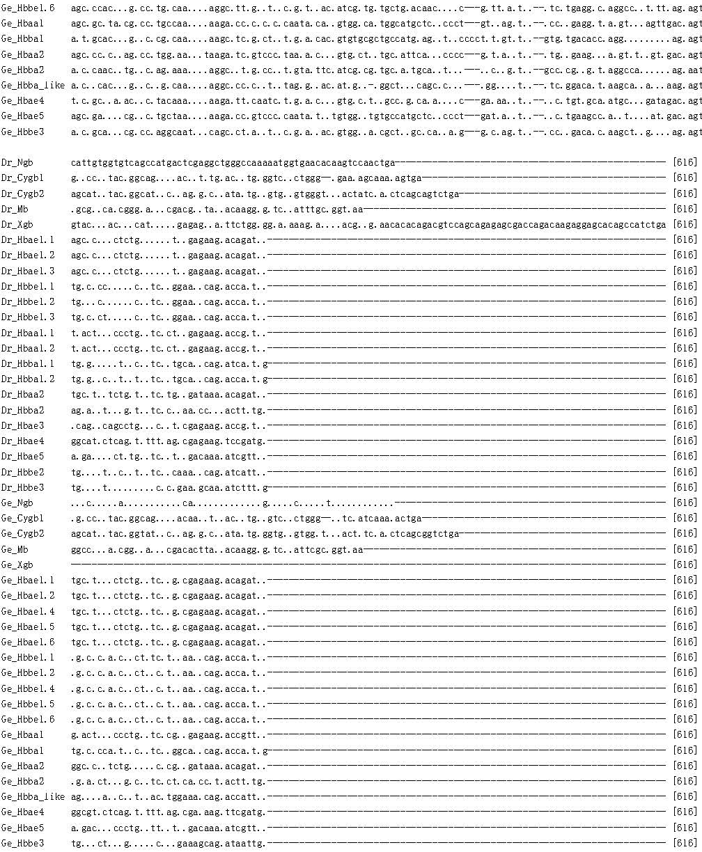
Fig. 9. Nucleotide alignment of all G. eckloni and D. rerio globin gene sequences. Ge_hbae1.3 and Ge_hbbe1.3 were not included because of premature stop codons.

