Figure S1
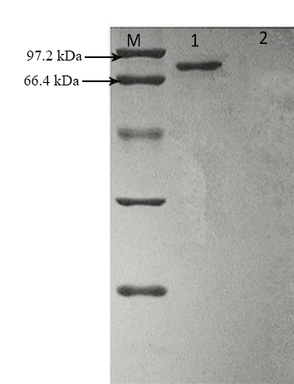
Figure S1. SDS-PAGE analysis of the purified AnLPMO14g (lane M stands for protein marker, lane 1 stands for AnLPMO14g, lane 2 stands for negative control)

Figure S2
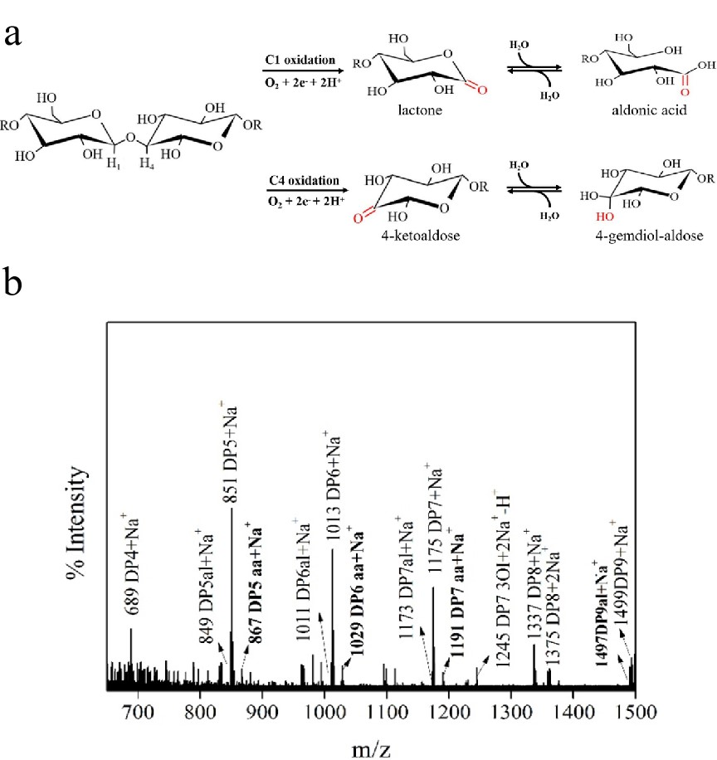
Figure S2. Scheme of chemical reaction in the form of C1 oxidation and C4 oxidation (a) and MALDI-TOF/TOF MS analysis of the degradation products from Avicel® by AnLPMO14g (b).

