Graphical Abstract
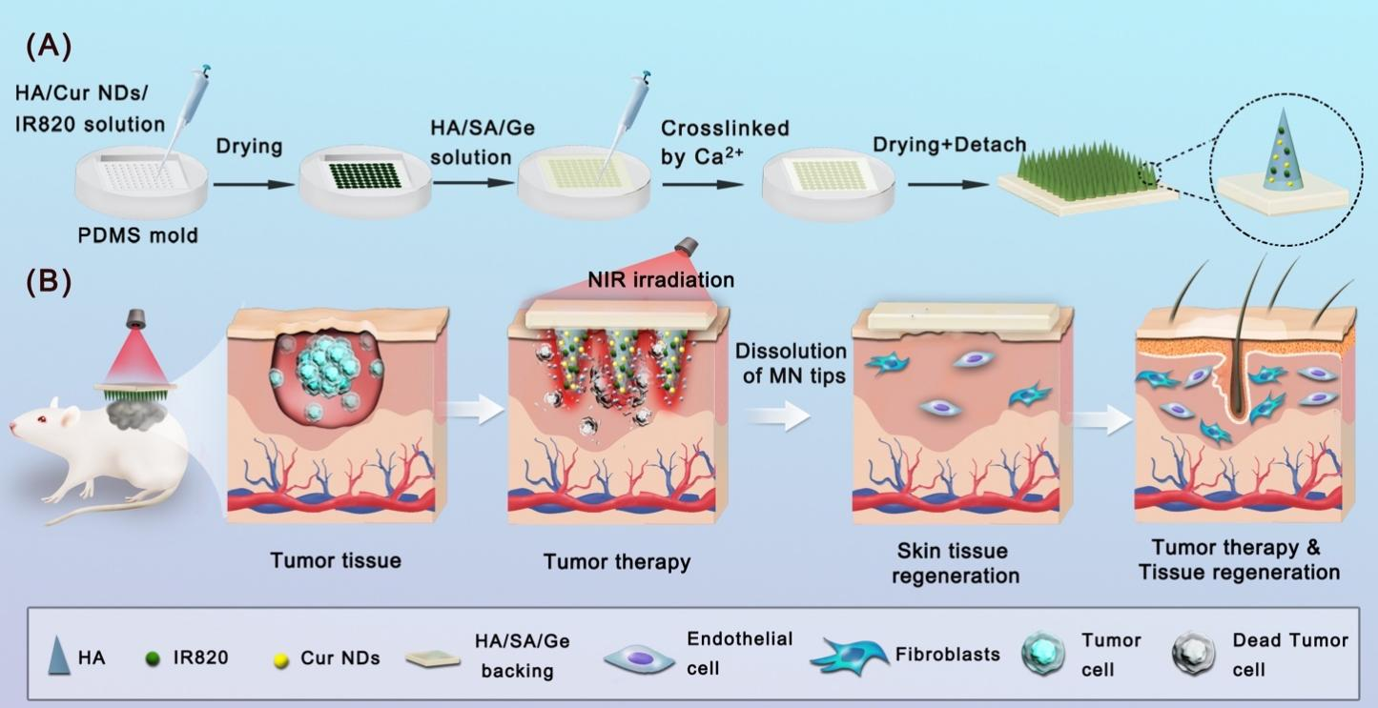The platform composed of embeddable curcumin nanodrugs/new Indocyanine Green/hyaluronic acid (Cur NDs/IR820/HA) microneedles and sodium alginate/gelatin/hyaluronic acid (SA/Ge/HA) supporting back layer was prepared through a two-step casting process. Once the embeddable microneedles insert into skin, they rapidly dissolve and activate drug release successfully for tumor treatment. Moreover, the SA/Ge/HA supporting back layer left behind to cover the wound and promote the proliferation of endothelial and ﬁbroblasts cells for enhanced skin regeneration.

