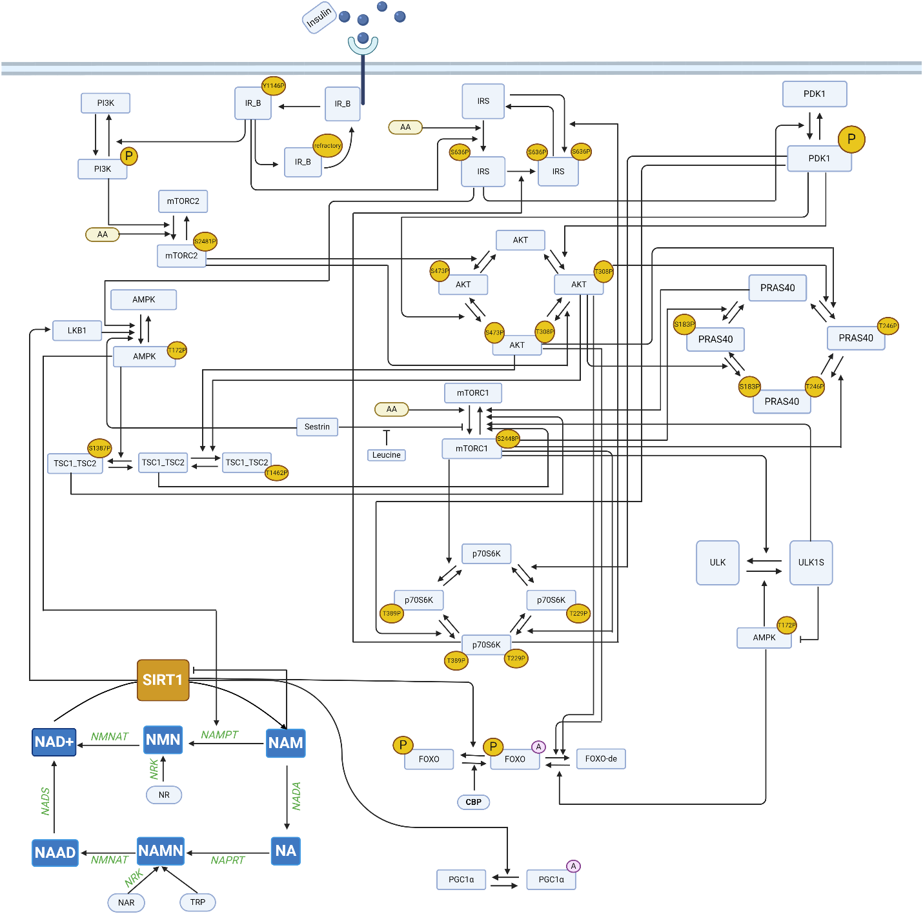

Figure S1. Schematic diagram depicting connections among model components that form the signaling pathways. AA represents amino acids; “A” in purple circles denote the acetylated form of the complex; “P” in yellow circles denote the phosphorylated form.

Table S1. Model equations.

$$\frac{d\left[IRβ\right]}{dt}$$  $$\frac{d\left[IRβ_pY1146\right]}{dt}$$  $$\frac{d\left[IRβ_refractory \right]}{dt}$$  $$\frac{d\left[mTORC1_ pS2448\right]}{dt}$$  $$\frac{d\left[mTORC1\right]}{dt}$$  $$\frac{d\left[mTORC2\right]}{dt}$$  $$\frac{d\left[mTORC2_pS2481\right]}{dt}$$  $$\frac{d\left[IRS\right]}{dt}$$  $$\frac{d\left[IRS_p\right]}{dt}$$  $$\frac{d\left[IRS_pS636\right]}{dt}$$  $$\frac{d\left[TSC1_TSC2\right]}{dt}$$  $$\frac{d\left[\left(TSC1_TSC2_pT1462\right)\right]}{dt}$$  $$\frac{d\left[\left(TSC1_TSC2_pS1387\right)\right]}{dt}$$  $$\frac{d\left[PRAS40\right]}{dt}$$  $$\frac{d\left[PRAS40_pS183\right]}{dt}$$  $$\frac{d\left[PRAS40_pT246\right]}{dt}$$  $$\frac{d\left[PRAS40_pT246_pS183\right]}{dt}$$  $$\frac{d\left[AKT\right]}{dt}$$  $$\frac{d\left[Akt_pT308_pS473\right]}{dt}$$  $$\frac{d\left[Akt_pT308\right]}{dt}$$  $$\frac{d\left[Akt_pS473\right]}{dt}$$  $$\frac{d\left[p70S6K\right]}{dt}$$  $$\frac{d\left[p70S6K_pT229\right]}{dt}$$  $$\frac{d\left[p70S6K_pT389\right]}{dt}$$  $$\frac{d\left[p70S6K_pT389_pT229\right]}{dt}$$  $$\frac{d\left[PI3K\right]}{dt}$$  $$\frac{d\left[PI3K_p\right]}{dt}$$  $$\frac{d\left[PDK1\right]}{dt}$$  $$\frac{d\left[PDK1_p\right]}{dt}$$  $$\frac{d\left[AMPK\right]}{ dt }$$  $$\frac{d\left[AMPK_pT172\right]}{dt}$$  $$\frac{d\left[FOXO_de\right]}{dt}$$  $$\frac{d\left[FOXO_AC_P\right]}{dt}$$  $$\frac{d\left[FOXO_P\right]}{dt}$$  $$\frac{d[PGC1α]}{dt}$$  $$\frac{d[AC_PGC1α]}{dt}$$  $$\frac{d[ULK1]}{dt}$$  $$\frac{d[AC_ULK1]}{dt}$$  $$\frac{d[Nam_ex]}{dt}$$  $$\frac{d[NADbound]}{dt}$$  $$\frac{d[NR]}{dt}$$  $$\frac{d[NaAD]}{dt}$$  $$\frac{d[NMN]}{dt}$$  $$\frac{d[NA]}{dt}$$  $$\frac{d[NaMN]}{dt}$$  $$\frac{d[NAM]}{dt}$$  $$\frac{d[NAD]}{dt}$$  $$\frac{d[NAR]}{dt}$$  NMN_efflux  NAPRT  NMNAT1_NMN  NMNAT1_NaMN  NADS  NT5_NMN  PNP_NR  NNMT  Nam_efflux  NT5_NaMN  SIRT  NAD_consumption_without_Nam_inhibition  NADA  NAMimport  NAMPT  NAR_efflux  NA_efflux  NAD_binding  NRK1_NaMN  PNP_NAR  NR_efflux  NRK1_NMN | $$+\left(par_IR_beta_ready*\left[IRβ_refractory\right]\right)$$  $$-([IRβ]*par_IR_beta_phos_by_Insulin*[Insulin])$$  $$([IRβ]*par_IR_beta_phos_by_Insulin*[Insulin])$$  $$-(par_IR_beta_pY1146_dephos*[IRβ_pY1146])$$  $$+(par_IR_beta_pY1146_dephos*[IRβ_pY1146])$$  $$-(par_IR_beta_ready*[IRβ_refractory])$$  $$-([TSC1_TSC2]+[TSC1_TSC2_pS1387])*[mTORC1_pS2448]*par_mTORC1_pS2448_dephos_by_TSC1_TSC2)$$  $$-(b_pras_mtorc1*0.00068*[mTORC1_pS2448]*10^(0.25*[PRAS40]))$$  $$-([mTORC1_pS2448]*[Act_ULK1]*0.00016)$$  $$+ [mTORC1]*par_mTORC1_S2448_activation_by_Amino_Acids$$  $$*( \frac{mTORC1_{vmax}*([leucine_{a}]+[leucine_{conc}])}{[leucine_{a}]+[leucine_{conc}]+[sestrin2]} )$$  $$+([TSC1_TSC2]+[TSC1_TSC2_pS1387])*[mTORC1_pS2448]*par_mTORC1_pS2448_dephos_by_TSC1_TSC2)$$  $$+(b_pras_mtorc1*0.00068*[mTORC1_pS2448]*10^(0.25*[PRAS40]))$$  $$+([mTORC1_pS2448]*[Act_ULK1]*0.00016)$$  $$-[mTORC1]*par_mTORC1_S2448_activation_by_Amino_Acids$$  $$*( \frac{mTORC1_{vmax}*([leucine_{a}]+[leucine_{conc}])}{[leucine_{a}]+[leucine_{conc}]+[sestrin2]} )$$  $$-([Amino_Acid]* [mTORC2]*par_mTORC2_S2481_phos_by_Amino_Acids)$$  $$-([PI3K_p]*[mTORC2]*par_mTORC2_S2481_phos_by_PI3K_variant_p)$$  $$+(par_mTORC2_pS2481_dephos*[mTORC2_pS2481])$$  $$+([Amino_Acid]* [mTORC2]*par_mTORC2_S2481_phos_by_Amino_Acids)$$  $$+([PI3K_p]*[mTORC2]*par_mTORC2_S2481_phos_by_PI3K_variant_p)$$  $$-(par_mTORC2_pS2481_dephos*[mTORC2_pS2481])$$  $$-([Amino_acid]*[IRS]*par_IRS_phos_by_Amino_Acids)$$  $$-([IRS]* par_IRS_phos_by_IR_beta_pY1146*[IRβ-pY1146])$$  $$-([IRS]*par_IRS_phos_by_p70_S6K_pT229_pT389*$$  $$[p70_S6K_pT229_pT389])$$  $$+(par_IRS_pS636_turnover* [IRS_pS636])$$  $$+([Amino_Acid]* [IRS]* par_IRS_phos_by_Amino_Acids)$$  $$+([IRS]* par_IRS_phos_by_IR_beta_pY1146* [IRβ-pY1146])$$  $$-([IRS_p]* par_IRS_p_phos_by_p70_S6K_pT229_pT389* [p70S6K_pT229_pT389])$$  $$+([IRS_p]*par_IRS_p_phos_by_p70_S6K_pT229_pT389*[p70S6K_pT229_pT389])$$  $$+([IRS]* par_IRS_phos_by_p70_S6K_pT229_pT389* [p70S6K_pT229_pT389])$$  $$-(par_IRS_pS636_turnover*[IR_pS636])$$  $$-([AMPK_pT172]* [TSC1_TSC2]*par_TSC1_TSC2_S1387_phos_by_AMPK_pT172)$$  $$-(([AKT_pT308]+[AKT_pT3089_pS473])*[TSC1_TSC2]*par_TSC1_TSC2_T1462_phos_by_Akt_pT308)$$  $$+(par_TSC1_TSC2_pS1387_dephos*[TSC1_TSC2_pS1387])$$  $$+(par_TSC1_TSC2_pT1462_dephos*[TSC1_TSC2_pT1462])$$  $$+(([Akt-pT308] +[Akt_pT308_pS473])*[TSC1_TSC2]* par_TSC1_TSC2_T1462_phos_by_Akt_pT308)$$  $$-(par_TSC1_TSC2_pT1462_dephos*[TSC1_TSC2_pT1462])$$  $$+([AMPK-pT172]* [TSC1_TSC2]*par_TSC1_TSC2_S1387_phos_by_AMPK_pT172)$$  $$-(par_TSC1_TSC2_pS1387_dephos*[TSC1_TSC2_pS1387])$$  $$-([PRAS40]*par_PRAS40_S183_phos_by_mTORC1_pS2448_first*[mTORC1_pS2448])$$  $$-(([Akt_pT308]+ [Akt_pT308_pS473])*[PRAS40]*par_PRAS40_T246_phos_by_Akt_pT308_first)$$  $$+(par_PRAS40_pS183_dephos_first*[PRAS40_pS183])$$  $$+(par_PRAS40_pT246_dephos_first*[PRAS40_pT246])$$  $$+([PRAS40]*par_PRAS40_S183_phos_by_mTORC1_pS2448_first *[mTORC1_pS2448])$$  $$-(([Akt_pT308]+ [Akt_pT308_pS473])*[PRAS40_pS183]*par_PRAS40_T246_phos_by_Akt_pT308_second)$$  $$-(par_PRAS40_pS183_dephos_first*[PRAS40_pS183])$$  $$+(par_PRAS40_pT246_dephos_second*[PRAS40_pT246_pS183])$$  $$-(par_PRAS40_S183_phos_by_mTORC1_pS2448_second*[PRAS40_pT246]* [mTORC1_pS2448])$$  $$-(par_PRAS40_pT246_dephos_first*[PRAS40_pT246])$$  $$+([Akt_pT308]* [Akt_pT308_pS473]* [PRAS40]*par_PRAS40_T246_phos_by_Akt_pT308_first)$$  $$+(par_PRAS40_pS183_dephos_second*[PRAS40_pT246_pS183])$$  $$+(([Akt_pT308]+ [Akt_pT308_pS473])*[PRAS40_pS183]*par_PRAS40_T246_phos_by_Akt_pT308_second)$$  $$+(par_PRAS40_S183_phos_by_mTORC1_pS2448_second* [PRAS40_pT246]* [mTORC1_pS2448])$$  $$-(par_PRAS40_pS183_dephos_second*[PRAS40_pT246_pS183])$$  $$-(par_PRAS40_pT246_dephos_second*[PRAS40_pT246_pS183])$$  $$-([AKT]* par_Akt_T308_phos_by_PI3K_p_PDK1_first* [PDK1_p])$$  $$-([AKT]*par_Akt_S473_phos_by_mTORC2_pS2481_first* [mTORC2_pS2481])$$  $$+(par_Akt_pT308_dephos_first*[Akt_pT308])$$  $$+(par_Akt_pS473_dephos_first*[Akt_pS473])$$  $$+(par_Akt_T308_phos_by_PI3K_p_PDK1_second*[Akt_pS473]* [PDK1_p])$$  $$+(par_Akt_S473_phos_by_mTORC2_pS2481_second*[Akt_pT308]*[mTORC2_pS2481])$$  $$-(par_Akt_pT308_dephos_first*[Akt_pT308_pS473])$$  $$-(par_Akt_pS473_dephos_second*[Akt_pT308_pS473])$$  $$+([AKT]* par_Akt_T308_phos_by_PI3K_p_PDK1_first*[PDK1_p])$$  $$-(par_Akt_S473_phos_by_mTORC2_pS2481_second* [Akt_pT308]* [mTORC2_pS2481])$$  $$-(par_Akt_pT308_dephos_first*[Akt_pT308])$$  $$+(par_Akt_pS473_dephos_second*[Akt_pT308_pS473])$$  $$+(par_Akt_pS473_dephos_second*[AKT_pT308_pS473])$$  $$-(par_Akt_pT308_dephos_first*[AKT_pS473])$$  $$+(par_Akt_S473_phos_by_mTORC2_pS2481_first*[AKT]*[mTORC2_pS2481])$$  $$-(par_Akt_T308_phos_by_PI3K_p_PDK1_second*[Akt_pS473]* [PDK1_p])$$  $$-([PDK1_p]* [p70S6K]*par_p70_S6K_T229_phos_by_PI3K_p_PDK1_first)$$  $$-([mTORC1_pS2448]* [p70S6K]* par_p70_S6K_T389_phos_by_mTORC1_pS2448_first)$$  $$+(par_p70_S6K_pT229_dephos_first*[p70S6K_pT229])$$  $$+(par_p70_S6K_pT389_dephos_first*[p70S6K_pT389])$$  $$+([PDK1_p]*[p70S6K]*par_p70_S6K_T229_phos_by_PI3K_p_PDK1_first)$$  $$-([mTORC1_pS2448]*par_p70_S6K_T389_phos_by_mTORC1_pS2448_second*[p70S6K_pT229])$$  $$+(par_p70_S6K_pT389_dephos_second*[p70S6K_pT229_pT389])$$  $$-(par_p70_S6K_pT229_dephos_first*[p70S6K_pT229])$$  $$+([mTORC1_pS2448]* [p70S6K]* par_p70_S6K_T389_phos_by_mTORC1_pS2448_first)$$  $$-([PDK1_p]* par_p70_S6K_T229_phos_by_PI3K_p_PDK1_second* [p70S6K_pT389])$$  $$-(par_p70_S6K_pT389_dephos_first*[p70S6K_pT389])$$  $$+(par_p70_S6K_pT229_dephos_second*[p70S6K_pT229_pT389])$$  $$+(\left[PDK1_{p}\right]*par_p70_S6K_T229_phos_by_PI3K_p_PDK1_second* [p70S6K_pT389])$$  $$+(\left[mTORC1_{pS2448}\right]*par_p70_S6K_T389_phos_by_mTORC1_pS2448_second*[p70S6K_pT229])$$  $$-(par_p70_S6K_pT229_dephos_second*[p70S6K_pT229_pT389])$$  $$-(par_p70_S6K_pT389_dephos_second*[p70S6K_pT229_pT389])$$  $$+(par_PI3K_variant_p_dephos*[PI3K_p])$$  $$-([IRβ_pY1146]*[PI3K]*par_PI3K_variant_phos_by_IR_beta_pY1146)$$  $$-(par_PI3K_variant_p_dephos*[PI3K_p])$$  $$+([IRβ_pY1146]*[PI3K]*par_PI3K_variant_phos_by_IR_beta_pY1146)$$  $$+(par_PI3K_p_PDK1_dephos*[PDK1_p])$$  $$-([IRS_p]* [PDK1]* par_PI3K_PDK1_phos_by_IRS_p)$$  $$-(par_PI3K_p_PDK1_dephos*[PDK1_p])$$  $$+([IRS_p]* [PDK1]* par_PI3K_PDK1_phos_by_IRS_p)$$  $$-(scaling factor_AA*[AMPK]*par_AMPK_T172_phos_by_AminoAcids*[leucine_conc]*[sestrine_conc])$$  $$-([AMPK]* par_AMPK_T172_phos* [IRS_p])$$  $$+(par_AMPK_pT172_dephos*[AMPK_pT172])$$  $$-(ksirt_LKB1*[SIRT]*[AMPK])$$  $$+([Act_ULK1]*[AMPK_pT172]*kUKAP)$$  $$+(100*[AMPK]*par_AMPK_T172_phos_by_AminoAcids*[leucine_conc]*[sestrine_conc])$$  $$+([AMPK]* par_AMPK_T172_phos* [IRS_p])$$  $$-(par_AMPK_pT172_dephos*[AMPK_pT172])$$  $$+(ksirt*[SIRT]*[AMPK])$$  $$-([Act_ULK1]*[AMPK_pT172]*kUKAP)$$  $$+kAKT*([Akt_pT308]+[Akt_pT308_pS473])*[FOXO_AC_P] - kAMPK*[AMPK_pT172]*[FOXO_de]$$  $$+ kAMPK*[FOXO_de]*[AMPK_pT172] - kAKT*([Akt_pT308_pS473]+[Akt_pT308])*[FOXO_AC_P]$$  $$- kSIRTFOXO*\left[FOXO_AC_P\right]*[SIRT] + kCBp*[FOXO_P]*[CBP]$$  $$kSIRTFOXO*[FOXO_AC_P]*[SIRT] - kCBp*[FOXO_P]*[CBP]$$  $$+ kdn*[ AC_PGC1α]$$  $$-\left(\frac{Vspgc* PGC1α*SIRT}{kAPGC+SIRT}\right)$$  +$Vopgc$  $$-\left(\frac{Vspgc* PGC1α*SIRT}{kAPGC+SIRT}\right)$$  $$-\left(Vdpgc*\frac{\left[AC_PGC1α\right]}{kdpgc+ \left[AC_PGC1α\right]}\right)$$  $$- kdn* [AC_PGC1α]$$  $$-k10*[ULK1]*[AMPK_pT172] + kULKd*[Act_ULK1] + KULKM*[Act_ULK1]*[mTORC1_pS2448]$$  $$k10*[ULK1]*[AMPK_pT172] - kULKd*[Act_ULK1] - KULKM*[Act_ULK1]*[mTORC1_pS2448]$$  $$(-(NAMimport) + 0.9625*(NAMimport) + (Nam_uptake))$$  $$(1/NamPT_compartment * (NAD_binding))$$  $$(1/NamPT_compartment * ((NT5_NMN) - (PNP_NR) - (NR_efflux) - (NRK1_NMN)))$$  $$(1/NamPT_compartment * ((NMNAT1_NaMN) - (NADS)))$$  $$(1/NamPT_compartment * (-(NMN_efflux) - (NMNAT1_NMN) - (NT5_NMN) + (NAMPT) + (NRK1_NMN)))$$  $$(1/NamPT_compartment * (-(NAPRT) + (NADA) - (NA_efflux) + (PNP_NAR)))$$  $$(1/NamPT_compartment * ((NAPRT) - (NMNAT1_NaMN) - (NT5_NaMN) + (NRK1_NaMN)))$$  $$(1/NamPT_compartment * ((PNP_NR) - (NNMT) - (Nam_efflux) + (SIRT) +$$  $$(NAD_consumption_without_Nam_inhibition) - (NADA) + (NAMimport) - (NAMPT)))$$  $$(1/NamPT_compartment * ((NMNAT1_NMN) + (NADS) - (SIRT) - (NAD_consumption_without_Nam_inhibition)$$  $$- (NAD_binding) - (NAD_efflux)))$$  $$(1/NamPT_compartment * ((NT5_NaMN) - (NAR_efflux) - (NRK1_NaMN) - (PNP_NAR)))$$  $$(NamPT_compartment * celldivision_rate_NamPT_compartment * NMN)$$  $$\left(\frac{NamPT_ compartment*NAPRT_E_T* NAPRT_turnovver* NA * ATP*NAPRT_scaling}{NAPRT_Km+ NA}\right)$$  $$\frac{\begin{aligned}NamPT_compartment * (ETNMNAT * NMNAT1_NMN_scaling * \\ \left(\left(NMNAT_NMN_kcat_A*\frac{NMN}{NMNAT_NMN_km_A}\right)–\left(NMNAT1_NMN_kcat_PA*\frac{NAD}{NMNAT1_NMN_km_PA}\right)\right)\end{aligned}}{1+\frac{NMN}{NMNAT1_NMN_Km_A}+\frac{NaMN}{NMNAT1_NMN_Km_B}+\frac{NAD}{NMNAT1_NMN_Km_PA}+\frac{NaAD}{NMNAT1_NMN_Km_PB}}$$  $$\frac{NamPT_compartment * (ETNMNAT * NMNAT1_NaMN_scaling * \left(\frac{NMNAT1_NaMN_kcat_A*NaMN}{NMNAT1_NaMN_Km_A} - \frac{NMNAT1_NAMN_kcat_PA*NaAD}{NMNAT1_NaMN_Km_PA}\right)}{1+\frac{NaMN}{NMNAT1_NaMN_Km_A}+\frac{NMN}{NMNAT1_NaMN_Km_B}+\frac{NaAD}{NMNAT1_NaMN_Km_PA}+\frac{NAD}{NMNAT1_NaMN_Km_PB}}$$  $$\frac{NamPT_compartment *NADS_E_T * NADS_turnover * NaAD * ATP *NADS_scaling}{(NADS_Km + NaAD}$$  $$\frac{NamPT_compartment * NT5_NMN_ET * NT5_NMN_scaling * NT5_NMN_kcat*NMN}{NT5_NMN_Km + NMN}$$  $$\frac{NamPT_compartment *PNP_NR_E_T * PNP_NR_turnover * NR * Pi *PNP_NR_scaling}{PNP_NR_Km + NR}$$  $$\frac{NamPT_compartment* NNMT_ET* NNMT_scaling* NNMT_Kcat* SAM*NAM}{Kma * (Kmb + NAM)* (1 +\frac{methyl_NAM}{NNMTki})+ SAM*Kmb + SAM*NAM}$$  $$(NamPT_compartment * celldivision_rate_NamPT_compartment * NAM)$$  $$\frac{NamPT_compartment * NT5_NaMN_ET * NT5_NaMN_scaling * NT5_NaMN_kcat*NaMN}{NT5_NaMN_Km + NaMN}$$  $$\frac{NamPT_compartment * SIRT_ET * SIRT_scaling * SIRT_{Kcat}* NAD *H3_{ac}}{((SIRT_Km + NAD) * (1+\frac{NAM}{SIRT_Ki}))}$$  $$NamPT_compartment*NAD_consumption_without_Nam_inhibition_ET**\frac{NAD_consumption_without_Nam_inhibition_scaling*NAD_consumption_without_Nam_inhibition_kcat *NAD}{NAD_consumption_without_Nam_inhibition_Km+NAD}$$  $$\frac{NamPT_compartment*NADA_ET*NADA_scaling*NADA_{Kcat}*NAM}{NADA_{Km}+NAM+\frac{NADA_Km*NA}{NADA_Ki}}$$  $$(NamPT_compartment*(Nam_transporter*Nam_ex-Nam_transporter*NAM))$$  $$\frac{NamPT_compartment*((NAMPT_ET*(NAMPT_scaling*\left(Kcat_Namprt\right)*NAM*\left(0.8+0.2*\frac{AMPK_pT172}{15}\right)}{(Km_NamPRT)+NAM+(Km_NamPRT)*\frac{NAD}{NAMPT_Ki)}}$$  $$NamPT_compartment*celldivision_rate_NamPT_compartment*NAR$$  $$NamPT_compartment*celldivision_rate_NamPT_compartment*NA$$  $$NamPT_compartment*(NAD_binding_k1*NAD-NAD_binding_k2*NADbound)$$  $$\frac{NamPT_compartment*NRK1_NaMN_ET*NRK1_NaMN_scaling*NRK1_NaMN_kcat*NAR}{NRK1_NaMN_Km+NAR}$$  $$\frac{NamPT_compartment*PNP_NAR_E_T*PNP_NAR_turnover*NAR*Pi*PNP_NAR_scaling}{PNP_NAR_Km+NAR}$$  $$NamPT_compartment*celldivision_rate_NamPT_compartment*NR$$  $$\frac{NamPT_compartment*NRK1_NMN_ET*NRK1_NMN_kcat*NRK1_NMN_scaling*NR}{\left(NRK1_NMN_Km+NR\right)}$$
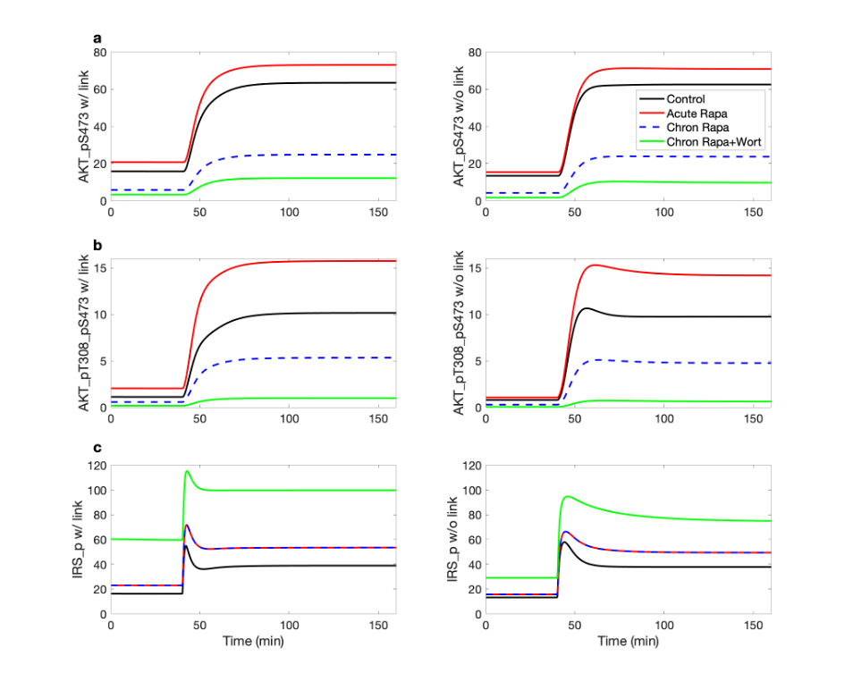
Figure S2. Effects of insulin, rapamycin, and wortmannin on key proteins and their interactions. Insulin was lowered to 10% of its baseline level for the initial 40 min of the simulation, and subsequently returned to baseline level. Simulations are conducted for control, acute and chronic administration of rapamycin, chronic administration of rapamycin with wortmannin. The inhibition of PRAS40 of mTORC1 is represented in the left panels but not the right ones.

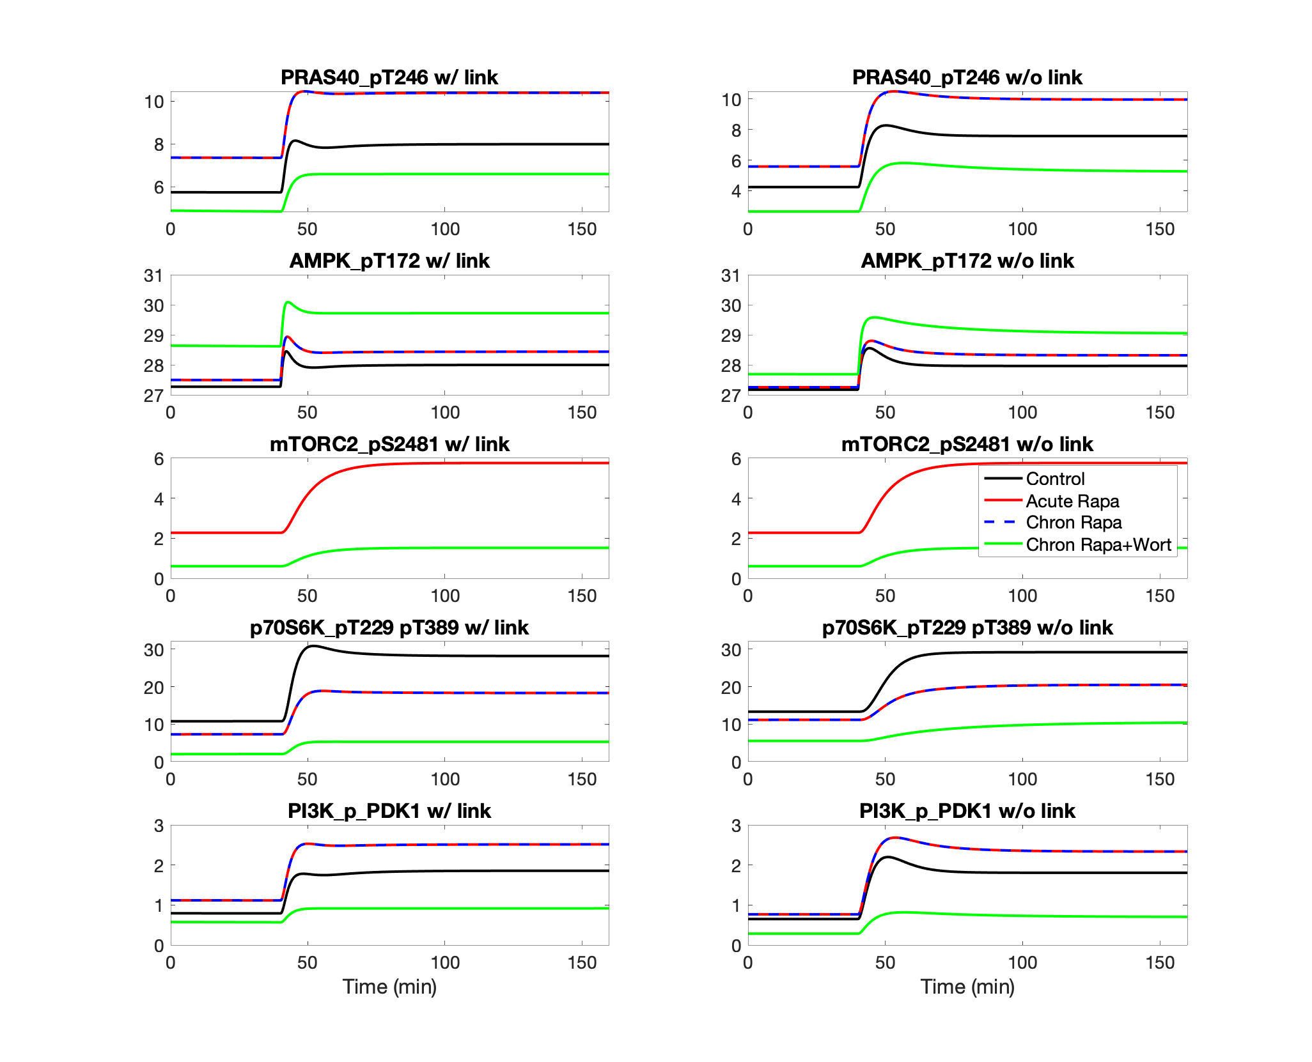
Figure S3. Effects of insulin, rapamycin, and wortmannin on key proteins and their interactions. Notations are analogous to Fig. S2.

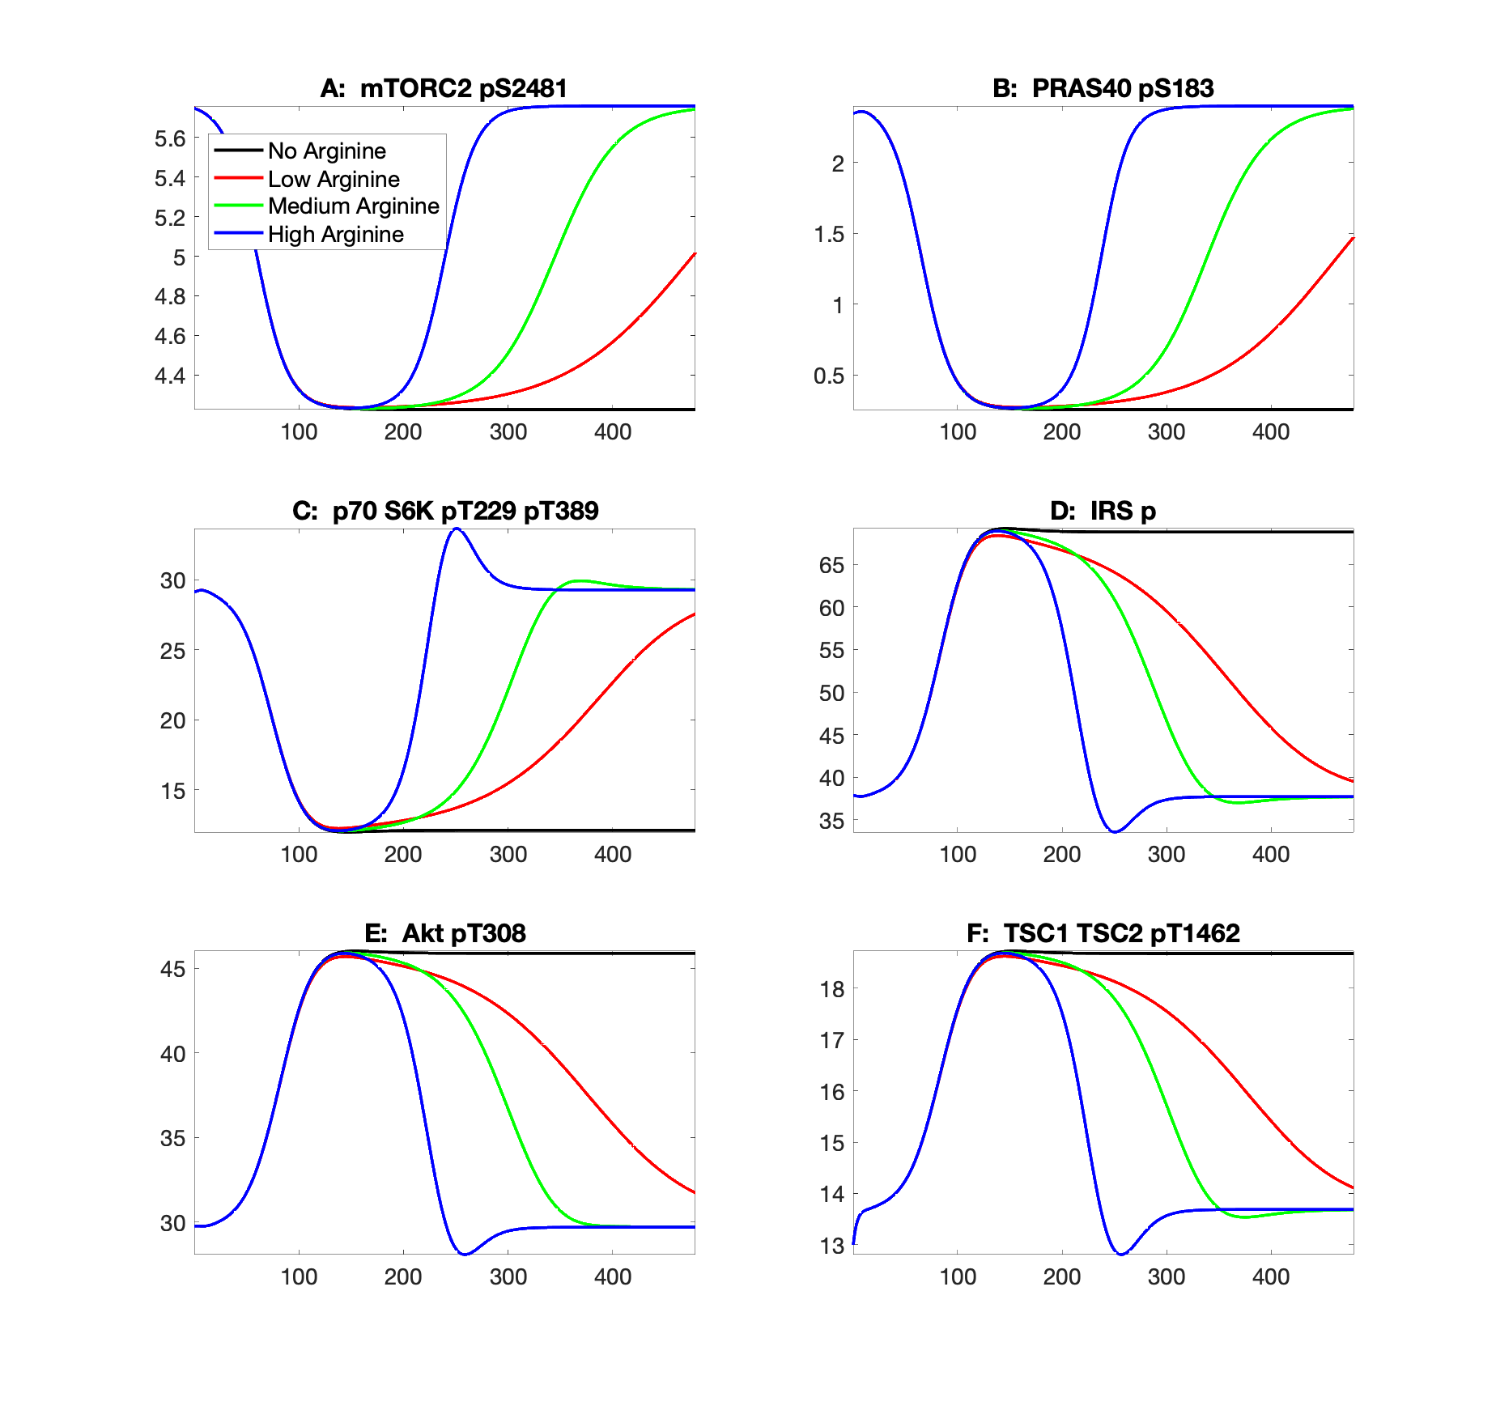
Figure S4. Effect of protein deprivation and subsequent leucine efflux on key model variables, obtained for differing arginine levels.

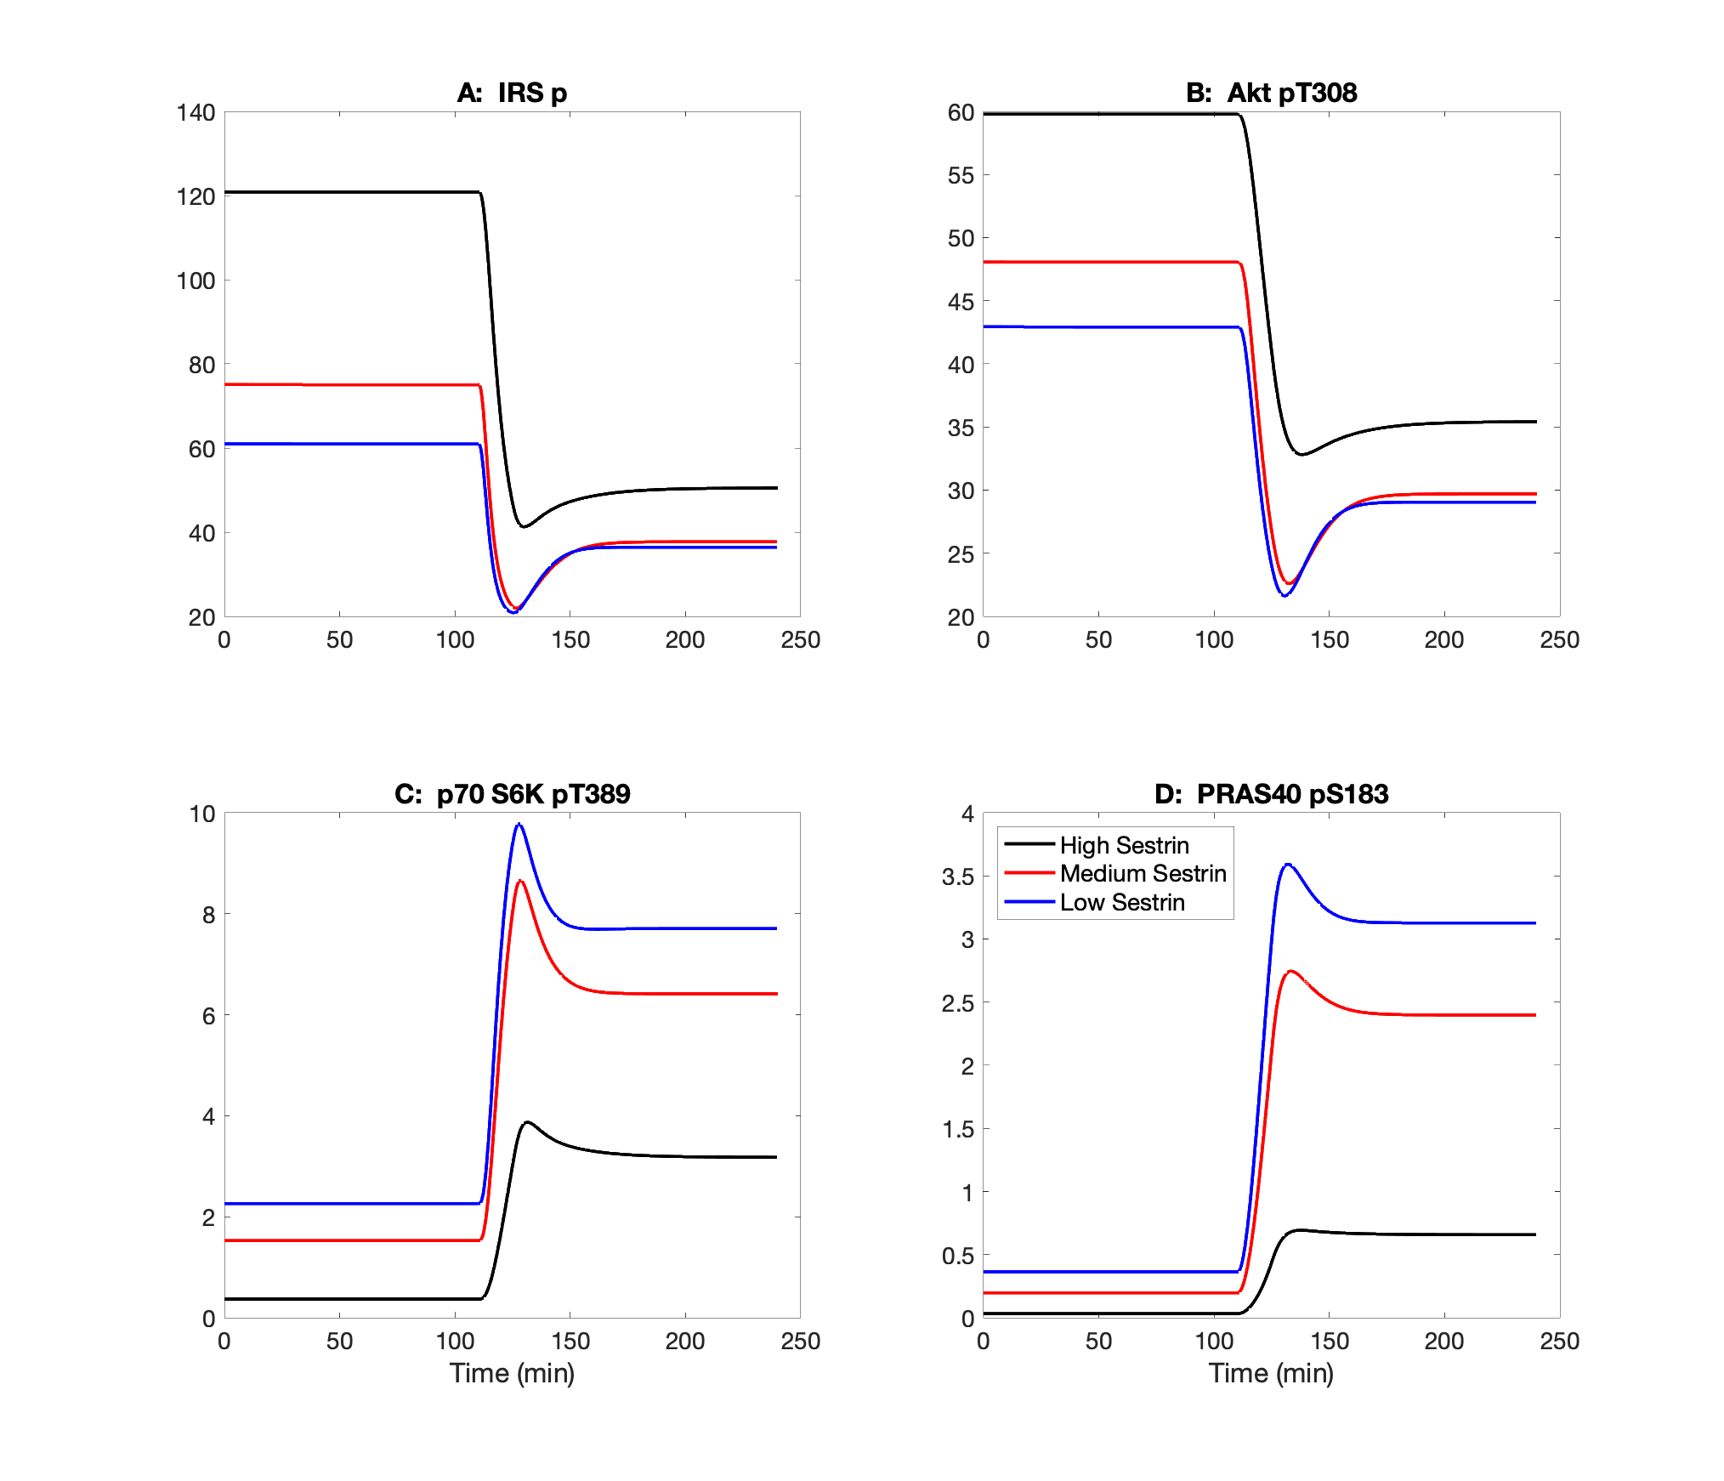 Figure S5. Effect of protein depletion and restoration on key model variables, obtained for differing sestrin2 levels.

