Supplementary Table S1.
Intraoperative details of validation set
Variables | Patients (n = 100)
Operative time (min), median [range] | 232 [89-664]
Blood loss (ml), median [range] | 40 [5-11150]

Supplementary Table S2.
Postoperative complications of Clavien-Dindo classification (CD) grade ≥ II in validation set
Complication | Patients (n = 100)
Total complications (CD grade ≥ II), n (%) | 18 (18.0%)
Anastomotic leakage | 3 (3.0%)
Pelvic abscess | 3 (3.0%)
Bleeding | 2 (2.0%)
Bowel obstruction / ileus | 3 (3.0%)
Abdominal wound infection | 3 (3.0%)
Venous thromboembolism | 2 (2.0%)
Cerebral embolism | 1 (1.0%)
Foreign body residue | 1 (1.0%)
Clavien-Dindo classification, n (%)
Grade II | 7 (0.07%)
Grade III | 10 (1.00%)
Grade IV | 1 (0.01%)
Grade V | 0 (0%)

Supplementary Table S3.
Univariate analysis of clinical characteristics associated with postoperative complications of Clavien-Dindo classification (CD) grade ≥ II in validation set
Factors | Category |  | Number of patients | Incidence of  complication (%) | OR (95% CI) | P value
Age, years |  | ≥ 66 | 46 | 15.12 | 1.266 (0.440-3.646) | 0.791
 |  | < 66 | 54 | 18.52
Sex |  | Male | 53 | 20.75 | 1.790 (0.605-5.290) | 0.424
 |  | Female | 47 | 12.77
Tumor location |  | Rectum | 31 | 32.26 | 4.218 (1.425-12.485) | 0.010*
 |  | Colon | 69 | 10.14
Surgical approach |  | Open | 8 | 50.00 | 6.077 (1.349-27.370) | 0.027*
 |  | Lap | 92 | 14.13
Histological grade |  | por, muc | 6 | 33.33 | 2.633 (0.442-15.692) | 0.269
 |  | tub1, tub2 | 94 | 15.96
Tumor invasion |  | T4 | 11 | 18.18 | 1.096 (0.215-5.593) | 1.000
 |  | T1/T2/T3 | 89 | 16.85
Lymph node metastasis |  | N2 | 24 | 12.5 | 0.633 (0.165-2.420) | 0.756
 |  | N1 | 76 | 18.42
Operative time, min |  | > 280 | 34 | 35.29 | 6.655 (2.104-21.048) | 0.001*
 |  | ≤ 280 | 66 | 7.58
Blood loss, ml |  | > 140 | 22 | 40.91 | 6.058 (1.974-18.591) | 0.002*
 |  | ≤ 140 | 78 | 10.26
Kansai Prognostic Score |  | ≥2 | 12 | 88.64 | 10.920 (2.908-41.003) | <0.001*
 |  | ≤1 | 88 | 11.36
OR = odds ratio, CI = confidence interval, Open = open surgery, Lap = laparoscopic surgery, por = poorly differentiated adenocarcinoma, muc = mucinous adenocarcinoma, tub1 = well-differentiated adenocarcinoma, tub2 = moderately differentiated adenocarcinoma, Asterisk values indicate P-values < 0.05.
Supplementary Table S4.
Multivariate analysis of clinical characteristics associated with postoperative complications (Clavien-Dindo classification grade ≥ II) in validation set
Factors | OR (95% CI) | P value
Tumor location (rectum / colon) | 1.864 (0.435-7.988) | 0.401
Surgical approach (open / lap) | 2.716 (0.306-24.129) | 0.370
Operative time, min (>280 / ≤ 280) | 3.476 (0.742-16.279) | 0.114
Blood loss, ml (>140 / ≤ 140) | 1.329 (0.269-6.557) | 0.727
Kansai Prognostic Score (≥2 / ≤1) | 6.472 (1.341-31.237) | 0.020*
OR = odds ratio, CI = confidence interval, open = open surgery, lap = laparoscopic surgery, Asterisk values indicate P-values < 0.05.

Supplementary fig. S1
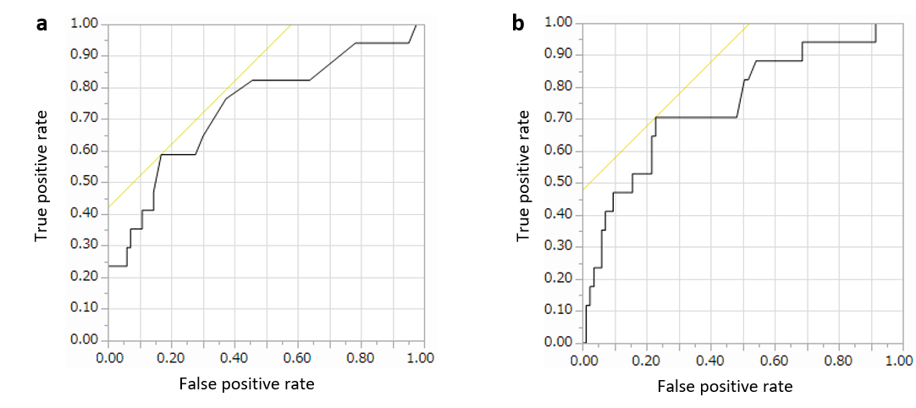
Receiver-operating characteristic (ROC) curves analysis for the cut-off value of the blood loss and operative time. (a) The area under the curve (AUC) of the blood loss was 0.737. The optimal cut-off value in the ROC curve was 140 mL which was set as the cut-off value. (b) AUC of PC was 0.746. The optimal cut-off value in the ROC curve was 280 minutes; 280 minutes was set as the cut-off value.

