One-step preparation of RGO/Fe₃O₄-FeVO₄ nanocomposites as highly effective photocatalysts under natural sunlight illumination

Qana A. Alsulami ª,*, A. Rajeh ^{b}, Mohammed A. Mannaa ^{c}, Soha M. Albukhari ª, Doaa F. Baamer ª
ª Chemistry Department, Faculty of Science, King Abdulaziz University, Jeddah, Saudi Arabia.
^{b} Physics Department, 1q2Faculty of Science, Amran University, Yemen.
^{c} Chemistry Department, Faculty of Science, Amran University, Yemen.

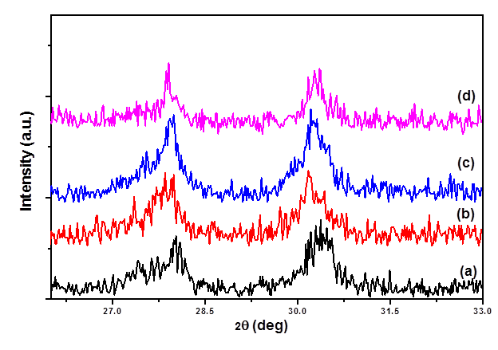
Fig.1S. XRD patterns of (a) Fe₃O₄-FeVO₄ and (b) 5%, (c) 10%, (d) 15%xRGO/Fe₃O₄-FeVO₄ nanocomposites
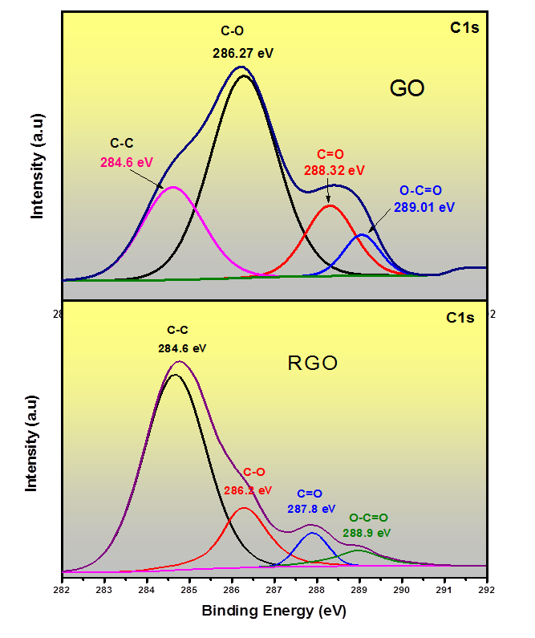
Fig.2S: XPS spectra of GO and RGO.
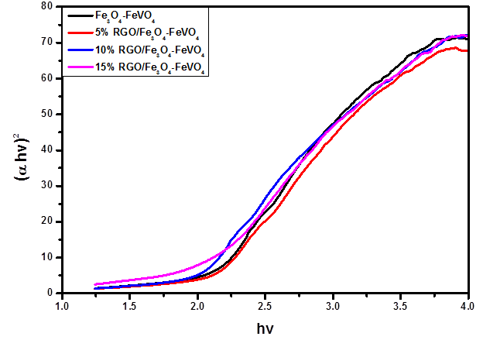
Fig.3S. Tauc’s plot for optical band gap calculation of Fe₃O₄-FeVO₄ and xRGO/Fe₃O₄-FeVO₄

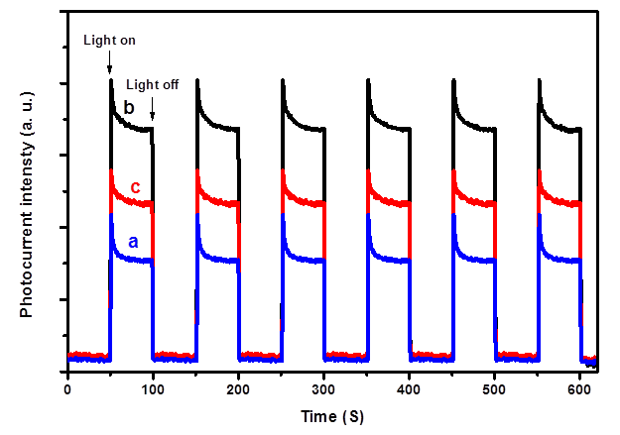
Fig.4S. Photocurrent response of (a) Fe₃O₄-FeVO₄ (b) 10%RGO/Fe₃O₄-FeVO₄ and (c) 15%RGO/Fe₃O₄-FeVO₄

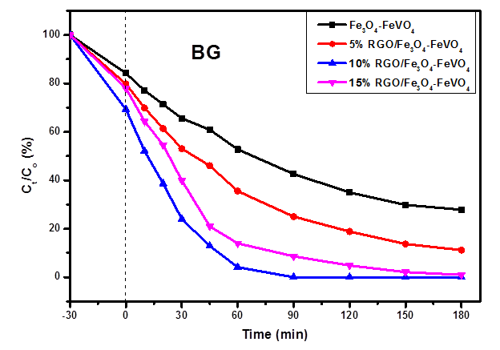
Fig.5S. Photocatalytic degradation of BG over of Fe₃O₄-FeVO₄ and xRGO/Fe₃O₄-FeVO₄nanocomposites vs. irradiation time.

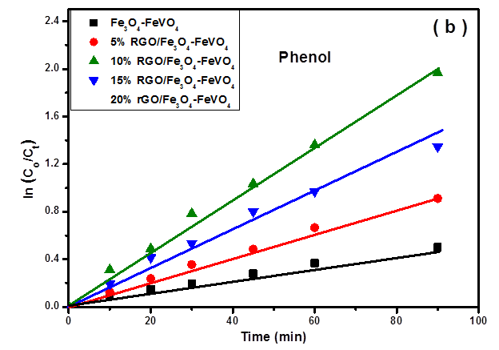
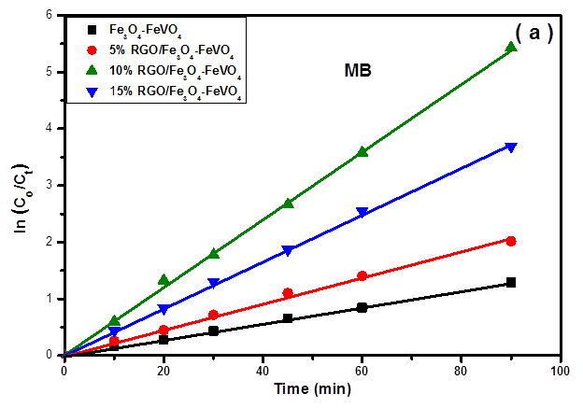
Fig. 6S. The pseudo first-order kinetic of photodegradation of (a) MB and (b) phenol over of Fe₃O₄-FeVO₄ and xRGO/Fe₃O₄-FeVO₄nanocomposites.
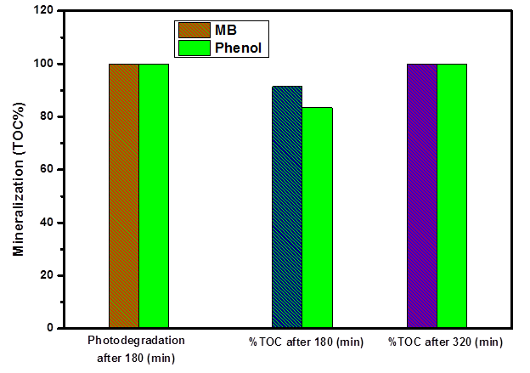
Fig.7S: TOC% removal and photodegradation of MB and phenol vs. time

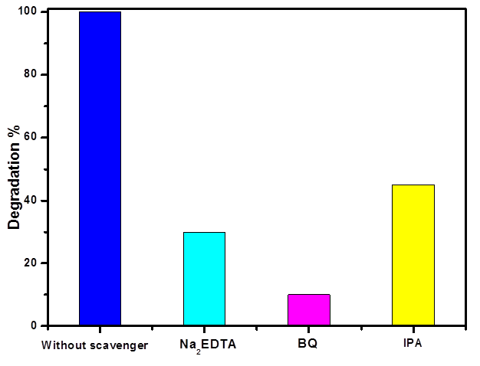
Fig.8S: Photodegradation of MB over 10%RGO/Fe₃O₄-FeVO₄ in the absence and presence of different scavengers under similar reaction conditions.

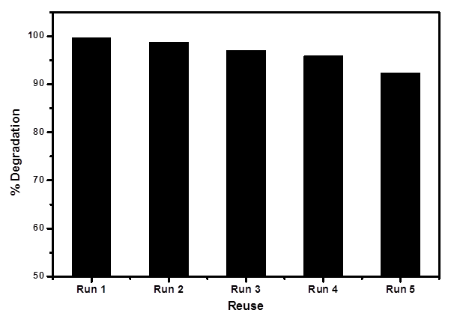
a

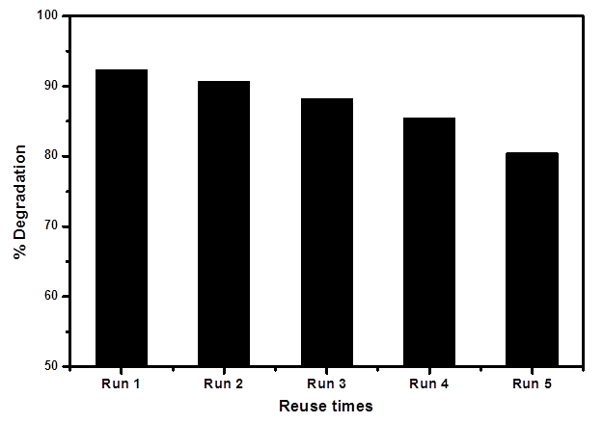
b

.

Fig. 9S. Effect of reuse times of 10%RGO/Fe₃O₄-FeVO₄photocatalyst on the photocatalytic degradation of (a) MB and (b) Phenol.

Table 1S: Comparison of the photodegradation performances of different organic pollutants by different photocatalysts.
Catalyst | Type of pollutant | Light source | Time, (min.) | Efficiency (%) | Ref.
RGO/Fe₃O₄-FeVO₄ | MB | Sunlight | 60 | 100% | This  work
RGO/Fe₃O₄-FeVO₄ | Phenol | Sunlight | 150 | 100% | This  work
RGO/Fe₃O₄-FeVO₄ | BG | Sunlight | 90 | 100% | This  work
rGO-FeVO₄,  (0.05 gm) | MG | Sunlight | 120 | 100% | [23]
rGO-FeVO₄,  (0.05 gm) | Phenol | Sunlight | 180 | 92.3% | [23]
rGO-FeVO₄,  (0.05 gm) | MB | Sunlight | 60 | 100% | [23]
rGO-FeVO₄,  (0.05 gm) | RhB | Sunlight | 90 | 100% | [23]
rGO-FeVO₄,  (0.12 gm) | MB | Visible | 180 | 80.5 | [50]
FeVO₄/Bi₇O₉I₃  (0.1 gm) | MB | visible | 360 | 81.3 | [14]
FeVO₄/Bi₇O₉I₃  (0.1 gm) | RhB | visible | 360 | 98.9% | [14]
FeVO₄/Bi₇O₉I₃  (0.1 gm) | MO | visible | 360 | 94.9% | [14]
BiVO₄/FeVO₄@rGO (0.3 gm) | tetracycline | visible | 90 | 93 | [18]
ZnO/FeVO₄ /H₂O₂ /pH5.5 | Sodium dodecyl sulfate | UV | 45 | 99% | [21]
BiVO₄/FeVO₄ (0.2gm) | Metronidazole | visible | 90 | 90% | [5]
RGO-FeWO₄/Fe₃O₄ (0.2 gm) | RhB | visible | 240 | 35% | [42]
NRGO-CoWO₄-Fe₂O₃ (0.2 gm) | MB | visible | 120 | 98.23 | [51]
rGO/BiVO₄ | MB | visible | 120 | 97% | [9]
FeVO₄:Zn²⁺,  (0.03 gm) | MB | Visible | 180 | 99 | [16]
FeVO₄:Mn,  (0.03 gm) | MG | Visible | 180 | 98 | [16]
FeVO₄-IL/H₂O₂,  (0.1 gm) | RhB | Visible | 120 | 95 | [52]
Bi₂O₃/FeVO₄  (0.05 gm) | MG | Visible | 240 | 88.7 | [53]

