Supplementary Material

Human peripheral monocytes capture elements of the state of microglial activation in the brain

Daniel Felsky PhD^{1,2,3}, Hans-Ulrich Klein⁴, Vilas Menon⁴, Yiyi Ma⁵, Yanling Wang^{5,6}, Milos Milic¹, Peter Zhukovsky¹, Julie A Schneider MD^{5,6}, David A. Bennett MD^{5,6}, Philip L. De Jager MD⁴

1. Krembil Centre for Neuroinformatics, Centre for Addiction and Mental Health, 250 College Street, Toronto, ON, CA
2. Department of Psychiatry and Dalla Lana School of Public Health, University of Toronto, Toronto, ON, Canada
3. Institute of Medical Science, University of Toronto, Toronto, ON, Canada
4. Center for Translational and Computational Neuroimmunology, Department of Neurology and the Taub Institute for Research on Alzheimer’s Disease and the Aging Brain, Columbia University Irving Medical Center, 630 West 168th Street, New York, NY 10032, USA.
5. Department of Neurological Sciences, Rush University Medical Center, 1653 West Congress Parkway, Chicago, IL 60612, USA.
6. Rush Alzheimer’s Disease Center, Rush University Medical Center, 1653 West Congress Parkway, Chicago, IL 60612, USA.
Contents
Supplementary Methods 3
Neuropathological assessment details 3
Isolation of Peripheral blood monocytes 4
Sequencing of RNA from Monocytes 4
Sequencing of RNA from Bulk brain (DLPFC) 4
Supplementary Table Descriptions 6
Supplementary Figure Legends 6
Supplementary References 7

Supplementary Figure 1 8
Supplementary Figure 2 9
Supplementary Figure 3 10
Supplementary Figure 4 11
Supplementary Figure 5 12
Supplementary Figure 6 13
Supplementary Figure 7 14
Supplementary Figure 8 15
Supplementary Figure 9 16
Supplementary Figure 10 17

Supplementary Methods

Neuropathological assessment details
These details related to neuropathological measurements have been previously published as supplementary methods in Felsky et al., 2019¹ and are included here for reader convenience. All brains were examined by a board-certified neuropathologist blinded to clinical data. After weighing, each brain was cut into 1cm coronal slabs using a Plexiglas jig. Slabs from one hemisphere, and slabs from the other hemisphere not designated for rapid freezing, were fixed for at least 3 days in 4% paraformaldehyde. We used defined landmarks to obtain at least two tissue blocks from each of the following regions: dorsolateral prefrontal cortex, middle and inferior temporal cortex, inferior parietal, hippocampus CA1/subiculum, entorhinal cortex proper, ventromedial caudate, and posterior putamen. Tissue blocks were processed, embedded in paraffin, cut into either 6 micron or 20μm sections, and mounted on glass slides. Neuropathologic diagnoses were made by a board-certified neuropathologist blinded to age and clinical data. Bielschowsky silver stain 6 micron sections were used to visualize neuritic plaques, diffuse plaques, and neurofibrillary tangles in the frontal, temporal, parietal, entorhinal, and hippocampal cortices, as previously described,² for the pathologic diagnosis of AD. A neuropathologic diagnosis of “no AD,” “low likelihood AD,” “intermediate likelihood AD,” or “high likelihood AD” was given based on semiquantitative estimates of neuritic plaque density as recommended by CERAD and the neurofibrillary tangle stage by Braak and Braak as recommended by the National Institute on Aging (NIA) - Reagan criteria. For analyses, the neuropathologic diagnosis of AD was considered absent if NIA-Reagan diagnosis was no or low and present if intermediate or high likelihood. The density of neuritic plaques, diffuse plaques and neurofibrillary tangles was characterized using Bielschowsky silver stain for visualization and a graticule to count total number of each in a 1-mm² area (100 magnification) of highest density. Counts for each marker were completed for each of five regions (midfrontal cortex, middle temporal cortex, inferior parietal cortex, entorhinal cortex, and hippocampus CA1/subiculum) and then converted to standardized scores. Supplementary Table 9 describes the distributions of tau and amyloid neuropathologies in the pathologically confirmed AD and non-AD groups separately for both the entire available ROS/MAP cohort and the sample subset for which postmortem microglial density data were available.

Thirteen additional pathologies were measured in our cohort: Lewy bodies, macroscopic infarcts (acute, sub-acute, and chronic measured separately), microscopic infarcts (acute, sub-acute, and chronic measured separately), atherosclerosis, arteriolosclerosis, cerebral amyloid angiopathy (CAA), hippocampal sclerosis, neuronal loss in the substantia nigra,³ and transactive response DNA-binding protein 43 kDa (TDP-43) proteinopathy. CAA was graded on a five-level scale (0 to 4) in four neocortical regions (mid-frontal, angular gyrus, inferior temporal gyrus, and calcarine cortex) and averaged to derive a CAA score, as previously described.⁴ Chronic macroscopic and microscopic infarcts were each dichotomized as present or absent. Atherosclerosis was scored on a four-level severity scale, and arteriolosclerosis was measured on a four-level scale by small vessel pathologies in anterior basal ganglia.⁵ Nigral, limbic, and neocortical Lewy bodies were dichotomized as present or absent, as identified using immunohistochemistry. Hippocampal sclerosis was recorded as either present or absent as evaluated with H&E stain. Pathological diagnosis of AD was given for cases with high or intermediate likelihood of AD per the modified National Institute of Aging–Reagan Institute criteria.⁶ For a subset of participants (n = 826), transactive response DNA-binding protein 43 kDa (TDP-43) proteinopathy was measured and categorized into four steps of severity as previously described:⁷ no inclusions (stage 0), inclusions in amygdala only (stage I), inclusions in amygdala as well as entorhinal cortex and/or hippocampus CA1 (stage II), and inclusions in amygdala, neocortex, and entorhinal cortex and/or hippocampus CA1 (stage III). In addition, a semi-quantitative six-point scale for the severity of the TDP-43 cytoplasmic inclusions was rated as previously described (n=812).⁸

Immunohistochemistry for microglia was performed using an Automated Leica Bond immunostainer (Leica Microsystems Inc., Bannockborn IL) and anti-human HLA-DP, DQ, DR antibodies (clone CR3/43; DakoCytomation, Carpinteria CA; 1:100 dilution; catalog number MA1-25914) using standard Bond epitope retrieval and detection. An investigator blinded to the clinical and pathologic data, outlined the cortical or subcortical gray region of interest on each slide using a Microbrightfield Stereology System. The Stereo Investigator 8.0 software program was used to place a 1000 × 750μm sampling grid over the region and the program was engaged to sample 4.0% of the region with a 200 × 150μm counting frame at 400x magnification at interval grid intersection points. Using separate tags for stage I, II and III microglia, the operator marked the microglia at each intersection point. These counts were then upweighted by the stereology software to estimate total number of microglia (stage I, II, and III) in the defined area. Different stages of activation from least (stage I) to most (stage III) activated can be defined morphologically; when these cells become activated, their long fine processes contract and thicken and the cell body adopts a larger more rounded cellular conformation. Data from the two adjacent blocks of tissue (0.5 to 1.0 cm apart) were averaged to obtain composite average densities of microglia in each region.

Isolation of Peripheral blood monocytes
After thawing, PBMCs were washed in 10ml PBS (Lonza, 17-516F) and CD14+CD16- monocytes were isolated using the EasySep Human Monocyte Isolation Kit (Negative selection kit, Stemcell Technologies, 19359) according to manufacturer's instructions. The monocyte suspension was spun down and incubated with anti-CD14 AlexaFluor488 (Biolegend, 301804, clone M5E2) and anti-CD16 APC (Biolegend, 302012, clone 3G8) antibodies as well as Live Dead Fixable Aqua Dead cell stain (Invitrogen, L34957) for 20 min on ice. Subsequently the cell suspensions were washed twice with staining buffer (PBS containing 1% FBS (Gibco, 10438026)), filtered through a 70 μm filter and the Live (BV510-) CD14+/CD16-cells were sorted on a BD Influx cell sorter. 2000 cells were sorted per well in a 96 well PCR plate (Eppendorf, 951020401) containing 10 μl of TCL buffer (Qiagen, 1031576) with 1% β-mercaptoethanol (Sigma, M3148). Following FACS the lysate was vigorously vortexed for 30 s, spun down, snap frozen on dry ice and stored at −80 °C until further processing.

Sequencing of RNA from Monocytes
cDNA was prepared from 20-2000 FACS-sorted cells stored at -80°C and thawed to lyse. RNA was purified using a bead-based clean-up immediately followed by priming, reverse transcription with template switching using Thermo Scientific Maxima H Minus Reverse Transcriptase and Invitrogen Superase-In RNase Inhibitor, and enrichment with 18-22 cycles of PCR amplification. cDNA was evaluated using fluorescent-based assays including PicoGreen (Life Technologies), Qubit Fluorometer (Invitrogen), and Fragment Analyzer (Advanced Analytics). Final RNA libraries were prepared using the Nextera XT DNA Library Prep kit in accordance with the manufacturer’s instructions. Briefly, 1 ng of amplified cDNA underwent tagmentation to fragment and tag cDNA with adapter sequences. Tagmented cDNA was then ligated with Illumina Nextera dual indices and enriched using 12 cycles of PCR amplification. Final libraries were evaluated using Picogreen (Life Technologies) and Fragment Analyzer (Advanced Analytics). For samples in the batch 1 and 2, libraries were pooled and sequenced on a HiSeq 2500 (Illumina) using 2 x 101bp (Batch 1) and 2 x 76bp cycles (Batch 2). For samples in the batch 3, libraries were pooled and sequenced on a NovaSeq 6000 (Illumina) using 2 x 50bp cycles.

Sequencing of RNA from Bulk brain (DLPFC)
RNA sequencing on DLPFC tissue was carried out in 13 batches within three distinct library preparation and sequencing pipelines. All samples were extracted using Qiagen's miRNeasy mini kit (cat. no. 217004) and the RNase free DNase Set (cat. no. 79254), and quantified by Nanodrop and quality was evaluated by Agilent Bioanalyzer. Pipeline1: The Broad Institutes's Genomics Platform performed RNA-Seq library preparation using the strand specific dUTP method [REF1 - Levin et al., Nature Methods 2010] with poly-A selection [REF2 - Adiconis et al., Nature Methods 2013]. This method begins with poly-A selection followed by first strand specific cDNA synthesis, and then uses dUTP for second strand specific cDNA synthesis followed by fragmentation and Illumina adapter ligation for library construction. We have completed RNA-Seq with 582 of the samples that met quality (Bioanalyzer RNA integrity (RIN) score >5) and quantity thresholds (5ug). Sequencing was performed on the Illumina HiSeq with 101bp paired-end reads and achieved coverage of 150M reads of the first 12 samples. These 12 samples will serve as a deep coverage reference and included 2 males and 2 females of non-impaired, mild cognitive impaired, and Alzheimer's cases. This is batch "0". The remaining samples were sequenced with coverage of 50M reads. The libraries were constructed and pooled according to the RIN scores such that similar RIN scores would be pooled together. Varying RIN scores results in a larger spread of insert sizes during library construction and leads to uneven coverage distribution throughout the pool. In our sample set, we noticed that samples with lower RIN scores between 5 and 6 had more adapter contamination. An additional 57 samples were submitted at a later date to the platform and run on an updated protocol requiring only 250ng of input RNA. This protocol is a modification of Illumina's TruSeq protocol to include long insert sizes and also be strand specific. These late samples were sequenced in batch 2 on plates 7 and 8.

For pipeline 2, RNA sequencing libraries were prepared using the KAPA Stranded RNA-Seq Kit with RiboErase (kapabiosystems) in accordance with the manufacturer’s instructions. Briefly, 500ng of total RNA was used for ribosomal depletion and fragmentation. Depleted RNA underwent first and second strand cDNA synthesis. cDNA was then adenylated, ligated to Illumina sequencing adapters, and amplified by PCR. Final libraries were evaluated using fluorescent-based assays including PicoGreen (Life Technologies) or Qubit Fluorometer (invitrogen) and Fragment Analyzer (Advanced Analytics) or BioAnalyzer (Agilent 2100). Sequencing was done on Illumina NovaSeq6000 sequence using 2 x 100bp cycles targeting 30 million reads per sample.

For pipeline 3, 50mgs of frozen brain tissue was dissected and homogenized in DNA/RNA shield buffer (Zymo, R1100) with 3mm beads using a bead homogenizer. RNA was subsequently extracted using Chemagic RNA tissue kit (Perkin Elmer, CMG-1212) on a Chemagic 360 instrument. RNA was concentrated (Zymo, R1080) and RQN values calculated with a Fragment Analyzer total RNA assay (Agilent, DNF-471). RNA concentration was determined using Qubit broad range RNA assay (Invitrogen, Q10211) according to the manufacturer’s instructions. 500ng total RNA was used as input for sequencing library generation and rRNA was depleted with RiboGold (Illumina, 20020599). A Zephyr G3 NGS workstation (Perkin Elmer) was utilized to generate TruSeq stranded sequencing libraries (Illumina, 20020599) with custom unique dual indexes (IDT) according to the manufacturer’s instructions with the following modifications. RNA was fragmented for 4 minutes at 85°C. First strand synthesis was extended to 50 minutes. Size selection post adapter ligation was modified to select for larger fragments. Library size and concentrations were determined using an NGS fragment assay (Agilent, DNF-473) and Qubit ds DNA assay (Invitrogen, Q10211) respectively, according to the manufacturer’s instructions. The modified protocol yielded libraries with an average insert size of around 330-370bp. Libraries were normalized for molarity and sequenced on a NovaSeq 6000 (Illumina) at 40-50M reads, 2x150bp paired end.

Supplementary Table Descriptions
Supplementary Table 1. Demographic summary of ROS/MAP participants included in Monocyte Gene expression analysis, stratified by RNA sequencing batch.

Supplementary Table 2. Gene set overrepresentation analysis results from monocyte-bulk brain correlation.

Supplementary Table 3. Results of hypergeometric overlap of differential expression results in monocytes with differential expression results from experiments included in the MyeloidLandscape2 browser.

Supplementary Table 4. Gene set overrepresentation analysis results for significantly up- and down-regulated genes from differential expression analysis of 26 cognitive and neuropathologic traits.

Supplementary Table 5. Whole-transcriptome rank-based gene set enrichment analysis (GSEA) results for differential expression analysis of 26 cognitive and neuropathologic traits.

Supplementary Figure Legends
Supplementary Figure 1. Significantly overlapping sets of differentially expressed genes from monocyte differential expression analyses and the Myeloid Landscape 2 differential expression experiments. Piecharts are shown only where hypergeometric overlap of significant genes (two-sided corrected p_{FDR}<0.05 in both experiments) was significant at uncorrected p<0.05. The colors within each piechart denote the direction of effect in each experiment. The labeled numbers are the observed number of overlapping significantly differentially expressed genes between experiments. For full statistics including raw hypergeometric p-values, expected overlap, fold-enrichment, and universe size, please see Supplementary Table 3. Note that the label name for experiment GSE52564 has been truncated to aid the readability of the plot. Full details for all experiments are available at http://research-pub.gene.com/BrainMyeloidLandscape/BrainMyeloidLandscape2/#.

Supplementary Figure 2. Top gene set enrichment analysis (GSEA) results for differential expression of 26 cognitive and neuropathologic traits. A) Heatmap showing normalized enrichment score (NES) for all GO terms with at least one trait having an NES > 2 or < -2 and corrected enrichment p-value < 0.05. FDR-based multiple testing correction was first applied across all tested GO terms for each phenotype separately, and then again using the Bonferroni approach to account for the number of phenotypes tested (FDR p-value threshold = 0.05/26 = 0.0019). B) Heatmap showing NES for significant enrichments against condensed GO ontologies to aid in interpretation of overlapping GO group themes from panel A. All GO terms with corrected p-value<0.05 (n=84) were entered into the rrvgo similarity and term-reduction pipeline (similarity parameter set to 0.8), which yielded 22 parent GO terms covering all 84 terms identified within each pathology separately.

Supplementary Figure 3. Overlap in gene membership between modules derived from monocytes and DLPFC. Numbers within cells are the number of genes overlapping between module identities in DLPFC and monocytes. The color scale represents –log₁₀(p-values) from the hypergeometric test of overlap (calculated using the overlapTableUsingKME function in WGCNA).

Supplementary Figure 4. Module membership vs. trait association in monocytes and DLPFC. The y-axes represent moderated t-statistics for each gene (data point) from transcriptome-wide differential expression analyses of the mid-frontal cortical proportion of activation microglia (PAM) phenotype (left panel) and neurofibrillary tangles (NFT; right panel). The x-axes represent the loadings of each gene onto the first principal component (eigengene) of the module to which it belongs (facet titles).

Supplementary Figure 5. Association of top 20 whole transcriptome expression principal components (PCs) with technical and biological covariates co-variates in (Monocytes). Correlation values shown correspond to different statistics of association, depending on the datatype of each covariate. For continuous variables, Pearson correlation was used. For categorical variables, one-way ANOVA was used (Kruskall-Wallis test was used instead of one-way ANOVA if Shapiro-Wilk normality test of expression PC was rejected at p<0.05). The “correlation” values for ANOVA correspond to the square root of the explained sum of squares divided by the total sum of squares. For Krustall-Wallis tests, the “correlation” values were calculated as the square root of the rank sum statistic divided by the total number of observations. All p-values used for determining significance were two-sided.

Supplementary Figure 6. Association of top 20 whole transcriptome expression principal components (PCs) with technical and biological covariates co-variates in (DLPFC). Correlation values shown correspond to different statistics of association, depending on the datatype of each covariate. For continuous variables, Pearson correlation was used. For categorical variables, one-way ANOVA was used (Kruskall-Wallis test was used instead of one-way ANOVA if Shapiro-Wilk normality test of expression PC was rejected at p<0.05). The “correlation” values for ANOVA correspond to the square root of the explained sum of squares divided by the total sum of squares. For Krustall-Wallis tests, the “correlation” values were calculated as the square root of the rank sum statistic divided by the total number of observations. All p-values used for determining significance were two-sided.

Supplementary Figure 7. Correlation matrix of technical and biological covariates in monocyte dataset. Correlation values shown correspond to different statistics of association, depending on the datatype of each covariate. For two continuous variables, Pearson correlation was used. For one continuous and one categorical variable, one-way ANOVA was used (Kruskall-Wallis test was used instead of one-way ANOVA if Shapiro-Wilk normality test of expression PC was rejected at p<0.05). The “correlation” values for ANOVA correspond to the square root of the explained sum of squares divided by the total sum of squares. For Krustall-Wallis tests, the “correlation” values were calculated as the square root of the rank sum statistic divided by the total number of observations. For two categorical variables, Fisher’s exact tests were used. All p-values used for determining significance were two-sided.

Supplementary Figure 8. Correlation matrix of technical and biological covariates in DLPFC dataset. Correlation values shown correspond to different statistics of association, depending on the datatype of each covariate. For two continuous variables, Pearson correlation was used. For one continuous and one categorical variable, one-way ANOVA was used (Kruskall-Wallis test was used instead of one-way ANOVA if Shapiro-Wilk normality test of expression PC was rejected at p<0.05). The “correlation” values for ANOVA correspond to the square root of the explained sum of squares divided by the total sum of squares. For Krustall-Wallis tests, the “correlation” values were calculated as the square root of the rank sum statistic divided by the total number of observations. For two categorical variables, Fisher’s exact tests were used. All p-values used for determining significance were two-sided.

Supplementary Figure 9. Dendrograms of subject hierarchical clustering based on monocyte gene expression A) before and B) after pruning for outliers. Dendrograms of subject hierarchical clustering based on DLPFC expression data C) before and D) after pruning for outliers. See Methods for approach to outlier detection in both datasets.

Supplementary Figure 10. Results of power threshold search experiment prior to WGCNA in monocytes (A,B) and DLPFC (C,D). The signed R2 and mean connectivity axes (y) correspond to graph metrics used in determining the scale-free topology of co-expression networks. The plotted numbers correspond to the set of tested soft-thresholding power values (x-axis). For details on graph metrics used for determining appropriate soft-thresholding powers in WGCNA please see Zhang and Horvath, 2005⁹.

Supplementary References
1. Felsky, D. et al. Neuropathological correlates and genetic architecture of microglial activation in elderly human brain. Nat. Commun. 10, 409 (2019).
2. Schneider, J. A., Wilson, R. S., Bienias, J. L., Evans, D. A. & Bennett, D. A. Cerebral infarctions and the likelihood of dementia from Alzheimer disease pathology. Neurology 62, 1148–1155 (2004).
3. Buchman, A. S. et al. Nigral Pathology and Parkinsonian Signs in Elders without Parkinson’s Disease. Ann. Neurol. 71, 258–266 (2012).
4. Boyle, P. A. et al. Cerebral amyloid angiopathy and cognitive outcomes in community-based older persons. Neurology 85, 1930–1936 (2015).
5. Yip, A. G. et al. APOE, vascular pathology, and the AD brain. Neurology 65, 259–265 (2005).
6. Bennett, D. A. et al. Neuropathology of older persons without cognitive impairment from two community-based studies. Neurology 66, 1837–1844 (2006).
7. Yu, L. et al. The TMEM106B locus and TDP-43 pathology in older persons without FTLD. Neurology 84, 927–934 (2015).
8. Wilson, R. S. et al. TDP-43 Pathology, Cognitive Decline, and Dementia in Old Age. JAMA Neurol. 70, 1418–1424 (2013).
9. Zhang, B. & Horvath, S. A general framework for weighted gene co-expression network analysis. Stat. Appl. Genet. Mol. Biol. 4, Article17 (2005).

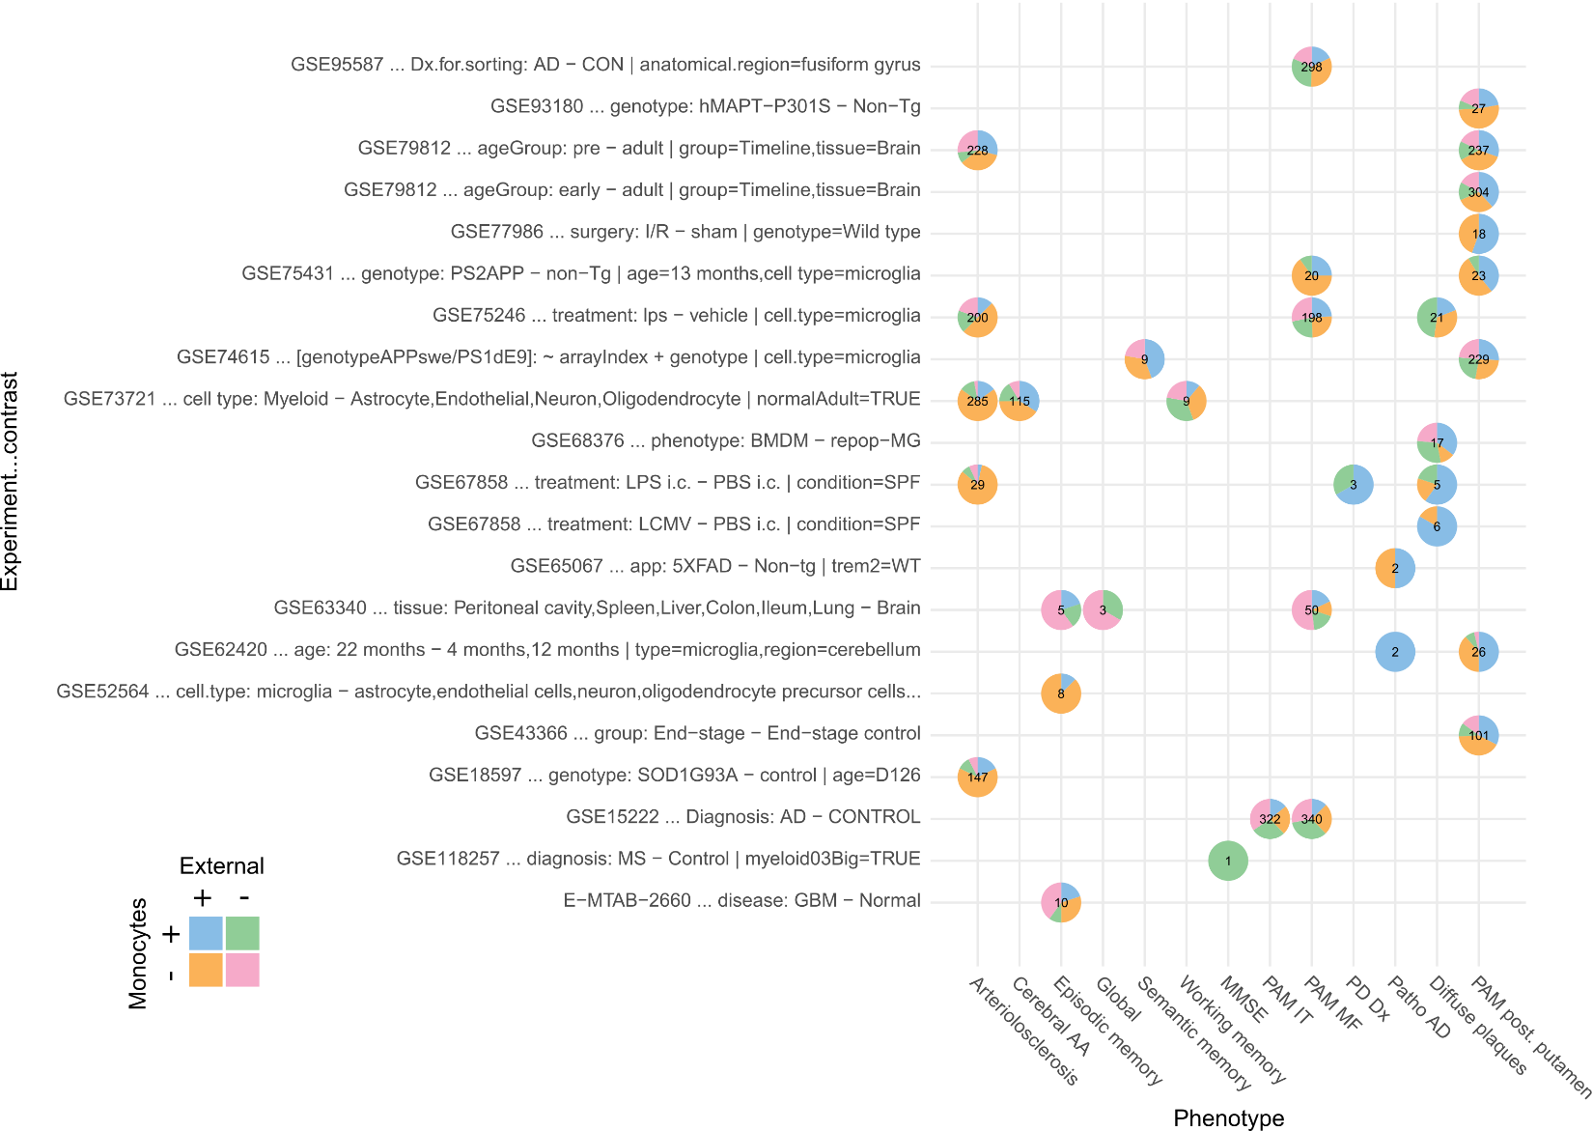
Supplementary Figure 1
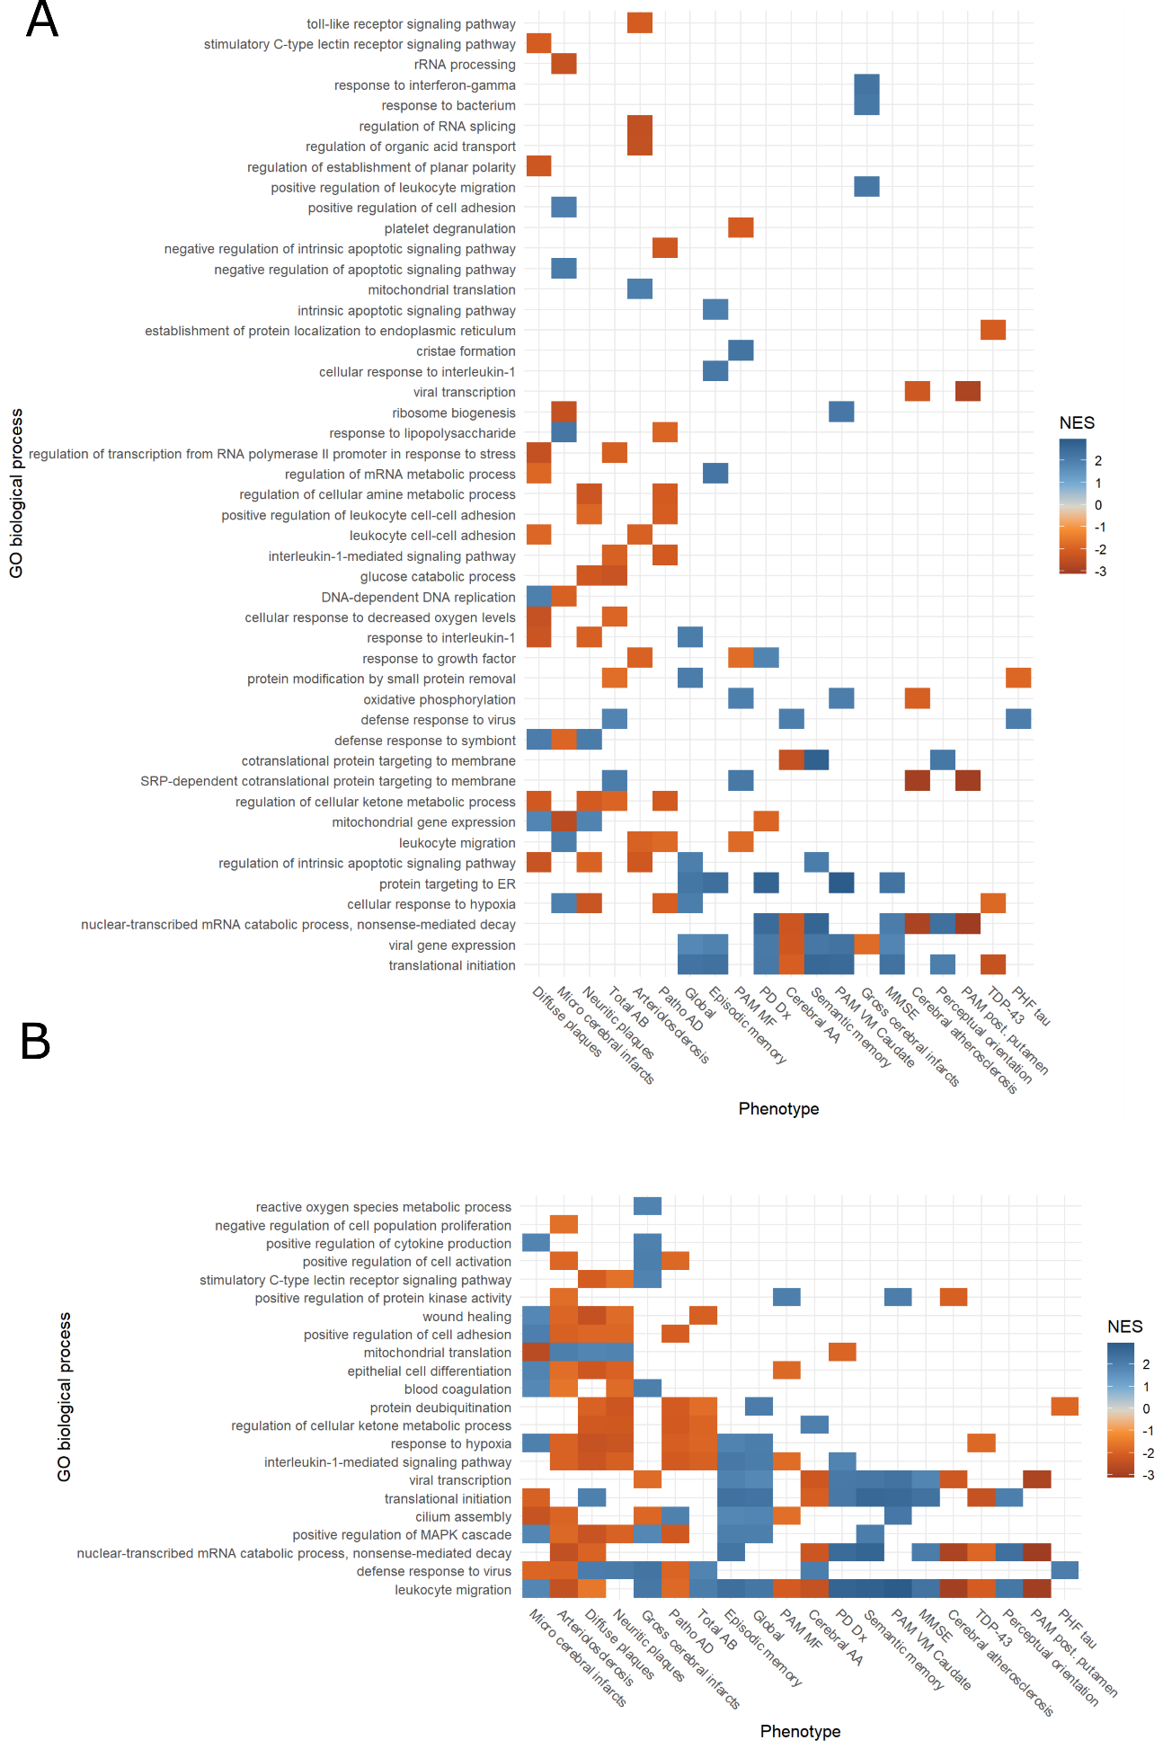
Supplementary Figure 2

Supplementary Figure 3

Supplementary Figure 4
Supplementary Figure 5
Supplementary Figure 6
Supplementary Figure 7
Supplementary Figure 8
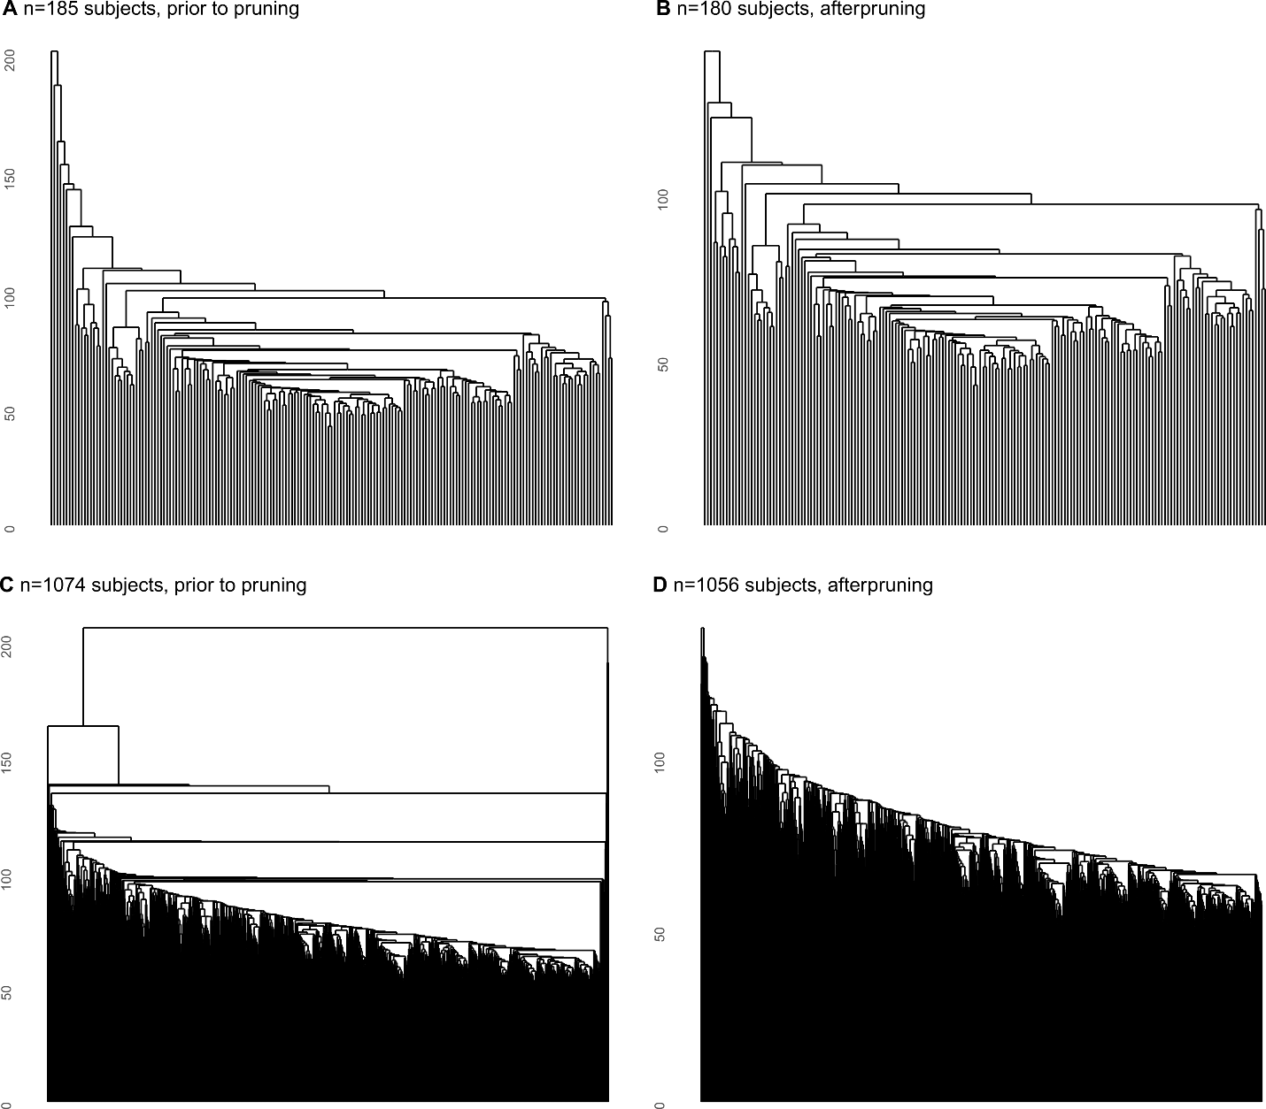
Supplementary Figure 9
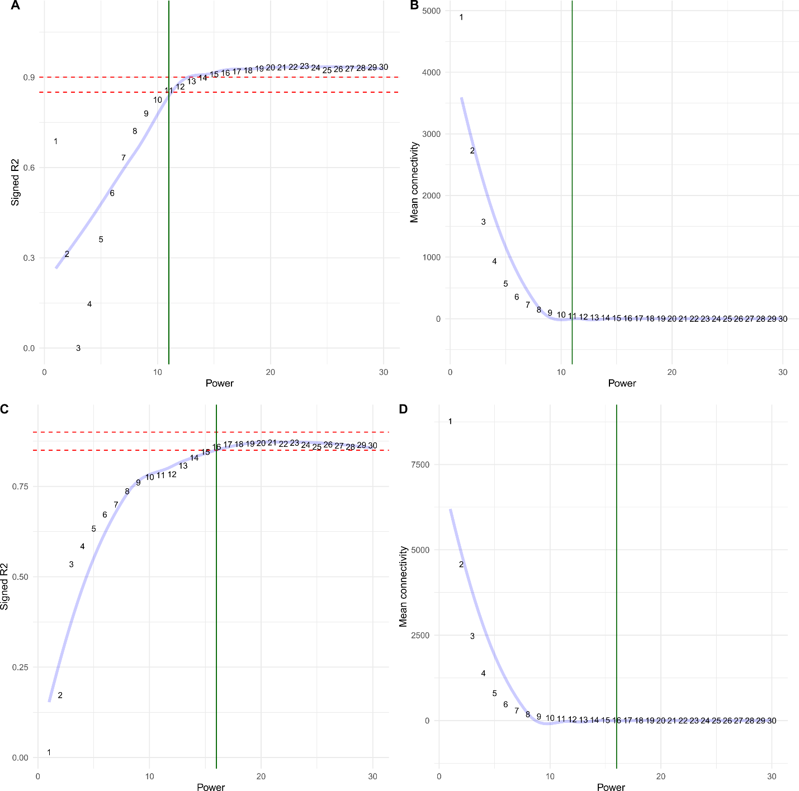
Supplementary Figure 10

