Fig. S1. Survival (mean± SD) of Hypothenemus hampei 72 hours after topical application of acetone, none, and surfactants (Ethanol + Tween 80 + ultrapure water). All solvents did not affect the survival of females CBB (ANOVA: F = 0.16; df = 2,9; P = 0.85).
Fig. S2. Survival probability of Hypothenemus hampei after topical application of Pogostemon cablin essential oil (EO) and its emulsion (18% of EO). Shaded areas represent 95% confidence intervals. Lower case letters indicate significant differences among treatments [Kaplan–Meier method, Log-Rank test (χ² = 103, df = 2; P < 0.0001) and Bonferroni correction].
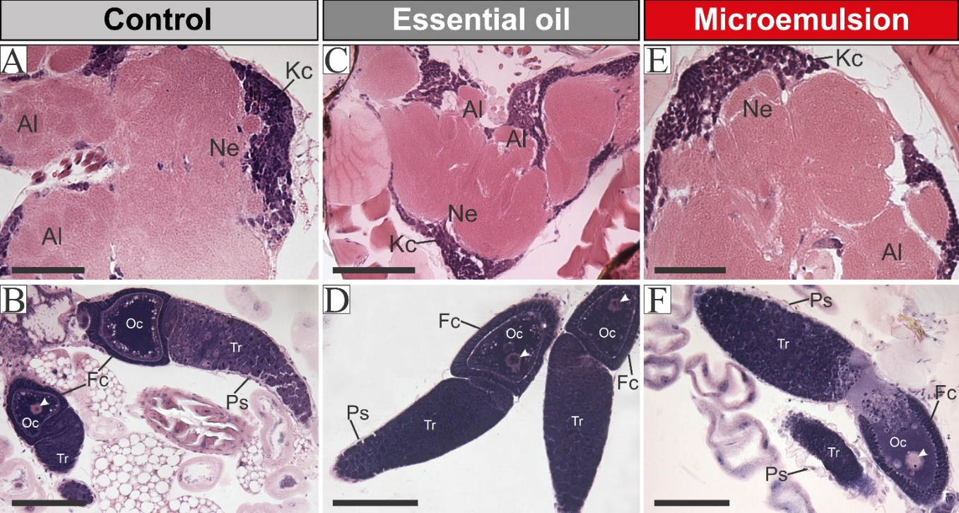
Fig. S3. Light micrographs of the brain and ovaries of Hypothenemus hampei of the control group (A-B) and exposed to the Pogostemon cablin essential oil (C-D) or microemulsion (E-F) after 72h. Kenyon cells (Kc), neuropil of the mushroom bodies (Ne), and antennal lobe (Al). Tropharium (Tr), oocyte (Oc), germinal vesicle (arrowhead), follicular cells (Fc), and peritoneal sheath (Ps). Bars = 40 µm.

