Supplemental figures
Figure S1 2-D plot for interaction analysis between genomic regions. A: RHBV incidence. B: RHBV severity

A
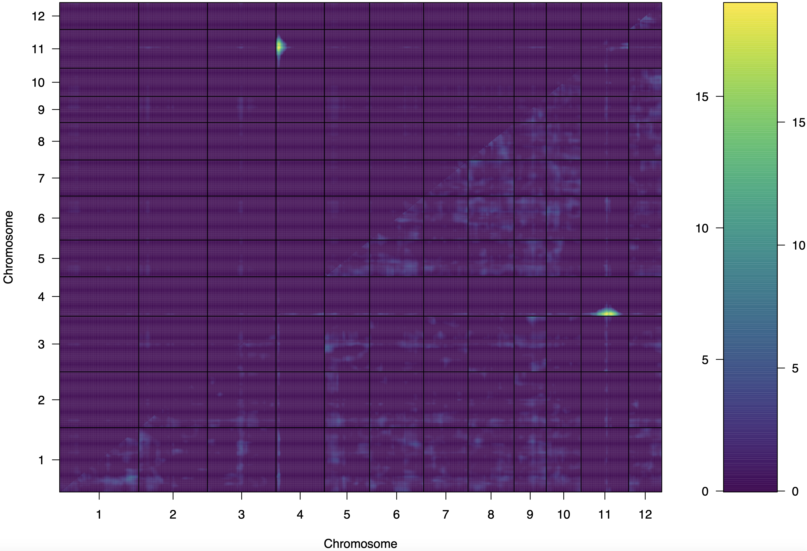

B
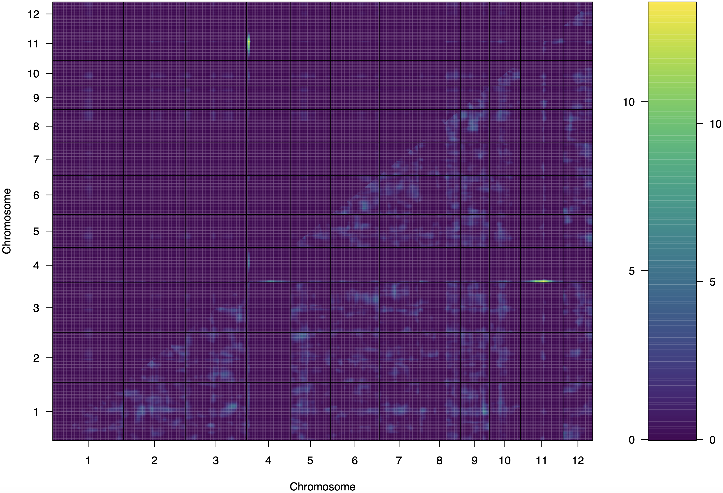

Figure S2 Graphical genotyping showing probable local ancestry for the four RHBV-resistant parents (green arrows), in the two QTL regions qHBV4.1 and qHBV4.2 on chromosome 4. Red: indica origin, including the Aus cluster. Blue: Japonica origin, including temperate, sub-tropical and tropical clusters.

