Strategic low-cost energy investment opportunities and challenges towards achieving universal access (SDG7) in each African nation

- Total primary energy supply (Mtoe) and total final consumption (Mtoe) in Africa across the scenarios.
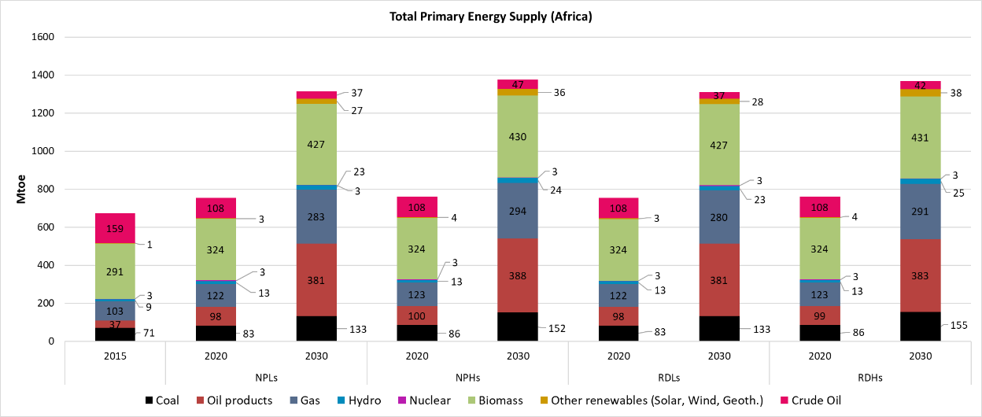
Figure 1. Total primary energy supply (Mtoe) in Africa across the scenarios (2020, 2030).
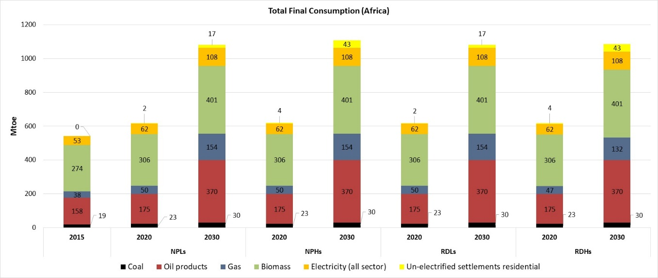
Figure 2. Total final consumption (Mtoe) in Africa across the scenarios (2020, 2030).

- Overall technology mix (total installed capacity)
  - Overall technology mix (GW) in CAPP

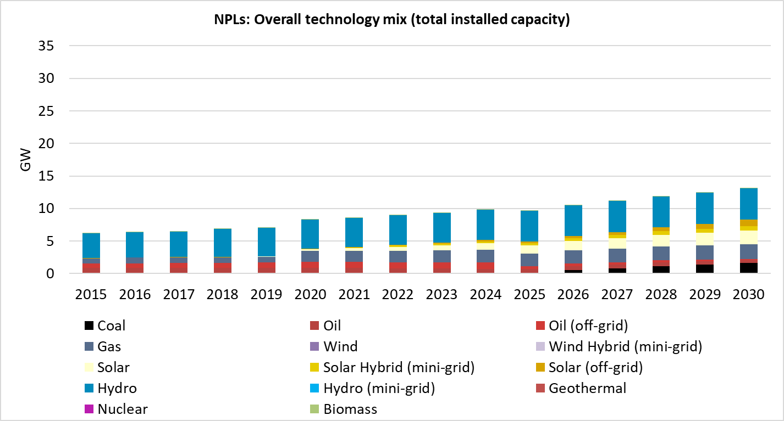
Figure 3. Overall technology mix (GW) in CAPP in the New Policies Low (NPLs) scenario.
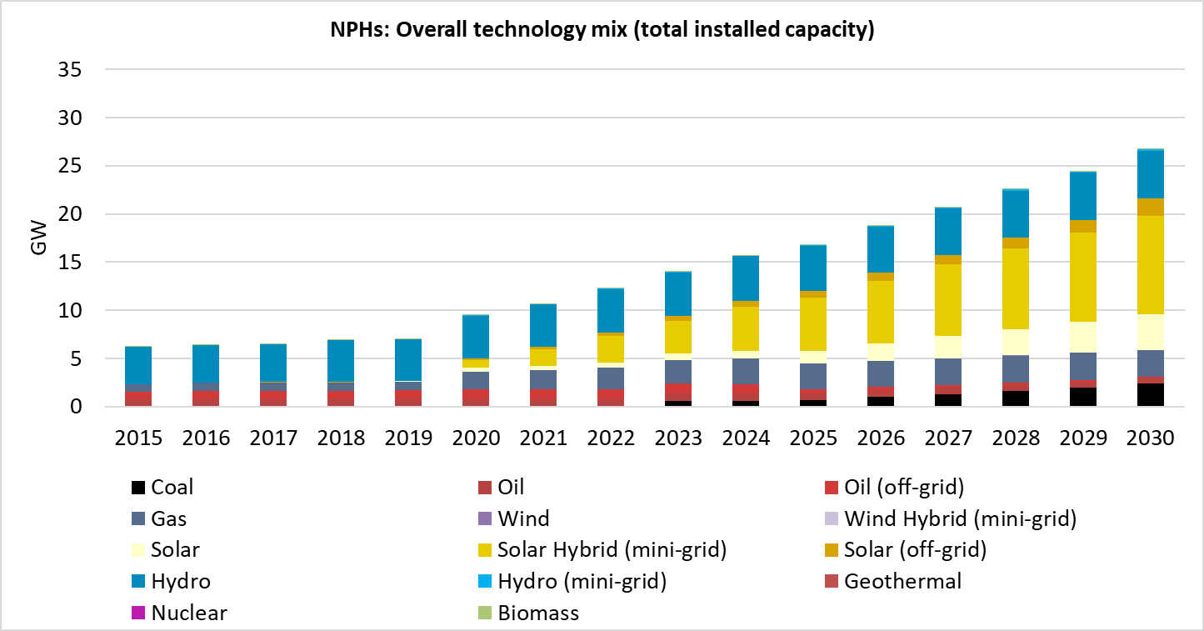

Figure 4. Overall technology mix (GW) in CAPP in the New Policies High (NPHs) scenario.

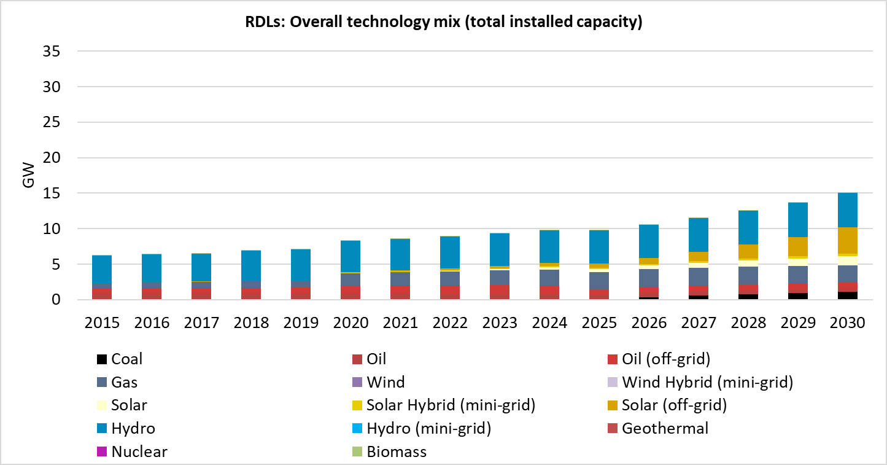
Figure 5. Overall technology mix (GW) in CAPP in the Renewable Development Low (RDLs) scenario.
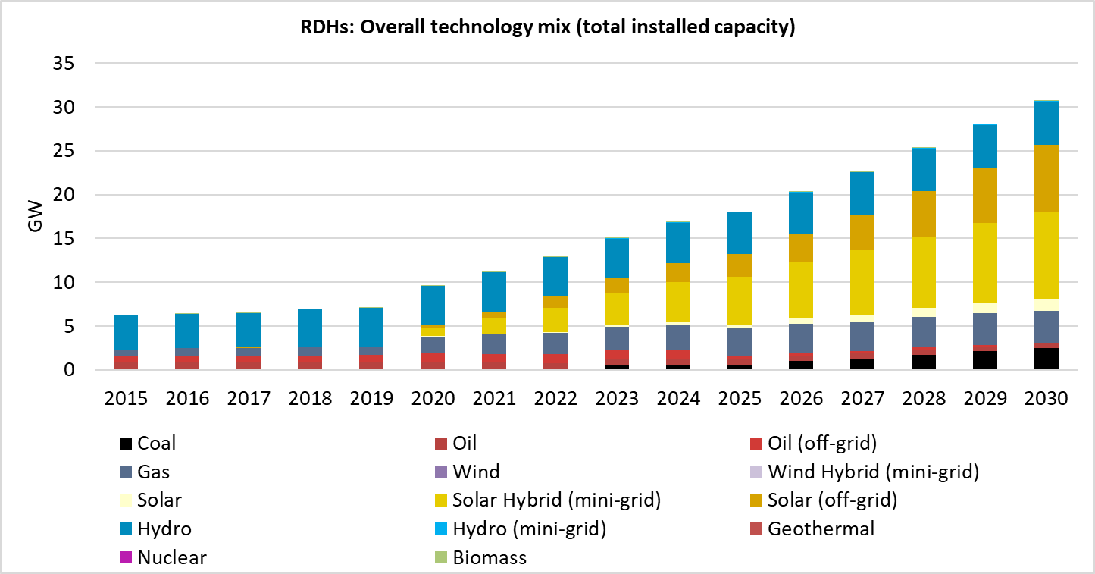
Figure 6. Overall technology mix (GW) in CAPP in the Renewable Development High (RDHs) scenario.

  - Overall technology mix (GW) in EAPP

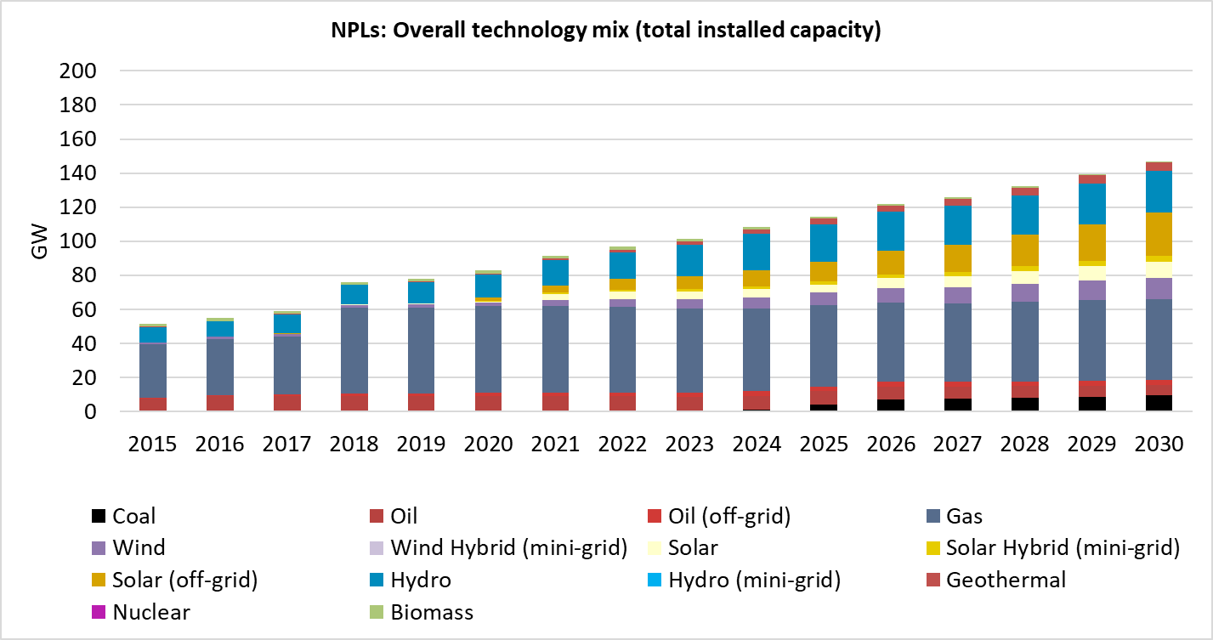
Figure 7. Overall technology mix (GW) in EAPP in the New Policies Low (NPLs) scenario.

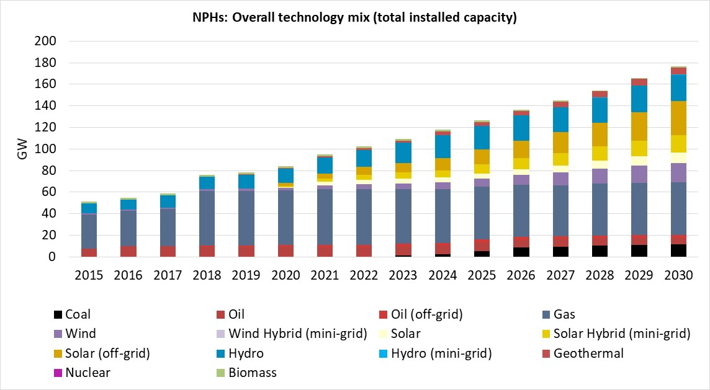
Figure 8. Overall technology mix (GW) in EAPP in the New Policies High (NPHs) scenario.
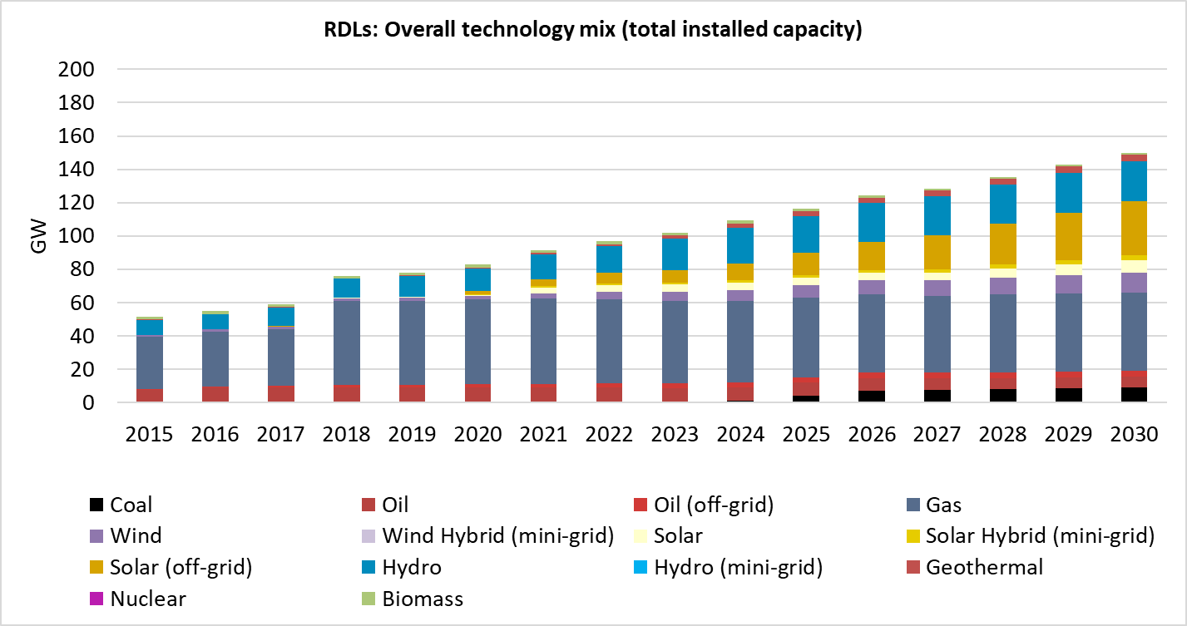
Figure 9. Overall technology mix (GW) in EAPP in the Renewable Development Low (RDLs) scenario.
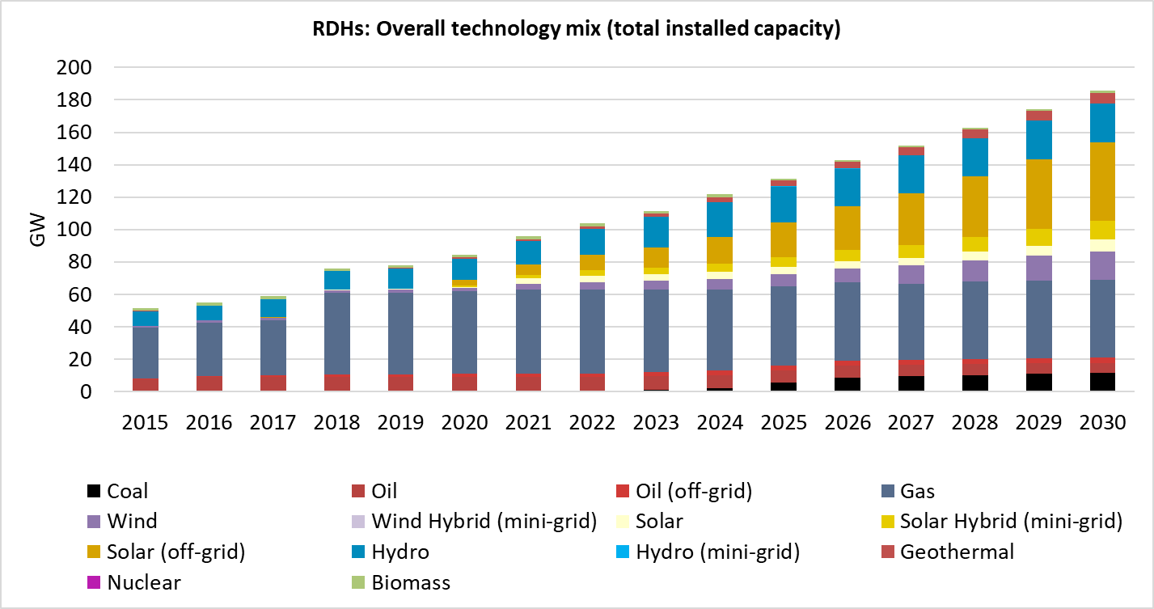
Figure 10. Overall technology mix (GW) in EAPP in the Renewable Development High (RDHs) scenario.

  - Overall technology mix (GW) in WAPP

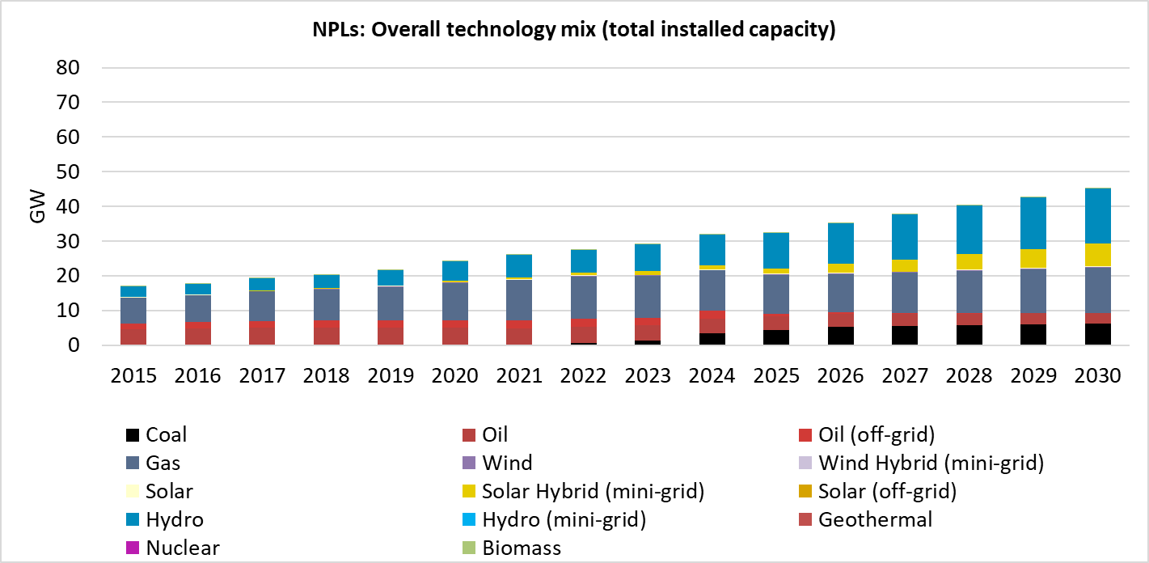
Figure 11. Overall technology mix (GW) in WAPP in the New Policies Low (NPLs) scenario.

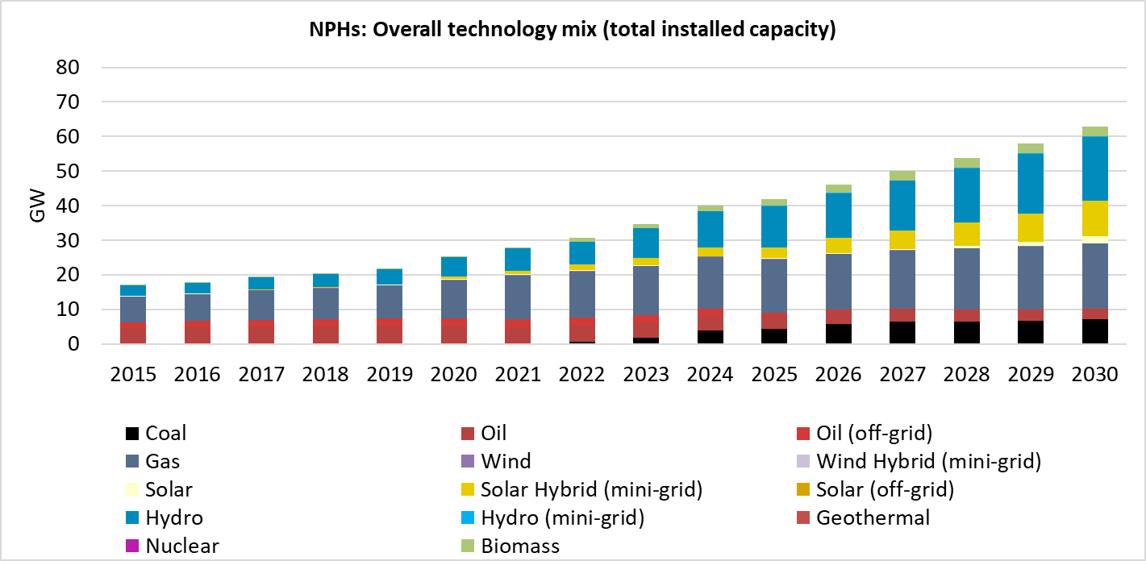
Figure 12. Overall technology mix (GW) in WAPP in the New Policies High (NPHs) scenario.
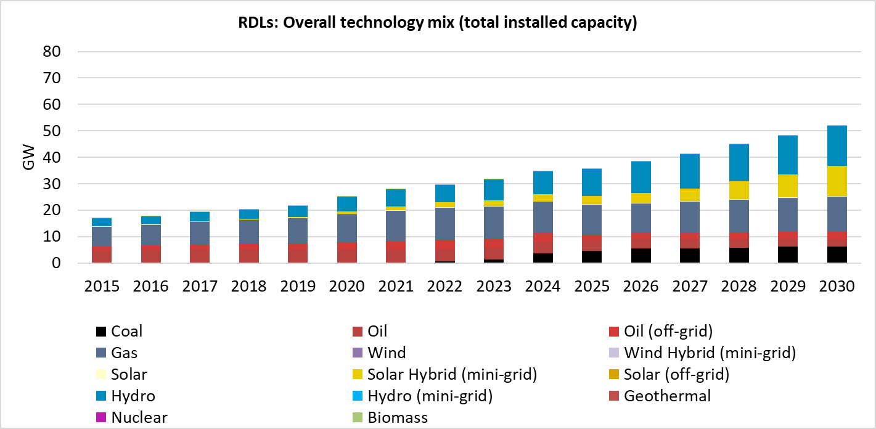
Figure 13. Overall technology mix (GW) in WAPP in the Renewable Development Low (RDLs) scenario.
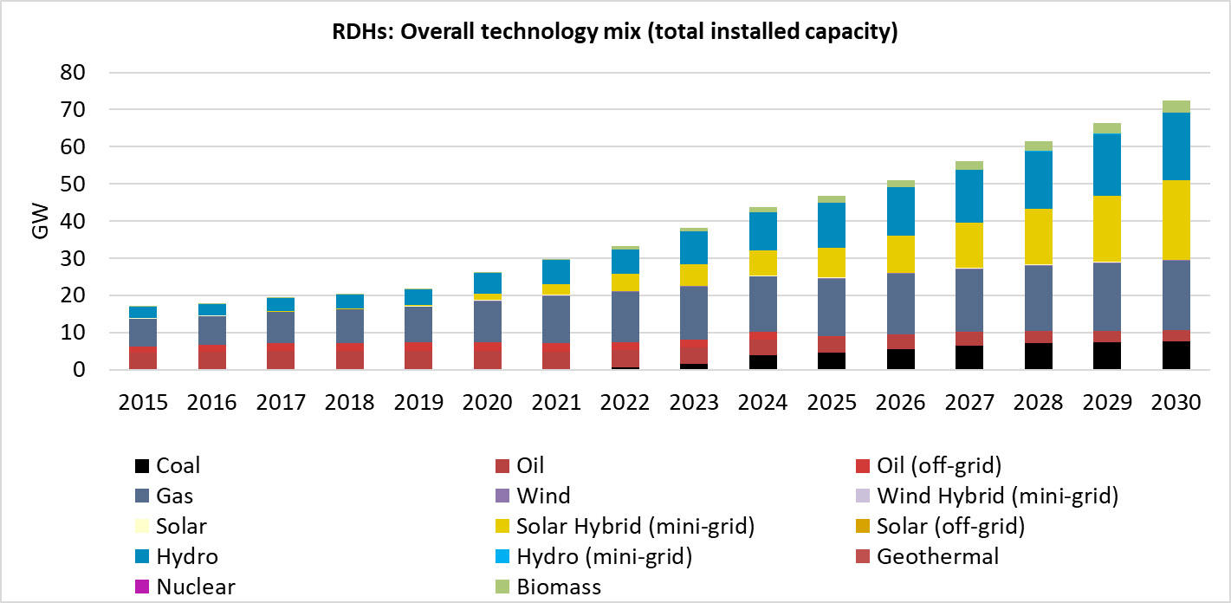
Figure 14. Overall technology mix (GW) in WAPP in the Renewable Development High (RDHs) scenario.
  - Overall technology mix (GW) in SAPP

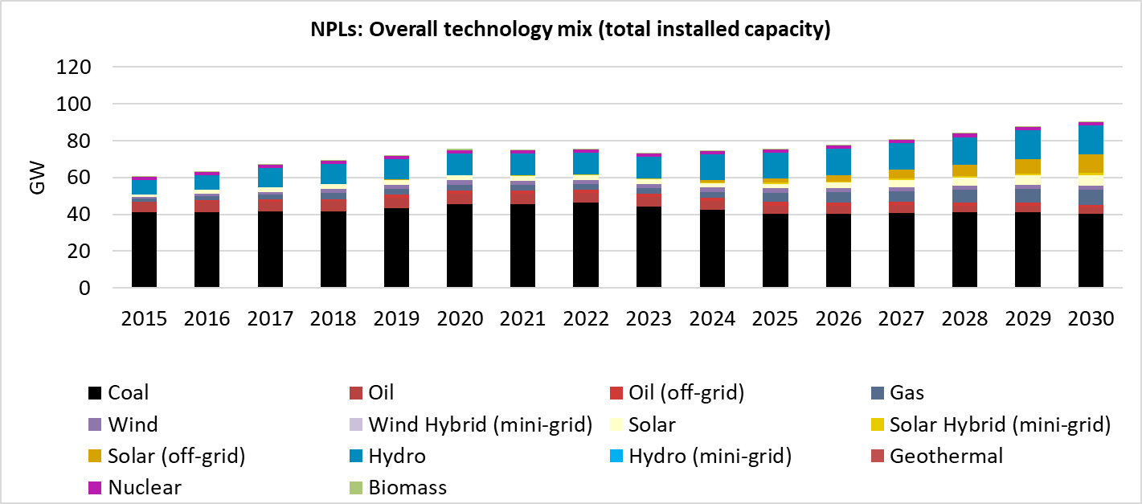
Figure 15. Overall technology mix (GW) in SAPP in the New Policies Low (NPLs) scenario.

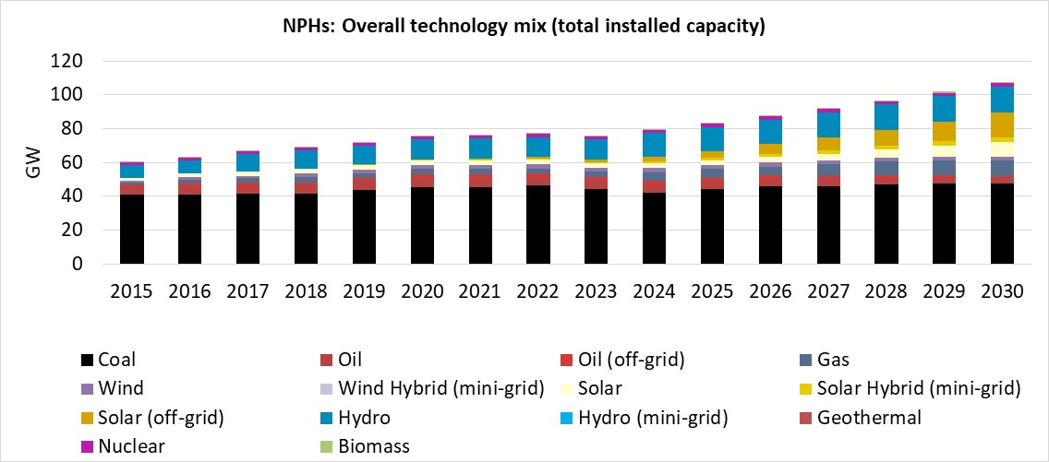
Figure 16. Overall technology mix (GW) in SAPP in the New Policies High (NPHs) scenario.
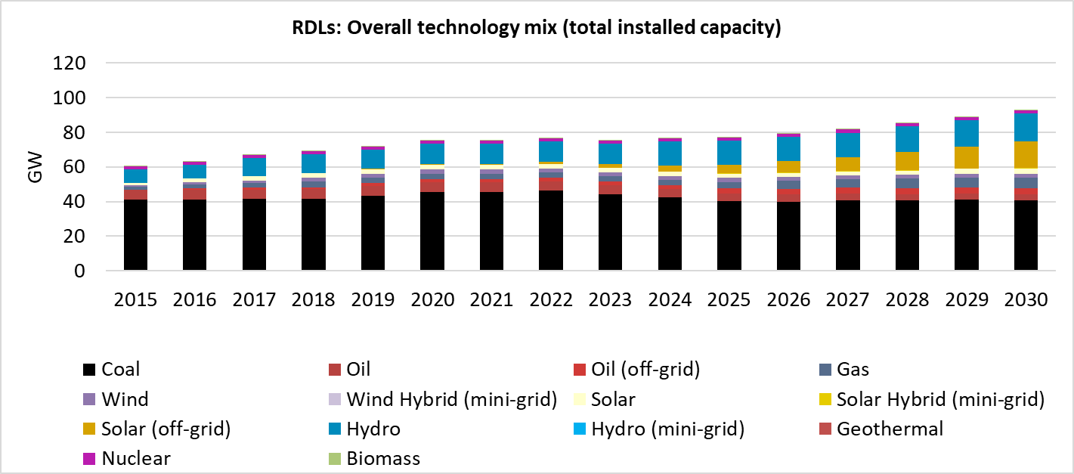
Figure 17. Overall technology mix (GW) in SAPP in the Renewable Development Low (RDLs) scenario.
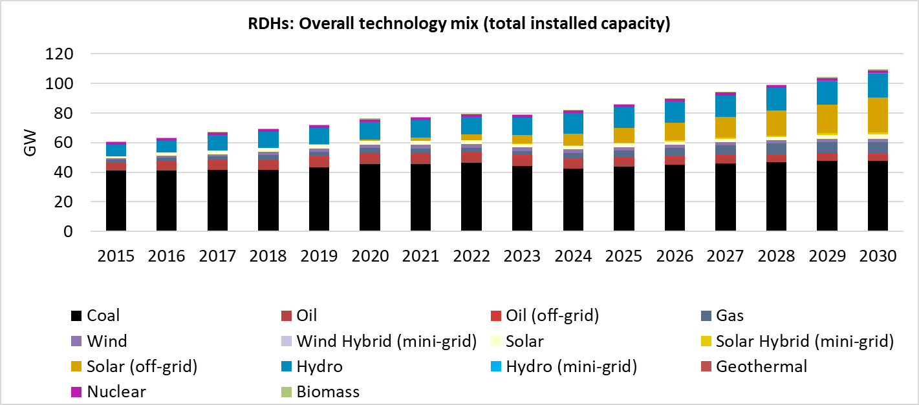
Figure 18. Overall technology mix (GW) in SAPP in the Renewable Development High (RDHs) scenario.
  - Overall technology mix (GW) in NAPP
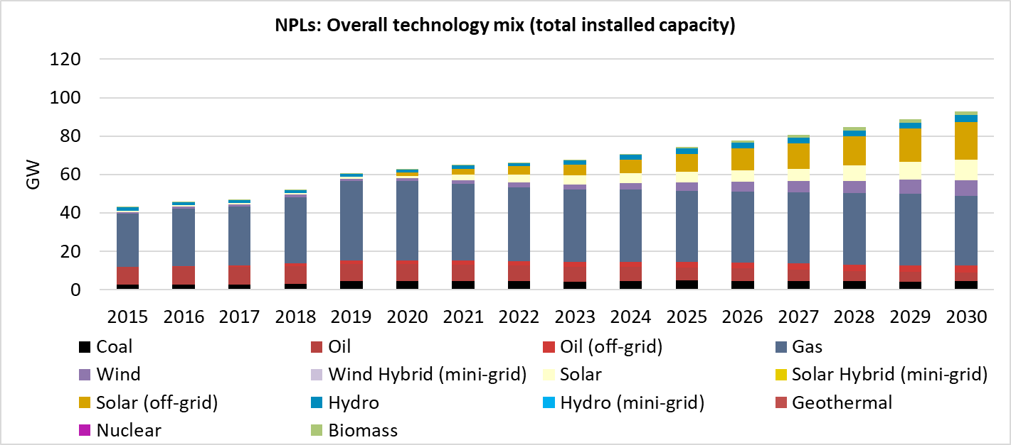
Figure 19. Overall technology mix (GW) in NAPP in the New Policies Low (NPLs) scenario.

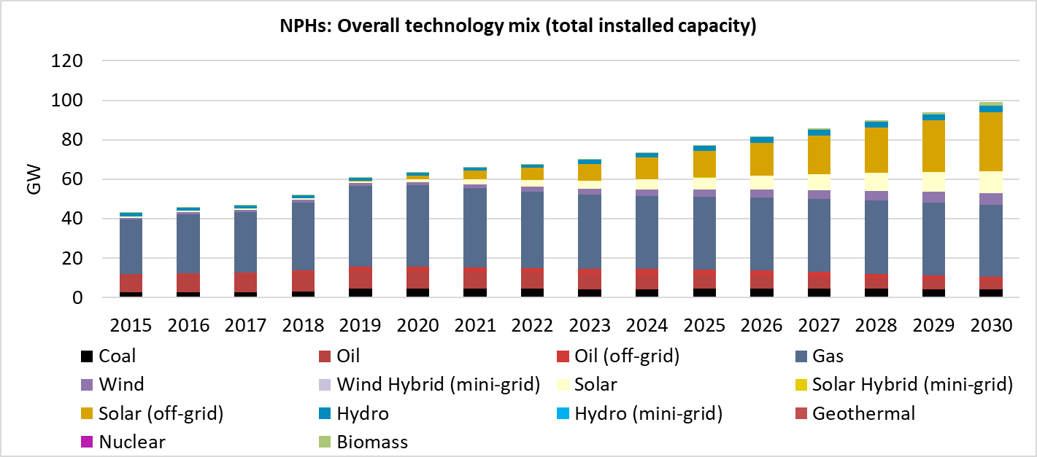
Figure 20. Overall technology mix (GW) in NAPP in the New Policies High (NPHs) scenario.
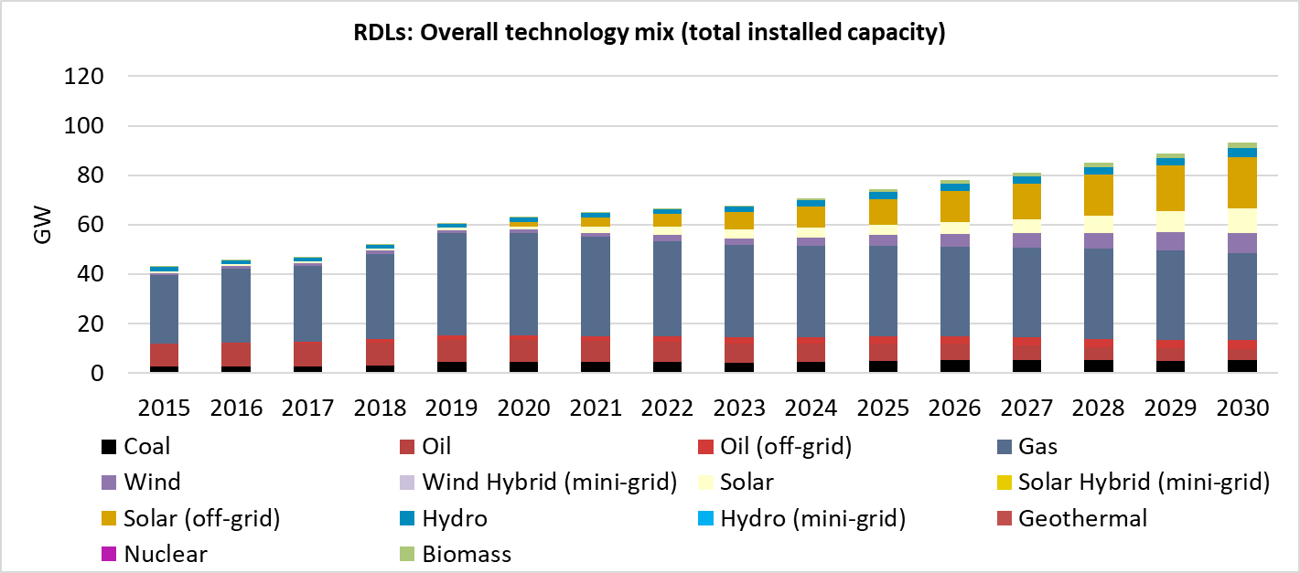
Figure 21. Overall technology mix (GW) in NAPP in the Renewable Development Low (RDLs) scenario.
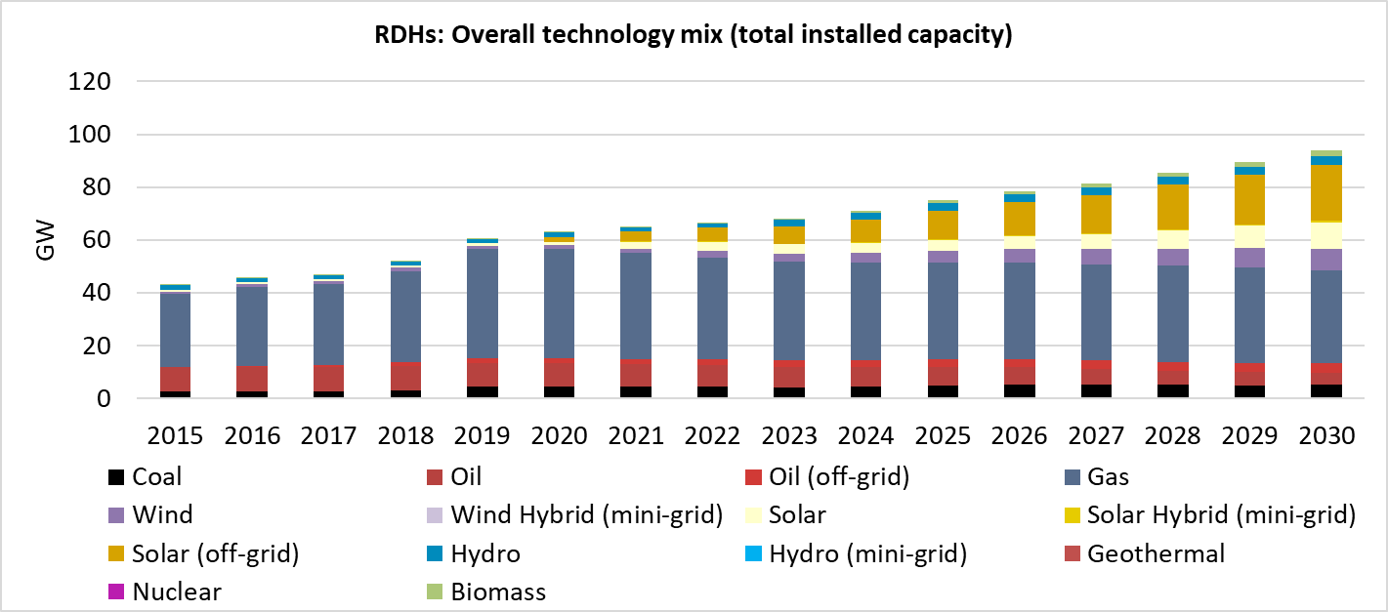
Figure 22. Overall technology mix (GW) in NAPP in the Renewable Development High (RDHs) scenario.
  - Comparison of overall technology mix (GW) in Africa

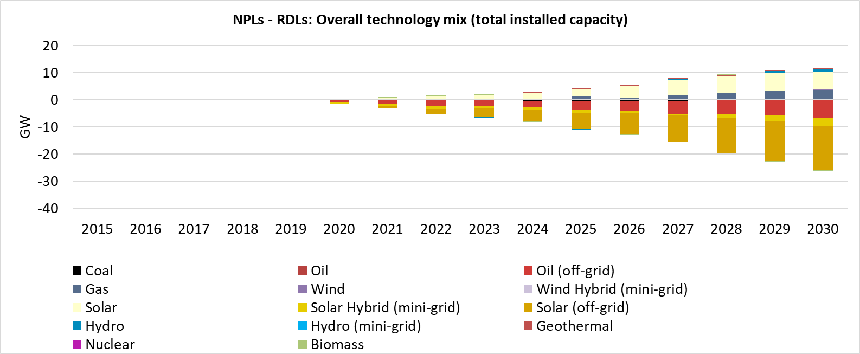
Figure 23. Comparison of overall technology mix (GW) in Africa between the New Policies (Low) and Renewable Development (Low) scenarios.
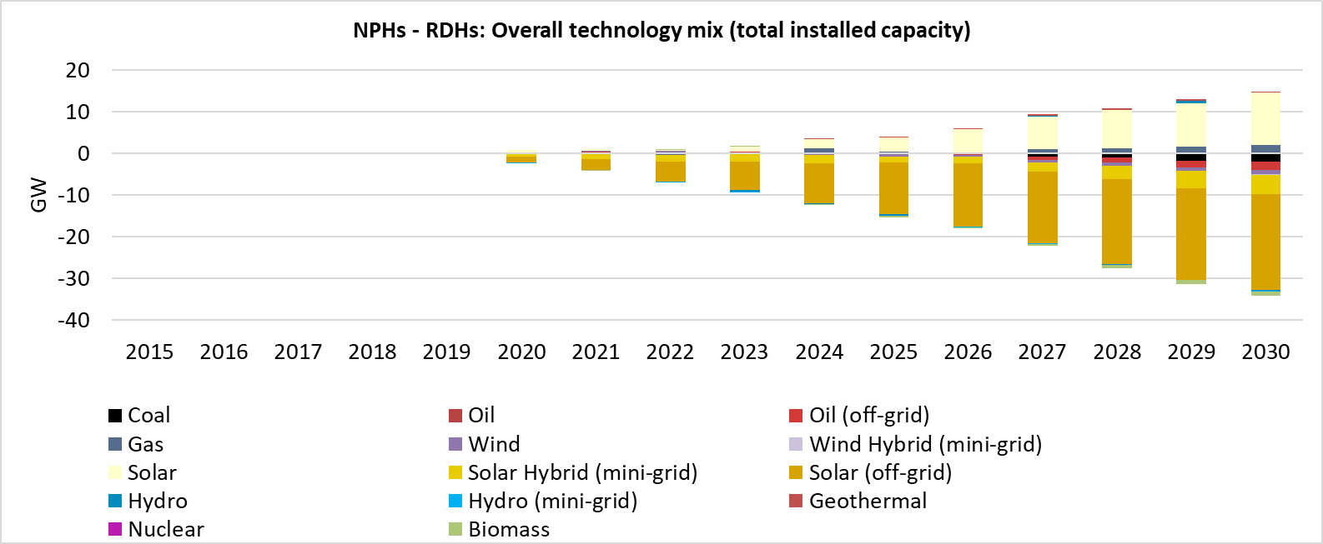
Figure 24. Comparison of overall technology mix (GW) in Africa between the New Policies (High) and Renewable Development (High) scenarios.

- Electrification mix
  - Overall electrification mix (PJ) in CAPP

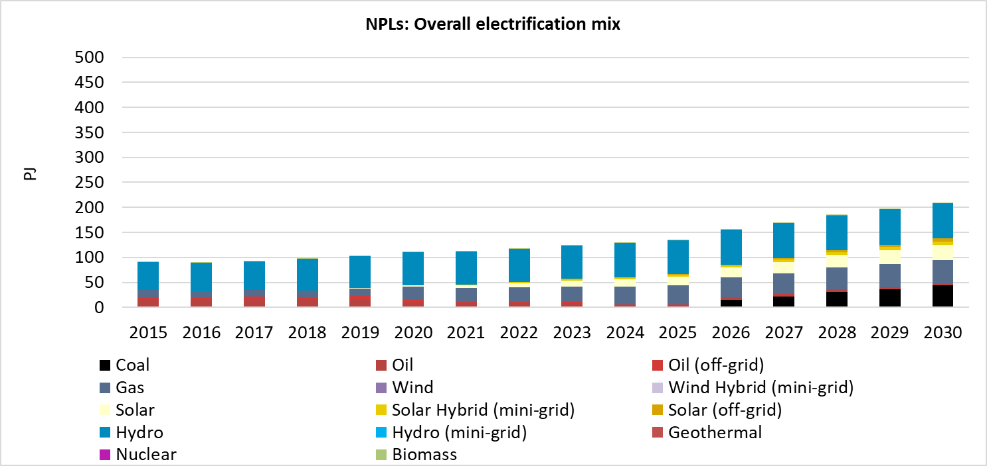
Figure 25. Overall electrification mix (PJ) in CAPP in the New Policies Low (NPLs) scenario.

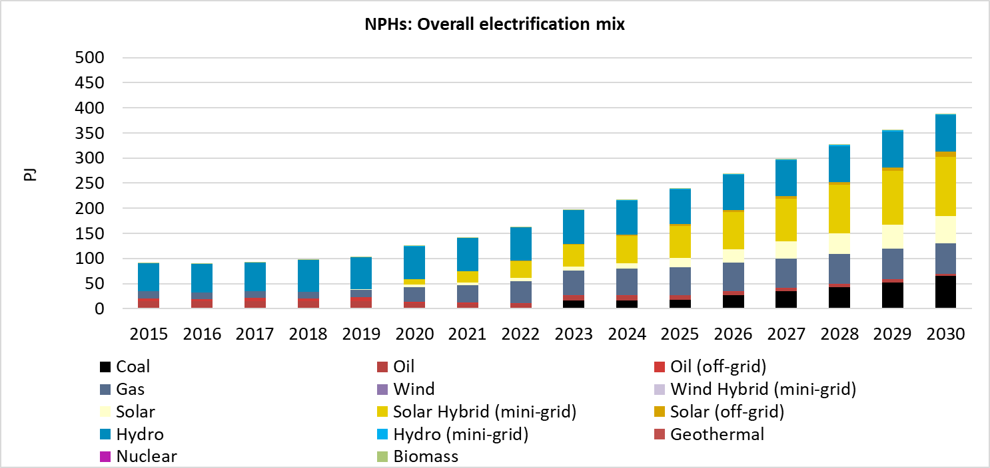
Figure 26. Overall electrification mix (PJ) in CAPP in the New Policies High (NPHs) scenario.

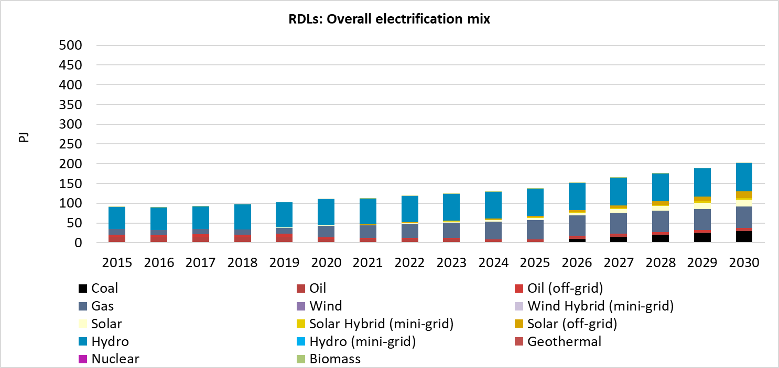
Figure 27. Overall electrification mix (PJ) in CAPP in the Renewable Development Low (RDLs) scenario.

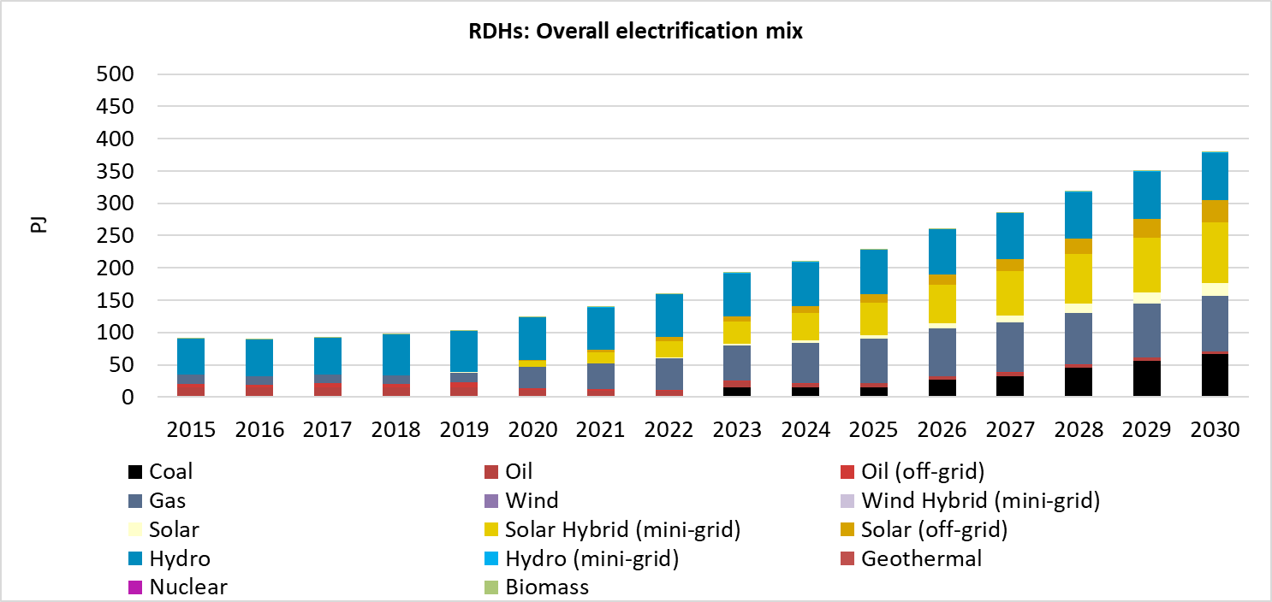
Figure 28. Overall electrification mix (PJ) in CAPP in the Renewable Development High (RDHs) scenario.
  - Overall electrification mix (PJ) in EAPP

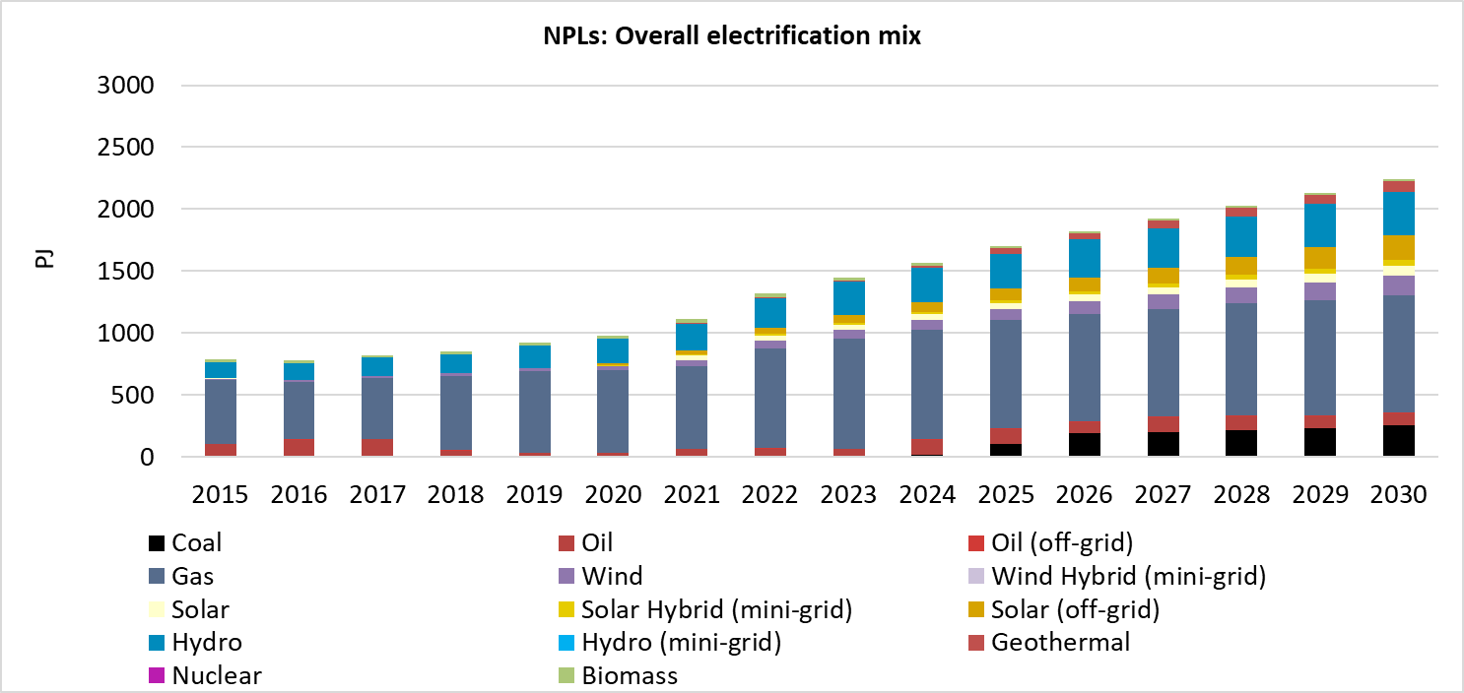
Figure 29. Overall electrification mix (PJ) in EAPP in the New Policies Low (NPLs) scenario.
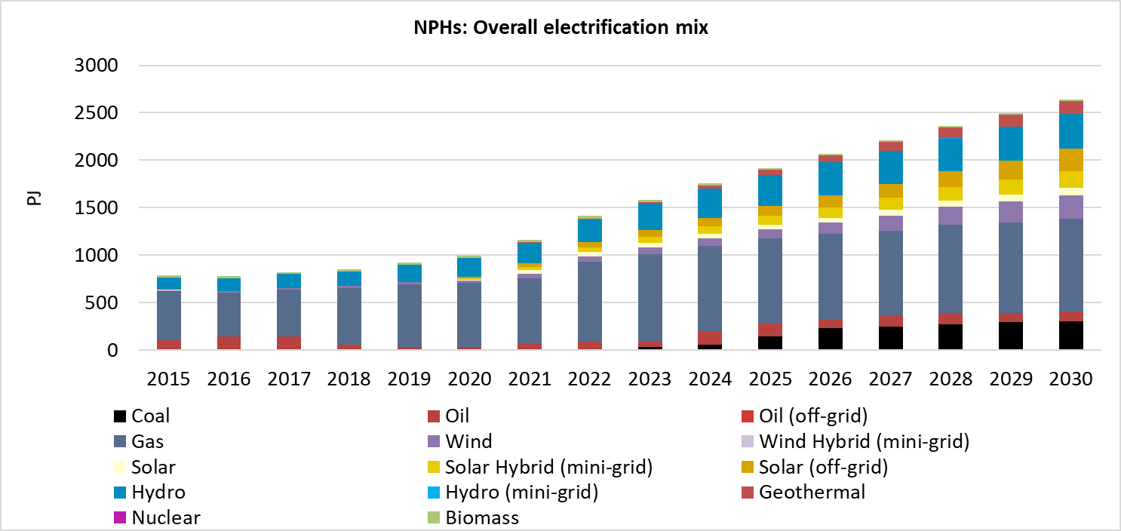
Figure 30. Overall electrification mix (PJ) in EAPP in the New Policies High (NPHs) scenario.
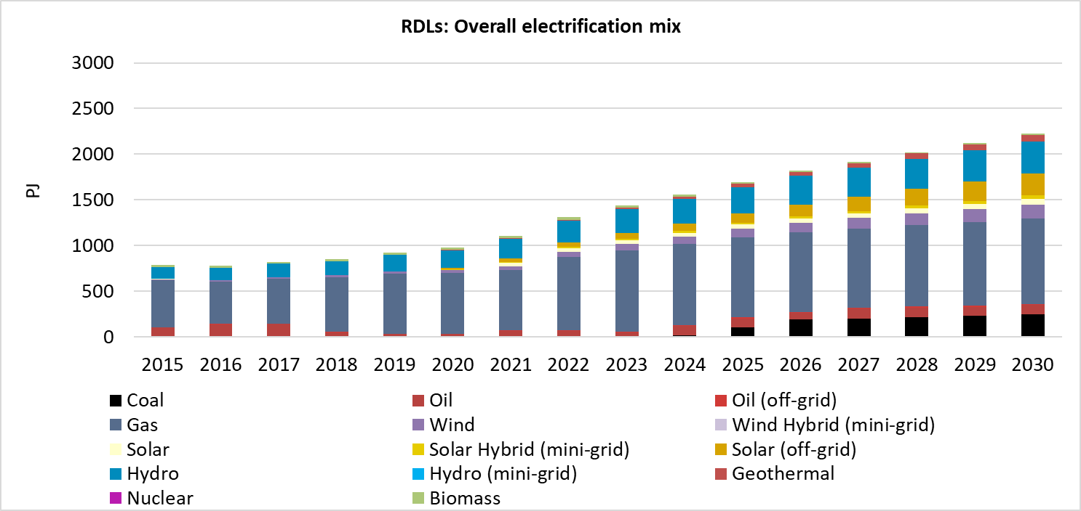
Figure 31. Overall electrification mix (PJ) in EAPP in the Renewable Development Low (RDLs) scenario.
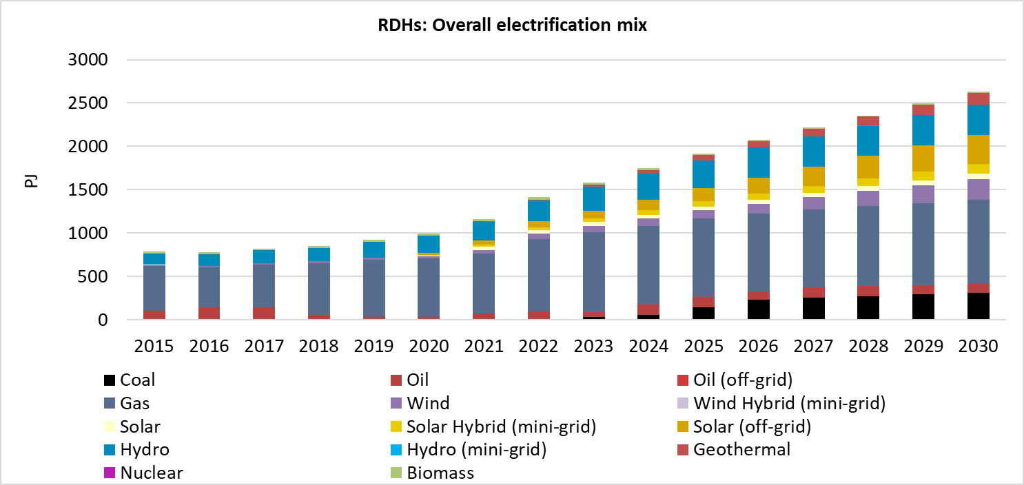
Figure 32. Overall electrification mix (PJ) in EAPP in the Renewable Development High (RDHs) scenario.
  - Overall electrification mix (PJ) in WAPP

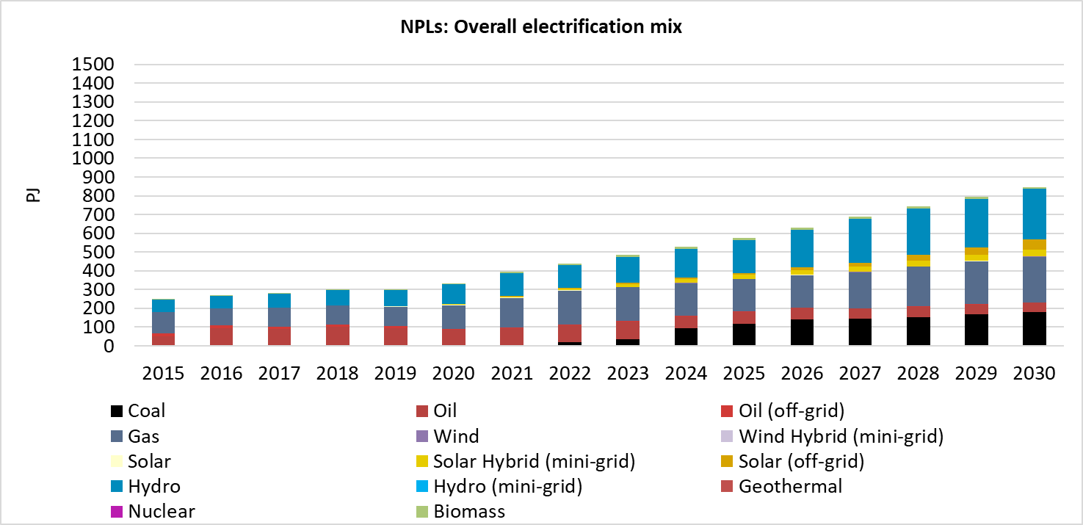
Figure 33. Overall electrification mix (PJ) in WAPP in the New Policies Low (NPLs) scenario.

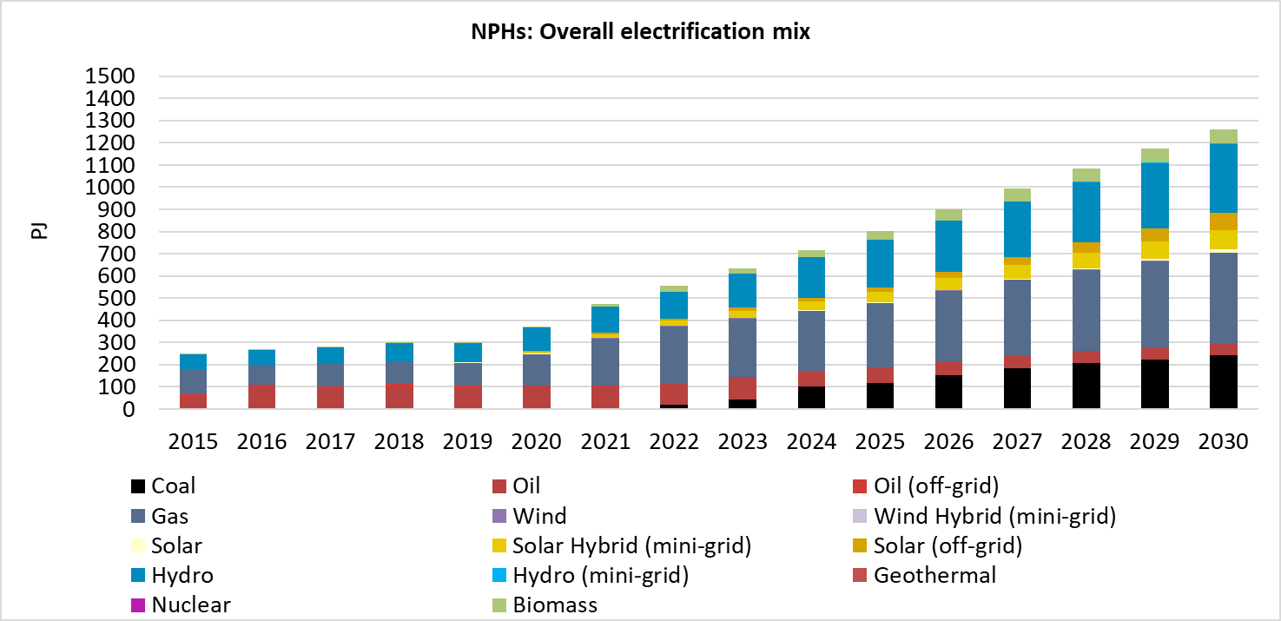
Figure 34. Overall electrification mix (PJ) in WAPP in the New Policies High (NPHs) scenario.
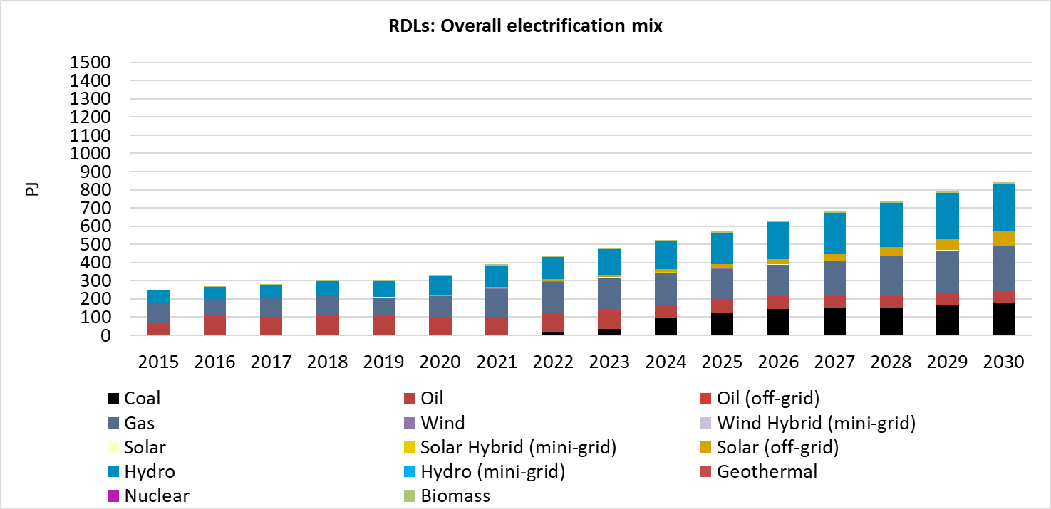
Figure 35. Overall electrification mix (PJ) in WAPP in the Renewable Development Low (RDLs) scenario.

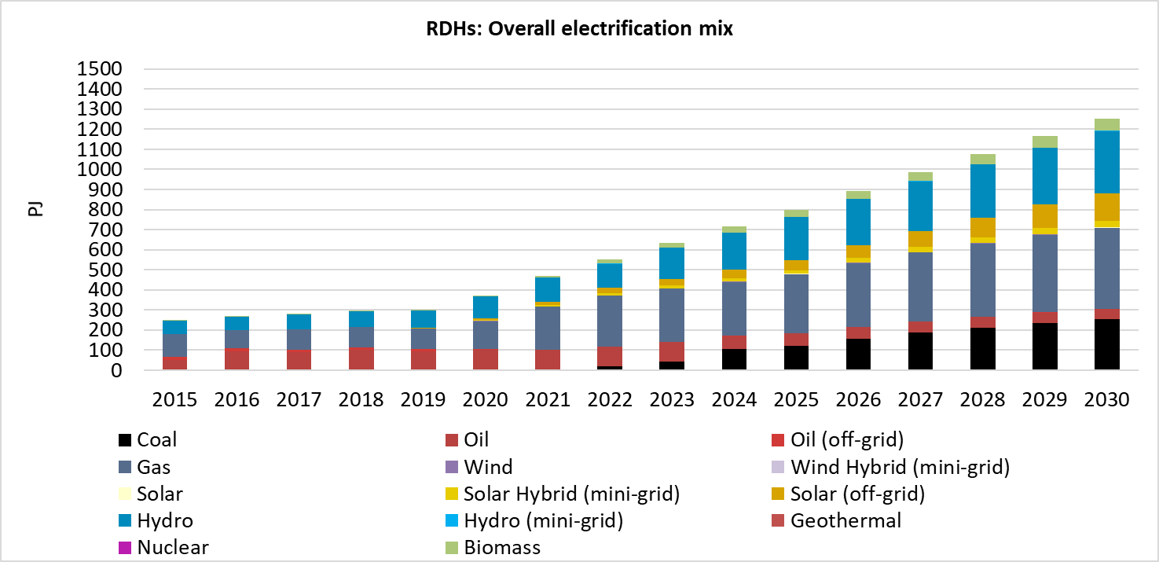
Figure 36. Overall electrification mix (PJ) in WAPP in the Renewable Development High (RDHs) scenario.
  - Overall electrification mix (PJ) in SAPP
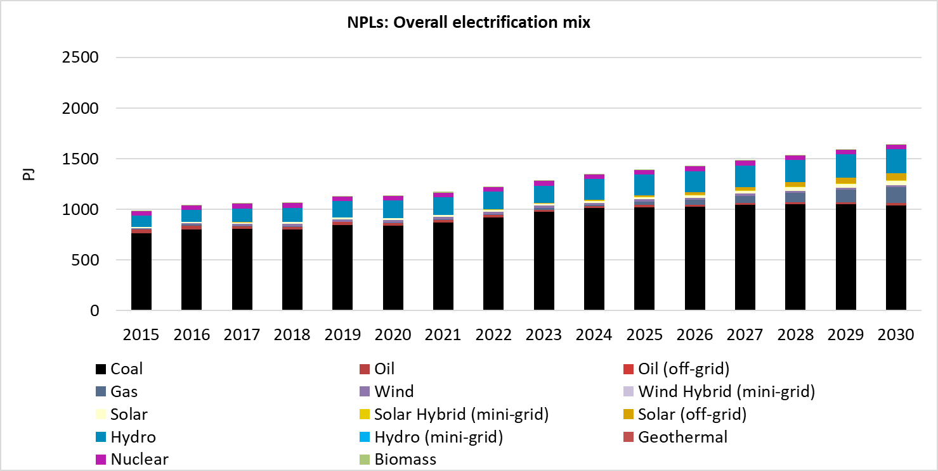
Figure 37. Overall electrification mix (PJ) in SAPP in the New Policies Low (NPLs) scenario.
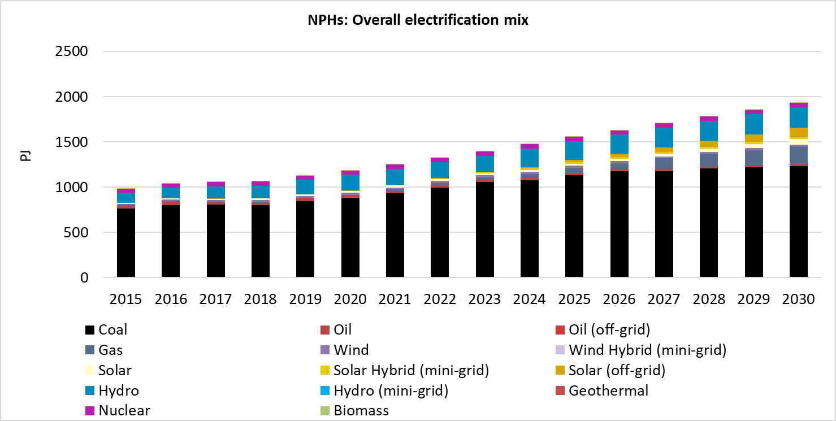
Figure 38. Overall electrification mix (PJ) in SAPP in the New Policies High (NPHs) scenario.
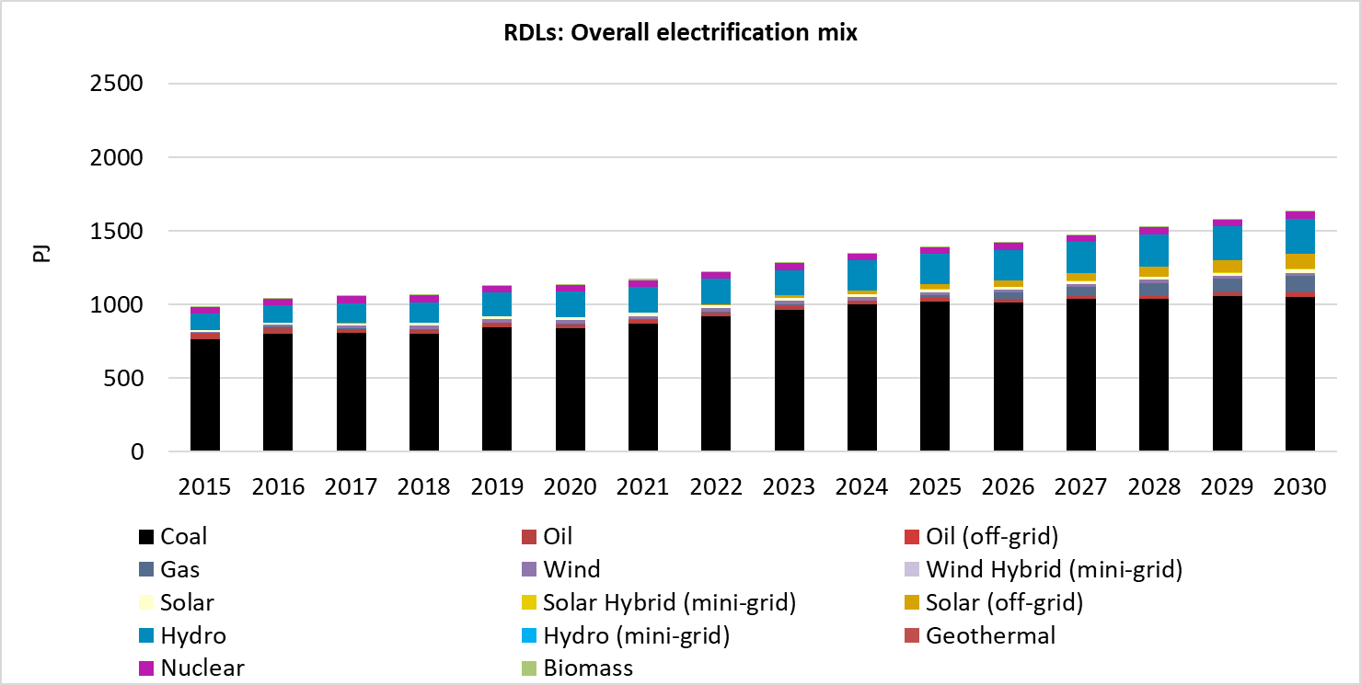
Figure 39. Overall electrification mix (PJ) in SAPP in the Renewable Development Low (RDLs) scenario.
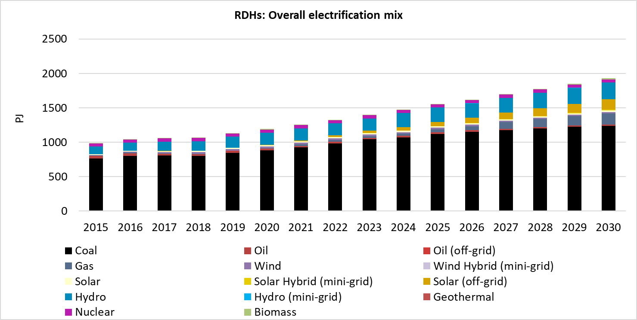
Figure 40. Overall electrification mix (PJ) in SAPP in the Renewable Development High (RDHs) scenario.
  - Overall electrification mix (PJ) in NAPP

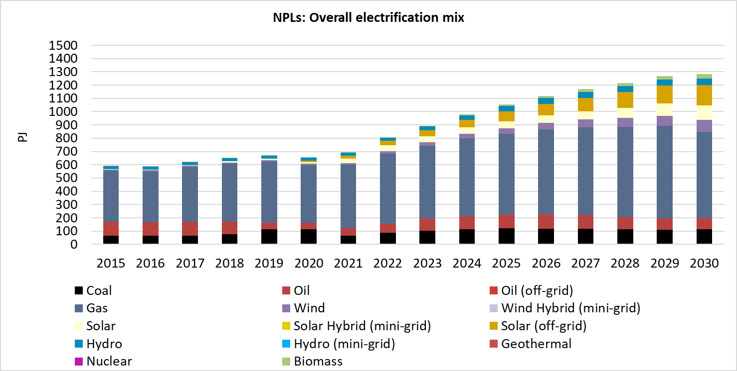
Figure 41. Overall electrification mix (PJ) in NAPP in the New Policies Low (NPLs) scenario.
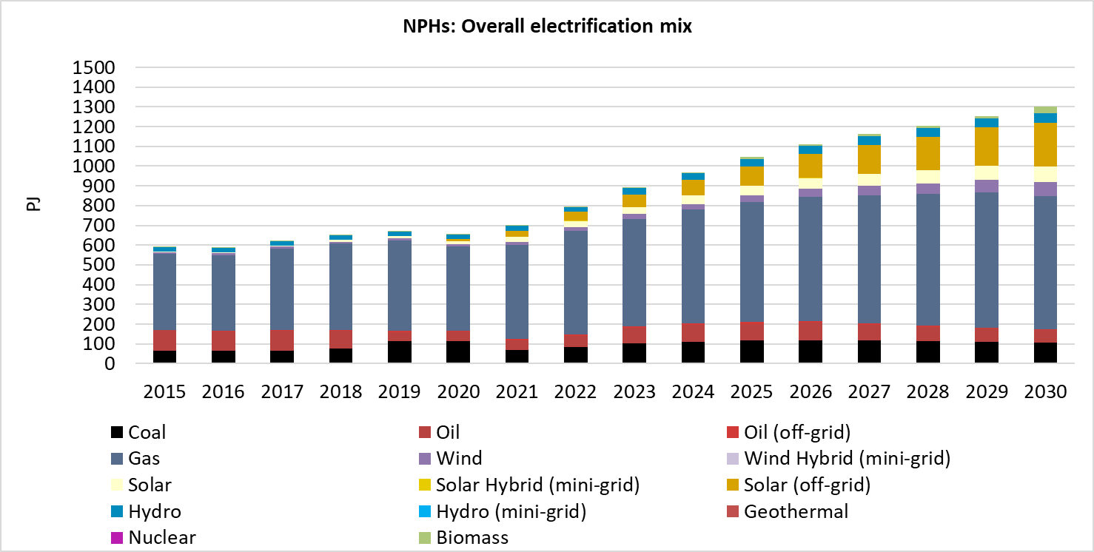
Figure 42. Overall electrification mix (PJ) in NAPP in the New Policies High (NPHs) scenario.
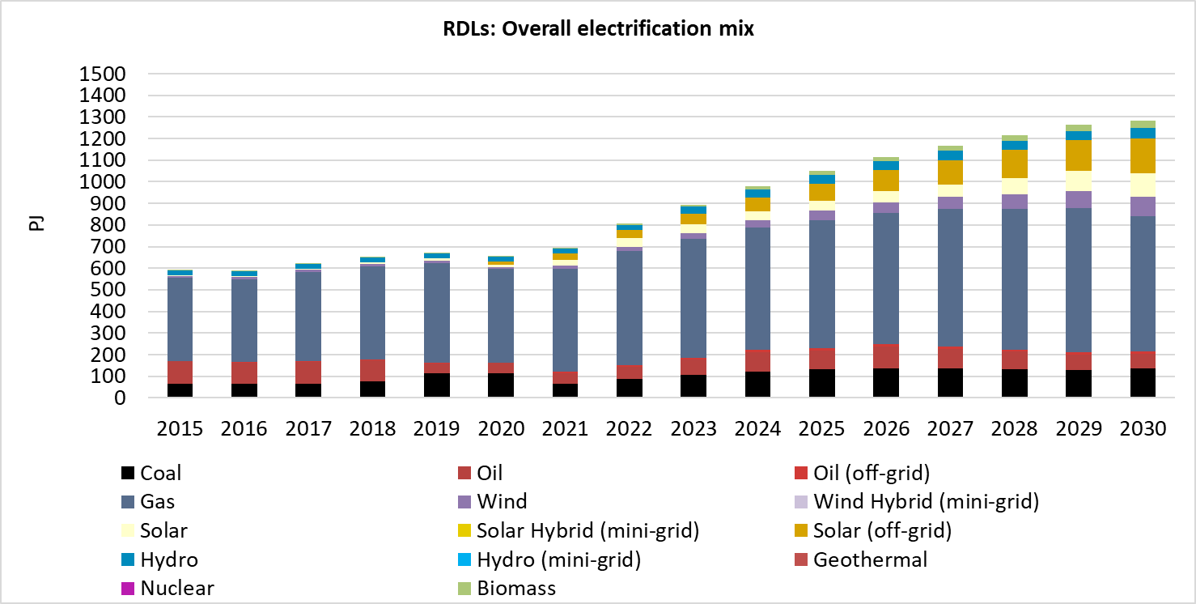
Figure 43. Overall electrification mix (PJ) in NAPP in the Renewable Development Low (RDLs) scenario.

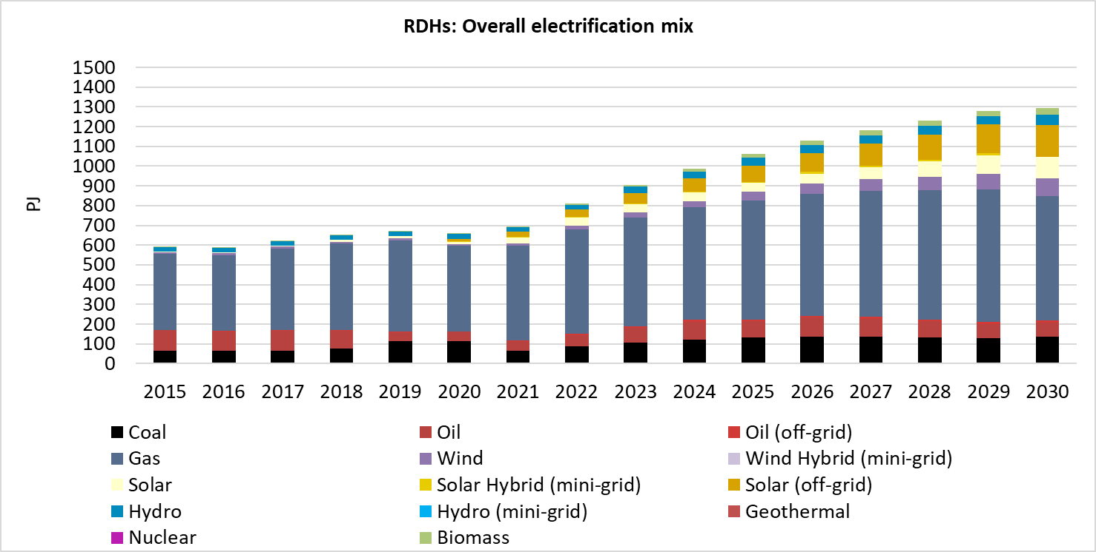
Figure 44. Overall electrification mix (PJ) in NAPP in the Renewable Development High (RDHs) scenario.
  - Comparison of overall electrification mix (PJ) in Africa
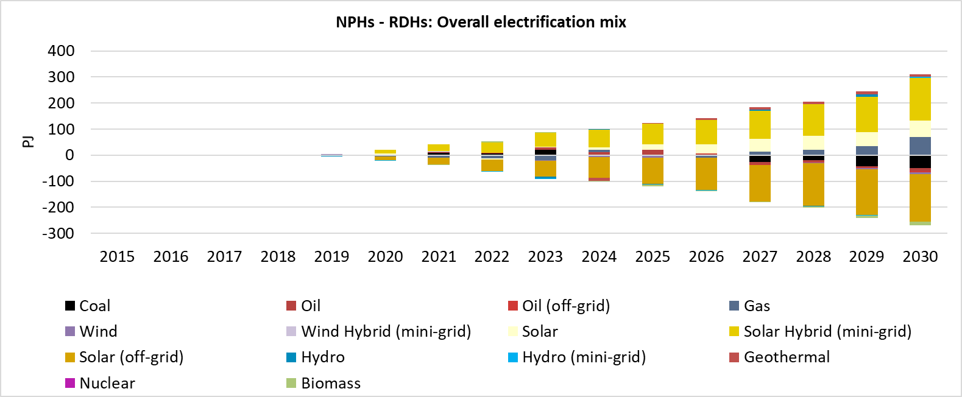
Figure 45. Comparison of overall electrification mix (PJ) in Africa between the New Policies (High) and Renewable Development (High) scenarios.
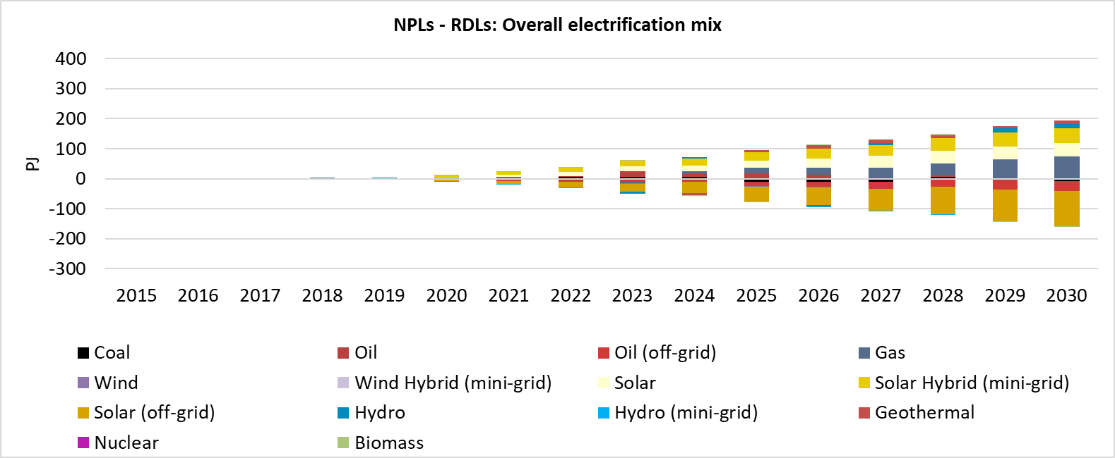
Figure 46. Comparison of overall electrification mix (PJ) in Africa between the New Policies (Low) and Renewable Development (Low) scenarios.

- Electricity supply share (%)
  - New Policies (Low) (NPLs) scenario

Figure 47. Comparison of the electricity supply share (%) among the power pools in the NPLs scenario.
  - New Policies (High) (NPHs) scenario

Figure 48. Comparison of the electricity supply share (%) among the power pools in the NPHs scenario.

  - Renewable Development (Low) (RDLs) scenario

Figure 49. Comparison of the electricity supply share (%) among the power pools in the RDLs scenario.

  - Renewable Development (High) (RDHs) scenario

Figure 50. Comparison of the electricity supply share (%) among the power pools in the RDHs scenario.
- Carbon Dioxide emissions (Mton)

Figure 51. Comparison of the annual carbon dioxide emissions (Mton) among the power pools for the different scenarios.
- Energy Balances
Table 1. Enery balances for Africa in the New Policies Low scenario (2015, 2020, 2025, 2030).
Africa (New Policies Low) | 2015 | 2020 | 2025 | 2030
Energy Balance, by fuel (Mtoe)
Primary Production | 1147.92 | 1211.84 | 1511.12 | 1542.24
Coal | 124.27 | 126.35 | 146.15 | 155.02
Crude Oil | 448.68 | 434.28 | 341.31 | 277.87
Oil products | 0.00 | 0.00 | 0.00 | 0.00
Natural gas | 270.10 | 306.79 | 619.39 | 628.93
Nuclear | 3.34 | 3.34 | 3.34 | 3.34
Hydro | 9.38 | 13.48 | 18.46 | 23.41
Other renewables (Solar, Wind, Geoth.) | 1.12 | 3.38 | 12.97 | 26.73
Biofuels/Waste | 291.03 | 324.22 | 369.50 | 426.94
Electricity | 0.00 | 0.00 | 0.00 | 0.00
Imports | 117.74 | 158.53 | 374.88 | 559.13
Coal | 1.66 | 8.81 | 18.14 | 29.77
Crude Oil | 32.73 | 5.63 | 20.79 | 67.34
Oil products | 77.31 | 135.81 | 323.56 | 409.37
Natural gas | 2.06 | 2.43 | 3.46 | 40.93
Nuclear | 0.00 | 0.00 | 0.00 | 0.00
Hydro | 0.00 | 0.00 | 0.00 | 0.00
Other renewables (Solar, Wind, Geoth.) | 0.00 | 0.00 | 0.00 | 0.00
Biofuels/Waste | 0.00 | 0.00 | 0.00 | 0.00
Electricity | 3.99 | 5.84 | 8.92 | 11.72
Exports | -591.64 | -615.90 | -828.19 | -788.12
Coal | -54.95 | -52.27 | -52.27 | -52.18
Crude Oil | -322.80 | -332.24 | -332.24 | -308.14
Oil products | -40.17 | -38.19 | -33.16 | -28.42
Natural gas | -169.30 | -186.97 | -401.21 | -387.28
Nuclear | 0.00 | 0.00 | 0.00 | 0.00
Hydro | 0.00 | 0.00 | 0.00 | 0.00
Other renewables (Solar, Wind, Geoth.) | 0.00 | 0.00 | 0.00 | 0.00
Biofuels/Waste | -0.43 | -0.39 | -0.39 | -0.39
Electricity | -3.99 | -5.84 | -8.92 | -11.72
Total Primary Energy Supply | 674.03 | 754.47 | 1057.81 | 1313.25
Power generation (Mtoe)
Fuel Inputs Therm. Power | -127.66 | -133.87 | -186.97 | -214.65
Coal | -50.75 | -58.12 | -83.55 | -100.08
Oil products | -21.03 | -14.00 | -22.88 | -21.47
Natural gas | -50.76 | -56.32 | -74.24 | -85.77
Nuclear | -3.34 | -3.34 | -3.34 | -3.34
Hydro | 0.00 | 0.00 | 0.00 | 0.00
Biofuels/Waste | -1.78 | -2.10 | -2.96 | -3.99
Gross Elec. Generation | 64.58 | 76.76 | 116.05 | 148.60
Coal | 19.79 | 22.67 | 32.58 | 39.03
of which CCS | 0.00 | 0.00 | 0.00 | 0.00
Oil | 7.36 | 4.73 | 6.97 | 5.62
Oil (off-grid) | 0.59 | 0.39 | 0.58 | 0.59
Natural gas | 24.59 | 30.10 | 41.34 | 48.88
of which CCS | 0.00 | 0.00 | 0.00 | 0.00
Biofuels/Waste | 0.63 | 0.75 | 1.06 | 1.42
of which CCS | 0.00 | 0.00 | 0.00 | 0.00
Nuclear | 1.10 | 1.10 | 1.10 | 1.10
Hydro | 9.38 | 13.48 | 18.46 | 23.41
Wind | 0.74 | 1.51 | 3.80 | 6.36
Solar | 0.36 | 0.95 | 3.27 | 6.25
Solar (off-grid) | 0.01 | 0.79 | 4.53 | 11.45
Solar (mini-grid) | 0.00 | 0.21 | 1.28 | 2.34
Wind (mini-grid) | 0.00 | 0.00 | 0.00 | 0.00
Hydro (mini-grid) | 0.00 | 0.00 | 0.01 | 0.01
Other | 0.01 | 0.09 | 1.06 | 2.12
Oil refineries (Mtoe)
Crude Oil | -155.35 | -104.31 | -26.51 | -33.96
Oil products | 153.80 | 103.27 | 26.24 | 33.62
Grid Losses (Mtoe)
Power generation | -9.71 | -12.68 | -24.29 | -34.24
Total Final Consumption (Mtoe)
Total | 541.59 | 617.26 | 847.77 | 1080.56
Coal | 18.69 | 23.03 | 26.55 | 30.41
Oil products | 157.50 | 174.89 | 275.29 | 369.67
Natural gas | 37.64 | 49.90 | 102.61 | 154.49
Biofuels/Waste | 274.37 | 305.64 | 347.84 | 401.43
Electricity | 53.38 | 62.24 | 86.23 | 107.61
Un-electrified settlements residential demand | 0.00 | 1.54 | 9.24 | 16.95
GHG emissions (Mt CO2 eq.)
Total CO2 | 28.97 | 32.07 | 55.70 | 66.81

Table 2. Enery balances for Africa in the New Policies High scenario (2015, 2020, 2025, 2030).
Africa (New Policies High) | 2015 | 2020 | 2025 | 2030
Energy Balance, by fuel (Mtoe)
Primary Production | 1147.94 | 1216.48 | 1533.26 | 1576.58
Coal | 124.27 | 129.04 | 155.17 | 170.51
Crude Oil | 448.68 | 435.02 | 341.28 | 274.38
Oil products | 0.00 | 0.00 | 0.00 | 0.00
Natural gas | 270.11 | 307.46 | 626.50 | 637.48
Nuclear | 3.34 | 3.34 | 3.34 | 3.34
Hydro | 9.38 | 13.48 | 20.40 | 24.46
Other renewables (Solar, Wind, Geoth.) | 1.12 | 3.78 | 15.43 | 35.63
Biofuels/Waste | 291.03 | 324.36 | 371.15 | 430.77
Electricity | 0.00 | 0.00 | 0.00 | 0.00
Imports | 117.82 | 161.46 | 385.49 | 586.35
Coal | 1.66 | 8.81 | 19.26 | 33.61
Crude Oil | 32.73 | 5.71 | 26.28 | 80.73
Oil products | 77.31 | 137.90 | 328.31 | 416.45
Natural gas | 2.06 | 2.43 | 3.65 | 43.42
Nuclear | 0.00 | 0.00 | 0.00 | 0.00
Hydro | 0.00 | 0.00 | 0.00 | 0.00
Other renewables (Solar, Wind, Geoth.) | 0.00 | 0.00 | 0.00 | 0.00
Biofuels/Waste | 0.00 | 0.00 | 0.00 | 0.00
Electricity | 4.07 | 6.60 | 7.99 | 12.14
Exports | -591.72 | -616.66 | -827.09 | -788.54
Coal | -54.95 | -52.27 | -52.27 | -52.18
Crude Oil | -322.80 | -332.24 | -332.24 | -308.14
Oil products | -40.17 | -38.19 | -33.16 | -28.42
Natural gas | -169.30 | -186.97 | -401.05 | -387.28
Nuclear | 0.00 | 0.00 | 0.00 | 0.00
Hydro | 0.00 | 0.00 | 0.00 | 0.00
Other renewables (Solar, Wind, Geoth.) | 0.00 | 0.00 | 0.00 | 0.00
Biofuels/Waste | -0.43 | -0.39 | -0.39 | -0.39
Electricity | -4.07 | -6.60 | -7.99 | -12.14
Total Primary Energy Supply | 674.04 | 761.28 | 1091.66 | 1374.39
Power generation (Mtoe)
Fuel Inputs Therm. Power | -127.68 | -140.16 | -216.34 | -266.55
Coal | -50.75 | -60.81 | -93.68 | -119.41
Oil products | -21.03 | -16.78 | -32.97 | -39.15
Natural gas | -50.77 | -56.99 | -81.74 | -96.82
Nuclear | -3.34 | -3.34 | -3.34 | -3.34
Hydro | 0.00 | 0.00 | 0.00 | 0.00
Biofuels/Waste | -1.78 | -2.24 | -4.61 | -7.82
Gross Elec. Generation | 64.58 | 79.63 | 132.81 | 179.79
Coal | 19.79 | 23.72 | 36.54 | 46.57
of which CCS | 0.00 | 0.00 | 0.00 | 0.00
Oil | 7.36 | 5.13 | 7.06 | 5.50
Oil (off-grid) | 0.59 | 0.40 | 0.59 | 0.46
Natural gas | 24.59 | 30.50 | 45.71 | 55.33
of which CCS | 0.00 | 0.00 | 0.00 | 0.00
Biofuels/Waste | 0.63 | 0.80 | 1.65 | 2.79
of which CCS | 0.00 | 0.00 | 0.00 | 0.00
Nuclear | 1.10 | 1.10 | 1.10 | 1.10
Hydro | 9.38 | 13.48 | 20.40 | 24.46
Wind | 0.74 | 1.51 | 3.71 | 8.16
Solar | 0.36 | 1.04 | 3.20 | 6.75
Solar (off-grid) | 0.01 | 0.96 | 6.04 | 15.36
Solar (mini-grid) | 0.00 | 0.89 | 5.35 | 9.81
Wind (mini-grid) | 0.00 | 0.00 | 0.00 | 0.00
Hydro (mini-grid) | 0.00 | 0.02 | 0.11 | 0.20
Other | 0.01 | 0.09 | 1.35 | 3.29
Oil refineries (Mtoe)
Crude Oil | -155.35 | -105.13 | -31.96 | -43.86
Oil products | 153.80 | 104.08 | 31.64 | 43.42
Grid Losses (Mtoe)
Power generation | -9.71 | -14.68 | -36.12 | -55.55
Total Final Consumption (Mtoe)
Total | 541.59 | 619.65 | 862.12 | 1106.86
Coal | 18.69 | 23.03 | 26.55 | 30.41
Oil products | 157.50 | 174.89 | 275.29 | 369.67
Natural gas | 37.64 | 49.90 | 102.61 | 154.49
Biofuels/Waste | 274.37 | 305.64 | 347.84 | 401.43
Electricity | 53.38 | 62.24 | 86.23 | 107.61
Un-electrified settlements residential demand | 0.00 | 3.93 | 23.59 | 43.26
GHG emissions (Mt CO2 eq.)
Total CO2 | 28.97 | 32.55 | 57.70 | 70.30

Table 3. Enery balances for Africa in the Renewable Deployment Low scenario (2015, 2020, 2025, 2030).
Africa (Renewable Deployment Low) | 2015 | 2020 | 2025 | 2030
Energy Balance, by fuel (Mtoe)
Primary Production | 1148.24 | 1211.63 | 1512.06 | 1540.48
Coal | 124.27 | 126.32 | 147.00 | 155.81
Crude Oil | 448.68 | 434.26 | 341.57 | 277.06
Oil products | 0.00 | 0.00 | 0.00 | 0.00
Natural gas | 270.42 | 306.59 | 618.84 | 626.27
Nuclear | 3.34 | 3.34 | 3.34 | 3.34
Hydro | 9.38 | 13.48 | 18.48 | 23.09
Other renewables (Solar, Wind, Geoth.) | 1.12 | 3.42 | 13.27 | 27.87
Biofuels/Waste | 291.03 | 324.21 | 369.55 | 427.04
Electricity | 0.00 | 0.00 | 0.00 | 0.00
Imports | 117.74 | 158.47 | 372.19 | 558.37
Coal | 1.66 | 8.81 | 17.92 | 29.42
Crude Oil | 32.73 | 5.67 | 20.65 | 68.43
Oil products | 77.31 | 135.82 | 321.82 | 409.19
Natural gas | 1.93 | 2.43 | 3.22 | 40.60
Nuclear | 0.00 | 0.00 | 0.00 | 0.00
Hydro | 0.00 | 0.00 | 0.00 | 0.00
Other renewables (Solar, Wind, Geoth.) | 0.00 | 0.00 | 0.00 | 0.00
Biofuels/Waste | 0.00 | 0.00 | 0.00 | 0.00
Electricity | 4.12 | 5.74 | 8.57 | 10.74
Exports | -591.77 | -615.79 | -827.84 | -787.14
Coal | -54.95 | -52.27 | -52.27 | -52.18
Crude Oil | -322.80 | -332.24 | -332.24 | -308.14
Oil products | -40.17 | -38.19 | -33.16 | -28.42
Natural gas | -169.30 | -186.97 | -401.21 | -387.28
Nuclear | 0.00 | 0.00 | 0.00 | 0.00
Hydro | 0.00 | 0.00 | 0.00 | 0.00
Other renewables (Solar, Wind, Geoth.) | 0.00 | 0.00 | 0.00 | 0.00
Biofuels/Waste | -0.43 | -0.39 | -0.39 | -0.39
Electricity | -4.12 | -5.74 | -8.57 | -10.74
Total Primary Energy Supply | 674.21 | 754.31 | 1056.41 | 1311.71
Power generation (Mtoe)
Fuel Inputs Therm. Power | -127.85 | -133.72 | -185.53 | -212.50
Coal | -50.75 | -58.10 | -84.17 | -100.51
Oil products | -21.03 | -14.07 | -21.55 | -21.77
Natural gas | -50.94 | -56.12 | -73.47 | -82.79
Nuclear | -3.34 | -3.34 | -3.34 | -3.34
Hydro | 0.00 | 0.00 | 0.00 | 0.00
Biofuels/Waste | -1.78 | -2.09 | -3.01 | -4.09
Gross Elec. Generation | 64.58 | 76.69 | 115.61 | 147.80
Coal | 19.79 | 22.66 | 32.83 | 39.20
of which CCS | 0.00 | 0.00 | 0.00 | 0.00
Oil | 7.36 | 4.73 | 6.53 | 5.64
Oil (off-grid) | 0.59 | 0.46 | 0.93 | 1.39
Natural gas | 24.60 | 30.00 | 40.89 | 47.14
of which CCS | 0.00 | 0.00 | 0.00 | 0.00
Biofuels/Waste | 0.63 | 0.74 | 1.07 | 1.46
of which CCS | 0.00 | 0.00 | 0.00 | 0.00
Nuclear | 1.10 | 1.10 | 1.10 | 1.10
Hydro | 9.38 | 13.48 | 18.48 | 23.09
Wind | 0.74 | 1.51 | 3.84 | 6.35
Solar | 0.36 | 0.90 | 2.71 | 5.18
Solar (off-grid) | 0.01 | 0.91 | 5.71 | 14.24
Solar (mini-grid) | 0.00 | 0.10 | 0.63 | 1.14
Wind (mini-grid) | 0.00 | 0.00 | 0.00 | 0.00
Hydro (mini-grid) | 0.00 | 0.00 | 0.01 | 0.02
Other | 0.01 | 0.09 | 0.88 | 1.85
Oil refineries (Mtoe)
Crude Oil | -155.35 | -104.33 | -26.63 | -34.24
Oil products | 153.80 | 103.29 | 26.36 | 33.90
Grid Losses (Mtoe)
Power generation | -9.71 | -12.62 | -24.08 | -33.67
Total Final Consumption (Mtoe)
Total | 541.59 | 617.26 | 847.77 | 1080.56
Coal | 18.69 | 23.03 | 26.55 | 30.41
Oil products | 157.50 | 174.89 | 275.29 | 369.67
Natural gas | 37.64 | 49.90 | 102.61 | 154.49
Biofuels/Waste | 274.37 | 305.64 | 347.84 | 401.43
Electricity | 53.38 | 62.24 | 86.23 | 107.61
Un-electrified settlements residential demand | 0.00 | 1.54 | 9.25 | 16.95
GHG emissions (Mt CO2 eq.)
Total CO2 | 28.98 | 32.06 | 55.60 | 66.71

Table 4. Enery balances for Africa in the Renewable Deployment High scenario (2015, 2020, 2025, 2030).
Africa (Renewable Deployment High) | 2015 | 2020 | 2025 | 2030
Energy Balance, by fuel (Mtoe)
Primary Production | 1147.94 | 1216.49 | 1537.18 | 1583.12
Coal | 124.27 | 129.16 | 155.33 | 172.97
Crude Oil | 448.68 | 434.55 | 342.49 | 277.30
Oil products | 0.00 | 0.00 | 0.00 | 0.00
Natural gas | 270.11 | 307.63 | 626.56 | 634.94
Nuclear | 3.34 | 3.34 | 3.34 | 3.34
Hydro | 9.38 | 13.48 | 20.43 | 24.52
Other renewables (Solar, Wind, Geoth.) | 1.12 | 3.96 | 17.53 | 38.34
Biofuels/Waste | 291.03 | 324.36 | 371.51 | 431.71
Electricity | 0.00 | 0.00 | 0.00 | 0.00
Imports | 117.82 | 160.89 | 375.80 | 573.06
Coal | 1.66 | 8.82 | 19.17 | 34.19
Crude Oil | 32.73 | 5.72 | 22.01 | 72.40
Oil products | 77.31 | 137.26 | 323.94 | 411.57
Natural gas | 2.06 | 2.43 | 3.63 | 43.09
Nuclear | 0.00 | 0.00 | 0.00 | 0.00
Hydro | 0.00 | 0.00 | 0.00 | 0.00
Other renewables (Solar, Wind, Geoth.) | 0.00 | 0.00 | 0.00 | 0.00
Biofuels/Waste | 0.00 | 0.00 | 0.00 | 0.00
Electricity | 4.07 | 6.67 | 7.06 | 11.81
Exports | -591.72 | -616.73 | -826.16 | -788.21
Coal | -54.95 | -52.27 | -52.27 | -52.18
Crude Oil | -322.80 | -332.24 | -332.24 | -308.14
Oil products | -40.17 | -38.19 | -33.16 | -28.42
Natural gas | -169.30 | -186.97 | -401.04 | -387.28
Nuclear | 0.00 | 0.00 | 0.00 | 0.00
Hydro | 0.00 | 0.00 | 0.00 | 0.00
Other renewables (Solar, Wind, Geoth.) | 0.00 | 0.00 | 0.00 | 0.00
Biofuels/Waste | -0.43 | -0.39 | -0.39 | -0.39
Electricity | -4.07 | -6.67 | -7.06 | -11.81
Total Primary Energy Supply | 674.04 | 760.65 | 1086.83 | 1367.97
Power generation (Mtoe)
Fuel Inputs Therm. Power | -127.68 | -139.46 | -209.69 | -256.62
Coal | -50.75 | -60.94 | -93.76 | -122.44
Oil products | -21.03 | -15.79 | -25.85 | -28.12
Natural gas | -50.77 | -57.16 | -81.78 | -93.95
Nuclear | -3.34 | -3.34 | -3.34 | -3.34
Hydro | 0.00 | 0.00 | 0.00 | 0.00
Biofuels/Waste | -1.78 | -2.24 | -4.97 | -8.76
Gross Elec. Generation | 64.58 | 79.63 | 132.73 | 178.84
Coal | 19.79 | 23.77 | 36.57 | 47.75
of which CCS | 0.00 | 0.00 | 0.00 | 0.00
Oil | 7.36 | 5.12 | 6.60 | 5.78
Oil (off-grid) | 0.59 | 0.39 | 0.55 | 0.59
Natural gas | 24.59 | 30.60 | 45.74 | 53.68
of which CCS | 0.00 | 0.00 | 0.00 | 0.00
Biofuels/Waste | 0.63 | 0.80 | 1.78 | 3.13
of which CCS | 0.00 | 0.00 | 0.00 | 0.00
Nuclear | 1.10 | 1.10 | 1.10 | 1.10
Hydro | 9.38 | 13.48 | 20.43 | 24.52
Wind | 0.74 | 1.51 | 3.89 | 8.31
Solar | 0.36 | 0.90 | 2.71 | 5.22
Solar (off-grid) | 0.01 | 1.29 | 8.46 | 19.68
Solar (mini-grid) | 0.00 | 0.57 | 3.43 | 5.89
Wind (mini-grid) | 0.00 | 0.00 | 0.00 | 0.00
Hydro (mini-grid) | 0.00 | 0.02 | 0.14 | 0.11
Other | 0.01 | 0.09 | 1.34 | 3.06
Oil refineries (Mtoe)
Crude Oil | -155.35 | -104.67 | -28.90 | -38.45
Oil products | 153.80 | 103.63 | 28.61 | 38.06
Grid Losses (Mtoe)
Power generation | -9.71 | -14.73 | -36.47 | -56.45
Total Final Consumption (Mtoe)
Total | 540.30 | 617.20 | 854.77 | 1084.80
Coal | 18.69 | 23.03 | 26.55 | 30.41
Oil products | 157.50 | 174.89 | 275.29 | 369.67
Natural gas | 36.35 | 47.45 | 95.25 | 132.41
Biofuels/Waste | 274.37 | 305.64 | 347.84 | 401.43
Electricity | 53.38 | 62.24 | 86.23 | 107.61
Un-electrified settlements residential demand | 0.00 | 3.93 | 23.60 | 43.26
GHG emissions (Mt CO2 eq.)
Total CO2 | 28.97 | 32.49 | 57.18 | 69.71

