Amelioration of Lead Toxicity by Ascorbic Acid in Sugarcane under in vitro condition

Yasmeen Saleem¹, Aamir Ali¹, Shagufta Naz², Muhammad Jamil³
1Department of Botany, University of Sargodha, Sargodha, Pakistan. 2Department of Biotechnology, Lahore College for Women University Lahore, Pakistan, Islamia university Bahawalpur Pakistan
Corresponding Author: yasmeensaleem83@yahoo.com

Supplementary file
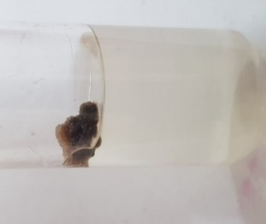
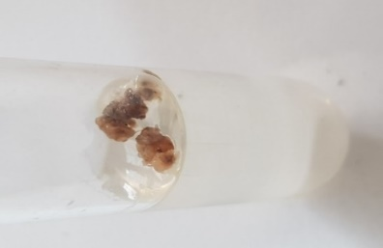
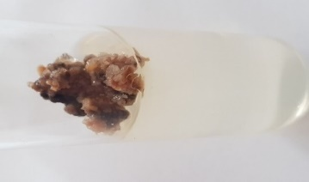
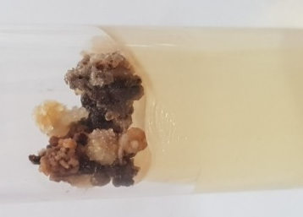
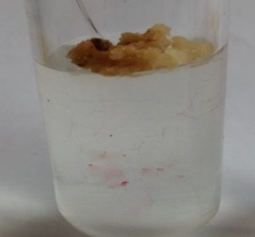
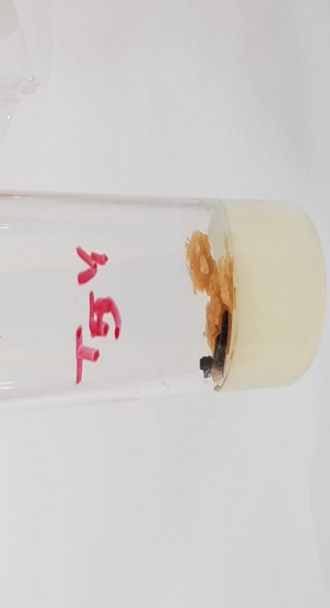

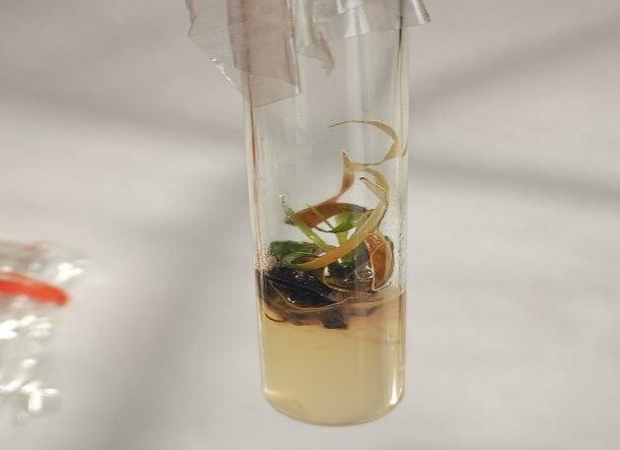
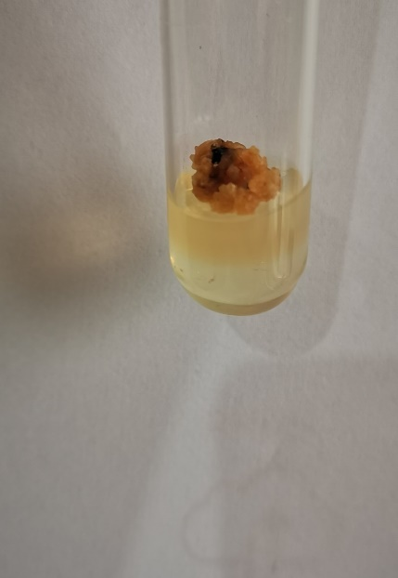
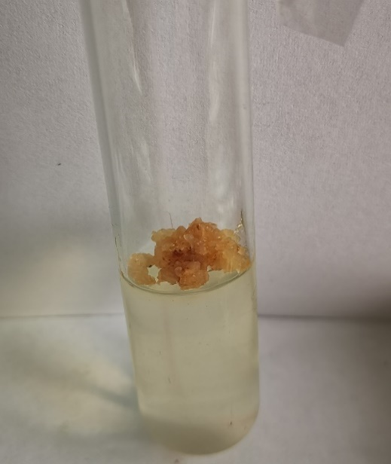
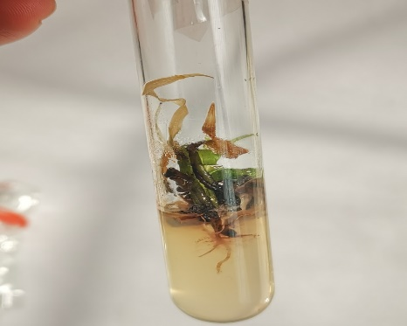
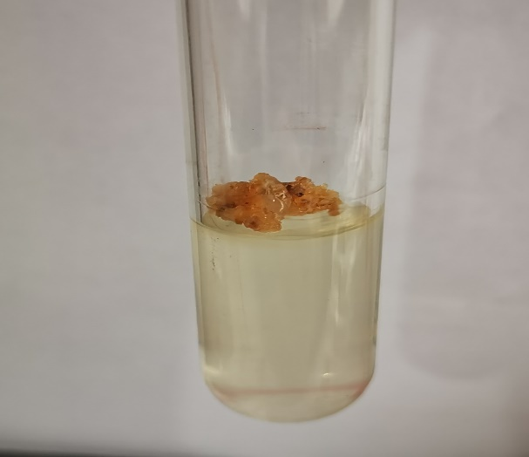
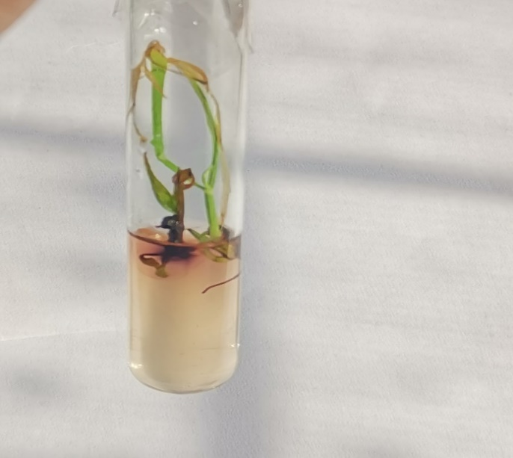

4 a) |  | SOD |  |  |  | CAT
 | Days | Treat. (T) | AsA.T | TxAsA.T | Error | Treat. (T) | AsA.T | TxAsA.T | Error
YT-53 | 30-Days | 0.00229*** | 0.00062*** | 0.00019*** | 0.00001 | 6.97*** | 2.69*** | 0.114** | 0.02449
YT-53 | 60-days | 0.0018*** | 0.0001** | 0.00002** | 0.00001 | 61.85*** | 69.74*** | 4.68*** | 0.1838
YT-53 | 90-Days | 0.00455*** | 0.00015*** | 0.00003*** | 4.86E-06 | 142.53*** | 2.86ns | 1.46ns | 0.787
CP-77-400 | 30-Days | 0.0018*** | 0.00035*** | 0.00016*** | 0.00001 | 4.56*** | 1.91*** | 0.093*** | 0.02
CP-77-400 | 60-days | 0.002*** | 0.0002*** | 0.00003*** | 0.00001 | 21.73*** | 78.1*** | 8.74*** | 0.37
CP-77-400 | 90-Days | 0.007*** | 0.00095* | 0.002*** | 0.0002 | 107.23*** | 2.97ns | 2.2ns | 2.76
NSG-59 | 30-Days | 8.4E-04*** | 1.8E-04*** | 1.7E-04*** | 9.30E-06 | 12.33*** | 12.99*** | 0.51*** | 0.0585
NSG-59 | 60-days | 0.002*** | 0.0007*** | 0.00005*** | 0.00001 | 74.2*** | 6.78*** | 2.49*** | 0.1425
NSG-59 | 90-Days | 0.02*** | 0.0003*** | 0.00006*** | 0.00001 | 67.73*** | 1.74*** | 0.33** | 0.0847
 | Days | POD |  |  |  | TPC
YT-53 | 30-Days | 0.0016*** | 0.0001*** | 0.000002ns | 1.19E-06 | 0.56*** | 0.024* | 0.018*** | 0.00338
YT-53 | 60-days | 0.003*** | 0.00006*** | 0.000003*** | 4.78E-07 | 1.59*** | 0.16*** | 0.014*** | 0.00151
YT-53 | 90-Days | 0.004*** | 0.0001*** | 0.000005*** | 6.95E-07 | 1.47*** | 0.155*** | 0.03*** | 0.00334
CP-77-400 | 30-Days | 0.0016*** | 0.002*** | 1.49E-04*** | 2.83E-06 | 15.41ns | 13.98ns | 13.58ns | 13.4
CP-77-400 | 60-days | 0.001*** | 2.03E-04*** | 4.19E-06*** | 2.91E-07 | 0.3*** | 0.1*** | 0.0018ns | 0.00128
CP-77-400 | 90-Days | 7.3E-04*** | 1.5E-04*** | 5.9E-05*** | 1.40E-07 | 4.067*** | 0.22*** | 0.05*** | 0.00238
NSG-59 | 30-Days | 6.7E-04*** | 8.1E-05* | 2.9E-05ns | 1.50E-05 | 0.3*** | .05*** | 0.001ns | 0.0007
NSG-59 | 60-days | 0.0005*** | 0.002*** | 0.001*** | 0.00003 | 0.64*** | 0.07*** | 0.003ns | 0.00199
NSG-59 | 90-Days | 0.22ns | 0.22ns | 0.21ns | 0.21 | 3.8*** | 0.06*** | 0.006*** | 0.001
Table 4. Mean squares after two-way analysis of variance (ANOVA) of biochemical parameters along genotype and days wise (4 a) and three parameters are genotype wise (4b)
4 b) | YT-53 |  |  | CP-77-400 |  |  | NSG-59
 | AsA | Pb | BCF | AsA | Pb | BCF | AsA | Pb | BCF
Treat (T) | 479.12*** | 0.4*** | 0.00003ns | 1482*** | 41.85ns | 4.27E-05ns | 1655.23*** | 0.25*** | 3.2E-07***
AsA.T | 6458.21*** | 0.001ns | 0.000016ns | 14844*** | 43.23ns | 4.39E-05ns | 63.7*** | 0.02*** | 4.1E-08***
TxAsA.T | 12.53*** | 0.02ns | 0.000016ns | 672.2*** | 41.03ns | 4.16E-05ns | 476.45*** | 0.001*** | 1.2E-08***
Error | 0.88 | 0.0179 | 1.4E-05 | 33.4 | 41.19 | 4.17E-05 | 0.36 | 0.00016 | 3.3E-10

Anova for graphs for biochemical analysis

