Title: Developmental independence of median fins from the larval fin fold revises their evolutionary origin.

Authors:
Kazuhide Miyamoto¹, Koichi Kawakami^{2,3}, Koji Tamura¹, Gembu Abe^{1*}

Affiliations:
¹ Department of Ecological Developmental Adaptability Life Sciences, Graduate School of Life Sciences, Tohoku University, Aobayama Aoba-ku, Sendai 980-8578, Japan
² Laboratory of Molecular and Developmental Biology, National Institute of Genetics, Mishima, Shizuoka, 411-8540, Japan
³ Department of Genetics, The Graduate University for Advanced Studies, SOKENDAI, Mishima, Shizuoka, 411-8540, Japan

*Corresponding authors:
Gembu Abe
Address: Laboratory of Organ Morphogenesis,
Department of Ecological Developmental Adaptability Life Sciences, Graduate School of Life Sciences, Tohoku University,
Aobayama Aoba-ku, Sendai 980-8578, Japan.
Tel: +81-22-795-6677
Fax: +81-22-795-6677
Email: gembu.abe.b5@tohoku.ac.jp

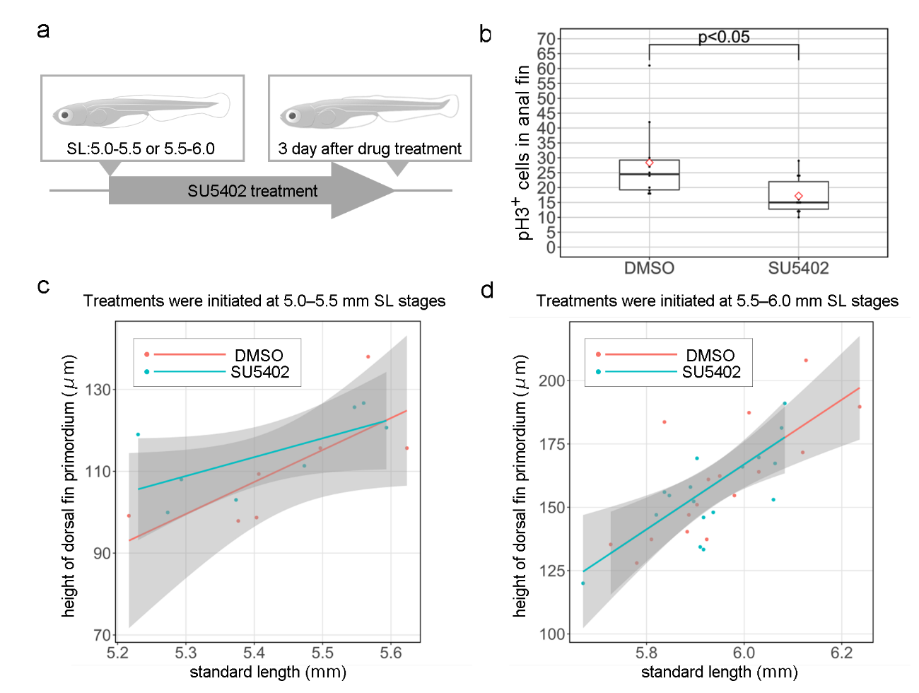
Figure S1. Effect of SU5402 treatment. (a) Scheme of SU5402 treatment. (b) Boxplots of phospho-histone-H3-positive cells in anal fin primordia after SU5402 treatment that started at 5.0–5.5 mm SL. This proportion was calculated from the number of pH3-positive cells in anal fin primordium. (c,d) Quantification of dorsal fin primordium height after SU5402 treatments started at 5.0–5.5 mm SL (c) and 5.5–6.0 mm SL (d). Whiskers in (b) show maximum and minimum values within 1.5 times the interquartile range. Boxes show the median and 25th and 75th percentiles. The P value in (b) is the result of Welch's t test (P = 0.03447). Standard length/height of the dorsal fin primordium angle slope between trials of DMSO control fish and SU5402-treated fish was not significantly different ((c) P = 0.01019; ANCOVA, (d) P = 5.931e-06; ANCOVA). The 95% confidence intervals are indicated as grey areas in (c,d).

