Supplementary information

Reduced burden from major diseases due to an increase in vegetable intake in Japan: projections of disability-adjusted life years, 2017-2040

Authors: Shiori Tanaka^{1,2#†}, Daisuke Yoneoka^{1,3,4#}, Aya Ishizuka¹, Ueda Peter^{1,5}, Keiji Nakamura^{6,7}, Hisayuki Uneyama⁷, Naoki Hayashi⁷, Kenji Shibuya^{1,8}, Shuhei Nomura^{1,4}
# Shared first authorship

Affiliations:
- Department of Global Health Policy, Graduate School of Medicine, The University of Tokyo, Tokyo, Japan
- Epidemiology and Prevention Group, Center for Public Health Sciences, National Cancer Center, 5-1-1 Tsukiji, Chuo-ku, Tokyo 104-0045, Japan
- Graduate School of Public Health, St. Luke's International University, Tokyo, Japan
- Department of Health Policy and Management, School of Medicine, Keio University, Tokyo, Japan
- Clinical Epidemiology Division, Department of Medicine, Solna, Karolinska Institutet, Stockholm, Sweden
- Graduate School of Environmental and Information Studies, Tokyo City University, Yokohama, Japan
- Ajinomoto Co., Inc., Tokyo, Japan
- Institute for Population Health, King's College London, London, UK; Department of Global Health Policy

Supplementary figure 1: Observed and projected 20–49 age group DALYs rate (per 100,000) for cardiovascular diseases for reference forecast and three alternative scenarios, 1995–2040: (A) male, (B) female, and (C) both sexes combined. The black lines represent the observed values, and the pink lines and the grey areas before 2016 represent the smoothed lines and their projection intervals.
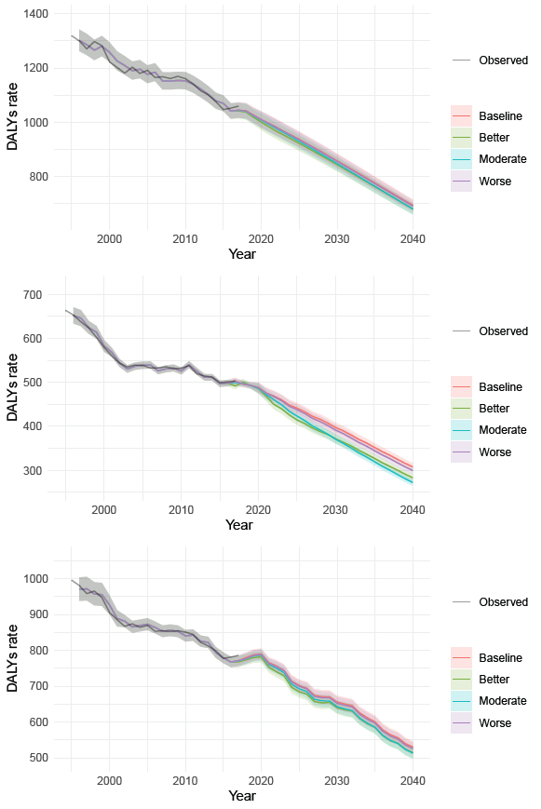
C
B
A

Supplementary figure 2: Observed and projected 50–69 age group DALYs rate (per 100,000) for cardiovascular diseases for reference forecast and three alternative scenarios, 1990–2040: (A) male, (B) female, and (C) both sexes combined. The black lines represent the observed values, and the pink lines and the grey areas before 2016 represent the smoothed lines and their projection intervals.
A
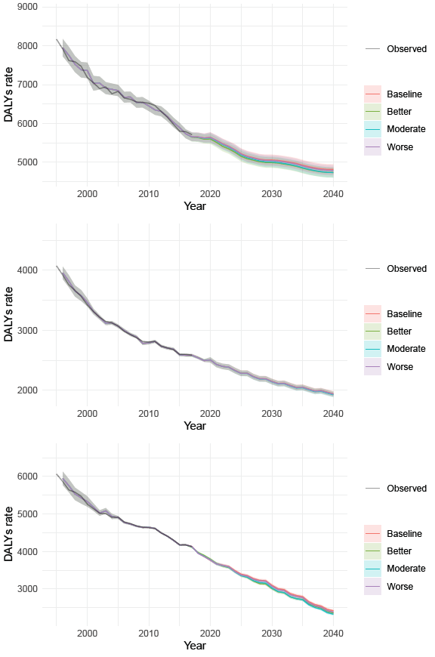
C
B
Supplementary figure 3: Observed and projected ≥70 age group DALYs rate (per 100,000) for cardiovascular diseases for reference forecast and three alternative scenarios, 1990–2040: (A) male, (B) female, and (C) both sexes combined. The black lines represent the observed values, and the pink lines and the grey areas before 2016 represent the smoothed lines and their projection intervals.
A
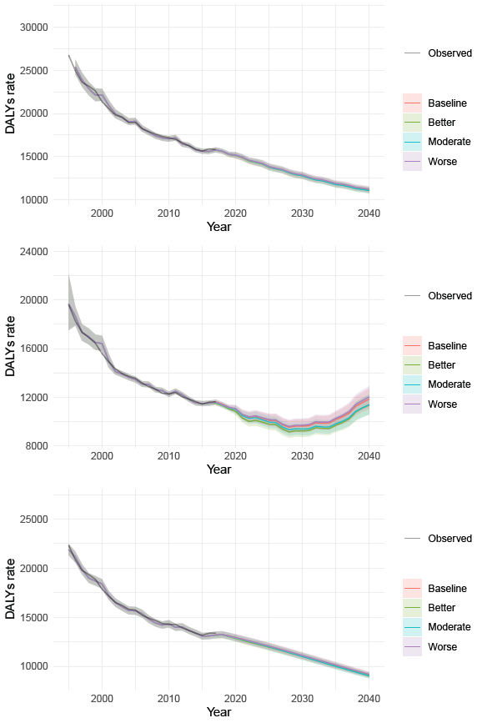
C
B

Supplementary figure 4: Observed and projected 20–49 age group DALYs rate (per 100,000) for cancer for reference forecast and three alternative scenarios, 1990–2040: (A) male, (B) female, and (C) both sexes combined. The black lines represent the observed values, and the pink lines and the grey areas before 2016 represent the smoothed lines and their projection intervals.
A
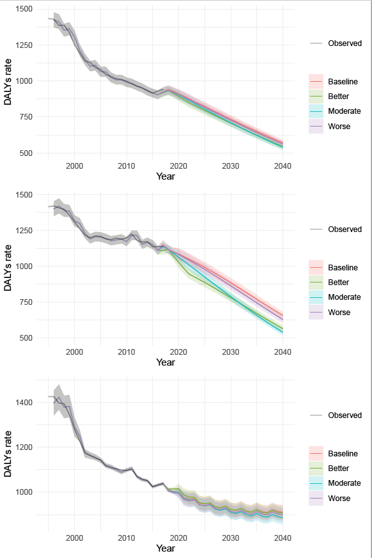
C
B

Supplementary figure 5: Observed and projected 50–69 age group DALYs rate (per 100,000) for cancer for reference forecast and three alternative scenarios, 1990–2040: (A) male, (B) female, and (C) both sexes combined. The black lines represent the observed values, and the pink lines and the grey areas before 2016 represent the smoothed lines and their projection intervals.
A
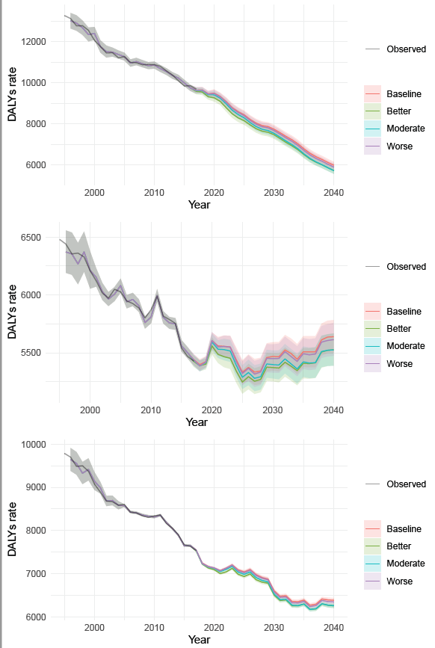
C
B

Supplementary figure 6: Observed and projected ≥70 age group DALYs rate (per 100,000) for cancer for reference forecast and three alternative scenarios, 1990–2040: (A) male, (B) female, and (C) both sexes combined. The black lines represent the observed values, and the pink lines and the grey areas before 2016 represent the smoothed lines and their projection intervals.
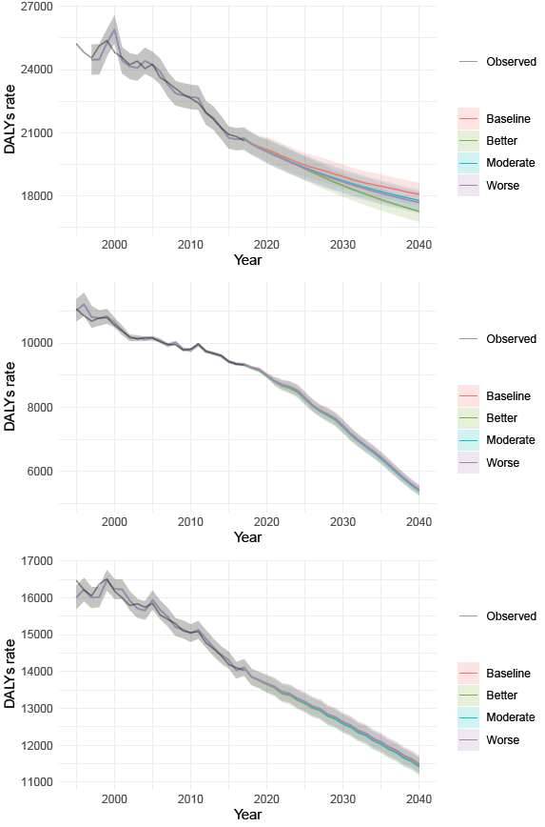
C
B
A
Supplementary figure 7: Observed and projected 20–49 age group DALYs rate (per 100,000) for diabetes and kidney diseases for reference forecast and three alternative scenarios, 1990–2040: (A) male, (B) female, and (C) both sexes combined. The black lines represent the observed values, and the pink lines and the grey areas before 2016 represent the smoothed lines and their projection intervals.
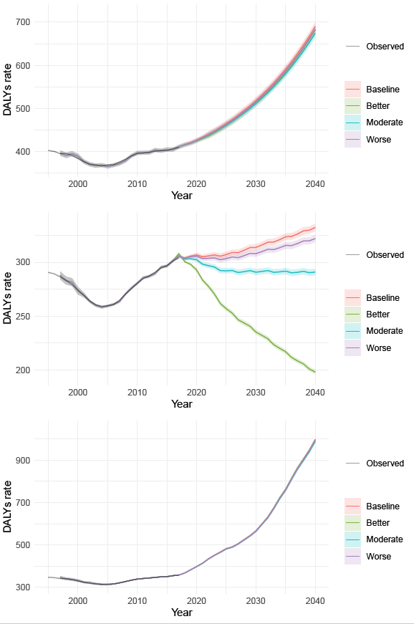
C
B
A
Supplementary figure 8: Observed and projected 50–69 age group DALYs rate (per 100,000) for diabetes and kidney diseases for reference forecast and three alternative scenarios, 1990–2040: (A) male, (B) female, and (C) both sexes combined. The black lines represent the observed values, and the pink lines and the grey areas before 2016 represent the smoothed lines and their projection intervals.
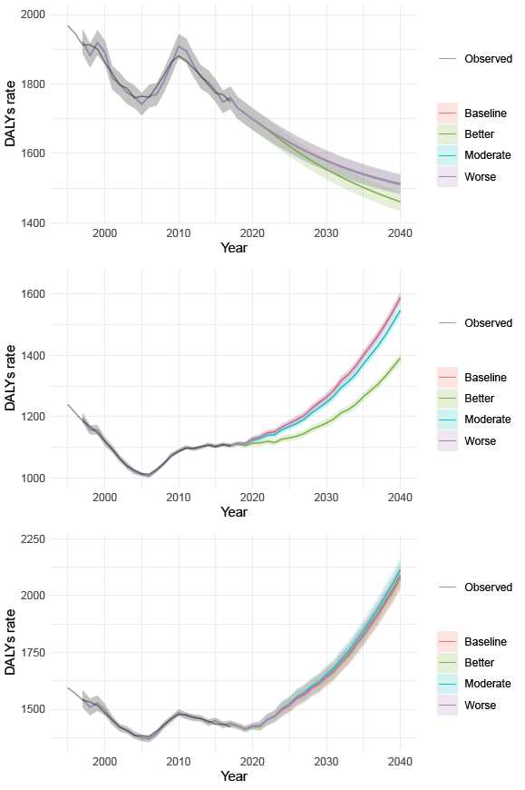
C
B
A
Supplementary figure 9: Observed and projected ≥70 age group DALYs rate (per 100,000) for diabetes and kidney diseases for reference forecast and three alternative scenarios, 1990–2040: (A) male, (B) female, and (C) both sexes combined. The black lines represent the observed values, and the pink lines and the grey areas before 2016 represent the smoothed lines and their projection intervals.
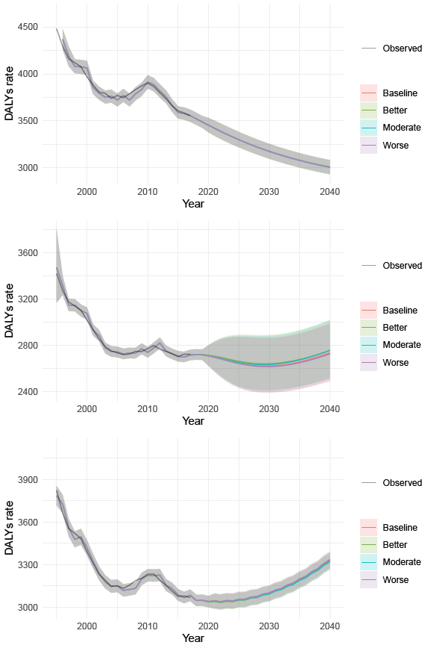
C
B
A

Supplemental Table 1: Estimated sets of parameters in ARIMA(p,d,q) and Akaike Information Criteria (AIC)
Disease | Age group | Sex | p | d | q | AIC
Cardiovascular diseases | 20–49 | Male | 1 | 1 | 1 | -106.6
Cardiovascular diseases | 20–49 | Female | 4 | 1 | 1 | -124.0
Cardiovascular diseases | 20–49 | Both sexes combined | 5 | 1 | 0 | -112.5
Cardiovascular diseases | 50–69 | Male | 9 | 1 | 0 | -139.5
Cardiovascular diseases | 50–69 | Female | 3 | 1 | 1 | -139.5
Cardiovascular diseases | 50–69 | Both sexes combined | 8 | 1 | 2 | -149.1
Cardiovascular diseases | ≥70 | Male | 5 | 1 | 3 | -104.9
Cardiovascular diseases | ≥70 | Female | 7 | 0 | 0 | -115.7
Cardiovascular diseases | ≥70 | Both sexes combined | 1 | 1 | 1 | -138.2
Cardiovascular diseases | All ages | Male | 4 | 1 | 2 | -128.1
Cardiovascular diseases | All ages | Female | 6 | 1 | 3 | -138.4
Cardiovascular diseases | All ages | Both sexes combined | 3 | 1 | 1 | -124.4
Cancer | 20–49 | Male | 1 | 1 | 0 | -101.2
Cancer | 20–49 | Female | 0 | 1 | 1 | -108.3
Cancer | 20–49 | Both sexes combined | 10 | 2 | 0 | -182.3
Cancer | 50–69 | Male | 9 | 1 | 0 | -139.5
Cancer | 50–69 | Female | 4 | 1 | 3 | -139.5
Cancer | 50–69 | Both sexes combined | 8 | 1 | 0 | -158.5
Cancer | ≥70 | Male | 2 | 2 | 1 | -102.8
Cancer | ≥70 | Female | 8 | 1 | 2 | -154.1
Cancer | ≥70 | Both sexes combined | 5 | 1 | 1 | -154.5
Cancer | All ages | Male | 6 | 0 | 0 | -121.8
Cancer | All ages | Female | 4 | 1 | 2 | -126.0
Cancer | All ages | Both sexes combined | 11 | 0 | 0 | -161.6
Diabetes and kidney diseases | 20–49 | Male | 0 | 2 | 4 | -134.9
Diabetes and kidney diseases | 20–49 | Female | 5 | 2 | 1 | -162.8
Diabetes and kidney diseases | 20–49 | Both sexes combined | 4 | 1 | 3 | -138.6
Diabetes and kidney diseases | 50–69 | Male | 3 | 2 | 3 | -157.1
Diabetes and kidney diseases | 50–69 | Female | 7 | 2 | 2 | -146.9
Diabetes and kidney diseases | 50–69 | Both sexes combined | 3 | 2 | 3 | -133.2
Diabetes and kidney diseases | ≥70 | Male | 1 | 1 | 0 | -126.3
Diabetes and kidney diseases | ≥70 | Female | 2 | 0 | 0 | -138.1
Diabetes and kidney diseases | ≥70 | Both sexes combined | 1 | 2 | 3 | -162.4
Diabetes and kidney diseases | All ages | Male | 1 | 2 | 2 | -128.5
Diabetes and kidney diseases | All ages | Female | 5 | 2 | 1 | -145.7
Diabetes and kidney diseases | All ages | Both sexes combined | 0 | 2 | 3 | -140.6

Supplementary table 2: Observed and projected DALYs rate (per 100,000) in GBD 2016, and in the 2040 reference forecast and three alternative scenarios
Disease | Age group | Sex | 2016 | 2040 forecast  (95% PIs) | 2040 better and moderate  scenarios (95% PIs)* | 2040 worse  scenario (95% PIs)
Cardiovascular diseases | 20–49 | Male | 1052.2 | 677.5 (657.2－698.5) | 664.1 (644.2－684.7) | 674.3 (654.1－695.1)
Cardiovascular diseases | 20–49 | Female | 501.0 | 298.8 (290.5－307.4) | 274.8 (267.2－282.7) | 290.3 (282.2－298.6)
Cardiovascular diseases | 20–49 | Both sexes combined | 781.2 | 539.8 (523.3 – 556.7) | 524.0 (508.1 – 540.3) | 535.7 (519.5 – 552.5)
Cardiovascular diseases | 50–69 | Male | 5790.2 | 4821.1 (4690.2－4955.6) | 4741.5 (4612.8－4873.8) | 4794.2 (4664.1－4928.0)
Cardiovascular diseases | 50–69 | Female | 2600.1 | 1949.6 (1907.7－1992.4) | 1943.2 (1901.4－1985.9) | 1945.7 (1903.9－1988.4)
Cardiovascular diseases | 50–69 | Both sexes combined | 4174.7 | 2379.6 (2342.9 －2417.0) | 2315.9 (2280.2 －2352.2) | 2346.2(2310.0－2383.0)
Cardiovascular diseases | ≥70 | Male | 15884.6 | 10919.2 (10582.5－11266.7) | 10895.6 (10559.5－11242.3) | 11015.8 (10676.0－11366.3)
Cardiovascular diseases | ≥70 | Female | 11594.4 | 12351.2 (11497.3－13268.5) | 11859.4 (11039.5－12740.2) | 12542.9 (11675.7－13474.4)
Cardiovascular diseases | ≥70 | Both sexes combined | 13373.6 | 9105.1 (8822.4－9397.0) | 8907.1 (8630.1－9193.0) | 8938.8 (8660.9－9225.8)
Cardiovascular diseases | All ages | Male | 4590.3 | 3411.8 (3319.0－3507.1) | 3398.3 (3305.9－3493.2) | 3409.1 (3316.5－3504.4)
Cardiovascular diseases | All ages | Female | 3400.8 | 4038.2 (3976.1－4101.2) | 4038.1 (3976.0－4101.2) | 4038.0 (3975.9－4101.1)
Cardiovascular diseases | All ages | Both sexes combined | 3980.4 | 4194.3 (4075.4－4316.7) | 4027.1 (3912.9－4144.6) | 4189.6 (4070.8－4311.9)
Cancer | 20–49 | Male | 929.4 | 556.0 (536.1－576.7) | 530.5 (511.4－550.2) | 546.7 (527.1－567.1)
Cancer | 20–49 | Female | 1137.0 | 634.7 (611.6－658.6) | 544.2 (524.4－564.7) | 605.6 (583.6－628.4)
Cancer | 20–49 | Both sexes combined | 1031.4 | 913.7 (883.4 – 945.0) | 909.8 (879.6 – 941.0) | 903.1 (873.2 – 934.1)
Cancer | 50–69 | Male | 9860.2 | 5864.8 (5703.6－6030.6) | 5604.0 (5450.0－5762.5) | 5776.5 (5617.7－5939.8)
Cancer | 50–69 | Female | 5469.0 | 5715.7 (5573.0－5862.1) | 5594.4 (5454.7－5737.7) | 5689.9 (5547.8－5835.6)
Cancer | 50–69 | Both sexes combined | 7636.3 | 6380.6 (6326.7－6435.1) | 6260.8 (6207.8－6314.2) | 6340.1 (6286.4－6394.1)
Cancer | ≥70 | Male | 20818.2 | 18012.0 (17492.1－18547.4) | 17159.3 (16664.0－17669.4) | 17606.6 (17098.4－18129.9)
Cancer | ≥70 | Female | 9342.7 | 5244.6 (5103.7－5389.4) | 5213.1 (5073.0－5357.0) | 5255.4 (5114.2－5400.5)
Cancer | ≥70 | Both sexes combined | 14102.1 | 11372.2 (11150.8 －11598.0) | 11334.8 (11114.2－11559.8) | 11402.3 (11180.4－11628.7)
Cancer | All ages | Male | 6449.7 | 7354.7 (7145.4－7570.2) | 6953.5 (6755.6－7157.2) | 7288.2 (7080.8－7501.7)
Cancer | All ages | Female | 3940.3 | 3457.3 (3354.9－3562.9) | 3227.1 (3131.5－3325.6) | 3447.6 (3345.5－3552.8)
Cancer | All ages | Both sexes combined | 5163.1 | 5510.8 (5372.1－5653.2) | 5201.5 (5070.5－5335.9) | 5502.1 (5363.5－5644.2)
Diabetes and kidney diseases | 20–49 | Male | 406.6 | 713.2 (702.2－724.4) | 705.5 (694.6－716.6) | 706.9 (695.9－718.0)
Diabetes and kidney diseases | 20–49 | Female | 301.1 | 335.5 (332.0－339.1) | 195.6 (193.6－197.7) | 324.7 (321.3－328.1)
Diabetes and kidney diseases | 20–49 | Both sexes combined | 354.7 | 948.8 (947.5 – 950.1) | 946.2 (944.8 – 947.5) | 944.4 (943.1 – 945.7)
Diabetes and kidney diseases | 50–69 | Male | 1769.5 | 1504.9 (1477.5－1532.7) | 1453.4 (1427.0－1480.4) | 1508.6 (1481.1－1645.2)
Diabetes and kidney diseases | 50–69 | Female | 1109.4 | 1630.7 (1612.3－1649.2) | 1417.6 (1401.6－1433.7) | 1626.7 (1608.4－1202.6)
Diabetes and kidney diseases | 50–69 | Both sexes combined | 1435.2 | 2134.8 (2083.1－2187.7) | 2140.9 (2089.1－2194.0) | 2152.1 (2100.0－2205.5)
Diabetes and kidney diseases | ≥70 | Male | 3585.3 | 2994.8 (2920.6－3070.8) | 2994.4 (2920.3－3070.4) | 2996.8 (2922.6－3072.9)
Diabetes and kidney diseases | ≥70 | Female | 2721.2 | 2752.8 (2513.7－3014.7) | 2774.6 (2533.5－3038.5) | 2743.9 (2505.6－3005.0)
Diabetes and kidney diseases | ≥70 | Both sexes combined | 3079.6 | 3370.7 (3312.1－3430.4) | 3368.0 (3309.4－3427.7) | 3377.6 (3318.8－3437.4)
Diabetes and kidney diseases | All ages | Male | 1235.0 | 1965.9 (1928.3－2004.4) | 1804.2 (1769.6－1839.5) | 2008.5 (1970.0－2047.8)
Diabetes and kidney diseases | All ages | Female | 1003.6 | 2765.0 (2727.3－2803.3) | 2386.0 (2353.4－2419.0) | 2799.6 (2761.4－2838.4)
Diabetes and kidney diseases | All ages | Both sexes combined | 1116.4 | 2083.5 (2049.7－2117.8) | 2081.3 (2047.5－2115.6) | 2083.1 (2049.3－2117.4)
GBD: Global Burden of Disease study; PIs: prediction intervals. * Because the vegetable intake as of 2040 is the same by definition in the better and moderate scenarios, the projected DALYs rate converged mathematically to the almost same values.

