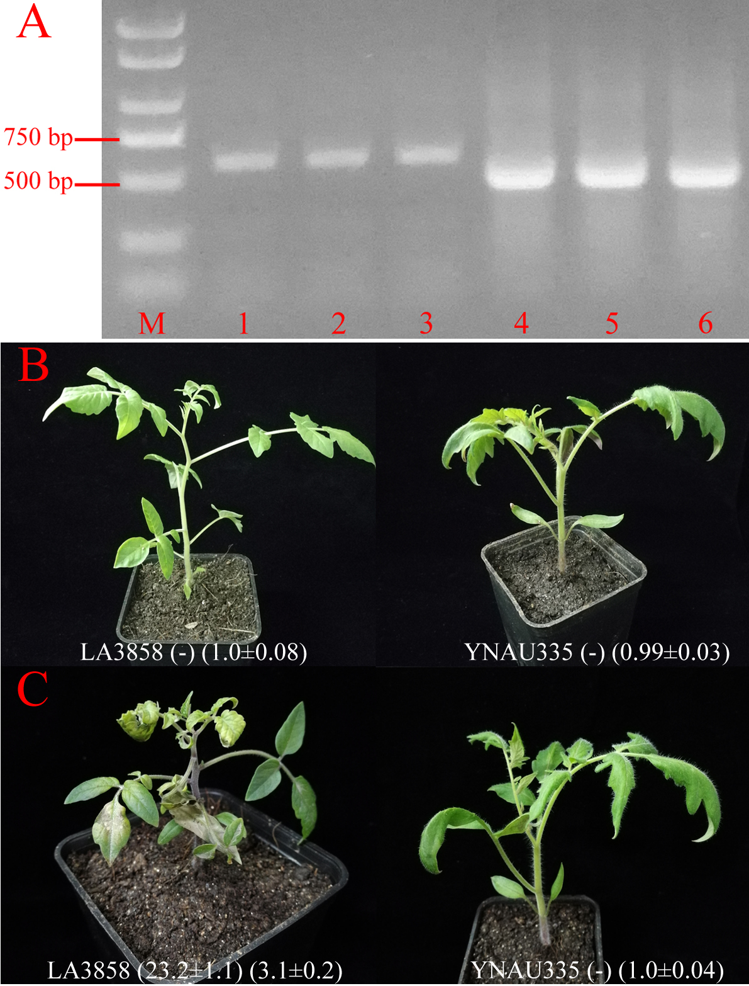
Figure S1. Genotyping of the PCR-amplified tomato materials. Electropherogram was obtained with the ‘Sw-5-2’ primer pair in which lanes 1-6 indicated L. peruvianum LA3858, LA2823, PI128657, YNAU335, NO.5, and 96712I, respectively (A). LA3858 and YNAU335 were inoculated with phosphate buffer (B) and TSWV by mechanical method (C). The numbers in the first and second brackets indicate the Ct values of the N gene using RT-qPCR and the ratios of the sample OD₄₁₅ to the control OD₄₁₅ using ELISA, which are shown as the means of the three biological replicates ± standard deviations (SDs), “-”: not detected.

