Supplementary Materials

Functional charateristics of the stelar K⁺ outward rectifying channel (EeSKOR) gene in Elytrigia elongata
Authors: Yantong Zhou, Xiaoxia Tian, Yong Zhang, Peichun Mao, Mingli Zheng & Lin Meng¹
Institutional addresses: Beijing Research and Development Centre for Grass and Environment, Beijing Academy of Agriculture and Forestry Sciences, Beijing 100097, P. R. China
¹ Corresponding author: menglin9599@sina.com
Tel: +86-10-51503345
Fax: +86-10-51503297

Table S1 Primer sequences used in the experiments
Name of primer | Primer sequence（5'-3'）
SKOR-1 | TACCTGRTCGGSAACATGACGGCG
SKOR-2 | GATGCTRGTCARGGAYTGCTTGTC
3' RACE primer (3'-O) | ACATGGATGTCTGGAAGAGATTGT
3' RACE primer (3'-I) | ATGTGGATCAGAAAAGGTCATCTCAGA
5' RACE primer (5'-O) | ACAATCTGGCTCAGGAAGTCCTCT
5' RACE primer (5'-I) | CTCTTGTAGCTGCTCTCGTACTGC
EeSKOR-F | CTACTGATCGGCTGCTGCAACAGCAGC
EeSKOR-R | ATGGAGAGGGAGATTGTAGCAAGAG
DPF1 | AGGGAGATTGTAGCAGTAT
DPR1 | CCTCCCGATCCATGTGCCCCCCTCAA

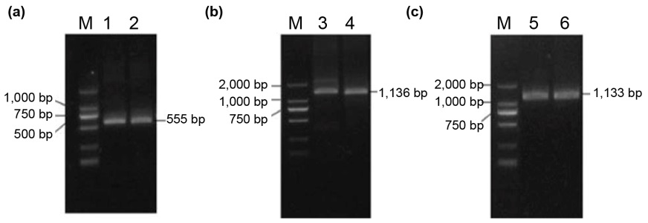

Figure S1 PCR amplification products of EeSKOR gene
Notes: (a) Core fragment PCR amplification products; (b) 5'- end PCR amplification product; (c) 3'-end PCR amplification product; M-marker

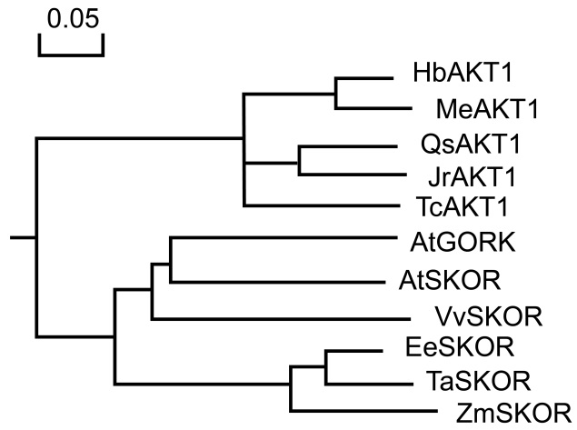

Figure S2 Phylogenetic tree analysis of EeSKOR with closely related SKOR from different plant species
Notes: HbAKT1 (Heveabra siliensis, XM_021790545), MeAKT1 (Manihot esculenta, XM_021736424), QsAKT1 (Quercus suber, XM_024069160), JrAKT1 (Juglans regia, XM_018985513), TcAKT1 (Theobroma cacao, XM_007013273), AtGORK (Arabidopsis tenuiflora, NM_123109.5), AtSKOR (Arabidopsis tenuiflora, NM_111153), VvSKOR (Vitis vinifera, XM_002282362), EeSKOR (Elytrigia elongata, MK203848), TaSKOR (Triticum aesticum, AK331457), ZmSKOR (Zea mays, NM_001357855)

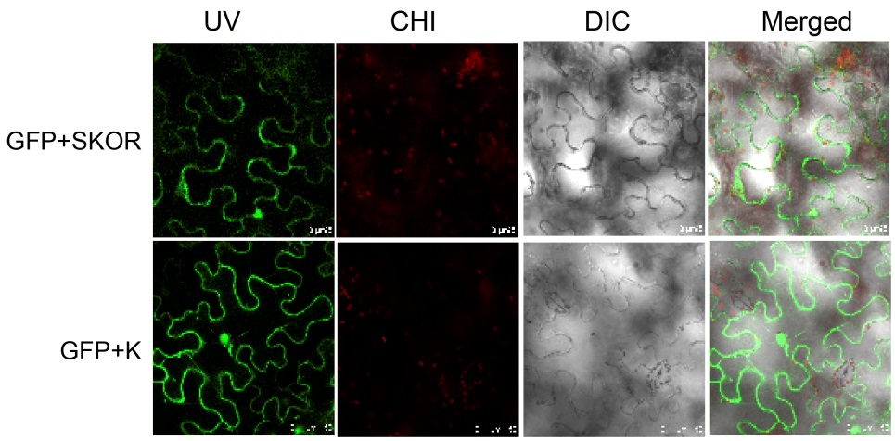

Figure S3 Analysis of EeSKOR protein subcellular localization
Notes: GFP green fluorescent protein localization (UV), chloroplast spontaneous fluorescence (CHI), light field (DIC), and superimposed picture of three channels (merged) of the target gene (GFP+SKOR)/empty vector (GFP+K) from left to right

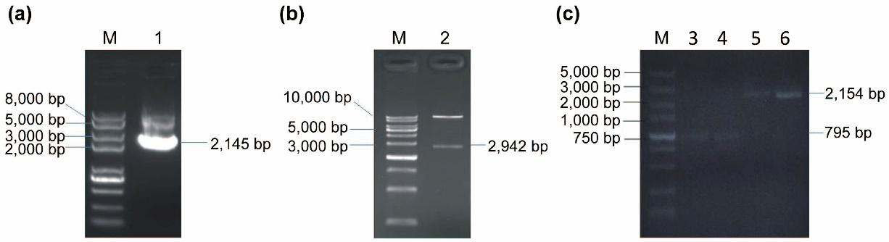

Figure S4 (a) PCR amplification product of EeSKOR gene ORF; (b) PCAMBIA1301 vector Hind III/Bgl II double enzyme digestion test, and (c) positive test of agrobacterium
Notes：1-PCR products of EeSKOR gene ORF; 2-enzyme digestion products of pCAMBIA1301-35S- EeSKOR-Nos; 3,4-Kan; 5,6-ORF; M-Marker

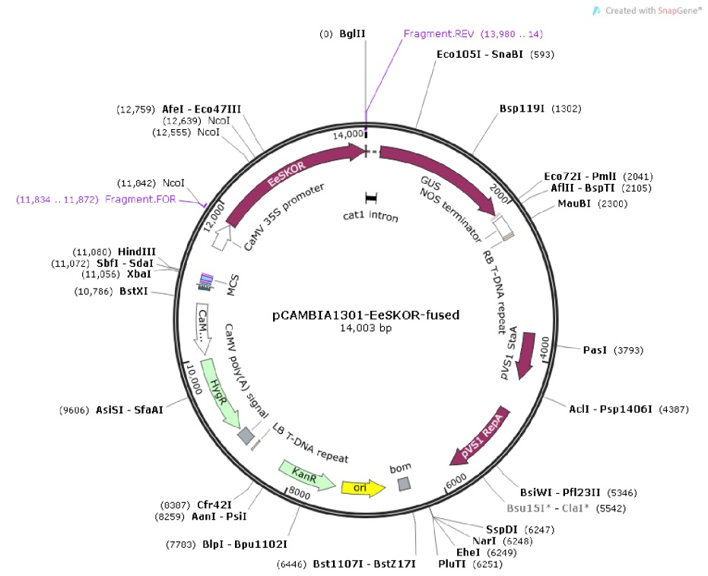

Figure S5 Schematic diagram of pCAMBIA1301-35S-EeSKOR-Nos carrier construction

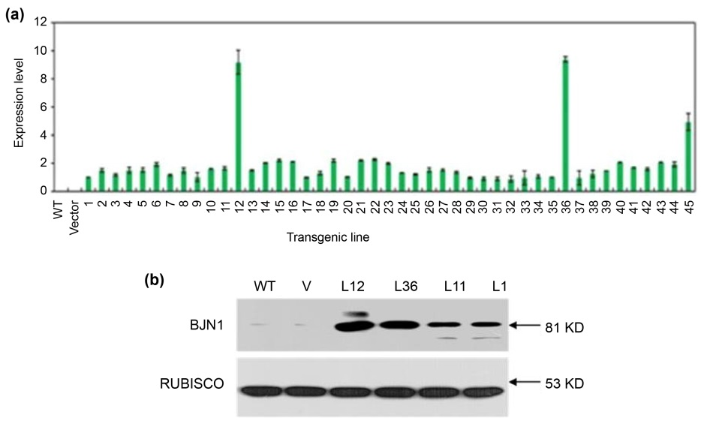
Figure S6 (a) The relative expression level of EeSKOR in forty-five transgenic tobacco plants detected by qRT-PCR; (b) Western blot analysis of EeSKOR-transgenic tobacco plants L12, L36, L11, L1, and WT and Vector (V)

