Synthesis and characterization of chitosan-acrylic acid based hydrogels and investigation the properties of bilayered design with incorporated alginate beads
Tamara Erceg¹, Gaja Brakus², Alena Stupar³, Miroslav Cvetinov⁴, Miroslav Hadnađev³, Ivan Ristić¹
¹ University of Novi Sad, Faculty of Technology Novi Sad, 21000 Novi Sad, Serbia,
²High school Jovan Jovanović Zmaj, 21000 Novi Sad, Serbia
³ University of Novi Sad Institute of Food Technology in Novi Sad, 21000 Novi Sad
⁴ University of Novi Sad, Academy of Arts, 21000 Novi Sad
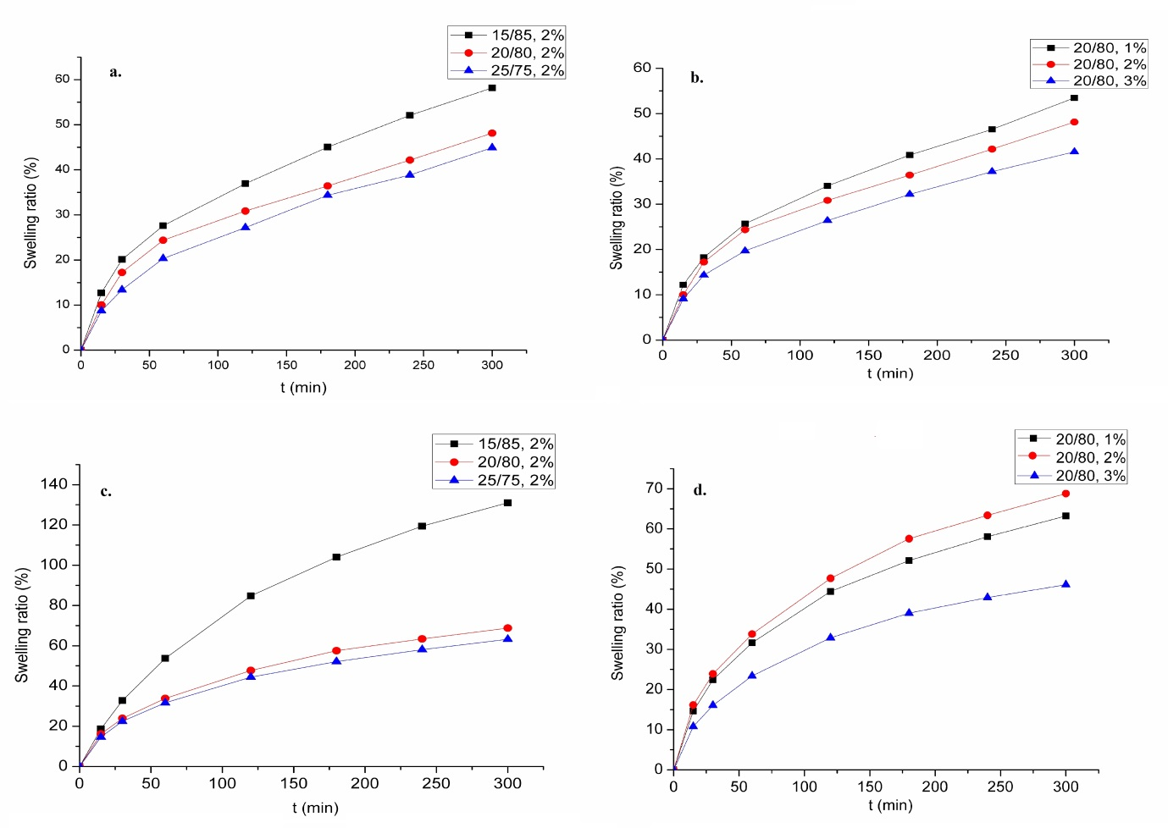
Figure S1. Swelling ratio as a function of time for hydrogels at physiological temperature a) with different amount of grafted AA at pH 3, b) with different amount of cross linking agent at pH 3, c) with different amount of grafted AA at pH 7.4, d) with different amount of crosslinking agent at pH 7.4

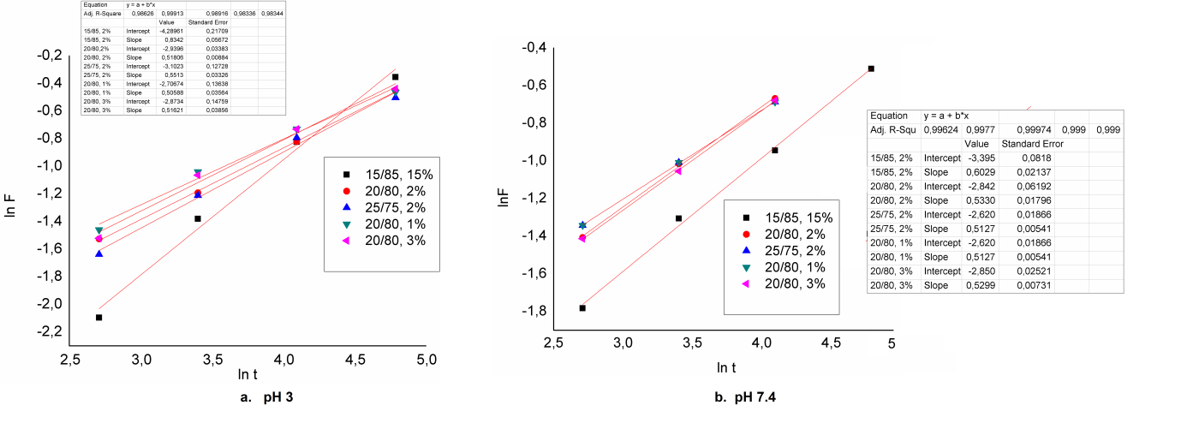
Figure S2. Plot of ln F versus ln t according to Equation 2 at pH 3 and pH 7.4 (room temperature).

Figure S3. Plot of ln F versus ln t according to Equation 2 at pH 3 and pH 7.4 (physiological temperature).

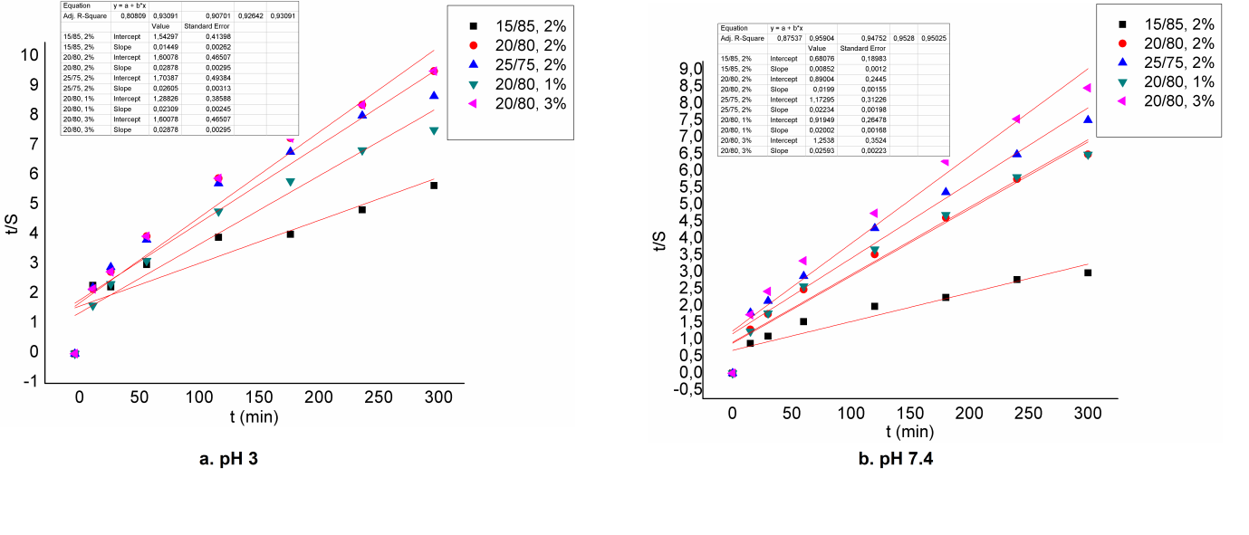
Figure S4. Plot of t/S versus time according to Equation 4 at pH 3 and pH 7.4 (room temperature).
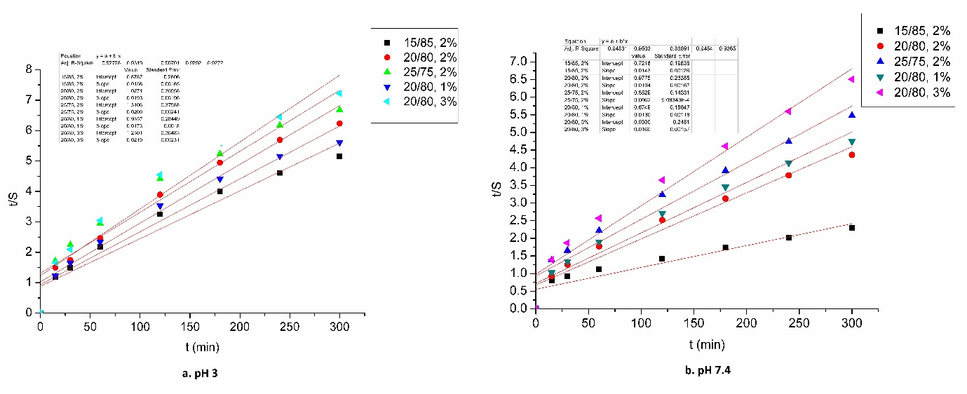
Figure S5. Plot of t/S versus time according to Equation 4 at pH 3 and pH 7.4 (physiological temperature).

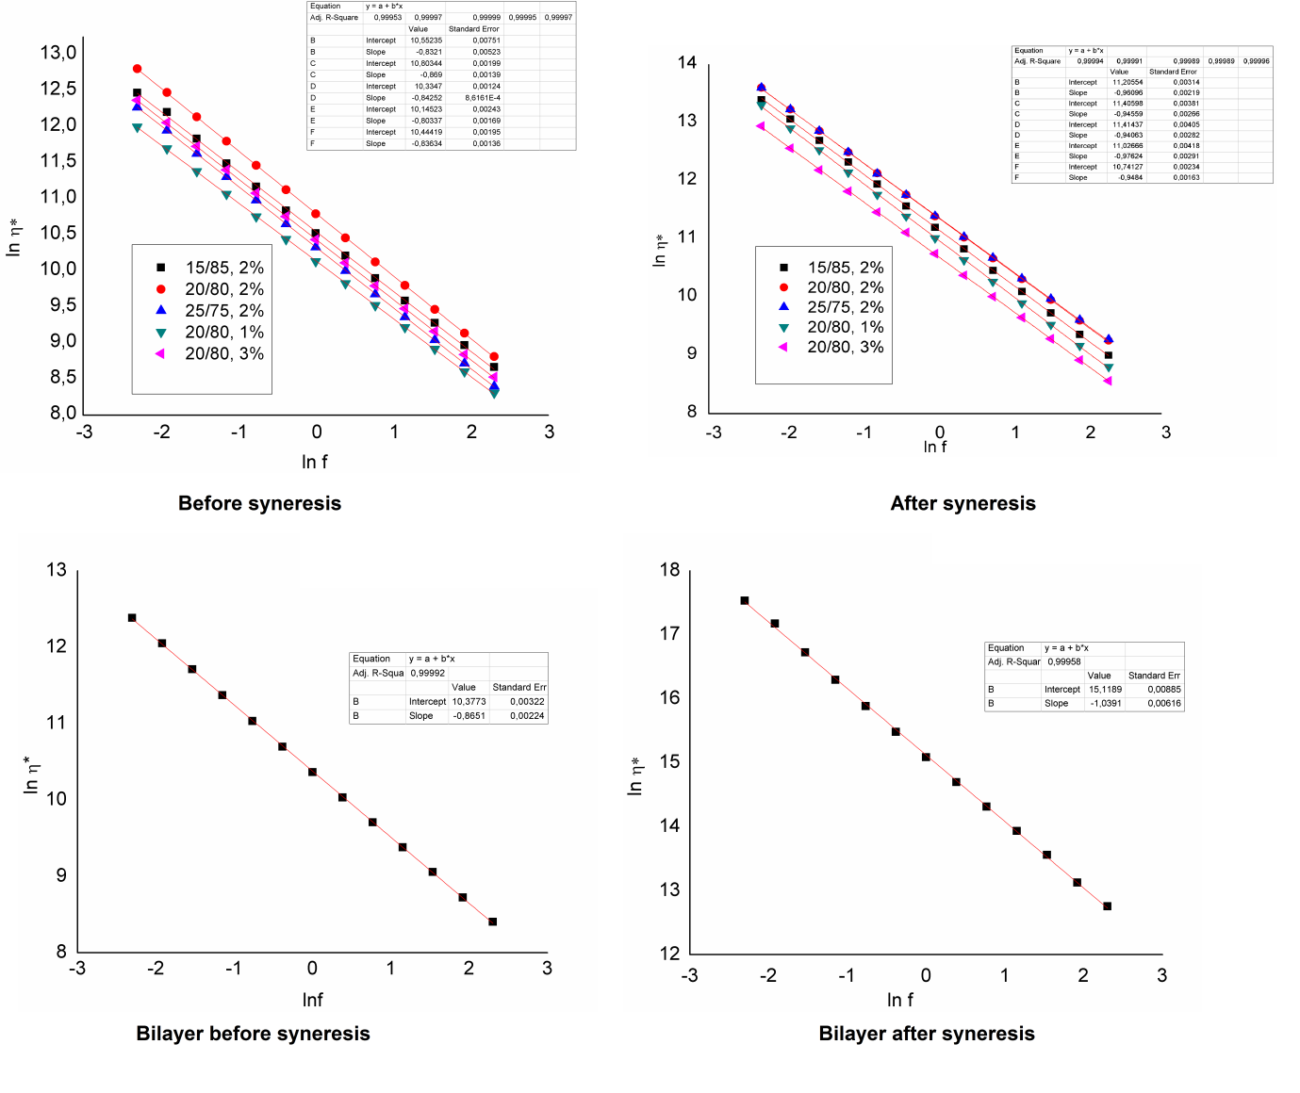
Figure S6. Variation of lnη* in function of lnf.

Table S1. Plateau values of shear elastic modulus before and after syneresis.
Sample | G` (Pa)  before syneresis | G` (Pa)  after syneresis
15/85, 2% | 37853.85 | 72530.77
Standard Deviation | 51.15 | 95.33
Range | 102.31 | 188.46
20/80, 2% | 48955.38 | 89725.38
Standard Deviation | 79.38 | 158.38
Range | 158.77 | 316.77
25/75, 2% | 30645.38 | 90443.08
Standard Deviation | 97.62 | 97.73
Range | 195.23 | 195.45
20/80, 1% | 25254.62 | 61436.92
Standard Deviation | 66.39 | 136.45
Range | 132.77 | 272.91
20/80, 3% | 34263.85 | 46233.08
Standard Deviation | 103.85 | 43.78
Range | 207.69 | 87.55

Figure S7. Calibration curve: ΔEab* values in function of extract concentration.

