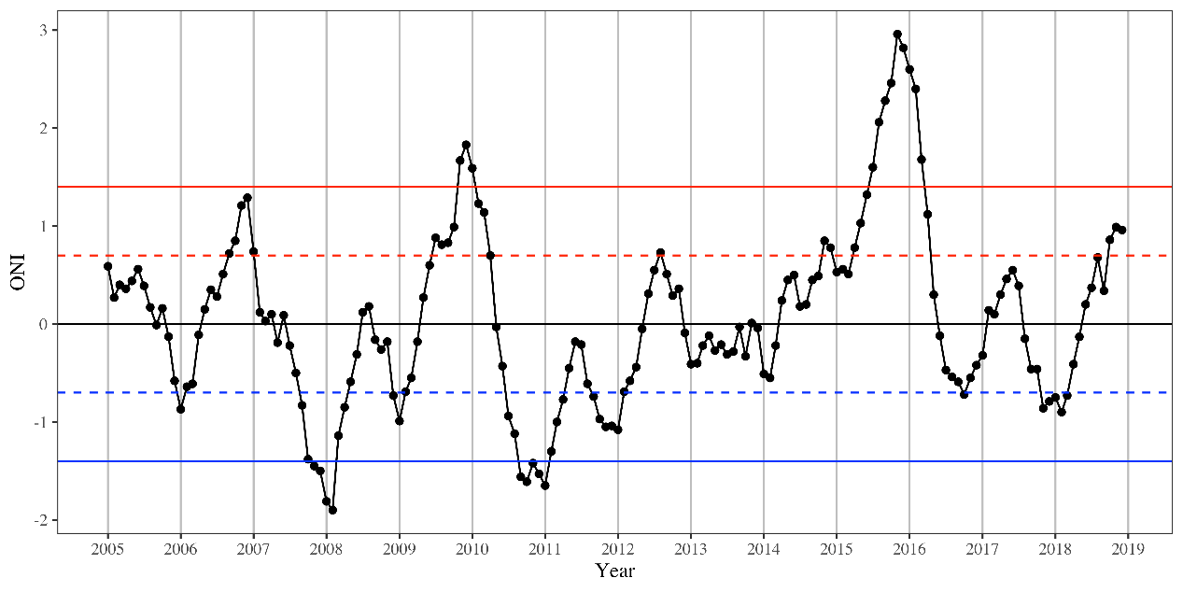
Fig. S1 Oceanic El Niño index (ONI), which characterizes ENSO events in the Pacific Ocean, downloaded from Climate Prediction Center spanning from 2005 – 2018, and strong La Niña events occurred two times, whereas the strong El Niño events occurred two times in this period.

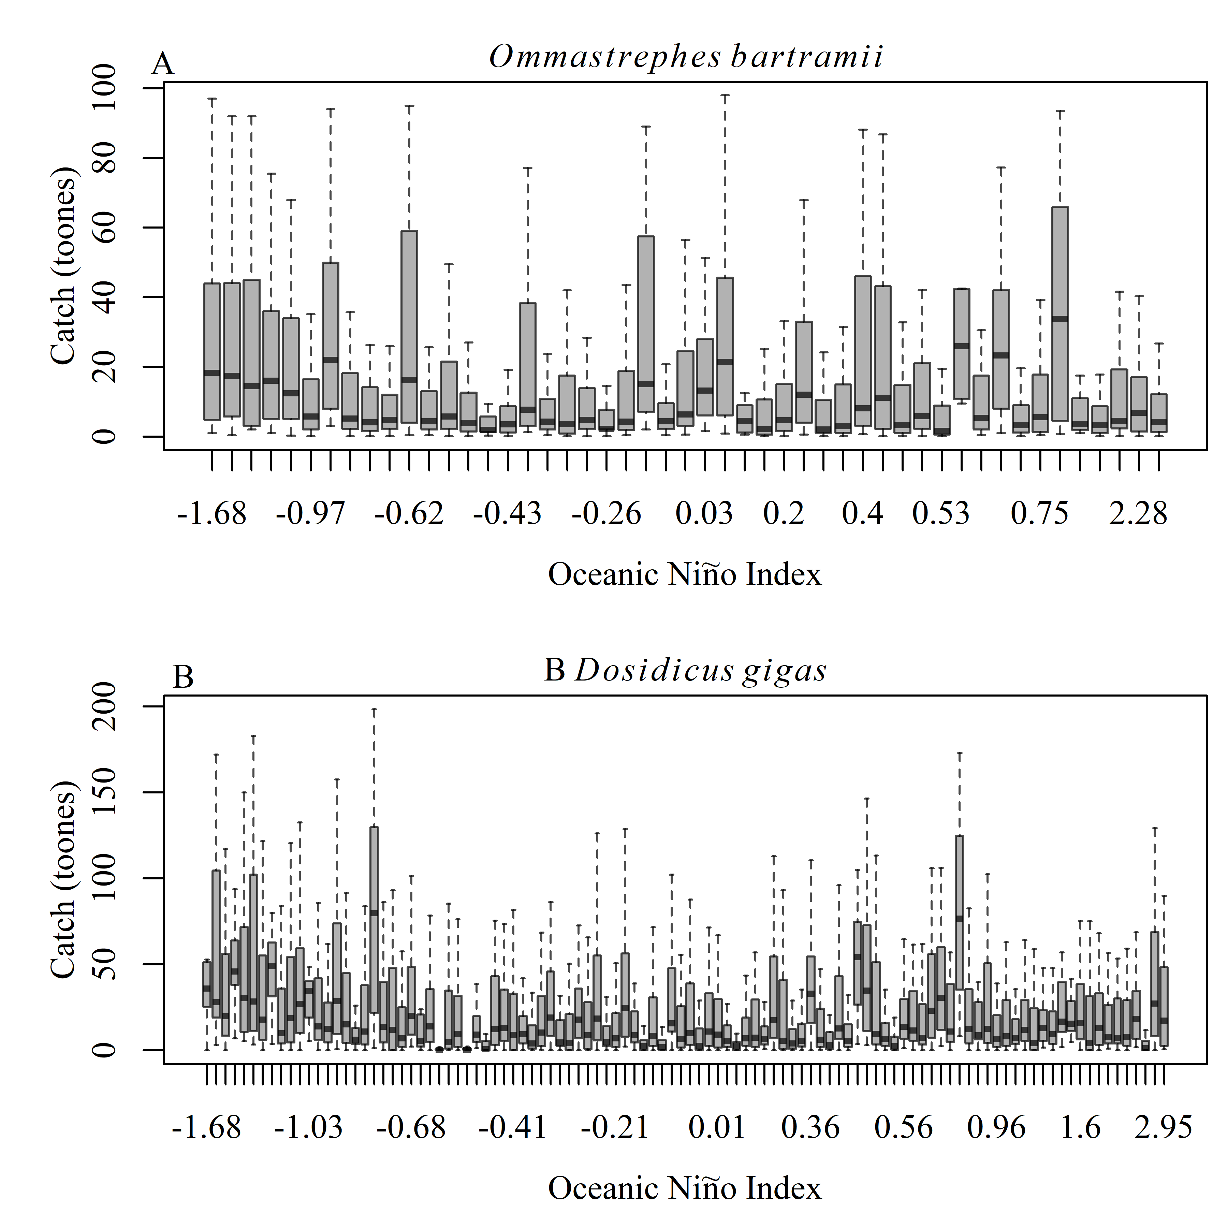
Fig. S2 Boxplot of catch conditional on Oceanic Niño Index.

Methods and results
A set of generalized additive mixed models (GAMMS) were developed with a gamma distribution and log-link including Catch as response variable, Month, Longitude, Latitude, SST, SSS, Chl as fixed random effects, and fONI as random effect for each stock, respectively. Five potential model structures of smoother of each fixed variable were as following²¹. The best model was determined by AIC values.

- ModG: a single common smoother for all observations.
- ModGS: a global smoother plus ONI-level smoothers that have the same wiggliness.
- ModGI: A global smoother plus ONI-level smoothers with different wiggliness.
- ModS: ONI-specific smoothers without a global smoother, but with all smoothers having the same wiggliness.
- ModI: ONI-specific smoothers with different wiggliness.

For each stock, ModG and ModGI have the relative lower AIC values than other models (Table S1). However, the available datasets are not enough for the structure ModGI, especially for “La Liña” and “El Niño” levels. The response curves show strange and are difficult to comprehend biologically in ModGI. Thus, ModG is the final model, and used to hindcast the preferred habitat distribution during 2005 – 2018 for each squid.
Table S1 The summary of GAMM with five model structures for each stock.
Stock |  | O. bartramii in Northwest Pacific Ocean |  |  |  |  | D. gigas in the equatorial waters |  |  |  |  | D. gigas in the offshore of Peru and Chile
GAMMs |  | ModG | ModGS | ModGI | ModS | ModI | ModG | ModGS | ModGI | ModS | ModI | ModG | ModGS | ModGI | ModS | ModI
Smooth terms | s(Month) | * | * | * | * | ** | * | * | * | * | * | *** | *** | *** | *** | ***
Smooth terms | te(Lon, Lat) | *** | *** | *** | *** | *** | *** | *** | *** | *** | *** | *** | *** | *** | *** | ***
Smooth terms | s(SST) | *** | * | * |  |  | * | . | ** |  |  | *** | *** | ***
Smooth terms | s(SST,fONI) |  | ** |  | *** |  |  | ** |  | *** |  |  | * |  | ***
Smooth terms | s(SST):fONI1 |  |  | . |  | ** |  |  | ** |  | ** |  |  |  |  | ***
Smooth terms | s(SST):fONI2 |  |  | * |  | *** |  |  | *** |  | *** |  |  |  |  | ***
Smooth terms | s(SST):fONI3 |  |  | *** |  | *** |  |  |  |  | *** |  |  | . |  | ***
Smooth terms | s(SST):fONI4 |  |  | * |  | *** |  |  |  |  | * |  |  | *** |  | ***
Smooth terms | s(SST):fONI5 |  |  | * |  | *** |  |  |  |  | * |  |  | * |  | .
Smooth terms | s(SSS) | *** |  | . |  |  | *** |  |  |  |  | *** | * | .
Smooth terms | s(SSS,fONI) |  | *** | . | *** |  |  | *** |  | *** |  |  | * |  | ***
Smooth terms | s(SSS):fONI1 |  |  | * |  | * |  |  | . |  | * |  |  |  |  | **
Smooth terms | s(SSS):fONI2 |  |  | ** |  | * |  |  | . |  |  |  |  |  |  | ***
Smooth terms | s(SSS):fONI3 |  |  | . |  | *** |  |  | ** |  | *** |  |  | * |  | ***
Smooth terms | s(SSS):fONI4 |  |  | *** |  | ** |  |  |  |  | ** |  |  | *** |  | ***
Smooth terms | s(SSS):fONI5 |  |  | *** |  | *** |  |  |  |  | * |  |  | ** |  | ***
Smooth terms | s(Chl) | . | . | . |  |  | ** | * | .
Smooth terms | s(Chl,fONI) |  | . |  | . |  |  | *** |  | *** |  | * | ** |  | **
Smooth terms | s(Chl):fONI1 |  |  |  |  | . |  |  | . |  | *
Smooth terms | s(Chl):fONI2 |  |  |  |  |  |  |  | * |  |  |  |  | ** |  | **
Smooth terms | s(Chl):fONI3 |  |  |  |  | . |  |  | ** |  | ** |  |  |  |  | .
Smooth terms | s(Chl):fONI4 |  |  | . |  | * |  |  | *** |  | ***
Smooth terms | s(Chl):fONI5 |  |  | . |  | ** |  |  | *** |  | * |  |  | * |  | .
Smooth terms | s(fONI) | *** |  | *** |  |  | *** |  | *** |  | * | *** |  | *** |  | ***
R² |  | 0.34 | 0.34 | 0.34 | 0.34 | 0.33 | 0.44 | 0.43 | 0.44 | 0.44 | 0.43 | 0.28 | 0.28 | 0.29 | 0.28 | 0.28
Deviance explained |  | 49.6% | 49.0% | 49.6% | 49.0% | 49.5% | 59.0% | 58.1% | 59.1% | 58.2% | 58.7% | 38.6% | 38.1% | 38.7% | 38.4% | 38.6%
AIC |  | 23699 | 23715 | 23697 | 23714 | 23695 | 11796 | 11811 | 11794 | 11809 | 11798 | 55866 | 55912 | 55864 | 55897 | 55872

Significance codes: 0 ‘***’ 0.001 ‘**’ 0.01 ‘*’ 0.05 ‘.’ 0.1 ‘’ 1; no term in the corresponding model.

Fig. S3 Maps of habitat distribution for O. bartramii in the Northwest Pacific Ocean during 2005 – 2018. The area for each subplot is 38° N – 45° N, 145° E – 165° E. The red lines (Scaled Abundance = 0.6) are the contour of suitable habitat area.

Fig. S4 Maps of habitat distribution for D. gigas in the equatorial waters of the Southeast Pacific Ocean during 2005 – 2018. The area for each subplot is 3° N – 5° S, 120° W – 90˚W. The red lines (Scaled Abundance = 0.6) are the contour of suitable habitat area.
Fig. S5 Maps of habitat distribution for D.gigas offshore of Peru and Chile during 2005 – 2018. The area for each subplot is 5° S – 30° S, 90° W – 75˚W. The red lines (Scaled Abundance = 0.6) are the contour of suitable habitat area.

