TITLE: Whole genome analysis of Extensively Drug Resistant Mycobacterium tuberculosis strains in Peru

Authors:
- Elias David Santos Lázaro (edavid.sant@gmail.com) ¹
- Ronnie Gustavo Gavilán Chávez (ronniegavilan@gmail.com) ^{1,3}
- Lely del Rosario Solari Zerpa (lelysol@hotmail.com) ¹
- Aiko Naomi Vigo Tayro (aiko.vt.anvt@gmail.com) ¹
- Zully Margoth Puyén Guerra (zpuyeng@gmail.com) ^{1,2,}*
* Corresponding author

Affiliations:
¹ Instituto Nacional de Salud, Lima, Peru.
² Escuela de Medicina, Universidad Peruana de Ciencias Aplicadas, Lima, Peru.

³ Escuela Profesional de Medicina Humana, Universidad Privada San Juan Bautista, Lima, Peru.

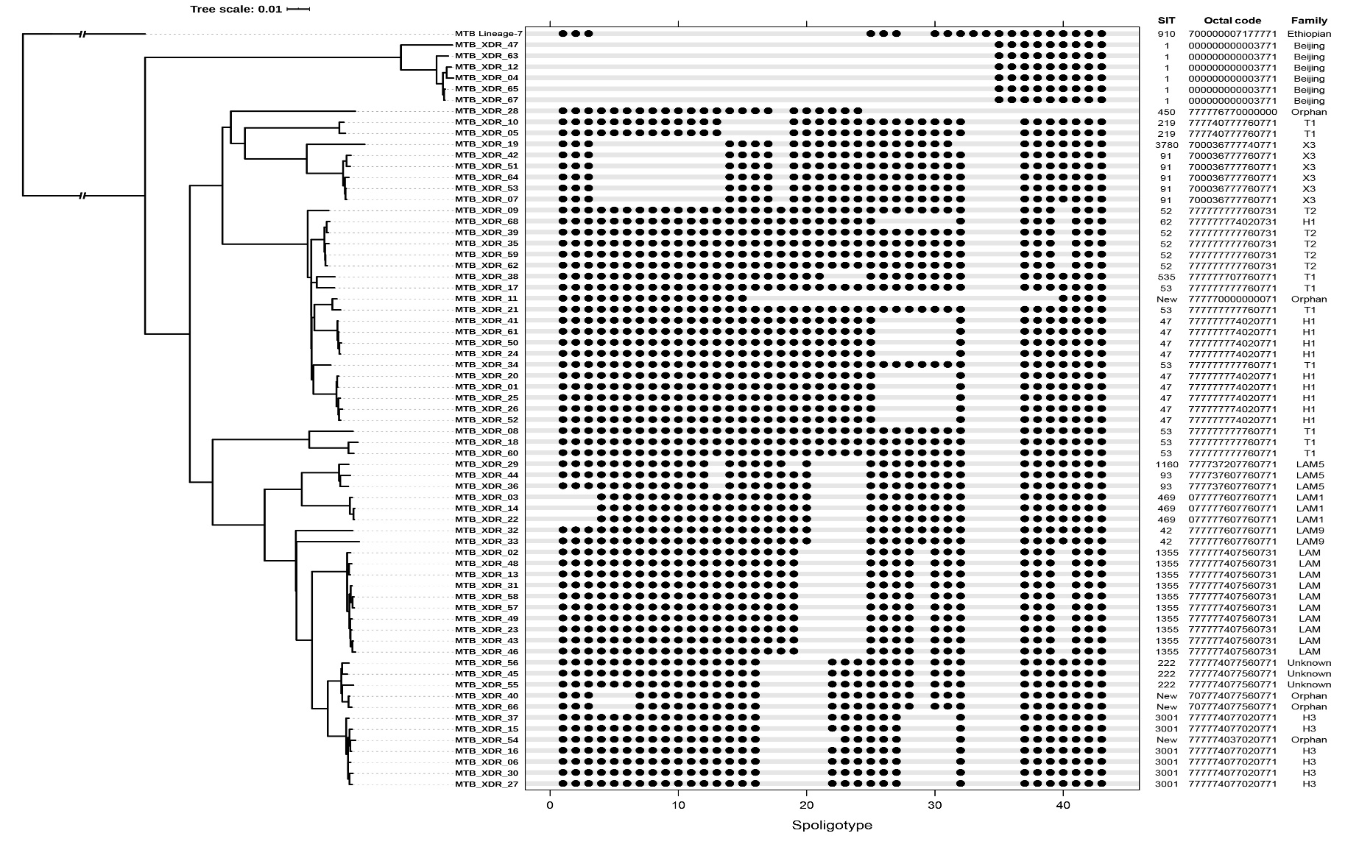
Supplementary Figure S1: in silico spoligotype patterns of Peruvian M. tuberculosis XDR isolates. SITs and families were annotated using the SITVIT2 database. The patterns are correlated with the Maximum likelihood tree previously generated.

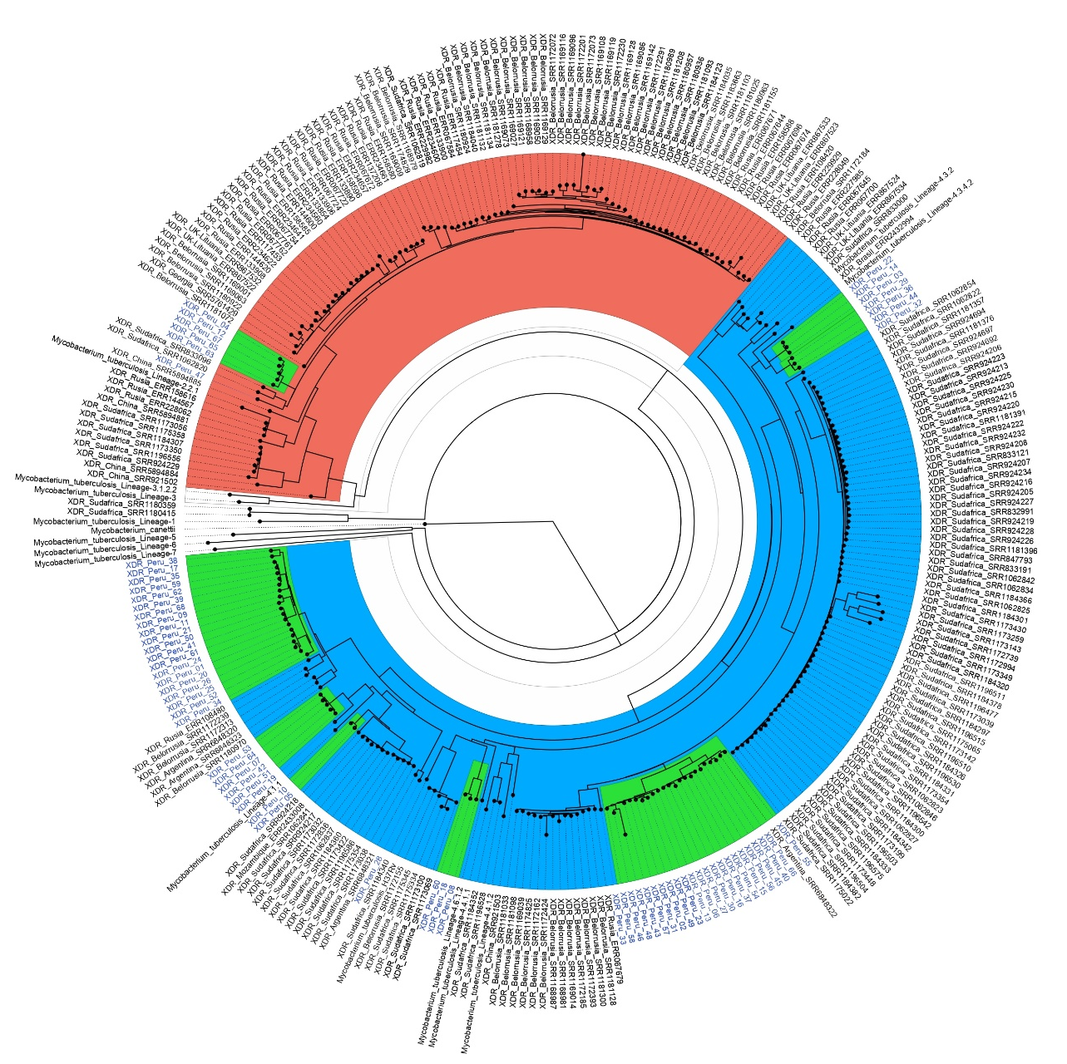

Supplementary Figure S2: global phylogenomic of 289 XDR-TB isolates belonging to South America, Europe, Africa and Asia. The tree was constructed using 16798 SNPs. The preponderance of ‘Lineage 2’ (red background) and ‘Lineage 4’ (blue background) is evident. Clusters containing Peruvian strains are highlighted in green. The tree was rooted at Mycobacterium canettii strain (Genbank, Access number: NC_019950.1).

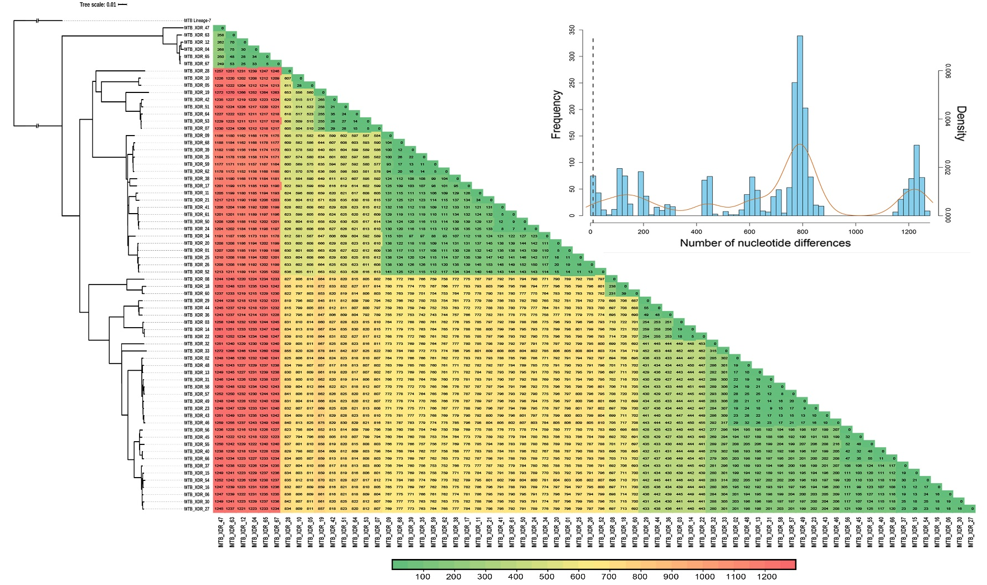
Supplementary Figure S3: Correlation between phylogenetic tree and nucleotide distance matrix of all XDR isolates. The tree generated by RAxML analysis and colour intensities are according to the genetic pairwise distances. At top right is illustrated the histogram of Pairwise distance (Hamming distance). The vertical dotted line indicates a cut point of 10 nucleotides differences.

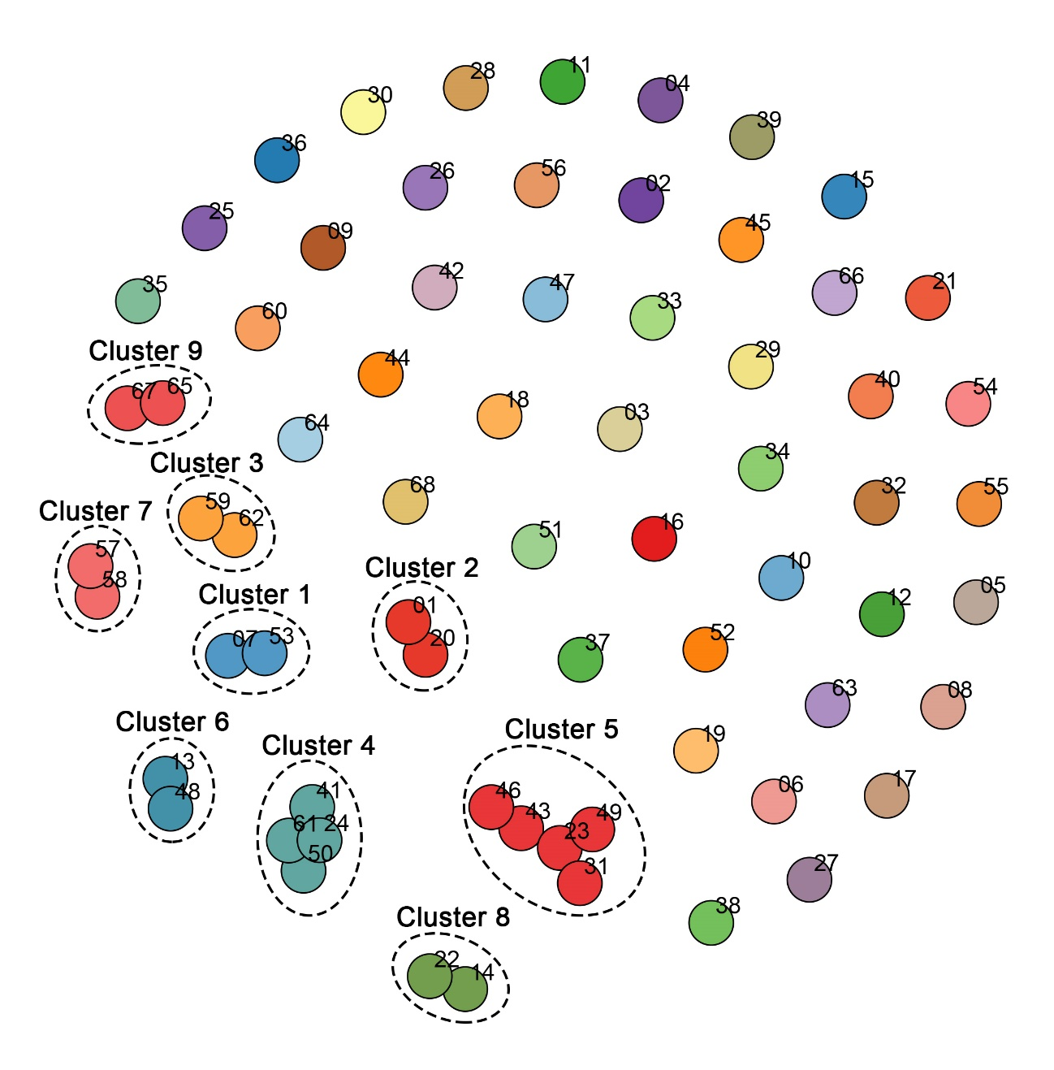
Supplementary Figure S4: Cluster determination of all XDR isolates. Image generated with Gengraph function using a cut off that groups only simples with less than or equal 10 nucleotide differences. Isolates numbering are according “XDR_#” OR “MTB_XDR_#” format (Only the "#" value is showed in the upper right of each node).

