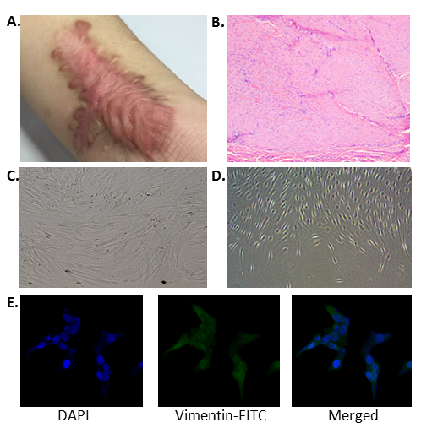
Supplementary Figure 1. (a). Representative pictures of human keloid scar. (b). H&E staining for human keloid (10×). (c). Gross morphology of scar fibroblasts isolated from human keloid (10X). (d). Gross morphology of normal human skin fibroblasts (10X). (e). Immunofluorescence staining of human fibroblast specific protein (Vimentin) (40X).

