Supporting Information
Biodegradable MoSe₂@PVP with multi-enzyme activity ameliorates acute pancreatitis
Pei Xie,^{a,1} Liying Zhang,^{b,1} Hui Shen,^{a,1} Hang Wu,ª Jiulong Zhao,^{a,}* Shige Wang, ^{b} and Lianghao Hu ^{a,}*

Figure S1. (a) SEM of MoSe₂@PVP NPs. (b) Histogram of diameter distribution of MoSe₂@PVP NPs. Dynamic light scattering and Tyndall photographs of MoSe₂@PVP NPs in (c) DMEM, (d) saline, and (e) H₂O.

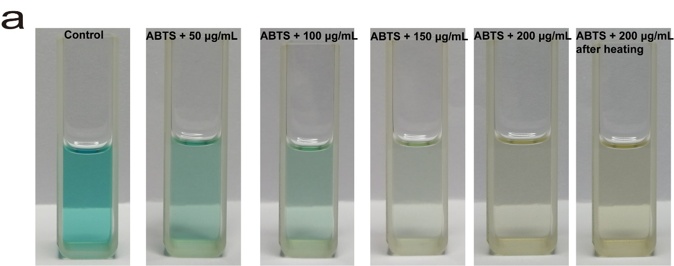
Figure S2. (a) The photographs of scavenging ability of MoSe₂@PVP NPs for ABTS⁺.

Figure S3. (a) Absorbance of the reaction of H₂O₂ in the presence of MoSe₂@PVP NPs (200 μg/mL) with time; (b) Kinetic change at 650 nm of POD-like of MoSe₂@PVP NPs. (c) Kinetic changes at 340 nm of GPx-like of MoSe₂@PVP NPs.
Figure S4. (a-i) Hematological test results of mice after intraperitoneal injection with MoSe₂@PVP NPs.

