Supplemental Materials for

Genetic composition and evolution of the prevalent Mycobacterium tuberculosis lineages 2 and 4 in the Chinese and Zhejiang Province populations
Beibei Wu*, Wenlong Zhu*, Yue Wang, Qi Wang, Lin Zhou, Zhengwei Liu, Lijun Bi, Mathema Barun, Barry N. Kreiswirth, Liang Chen, Songhua Chen, Xiaomeng Wang#, and Weibing Wang#
* These authors contributed equally to this work
# Corresponding authors:
Dr. Xiaomeng Wang
Institute of Tuberculosis Control, Zhejiang Provincial Center for Disease Control and Prevention, 3399 Binsheng Road, Binjiang District, Hangzhou, Zhejiang 310051, China (e-mail: xmwang@cdc.zj.cn)
Dr. Weibing Wang
Department of Epidemiology, School of Public Health & Key Laboratory of Public Health Safety (Ministry of Education), Fudan University, 138 Yi Xue Yuan Road, Shanghai 200032, China (e-mail: wwb@fudan.edu.cn).

This PDF file includes:
Figure S1 to Figure S5
Other supplementary materials for this manuscript include the following:
Table S1 to Table S3 (Excel format files)
Figure S1. Changes of the distribution of Mycobacterium tuberculosis sub-lineages in Zhejiang Province from 1998 to 2013. a) 1998, b) 2003, c) 2008, d) 2013. The size of the circle represents the sample size of the strains.

Figure S2. Phylogenetic tree of Mycobacterium tuberculosis in China.

Figure S3. Phylogenetic tree of Mycobacterium tuberculosis in Zhejiang Province.

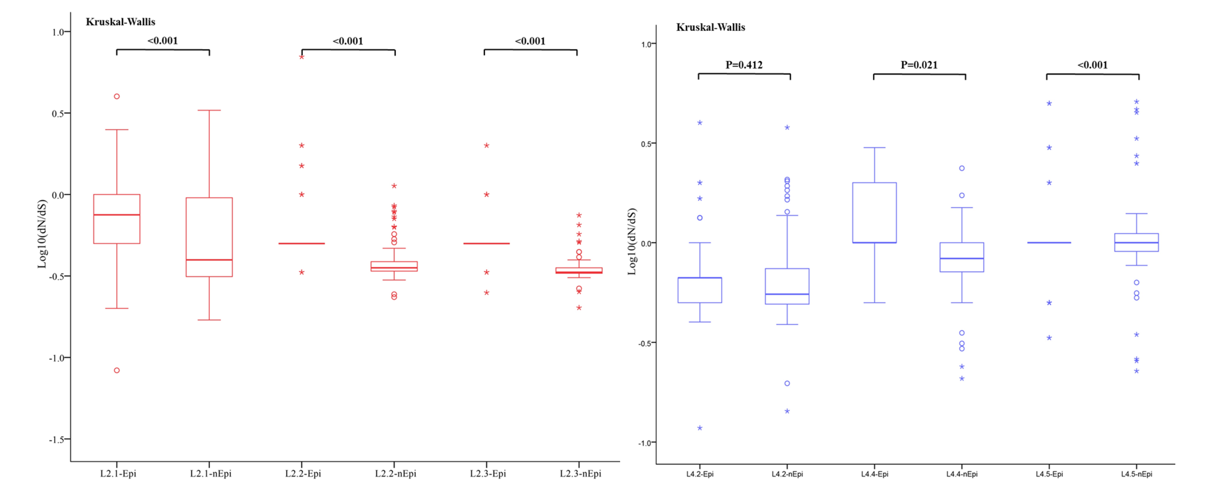
Figure S4. Pairwise ratios of rates of nonsynonymous to synonymous substitutions (dN/dS) in sublineages in lineage 2 and lineage 4 for epitopes and non-epitope regions of T cell antigens.

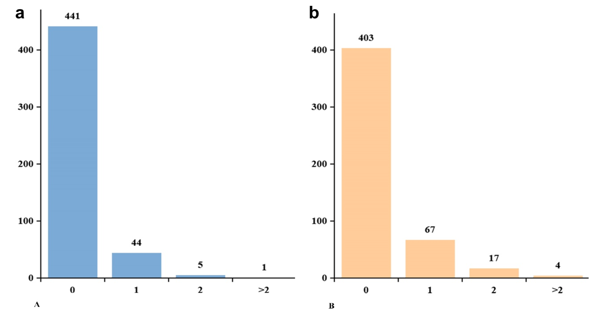
Figure S5. Frequency distribution of the number of epitopes with nonsynonymous variants. A total of 491 T cell epitopes were included in the analysis. The number above each bar corresponds to the epitope count. a) lineage 4, b) lineage 2.

