Supplementary Information for “High critical current density and high-tolerance superconductivity in high-entropy alloy thin films”
Soon-Gil Jung^{1,2,5,}* Yoonseok Han^{1,2,5}, Jin Hee Kim³, Rahmatul Hidayati³, Jong-Soo Rhyee³, Jung Min Lee², Won Nam Kang², Woo Seok Choi², Hye-ran Jeon⁴, Jaekwon Suk⁴, and Tuson Park^{1,2,†}
¹ Center for Quantum Materials and Superconductivity (CQMS), Sungkyunkwan University, Suwon 16419, South Korea
² Department of Physics, Sungkyunkwan University, Suwon 16419, Republic of Korea
³ Department of Applied Physics, Integrated Education Institute for Frontier Science and Technology (BK 21 Four), and Institute of Natural Science, Kyung Hee University, Yongin 17104, Republic of Korea
⁴ Korea Multi-purpose Accelerator Complex, Korea Atomic Energy Research Institute, Gyeongju, Gyeongbuk 38180, Republic of Korea

In this supplement, we present additional data and analyses that support the results presented in the main text.
Table S1. Atomic ratio of Ta–Nb–Hf–Zr–Ti HEA superconducting (SC) thin films. Results obtained from energy dispersive spectroscopy (EDS) for the atomic ratios of Ta–Nb–Hf–Zr–Ti HEA SC thin films fabricated via the pulsed laser deposition (PLD) technique at various substrate temperatures (T_{s}): 270, 370, 470, 520, 570, and 620 ºC. No significant differences were observed among the compositional ratios of the films.
T_{s}  Element | 270 ºC | 370 ºC | 470 ºC | 520 ºC | 570 ºC | 620 ºC
Ti | 11.41 | 12.76 | 13.47 | 10.86 | 11.77 | 12.02
Zr | 14.53 | 14.23 | 12.62 | 11.63 | 14.26 | 14.26
Hf | 17.86 | 17.63 | 17.43 | 18.48 | 18.08 | 16.38
Nb | 36.82 | 36.74 | 36.19 | 38.74 | 36.68 | 37.45
Ta | 19.37 | 18.64 | 20.29 | 20.29 | 19.20 | 19.89

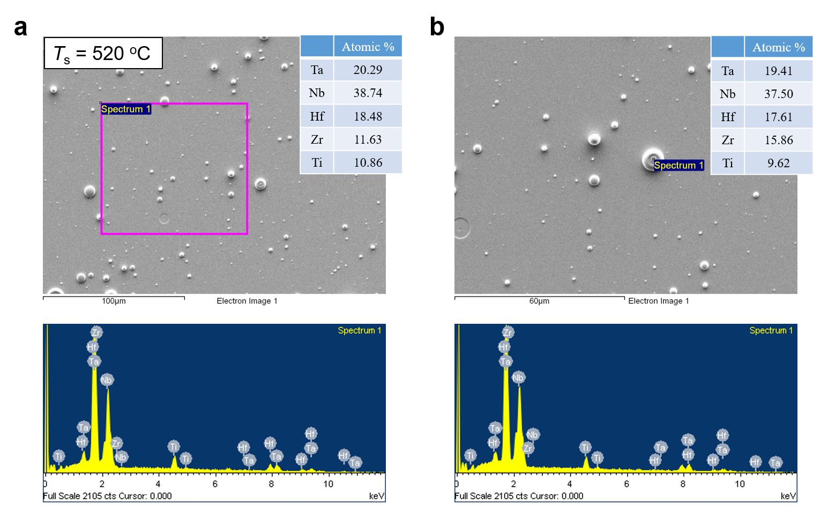
Figure S1. EDS results for Ta–Nb–Hf–Zr–Ti HEA SC thin films. Representative EDS spectra of the Ta–Nb–Hf–Zr–Ti HEA SC thin films fabricated at the optimal T_{s} = 520 ºC for (a) a large area and (b) a droplet region. The difference in atomic ratios between the large area and the droplet region is negligible.

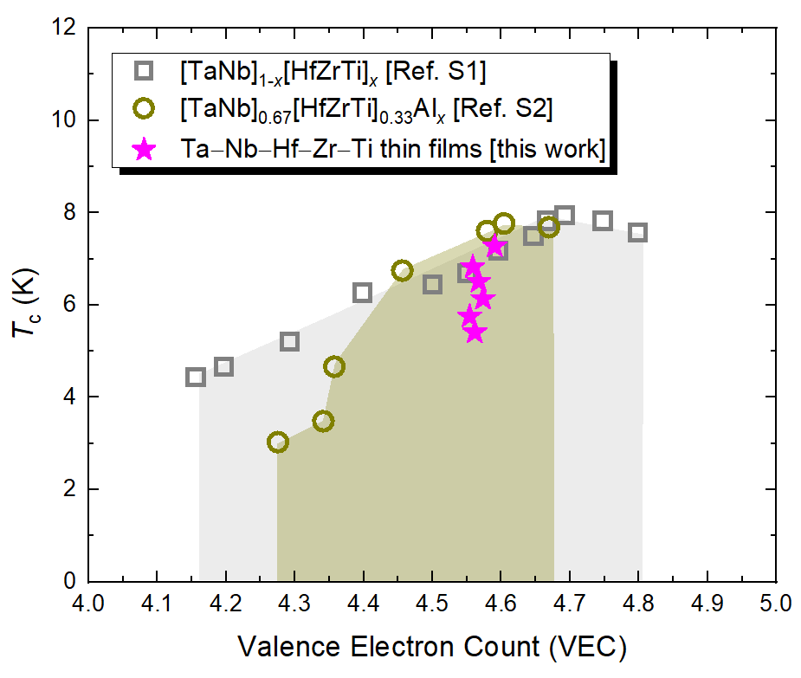
Figure S2. SC transition temperature (T_{c}) with respect to the valence electron count (VEC) for Ta–Nb–Hf–Zr-Ti HEA superconductors. The range of VEC values, i.e., electrons per atom (e/a, d-electron), for the Ta–Nb–Hf–Zr–Ti HEA SC thin films was 4.55–4.59, which is close to the optimal VEC for the highest T_{c} in HEA superconductors with a bcc structure [S1–S3], although their T_{c} values are different. This result indicates that the substrate temperature T_{s} is one of the critical parameters for fabricating high-quality HEA SC thin films. The VEC value represents the average of the number of valence electrons for the constituent atoms that compose the alloy. For example, the number of valence electrons is 5 and 4 for (Ta, Nb) and (Hf, Zr, Ti), respectively. Here, the VEC value of the Ta–Nb–Hf–Zr–Ti HEA SC thin films was determined using the EDS results in Table S1.

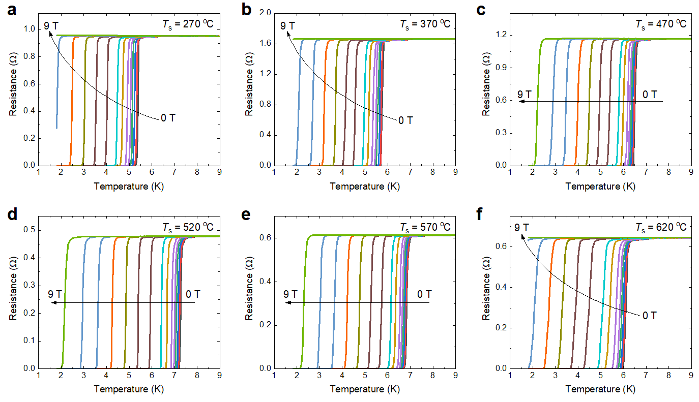
Figure S3. Temperature dependence of electrical resistance in a magnetic fields for Ta–Nb–Hf–Zr–Ti HEA SC thin films. a–f, Electrical resistance as a function of temperature at magnetic fields from 0 to 9 T for the HEA SC thin films fabricated at T_{s} = 270, 370, 470, 520, 570, and 620 ºC. H_{c2}(T) was obtained using the criterion of T_{cR}, namely 50% transition of the resistance at the T_{c} onset for each magnetic field.
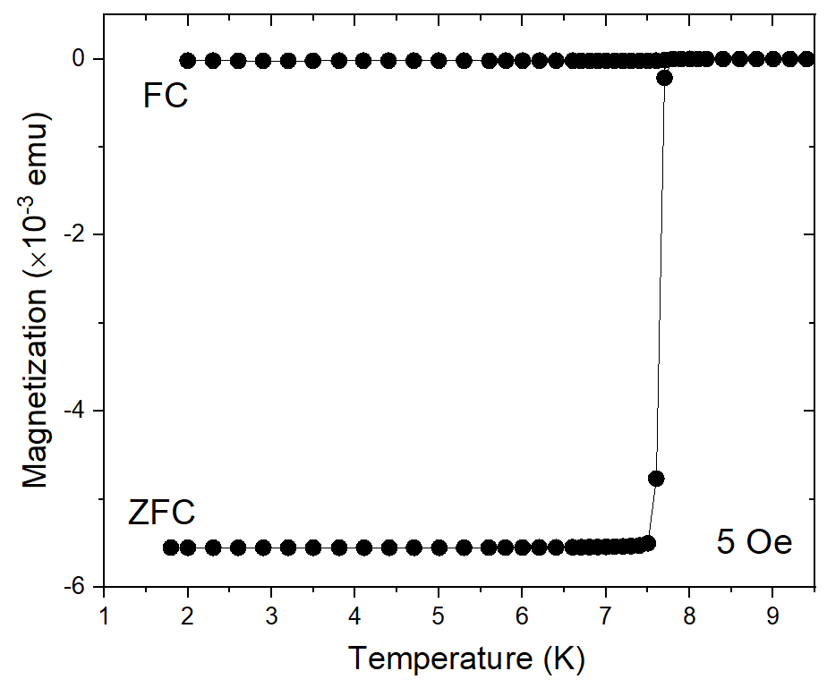
Figure S4. Temperature dependence of magnetization for the HEA target. Zero-field-cooled (ZFC) and field-cooled (FC) dc magnetization (M) of Ta_{1/6}Nb_{2/6}Hf_{1/6}Zr_{1/6}Ti_{1/6} HEA superconductors used as the target for growing HEA SC thin films displayed as a function of temperature. A very sharp SC transition is observed in the ZFC M(T) curve with T_{cM} of 7.8 K.
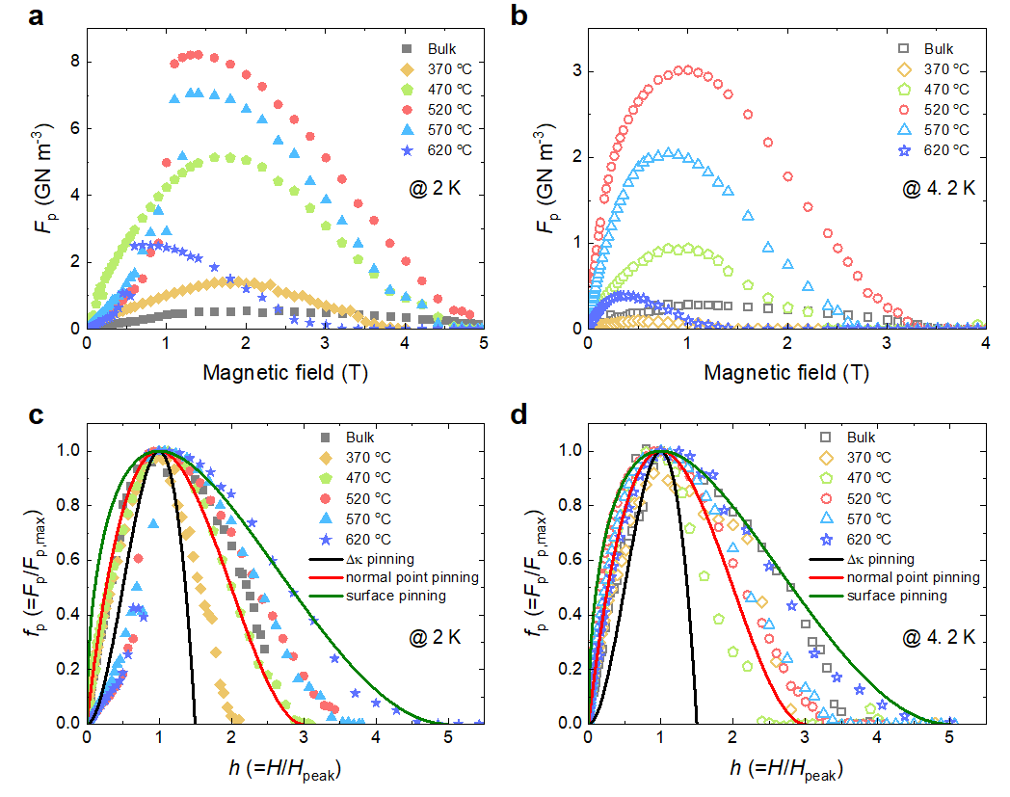
Figure S5. Flux pinning force density of Ta–Nb–Hf–Zr–Ti HEA SC thin films. Magnetic field dependence of the volume flux pinning force density (F_{p} = J_{c} × μ₀H) for the HEA SC bulk and thin films at (a) 2.0 K and (b) 4.2 K. The maximum F_{p} (F_{p,max}) values of the film deposited at the optimal T_{s} = 520 ºC are 8.22 and 3.02 GN m⁻³ at 2.0 and 4.2 K, which are 14.7 and 10.4 times higher than that of the bulk sample, respectively. c, d, Normalized flux pinning force density (F_{p}/F_{p,max}) as a function of the reduced magnetic field (H/H_{peak}) at 2.0 and 4.2 K, respectively, where H_{peak} represents the magnetic field at F_{p,max}. The flux pinning mechanism of most of the films is close to normal point pinning, indicating that the intrinsic disorder associated with the different atomic sizes of the constituent atoms in HEAs plays an important role in the field performance of J_{c} in HEA superconductors. The solid lines were plotted using the equations f_{p}(h) = 3h²(1-2h/3), (9/4)h(1-h/3)², and (25/16)h^{1/2}(1-h/5)² for Δκ-pinning, normal point pinning, and surface pinning, respectively, where κ is the Ginzburg–Landau parameter [S4–S6].
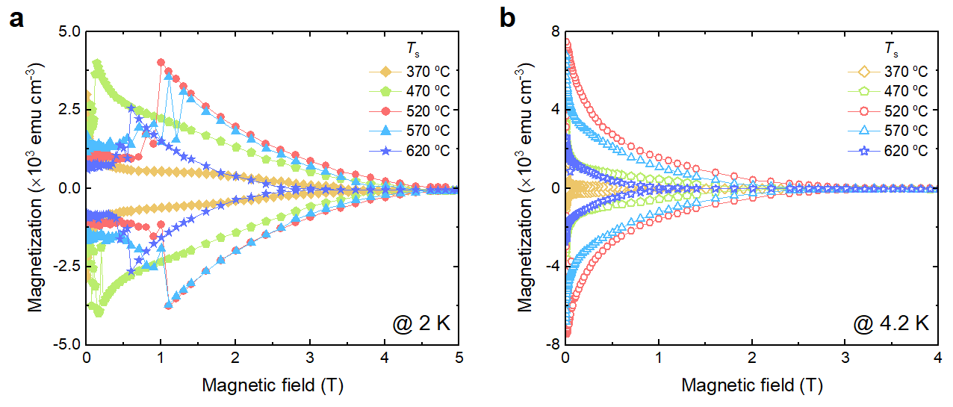
Figure S6. Magnetization hysteresis loops for Ta–Nb–Hf–Zr–Ti HEA SC thin films. Magnetic field–magnetization (M–H) hysteresis loops of Ta–Nb–Hf–Zr–Ti HEA SC thin films at (a) 2.0 K and (b) 4.2 K. A large flux jump was observed at 2.0 K for the HEA SC thin films with a relatively higher T_{c}, which resulted in a smaller low-field J_{c} compared with that at 4.2 K. The flux jump is attributed to thermomagnetic instability [S7, S8]; thus, the J_{c} value of an HEA SC thin film can be increased by reducing the thermal instability.
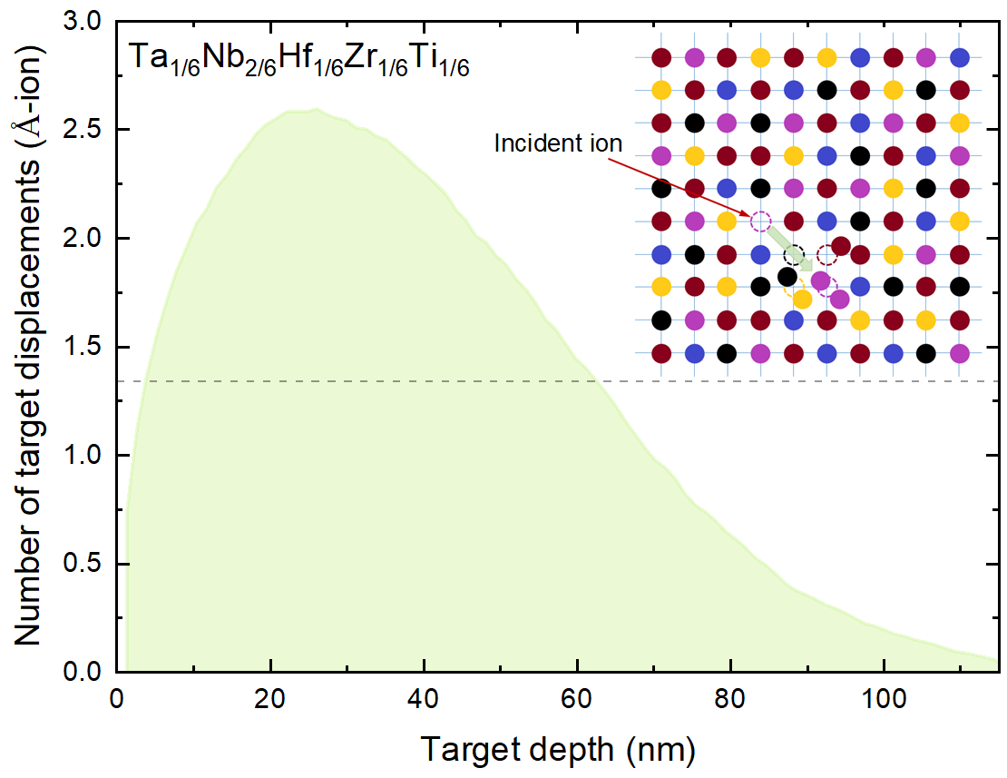
Figure S7. Displacements simulated by the Stopping and Range of Ions in Matter (SRIM) software for 200-keV Kr-ion-irradiated Ta_{1/6}Nb_{2/6}Hf_{1/6}Zr_{1/6}Ti_{1/6}. SRIM simulation result for the number of displacements produced by 200-keV Kr-ion irradiation for a Ta_{1/6}Nb_{2/6}Hf_{1/6}Zr_{1/6}Ti_{1/6} HEA (with a mass density of 9.9 g cm⁻³ and an atomic density of ρ_{HEA} = 5.226 × 10²² atoms cm⁻³). The dpa value was obtained as follows:
$\frac{displacements}{ions×Å}×\frac{{10}^{8}(Å/cm)×dose(ions/{cm}^{2})}{ρ_{HEA}(\frac{atoms}{{cm}^{3}})}=\frac{displacements}{atom}=dpa$.
Here, the dpa values were evaluated using the average number of displacements (1.34 Å-ion), which is indicated by the dashed line. The doses of 1.5 × 10¹⁴, 5 × 10¹⁴, 1 × 10¹⁵, 3 × 10¹⁵, 5 × 10¹⁵, 7 × 10¹⁵, 1 × 10¹⁶, and 3 × 10¹⁶ Kr ions cm⁻² corresponded to dpa values of 0.38, 1.28, 2.56, 7.69, 12.82, 17.95, 25.64, and 76.92, respectively. The dpa value reflects the level of displacement damage generated by irradiation, and dpa = 0.01 indicates that 1% of target atoms were displaced from their lattice sites by irradiation. Inset is a simple illustration showing an example corresponding to dpa = 0.05.
Supplementary References
[S1] von Rohr, F. O., Winiarski, M. J., Tao, J., Klimczuk, T. & Cava, R. J., Effect of electron count and chemical complexity in the Ta–Nb–Hf–Zr–Ti high-entropy alloy superconductor. PNAS 113, E7144–E7150 (2016).
[S2] von Rohr, F. O. & Cava, R. J., Isoelectronic substitutions and aluminium alloying in the Ta–Nb–Hf–Zr–Ti high-entropy alloy superconductor. Phys. Rev. Mater. 2, 034801 (2018).
[S3] Sun, L. & Cava, R. J., High-entropy alloy superconductors: Status, opportunities, and challenges. Phys. Rev. Mater. 3, 090301 (2019).
[S4] Dew-Hughes, D., Flux pinning mechanisms in type II superconductors. Philos. Mag. 30, 293–305 (1974).
[S5] Higuchi, T., Yoo, S. I. & Murakami, M., Comparative study of critical current densities and flux pinning among a flux-grown NdBa₂Cu₃O_{y} single crystal, melt-textured Nd–Ba–Cu–O, and Y–Ba–Cu–O bulks. Phys. Rev. B 59, 1514–1527 (1999).
[S6] Jung, S. –G., Pham, D., Han, Y., Lee, J. M., Kang, W. N., Kim, C., Yeo, S., Jun, B. –H. & Park, T., Improvement of bulk superconducting current capability of MgB₂ films using surface degradation. Scr. Mater. 209, 114424 (2022).
[S7] Choi, E. –M., Lee, H. –S., Kim, H. –J., Lee, S. –I., Kim, H. –J. & Kang, W. N., Enhancement at low temperatures of the critical current density for Au-coated MgB₂ thin films. Appl. Phys. Lett. 84, 82–84 (2004).
[S8] Mints, R. G. & Brandt, E. H., Flux jumping in thin films. Phys. Rev. B 54, 12421–12426 (1996).

