a
b

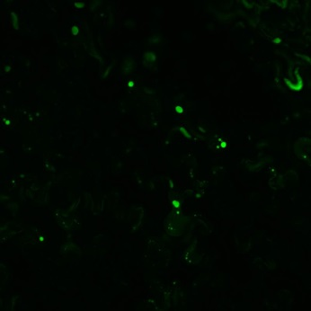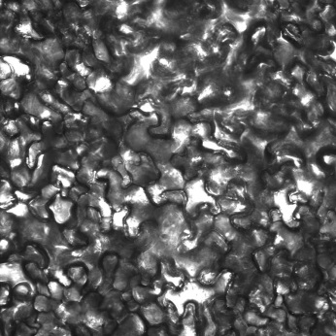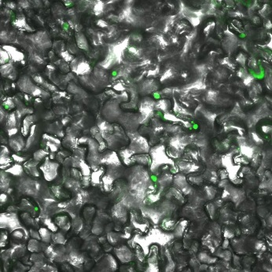
GFP Bright field Merged

Supplementary Fig. 1 a MeMYB108 encodes a MYB transcription factor. Phylogenetic analysis of the MYB transcription factors of Arabidopsis and cassava. Eighbor-joining phylogeny of MYB genes of 2 species, as determined by MEGA5.0. Numbers on branches are bootstrap proportions from 1000 replicates. The Red box shows MeMYB108. b Subcellular localization of MeMYB108 in tobacco epidermal cells.

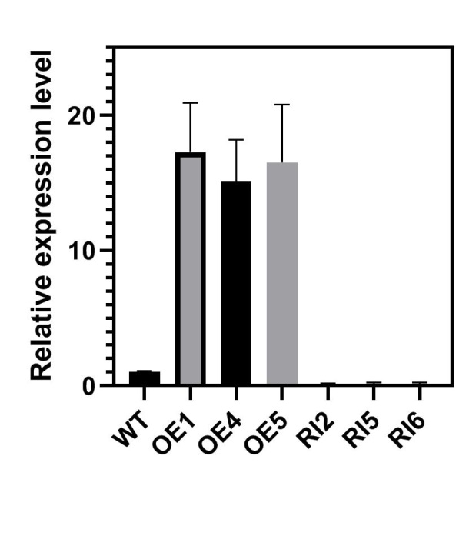
Supplementary Fig. 2 The expression levels of MeMYB108 in wildtype, overexpression lines (OE1, OE4, OE5) and MeMYB108-RNA interference lines (RI2, RI5, RI6) were analyzed by RT-qPCR. Error bars indicate the SE based on three technical replicates. Two transgenic lines OE1 and OE5, and two RNA interference transgenic lines RI2 and RI6 were selected for futher analysis.

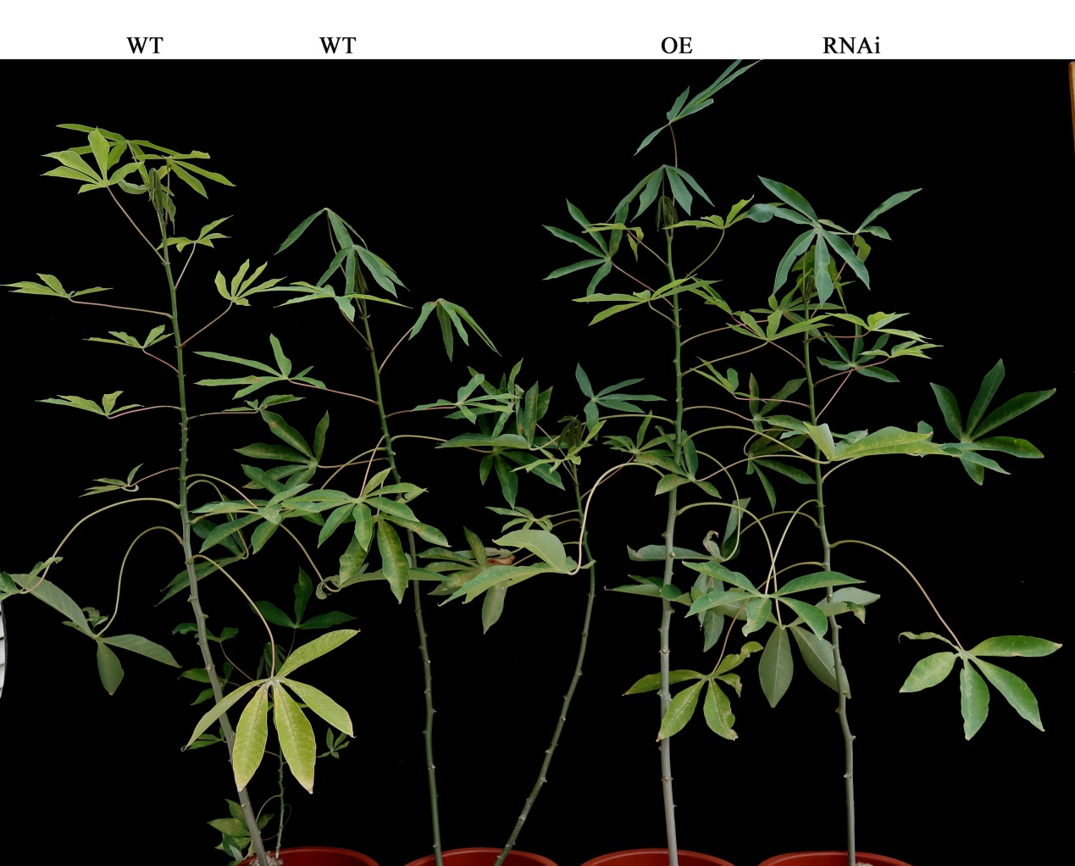
Supplementary Fig. 3 Phenotype of WT, MeMYB108-OE and MeMYB108-RNAi plants under the same normal growth conditions

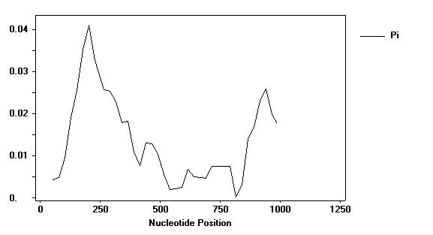
Supplementary Fig. 4 Nucleotide diversity of MeMYB108 by sliding windows analysis.
The DNA nucleotide diversity was analyzed by sliding window with a window size of 100bp and a step size of 25bp using DnaSP5 software

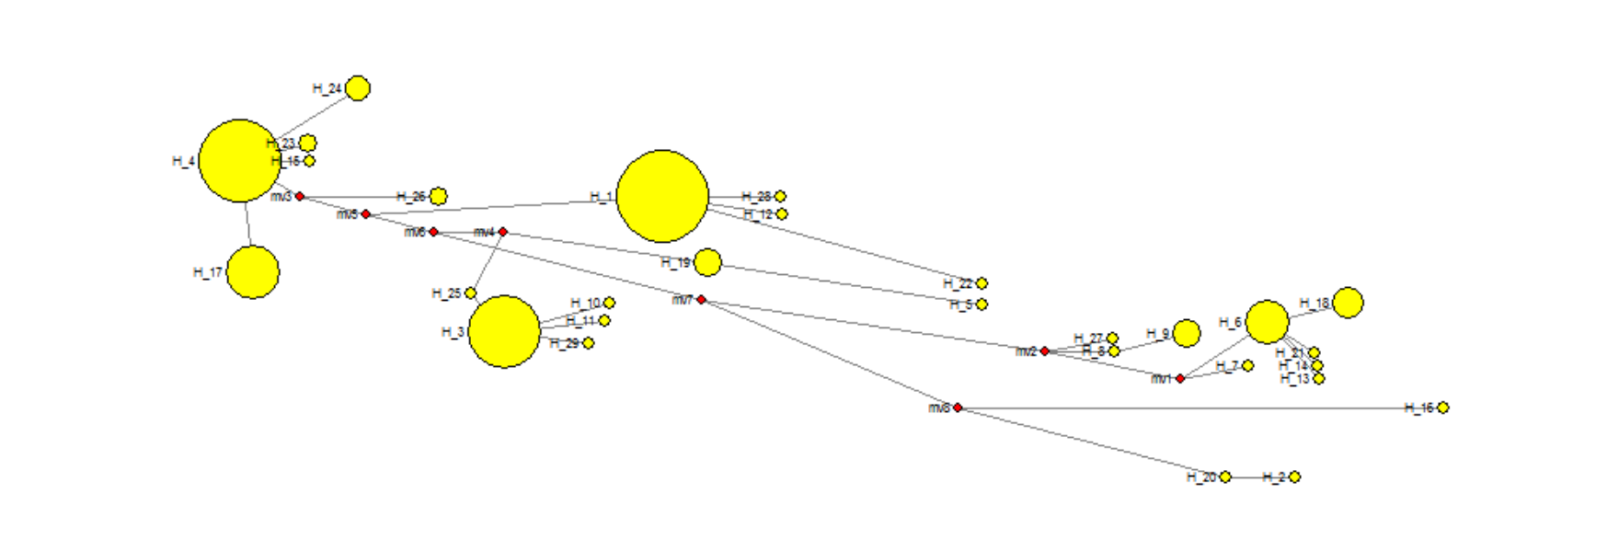
Supplementary Fig. 5 Haplotype networks of MeMYB91 exons.
The exon region of the MeMYB108 gene includes 29 haplotypes and 7 major haplotypes.

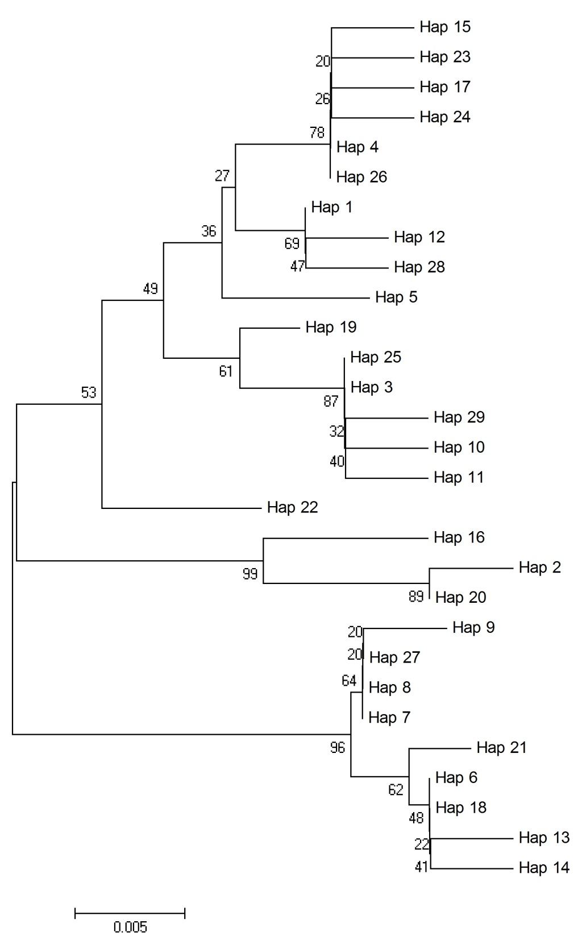
Supplementary Fig.6 Haplotypes phylogenetic tree of MeMYB108 exons. Neighbor-joining phylogenetic analysis is shown for the MeMYB108 exons. The phylogenetic tree was constructed using the ClustalW and MEGA programs. Tree topology with bootstrap support is based on a percentage of 1,000 replicates. Those numbers on the nodes are bootstrap percentages, indicating the reliability of the cluster descending from that node. All of these haplotypes can be divided into two categories.

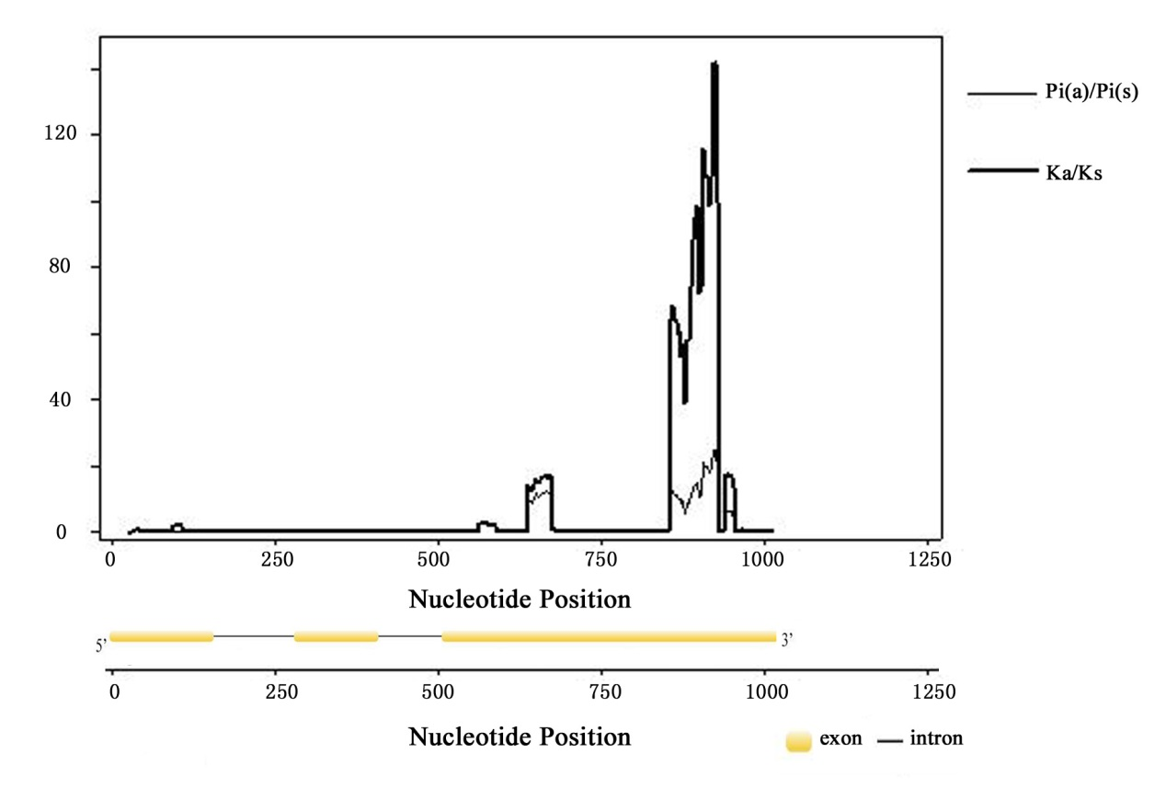
Exon 3
Exon 2
Exon 1
Supplementary Fig.7 Ka/Ks analysis of two cluster exon haplotypes of MeMYB108 by sliding windows method. Positive selection was indicated in the third exon region.
Note：Nucleotide position means the location which was relative to the first nucleotide A of the start codon.

31465734 | 31465762 | 31465765 | 31465773 | 31465774 | 31465804
S1 | S2 | S3 | S4 | S5 | S6 | Frequency
G | G | C | G | G | G | 0.853
A | A | A | T | T | A | 0.134
A | G | C | T | T | G | 0.013

Supplementary Fig. 8 Phylogenetic tree of MeMYB108 in 97 varieties constructed based on seven SNPs (S1–S6).
Six SNPs, SNP1_31465734, SNP1_31465773, SNP1_31465774, SNP1_31465762, SNP1_31465765 and SNP1_31465804, were significantly associated with CAT under leaf abscission induced by drought. The NJ cluster tree of 97 cassava varieties/lines was constructed based on the six SNPs, and 97 cassava accessions were divided into two groups. There was significant linkage disequilibrium among the six SNPs.

