SUPPLEMENTARY INFORMATION

Mercury in soil, sediment, and lake water in upland headwater catchments in Ireland

Sarah A.M. Nelson*, Holger Hintelmann, & Julian Aherne
Environmental and Life Science, Trent University, Peterborough, Ontario, Canada K9L 0G2
* sanelson@trentu.ca

A: Equations
Total Hg (THg) in catchment soil was quantified as soil THg pool, using the bulk density measurements:
$$\frac{ng THg}{g soil}×\frac{g soil}{{cm}^{3}}×\frac{10 cm depth}{1}×\frac{1 µg}{1000 ng}×\frac{10 000 {cm}^{2}}{1 m^{2}}=\frac{µg THg}{m^{2}}$$

Total Hg normalised by organic carbon (THg/OC) in water was calculated as:
$$\frac{ng THg}{L water}×\frac{1 mg}{1 000 000 ng}=\frac{mg THg}{L water}$$

$$\frac{mg THg}{L water}÷\frac{mg DOC}{L water}=\frac{mg THg}{L water}×\frac{L water}{mg DOC}=\frac{mg THg}{mg DOC}$$

$$\frac{mg THg}{mg DOC}×\frac{1 000 000 mg}{1 kg}=\frac{mg THg}{kg DOC}$$

Total Hg normalised by organic carbon (THg/OC) in sediment and soil was calculated using the widely used ‘van Bemmelen factor’ to convert percent organic matter to organic carbon (Wolff, 1864; van Bemmelen, 1890):

$$\left(\%OM÷1.72\right)×10=\frac{mg OC}{g soil}$$

$$\frac{ng THg}{g soil}÷\frac{mg C}{g soil}=\frac{ng THg}{g soil}×\frac{g soil}{mg OC}=\frac{ng THg}{mg OC}$$

$$\frac{ng THg}{mg OC}×\frac{1 000 000 mg}{1 kg}×\frac{1 mg}{1 000 000 ng}=\frac{mg THg}{kg OC}$$

The Normalized Median Absolute Deviation (NMAD) was calculated as:

$$Median \left[ABS\left(x_{1}-y\right), ABS\left(x_{2}-y\right)…ABS(x_{31}-y)\right] ÷y ×100\%$$

where ABS is absolute value, x is the individual value of the variable of interest, and y is the median of the variable of interest. Note: Variability in pH was calculated using concentration of H⁺ ion because NMAD underestimated the variability of pH when using pH units, due to the logged scale and finite range of values.

References:
Van Bemmelen, J.M. (1890). Über die Bestimmung des Wassers, des Humus, des Schwefels, der in den colloïdalen Silikaten gebundenen Kieselsäure, des Mangans usw im Ackerboden. Die Landwirthschaftlichen Versuchs-Stationen, 37(279).

Wolff, E. (1864). Entwurf zur bodenanalyse. Zeitschrift für analytische Chemie, 3(1), 85–115.

B: Additional data to support results

Table SI-1: Physical and climate characteristics of upland lake catchments (n=31) sampled during April–July 2017 and 2018 in the Republic of Ireland. Note: NMAD=Normalized Median Absolute Deviation.
 | Units | Min–Max | Median | NMAD (%)
Site Characteristics
Elevation | masl | 247–712 | 476 | 25
Lake Surface Area | ha | 0.12–13 | 1.6 | 51
Catchment Area | ha | 0.56–65 | 11 | 87
Lake:Catchment |  | 0.03–0.5 | 0.17 | 52
Solar Radiation | kJ/m²/d | 8444–9507 | 9021 | 3
Air Temperature | °C | 5.5–9.1 | 7.4 | 11
Precipitation | m/yr | 1.3–3.4 | 2.1 | 15
Soil Moisture | m³/m³ | 0.4–0.9 | 0.5 | 19
Peatland Coverage | % | 0–100 | 100 | 0¹
¹ Due to limited data variation, and half the upland lakes having a peatland coverage of 100%, NMAD (%) was 0.

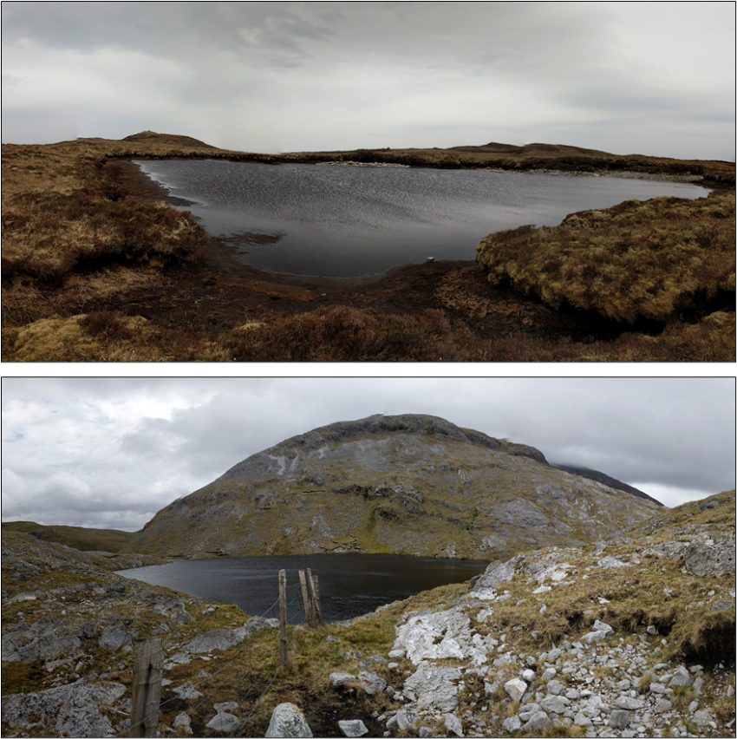
Fig. SI-1 Photograph of two of the 31 upland lakes sampled during April–July 2017 and 2018 in the Republic of Ireland. The lake catchments varied between peat bog (upper) and rocky terrain (lower), with the southern sites tending to have more exposed rock.

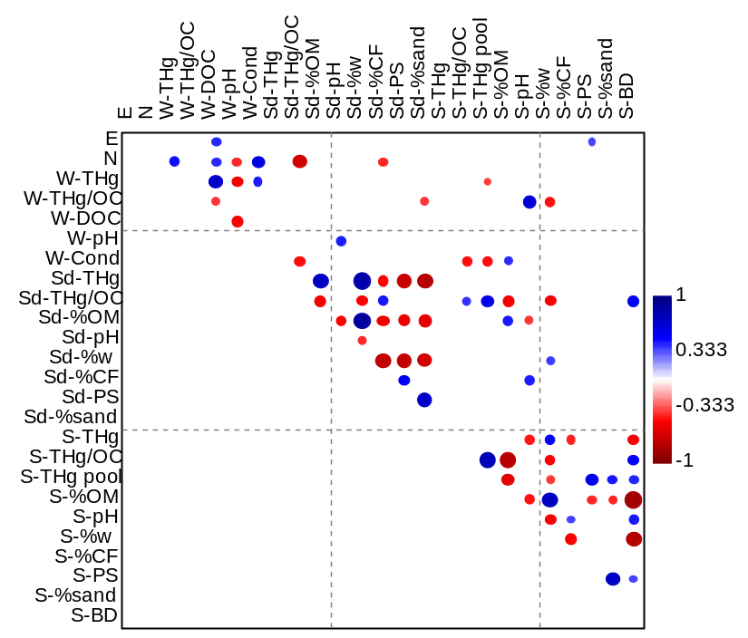

Fig. SI-2 Spearman rank correlations in upland lake water, sediment, and catchment soil (n=31) in the Republic of Ireland, sampled during April–July 2017 and 2018. Note: W indicates water chemistry parameter, Se indicates lake sediment, S indicates catchment soil, E=easting, N=northing, THg=total mercury, THg/OC=total mercury normalized by organic carbon, DOC=dissolved organic carbon, %w=sample moisture, CF=coarse fragments, %OM=organic matter, PS= particle size geometric mean, BD=bulk density.

THg-Water | THg-Sediment | THg-Soil
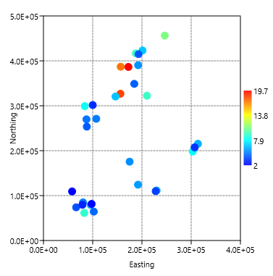 | 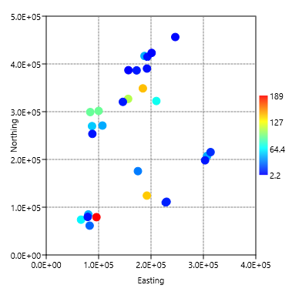 | 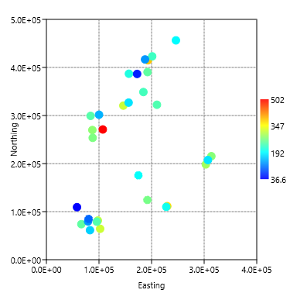
THg/OC-Water | THg/OC-Sediment | THg/OC-Soil
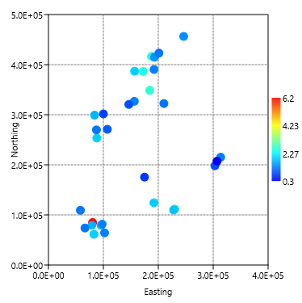 | 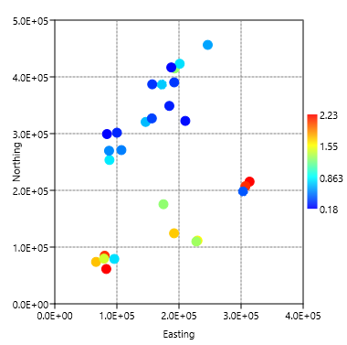 | 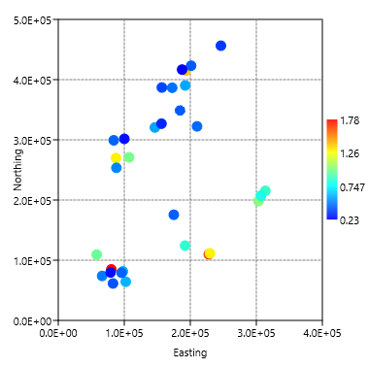
DOC-Water | %OM-Sediment | %OM-Soil
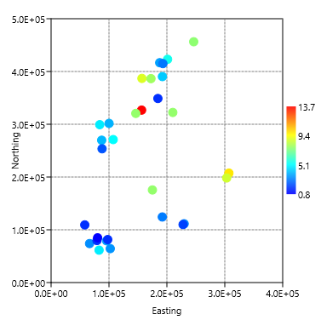 | 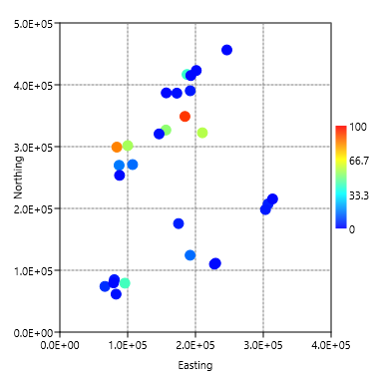 | 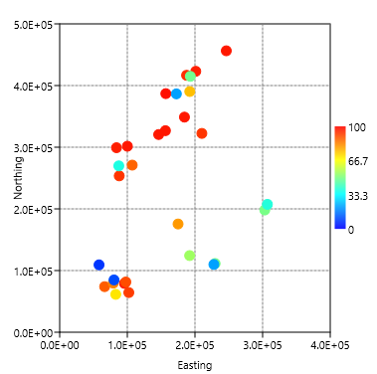
Fig. SI-3 Bubble plots sowing the regional patterns of total mercury (THg; ng/L), total mercury normalized by organic carbon (THg/OC; mg/kg), and organic carbon (or matter) content in water, sediment, and soil (n=31) in upland lakes in the Republic of Ireland, sampled during April–July 2017 and 2018. Organic content quantified as dissolved organic carbon (DOC; mg/L) in water, and percent organic matter by weight (%OM) for soil and sediment.

