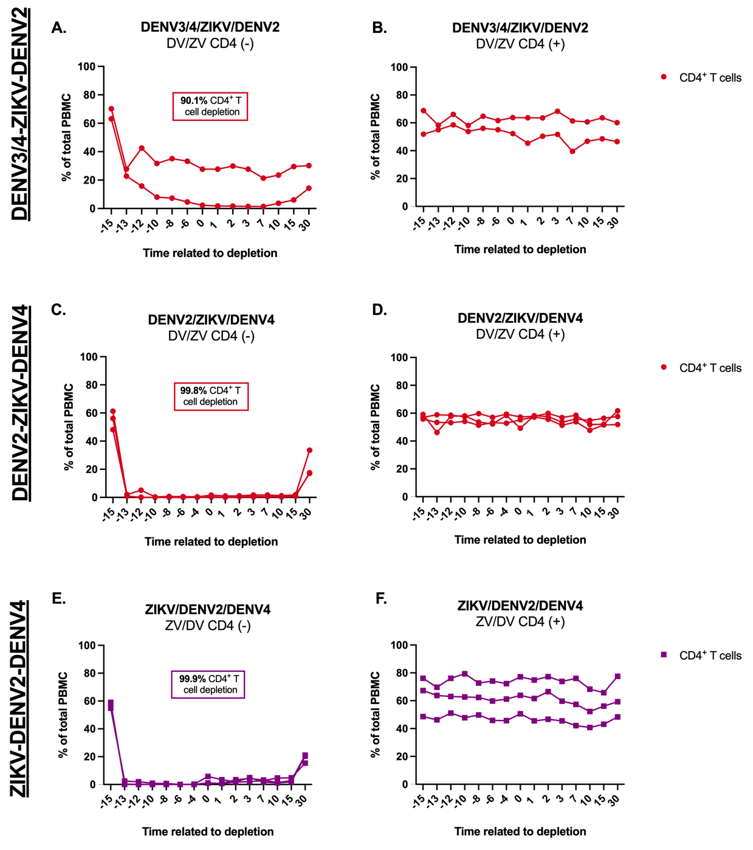

S1 Figure. CD4⁺ T cell depletion dynamic. Frequency of CD4⁺ T cells before and after depletion treatment were assessed by immunophenotyping using flow cytometry during pre-treatment and post-infection. Depletion efficacy for depleted and non-depleted animals from the (A-B) DENV3/4-ZIKV-DENV2 infection sequence (C-D) DENV2-ZIKV-DENV4 infection sequence and (E-F) ZIKV-DENV2-DENV4 infection sequence.

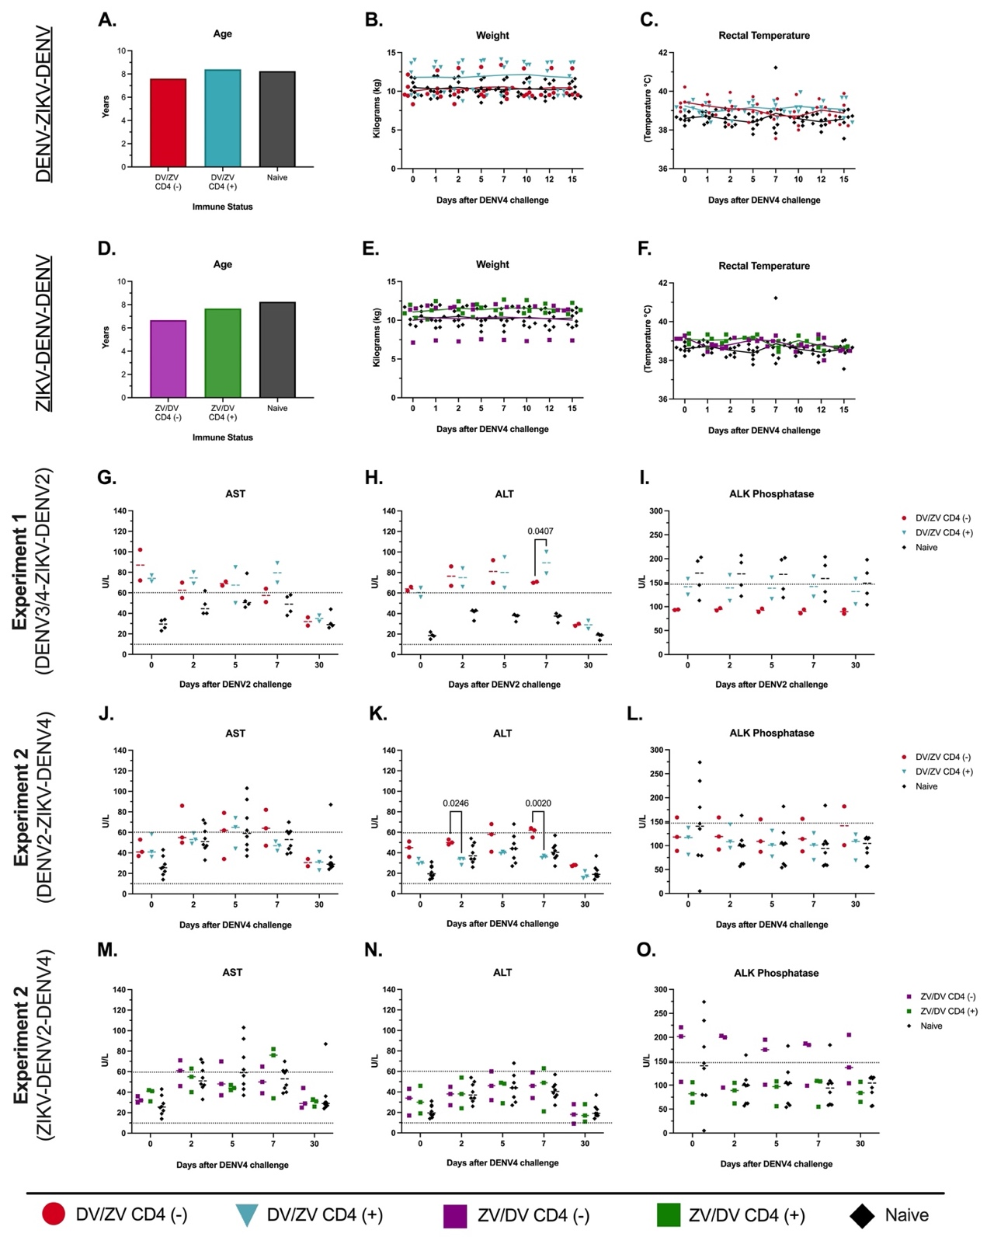

S2 Figure. Clinical status and vital signs kinetics in flavivirus-immune and naïve macaques. Animals depleted of CD4⁺ T cells are shown in red (DENV-primed) and purple (ZIKV-primed), DENV and ZIKV immune-competent are shown in blue and green, and flavivirus-naïve animals are shown in black in all panels. (A & D) Average age of the animals used per infection sequence. (B & E). Weight (kg) was measured at baseline, 1, 2, 5, 7, 10, 12, and 15 pi. (C & F) Rectal temperature (°C) was monitored at baseline,1, 2, 5, 7, 10, 12, and 15 pi. Comprehensive metabolic panel (CMP) was performed to assess levels (U/L) of liver enzymes (J & M) aspartate transaminase (AST), and (K & N) alanine transaminase (ALT), and (L & O) alkaline phosphatase (ALK Phosphatase) at baseline, 2, 5, 7 and 30 pi. Normal range of AST, ALT, and ALK Phosphatase are depicted for reference. Statistically significant differences between groups were determined using Two-Way Anova adjusted for Tukey’s multiple comparisons test.
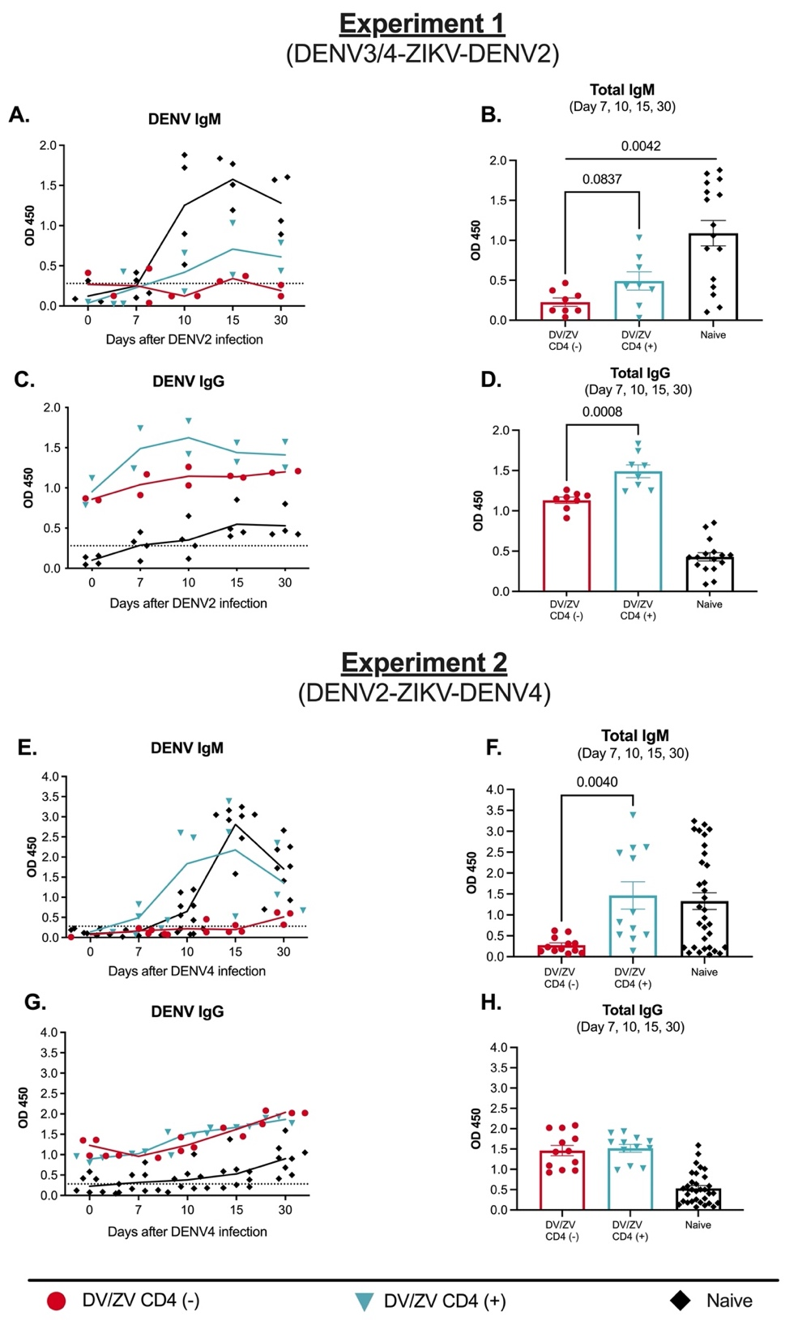

S3 Figure. Depletion of immune cell subsets modifies the serological profile during heterologous infections in DENV-primed individuals. The quantity of the humoral response was assessed using different commercial ELISA tests (A-H). (B, D, F & H) Pool of OD readings for total antibody production against DENV from animals depleted and non-depleted with different DENV infecting sequences is shown. Animals depleted of CD4⁺ T cells are shown in red, DENV/ZIKV immune-competent animals are shown in blue and flavivirus-naïve animals are shown in black in all panels. Dotted lines indicate the limit of detection for each test. Statistically significant differences among and within groups were calculated using Tukey's multiple comparisons tests and unpaired t-tests.

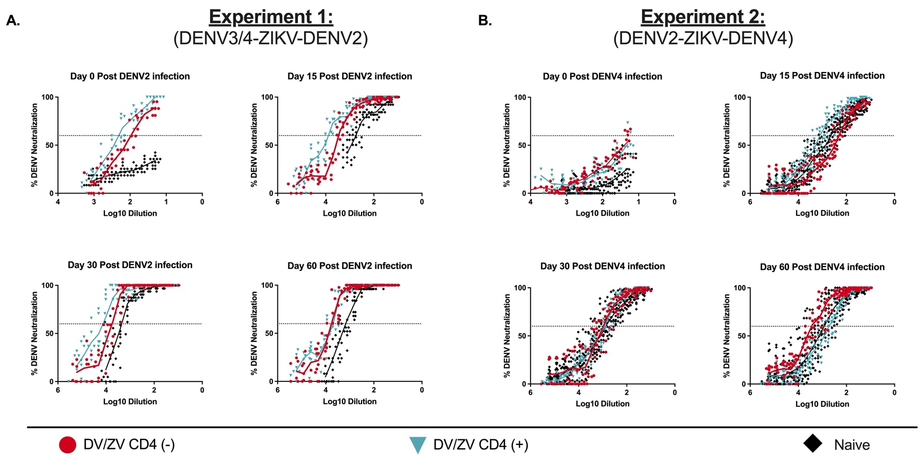

S4 Figure. Geometric mean titers of DENV neutralizing antibodies. Dilution titers against DENV2 or DENV-4 during days 0, 15, 30 & 60 post-infection (A & B). Animals depleted of CD4⁺ T cells are shown in red, DENV/ZIKV immune-competent animals are shown in blue and flavivirus-naïve animals are shown in black in all panels. The dotted line indicates 60% of neutralization. Non-neutralizing sera were assigned a value of one-half of the detection limit for visualization and calculation of the geometric means and confidence intervals. Statistically significant differences among groups are reported as multiplicity adjusted p values calculated by two-way ANOVA using Tukey's multiple comparisons tests.

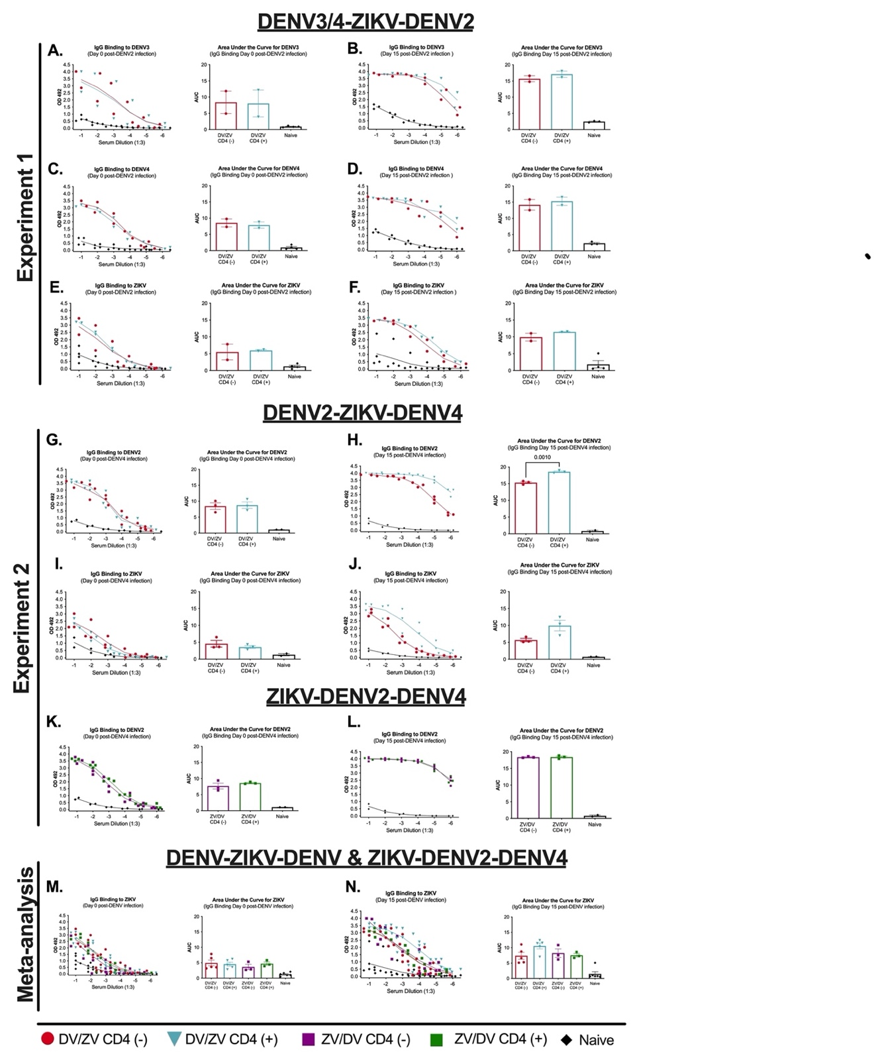

S5 Figure. Sequence of infections and lack of CD4 T cells modify the IgG-binding capabilities to previous infecting flaviviruses. The quality of the recall humoral response per infecting sequence was assessed using an endpoint dilution binding ELISA (A-N). Animals depleted of CD4⁺ T cells are shown in red (DENV-primed) and purple (ZIKV-primed), DENV and ZIKV immune-competent are shown in blue and green, and flavivirus-naïve animals are shown in black in all panels. (A-F) Binding results for experiment 1 (n=8, DENV3/4-ZIKV-DENV2) against DENV3, DENV4, and ZIKV for baseline and day 15 p.i. are shown. (G-L) Binding results for experiment 2 (n=20, DENV2-ZIKV-DENV4 & ZIKV-DENV2-DENV4) against ZIKV and DENV2 for baseline and day 15 p.i. are shown. (M-N) Meta-analysis of the binding results for experiments 1 and 2 against ZIKV for baseline and day 15 p.i are shown. Statistically significant differences among groups were observed using multiple unpaired t-tests.
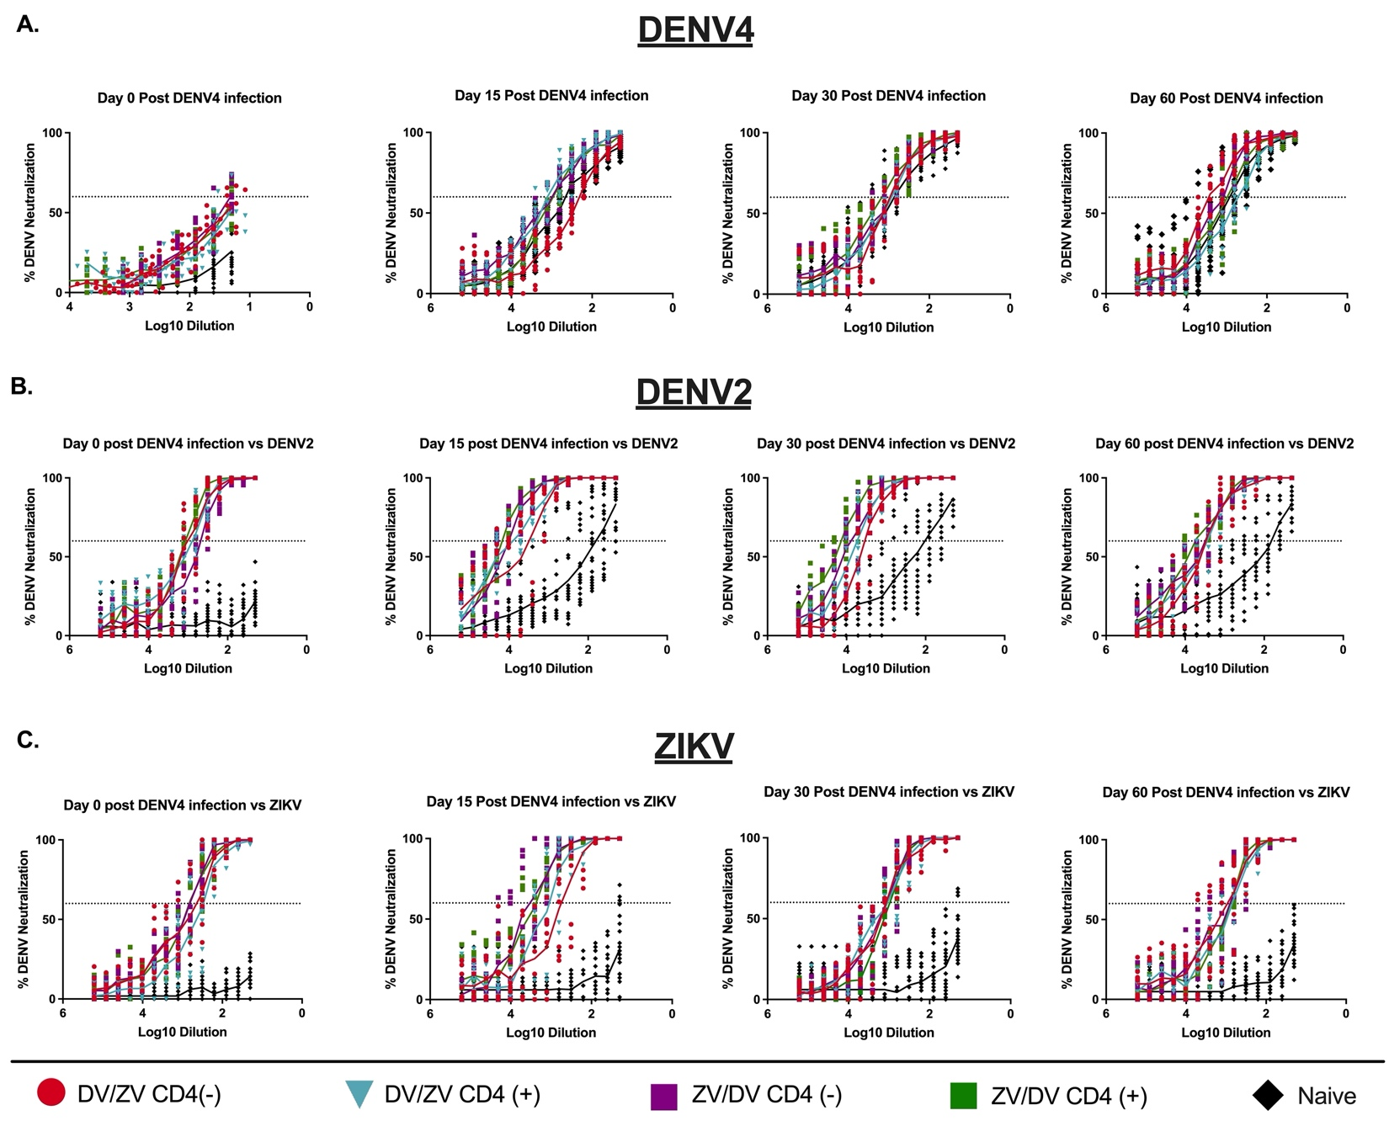

S6 Figure. Geometric mean titers of DENV-4 , DENV-2 and ZIKV neutralizing antibodies. Dilution titers against DENV-4 or DENV-2 or -ZIKV during days 0, 15, 30 & 60 post-infection (A & B). Animals depleted of CD4⁺ T cells are shown in red (DENV-primed) and purple (ZIKV-primed), DENV and ZIKV immune-competent animals are shown in blue and green, and flavivirus-naïve animals are shown in black in all panels. The dotted line indicates 60% of neutralization. Non-neutralizing sera were assigned a value of one-half of the detection limit for visualization and calculation of the geometric means and confidence intervals. Statistically significant differences among groups are reported as multiplicity adjusted p values calculated by two-way ANOVA using Tukey's multiple comparisons tests.

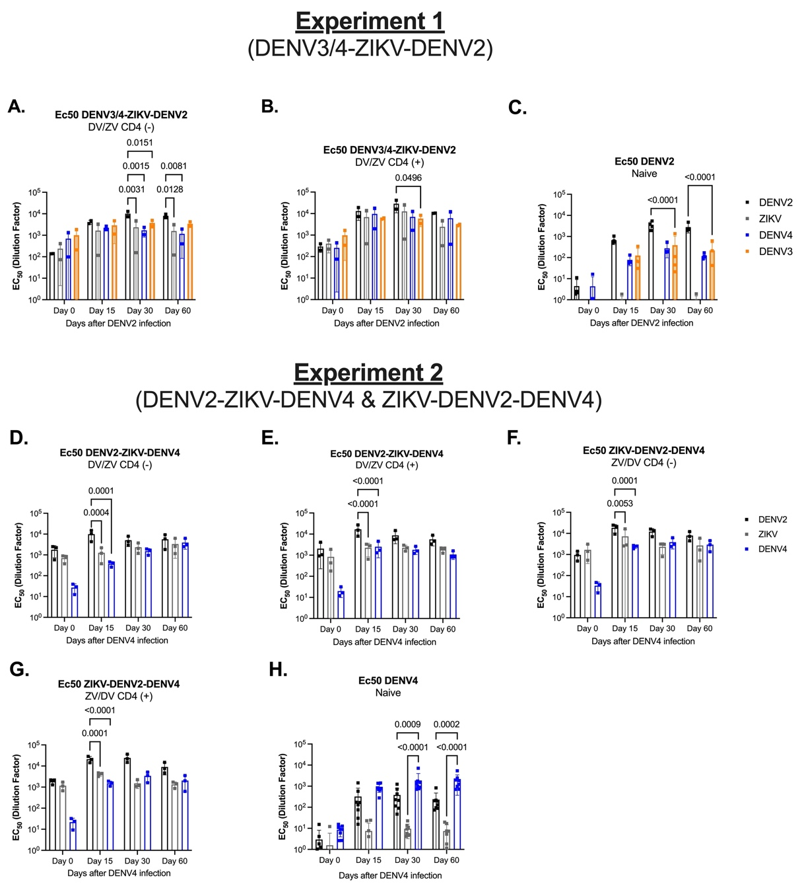

S7 Figure. Recall humoral response to heterologous DENV serotypes and ZIKV. PRNT and FRNT assays were performed to determine the effect of immune hindrance in the amnestic response against different DENV and ZIKV. The 50% effective concentration of neutralizing antibodies was determined. In all panels, EC50 values for DENV-2 are in black, ZIKV in gray, and DENV-4 in blue. Non-neutralizing samples were assigned a value of one-half of the detection limit for visualization and calculation of the geometric means and confidence intervals. (A-E) EC50 values of neutralizing antibodies against DENV-2, ZIKV, and DENV-4 before and after DENV-2 or DENV-4 tertiary infection. Statistically significant differences among and within groups are reported as multiplicity adjusted p values calculated by two-way ANOVA using Tukey's multiple comparisons test.

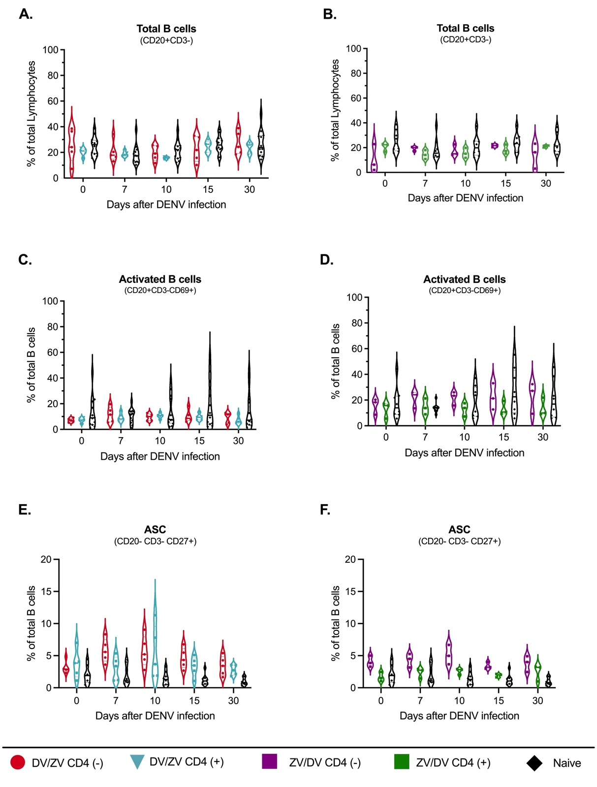

S8 Figure. DENV/ZIKV & ZIKV/DENV infection sequences: B cells profile before and after DENV-4 infection. Frequency of B cells was assessed by immunophenotyping using flow cytometry (S9 Fig for gating strategy) during baseline, days 7, 10, 15, and 30 post-infection. Animals depleted of CD4⁺ T cells are shown in red (DENV-primed) and purple (ZIKV-primed), DENV and ZIKV immune-competent are shown in blue and green, and flavivirus-naïve animals are shown in black in all panels. (A-B) Percentage of total B cells (CD20⁺CD3⁻) (C-D) Frequency of activated B cells (CD20⁺ CD3⁻CD69⁺) (E-F) Percentage of antibody-secreting cells (ASC) (CD20⁻ CD3⁻CD27⁺)

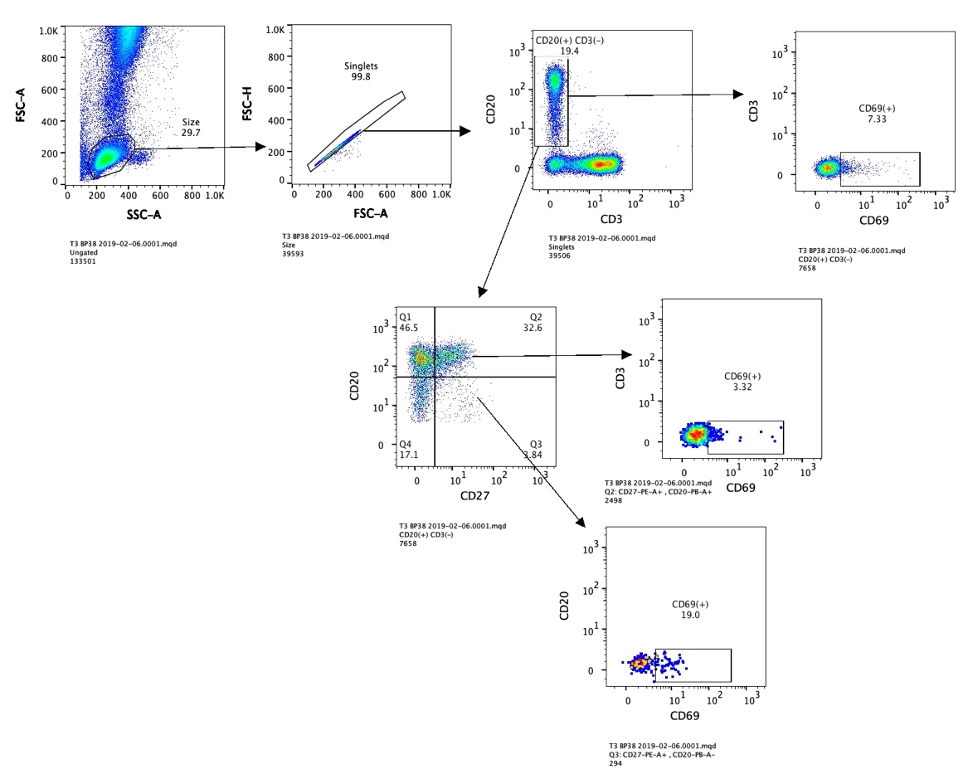

S9 Figure. Gating strategy for immunophenotyping and activation of B cells and subpopulations. Single cells (singlets) were selected by their FSC area (FSC-A) and height (FSC-H) patterns. Lymphocytes (LYM) were gated based on their characteristic forward and side scatter pattern (FSC, SSC). B cells were defined as CD20⁺CD3⁻, memory B cells as CD20⁺CD3⁻CD27⁺and ASC as CD20⁻ CD3⁻CD27⁺. The activation of B and subpopulations was assessed by the presence of the early activation marker CD69⁺.

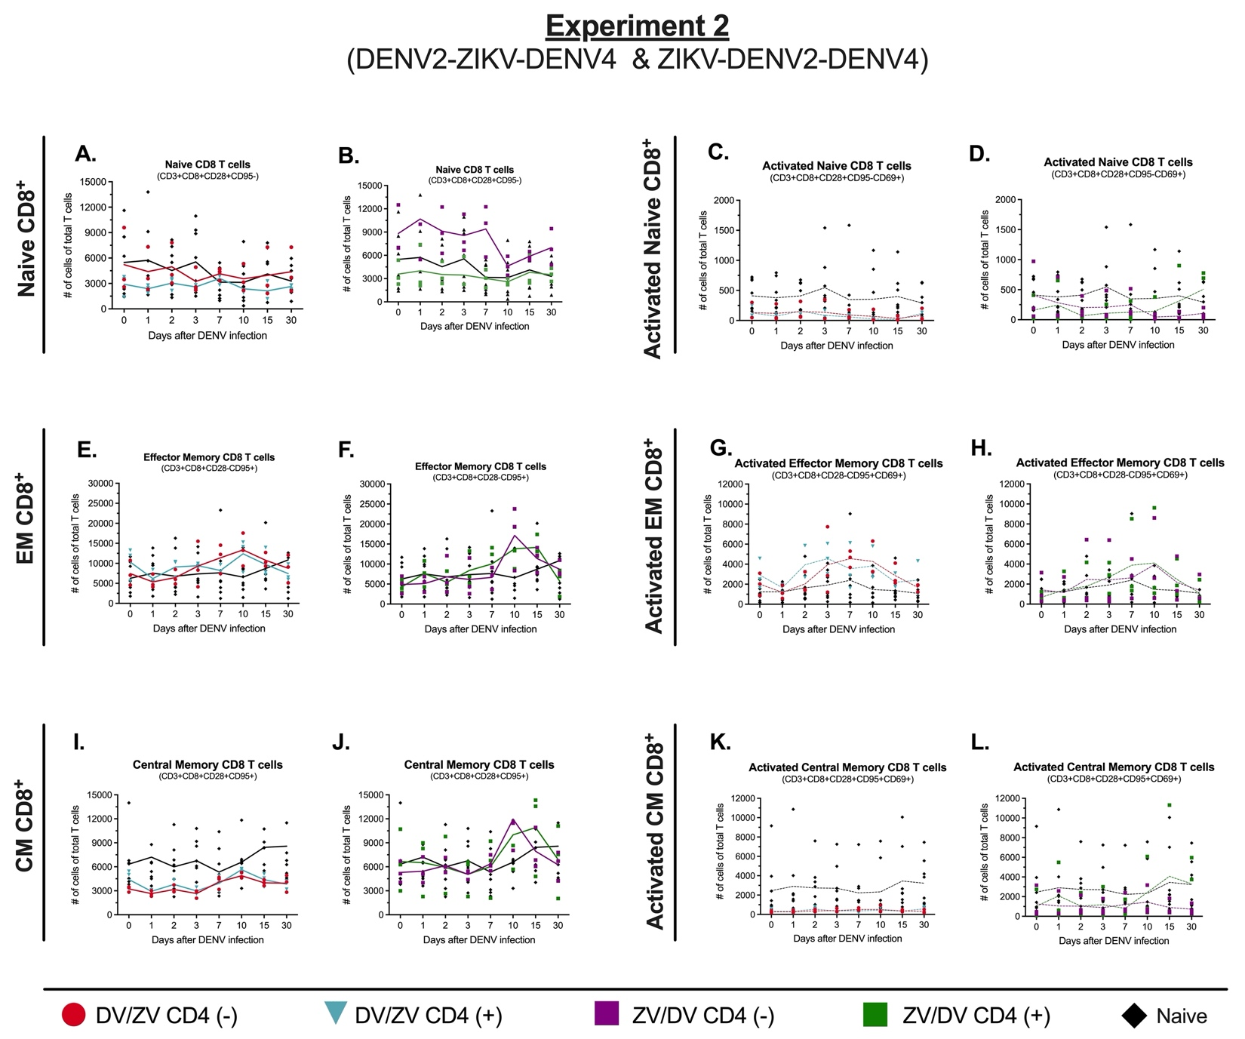
S10 Figure. DENV/ZIKV & ZIKV/DENV infection sequences: CD8⁺ T cells profile before and after DENV-4 infection. CD8⁺ T-cell compartments for experiment 2 (n= 20) were assessed by immunophenotyping using flow cytometry (S11 Fig for gating strategy) during baseline and days 1 through 3, 7, 10, 15, and 30 post-infection. Animals depleted of CD4⁺ T cells are shown in red (DENV-primed) and purple (ZIKV-primed), DENV and ZIKV immune-competent animals are shown in blue and green, and flavivirus-naïve animals are shown in black in all panels. Frequency and activation of naïve, effector (EM) and central memory (CM) CD8⁺ T cells. (A-D) Number of naïve and activated (CD69⁺) naïve CD8 T cells (CD3⁺CD4⁺CD28⁺CD95⁻). (E-H) Number of EM and activated EM CD8 T cells (T-EM: CD3⁺CD4⁺CD28⁻CD95⁺). (I-L) Number of CM and activated CM CD8 T cells (T-CM: CD3⁺CD4⁺CD28⁺CD95⁺).

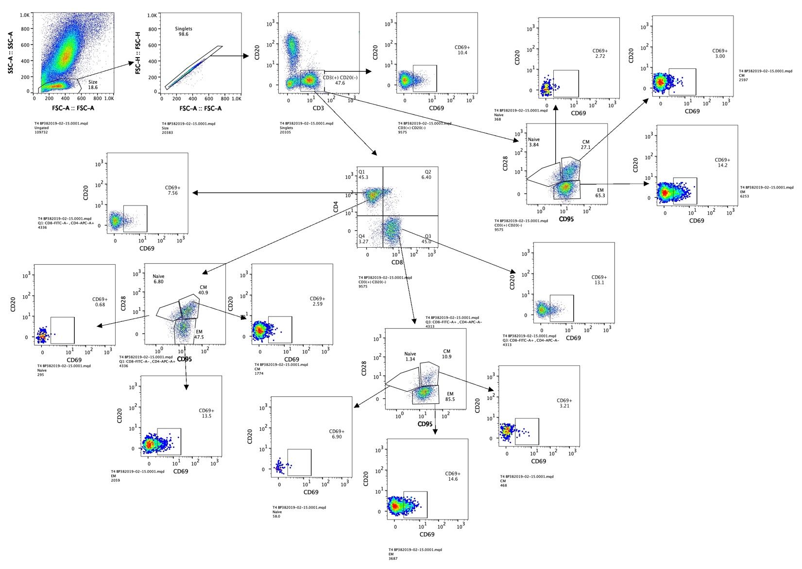
S11 Figure. Gating strategy for immunophenotyping and activation of T cells and subpopulations. Single cells (singlets) were selected by their FSC area (FSC-A) and height (FSC-H) patterns. Lymphocytes (LYM) were gated based on their characteristic forward and side scatter pattern (FSC, SSC). T cells were selected gating on the CD3⁺ population. CD4⁺ and CD8⁺ T cells were defined as CD3⁺CD4⁺ and CD3⁺ CD8⁺ , respectively. Naive (N; CD28⁺CD95⁻ ), effector memory (EM; CD28⁻CD95⁺ ) and central memory (CM; CD28⁺CD95⁺ ) T cell subpopulations were determined within CD8⁺ T cells. The activation of T and memory subpopulations was assessed by the presence of the early activation marker CD69⁺.

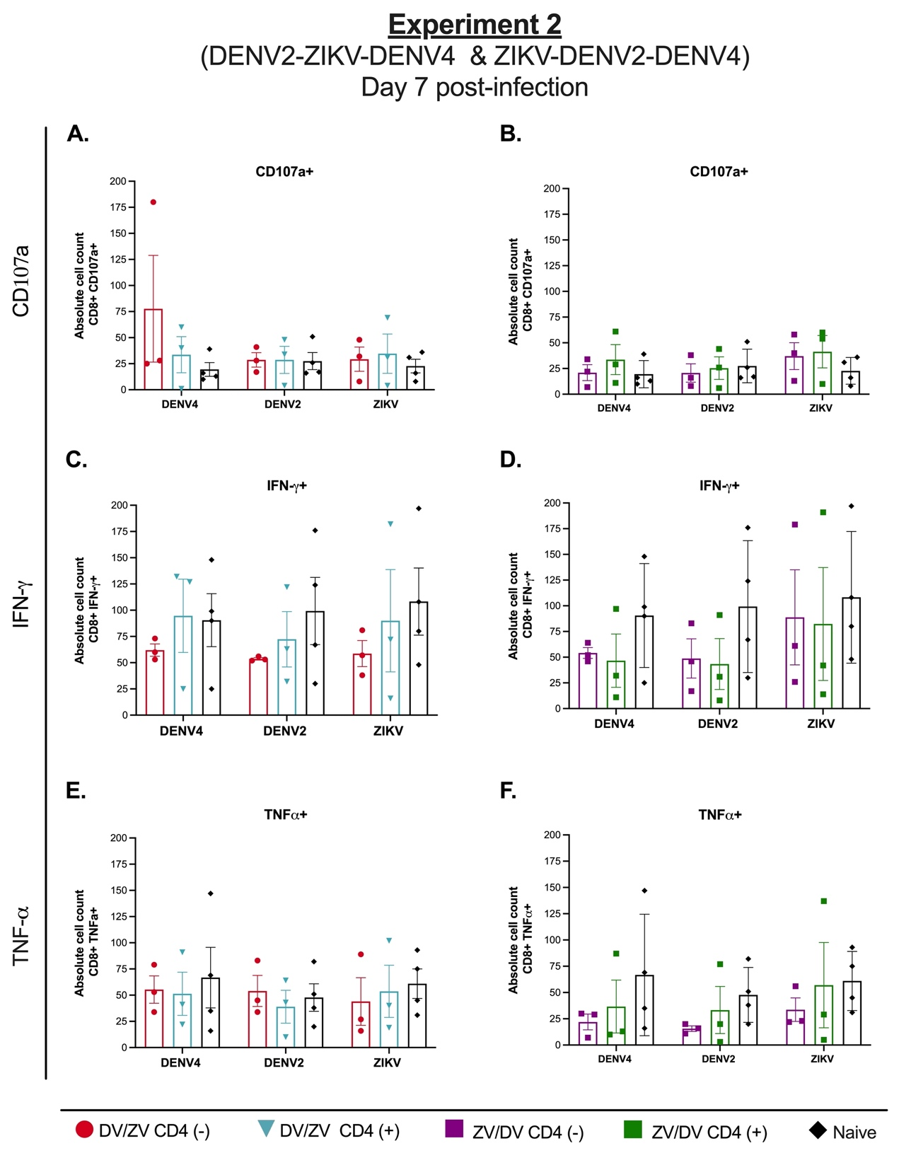

S12 Figure. Antigen-specific CD8⁺ responses prior and after tertiary DENV4 infection. T cell functional effector response was determined by the quantification (%) of (A–B) CD107a-expressing and (C–D) ) IFN-γ or (E–F) TNF-α-producing CD8⁺ T cells at 7 days post-infection for experiment 2 (n=16). Responses to DENV-4, DENV-2 and ZIKV was quantified. After antigenic stimulation, intracellular cytokine staining was performed using flow-cytometry analysis. Animals depleted of CD4⁺ T cells are shown in red (DENV-primed) and purple (ZIKV-primed), DENV and ZIKV immune-competent animals are shown in blue and green, and flavivirus-naïve animals are shown in black in all panels. Statistically significant differences between groups are reported as multiplicity adjusted p values calculated using two-way ANOVA adjusted for Tukey’s multiple comparisons test.
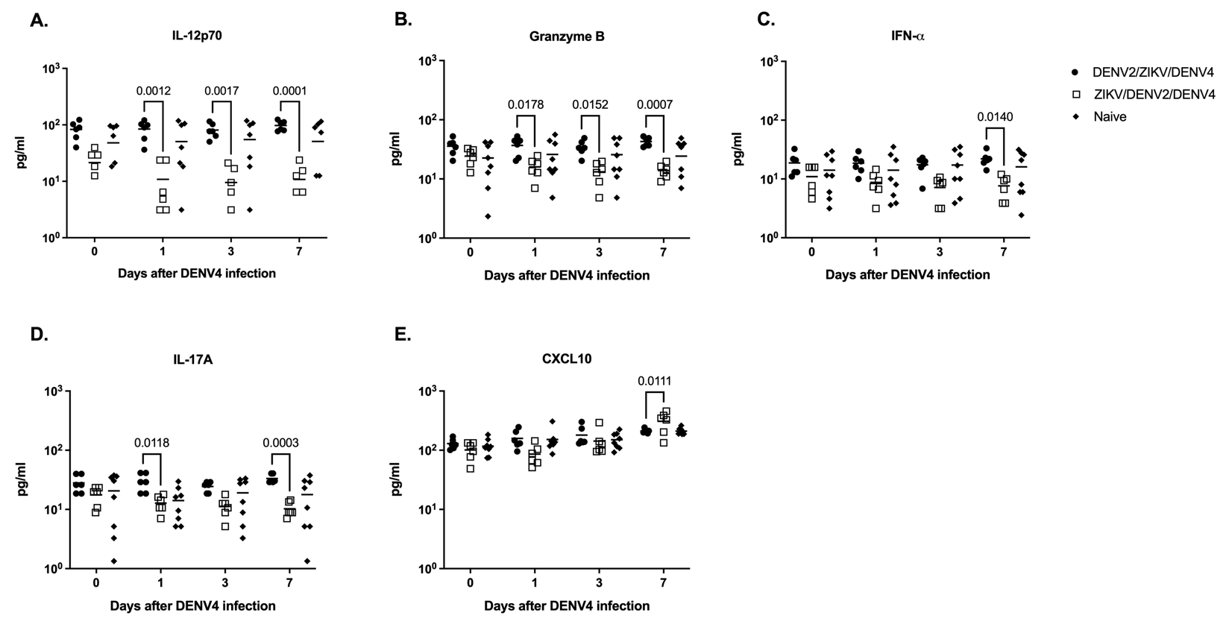

S13 Figure. Sequence of infection shapes the pro-inflammatory cytokine profile. Cytokine and chemokine expression levels were determined in serum (pg/ml) by multiplex bead assay (Luminex) at baseline, 1, 3, and 7 days after DENV infection. Differences between the two sequences of infections from experiment 2 regardless of CD4⁺ T cell status are shown. The panel includes (A) IL-12p70, (B) Granzyme B, (C) interferon-alpha (IFN-α), (D) IL-17A, and (E) C–X–C motif chemokine 10 (CXCL10/IP-10). DENV2-ZIKV-DENV4 immune animals (n=6) are shown in black circles, ZIKV-DENV2-DENV4 immune animals (n=6) are shown in blank squares and flavivirus-naïve animals (n=8) are shown in black diamonds. Statistically significant differences between groups are reported as multiplicity adjusted p values calculated using two-way ANOVA adjusted for Tukey’s multiple comparisons test.

