Supplementary information
Towards a Robotic Scientist for Synthesis of Nanocrystals
Haitao Zhao^{1,#,*}, Wei Chen^{1,#}, Zhehao Sun^{1,2,#}, Fuming Lai¹, Baicheng Zhang⁴, Zhuo Wang^{1,3}, Hao Huang¹, Oyawale Adetunji Moses¹, Mukhtar Lawan Adam¹, Zijian Chen¹, Cheng Heng Pang³, Tao Wu³, Paul K. Chu⁵, Yang Lu⁶, Jun Jiang^{4,*}, Zongyou Yin^{2,*} Xue-Feng Yu^{1,*}
¹ Materials Interfaces Center, Shenzhen Institute of Advanced Technology, Chinese Academy of Sciences, Shenzhen 518055, Guangdong, PR China
² Research School of Chemistry, Australian National University, ACT 2601, Australia
³ Department of Chemical and Environmental Engineering, The University of Nottingham Ningbo China, Ningbo 315100, PR China
⁴ School of Chemistry and Materials Science, University of Science and Technology of China, Hefei 230026, Anhui, PR China
⁵ Department of Physics, Department of Materials Science and Engineering, and Department of Biomedical Engineering, City University of Hong Kong, Tat Chee Avenue, Kowloon, Hong Kong, China
⁶ Department of Mechanical Engineering, City University of Hong Kong, Tat Chee Avenue, Kowloon, Hong Kong, China
# These authors contributed equally to this work
* Corresponding authors: ht.zhao@siat.ac.cn (H.T. Zhao); jiangj1@ustc.edu.cn (J. Jiang); zongyou.yin@anu.edu.au (Z.Y. Yin); xf.yu@siat.ac.cn (X.-F. Yu)
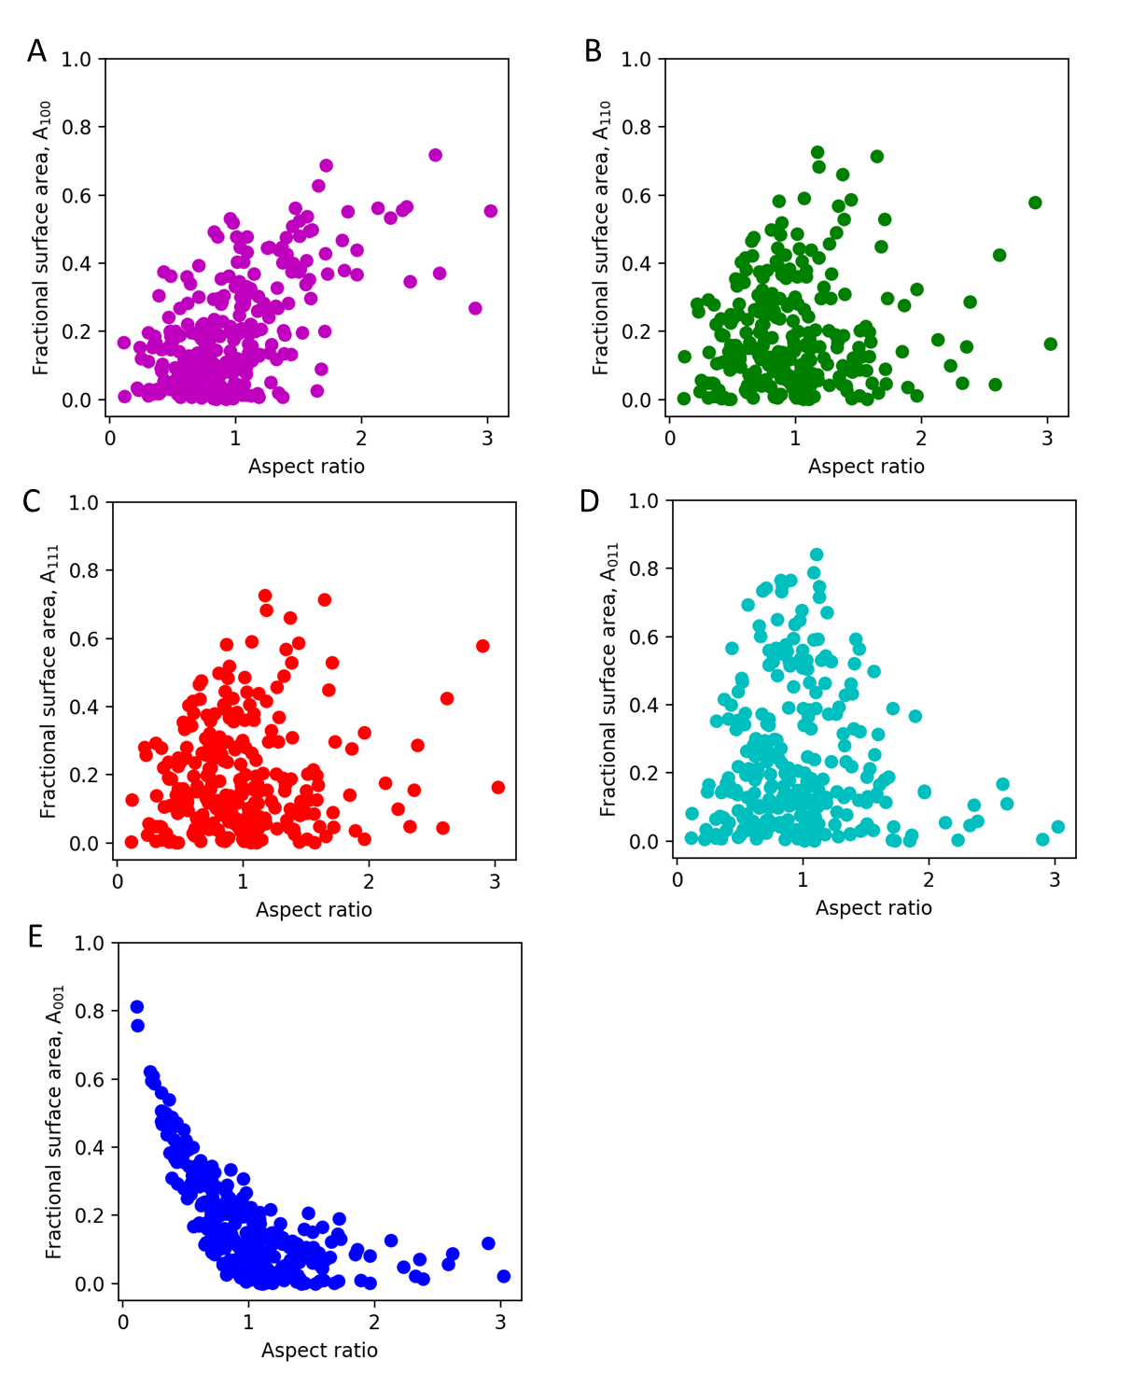
Fig. S1. The correlation analysis between fractional surface area and aspect ratio for the five equivalent planes of Au nanocrystals. A, (100) plane, $A_{100}=A_{(100)}+A_{(\overline{1}00)}+A_{(010)}+A_{(0\overline{1}0)}$. B, (110) plane, $A_{110}=A_{(110)}+A_{(\overline{1}10)}+A_{(110)}+A_{(1\overline{1}0)}$. C, (111) plane, $A_{111}=A_{(111)}+A_{(\overline{1}11)}+A_{(1\overline{1}1)}+A_{(11\overline{1})}+A_{(\overline{1}\overline{1}1)}+A_{(1\overline{1}\overline{1})}+A_{(\overline{1}1\overline{1})}+A_{(\overline{1}\overline{1}\overline{1})}$. D, (011) plane, $A_{011}=A_{(011)}+A_{(101)}+A_{(0\overline{1}1)}+A_{(01\overline{1})}+A_{(\overline{1}01)}+A_{(10\overline{1})}+A_{(\overline{1}0\overline{1})}+A_{(0\overline{1}\overline{1})}$. E, (001) plane, $A_{001}=A_{(001)}+A_{(00\overline{1})}$.

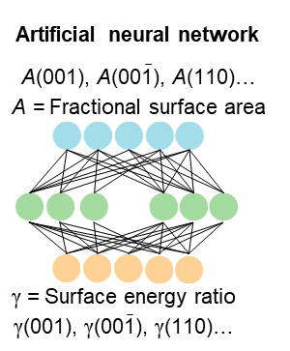
Fig. S2. Machine learning-aided rational design of crystal facet: artificial neural network (ANN) model of fractional surface area and surface energy ratio.
Fig. S3. Data mining of Au nanocrystals synthesis parameters from 1,300 related literatures (A-E). The color gradient indicates the usage frequency distribution of the synthesis parameters (concentration of chemical solutions). The synthesis parameters with blue labels are (relatively darker color) are recommended, and the DOI of the papers are listed below.
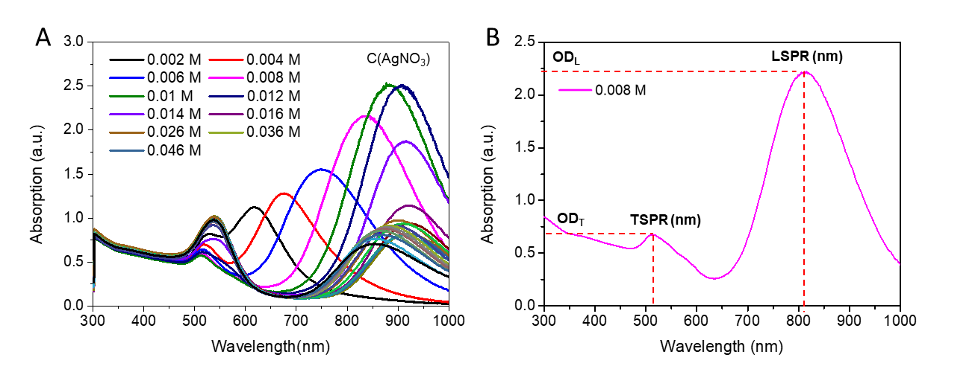
Fig. S4. UV-Vis-NIR absorption spectra from the in-situ experiments and characterizations. A, UV-Vis-NIR absorption spectra from in-situ characterizations. B, An example of the corresponding TSPR, LSPR, OD_{TSPR} and OD_{LSPR} dissociated from Fig.S4A.

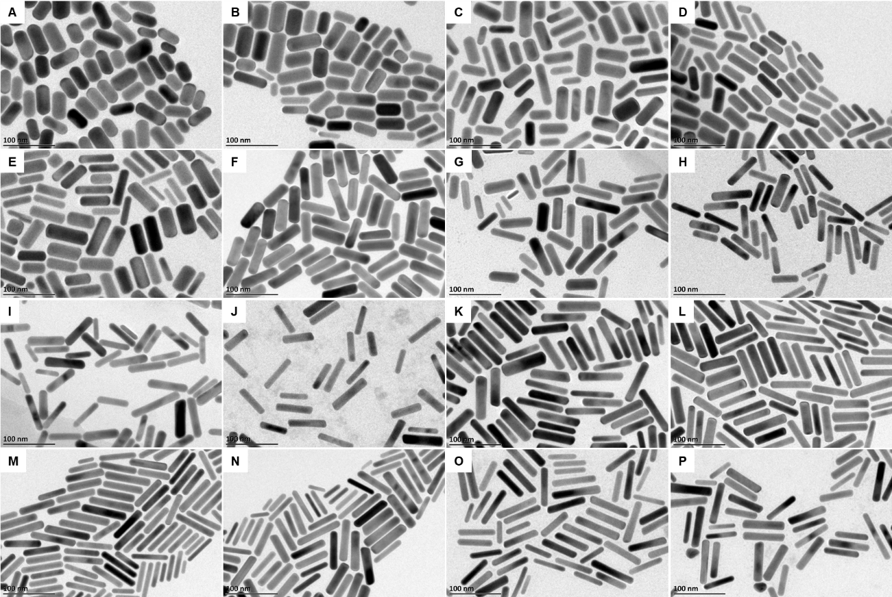
Fig. S5. TEM images of a small dataset (ex-situ characterization of typical samples with LSPR between 600 to 1,000 nm) of Au nanocrystals synthesized on the Robotic Scientist platform. The LSPR wavelength and average AR of samples are listed. A, LSPR=630 nm, AR=2.24. B, LSPR=653 nm, AR=2.49. C, LSPR=671 nm, AR= 2.54. D, LSPR=698 nm, AR= 2.95. E, LSPR=741 nm, AR= 3.37. F, LSPR=784 nm, AR= 3.81. G, LSPR=791 nm, AR= 3.83. H, LSPR=793 nm, AR= 3.89. I, LSPR=814 nm, AR= 4.10. J, LSPR=854 nm, AR= 4.24. K, LSPR=878 nm, AR= 4.73. L, LSPR=906 nm, AR= 4.96. M, LSPR=908 nm, AR= 5.30. N, LSPR=923 nm, AR= 5.31. O, LSPR=930 nm, AR= 5.32. P, LSPR=932 nm, AR= 5.00. The average AR of all samples was obtained by automatically counting more than 100 nanocrystals based on their corresponding TEM images.

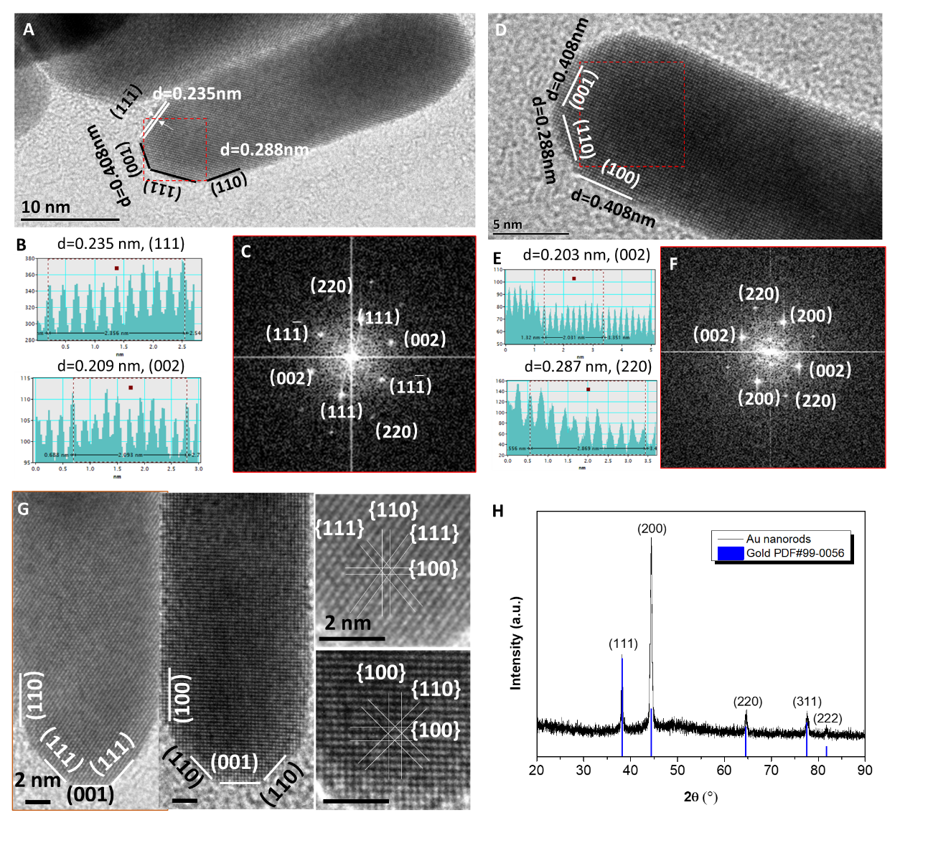
Fig. S6. HRTEM images and XRD pattern of Au nanocrystals synthesized on the Robotic Scientist platform. A-F, HRTEM images, lattice line and FFT patterns of Au nanocrystals. The lattice distance of 0.235 and 0.209 nm is indexed to (111) and (002) lattice planes respectively. The lattice distance of 0.203 and 0.287 nm is indexed to (002) and (220) lattice planes respectively. G, Two typical morphology and surface facets of Au nanocrystals. H, XRD pattern of Au nanocrystals, showing the typical diffraction peak of (111), (200) and (220) planes of face centered cubic structure of Au crystal ($Fm\overline{3}m$(No. 225), PDF#99-0056).
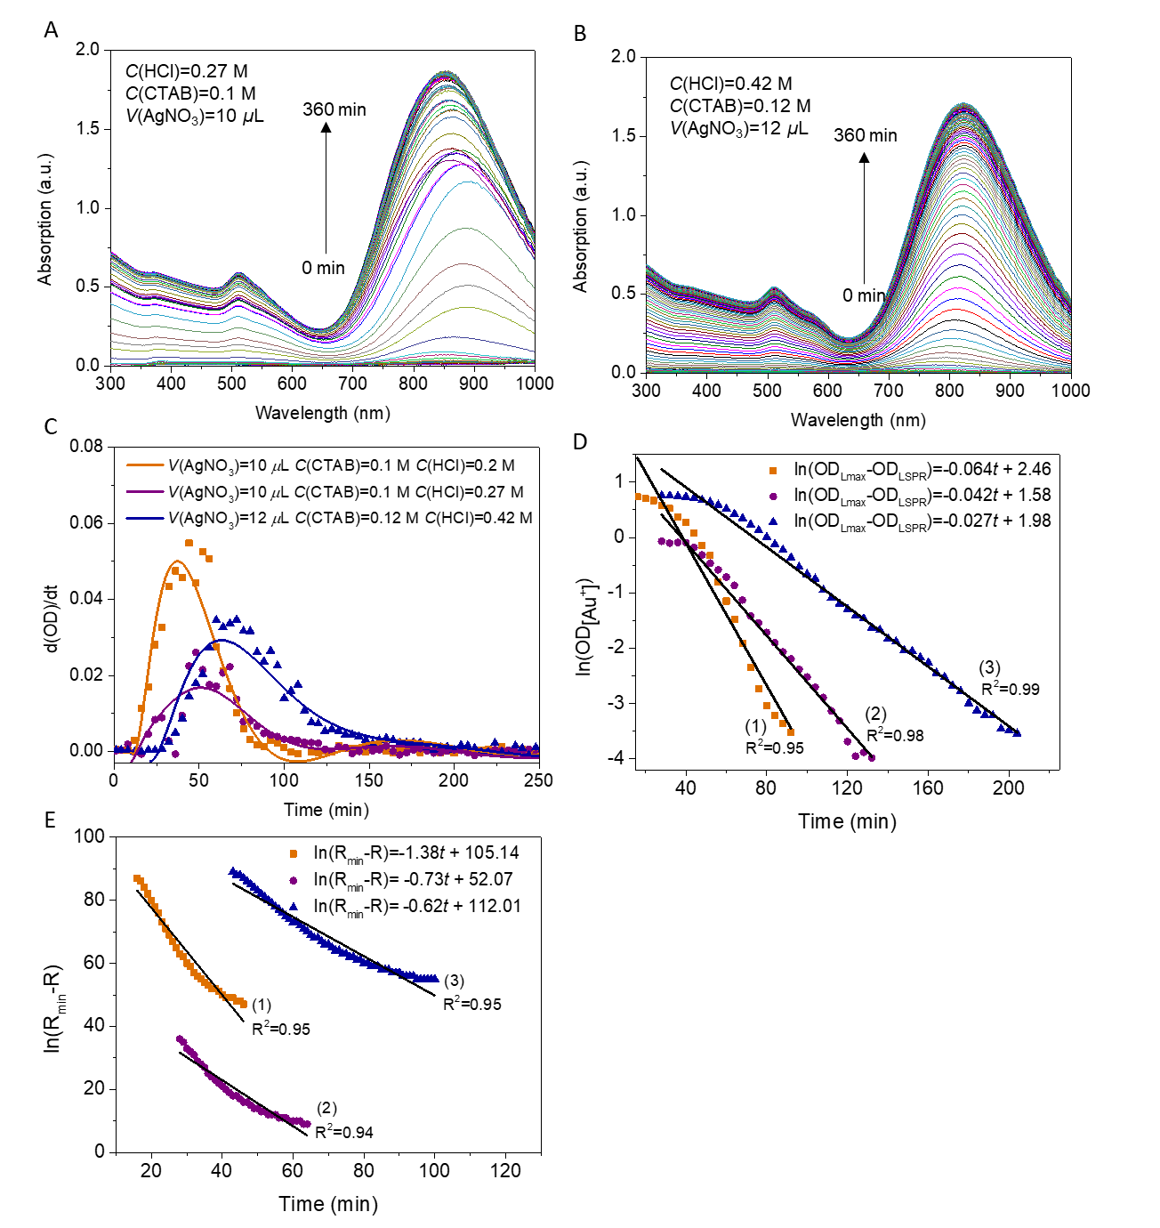
Fig. S7. Growth kinetic studies of Au nanocrystals with LSPR at 808 nm for model construction and rational design. A-B, The UV-Vis-NIR absorption spectra from dynamic state to steady state (0 min to 360 min). C, The growth rate estimated from the first derivatives of OD_{LSPR}. D, Scatter plot of ln(OD_{[Au+]}) over time indicates the pseudo-first-order growth kinetics models E, Scatter plot of ln(R_{min}-R) over time indicates the pseudo-first-order growth kinetics models. R_{min} refers to the steady-state R value, R means the real-time R value during growth. The experimental number 1, 2 and 3 are corresponding to experiments with C(HCl) as 0.20 M, 0.27 M and 0.40 M respectively. The formula of growth kinetic model is listed in Table S2.

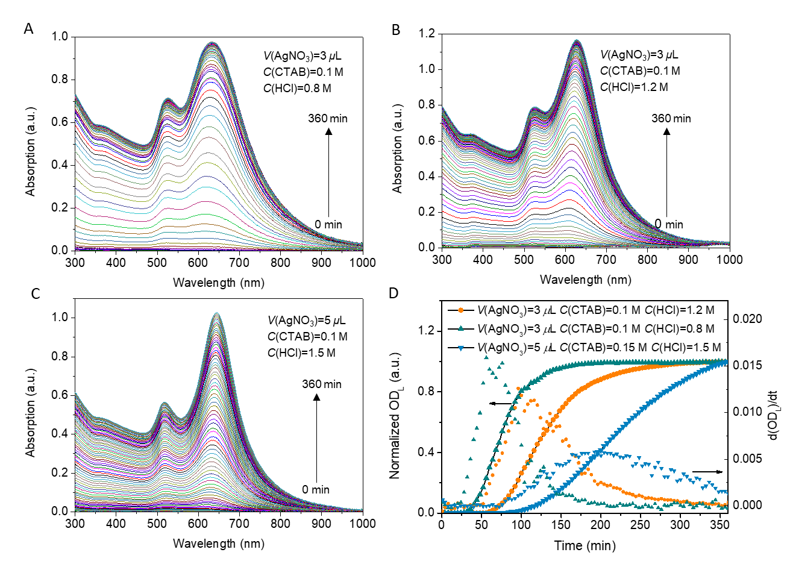
Fig. S8. Growth kinetic studies of Au nanocrystals with LSPR at 633 nm. A-C, The UV-Vis-NIR absorption spectra from dynamic state to steady state (0 min to 360 min). D, The OD_{LSPR} extracted from normalized UV-Vis-NIR spectra as a function of time, and the growth rate estimated from the first derivatives of OD_{LSPR}.

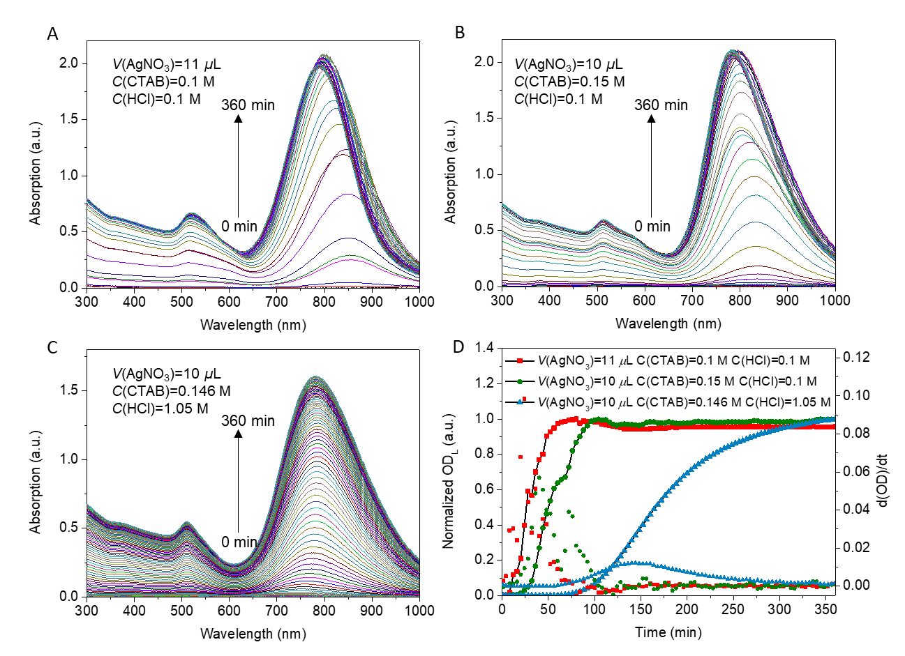
Fig. S9. Growth kinetic studies of Au Nanocrystals with LSPR at 780 nm. A-C, The UV-Vis-NIR absorption spectra from dynamic state to steady state (0 min to 360 min). D, The OD_{LSPR} extracted from normalized UV-Vis-NIR spectra as a function of time, and the growth rate estimated from the first derivatives of OD_{LSPR}.
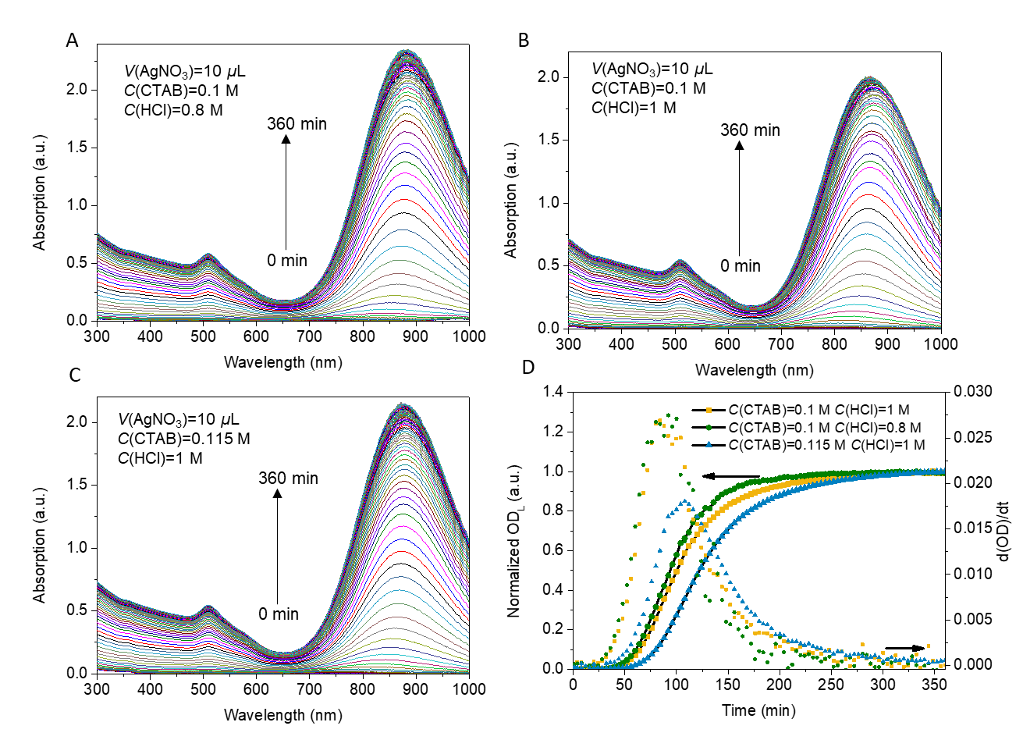
Fig. S10. Growth kinetic studies of Au Nanocrystals with LSPR at 870 nm. A-C, The UV-Vis-NIR absorption spectra from dynamic state to steady state (0 min to 360 min). D, The OD_{LSPR} extracted from normalized UV-Vis-NIR spectra as a function of time, and the growth rate estimated from the first derivatives of OD_{LSPR}.
Fig. 11. UV-Vis-NIR absorption spectra of orthogonal experiments executed on the Robotic Scientist platform by in-situ characterizations.

Fig. S12. Single-factor ML predicted models. A, HAuCl₄. B, Au seed. C, AA. The formula of ML predicted model is listed in Table S7 and Table S8.

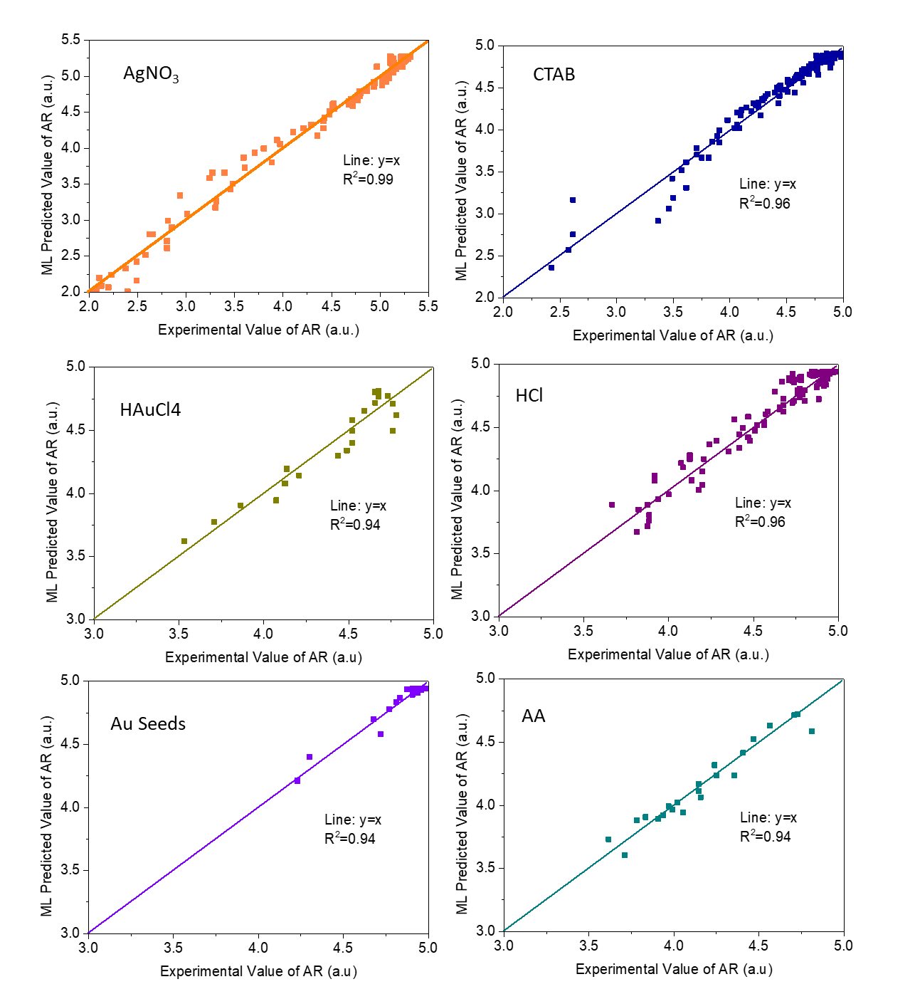
Fig. S13. The accuracy of the single-factor ML models. The scatter plots of the experimental AR and ML predicted AR presents the R² over 0.9, indicating an accurate prediction by ML model.

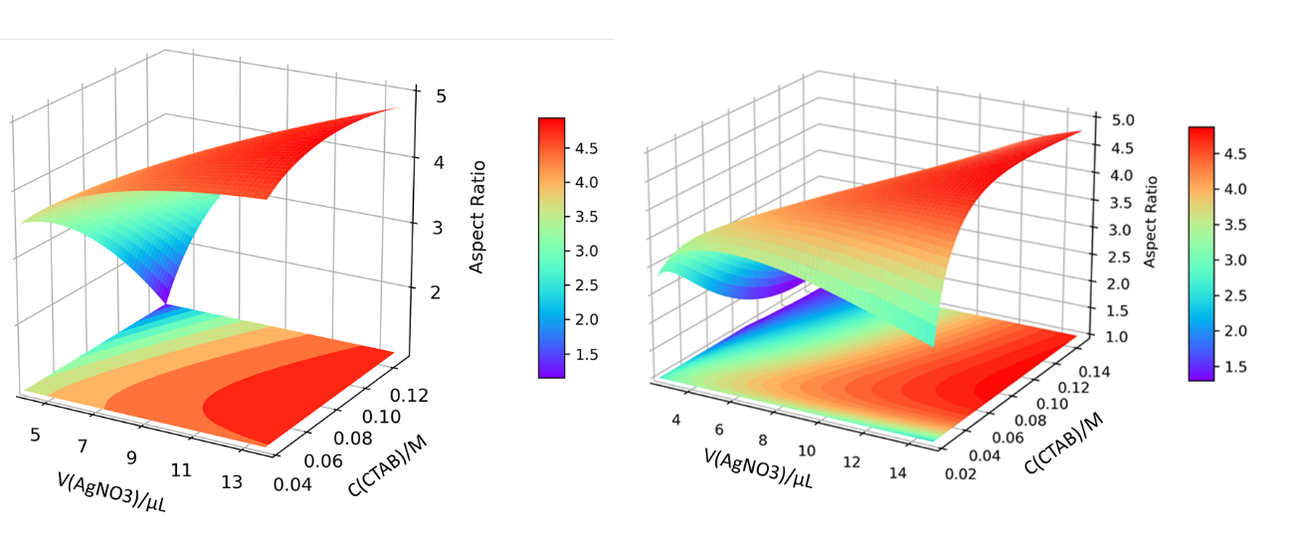
Fig. S14. Double-factor ML predicted models for controllable synthesis (CTAB and AgNO₃). Data was obtained by 64 preliminary experiments (left) and 96 extended experiments (right). AR changes as a function of factor C(CTAB) and V(AgNO₃). The formula of models is listed in Table S12-13.

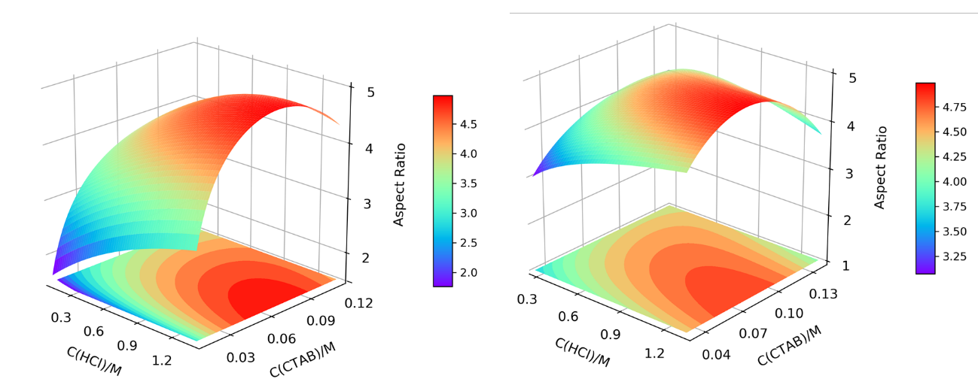
Fig. S15. Double-factor ML predicted models for controllable synthesis (CTAB and HCl). Data was obtained by 64 preliminary experiments (left) and 96 extended experiments (right). AR changes as a function of factor C(CTAB) and C(HCl). The formula of models is listed in Table S12-13.

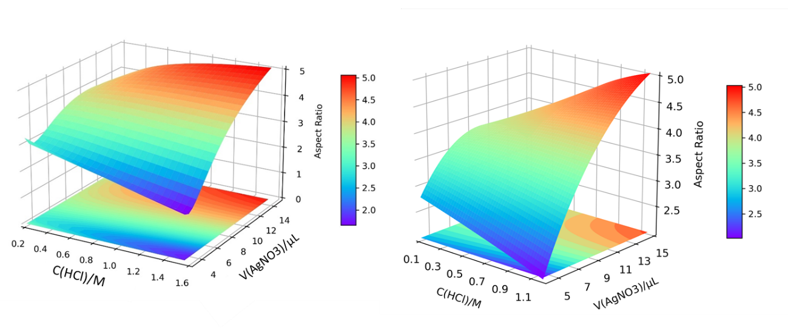
Fig. S16. Double-factor ML predicted models for controllable synthesis (HCl and AgNO₃). Data was obtained by 64 preliminary experiments (left) and 96 extended experiments (right). AR changes as a function of factor V(AgNO₃) and C(HCl). The formula of models is listed in Table S12-13.

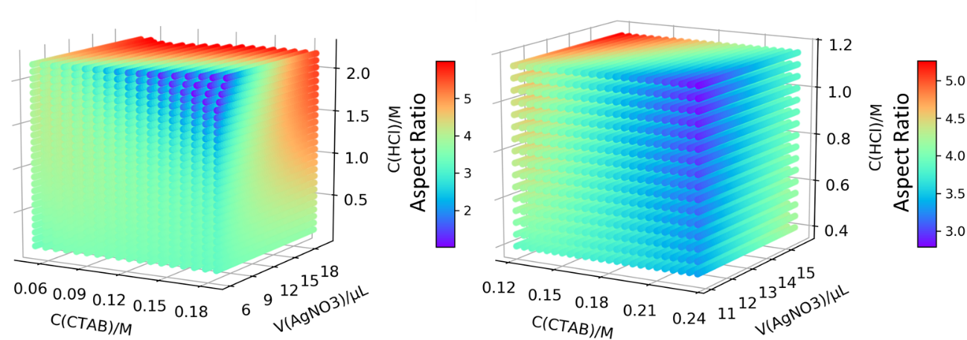
Fig. S17. Triple-factor ML predicted models. AR changes as a function of factor V(AgNO₃), C(CTAB) and C(HCl). Data was obtained by 64 preliminary experiments (left) and 96 extended experiments (right). The formula of models is listed in Table S15-16.

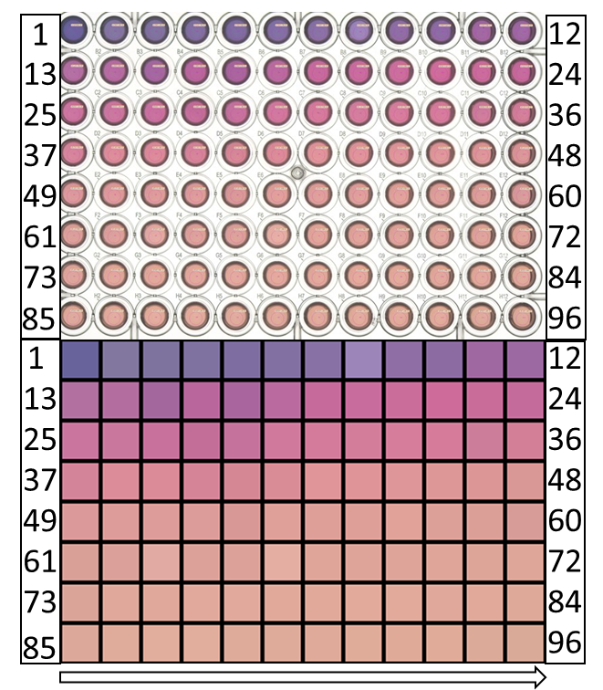
Fig. S18. The photo and digitized color of single-factor 96 experiments captured by color-ultra-sensitive camera on the Robotic Scientist platform. The RGB values of the color blocks auto-generated on the Robotic Scientist platform are shown in Table S17.

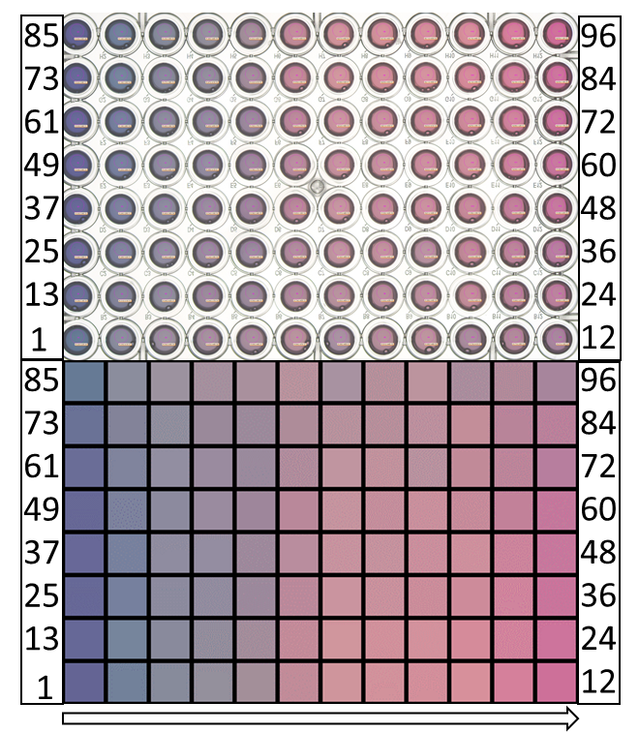
Fig. S19. The photo and digitized color of double-factor 96 experiments captured by color-ultra-sensitive camera on the Robotic Scientist platform. The RGB values of the color blocks auto-generated on the Robotic Scientist are shown in Table S18.

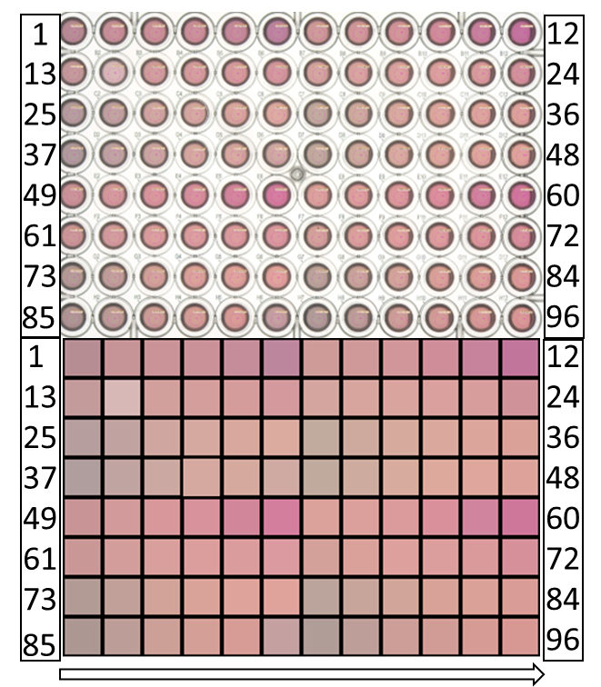
Fig. S20. The photo and digitized color of triple-factor 96 experiments captured by color-ultra-sensitive camera on the Robotic Scientist platform. The RGB values of the color blocks auto-generated on the Robotic Scientist are shown in Table S19.

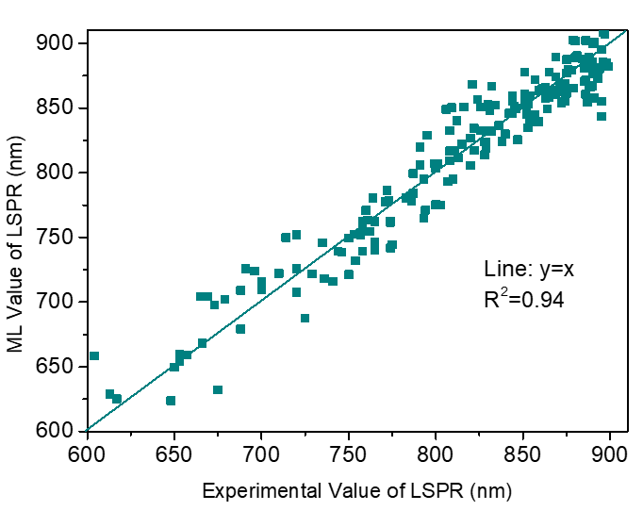
Fig. S21. The accuracy of LSPR-color model. The scatter plots of the experimental LSPR and ML predicted LSPR presents an R² over 0.9, indicating an accurate prediction by ML model.

Fig. S22. The UV-Vis-NIR absorption spectra of scale-up experiments. UV-Vis-NIR absorption spectra of 200 mL, 1 L and 15 L experiments with decreased C(HCl).
Table S1. The key information extracted from UV-Vis-NIR absorption spectra.
C(AgNO₃)  /M | TSPR  /nm | OD_{TSPR} | LSPR  /nm | OD_{LSPR} | OD Ratio | AR
0.002 | 528 | 0.82 | 614 | 1.12 | 1.37 | 2.04
0.003 | 521 | 0.74 | 640 | 1.11 | 1.49 | 2.31
0.004 | 516 | 0.70 | 673 | 1.28 | 1.83 | 2.66
0.005 | 515 | 0.67 | 736 | 1.38 | 2.04 | 3.31
0.006 | 515 | 0.64 | 744 | 1.55 | 2.41 | 3.40
0.007 | 514 | 0.64 | 784 | 1.58 | 2.46 | 3.80
0.008 | 511 | 0.66 | 812 | 1.91 | 2.87 | 4.10
0.009 | 511 | 0.62 | 848 | 2.15 | 3.46 | 4.47
0.010 | 509 | 0.57 | 874 | 2.54 | 4.41 | 4.75
0.012 | 512 | 0.61 | 907 | 2.52 | 4.10 | 5.09
0.014 | 533 | 0.76 | 913 | 1.87 | 2.46 | 5.16
0.016 | 538 | 0.96 | 919 | 1.14 | 1.19 | 5.22
0.018 | 536 | 1.00 | 919 | 0.94 | 0.94 | 5.22
0.020 | 536 | 1.02 | 919 | 0.82 | 0.81 | 5.22
0.022 | 537 | 1.01 | 911 | 0.82 | 0.81 | 5.14
0.024 | 537 | 1.01 | 908 | 0.80 | 0.79 | 5.10
0.026 | 534 | 1.01 | 895 | 0.98 | 0.96 | 4.97
0.028 | 534 | 0.98 | 909 | 0.94 | 0.95 | 5.11
0.030 | 534 | 0.98 | 904 | 0.95 | 0.98 | 5.06
0.034 | 534 | 0.92 | 892 | 0.92 | 0.99 | 4.94
0.038 | 534 | 0.96 | 876 | 0.90 | 0.94 | 4.77
0.042 | 534 | 0.96 | 869 | 0.88 | 0.92 | 4.70
0.046 | 534 | 0.96 | 867 | 0.81 | 0.84 | 4.68
0.048 | 534 | 0.96 | 860 | 0.79 | 0.82 | 4.60
Notes: The key information including TSPR, LSPR, OD_{TSPR} and OD_{LSPR} extracted from UV-Vis-NIR absorption spectra of experiments with 24 levels of C(AgNO₃). AR is calculated from LSPR and the OD Ratio is calculated from the extracted OD_{TSPR} and OD_{LSPR}.

Table S2. The growth kinetics ML model of OD_{LSPR} and color.
Exp. | ML model (OD_{LSPR} versus Time(t)) | R² | RMSE
1 | OD_{LSPR}=0.0026×(cbrt(t)×(ln(t))³)+0.0019×(t×sin(sqrt(t)))+  0.051×exp(sin(sqrt(t)))-0.12 | 0.99 | 0.01
2 | OD_{LSPR}=-0.94×sin(sqrt(sqrt(t)))-0.13×cos(sqrt(t))+0.032×exp(sin(sqrt(t)))+0.79 | 0.99 | 0.02
3 | OD_{LSPR}=0.0014×(cbrt(t)×(ln(t))³)+0.64×cos(cos(cbrt(t)))-0.058×sin(sqrt(t))-0.57 | 0.99 | 0.02
 | ML model (R, G, B versus Time(t))
1 | R=7.48×(ln(t)×sin(ln(t)))+4.48×sin(ln((t)³))-0.13×((t)³/(sqrt(t)))+249.54 | 0.99 | 0.95
1 | G=223×sin(sin(ln(t)))-3564×(cbrt(t)/(cbrt(t)))+2698×sin(cbrt(t)/sqrt(t))-702 | 0.99 | 1.50
1 | B=207×sin(sin(ln(t)))-3348×(cbrt(t)/(cbrt(t)))+2542×sin(cbrt(t)/sqrt(t))-6478 | 0.99 | 1.45
2 | R=4.80×(cbrt(t)×sin(ln(t)))-4.64×cos(ln((t)³))+7.83×((cos(t)+sin(t))/t)+247 | 0.99 | 1.06
2 | G=15.56×(cbrt(t)×sin(ln(t)))+6.56×sin(ln((t)³))-7.71×cos(ln((t)³))+234 | 0.99 | 2.23
2 | B=-958.08×cos(cbrt(sqrt(t)))-247.83×(ln(t)/exp((t)⁻¹))+ 27.24×((t)²/exp(sqrt(t)))+755 | 0.99 | 2.19
3 | R=-2.72×((ln(t))³/cbrt(t))+41.50×cos(sin(cbrt(t)))-23.46×(sin(cbrt(t))/cbrt(t))+248 | 0.99 | 1.45
3 | G=14.96×(cbrt(t)×sin(ln(t)))+29.76×(cos(sqrt(t))/cbrt(t))+  0.24×((t)³/exp(sqrt(T)))+232 | 0.99 | 1.69
3 | B=14.25×(cbrt(T)×sin(ln(t)))+28.24×(cos(sqrt(t))/cbrt(t))+  0.26×((t)³/exp(sqrt(t)))+232 | 0.99 | 1.76
Notes: The growth kinetics ML models for Au nanocrystals with LSPR around 808 nm are presented with their R² and Root Mean Square Error (RMSE). In regression analysis, an R² of 1 indicates that the regression predictions perfectly fit the data.

Table S3. Design and results of orthogonal experiments.
Num. | C(CTAB)  /M | C(HAuCl₄)  /M | V(Seed)  /μL | C(AgNO₃)  /M | C(HCl)  /M | C(AA)  /M | TSPR  (nm) | LSPR  (nm)
1 | 0.05  (L1) | 0.005  (L1) | 1.2  (L1) | 0.005  (L1) | 0.8  (L1) | 0.05  (L1) | 538 | 896
2 | 0.05 | 0.005 | 2.4  (L2) | 0.010  (L2) | 1.2  (L3) | 0.15  (L3) | 533 | 799
3 | 0.05 | 0.010  (L2) | 1.2 | 0.015  (L3) | 1.2 | 0.10  (L2) | 538 | 889
4 | 0.05 | 0.010 | 3.6  (L3) | 0.005 | 1.0  (L2) | 0.15 | 533 | 806
5 | 0.05 | 0.015  (L3) | 2.4 | 0.015 | 1.0 | 0.05 | No peak
6 | 0.05 | 0.015 | 3.6 | 0.010 | 0.8 | 0.10 | 508 | 774
7 | 0.10  (L2) | 0.005 | 1.2 | 0.015 | 1.0 | 0.15 | 544 | 765
8 | 0.10 | 0.005 | 3.6 | 0.005 | 1.2 | 0.10 | 528 | 906
9 | 0.10 | 0.010 | 2.4 | 0.010 | 1.0 | 0.10 | 511 | 899
10 | 0.10 | 0.010 | 3.6 | 0.015 | 0.8 | 0.05 | 518 | 927
11 | 0.10 | 0.015 | 1.2 | 0.010 | 1.2 | 0.05 | No peak
12 | 0.10 | 0.015 | 2.4 | 0.005 | 0.8 | 0.15 | 513 | 816
13 | 0.15  (L3) | 0.005 | 2.4 | 0.015 | 0.8 | 0.10 | 528 | 924
14 | 0.15 | 0.005 | 3.6 | 0.010 | 1.0 | 0.05 | 517 | 934
15 | 0.15 | 0.010 | 1.2 | 0.010 | 0.8 | 0.15 | 514 | 811
16 | 0.15 | 0.010 | 2.4 | 0.005 | 1.2 | 0.05 | No peak
17 | 0.15 | 0.015 | 1.2 | 0.005 | 1.0 | 0.10 | No peak
18 | 0.15 | 0.015 | 3.6 | 0.015 | 1.2 | 0.15 | 508 | 839
Note: The numbers in bold represent three levels of each factor (L1, L2 and L3, L2 is obtained from the recommended synthesis parameters.)

Table S4. Multivariate analysis of variance for nanorods formation.
 | Sum of quadratic | df | Mean square | F | p
Intercept | 56 | 1 | 56 | 640 | 0.000**
CTAB | 0.11 | 2 | 0.05 | 0.62 | 0.57
HAuCl₄ | 0.77 | 2 | 0.38 | 4.37 | 0.08
Au Seed | 0.44 | 2 | 0.22 | 2.50 | 0.17
AgNO₃ | 0.11 | 2 | 0.05 | 0.62 | 0.57
HCl | 0.44 | 2 | 0.22 | 2.50 | 0.17
AA | 0.77 | 2 | 0.38 | 4.37 | 0.08
Residual | 0.44 | 5 | 0.08
R ²=0.857
* p<0.05 ** p<0.01
Notes: Peak number is defined as dependent variable and the concentration of chemicals is defined as independent variables (factors). Herein, HAuCl₄ and AA are critical for Au nanorods formation.

Table S5. Multivariate analysis of variance for AR of Au nanocrystals.
 | Sum of quadratic | df | Mean square | F | p
Intercept | 138 | 1 | 138 | 305809 | 0.001**
CTAB | 0.91 | 2 | 0.45 | 1009 | 0.02*
HAuCl₄ | 0.41 | 2 | 0.20 | 461 | 0.03*
Au Seed | 0.45 | 2 | 0.22 | 497 | 0.03*
AgNO₃ | 0.46 | 2 | 0.23 | 509 | 0.03*
HCl | 0.39 | 2 | 0.19 | 440 | 0.03*
AA | 2.60 | 2 | 1.30 | 2876 | 0.01*
Residual | 0 | 1 | 0
R ²=1.000
* p<0.05 ** p<0.01
Notes: AR is defined as dependent variable and the concentration of chemicals is defined as independent variables (factors). Herein, all factors have a remarkable influence on the AR of obtained nanocrystals.

Table S6. Design of single-factor experiments.
Exp. Num. | V(Seed)/μL | V(AA)/μL | C(HAuCl₄)/M | C(CTAB)/M | V(AgNO₃)/ μL | C(HCl)/M
1 | 0 | 3 | 0.0010 | 0.01 | 2 | 0
2 | 0.5 | 4 | 0.0015 | 0.02 | 4 | 0.1
3 | 0.8 | 5 | 0.0020 | 0.02 | 6 | 0.2
4 | 1.2 | 6 | 0.0025 | 0.03 | 8 | 0.3
5 | 1.6 | 7 | 0.0030 | 0.04 | 10 | 0.4
6 | 2.0 | 8 | 0.0035 | 0.05 | 12 | 0.5
7 | 2.4 | 9 | 0.0040 | 0.05 | 14 | 0.6
8 | 2.8 | 10 | 0.0045 | 0.06 | 16 | 0.7
9 | 3.2 | 11 | 0.0050 | 0.07 | 18 | 0.8
10 | 3.6 | 12 | 0.0055 | 0.07 | 20 | 0.9
11 | 4.0 | 13 | 0.0060 | 0.08 | 22 | 1.0
12 | 4.4 | 14 | 0.0065 | 0.09 | 24 | 1.1
13 | 4.8 | 15 | 0.0070 | 0.10 | 26 | 1.2
14 | 5.2 | 16 | 0.0075 | 0.10 | 28 | 1.3
15 | 5.6 | 17 | 0.0080 | 0.11 | 30 | 1.4
16 | 6.0 | 18 | 0.0085 | 0.12 | 32 | 1.5
17 | 6.4 | 19 | 0.0090 | 0.13 | 34 | 1.6
18 | 6.8 | 20 | 0.0095 | 0.13 | 36 | 1.7
19 | 7.2 | 21 | 0.0100 | 0.14 | 38 | 1.8
20 | 7.6 | 22 | 0.0105 | 0.15 | 40 | 1.9
21 | 8.0 | 23 | 0.0110 | 0.15 | 42 | 2.0
22 | 8.4 | 24 | 0.0115 | 0.16 | 44 | 2.1
23 | 8.8 | 25 | 0.0120 | 0.17 | 46 | 2.2
24 | 9.2 | 26 | 0.0125 | 0.18 | 48 | 2.3
Extended Range for 96 levels | - | - | - | 0.010-0.153 | 0.6-19.6 | 0-1.9
Interval for 96 levels | - | - | - | 0.0015 | 0.2 | 0.02
Notes: The key structure-directing agents (AgNO₃, CTAB and HCl) were further investigated by expanding factors with 96 levels. The number in bold is the standard value. For single factor experiments, the levels of other factors are kept the same as the standard value except for the investigated factor.

Table S7. Single-factor ML predicted models.
Factor | Formula | R² | AR  RMSE | AR error | LSPR error  (nm)
V_{AgNO3} | c₁×(ln(V_{AgNO3})²)-c₂×(V_{AgNO3})+c₃× (V_{AgNO3}×ln(V_{AgNO3}))+c₄ | 0.98 | 0.11 | ± 0.08 | ± 7.90
C_{CTAB} | c₁×(C_{CTAB}²)+c₂×(ln(C_{CTAB}²))+c₃ | 0.96 | 0.11 | ± 0.07 | ± 7.14
C_{HCl} | c₁×(C_{HCl}+(C_{HCl*}cos(C_{HCl})))-c₂×(cos(exp(C_{HCl})/cos(C_{HCl}))) +c₃×(sin((C_{HCl}²)*(C_{HCl}³)))+c₄ | 0.96 | 0.06 | ± 0.05 | ± 5.11
C_{HAuCl4} | c₁×(ln(C_{HAuCl4})/C_{HAuCl4})-c₂(exp((C_{HAuCl4})³))  +c₃×(exp((C_{HAuCl4})²))+c₄ | 0.94 | 0.11 | ± 0.10 | ± 9.17
V_{seeds} | c₁×(exp(V_{seeds}) ⁻¹)+c₂ | 0.94 | 0.05 | ± 0.03 | ± 3.20
V_{AA} | -c₁×(V_{AA}³/exp(V_{AA}))+c₂×(ln(V_{AA})/V_{AA}³)+c₃ | 0.94 | 0.06 | ± 0.06 | ± 5.73

Table S8. The coefficient of SISSO generated ML models in Table S7.
Factors | C₁ | C₂ | C₃ | C₄
V_{AgNO3} | 3.62 | 3.43 | 0.58 | 6.31
C_{CTAB} | -99.29 | 0.76 | 9.38 | /
C_{HCl} | 0.69 | 0.03 | 0.02 | 3.82
C_{HAuCl4} | 9.01*10⁻⁵ | 3.71*10⁶ | 4.20*10⁴ | 3.72*10⁶
V_{seeds} | -1.21 | 4.94 | / | /
V_{AA} | 9.25 | 592.27 | 3.77 | /

Table S9. Design of double-factor experiments (CTAB and AgNO₃).
 | 64 experiments |  | 96 experiments
Levels | C(CTAB)/M | V(AgNO₃)/μL | C(CTAB)/M | V(AgNO₃)/μL
1 | 0.01 | 1 | 0.024 | 2.8
2 | 0.025 | 3 | 0.029 | 4.1
3 | 0.04 | 5 | 0.037 | 5.1
4 | 0.055 | 7 | 0.041 | 5.7
5 | 0.07 | 9 | 0.062 | 8.4
6 | 0.085 | 11 | 0.077 | 10.3
7 | 0.1 | 13 | 0.082 | 12.2
8 | 0.115 | 15 | 0.100 | 14.9
9 | - | - | 0.116 | -
10 | - | - | 0.125 | -
11 | - | - | 0.131 | -
12 | - | - | 0.146 | -
Notes: 8 levels with consistent intervals of C(CTAB) and V(AgNO₃) are designed for 64 preliminary experiments, 12 levels of randomly auto-generated value of C(CTAB) and 8 levels of randomly auto-generated value of V(AgNO₃) by code are designed for 96 extended experiments.

Table S10. Design of double-factor experiments: C(CTAB) and C(HCl).
 | 64 experiments |  | 96 experiments
Levels | C(CTAB)/M | C(HCl)/M | C(CTAB)/M | C(HCl)/M
1 | 0.010 | 0.1 | 0.036 | 0.27
2 | 0.025 | 0.2 | 0.047 | 0.46
3 | 0.040 | 0.4 | 0.057 | 0.57
4 | 0.055 | 0.6 | 0.062 | 0.65
5 | 0.070 | 0.8 | 0.072 | 0.72
6 | 0.085 | 1.0 | 0.087 | 0.93
7 | 0.100 | 1.2 | 0.097 | 1.05
8 | 0.115 | 1.4 | 0.104 | 1.36
9 | - | - | 0.118 | -
10 | - | - | 0.125 | -
11 | - | - | 0.131 | -
12 | - | - | 0.146 | -
Notes: 8 levels with consistent interval of C(CTAB) and C(HCl) are designed for 64 preliminary experiments, 12 levels of randomly auto-generated value of C(CTAB) and 8 levels of randomly auto-generated value of C(HCl) are designed for 96 extended experiments.

Table S11. Design of double-factor experiments: V(AgNO₃) and C(HCl).
 | 64 experiments |  | 96 experiments
Levels | C(HCl)/M | V(AgNO₃)/μL | C(HCl)/M | V(AgNO₃)/μL
1 | 0.1 | 1 | 0.15 | 3.9
2 | 0.2 | 3 | 0.38 | 5.0
3 | 0.4 | 5 | 0.50 | 5.9
4 | 0.6 | 7 | 0.78 | 6.6
5 | 0.8 | 9 | 0.87 | 7.1
6 | 1.0 | 11 | 1.01 | 8.9
7 | 1.2 | 13 | 1.27 | 9.7
8 | 1.4 | 15 | 1.35 | 10.1
9 | - | - | - | 11.2
10 | - | - | - | 12.2
11 | - | - | - | 13.7
12 | - | - | - | 15.0
Notes: 8 levels with consistent intervals of V(AgNO₃) and C(HCl) are designed for 64 preliminary experiments, 12 levels of randomly auto-generated value of V(AgNO₃) and 8 levels of randomly auto-generated value of C(HCl) are designed for 96 extended experiments.

Table S12. Double-factor ML predicted models.
Factors | AR ML Model | Dataset | R² | AR  RMSE | AR error | LSPR error (nm)
V_{AgNO3}  C_{CTAB} | c₁×(ln(C_{CTAB}×V_{AgNO3})+c₂×((C_{CTAB}/V_{AgNO3})/ln  (C_{CTAB}))+c₃×((V_{AgNO3}/C_{CTAB})/ln(C_{CTAB}))+c₄ | 64 | 0.94 | 0.22 | ± 0.18 | ± 17.53
V_{AgNO3}  C_{CTAB} | c₁×(ln(C_{CTAB})×((C_{CTAB})/V_{AgNO3}))+ c₂×((C_{CTAB}×V_{AgNO3})/exp(V _{AgNO3}))-c₃×((V_{AgNO3}/C_{CTAB})/ln(V_{AgNO3})) +c₄ | 96 | 0.96 | 0.17 | ± 0.14 | ± 13.60
V_{AgNO3}  C_{CTAB} | -c₁×((C_{CTAB}/ V_{AgNO3})×sin(V_{AgNO3}^{1/2})) +  c₂×(sin ((C_{CTAB}^{1/3})/C_{CTAB}^{1/2}))+  c₃×(sin(V_{AgNO3}^{1/2}/C_{CTAB}^{1/3}))-c₄ | 160 | 0.95 | 0.19 | ± 0.15 | ± 14.76
C_{HCl}  V_{AgNO3} | c₁×(ln(V_{AgNO3})/V_{AgNO3})-c₂×(V_{AgNO3}/exp(C_{HCl}))-c₃×(ln(V_{AgNO3})×(C_{HCl}/V_{AgNO3}))+c₄ | 64 | 0.98 | 0.13 | ± 0.11 | ± 10.36
C_{HCl}  V_{AgNO3} | c₁×(ln(V_{AgNO3}))²-c₂×( V_{AgNO3}²/exp(C_{HCl}))-c₃×(ln(V_{AgNO3})×(C_{HCl}/ V_{AgNO3}))+c₄ | 96 | 0.97 | 0.13 | ± 0.11 | ± 10.31
C_{HCl}  V_{AgNO3} | c₁×(ln(V_{AgNO3})/V_{AgNO3})-c₂×(V_{AgNO3}/exp(C_{HCl}))-c₃×(ln(V_{AgNO3})×(C_{HCl}/V_{AgNO3}))+c₄ | 160 | 0.94 | 0.20 | ± 0.17 | ± 16.10
C_{HCl}  C_{CTAB} | c₁×((ln(C_{CTAB}))²-c₂×(exp(C_{HCl}))⁻¹-c₃×((C_{CTAB}³)×exp(C_{HCl}))+c₄ | 64 | 0.98 | 0.08 | ± 0.07 | ± 6.93
C_{HCl}  C_{CTAB} | -c₁×(C_{HCl}×(C_{CTAB}³))+c₂×(ln(C_{HCl})×  exp(C_{CTAB})) +c₃×(ln(C_{CTAB}/C_{HCl}))+c₄ | 96 | 0.91 | 0.11 | ± 0.09 | ± 8.73
C_{HCl}  C_{CTAB} | c₁×(C_{CTAB}⁻¹/ln(C_{CTAB}))-c₂×(ln(C_{CTAB})× (C_{HCl}×C_{CTAB}))-c₃×((C_{HCl}× C_{CTAB})²)+c₄ | 160 | 0.95 | 0.11 | ± 0.09 | ± 8.88

Table S13. The coefficient of the ML models inTable S12.
Factors | C₁ | C₂ | C₃ | C₄
V_{AgNO3}  C_{CTAB} | 0.75 | 281.4 | 0.01 | 5.97
V_{AgNO3}  C_{CTAB} | 101.80 | 187.10 | 0.01 | 7.26
V_{AgNO3}  C_{CTAB} | -74.21 | 9.77 | 0.33 | 5.45
C_{HCl}  V_{AgNO3} | -19.60 | -0.25 | -3.30 | 10.79
C_{HCl}  V_{AgNO3} | 0.69 | -0.02 | -2.66 | 1.81
C_{HCl}  V_{AgNO3} | -18.93 | -0.26 | -3.77 | 10.51
C_{HCl}  C_{CTAB} | -0.16 | -2.24 | -227.15 | 6.95
C_{HCl}  C_{CTAB} | 668.69 | 1.90 | 1.18 | 8.17
C_{HCl}  C_{CTAB} | 0.07 | -10.51 | -111.82 | 3.76

Table S14. Design of triple-factor experiments.
 | 64 Experiments |  |  | 96 Experiments
Levels | C(CTAB)/M | V(AgNO₃)/μL | C(HCl)/M | C(CTAB)/M | V(AgNO₃)/μL | C(HCl)/M
1 | 0.05 | 5 | 0.1 | 0.12 | 11 | 0.4
2 | 0.10 | 10 | 0.8 | 0.16 | 12 | 0.8
3 | 0.15 | 15 | 1.5 | 0.20 | 13 | 1.0
4 | 0.20 | 20 | 2.2 | 0.24 | 14 | 1.2
5 | - | - | - | - | 15 | -
6 | - | - | - | - | 16 | -

Table S15. Triple-factor ML predicted models.
Factors | AR ML Model | Dataset | R² | AR  RMSE | AR error | LSPR error (nm)
C_{CTAB}  V_{AgNO3}  C_{HCl} | c₁×((C_{HCl}×V_{AgNO3})/ln(V_{AgNO3}))-c₂×(exp(C_{HCl})×  (C_{CTAB}/ V_{AgNO3}))-c₃×( V_{AgNO3}/C_{CTAB}²)+c₄ | 64 | 0.88 | 0.33 | ± 0.26 | ± 24.81
C_{CTAB}  V_{AgNO3}  C_{HCl} | c₁×(ln(V_{AgNO3}/C_{CTAB}))-c₂×(( V_{AgNO3}/C_{HCl})/C_{CTAB}²)-c₃×(C_{CTAB}×ln(C_{HCl}))-c₄ | 96 | 0.93 | 0.16 | ± 0.13 | ± 12.27
C_{CTAB}  V_{AgNO3}  C_{HCl} | c₁×(cos(ln(V_{AgNO3})/C_{CTAB}^{1/3}))-c₂×(cos(ln(C_{CTAB}))×  (ln(C_{HCl})×(C_{CTAB}× V_{AgNO3})))+c₃×(cos((V_{AgNO3}^{1/3})/  (C_{CTAB}^{1/2})))+c₄ | 160 | 0.86 | 0.28 | ± 0.21 | ± 20.81

Table S16. The coefficient of ML models in Table S15.
Factors | C₁ | C₂ | C₃ | C₄
C_{CTAB}  V_{AgNO3}  C_{HCl} | 0.24 | 20.55 | 0.00015 | 3.86
C_{CTAB}  V_{AgNO3}  C_{HCl} | 2.90 | 0.00076 | 3.15 | 8.12
C_{CTAB}  V_{AgNO3}  C_{HCl} | 1.18 | 0.62 | 0.37 | 3.94

Table S17. The LSPR of single-factor 96 experiments and the RGB of the digitalized color.
Exp. Num. | LSPR  (nm) | R | G | B | Exp. Num. | LSPR  (nm) | R | G | B | Exp. Num. | LSPR  (nm) | R | G | B
1 | 604 | 105 | 99 | 156 | 33 | 876 | 214 | 125 | 155 | 65 | 888 | 220 | 161 | 153
2 | 665 | 129 | 119 | 159 | 34 | 875 | 214 | 124 | 154 | 66 | 879 | 229 | 174 | 163
3 | 669 | 126 | 115 | 158 | 35 | 871 | 204 | 125 | 153 | 67 | 886 | 224 | 165 | 153
4 | 741 | 127 | 113 | 160 | 36 | 876 | 210 | 127 | 151 | 68 | 885 | 223 | 164 | 153
5 | 750 | 125 | 109 | 160 | 37 | 875 | 212 | 132 | 153 | 69 | 888 | 222 | 164 | 153
6 | 754 | 130 | 112 | 163 | 38 | 879 | 219 | 140 | 152 | 70 | 871 | 223 | 165 | 153
7 | 765 | 136 | 114 | 165 | 39 | 886 | 219 | 138 | 152 | 71 | 874 | 221 | 164 | 152
8 | 753 | 156 | 133 | 185 | 40 | 888 | 213 | 132 | 152 | 72 | 869 | 222 | 166 | 152
9 | 761 | 142 | 110 | 164 | 41 | 881 | 213 | 135 | 148 | 73 | 872 | 219 | 164 | 153
10 | 765 | 140 | 107 | 163 | 42 | 891 | 218 | 140 | 150 | 74 | 865 | 223 | 168 | 154
11 | 774 | 160 | 104 | 161 | 43 | 896 | 224 | 149 | 152 | 75 | 863 | 224 | 168 | 154
12 | 774 | 157 | 105 | 162 | 44 | 897 | 223 | 148 | 151 | 76 | 869 | 225 | 169 | 155
13 | 787 | 177 | 112 | 160 | 45 | 880 | 222 | 150 | 153 | 77 | 865 | 225 | 169 | 156
14 | 791 | 180 | 109 | 159 | 46 | 890 | 222 | 151 | 151 | 78 | 859 | 225 | 169 | 154
15 | 793 | 163 | 103 | 158 | 47 | 895 | 220 | 150 | 150 | 79 | 859 | 225 | 169 | 154
16 | 808 | 184 | 102 | 156 | 48 | 890 | 217 | 151 | 149 | 80 | 861 | 226 | 170 | 154
17 | 800 | 169 | 101 | 157 | 49 | 890 | 219 | 153 | 153 | 81 | 851 | 225 | 170 | 154
18 | 811 | 186 | 106 | 159 | 50 | 884 | 221 | 155 | 153 | 82 | 851 | 223 | 168 | 154
19 | 820 | 198 | 106 | 156 | 51 | 896 | 221 | 156 | 153 | 83 | 854 | 224 | 169 | 153
20 | 826 | 200 | 108 | 157 | 52 | 890 | 220 | 156 | 153 | 84 | 845 | 222 | 169 | 153
21 | 822 | 203 | 109 | 155 | 53 | 890 | 216 | 152 | 149 | 85 | 842 | 220 | 168 | 154
22 | 829 | 206 | 107 | 154 | 54 | 899 | 223 | 160 | 153 | 86 | 846 | 223 | 171 | 155
23 | 832 | 201 | 108 | 154 | 55 | 891 | 222 | 159 | 153 | 87 | 851 | 225 | 173 | 156
24 | 840 | 197 | 107 | 155 | 56 | 885 | 222 | 159 | 153 | 88 | 834 | 225 | 173 | 156
25 | 844 | 202 | 117 | 158 | 57 | 894 | 224 | 162 | 153 | 89 | 844 | 222 | 171 | 155
26 | 844 | 202 | 119 | 157 | 58 | 893 | 221 | 160 | 152 | 90 | 831 | 222 | 170 | 154
27 | 852 | 200 | 113 | 157 | 59 | 893 | 220 | 159 | 151 | 91 | 830 | 223 | 170 | 153
28 | 853 | 194 | 110 | 152 | 60 | 875 | 215 | 156 | 152 | 92 | 826 | 224 | 172 | 154
29 | 857 | 197 | 114 | 156 | 61 | 891 | 217 | 160 | 152 | 93 | 824 | 224 | 170 | 153
30 | 863 | 209 | 120 | 157 | 62 | 889 | 219 | 160 | 153 | 94 | 816 | 224 | 172 | 153
31 | 869 | 212 | 123 | 155 | 63 | 886 | 225 | 170 | 162 | 95 | 812 | 220 | 170 | 153
32 | 865 | 211 | 125 | 155 | 64 | 890 | 220 | 161 | 153 | 96 | 808 | 218 | 170 | 153

Table S18. The LSPR of double-factor 96 experiments and the RGB of the digitalized color.
Exp. Num. | LSPR  (nm) | R | G | B | Exp. Num. | LSPR  (nm) | R | G | B | Exp. Num. | LSPR  (nm) | R | G | B
1 | 675 | 102 | 122 | 149 | 33 | 838 | 193 | 138 | 152 | 65 | 836 | 201 | 145 | 157
2 | 720 | 139 | 141 | 157 | 34 | 822 | 188 | 133 | 154 | 66 | 853 | 203 | 141 | 154
3 | 746 | 156 | 146 | 159 | 35 | 813 | 183 | 126 | 158 | 67 | 875 | 205 | 139 | 154
4 | 757 | 165 | 144 | 158 | 36 | 666 | 124 | 129 | 157 | 68 | 878 | 208 | 132 | 157
5 | 758 | 169 | 144 | 157 | 37 | 700 | 140 | 138 | 158 | 69 | 887 | 201 | 117 | 156
6 | 773 | 184 | 147 | 157 | 38 | 744 | 154 | 139 | 159 | 70 | 617 | 102 | 104 | 151
7 | 757 | 168 | 146 | 161 | 39 | 762 | 158 | 134 | 155 | 71 | 653 | 118 | 133 | 156
8 | 771 | 181 | 144 | 155 | 40 | 800 | 185 | 136 | 154 | 72 | 679 | 137 | 138 | 156
9 | 772 | 188 | 148 | 158 | 41 | 828 | 197 | 148 | 159 | 73 | 696 | 147 | 141 | 156
10 | 758 | 170 | 141 | 157 | 42 | 847 | 196 | 142 | 156 | 74 | 720 | 163 | 141 | 155
11 | 764 | 177 | 138 | 154 | 43 | 854 | 201 | 144 | 157 | 75 | 795 | 195 | 139 | 153
12 | 760 | 167 | 133 | 156 | 44 | 859 | 198 | 139 | 154 | 76 | 809 | 208 | 150 | 157
13 | 648 | 106 | 114 | 150 | 45 | 857 | 194 | 129 | 153 | 77 | 832 | 209 | 145 | 155
14 | 725 | 131 | 131 | 153 | 46 | 864 | 196 | 120 | 156 | 78 | 857 | 211 | 146 | 157
15 | 736 | 144 | 142 | 157 | 47 | 657 | 120 | 129 | 158 | 79 | 880 | 213 | 139 | 154
16 | 774 | 154 | 137 | 154 | 48 | 700 | 143 | 140 | 160 | 80 | 889 | 210 | 131 | 156
17 | 775 | 156 | 138 | 155 | 49 | 720 | 148 | 141 | 161 | 81 | 895 | 205 | 116 | 156
18 | 794 | 174 | 140 | 153 | 50 | 750 | 158 | 137 | 156 | 82 | 613 | 100 | 100 | 148
19 | 786 | 183 | 146 | 157 | 51 | 807 | 185 | 141 | 158 | 83 | 650 | 114 | 129 | 154
20 | 787 | 183 | 143 | 155 | 52 | 828 | 199 | 147 | 159 | 84 | 673 | 135 | 139 | 155
21 | 793 | 188 | 144 | 158 | 53 | 829 | 197 | 146 | 158 | 85 | 691 | 148 | 144 | 156
22 | 815 | 195 | 142 | 153 | 54 | 852 | 202 | 143 | 157 | 86 | 714 | 163 | 143 | 153
23 | 799 | 184 | 132 | 153 | 55 | 863 | 206 | 144 | 157 | 87 | 791 | 193 | 140 | 153
24 | 808 | 186 | 129 | 155 | 56 | 874 | 204 | 132 | 156 | 88 | 806 | 207 | 149 | 156
25 | 688 | 128 | 132 | 157 | 57 | 874 | 199 | 120 | 157 | 89 | 821 | 210 | 146 | 155
26 | 729 | 146 | 142 | 161 | 58 | 613 | 103 | 104 | 151 | 90 | 851 | 211 | 143 | 154
27 | 758 | 154 | 139 | 159 | 59 | 653 | 118 | 128 | 158 | 91 | 869 | 215 | 144 | 155
28 | 765 | 154 | 138 | 157 | 60 | 688 | 140 | 139 | 158 | 92 | 898 | 213 | 128 | 155
29 | 803 | 176 | 140 | 156 | 61 | 710 | 146 | 140 | 159 | 93 | 895 | 205 | 112 | 153
30 | 810 | 192 | 149 | 160 | 62 | 735 | 156 | 137 | 156 | 94 | 890 | 204 | 132 | 156
31 | 820 | 193 | 146 | 157 | 63 | 801 | 187 | 137 | 155 | 95 | 889 | 206 | 144 | 157
32 | 783 | 184 | 146 | 159 | 64 | 829 | 202 | 148 | 159 | 96 | 887 | 202 | 143 | 157

Table S19. The LSPR of triple-factor 96 experiments and the RGB of the digitalized color.
Exp. Num. | LSPR  (nm) | R | G | B | Exp. Num. | LSPR  (nm) | R | G | B | Exp. Num. | LSPR  (nm) | R | G | B
1 | 806 | 183 | 141 | 148 | 33 | 765 | 215 | 170 | 158 | 65 | 873 | 219 | 154 | 159
2 | 810 | 198 | 147 | 151 | 34 | 786 | 219 | 168 | 157 | 66 | 758 | 211 | 161 | 154
3 | 821 | 201 | 147 | 151 | 35 | 811 | 220 | 165 | 155 | 67 | 786 | 218 | 161 | 155
4 | 821 | 202 | 145 | 152 | 36 | 834 | 218 | 161 | 153 | 68 | 818 | 221 | 160 | 156
5 | 818 | 197 | 140 | 154 | 37 | 728 | 176 | 157 | 157 | 69 | 853 | 220 | 158 | 156
6 | 813 | 188 | 135 | 157 | 38 | 748 | 192 | 164 | 161 | 70 | 868 | 218 | 153 | 154
7 | 859 | 206 | 155 | 153 | 39 | 784 | 203 | 168 | 161 | 71 | 890 | 213 | 144 | 153
8 | 859 | 208 | 153 | 153 | 40 | 828 | 254 | 254 | 254 | 72 | 720 | 179 | 155 | 149
9 | 871 | 209 | 150 | 153 | 41 | 806 | 207 | 170 | 162 | 73 | 732 | 192 | 160 | 153
10 | 872 | 207 | 141 | 154 | 42 | 715 | 191 | 170 | 157 | 74 | 756 | 209 | 163 | 153
11 | 875 | 199 | 131 | 155 | 43 | 729 | 205 | 171 | 158 | 75 | 784 | 218 | 163 | 154
12 | 878 | 193 | 117 | 155 | 44 | 748 | 215 | 171 | 158 | 76 | 799 | 222 | 163 | 155
13 | 799 | 195 | 155 | 154 | 45 | 767 | 221 | 169 | 157 | 77 | 828 | 224 | 163 | 156
14 | 752 | 216 | 184 | 183 | 46 | 786 | 222 | 166 | 156 | 78 | 717 | 187 | 164 | 155
15 | 828 | 209 | 159 | 156 | 47 | 806 | 221 | 163 | 154 | 79 | 735 | 200 | 165 | 154
16 | 830 | 212 | 158 | 156 | 48 | 848 | 201 | 148 | 150 | 80 | 755 | 210 | 165 | 154
17 | 839 | 213 | 156 | 156 | 49 | 868 | 210 | 154 | 154 | 81 | 776 | 216 | 162 | 152
18 | 839 | 211 | 153 | 156 | 50 | 891 | 216 | 151 | 155 | 82 | 790 | 218 | 161 | 152
19 | 800 | 211 | 165 | 158 | 51 | 902 | 215 | 146 | 156 | 83 | 810 | 218 | 156 | 150
20 | 826 | 215 | 165 | 158 | 52 | 910 | 210 | 134 | 154 | 84 | 711 | 173 | 151 | 147
21 | 844 | 217 | 163 | 158 | 53 | 912 | 212 | 126 | 158 | 85 | 719 | 188 | 157 | 151
22 | 864 | 218 | 160 | 157 | 54 | 848 | 219 | 161 | 155 | 86 | 738 | 204 | 159 | 151
23 | 877 | 215 | 157 | 156 | 55 | 871 | 220 | 160 | 156 | 87 | 757 | 212 | 159 | 151
24 | 880 | 208 | 146 | 153 | 56 | 889 | 219 | 154 | 156 | 88 | 774 | 215 | 156 | 149
25 | 754 | 181 | 158 | 157 | 57 | 911 | 218 | 144 | 155 | 89 | 714 | 196 | 160 | 160
26 | 781 | 192 | 163 | 160 | 58 | 911 | 209 | 132 | 157 | 90 | 703 | 177 | 157 | 152
27 | 802 | 208 | 167 | 160 | 59 | 923 | 207 | 119 | 155 | 91 | 716 | 189 | 158 | 152
28 | 818 | 213 | 169 | 160 | 60 | 771 | 201 | 152 | 150 | 92 | 742 | 204 | 158 | 151
29 | 841 | 216 | 168 | 158 | 61 | 789 | 210 | 157 | 155 | 93 | 756 | 210 | 156 | 150
30 | 842 | 220 | 171 | 160 | 62 | 830 | 217 | 159 | 156 | 94 | 771 | 214 | 155 | 149
31 | 723 | 193 | 170 | 158 | 63 | 851 | 219 | 158 | 157 | 95 | 786 | 215 | 152 | 148
32 | 741 | 205 | 170 | 157 | 64 | 876 | 219 | 156 | 157 | 96 | 873 | 219 | 154 | 159

Table S20. LSPR-color model.
Formula | R² | RMSE
LSPR=1.60×(R×sin(R/G))+16.88×sin((G/R)×sqrt(G))+  18.02×cos(R/sqrt(G))+518.40 | 0.94 | 18.18

Table S21. Database of 99 samples with LSPR between 808 ± 10 nm.
Num | C_{CTAB}  /M | C_{HAuCl4}  /M | V_{Seeds}  /μL | V_{AgNO3}  /μL | C_{HCl}  /M | V_{AA}  /μL | TSPR  /nm | OD_{TSPR} | LSPR  /nm | OD_{LSPR} | OD Ratio | AR
1 | 0.200 | 0.010 | 2.4 | 15.0 | 0.10 | 8 | 513 | 0.58 | 804 | 2.30 | 3.97 | 4.02
2 | 0.100 | 0.010 | 2.4 | 10.0 | 0.20 | 8 | 514 | 0.63 | 815 | 2.47 | 3.89 | 4.14
3 | 0.104 | 0.010 | 2.4 | 10.0 | 0.27 | 8 | 535 | 0.64 | 817 | 2.46 | 3.86 | 4.16
4 | 0.100 | 0.010 | 2.4 | 10.0 | 0.10 | 8 | 513 | 0.63 | 818 | 2.39 | 3.81 | 4.18
5 | 0.100 | 0.010 | 2.4 | 10.0 | 1.00 | 18 | 517 | 0.65 | 817 | 2.44 | 3.79 | 4.16
6 | 0.100 | 0.010 | 2.4 | 10.0 | 0.28 | 8 | 517 | 0.64 | 809 | 2.40 | 3.76 | 4.07
7 | 0.096 | 0.010 | 2.4 | 10.0 | 0.27 | 8 | 533 | 0.65 | 810 | 2.44 | 3.75 | 4.08
8 | 0.100 | 0.010 | 2.4 | 11.0 | 0.20 | 8 | 515 | 0.68 | 806 | 2.52 | 3.73 | 4.04
9 | 0.100 | 0.010 | 2.4 | 10.0 | 1.00 | 22 | 517 | 0.66 | 807 | 2.46 | 3.71 | 4.05
10 | 0.100 | 0.010 | 2.4 | 10.0 | 0.10 | 8 | 515 | 0.67 | 802 | 2.47 | 3.70 | 4.00
11 | 0.100 | 0.010 | 2.4 | 10.0 | 1.00 | 17 | 517 | 0.64 | 816 | 2.36 | 3.66 | 4.15
12 | 0.100 | 0.010 | 2.4 | 10.0 | 0.32 | 8 | 515 | 0.63 | 814 | 2.30 | 3.63 | 4.13
13 | 0.100 | 0.010 | 2.4 | 10.0 | 1.00 | 19 | 518 | 0.68 | 804 | 2.46 | 3.62 | 4.02
14 | 0.086 | 0.010 | 2.4 | 10.0 | 0.27 | 8 | 533 | 0.66 | 808 | 2.38 | 3.59 | 4.06
15 | 0.100 | 0.010 | 2.4 | 13.0 | 0.20 | 8 | 517 | 0.65 | 801 | 2.33 | 3.59 | 3.99
16 | 0.100 | 0.010 | 2.4 | 10.0 | 0.30 | 8 | 516 | 0.64 | 814 | 2.30 | 3.59 | 4.13
17 | 0.100 | 0.010 | 2.4 | 10.0 | 1.00 | 21 | 518 | 0.67 | 801 | 2.41 | 3.58 | 3.99
18 | 0.100 | 0.010 | 2.4 | 10.0 | 0.26 | 8 | 513 | 0.62 | 810 | 2.21 | 3.54 | 4.08
19 | 0.100 | 0.010 | 2.4 | 9.0 | 0.20 | 8 | 514 | 0.65 | 800 | 2.26 | 3.46 | 3.98
20 | 0.100 | 0.010 | 2.4 | 10.0 | 1.00 | 16 | 518 | 0.64 | 816 | 2.22 | 3.45 | 4.15
21 | 0.125 | 0.010 | 2.4 | 10.0 | 1.36 | 8 | 511 | 0.60 | 816 | 2.05 | 3.40 | 4.15
22 | 0.125 | 0.010 | 2.4 | 10.0 | 0.27 | 8 | 535 | 0.64 | 802 | 2.16 | 3.36 | 4.00
23 | 0.130 | 0.010 | 2.4 | 10.0 | 0.27 | 8 | 535 | 0.63 | 809 | 2.09 | 3.33 | 4.07
24 | 0.041 | 0.010 | 2.4 | 5.7 | 1.00 | 8 | 513 | 0.63 | 818 | 2.11 | 3.33 | 4.17
25 | 0.200 | 0.010 | 2.4 | 20.0 | 0.10 | 8 | 518 | 0.66 | 806 | 2.17 | 3.29 | 4.04
26 | 0.149 | 0.010 | 2.4 | 10.0 | 1.00 | 8 | 510 | 0.57 | 816 | 1.86 | 3.28 | 4.15
27 | 0.117 | 0.010 | 2.4 | 10.0 | 0.27 | 8 | 535 | 0.64 | 800 | 2.09 | 3.25 | 3.98
28 | 0.240 | 0.010 | 2.4 | 16.0 | 0.80 | 8 | 511 | 0.58 | 806 | 1.86 | 3.24 | 4.04
29 | 0.157 | 0.010 | 2.4 | 10.0 | 1.00 | 8 | 509 | 0.59 | 818 | 1.92 | 3.24 | 4.17
30 | 0.155 | 0.010 | 2.4 | 10.0 | 1.00 | 8 | 509 | 0.58 | 818 | 1.87 | 3.20 | 4.17
31 | 0.100 | 0.010 | 2.4 | 10.0 | 1.00 | 16 | 518 | 0.64 | 816 | 2.22 | 3.45 | 4.15
32 | 0.100 | 0.010 | 2.4 | 10.0 | 1.00 | 17 | 517 | 0.64 | 816 | 2.36 | 3.66 | 4.15
33 | 0.100 | 0.010 | 2.4 | 10.0 | 1.00 | 18 | 517 | 0.65 | 817 | 2.44 | 3.79 | 4.16
34 | 0.146 | 0.010 | 2.4 | 10.0 | 0.27 | 8 | 535 | 0.62 | 812 | 1.99 | 3.19 | 4.10
35 | 0.125 | 0.010 | 2.4 | 10.0 | 0.65 | 8 | 511 | 0.61 | 817 | 1.95 | 3.18 | 4.16
36 | 0.100 | 0.010 | 2.4 | 10.0 | 0.20 | 8 | 515 | 0.62 | 802 | 1.97 | 3.17 | 4.00
37 | 0.062 | 0.010 | 2.4 | 10.0 | 0.46 | 8 | 517 | 0.68 | 808 | 2.15 | 3.17 | 4.06
38 | 0.120 | 0.010 | 2.4 | 12.0 | 0.40 | 8 | 513 | 0.63 | 810 | 1.99 | 3.17 | 4.08
39 | 0.115 | 0.010 | 2.4 | 10.0 | 0.20 | 8 | 515 | 0.56 | 801 | 1.78 | 3.16 | 3.99
40 | 0.200 | 0.010 | 2.4 | 15.0 | 1.50 | 8 | 515 | 0.65 | 819 | 2.05 | 3.15 | 4.18
41 | 0.036 | 0.010 | 2.4 | 5.7 | 1.00 | 8 | 513 | 0.64 | 805 | 1.99 | 3.13 | 4.03
42 | 0.151 | 0.010 | 2.4 | 10.0 | 1.00 | 8 | 510 | 0.60 | 812 | 1.86 | 3.10 | 4.10
43 | 0.200 | 0.010 | 2.4 | 16.0 | 1.20 | 8 | 511 | 0.61 | 810 | 1.89 | 3.08 | 4.08
44 | 0.160 | 0.010 | 2.4 | 13.0 | 1.20 | 8 | 511 | 0.60 | 818 | 1.85 | 3.07 | 4.17
45 | 0.100 | 0.010 | 2.4 | 12.2 | 0.38 | 8 | 516 | 0.70 | 815 | 2.15 | 3.07 | 4.14
46 | 0.041 | 0.010 | 2.4 | 5.1 | 1.00 | 8 | 513 | 0.64 | 802 | 1.96 | 3.06 | 4.00
47 | 0.240 | 0.010 | 2.4 | 16.0 | 0.40 | 8 | 511 | 0.55 | 806 | 1.69 | 3.06 | 4.04
48 | 0.152 | 0.010 | 2.4 | 10.0 | 1.00 | 8 | 511 | 0.57 | 808 | 1.73 | 3.05 | 4.06
49 | 0.200 | 0.010 | 2.4 | 15.0 | 0.80 | 8 | 511 | 0.58 | 811 | 1.78 | 3.04 | 4.09
50 | 0.070 | 0.010 | 2.4 | 10.0 | 0.40 | 8 | 518 | 0.63 | 818 | 1.89 | 2.99 | 4.17
51 | 0.164 | 0.010 | 2.4 | 10.0 | 1.00 | 8 | 511 | 0.59 | 814 | 1.76 | 2.98 | 4.13
52 | 0.200 | 0.010 | 2.4 | 15.0 | 1.50 | 8 | 514 | 0.65 | 815 | 1.92 | 2.98 | 4.14
53 | 0.163 | 0.010 | 2.4 | 10.0 | 1.00 | 8 | 510 | 0.58 | 808 | 1.72 | 2.98 | 4.06
54 | 0.200 | 0.010 | 2.4 | 15.0 | 2.20 | 8 | 515 | 0.66 | 803 | 1.95 | 2.98 | 4.01
55 | 0.200 | 0.010 | 2.4 | 14.0 | 0.40 | 8 | 510 | 0.56 | 818 | 1.65 | 2.95 | 4.17
56 | 0.161 | 0.010 | 2.4 | 10.0 | 1.00 | 8 | 513 | 0.58 | 810 | 1.68 | 2.92 | 4.08
57 | 0.166 | 0.010 | 2.4 | 10.0 | 1.00 | 8 | 511 | 0.58 | 802 | 1.69 | 2.92 | 4.00
58 | 0.056 | 0.010 | 2.4 | 10.0 | 0.57 | 8 | 521 | 0.68 | 808 | 1.98 | 2.92 | 4.06
59 | 0.056 | 0.010 | 2.4 | 10.0 | 0.45 | 8 | 521 | 0.70 | 802 | 2.02 | 2.90 | 4.00
60 | 0.125 | 0.010 | 2.4 | 10.3 | 1.00 | 8 | 513 | 0.61 | 810 | 1.78 | 2.89 | 4.08
61 | 0.200 | 0.010 | 2.4 | 13.0 | 0.40 | 8 | 511 | 0.56 | 802 | 1.58 | 2.84 | 4.00
62 | 0.100 | 0.010 | 2.4 | 9.7 | 0.50 | 8 | 515 | 0.65 | 810 | 1.82 | 2.79 | 4.08
63 | 0.120 | 0.010 | 2.4 | 11.0 | 0.40 | 8 | 513 | 0.67 | 806 | 1.85 | 2.77 | 4.04
64 | 0.100 | 0.010 | 2.4 | 10.1 | 0.50 | 8 | 515 | 0.68 | 820 | 1.88 | 2.77 | 4.19
65 | 0.160 | 0.010 | 2.4 | 11.0 | 0.80 | 8 | 511 | 0.58 | 800 | 1.60 | 2.75 | 3.98
66 | 0.100 | 0.010 | 2.4 | 9.0 | 1.40 | 8 | 513 | 0.64 | 809 | 1.74 | 2.73 | 4.07
67 | 0.100 | 0.010 | 2.4 | 9.7 | 1.35 | 8 | 515 | 0.62 | 806 | 1.68 | 2.71 | 4.04
68 | 0.100 | 0.010 | 2.4 | 9.7 | 1.27 | 8 | 514 | 0.63 | 809 | 1.70 | 2.70 | 4.07
69 | 0.070 | 0.010 | 2.4 | 7.0 | 1.00 | 8 | 512 | 0.69 | 809 | 1.85 | 2.69 | 4.07
70 | 0.100 | 0.010 | 2.4 | 8.9 | 0.50 | 8 | 517 | 0.72 | 803 | 1.81 | 2.50 | 4.01
71 | 0.115 | 0.010 | 2.4 | 10.0 | 1.40 | 8 | 518 | 0.63 | 816 | 1.54 | 2.43 | 4.15
72 | 0.100 | 0.010 | 2.4 | 8.9 | 0.87 | 8 | 518 | 0.70 | 807 | 1.68 | 2.39 | 4.05
73 | 0.120 | 0.010 | 2.4 | 16.0 | 0.40 | 8 | 528 | 0.72 | 813 | 1.71 | 2.38 | 4.11
74 | 0.100 | 0.010 | 2.4 | 8.9 | 1.01 | 8 | 518 | 0.73 | 801 | 1.72 | 2.36 | 3.99
75 | 0.100 | 0.012 | 2.4 | 10.0 | 1.00 | 8 | 528 | 0.68 | 820 | 1.58 | 2.35 | 4.19
76 | 0.100 | 0.010 | 2.4 | 8.9 | 0.78 | 8 | 518 | 0.73 | 800 | 1.70 | 2.32 | 3.98
77 | 0.100 | 0.010 | 2.4 | 14.9 | 0.38 | 8 | 533 | 0.75 | 808 | 1.71 | 2.27 | 4.06
78 | 0.047 | 0.010 | 2.4 | 10.0 | 0.65 | 8 | 530 | 0.76 | 812 | 1.66 | 2.20 | 4.10
79 | 0.031 | 0.010 | 2.4 | 10.0 | 1.00 | 8 | 528 | 0.73 | 806 | 1.59 | 2.17 | 4.04
80 | 0.033 | 0.010 | 2.4 | 10.0 | 1.00 | 8 | 533 | 0.79 | 818 | 1.60 | 2.03 | 4.17
81 | 0.100 | 0.010 | 2.4 | 14.9 | 0.50 | 8 | 540 | 0.79 | 813 | 1.56 | 1.98 | 4.11
82 | 0.036 | 0.010 | 2.4 | 8.4 | 1.00 | 8 | 536 | 0.81 | 815 | 1.53 | 1.88 | 4.14
83 | 0.040 | 0.010 | 2.4 | 10.0 | 0.80 | 8 | 536 | 0.86 | 818 | 1.44 | 1.68 | 4.17
84 | 0.035 | 0.010 | 2.4 | 10.0 | 1.00 | 8 | 538 | 0.84 | 817 | 1.41 | 1.68 | 4.16
85 | 0.035 | 0.010 | 2.4 | 10.0 | 0.93 | 8 | 539 | 0.91 | 806 | 1.25 | 1.37 | 4.04
86 | 0.035 | 0.010 | 2.4 | 10.0 | 1.05 | 8 | 539 | 0.93 | 818 | 1.16 | 1.25 | 4.17
87 | 0.037 | 0.010 | 2.4 | 10.0 | 1.00 | 8 | 540 | 0.98 | 820 | 1.10 | 1.12 | 4.19
88 | 0.036 | 0.010 | 2.4 | 10.3 | 1.00 | 8 | 539 | 0.96 | 806 | 1.06 | 1.11 | 4.04
89 | 0.035 | 0.010 | 2.4 | 10.0 | 1.00 | 8 | 543 | 1.02 | 811 | 1.08 | 1.06 | 4.09
90 | 0.100 | 0.003 | 2.4 | 10.0 | 1.00 | 8 | 530 | 0.25 | 818 | 0.26 | 1.05 | 4.17
91 | 0.025 | 0.010 | 2.4 | 10.0 | 1.20 | 8 | 540 | 0.94 | 807 | 0.98 | 1.04 | 4.05
92 | 0.042 | 0.010 | 2.4 | 12.2 | 1.00 | 8 | 538 | 0.99 | 815 | 1.01 | 1.02 | 4.14
93 | 0.025 | 0.010 | 2.4 | 10.0 | 1.40 | 8 | 538 | 0.95 | 818 | 0.97 | 1.02 | 4.17
94 | 0.100 | 0.002 | 2.4 | 10.0 | 1.00 | 8 | 528 | 0.10 | 806 | 0.10 | 1.02 | 4.04
95 | 0.033 | 0.010 | 2.4 | 10.0 | 1.00 | 8 | 543 | 1.27 | 808 | 1.27 | 1.00 | 4.06
96 | 0.034 | 0.010 | 2.4 | 10.0 | 1.00 | 8 | 547 | 1.04 | 800 | 0.98 | 0.95 | 3.98
97 | 0.050 | 0.010 | 2.4 | 15.0 | 0.80 | 8 | 540 | 1.01 | 816 | 0.91 | 0.90 | 4.15
98 | 0.042 | 0.010 | 2.4 | 14.9 | 1.00 | 8 | 537 | 1.00 | 810 | 0.88 | 0.88 | 4.08
99 | 0.050 | 0.010 | 2.4 | 20.0 | 0.80 | 8 | 535 | 1.02 | 800 | 0.87 | 0.85 | 3.98

Table S22. Optimization for target Au nanocrystals with LSPR as 808 nm.
Exp. | Group | V( AgNO₃)  /μL | C(CTAB)  /M | C(HCl)  /M | LSPR  (nm) | OD  Ratio | FWHM  (nm)
1 | Single factor | 15.6 | 0.10 | 1.00 | 805 | 2.43 | 190
2 | Single factor | 20.0 | 0.15 | 1.00 | 786 | 2.69 | 196
3 | Single factor | 20.0 | 0.10 | 0.20 | 779 | 3.13 | 142
4 | Double factors | 11.4 | 0.04 | 1.00 | 800 | 2.60 | 179
5 | Double factors | 20.0 | 0.10 | 0.27 | 794 | 3.35 | 145
6 | Double factors | 20.0 | 0.10 | 0.20 | 782 | 3.08 | 133
7 | Triple factors | 24.0 | 0.12 | 0.40 | 807 | 3.17 | 155
8 | Extended experiment | 24.0 | 0.12 | 0.50 | 827 | 3.18 | 164
9 | Extended experiment | 24.0 | 0.12 | 0.60 | 849 | 3.14 | 186
10 | Extended experiment | 26.0 | 0.15 | 0.50 | 849 | 3.46 | 180
11 | Extended experiment | 20.0 | 0.10 | 0.60 | 829 | 3.09 | 183
12 | Extended experiment | 22.0 | 0.10 | 0.40 | 809 | 3.14 | 156
Notes: The values in bold represent the adjusted parameters, which are different from the standard synthetic method.

Experimental Methods.

Data mining of synthesis parameters.
The Au nanocrystals were synthesized according to synthesis protocols that recommended by our Automated Literature Recommendation System (ALRS). The ALRS process consists of several steps, including (1) 1,300 journal papers from publisher such as ACS Publicaitons, RSC Publishing, Wiley, Springer, Science, Science Direct Elesvier was downloaded firstly and served as the basis to build the relevant corpus. The full text of articles in PDF format were searched with “gold nanorods synthesis” as key words and confined to research papers published after year 2000. (2) Extracting DOI of articles. (3) Processing the text to identify the target experimental methods paragraph. (4) Extracting the numerical value of experimental parameters to obtain the frequency distribution maps. The automatically recommended synthesis protocols with the statistically representative synthesis parameters (more condensed color for each chemical in Fig. S3-S7) was then adapted for experiment designing.
Among the recommended 10 papers, we evaluated each method and considered practical constraints such as ease of synthesis for automatic experiments. We found that paper #19¹, #636², #862³, #939⁴ and #993⁵ shared very similar synthesis parameters. Meanwhile, the synthesis parameters are operation-friendly to our Robotic Scientist platform. Then, based on the 10 academic papers recommended by ALRS, we have extended the experimental concentration of reagent chemicals for a wider exploration of Au nanocrystal synthesis. The boundary of the concentration of chemicals for orthogonal experiment is shown as in Fig.3c and Table S3.

Synthesis of Au nanocrystals on the Robotic Scientist platform.
The volume of all chemical solutions was reduced by 40 times to make the total volume of each experiment around 1 mL. The raw chemical solutions and Au seeds synthesis was prepared manually by dissolving chemicals into deionized water. Except this, all process were performed on the Robotic Scientist platform.
For a typical in-situ synthesis experiment, the manually prepared raw chemical solution was transported from the backrest storage rack to the synthesis platform. Then, CTAB (0.1 M, 1 mL) solution was pipetted into one well of the 96-well microplate by an automatic pipettor, then HAuCl₄ (0.01 M, 50 μL) was added into the CTAB solution followed by the injection of AgNO₃ (0.01 M, 10 μL), HCl (1M, 20 μL) and AA (0.1 M, 8 μL) on the synthesis platform. A 4-min mixing process was set for each addition of chemicals (exclude Au seeds). After that, 2.4 μL of pre-prepared seed solution was injected into the growth solution and then gently stirred for 10 s and left undisturbed at 28°C for 12 h. The concentrations of chemicals were adjusted according to the design of experiments when necessary.

In-situ Characterizations.
After the Au nanocrystals growth for 12 h, a program set for in-situ automatic optical absorption characterization was executed on the platform. Firstly, the 96-well plate was taken out from furnace, then 200 μL solution was transferred into a transparent 96-well plate for Ultraviolet-Visible-near-IR (UV-Vis-NIR) absorption measurement. The measurement was performed with a scanning range from 300 nm to 1000 nm by a scanning step of 1 nm on Multiskan Skyhigh microplate reader controlled by the Robotic Scientist operating system. The key information of UV-Vis-NIR absorption spectra was extracted automatically. The maximum wavelength of transverse absorption is used as transverse surface plasmon resonance (TSPR), typically between 500 nm and 550 nm. The wavelength of maximum longitudinal absorption is used as longitudinal surface plasmon resonance (LSPR), typically between 600 nm and 1000 nm in this work. Aspect ratio (AR) is calculated by according to the well-accepted formula⁶: LSPR=96AR+418 with TEM images shown in Fig. S5 for validation. The absorption of TSPR and LSPR peak is expressed as optical density of TSPR (OD_{TSPR}) and LSPR (OD_{LSPR}), the optical density ratio (OD ratio) refers to OD_{LSPR}/ OD_{TSPR}.
After the in-situ measurement of optical absorption spectra, in-situ color features characterization was performed on the Robotic Scientist platform. Typically, the 96-well microplate was transferred by the mobile robot for color analysis module where an ultra-color-sensitive mobile camera was installed. Then, a photo of the final experiment solution was taken, and the corresponding color was converted into RGB values.
Ex-situ Structural Characterization.
For the ex-situ characterization of the structure and morphology of nanocrystals, the solution was purified twice using deionized water aided by centrifugation. Then 8 μL of the purified sample was dropped onto the carbon-supported copper grid and gradually dried at room temperature overnight for transmission electron microscopy (TEM) and high-resolution transmission electron microscopy (HRTEM) characterization. The TEM images were acquired on a FEI Tecnai G2 F20 microscope operating at 120 kV. HRTEM images were taken on a FEI Tecnai G2 F20 microscope operating at 200 kV.
Powder X-ray diffraction (XRD) pattern was obtained using Cu Kα photons from a Bruker AXS D8 Advance operated at 40 kV and 30 mA. The sample was dispersed in deionized water to get a condensed solution and then deposited as a thin layer on a low background-scattering silicon substrate for scanning. The scanning range was 20-90°, with a scanning rate of 10°/min.

REFERENCES
1 Jia, H. et al. Synthesis of Absorption-Dominant Small Gold Nanorods and Their Plasmonic Properties. Langmuir 31, 7418-7426 (2015).
2 Li, Q., Jiang, R., Ming, T., Fang, C. & Wang, J. Crystalline structure-dependent growth of bimetallic nanostructures. Nanoscale 4, 7070-7077 (2012).
3 Ni, W., Kou, X., Yang, Z. & Wang, J. Tailoring Longitudinal Surface Plasmon Wavelengths, Scattering and Absorption Cross Sections of Gold Nanorods. ACS Nano 2, 677-686 (2008).
4 Chang, C. S. & Rothberg, L. J. Plasmon-Enhanced Photoconductivity in Amorphous Silicon Thin Films by Use of Thermally Stable Silica-Coated Gold Nanorods. Chem. Mater. 27, 3211-3215 (2015).
5 Chen, H. et al. Effect of the dielectric properties of substrates on the scattering patterns of gold nanorods. ACS Nano 5, 4865-4877 (2011).
6 Brioude, A., Jiang, X. C. & Pileni, M. P. Optical Properties of Gold Nanorods: DDA Simulations Supported by Experiments. J. Phys. Chem. B 109, 13138-13142 (2005).

