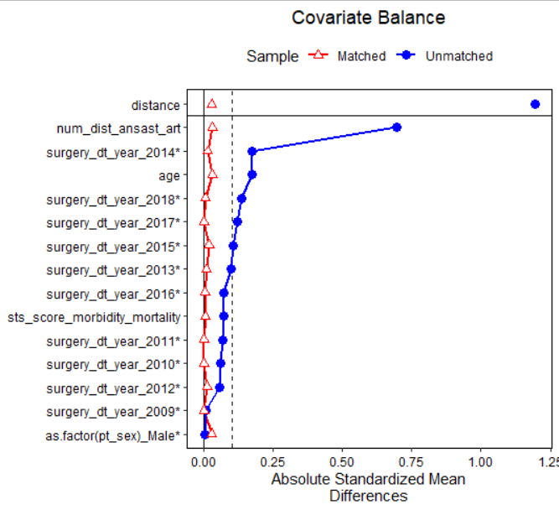
Appendix 2: Plot of covariate balance before and after 1: 1 PS matching (Unmatched: original cohort; Matched: PS matched cohort).

