Supplementary Information
Gas Phase Decomposition of (2,4,6-Trinitrotoluene (TNT) and 5-nitro-2,4-dihydro-3H-1,2,4-triazol-3-one (NTO) by Fe₁₃O₁₃ Nano-particle: Density Functional Theory Study
Leonid Gorb^{a,b}, Mykola Ilchenko^{c}, and Jerzy Leszczynskiª
^{a1}Interdisciplinary Center for Nanotoxicity, Department of Chemistry and Biochemistry, Jackson State University, P.O. Box 17910, 1325 Lynch Street, Jackson, MS 39217, USA.

^{b}Department of Molecular and Quantum Biophysics, Institute of Molecular Biology and Genetics, National Academy of Sciences of Ukraine, 150 Vul. Zabolotnogo, Kyiv 03143, Ukraine.

^{c}Department of Synthetic Bioregulators, Institute of Molecular Biology and Genetics, National Academy of Sciences of Ukraine, 150 Vul. Zabolotnogo, Kyiv 03143, Ukraine.

Top plane

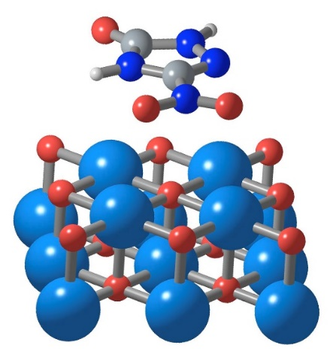  A 34.3 | 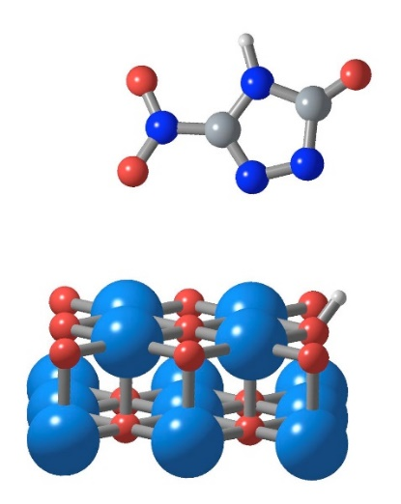  B 72.8

Bottom plane
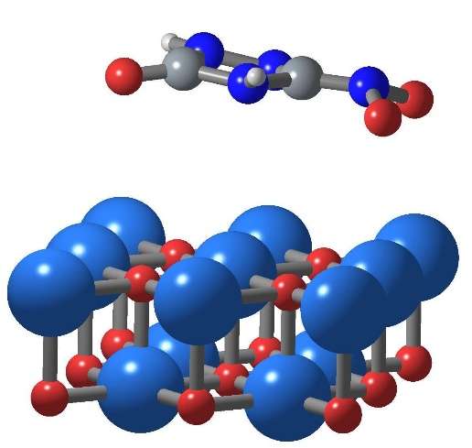 | 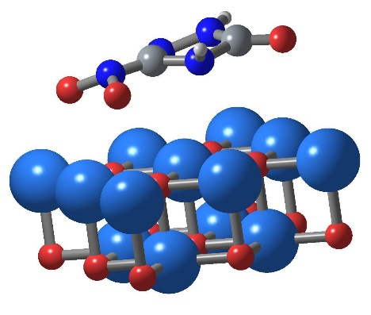

D 0.0
C 4.5

Figure 1s. Structures of the selected NTO adsorption complexes. Relative Gibbs free energy, kcal/mol, T = 298 K, (Colors of elements: Fe – light blue, O – red, N – blue, C- grey, H – light grey)

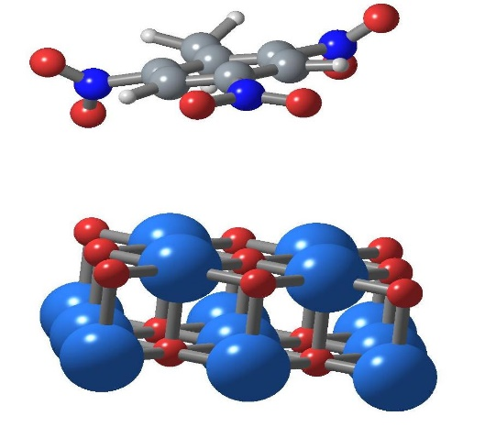 | 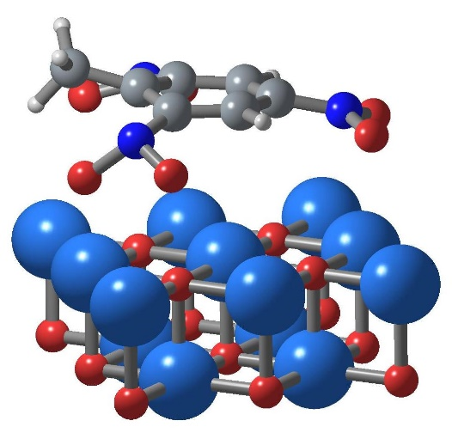
A 151.3 B 0.0
Figure 2s Structures of the selected TNT adsorption complexes. Relative Gibbs free energy, kcal/mol, T = 298 K, (Colors of elements: Fe – light blue, O – red, N – blue, C- grey, H – light grey)

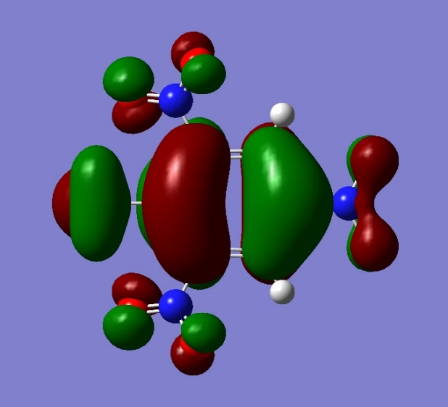  HOMO | 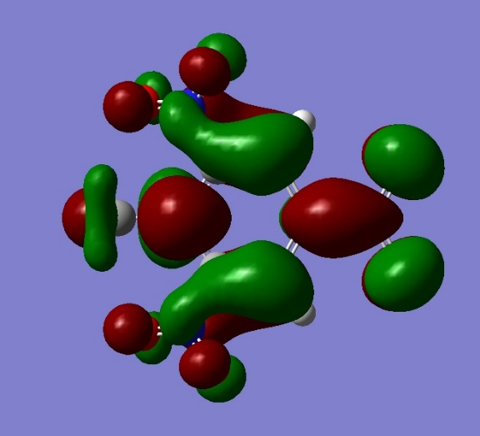  LUMO
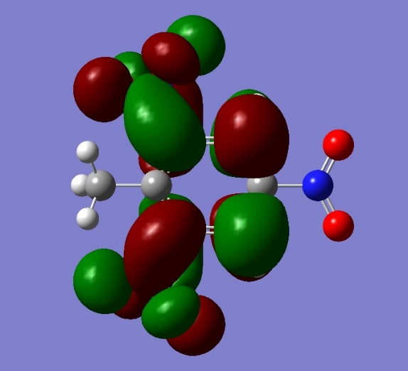  LUMO + 1 | 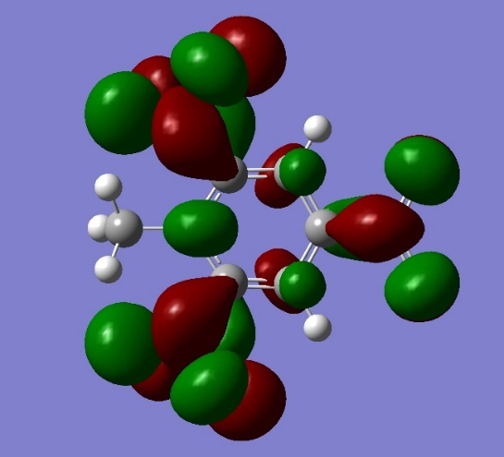  LUMO + 2

Figure 3s. View of TNT HOMO, LUMO, LUMO+1, LUMO2 orbitals calculated by at M06-2X approximation. The results obtained at BLYP- GD3BJ and B3LYP- GD3BJ are similar

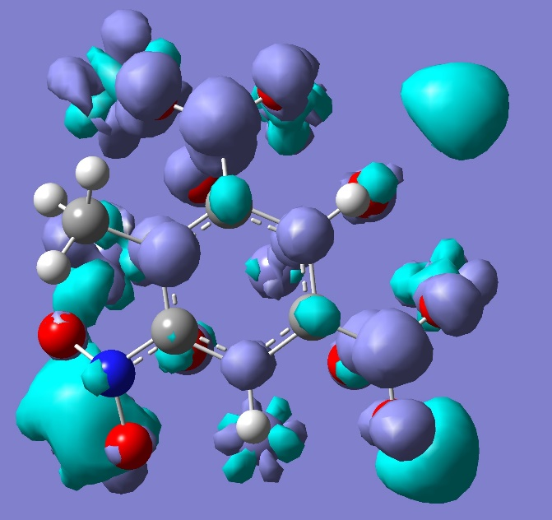

Figure 4s. View of TNT spin difference density calculated by at M06-2X approximation. The results obtained at BLYP-GD3BJ and B3LYP-GD3BJ are similar.

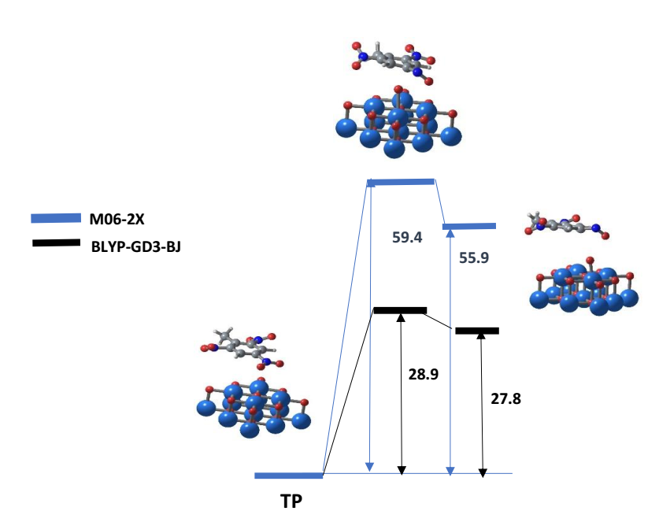
Figure 5s. Gibbs free energy profiles for TNT oxygen transfer (adsorption by top plane (TP) ) The similar in case of M06-2X functional is not found.

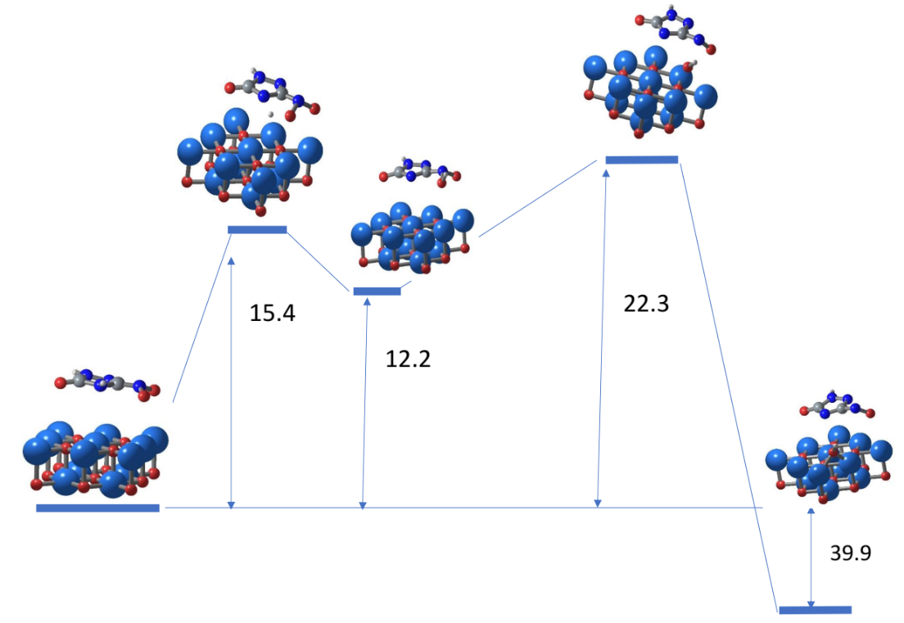

Figure 6s. Gibbs free energy profiles for NTO decomposition ( the adsorption state is located for 3.5 kcal/mol higher than adsorption state D Fig. 1).

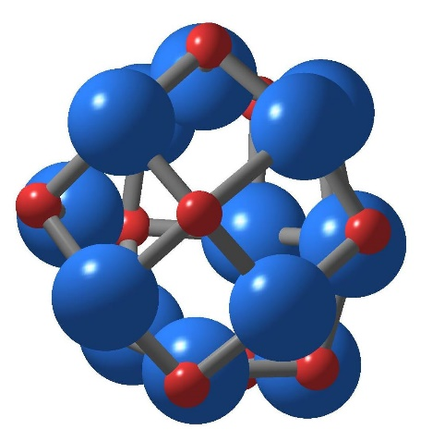 | 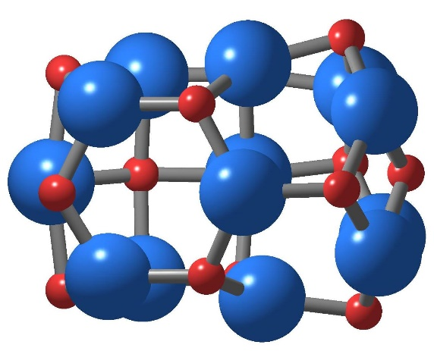

Figure 7s. Two different views of the optimized geometrical structure of Fe₁₃O₁₃ nano-particle. Fe – light blue, O – red.

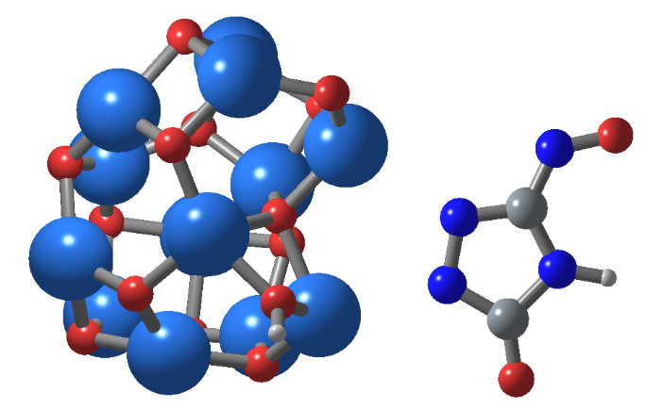
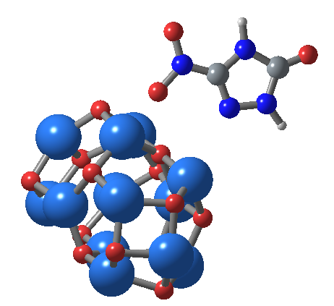

Figure 8s. Two different views of optimized geometrical structure of Fe₁₃O₁₃ nano-particle. Fe – light blue, O – red.

