Appendix 1 - Search strategy
- MEDLINE (Ovid SP) and Central search strategy
1 | All Fields: ((bronchoscopy) OR (endobronchial ultrasound)) OR (EBUS))
2 | All Fields: (dexmedetomidine)
3 | 1 AND 2
4 | Filters: Randomized Controlled Trial, Humans
5 | 3 AND 4

Figure S1: PRISMA flow diagram for systematic review and meta-analysis

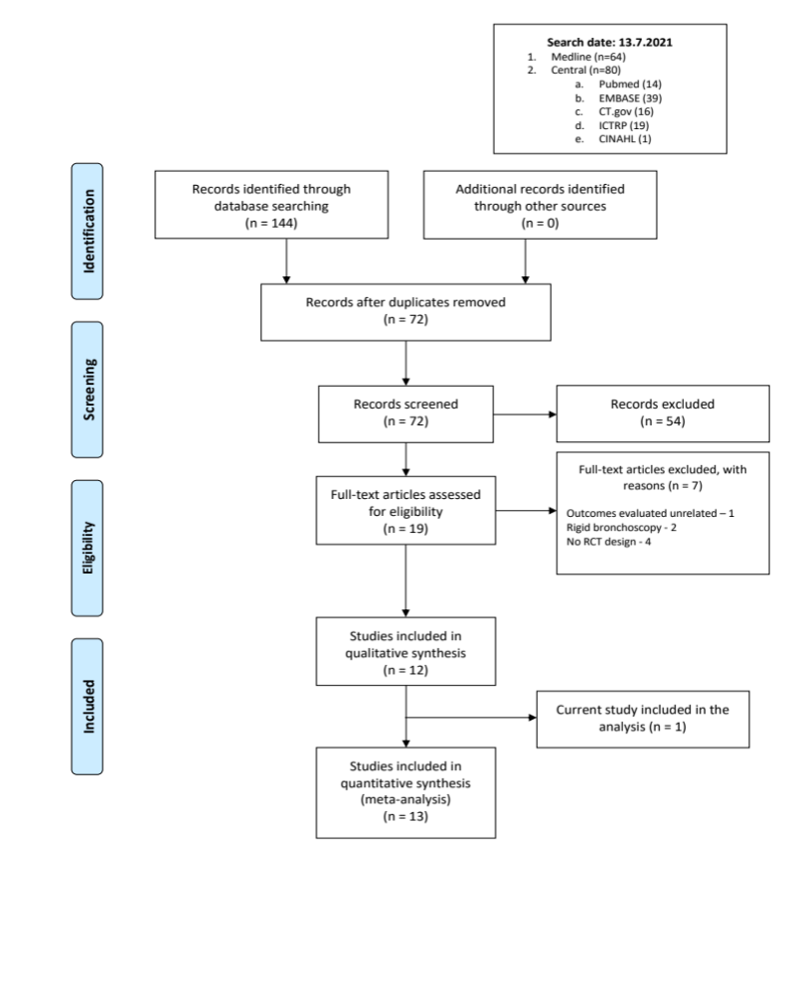

Figure S2. Risk of bias summary: review authors' judgements about each risk of bias item for each included study.
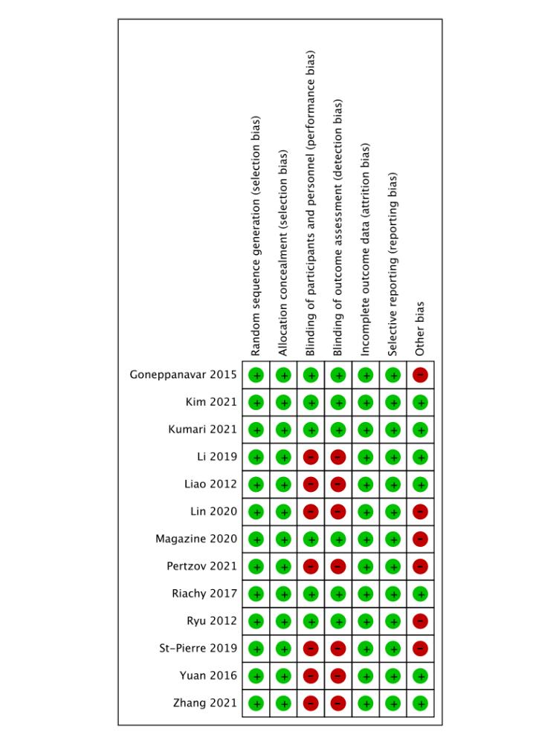

Figure S3. Risk of bias graph: review authors' judgements about each risk of bias item presented as percentages across all included studies.

