Supplementary material
Figure S1
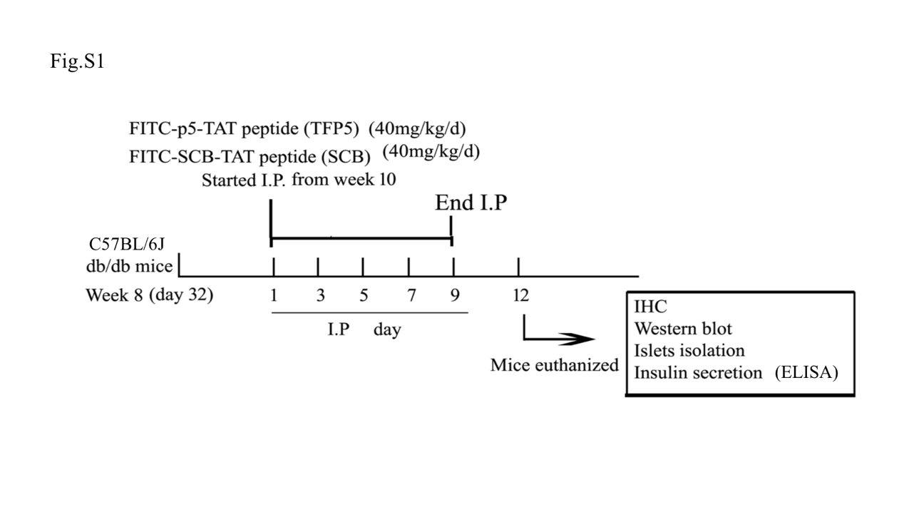Figure S1. Schematic chart of the treatment of db/db with TFP5 and SCB peptides. 8-week old db/db mice (n = 12) and 8-week old control C57BL/6J mice (n = 12) were divided into four groups: C57BL/6J + SCB, C57BL/6J + TFP5, db/db + SCB, and db/db + TFP5, with 6 mice per group. I.P. injection of mice was started on the 10th week with a single dose of 40 mg/kg/d TFP5 or with the same amount of SCB peptide as control on d1, d3, d5, d7, and d9. The mice were euthanized on d12 and islets were purified for Western blotting and insulin secretion test. Pancreases were collected and prepared for immunohistochemical studies and further biochemical analysis.

