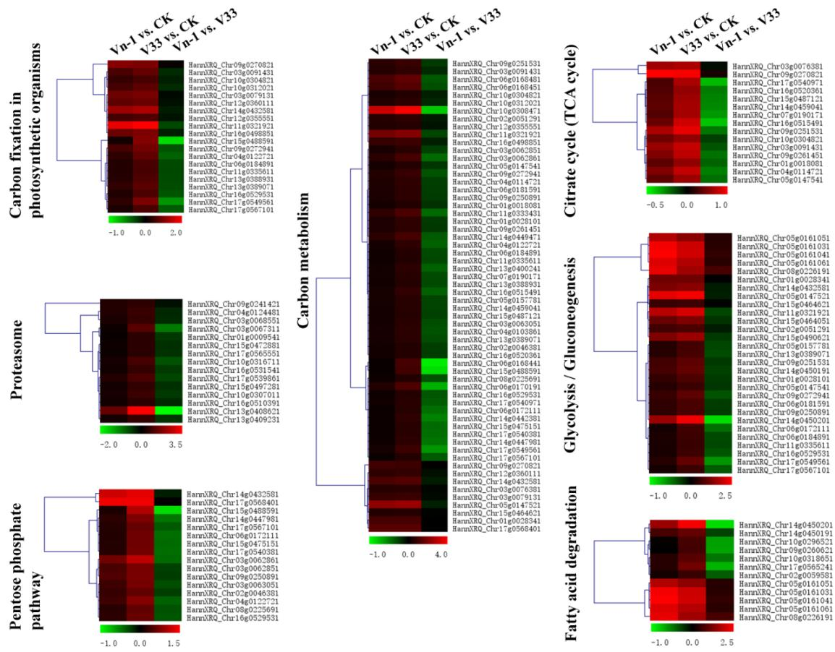
Fig S3. Heat map of DEGs involved in 7 KEGG pathways
These seven KEGG pathway enriched in V33 vs. CK comparison group, not in Vn-1 vs. CK comparison group.

Comparative transcriptome analysis reveals the mechanism of cross-protection against Verticillium wilt conferred on sunflower by hypovirulent strain Gibellulopsis nigrescens Vn-1

Authors：
Xin Zhao#, Bao-Zhu Dong#, Ying-Jie Zhao, Dong Wang, Lan Jing, Hong-You Zhou*
#Xin Zhao and Bao-Zhu Dong contributed equally to this work.

Institution:
College of Horticulture and Plant Protection, Inner Mongolia Agricultural University, Hohhot, 100010, China

