Supplementary Information

Aqueous enzymatic extraction of palm kernel oil

Firman Sebayang,^{a,b} Juliati Br. Tarigan,^{a,b} Mahlil Rizki,ª Ferizha Cinthya Utami,ª Taslia Anggriwati Hutagalung,ª Misdawati,^{c} Justaman A. Karo-karo,^{d} Suvimol Charoensiddhi,^{e} and Eko K. Sitepu^{a,b*}

ª Department of Chemistry, Faculty of Mathematics and Natural Sciences, Universitas Sumatera Utara, Medan 20155, Indonesia.
^{b} Carbon Research Centre, Universitas Sumatera Utara, Medan 20155, Indonesia
^{c} Department of Civil Engineering, Universitas Al Washliyah, Medan 20147, Indonesia.
^{d} Balai Riset dan Standarisasi Industri, Kementerian Perindustrian, Medan 20214, Indonesia.
^{e} Department of food science and technology, Faculty of Agro-Industry, Kasetsart University, Bangkok, Thailand 10900.

*Corresponding author: ekositepu@usu.ac.id

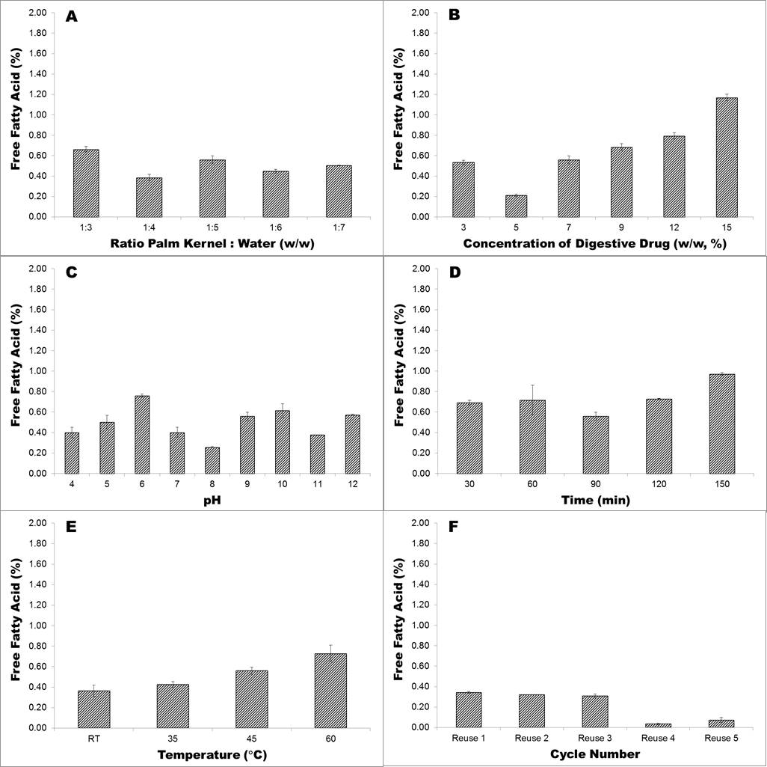
Figure 1. Effect of (A) ratio palm kernel to water; (B) weight of digestive drug; (C) pH; (D) reaction time; (E) temperature and (F) reusability of digestive drug on free fatty acid content of AEE intensified. Error bars represent SD.

Table 1. ANOVA and Hartley-Cochran homogeneity test and Tukey post hoc test for extraction efficiency of AEE palm kernel. Significance values below α<0.05 are colour coded in red.
Effect of Ratio Palm Kernel : Water

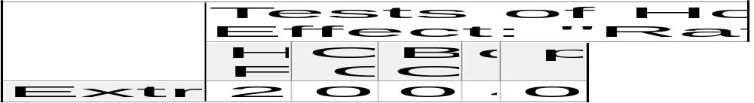
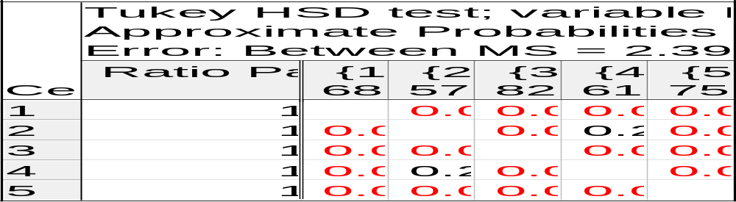

Effect of Weight of Vitazyme (Digestive Drug)


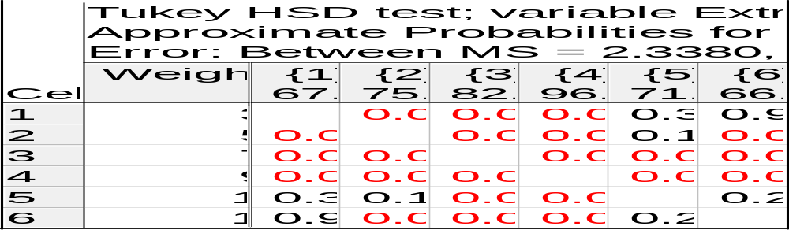

Effect of pH
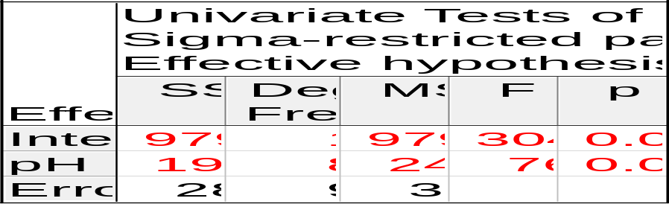
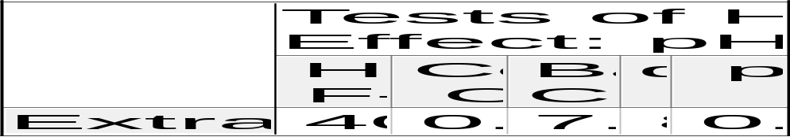
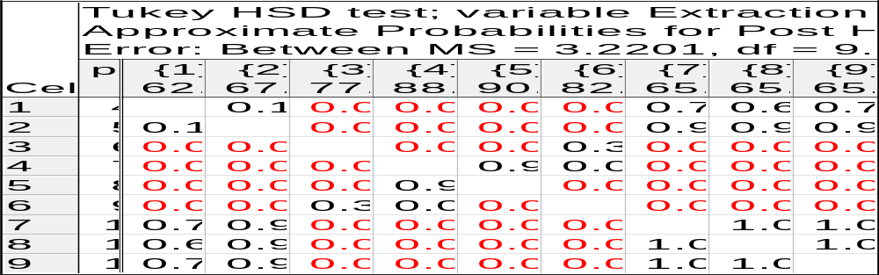

Effect of Reaction Time

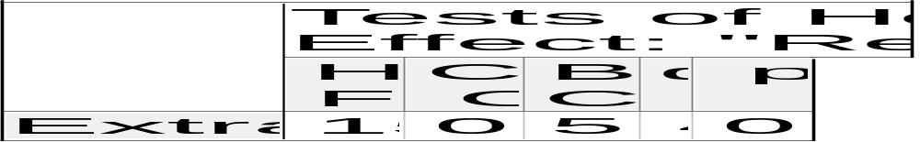
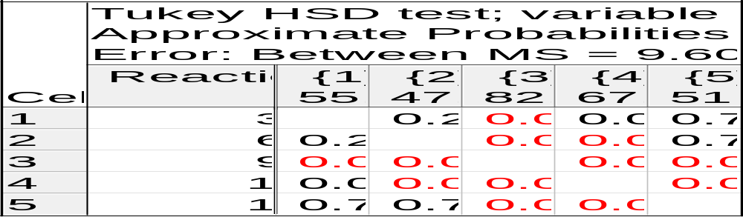

Effect of Temperature

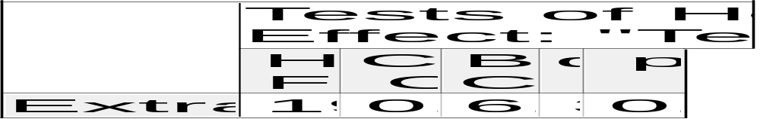
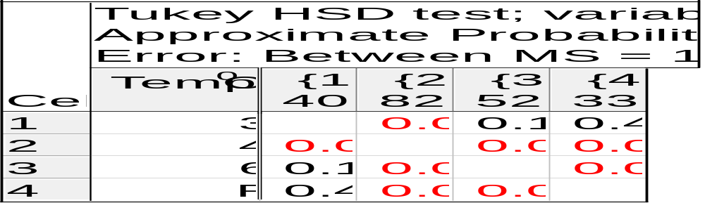

Table 2. ANOVA and Hartley-Cochran homogeneity test and Tukey post hoc test for Free Fatty Acid value of AEE palm kernel. Significance values below α<0.05 are colour coded in red.
Effect of Ratio Palm Kernel : Water

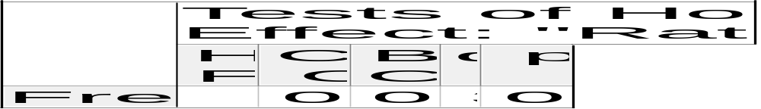
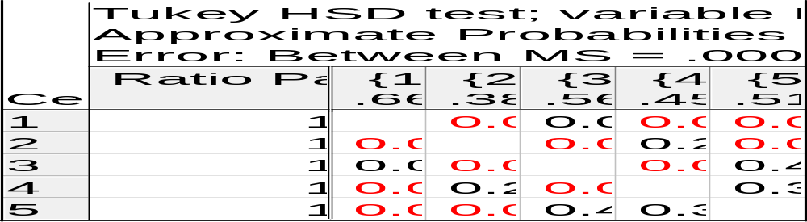

Effect of Weight of Vitazym (Digestive Drug)


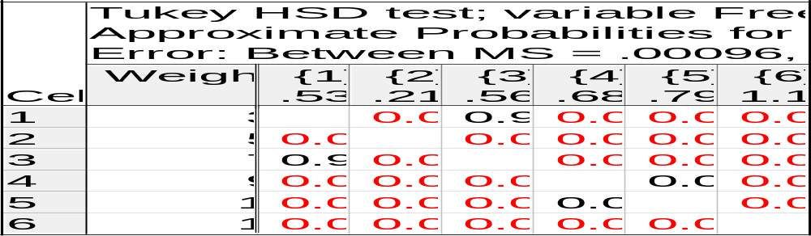

Effect of pH
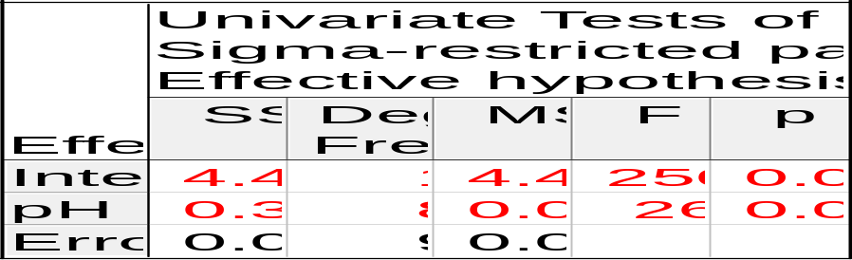

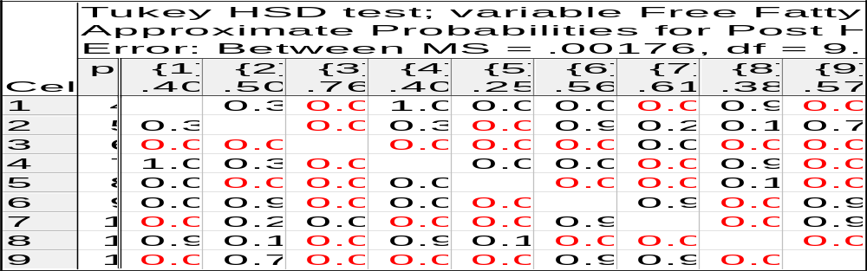

Effect of Reaction Time


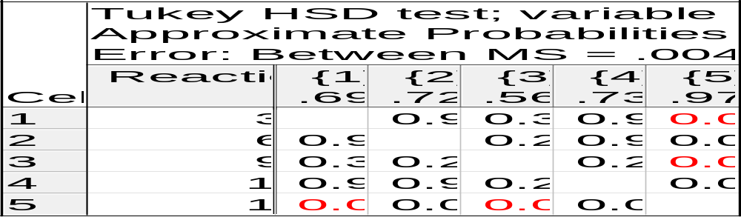

Effect of Temperature
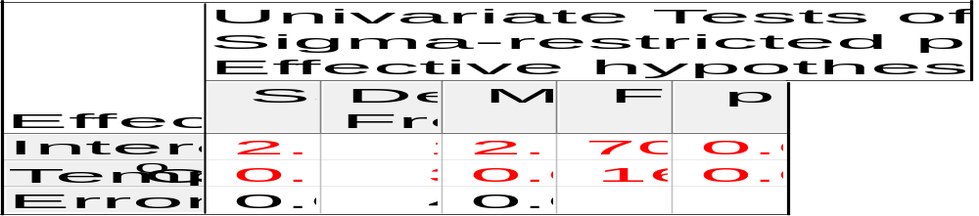

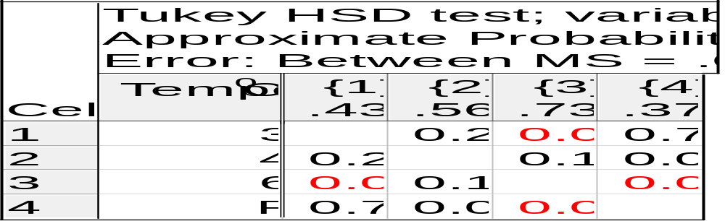

Table 3. ANOVA and Hartley-Cochran homogeneity test and Tukey post hoc test for Monoglyceride concentration (%) of AEE palm kernel. Significance values below α<0.05 are colour coded in red.
Effect of Ratio Palm Kernel : Water


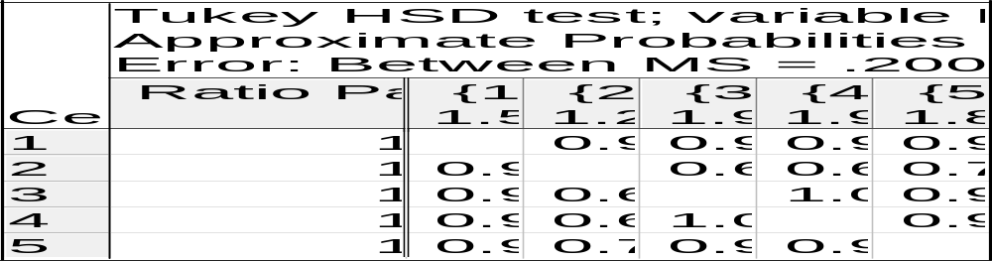

Effect of Weight of Vitazyme (Digestive Drug)


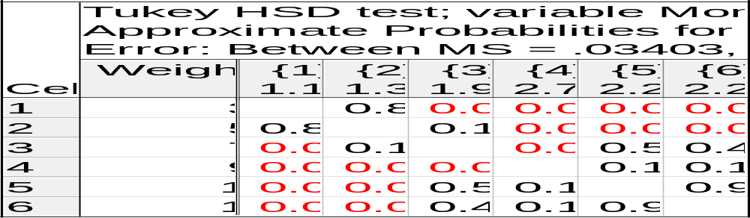

Effect of pH
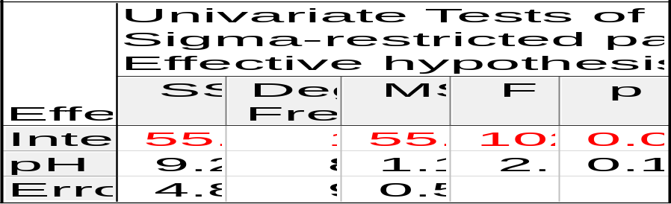

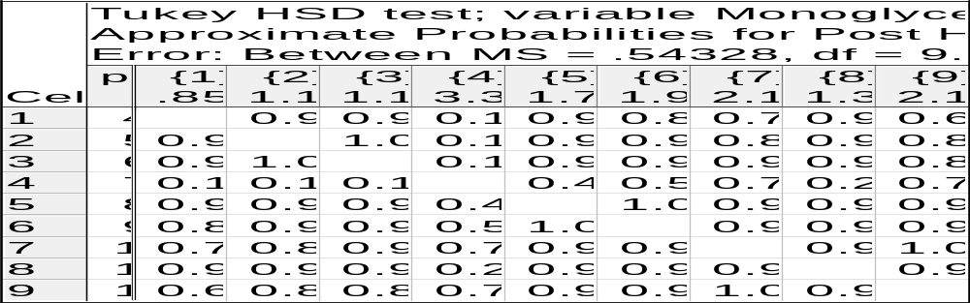

Effect of Reaction Time
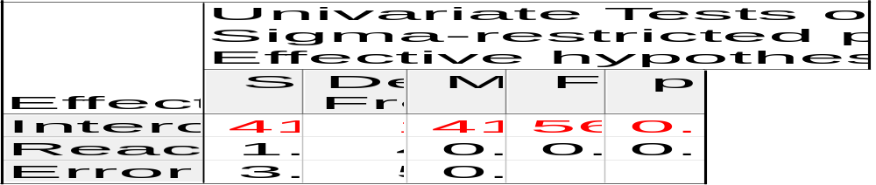

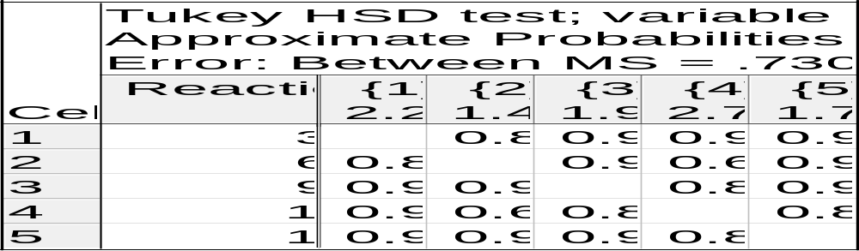

Effect of Temperature
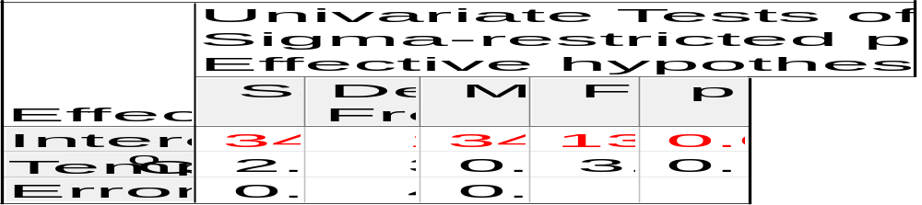

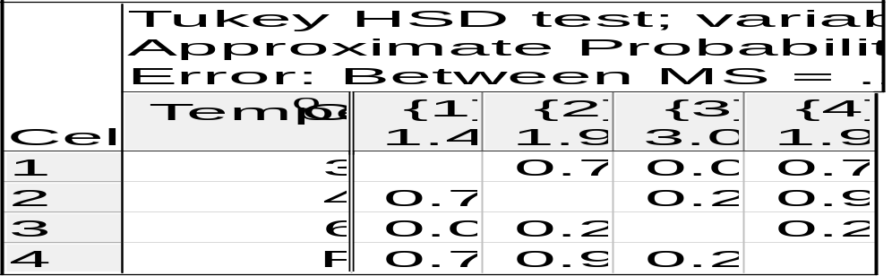

Table 4. ANOVA and Hartley-Cochran homogeneity test and Tukey post hoc test for Diglyceride concentration (%) of AEE palm kernel. Significance values below α<0.05 are colour coded in red.
Effect of Ratio Palm Kernel : Water


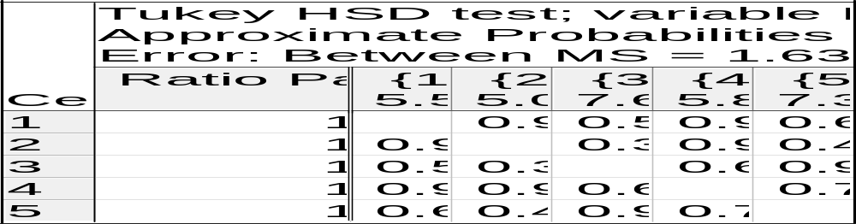

Effect of Weight of Vitazyme (Digestive Drug)


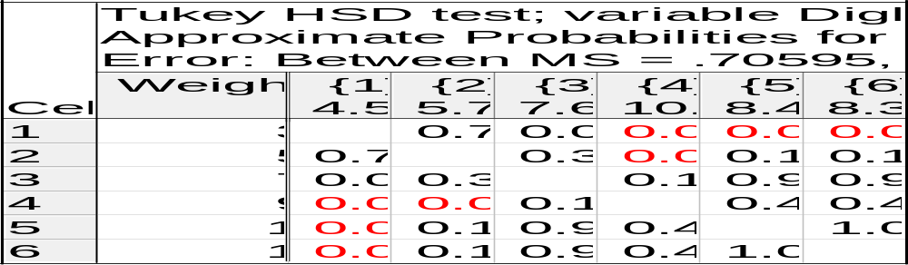

Effect of pH
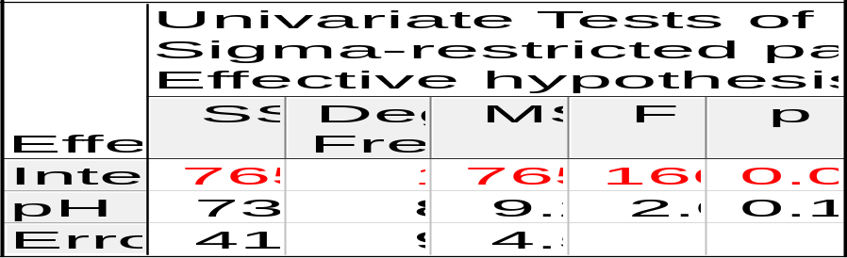

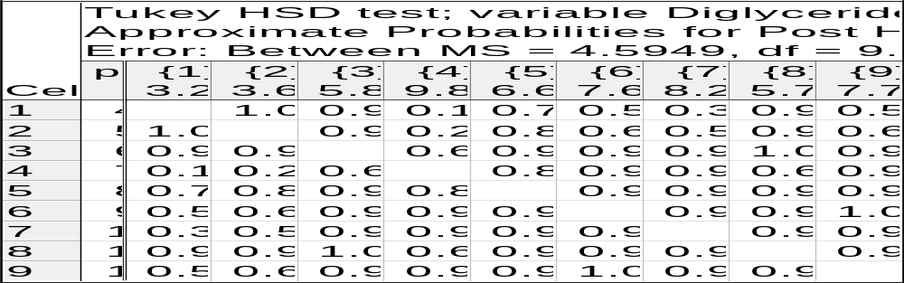

Effect of Reaction Time


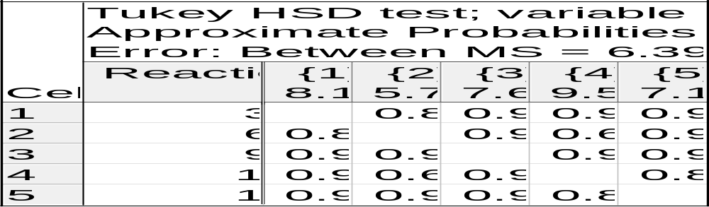

Effect of Temperature
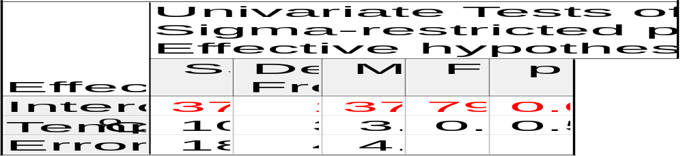
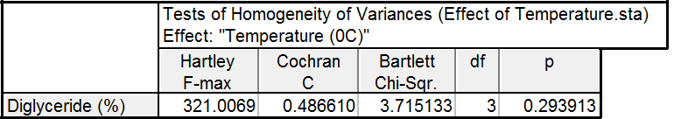
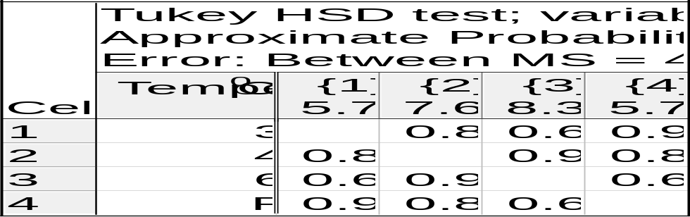

Table 5. ANOVA and Hartley-Cochran homogeneity test and Tukey post hoc test for Triglyceride concentration (%) of AEE palm kernel. Significance values below α<0.05 are colour coded in red.
Effect of Palm Kernel : Water

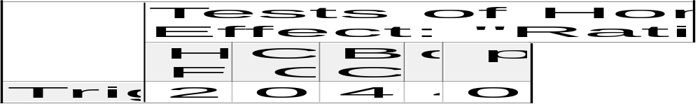
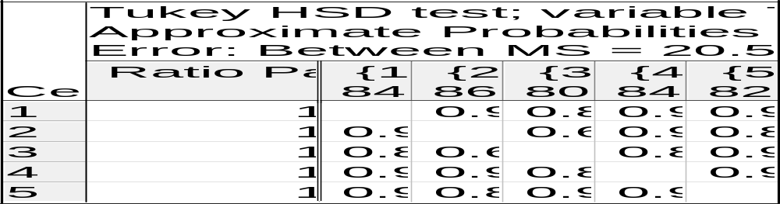

Effect of Weight of Vitazyme (Digestive Drug)


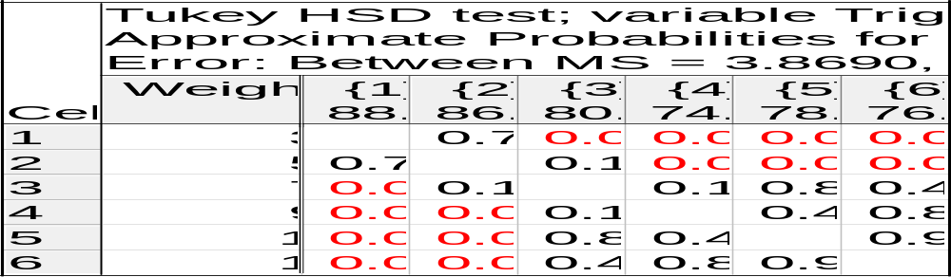

Effect of pH
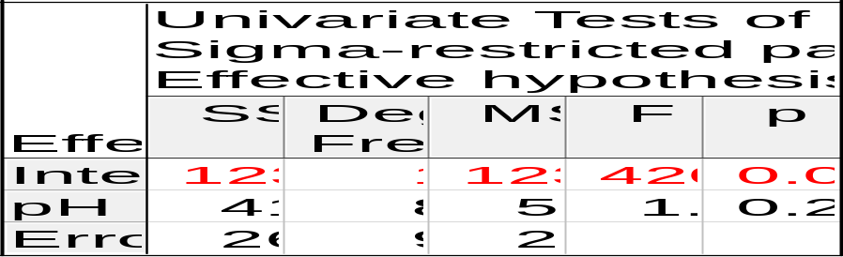
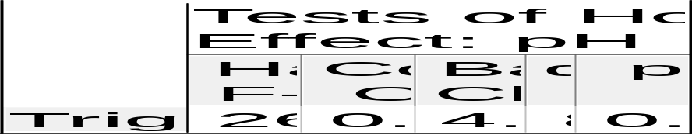

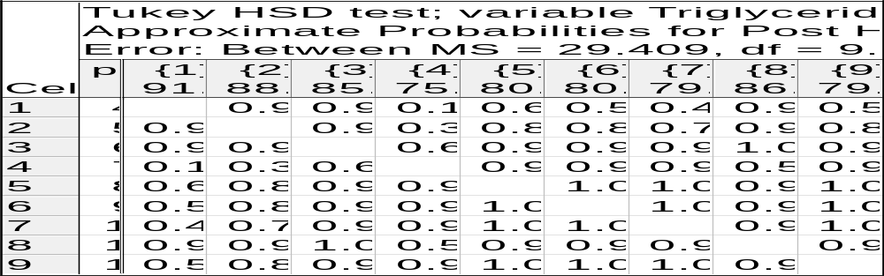

Effect of Reaction Time
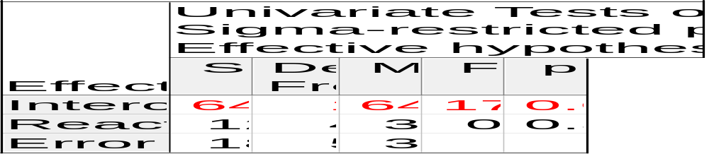
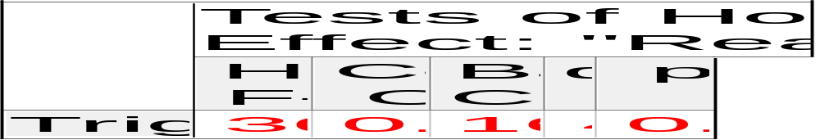
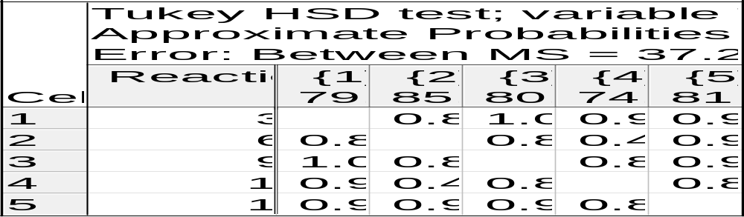

Effect of Temperature
